Supplementary Figure S2. Percentage of very preterm infants exposed to common pulmonary vasodilators by postmenstrual age. At any given postmenstrual age, the denominator represents infants that remain hospitalized.

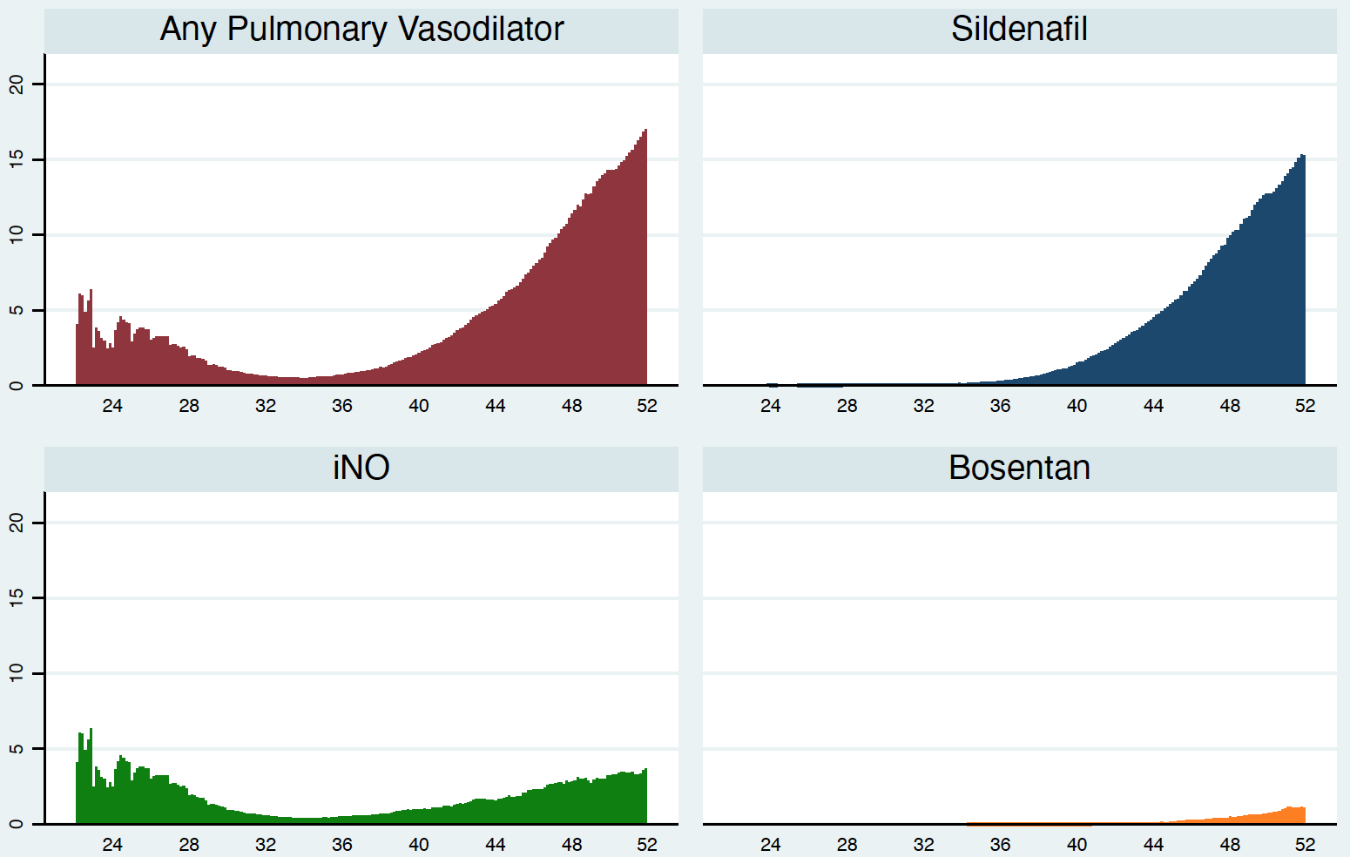
Percentage of infants exposed, %
Postmenstrual age, weeks

