S. Supplementary Material

S.1 Definitions of TrackMan Metrics

Table S.1 provides source names, definitions, and units for all TrackMan pitching metrics.
Common Name | TrackMan Column | Description | Units | Example
Release Speed | releaseSpeed | Speed of the ball as it leaves the pitcher’s hand, reported in miles per hour or meters per second. | km/r | 89.532
Spin Rate | spinRate | Speed at which the ball is spinning as detected by doppler radar. | rpm | 2416.975
Extension | extension | Distance towards home plate from which the pitcher releases the ball relative to the pitching rubber, reported in feet or meters. | m | 6.154
Vertical Release Angle | vertRelAngle | The vertical angle formed by the intersection of the y-axis and the ball’s path (in the vertical direction) as it leaves the pitcher’s hand. A negative number means the ball is sloping downward, while a positive number means it’s sloping upward. | deg | -1.595
Horizontal Release Angle | horzRelAngle | The horizontal angle formed by the intersection of the ball’s path (in the vertical direction) as it leaves the pitcher’s hand. A negative number means the ball is traveling towards the LHB batter’s box, while a positive number means it’s traveling towards the RHB batter’s box. | deg | 0.844
Release Height | relHeight | Vertical distance of the ball above home plate when the pitcher releases the ball, reported in feet or meters. | m | 7.054
Release Side | relSide | Distance from the y-axis from which the pitcher releases the ball, reported in feet or meters. | m | -0.936
Release Confidence | releaseConfidence | Confidence in the accuracy of the pitch release data | -- | High
Horizontal Break | horzBreak | Horizontal distance between where the ball crosses home plate and where it would have crossed if it had traveled in a straight line from release and were unaffected by gravity, reported in inches or centimeters. | cm | 2.231
Vertical Break | vertBreak | Distance between the height at which the ball crosses home plate and the height at which it would have crossed if it traveled in a straight line from release and were completely unaffected by gravity. | cm | -15.203
Induced Vertical Break | inducedVertBreak | Distance between the height at which the ball crosses home plate and the height at which it would have crossed if it traveled in a straight line from release and were affected by gravity. | cm | 17.281
Spin Axis | spinAxis | Direction in which the ball is spinning, reported in degrees of tilt. | deg | 187.343
Tilt | tilt | Spin axis converted into clock time, rounded to the nearest 15 minutes. As a rule of thumb, the ball will break in the direction of the number on the clock face. | -- | 3:00
Movement Confidence | movementConfidence | Confidence in the accuracy of the pitch movement/breaks data | -- | Low
Zone Time | zoneTime | Time elapsed from when the pitcher releases the ball to when it crosses the front of home plate, reported in seconds. | seconds | 0.410
Vertical Pitch Location | plateLocHeight | The height of the ball relative to home plate as it crosses the front of the plate, reported in feet or meters. | m | 2.814
Horizontal Pitch Location | plateLocSide | Distance from the y-axis to the ball as it crosses the front of home plate, reported in feet or meters. | m | -0.525
Zone Speed | zoneSpeed | Speed of the ball as it crosses the front of home plate, reported in miles per hour or meters per second. | km/h | 84.832
Vertical Approach Angle | vertApprAngle | The vertical angle formed by the intersection of the y-axis and the ball’s path (in the vertical direction) as it crosses the front of home plate. | deg | -4.858
Horizontal Approach Angle | horzApprAngle | The horizontal angle formed by the intersection of the y-axis and the ball’s path (in the x-direction) as it crosses the front of home plate. | deg | -2.694
Location Confidence | locationConfidence | Confidence in the accuracy of the pitch location data | -- | Medium
-- | x0 | The distance of the ball from the center of the rubber along the x-axis. | m | 0.864
-- | y0 | The distance of the ball from the tip of home plate along the y-axis. | m | 50.000
-- | z0 | The distance of the ball from the tip of home plate along the vertical axis. | m | 6.889
-- | vx0 | The velocity of the ball in the x-direction. | m/s | -1.401
-- | vy0 | The velocity of the ball in the y-direction. | m/s | -129.863
-- | vz0 | The velocity of the ball in the vertical direction. | m/s | -4.160
-- | ax0 | The acceleration of the ball in the x-direction. | m/s² | 9.536
-- | ay0 | The acceleration of the ball in the y-direction. | m/s² | 26.628
-- | az0 | The acceleration of the ball in the vertical direction. | m/s² | -14.156
-- | pfxx | The horizontal (left-right) movement of the pitch during the last 40 feet before the front of home plate, as compared to a theoretical pitch thrown at the same speed with no spin-induced movement. | cm | 5.572
-- | pfxz | The vertical (up-down) movement of the pitch during the last 40 feet before the front of home plate, as compared to a theoretical pitch thrown at the same speed with no spin-induced movement. | cm | 10.528
Speed Drop | speedDrop | The difference between RelSpeed and ZoneSpeed, reported in miles per hour or meters per second. | km/h | 7.243
Effective Speed | effectiveVelo | Effective speed of the pitch when taking the location of pitch into account. | km/h | 80.890
-- | pitchTrajectoryXc0 | 0 order coefficient for trajectory polynomial describing x-coordinate of the pitch | m | 55.489
-- | pitchTrajectoryXc1 | 1 order coefficient for trajectory polynomial describing x-coordinate of the pitch | m | -130.984
-- | pitchTrajectoryXc2 | 2 order coefficient for trajectory polynomial describing x-coordinate of the pitch | m | 13.314
-- | pitchTrajectoryYc0 | 0 order coefficient for trajectory polynomial describing y-coordinate of the pitch | m/s | 7.051
-- | pitchTrajectoryYc1 | 1 order coefficient for trajectory polynomial describing y-coordinate of the pitch | m/s | -3.564
-- | pitchTrajectoryYc2 | 2 order coefficient for trajectory polynomial describing y-coordinate of the pitch | m/s | -7.078
-- | pitchTrajectoryZc0 | 0 order coefficient for trajectory polynomial describing vertical coordinate of the pitch | m/s² | 0.932
-- | pitchTrajectoryZc1 | 1 order coefficient for trajectory polynomial describing vertical coordinate of the pitch | m/s² | -1.802
-- | pitchTrajectoryZc2 | 2 order coefficient for trajectory polynomial describing vertical coordinate of the pitch | m/s² | 4.768
Table S.1: Definitions of TrackMan metrics tracked for a pitched baseball.

S.2 Trigonometric Estimates of Arm Angle
The arm angle of a baseball pitcher (commonly referred to as arm “slot” in baseball pitching) refers to the amount of shoulder tilt at ball release. When joint kinematics at ball release are not available, the amount of shoulder tilt can be approximated by the position of the arm. Assuming the pitcher’s elbow is fully extended at release, the pitcher’s release position forms a right triangle where the hypotenuse is the fully extended arm, and the base is the horizontal distance perpendicular to the proximal end of the arm. Details of the estimation process for each component are provided below.
TrackMan measures the height of the ball at release relative to the ground but does not provide pitcher height or arm length. To account for this, two simplifying assumptions are made: (1) most pitchers release the ball just below the average standing height of pitchers the dataset due to the requirements of squatting down the angled mound; and (2) total arm span is typically about a 1:1 ratio with total height. Total arm span includes the width of the sternum, but we use half of the release height as a conservative estimate of the pitcher’s arm length at full extension to approximate the right triangle hypotenuse. The horizontal component must also be inferred, as TrackMan measures the horizontal position of the ball at release relative to the center of the pitcher’s mound instead of the pitcher’s body. To account for this, we assume that pitchers stand near the center of the mound on average and offset lateral release positions by the estimated width from the base of the neck to the proximal humerus of the shoulder. This width was set to 0.1 meters as a conservative estimate, but it may still overestimate the lateral component of arm angle, since pitchers do not always stand at the center of the mound.
Once both components of the right triangle have been estimated, the angle can be computed as the inverse cosine of the horizontal distance relative to the shoulder divided by the fully extended arm segment length. Angles were inverted such that 90 degrees corresponded to a completely lateral throw (i.e., sidearm) and 0 degrees to an overhead throw. Results showed that arm angle estimates were biased high (Table A.2), as more of the pitches should have fallen into the “mid” category based on other analyses of elite pitchers. However, since these angles were only used to evaluate model generalizability and not to generate any features, this was considered a negligible limitation. Future research may look to refine this arm slot estimation process to enable more precise release position feedback from ball tracking data.
Arm Slot Bin | Number of Pitches
High | 2,024,871
Mid | 150,265
Low | 39,847
Table 2a: Pitch counts for each arm angle category. High: 0-30 degrees, Mid: 30-60 degrees, Low: 60-90 degrees.

S.2 Euclidean Distance Loss Criterion
The objective of the deep learning model was to minimize the joint error of the vertical and horizontal predictions, and thus Euclidean distance was chosen as the loss function:
$\frac{1}{m}\sum_{j=1}^{m}{(\sqrt{\sum_{i=1}^{n}{(p_{j,i}-t_{j,i})^{2}}})}$ (1)
Where $p_{j,i}$ and $t_{j,i}$ represent the i-th element of the j-th predicted and target vector, respectively, and m is the number of vectors as determined by the batch size. The vectors were adapted to PyTorch tensors to be compatible with the DNN architecture outlined in the Methods section of this manuscript. An option was included to remove the square root and smooth the loss function, but performance of the model was deemed satisfactory without this adjustment.

S.3 Projectile Motion Estimates of Pitch Location
The following equations governs the two-dimensional motion of a projectile:
$x_{f} = x_{i} + v_{i}t + \frac{1}{2}a_{i}t^{2}$ (2)
$v_{f} = v_{i} + a_{i}t$ (3)
The equations can be solved in the lateral (x-y) and vertical (x-z) planes of motion by deconstructing the components of the initial position and velocity vectors. TrackMan provides the initial position as three separate metrics: extension ($x_{i_{x}}$), release side ($x_{i_{y}}$), and release height ($x_{i_{z}}$) of the ball. Initial velocity components were reconstructed using trigonometry of the release speed scalar and release angles, which are measured in the x-z ($θ_{v}$) and y-z ($θ_{h}$) planes of motion:
$v_{i_{x}} = v_{i}cosθ_{v}cosθ_{h}$ (4)
$v_{i_{y}} = v_{i}cosθ_{v}sinθ_{h}$ (5)
$v_{i_{z}} = v_{i}sinθ_{v}$ (6)
Basic algebra with the reconstructions confirms that the magnitude of the components sums to $v_{i}$. Following the assumption that gravity was the only force acting on the ball during flight, it was possible to generate a physics-based estimate of flight time to home plate based on the pitcher’s extension and equation 2. Extension is measured relative to the pitcher’s mound, and thus the estimated flight time for the ball is:
$\hat{t} = \frac{Δx}{v_{i_{x}}}$ (7)
Where $Δx$ is the distance between home plate and measured extension relative to the pitcher’s mound. Using each of the estimated parameters from equations (3) – (7), projectile motion location estimates using (2) were gathered for vertical and horizontal location as follows:
${\hat{x}}_{f_{y}} = x_{i_{y}} + v_{i_{y}}\hat{t}$ (8)
${\hat{x}}_{f_{z}} = x_{i_{z}} + v_{i_{z}}\hat{t} - \frac{1}{2}g{\hat{t}}^{2}$ (9)
Although the results were inaccurate (Table S.3), they provided features that could be used in the machine learning models developed for this study. As outlined in the discussion, this likely facilitated enhanced learning of the underlying ball flight physics in the deep learning model without the need to explicitly model all the interactions among features, as would be necessary for the linear regression model.
< TABLE S.3>

Error Distributions for Linear Regression and Physics Predictions
The error distributions for the predictions made with linear regression (horizontal, 1a; vertical, 2a; Euclidean distance, 3a) and physics (horizontal, 1b; vertical, 2b; Euclidean distance, 3b) are provided below. Dashed black lines indicate the 5th (if applicable) and 95th percentile errors.
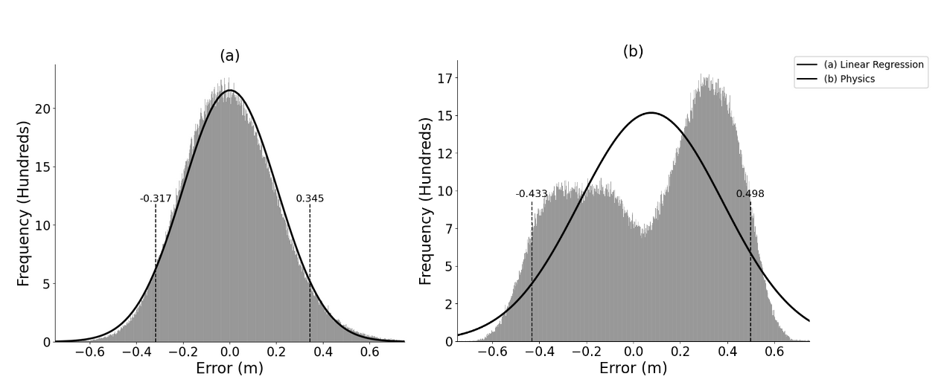
Figure S.1: Horizontal error distributions for linear regression (a, left) and physics (b, right) predictions. Errors were computed as predicted minus actual. The solid black line is a standard normal distribution scaled to the histogram data (gray bars). The black dashed lines indicate the 5th (left) and 95th (right) percentile errors, respectively.
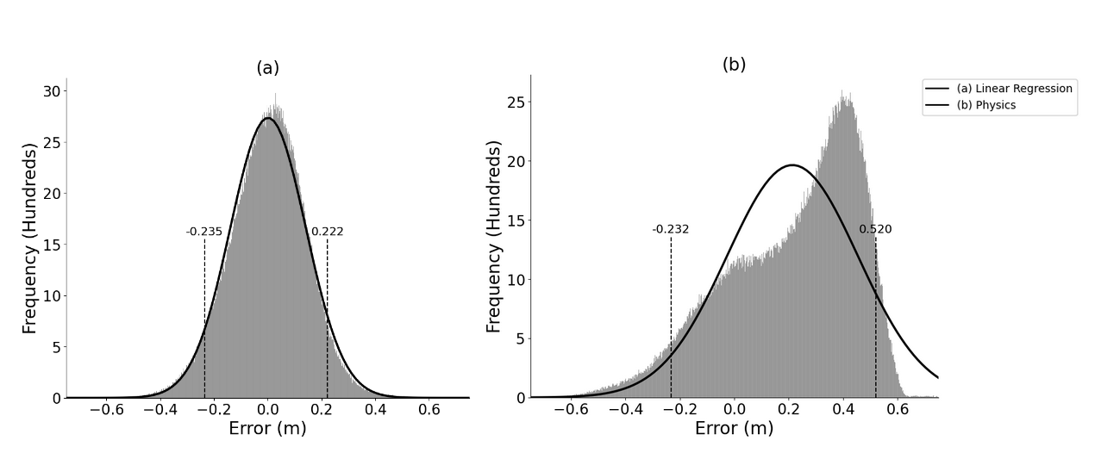
Figure S.2: Vertical error distributions for linear regression (a, left) and physics (b, right) predictions. Errors were computed as predicted minus actual. The solid black line is a standard normal distribution scaled to the histogram data (gray bars). The black dashed lines indicate the 5th (left) and 95th (right) percentile errors, respectively.
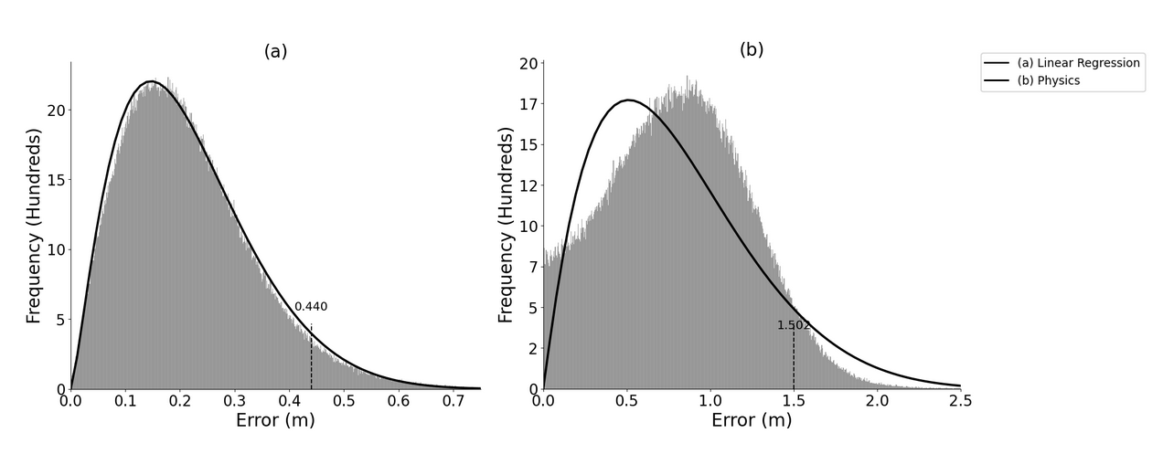

Figure S.3: Euclidean distance error distributions for linear regression (a, left) and physics (b, right) predictions. Errors were computed as predicted minus actual. The solid black line is a standard normal distribution scaled to the histogram data (gray bars). The black dashed line indicates the 95th percentile error.

S.4 Linear Regression Model Coefficients
The standardized coefficients for the vertical and horizontal location linear regression models can be found in the Table S.4. The input data were standardized for development of the DNN.
Feature | Horizontal Model Coefficient | Vertical Model Coefficient
Estimated z-Velocity at Plate | 0.026 | -0.005
Vertical Release Angle | 0.493 | 0.749
Estimated Time to Plate | -0.079 | -0.396
Extension | -0.003 | -0.006
Estimated y-Location at Plate | 1.284 | 0.024
Horizontal Release Angle | -2.059 | -0.044
Estimated z-Location at Plate | -0.372 | -0.266
Release Speed | 0.131 | -0.028
Release Height | 0.173 | 0.293
Release Side | -1.349 | -0.049
Spin Rate | -0.049 | -0.032
Table S.4: Standardized coefficients for each linear regression model.

