Haplotypes affecting stillbirth and fertility in Icelandic Dairy Cattle. Journal of Applied Genetics. Egill Gautason¹, Þórdís Þórarinsdóttir² and Goutam Sahana³
¹Agricultural University of Iceland, 311 Borgarnes, Iceland
²The Icelandic Agricultural Advisory Center, Óseyri 2, 603 Akureyri, Iceland
³Aarhus University, Center for Quantitative Genetics and Genomics, C. F. Møllers Allé 3, 8000 Aarhus, Denmark
goutam.sahana@qgg.au.dk

Daughter stillbirth 1
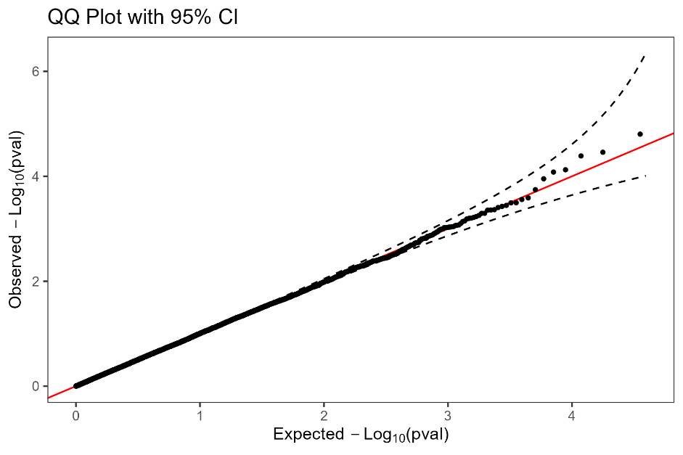

Sire stillbirth 1
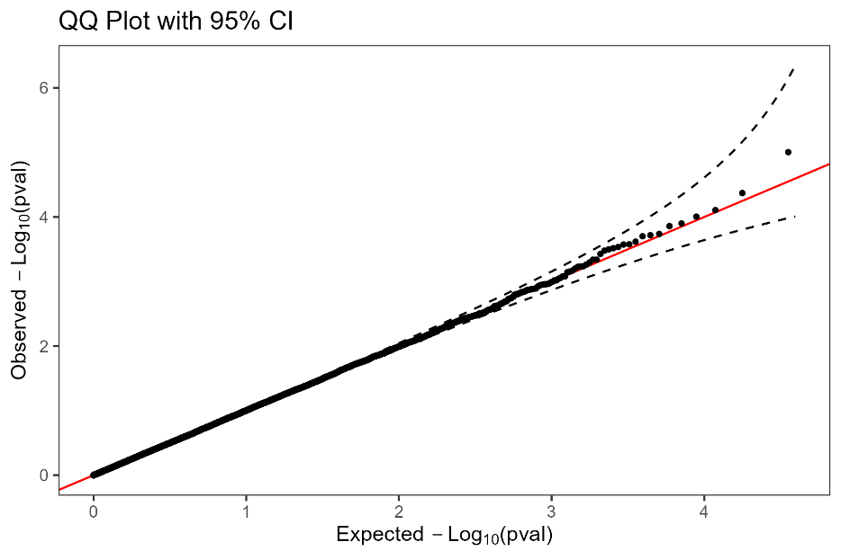

Daugher stillbirth 2

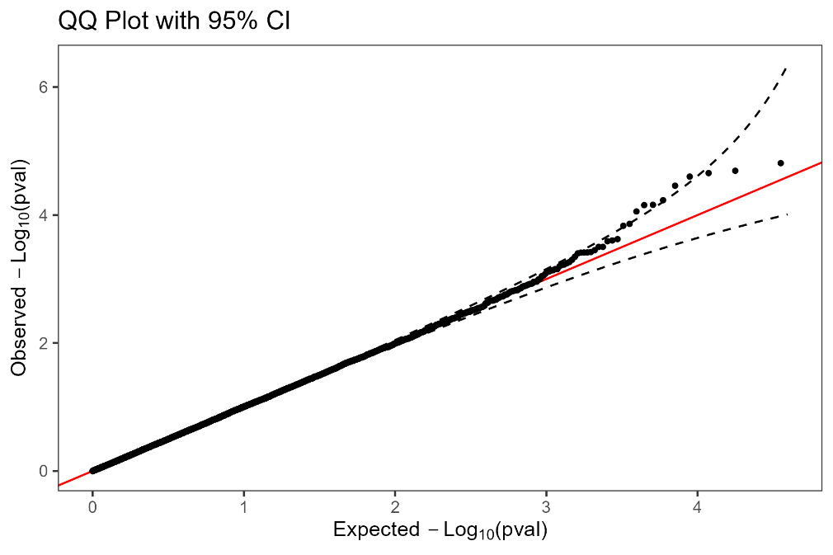

Sire stillbirth 2

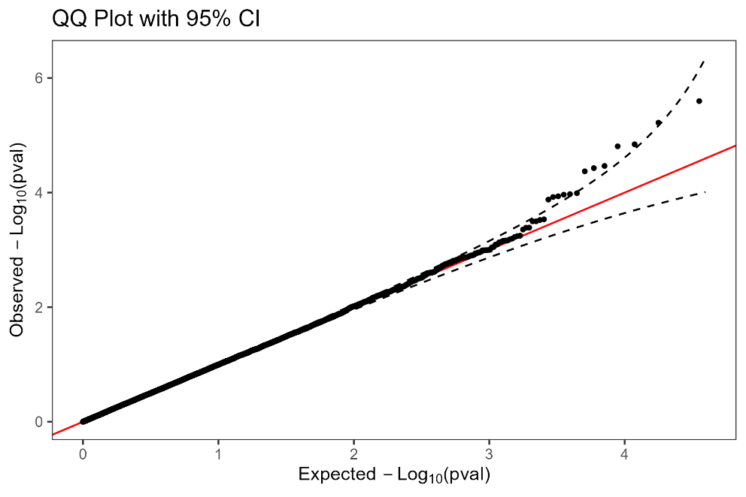

CI
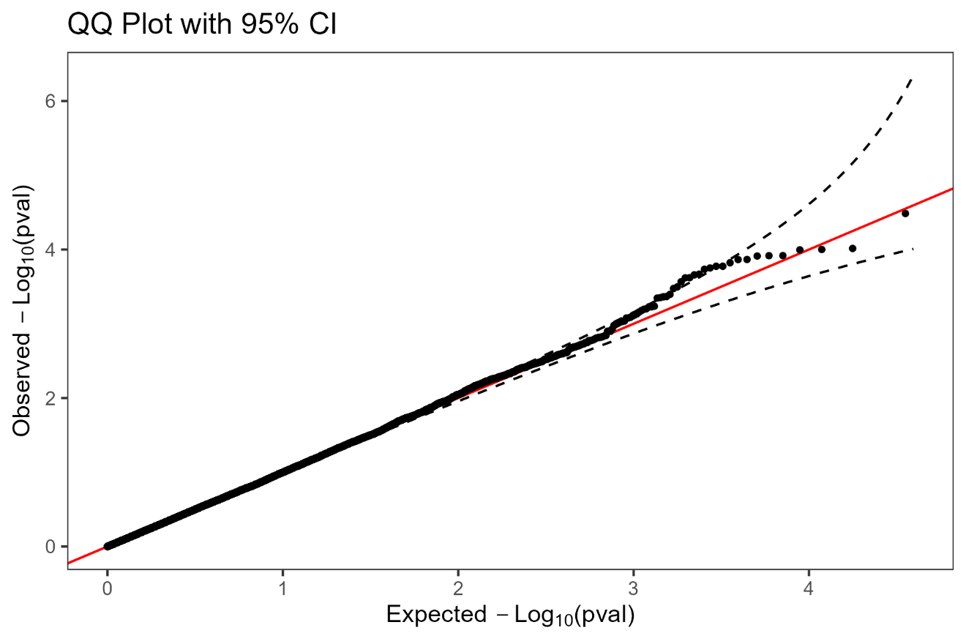IFL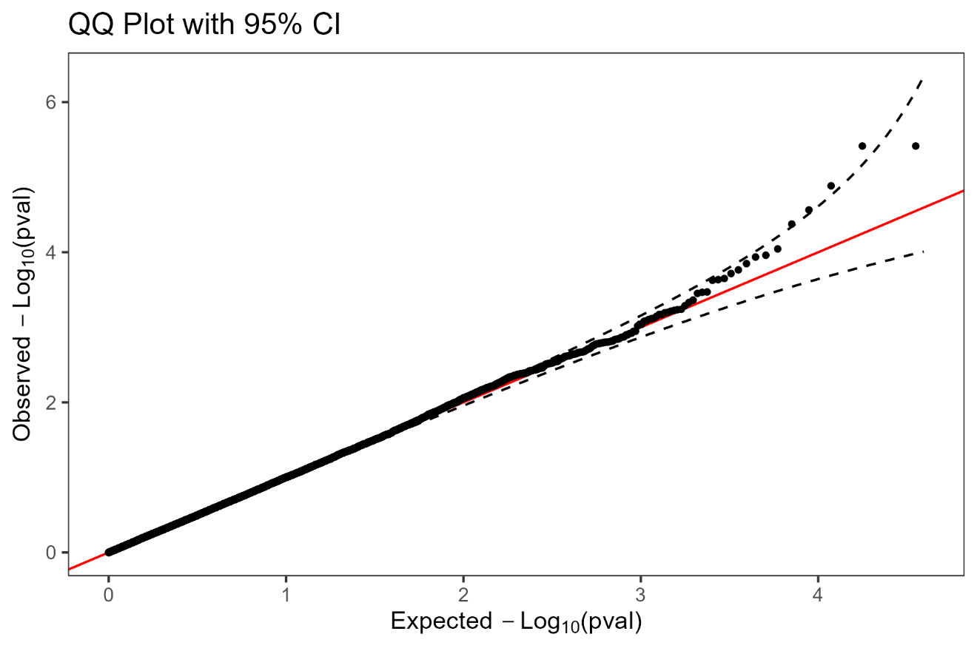

AIS

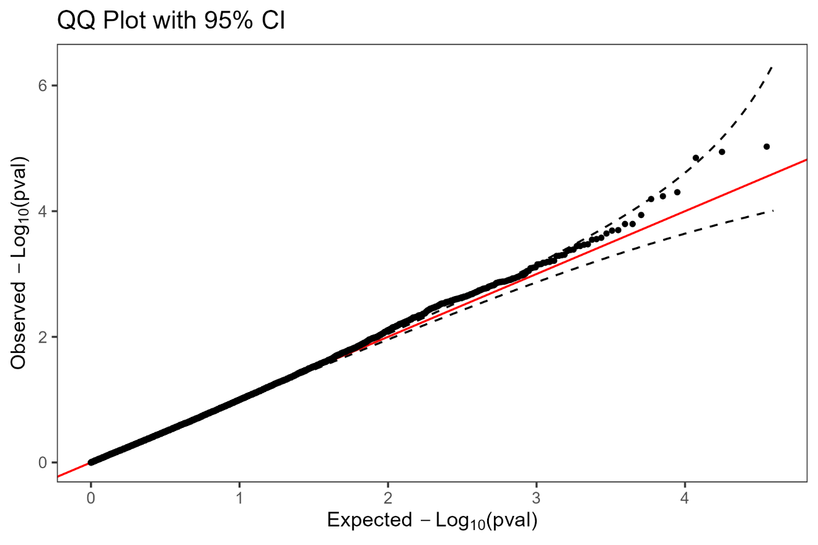

CR

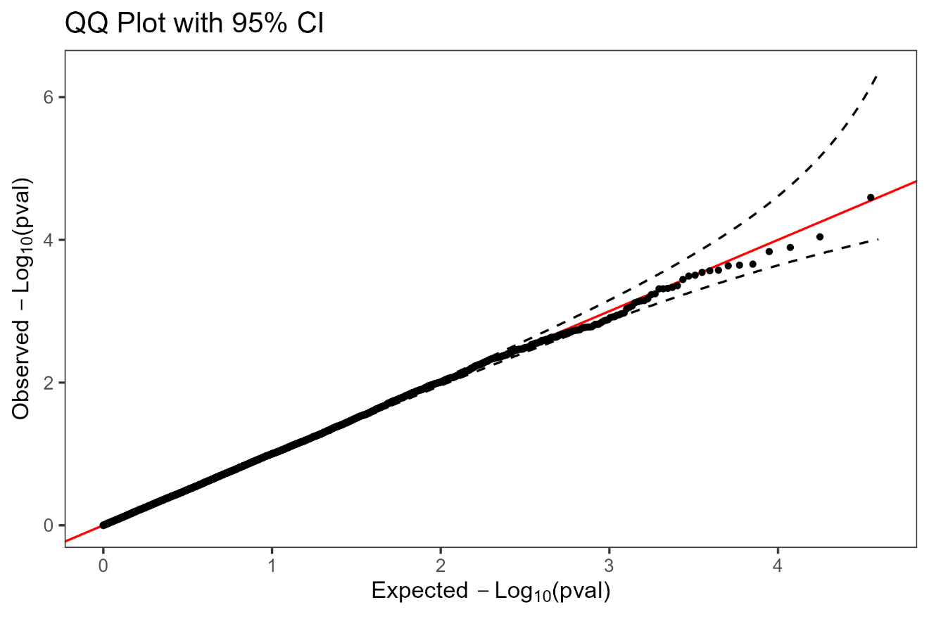

Infertility
