Supplementary Materials for

Data-Driven De Novo Design of Super-Adhesive Hydrogels
Hongguang Liao†, Sheng Hu†, Hu Yang, Lei Wang, Shinya Tanaka, Ichigaku Takigawa*, Wei Li*, Hailong Fan*, Jian Ping Gong*

Corresponding author: takigawa@icredd.hokudai.ac.jp; liw@szlab.ac.cn; fanhl@icredd.hokudai.ac.jp; gong@sci.hokudai.ac.jp

The PDF file includes:

Materials
Supplementary Methods
- Reactivity ratio measurement
- Hydrogel mechanical property characterization
- Histopathological study

Supplementary Figs. 1 to 12
Supplementary Algorithm 1
Supplementary Tables 1 to 6
References

Other Supplementary Materials for this manuscript include the following:

Supplementary Videos 1 to 3
Supplementary Data 1 to 2

Materials
2-(acryloyloxy)ethyl trimethyl ammonium chloride (ATAC, 79.4% in water) was provided by MT AquaPolymer, Inc. 2-phenoxyethyl acrylate (PEA) was provided by Osaka Organic Chemical Co., Ltd., Japan. Butyl acrylate (BA) and 2-hydroxyethyl acrylate (HEA) were purchased from Tokyo Chemical Industry Co., Ltd. 2-Carboxyethyl acrylate (CBEA) and Glycerol 1,3-diglycerolate diacrylate (GDD) were purchased from Sigma-Aldrich Co., Ltd. Acrylamide (AAm), 2-oxoglutaric acid, NaCl, dimethyl sulfoxide (DMSO), and dimethyl sulfate (DMS) were purchased from Wako Pure Chemical Industries, Ltd. All chemicals were used as purchased without further purification. Millipore deionized water was used in the experiments. Substrates for adhesion test used were commercially available glass (Matsunami Glass, Osaka, Japan, S2112), stainless steel (SS), aluminum alloy (Al), titanium alloy (Ti), polyoxymethylene (POM), phenol formaldehyde (PF), polycarbonate (PC), polypropylene (PP), polytetrafluoroethylene (PTFE), and poly(methyl methacrylate) (PMMA). The substrates were rinsed with ethanol and then with deionized water before use.

Reactivity ratio measurement
The monomer conversion during the free-radical polymerization was analyzed using ¹H-NMR (Agilent 500 MHz). The reaction solution contained 1.0 M monomers in total with different monomer ratios and 0.25 mol% UV initiator (2-oxoglutaric acid, in a concentration relative to the total monomer concentration). The polymerization was conducted in DMSO under the irradiation of UV light (3.9 mW cm⁻²) in the glove box. The concentration of unreacted monomers remaining in the solution was determined by comparing the integration of double bond protons of residual monomer to the integration of aromatic protons of both residual monomer and formed copolymer. To measure the monomer conversion, 150 μL of the sample was taken from the reaction solution tube at different reaction times and transferred from the glove box to air immediately to quench the reaction, and then 300 μL of DMSO-d₆ solvent was added into the sample.

Hydrogel mechanical property characterization
For the uniaxial tensile test, samples were cut into a dumbbell shape with the standard JIS-K6251-7 size (gauge length: 12 mm, width: 2 mm). The measurements were conducted using a universal testing machine (UTM, INSTRON 5965) at a steady velocity of 100 mm min⁻¹ in air. The Young’s modulus (E) was calculated from the slope of the stress–strain curve over 4–8% of the strain.
For the pure shear test, two samples, one with a single edge notch and one without a notch, were employed to measure the fracture energy (Γ). The samples were cut into a rectangular shape with a width of 35 mm and a length of 50 mm. Then, the samples were clamped along their long edges at a height (H) of 10 mm. A notch (10 mm) was intentionally introduced into one of the samples, which was then gradually extended to a critical stretch value (λc) at which the crack began to propagate. The rate of extension was fixed at 100 mm min⁻¹. Subsequently, an unnotched sample was stretched to the same stretch value (λc), with nominal stress (σ) recorded as a function of the stretch (λ). Based on the stress–stretch curve, the fracture energy of the gel can be calculated as $Γ=H\int_{1}^{λ_{c}}{σdλ}$.

Histopathological study
Histological examinations of wound healing were conducted under the dorsal skin of mature female Jcl:ICR mice, with an average weight of 20 g. Prior to surgery, the dorsal fur of the mice was shaved, and each mouse was anesthetized using isoflurane. Incision surgery was performed to implant 6 mm round hydrogel samples within the connective tissue, and surgical sutures were used to secure the hydrogels in place. Following surgery, the mice were allowed free movement and access to solid food and water in their cages. Tissue samples in contact with the hydrogel were collected on days 7 and 14 for histopathological analysis. All specimens were fixed in a 4% paraformaldehyde solution for 2–3 days. The samples were embedded in paraffin, and tissue sections measuring 3–4 μm in thickness were prepared. Representative sections were stained with hematoxylin and eosin (H&E) for observation under light microscopy. For the control groups, incisions were made at the corresponding positions on separate mice, and injured tissue sections without hydrogel contact were used for histopathological analysis. Each group consisted of two mice, and one mouse served as the control. Following the experiments, all mice were euthanized. The animal studies were conducted following the protocol approved by the Institutional Animal Care and Use Committee at Hokkaido University WPI-ICReDD.
Supplementary Figures and Tables
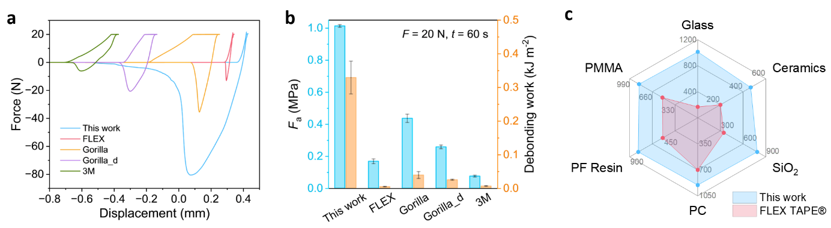
Supplementary Fig. 1. Adhesive performances comparison between R1-max gel fabricated in this work and commercial tapes under the same measurement condition (tack test with loading force of 20 N and a contact time of 60 s). (a) Force–displacement curves of adhesives from tack tests on the adhesion to a glass substrate in normal saline. FLEX TAPE: FLEX super strong waterproof tape®, Gorilla TAPE®: Gorilla extreme waterproof seal & repair tape®, Gorilla D-TAPE®: Gorilla weatherproof strong double-sided tape®, 3M TAPE®: 3M waterproof double-sided tape®. (b) $F_{a}$ and debonding work of adhesives calculated from Figure S1a. (c) Comparison of the R1-max with FLEX TAPE® in terms of underwater adhesive strength on different substrates, including glass, ceramics, silicon wafer (SiO₂), polycarbonates (PC), phenol formaldehyde resin (PF resin), and poly(methyl methacrylate) (PMMA). Error bars represent the standard deviation of N = 3 measurements.

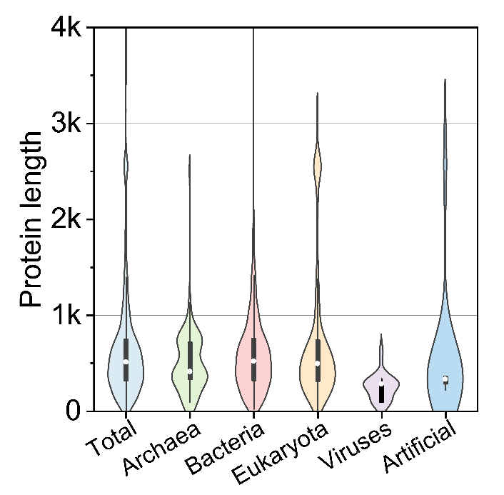
Supplementary Fig. 2. Violin plot of length distributions of adhesive proteins across the entire database (total) and within 5 biological categories.

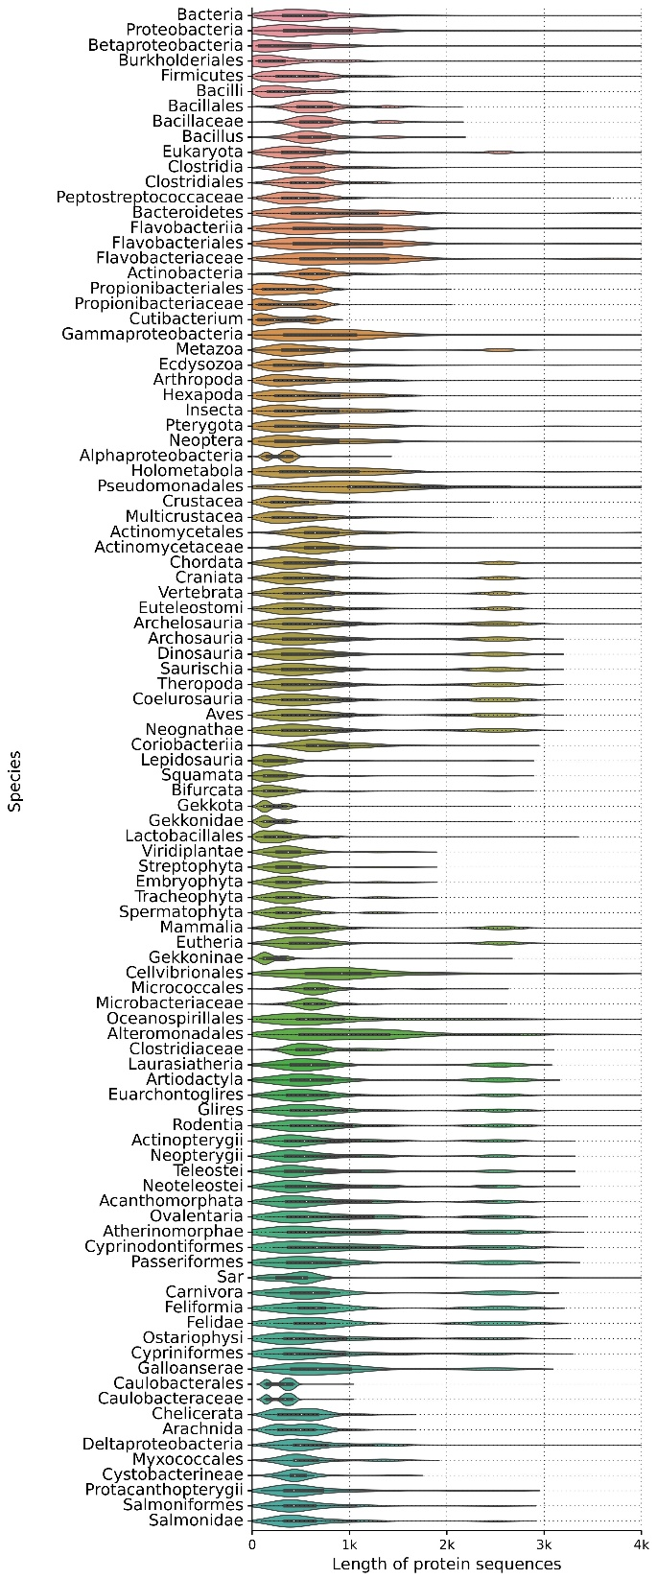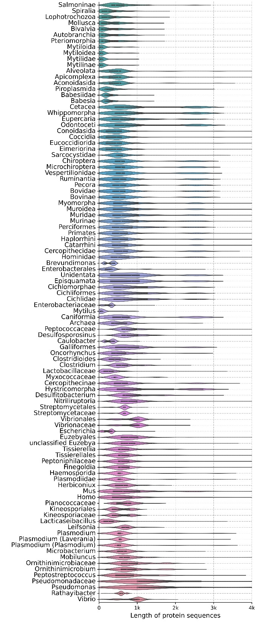
Supplementary Fig. 3. Violin plot of length distributions of adhesive proteins in the top 200 species ranked by the number of adhesive proteins each has.

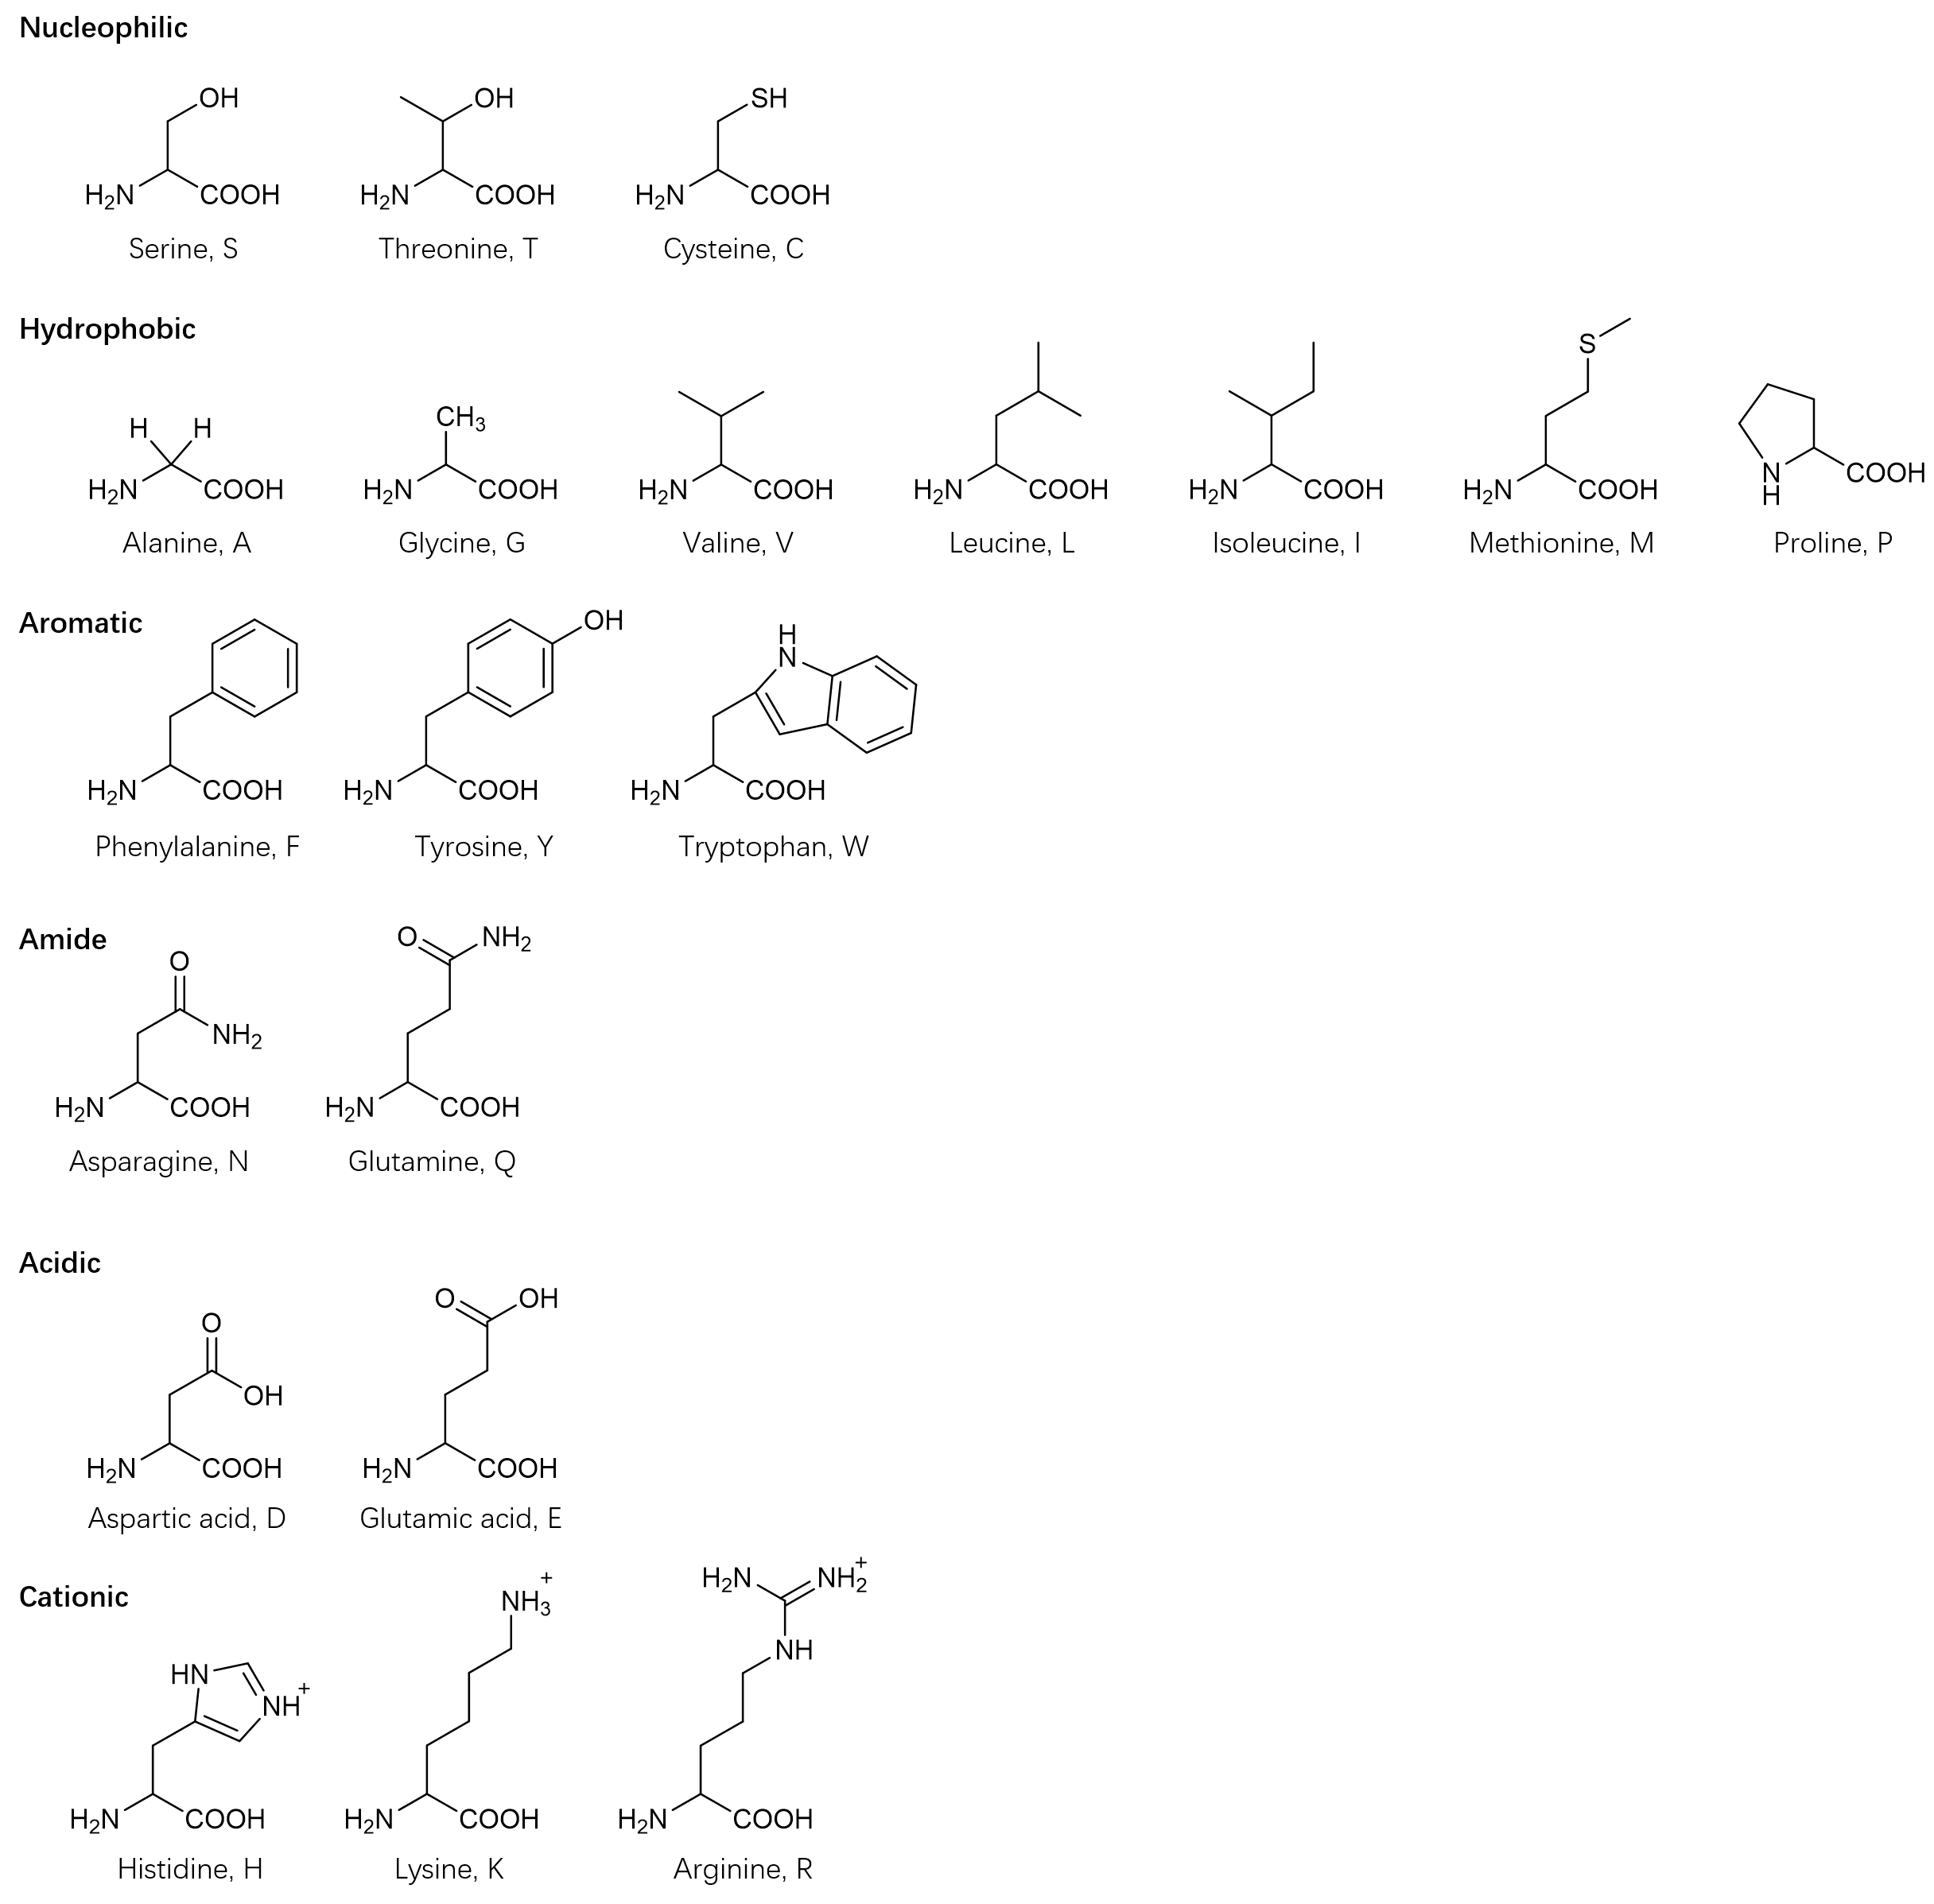
Supplementary Fig. 4. The six functional classes of amino acids categorized based on their functional side residues.

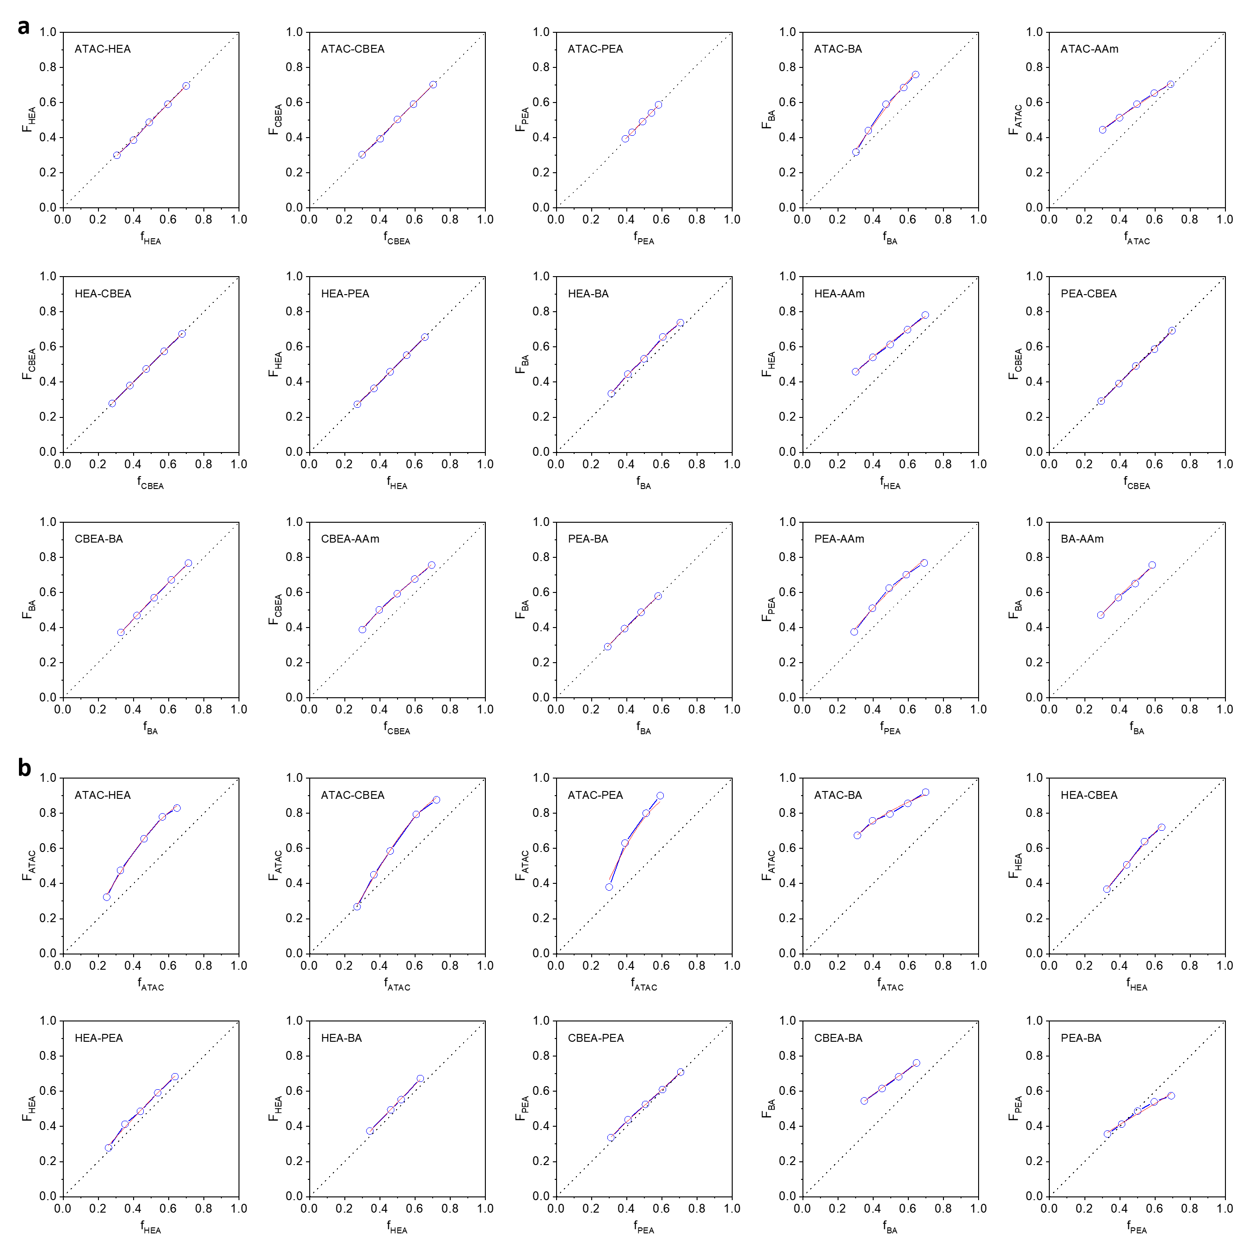
Supplementary Fig. 5. Relationship between the molar proportion of the monomer X in feed ($f_{X}$) and in copolymer ($F_{X}$) at a fixed total monomer concentration of 1.0 M for different pairs in (a) DMSO and (b) DMS. The conversion of monomers was less than 10%. The experimental data (dots) were fitted by the Mayo–Lewis equation (red dotted line).

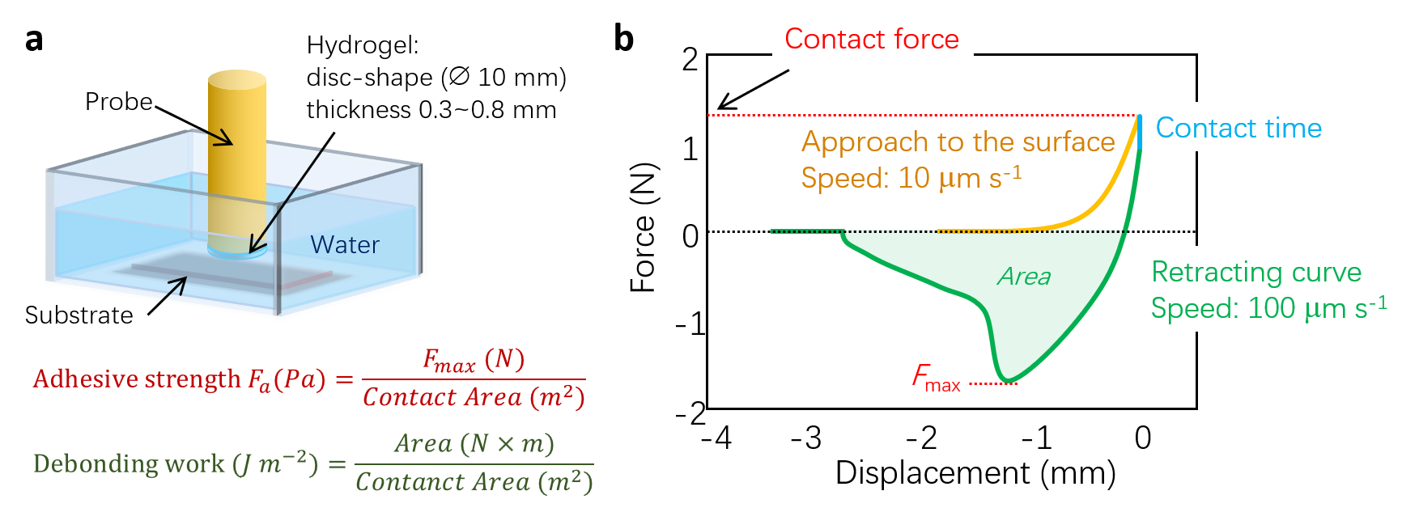
Supplementary Fig. 6. (a) Schematic diagram of tack test. (b) Illustration of the force–displacement curve with corresponding test parameters. The contact area was set the same as the disc area of samples (78.5 mm²).

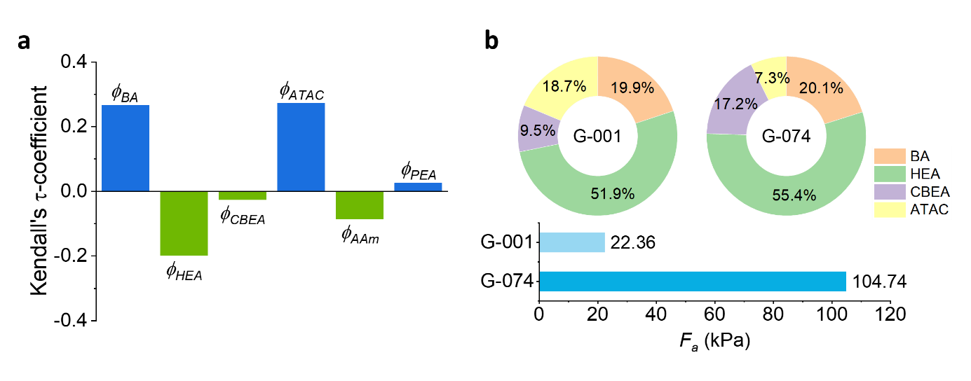
Supplementary Fig. 7. (a) Correlation between monomer proportions ($ϕ_{i}$) and adhesive strength ($F_{a}$), captured by Kendall’s τ coefficients. (b) An example to show non-straightforward correlations between $ϕ_{i}$ and $F_{a}$ due to the complex synergistic effect of different monomers. The Kendall’s τ-coefficient result reveals that $F_{a}$ has a weak positive correlation with $ϕ_{BA}$, $ϕ_{ATAC}$, and $ϕ_{PEA}$, while it has a weak negative correlation with $ϕ_{HEA}$, $ϕ_{AAm}$, and $ϕ_{CBEA}$. However, when comparing G-074 to G-001, $ϕ_{BA}$ is roughly the same, $ϕ_{HEA}$ and $ϕ_{CBEA}$ increase, and $ϕ_{ATAC}$ decreases. Kendall’s τ-coefficient result suggests that $F_{a}$ of G-074 should be lower than that of G-001, but in fact, $F_{a}$ of G-074 is about 5 times higher than that of G-001.

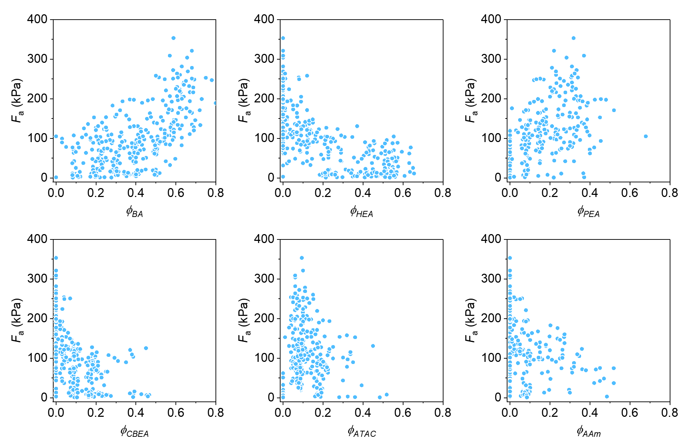
Supplementary Fig. 8. Adhesive strength $F_{a}$ as a function of individual monomer proportions for all hydrogel samples (see formulations in Supplementary Tables 3 and 4).

Supplementary Fig. 9. Adhesion stability of R1-max over 200 attachment-detachment cycles on a glass substrate in normal saline. Testing was conducted under 5 N loading force and 10 seconds contact time, with the lower loading force to reduce hydrogel fatigue during the test.
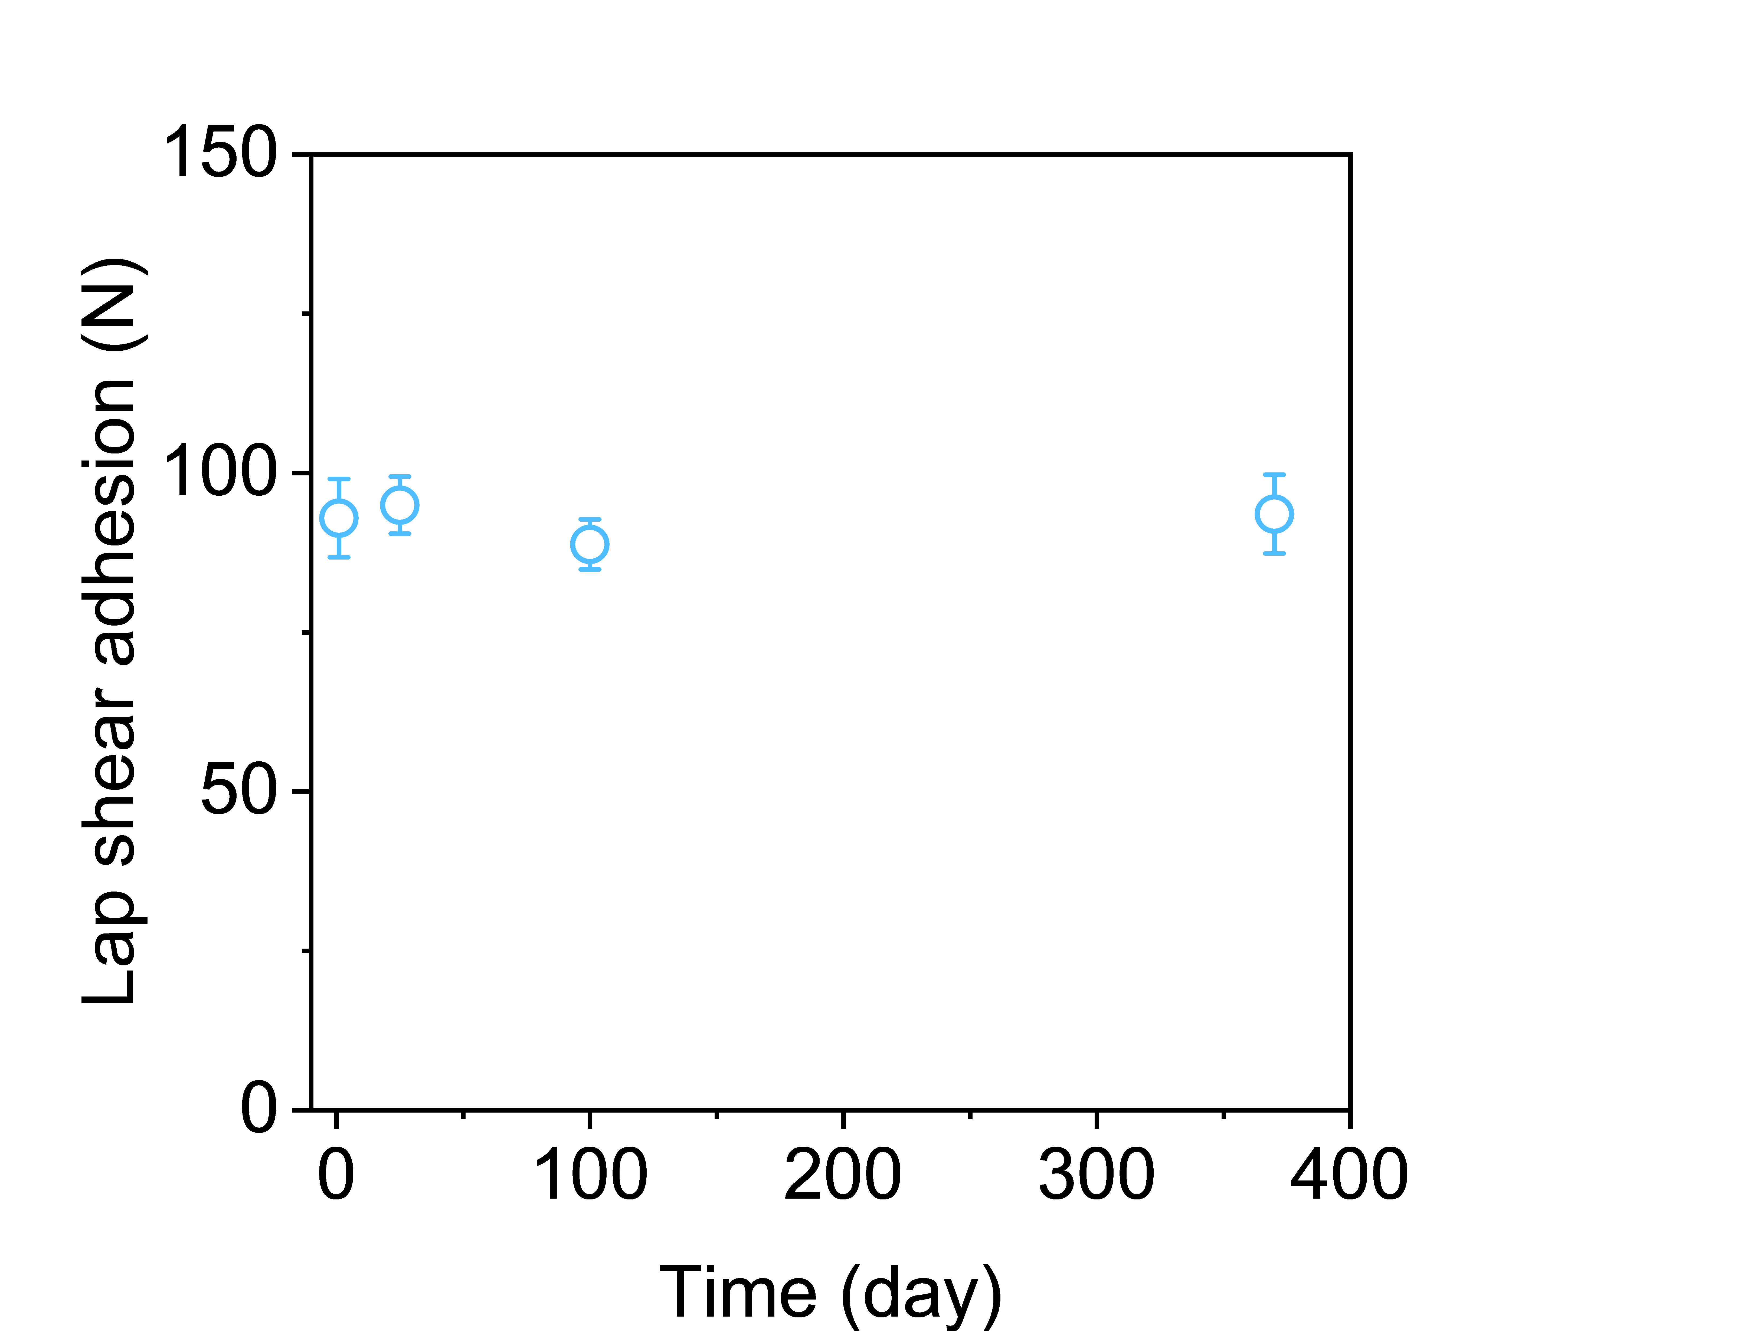
Supplementary Fig. 10. Lap shear adhesion of R1-max (joining two glass plates) as a function of days immersed in normal saline after sample preparation, demonstrating long-lasting adhesion. Sample size is 25×25 mm² with a thickness of 0.4 mm. Error bars represent the standard deviation of N = 3 measurements.

Supplementary Fig. 11. Debonding work of sampled hydrogels adhering to a glass substrate in deionized water, normal saline (0.154 M NaCl), and artificial seawater (0.7 M NaCl). Asterisk indicates cohesive failure during measurements. The top-performing adhesive gels from each round were chosen: G-max (G-042), R1-max (RFR-GP*-PRED-1), R2-max (GP_KB-EI-5), and R3-max (GP_KB-EI-7). All hydrogels were equilibrated in corresponding solutions before tack tests. Error bars represent the standard deviation of N = 3 measurements.

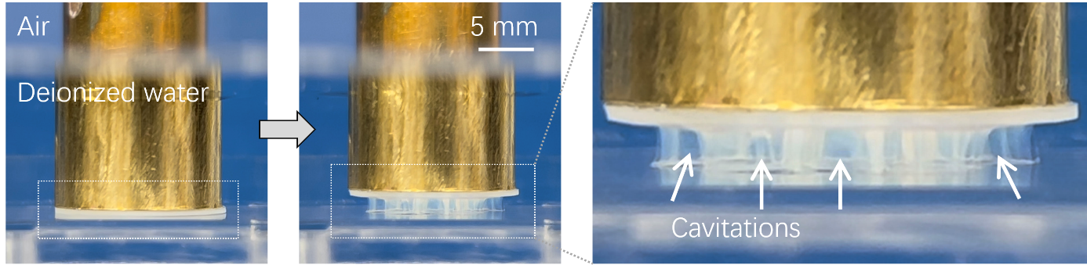
Supplementary Fig. 12. Photographic images illustrating the deformation of R2-max during retraction from a glass substrate in deionized water. The finger-like structures indicate cavitation caused by strong adhesion.

Supplementary Algorithm 1: SMBO for optimal monomer fraction extrapolation.
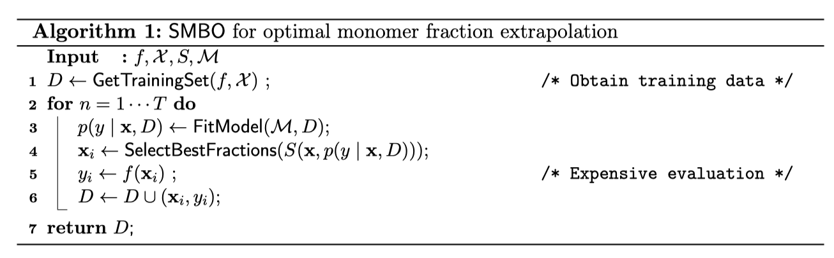
Supplementary Table 1. Tape-type underwater adhesives based on physical interactions as reported in the literature.
Hydrogels
Components | Substrates | Test method | Bonding condition  Curing time | Adhesive strength | Remarks | Ref.
P(BA-stat-ATAC-stat-PEA) | Glass, ceramics, plastic, metals, bones | Tack test  Lap shear  180° peel test | 10 -120 s in water | 500-1100 kPa  2.5-3 kJ m⁻² (peel) | Reusable (200 cycles)  Stable >1 year | This work
P(MATAC-co-AAm) | P(AAc) gel | Tack test | 1–1200 s in water | 10–20 kPa | - | 1
P(AAm) + TA + Alg-Na | Glass, Al, plastic, tissue | Lap shear | Underwater | 5–20 kPa | - | 2
P(cation-adj-π) | Glass, metal, plastics, hydrogels | Tack test  Lap shear | 10 s in seawater | 60 kPa | Reusable (16 cycles)  Stable 14 d | 3,4
P(cation-co-π_{rich}) | Glass, metal, plastics | Tack test  Lap shear | 10 s in water | 100–180 kPa | Reusable (50 cycles)  Stable 100 d | 5
P(AAc-co-MEA-co-Aa-co-AU) | Glass, metal, plastics | Lap shear | 30 min | 5–25 kPa | - | 6
P(AAm-co-urushiol) + Glycerol | Glass | 180° peel test  Lap shear | 2 min in water  Then 30 min in air | 200–400 J m⁻² (peel)  ~16 kPa (lap shear) | Antifreezing  anti-heating | 7
P(AAm-co-SMA) + SDS + Fe³⁺ | Glass, metal, plastics | Tack test | Wet surface  120 s | 15–60 kPa | Reusable (50 cycles)  Stable 15 d | 8
P(C₁₈-co-DMAEMA-co-HEA) + SDS + Fe³⁺ | Glass, PE, steel, rubber | Lap shear | 5-30 min | 10-30 kPa | Reusable (10 cycles) | 9
P(AAm-co-C₁₈) + PTA + Fe³⁺ | Glass, metal, plastics | Tack test | Wet surface  120 s | 40-90 kPa | - | 10
polydiolcitrates/P(GMA) | Glass, silica, metal, plastics | Tack test | 0 s in water | 50–100 kPa | Thermosensitive | 11
HPMC/SiW-P(DMAEMA)/Fe³⁺ | Glass, metal, plastics | Lap shear | 1 h in water | 45–55 kPa | - | 12
PEG-dA + TA | Glass, tissue | Tensile test  Lap shear | In water | 130 kPa (tensile)  22 kPa (lap shear) | - | 13
PAH-catechol | Glass, tissue, PET | Lap shear | 1 h in water | 1.5–10 kPa | - | 14
P(AAm-co-MAEDS) + P(LMA) + laponite | Glass, metal, plastics | Lap shear | 5 min in seawater | 5–35 kPa | Organohydrogel  Strength decreases during soaking | 15
Polyampholyte | Glass, PS, PA, tissue | Tack test | 10 s in water | 12–27 kPa | Drainage | 16
P(HEA-co-PEA-co-MEA) + MXene | Glass, metal, plastics, skin | Tack test | 2 min in water | 15-20 kPa | Reusable (5 cycles)  Conductivity | 17
P(SBVI) + graphene | Glass, metal, wood | Tack test | 10 min in water | 20-60 kPa | Conductivity | 18
P(AAm-co-BI) + PCD | Al | Tack test | 10 s in water | 20 kPa | - | 19
P(ATAC-co-EA) + TPP | PDMS | Tack test | 30 s in water | 55 kPa | - | 20
P(AAc-co-BA) | Glass, metal, plastics | Lap shear  Tack test | 5 min | 5-35 kPa | - | 21
P(AAm-co-MAEDS) + P(LMA) | Glass, metal, plastics | Lap-shear | 5 min-24 h  In water | 10-40 kPa | Phase separation gel | 22
P(AAc) + QAX + TA | Glass, metal, plastics | Lap-shear | 60 s in water | 45-55 kPa | - | 23
P(AAc-co-EHA) | Glass, metal, plastics, skin | Lap-shear | 30 min in water | 10-45 kPa | Reusable (15 cycles) | 24
P(AAc-co-BA-ATAC) DMSO | Metal, plastics, skin | Lap-shear | In water | 50-180 kPa | Solvent exchange | 25
P(Aac-co-HEAA-co-MMA) + PANa | Metal, glass, wood, plastics, skin | Lap-shear | In water | 5-20 kPa | Reusable (5 cycles) | 26
P(MA-co-HGAc-co-HG-co-AAm/AAc) | Metal, glass, plastics, skin | Lap-shear | 1 min in air then 12 h in water | 3-30 kPa | Solvent exchange | 27
P(C6-co-St-co-AAc-co-CD) | Metal, glass, plastics, skin | Lap-shear | 30 min in water | 20-100 kPa | Reusable (70 cycles) | 28
P(AAc-co-PEA) + Chitosan | Skin | Lap-shear | 30 s in water | 4-60 kPa | - | 29
Elastomers
Components | Substrates | Test method | Bonding condition  Curing time | Adhesive strength | Remarks | Ref.
P(PPO-co-GBC) | SS | Tack test  180° peel test | 5 s | 240 kPa  500 J m⁻² | Thermal sensitive | 30
P(MEA-co-ATU) | Glass, PS, Al, wood | Tack test | underwater | 50-160 kPa | - | 31
polydiolcitrates | Glass | Tack test | underwater | 80 kPa | - | 32
P(DMA-co-BA) + P(AAc-co-BA)-g-An | Glass, plastic | Tack test | 10 s in water | 15-60 kPa | Phototunable adhesion | 33
P(BA-co-AAc) | Glass, plastic, metal | Tack test | 60 s in water | 120-150 kPa | Reusable (30 cycles) | 34
P(IBOA-co-POFA) | Glass, plastic, metal | Tack test  Lap shear | In water | 75-180 kPa | Reusable (50 cycles)  Stable 40 d | 35
P(NVP-co-HPPA-co-C12A) | Glass, plastic, metal | Lap shear | In water | 250-400 kPa | Reusable (10 cycles)  Stable 15 d | 36
TFMD | Glass, plastic, metal | Lap shear | 20 min in water | 900-1200 kPa | - | 37
PDMS + TDCA + metal ions | Glass, plastic, metal | Tack test | 60 s in water | 5-35 kPa | Reusable (20 cycles) | 38

Supplementary Table 2. (separate file) Formulations used to fabricate hydrogels and their adhesive strength in normal saline (0.154 M NaCl). These formulations are derived from adhesive protein data mining analysis. The related symbols are monomer proportions ($ϕ_{i}$), $F_{a}$, and thickness (d). The top performance gel was highlighted in bold.

Supplementary Table 3. Monomer reactivity ratios (r) between various pairs in DMSO and DMS.
Reactivity ratios in DMSO
Monomer 1 | Monomer 2 | r₁ | r₂
ATAC | HEA | 1.06±0.03 | 1.01±0.04
ATAC | CBEA | 1.00±0.04 | 1.00±0.04
ATAC | PEA | 1.03±0.03 | 1.04±0.04
ATAC | BA | 1.51±0.30 | 2.83±0.45
ATAC | AAm | 0.82 ±0.04 | 0.29 ±0.02
HEA | CBEA | 0.99±0.01 | 1.00±0.01
HEA | PEA | 1.00±0.01 | 1.00±0.01
HEA | BA | 0.95±0.06 | 1.29±0.08
HEA | AAm | 1.30±0.06 | 0.37 ±0.03
CBEA | PEA | 0.96±0.02 | 0.99±0.03
CBEA | BA | 0.91±0.02 | 1.39±0.03
CBEA | AAm | 1.32±0.05 | 0.60 ±0.03
PEA | BA | 0.99±0.04 | 1.02±0.04
PEA | AAm | 1.73±0.21 | 0.71±0.11
BA | AAm | 2.01±0.24 | 0.45±0.08
Reactivity ratios in DMS
Monomer 1 | Monomer 2 | r₁ | r₂
ATAC | HEA | 4.42±0.56 | 1.28±0.18
ATAC | CBEA | 5.92±1.01 | 2.69±0.47
ATAC | PEA | 20.0±3.2 | 5.11±0.87
ATAC | BA | 4.01±0.48 | 0.16±0.06
HEA | CBEA | 1.92±0.20 | 1.11±0.13
HEA | PEA | 1.33±0.14 | 0.88±0.09
HEA | BA | 0.94±0.06 | 1.25±0.07
CBEA | PEA | 0.78±0.02 | 0.92±0.02
CBEA | BA | 0.25±0.02 | 1.38±0.06
PEA | BA | 0.33±0.05 | 0.50±0.06

Supplementary Table 4. (separate file) Hydrogel compositions predicted by machine learning and the true (experimental) adhesive strength in normal saline, determined via tack tests. The top-performing hydrogel in each round is highlighted in bold.

Supplementary Table 5. Formulations of hydrogels derived from data mining analysis of resilin proteins and their adhesive strength in normal saline (0.154 M NaCl). Adhesion testing was not feasible for gels r-03 to r-06 due to severe shrinkage and irregular shapes formed during solvent exchange.
No. | Φ_{HEA}Φ_{BA} | Φ_{HEA} | Φ_{CBEA} | Φ_{ATAC} | Φ_{PEA} | Φ_{AAm} | F_{a} (kPa)
r-01 | 0.36 | 0.33 | 0.00 | 0.08 | 0.23 | 0.00 | 68.7±3.1
r-02 | 0.06 | 0.32 | 0.00 | 0.00 | 0.16 | 0.46 | 18.2±0.4
r-03 | 0.39 | 0.32 | 0.10 | 0.00 | 0.19 | 0.00 | No data
r-04 | 0.38 | 0.34 | 0.10 | 0.00 | 0.19 | 0.00 | No data
r-05 | 0.47 | 0.19 | 0.14 | 0.00 | 0.19 | 0.00 | No data
r-06 | 0.19 | 0.52 | 0.00 | 0.00 | 0.20 | 0.09 | 19.9±2.8
r-07 | 0.19 | 0.51 | 0.10 | 0.00 | 0.19 | 0.00 | 29.4±0.9
r-08 | 0.00 | 0.39 | 0.36 | 0.00 | 0.18 | 0.06 | 10.2±2.9
r-09 | 0.18 | 0.53 | 0.00 | 0.07 | 0.22 | 0.00 | 36.8±2.4
r-10 | 0.09 | 0.58 | 0.12 | 0.00 | 0.12 | 0.08 | 9.2±0.2
r-11 | 0.37 | 0.26 | 0.00 | 0.00 | 0.31 | 0.06 | 10.7±1.2
r-12 | 0.12 | 0.59 | 0.00 | 0.10 | 0.10 | 0.09 | 42.4±6.6

Supplementary Table 6. Hyperparameter search ranges (if not stated explicitly, other parameters adopted Scikit-learn defaults).
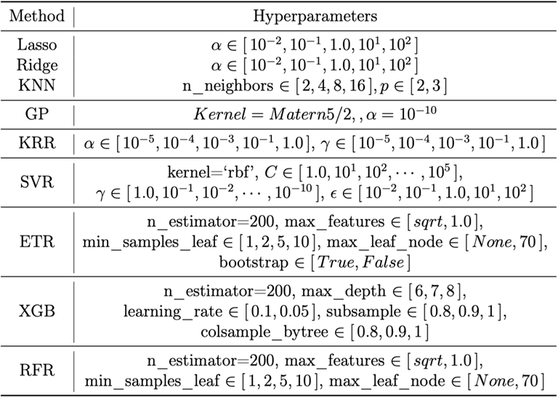

Supplementary Video 1. Mechanical properties of R1-max and R2-max hydrogels.

Supplementary Video 2. Adhering a rubber duck to a rock by R1-max hydrogel.

Supplementary Video 3. Repairing a damaged water pipe using R2-max hydrogel.

Supplementary Data 1. (separate file) Consensus sequence fragments of 200 species.

Supplementary Data 2. (separate file) Pairwise functional class counting within consensus sequence fragments of 200 species.

References
1 Cedano-Serrano, F. J. et al. From Molecular Electrostatic Interactions and Hydrogel Architecture to Macroscopic Underwater Adherence. Macromolecules 52, 3852-3862 (2019). https://doi.org:10.1021/acs.macromol.8b02696
2 Qiao, H. et al. Multiple Weak H-Bonds Lead to Highly Sensitive, Stretchable, Self-Adhesive, and Self-Healing Ionic Sensors. ACS Appl. Mater. Interfaces 11, 7755-7763 (2019). https://doi.org:10.1021/acsami.8b20380
3 Fan, H. L. et al. Adjacent cationic–aromatic sequences yield strong electrostatic adhesion of hydrogels in seawater. Nat. Commun. 10, 5127 (2019). https://doi.org:10.1038/s41467-019-13171-9
4 Fan, H. L., Cai, Y. R. & Gong, J. P. Facile Tuning of Hydrogel Properties by Manipulating Cationic-Aromatic Monomer Sequences. Sci. China: Chem. (2021). https://doi.org:https://doi.org/10.1007/s11426-021-1010-3
5 Fan, H. L., Wang, J. H. & Gong, J. P. Barnacle Cement Proteins-Inspired Tough Hydrogels with Robust, Long-Lasting, and Repeatable Underwater Adhesion. Adv. Funct. Mater. 31, 2009334 (2021). https://doi.org:https://doi.org/10.1002/adfm.202009334
6 Liu, X., Zhang, Q. & Gao, G. DNA-inspired anti-freezing wet-adhesion and tough hydrogel for sweaty skin sensor. Chem. Eng. J. 394, 124898 (2020). https://doi.org:https://doi.org/10.1016/j.cej.2020.124898
7 Fan, X. et al. An Antifreezing/Antiheating Hydrogel Containing Catechol Derivative Urushiol for Strong Wet Adhesion to Various Substrates. ACS Appl. Mater. Interfaces 12, 32031-32040 (2020). https://doi.org:10.1021/acsami.0c09917
8 Han, L., Wang, M., Prieto-López, L. O., Deng, X. & Cui, J. Self-Hydrophobization in a Dynamic Hydrogel for Creating Nonspecific Repeatable Underwater Adhesion. Adv. Funct. Mater. 30, 1907064 (2020). https://doi.org:10.1002/adfm.201907064
9 Wang, S. et al. Ultrasonic-Induced Synthesis of Underwater Adhesive and Antiswelling Hydrogel for Strain Sensor. ACS Appl. Mater. Interfaces 14, 50256-50265 (2022). https://doi.org:10.1021/acsami.2c16388
10 Fu, C. et al. Hydrogel with Robust Adhesion in Various Liquid Environments by Electrostatic Induced Hydrophilic and Hydrophobic Polymer Chains Migration and Rearrangement. Adv. Mater. 35, 2211237 (2023). https://doi.org:https://doi.org/10.1002/adma.202211237
11 Wang, Z. et al. Robust Underwater Adhesives Based on Dynamic Hydrophilic and Hydrophobic Moieties to Diverse Surfaces. ACS Appl. Mater. Interfaces 13, 3435–3444 (2021). https://doi.org:10.1021/acsami.0c20186
12 Wei, X. et al. Underwater Adhesive HPMC/SiW-PDMAEMA/Fe3+ Hydrogel with Self-Healing, Conductive, and Reversible Adhesive Properties. ACS Appl. Polym. Mater. 3, 837–846 (2021). https://doi.org:10.1021/acsapm.0c01177
13 Chen, K. et al. An All-in-One Tannic Acid-Containing Hydrogel Adhesive with High Toughness, Notch Insensitivity, Self-Healability, Tailorable Topography, and Strong, Instant, and On-Demand Underwater Adhesion. ACS Appl. Mater. Interfaces 13, 9748–9761 (2021). https://doi.org:10.1021/acsami.1c00637
14 Lee, J. N., Lee, S. Y. & Park, W. H. Bioinspired Self-Healable Polyallylamine-Based Hydrogels for Wet Adhesion: Synergistic Contributions of Catechol-Amino Functionalities and Nanosilicate. ACS Appl. Mater. Interfaces 13, 18324–18337 (2021). https://doi.org:10.1021/acsami.1c02141
15 Zhang, Z., Guo, L. & Hao, J. Emulsion-Based Organohydrogels with Switchable Wettability and Underwater Adhesion toward Durable and Ecofriendly Marine Antifouling Coatings. ACS Appl. Polym. Mater. (2021). https://doi.org:10.1021/acsapm.1c00214
16 Rao, P. et al. Tough Hydrogels with Fast, Strong, and Reversible Underwater Adhesion Based on a Multiscale Design. Adv. Mater. 30, 1801884 (2018). https://doi.org:doi:10.1002/adma.201801884
17 He, S. et al. Bio-Inspired Instant Underwater Adhesive Hydrogel Sensors. ACS Appl. Mater. Interfaces 14, 45869-45879 (2022). https://doi.org:10.1021/acsami.2c13371
18 Han, I. K. et al. Electroconductive, Adhesive, Non-Swelling, and Viscoelastic Hydrogels for Bioelectronics. Adv. Mater. 35, 2203431 (2022). https://doi.org:https://doi.org/10.1002/adma.202203431
19 Xu, W. et al. Synergy of Host–Guest and Cation−π Interactions for an Ultrastretchable, pH-Tunable, Surface-Adaptive, and Salt-Resistant Hydrogel Adhesive. Chem. Mater. 34, 8740-8748 (2022). https://doi.org:10.1021/acs.chemmater.2c01904
20 Huang, G. et al. Tough Hydrophobic Hydrogels for Monitoring Human Moderate Motions in Both Air and Underwater Environments. Chem. Mater. 35, 5953-5962 (2023). https://doi.org:10.1021/acs.chemmater.3c00867
21 Ming, X. et al. Isopropanol-regulated adhesion-controllable conductive gels for robust bioelectric signal monitoring and flexible underwater robots. Chem. Eng. J. 460, 141746 (2023). https://doi.org:https://doi.org/10.1016/j.cej.2023.141746
22 Zhang, Z., Guo, L. & Hao, J. Emulsion-Based Organohydrogels with Switchable Wettability and Underwater Adhesion toward Durable and Ecofriendly Marine Antifouling Coatings. ACS Appl. Polym. Mater. 3, 3060–3070 (2021). https://doi.org:10.1021/acsapm.1c00214
23 Chang, M. et al. A highly stretchable, UV resistant and underwater adhesive hydrogel based on xylan derivative for sensing. Int. J. Biol. Macromol. (2022). https://doi.org:https://doi.org/10.1016/j.ijbiomac.2022.08.077
24 Li, M. et al. Water-Induced Phase Separation for Anti-Swelling Hydrogel Adhesives in Underwater Soft Electronics. Adv. Sci. 10, 2304780 (2023). https://doi.org:https://doi.org/10.1002/advs.202304780
25 Sun, C. et al. Water-resistant and underwater adhesive ion-conducting gel for motion-robust bioelectric monitoring. Chem. Eng. J. 431, 134012 (2022). https://doi.org:https://doi.org/10.1016/j.cej.2021.134012
26 Du, P., Wang, J., Hsu, Y.-I. & Uyama, H. Hydrophobic Association Hydrogel Enabled by Multiple Noncovalent Interactions for Wearable Bioelectronics in Amphibious Environments. Chem. Mater. 36, 1318-1332 (2024). https://doi.org:10.1021/acs.chemmater.3c02454
27 Ye, B. et al. Glycopolymer-Based Antiswelling, Conductive, and Underwater Adhesive Hydrogels for Flexible Strain Sensor Application. ACS Biomater. Sci. Eng. 9, 6891-6901 (2023). https://doi.org:10.1021/acsbiomaterials.3c01539
28 Yang, H. et al. Reversible, ultra-strong underwater adhesive based on supramolecular interaction for instant liquid leakage sealing and robust tissue adhesion. Chem. Eng. J. 480, 148064 (2024). https://doi.org:https://doi.org/10.1016/j.cej.2023.148064
29 Zhao, G. et al. Barnacle inspired strategy combined with solvent exchange for enhancing wet adhesion of hydrogels to promote seawater-immersed wound healing. Bioactive Materials 41, 46-60 (2024). https://doi.org:https://doi.org/10.1016/j.bioactmat.2024.07.011
30 Beharaj, A., McCaslin, E. Z., Blessing, W. A. & Grinstaff, M. W. Sustainable polycarbonate adhesives for dry and aqueous conditions with thermoresponsive properties. Nat. Commun. 10, 5478 (2019). https://doi.org:10.1038/s41467-019-13449-y
31 Wang, Y.-J. et al. Polymer Pressure-Sensitive Adhesive with A Temperature-Insensitive Loss Factor Operating Under Water and Oil. Adv. Funct. Mater. n/a, 2104296 (2021). https://doi.org:https://doi.org/10.1002/adfm.202104296
32 Wang, Z. et al. Polymer Network Editing of Elastomers for Robust Underwater Adhesion and Tough Bonding to Diverse Surfaces. ACS Appl. Mater. Interfaces (2021). https://doi.org:10.1021/acsami.1c09239
33 Zhou, Y. et al. Pressure-Sensitive Adhesive with Enhanced and Phototunable Underwater Adhesion. ACS Appl. Mater. Interfaces 13, 50451-50460 (2021). https://doi.org:10.1021/acsami.1c16146
34 Niu, W., Zhu, J., Zhang, W. & Liu, X. Simply Formulated Dry Pressure-Sensitive Adhesives for Substrate-Independent Underwater Adhesion. ACS Mater. Lett. 4, 410-417 (2022). https://doi.org:10.1021/acsmaterialslett.1c00826
35 Wu, Y. et al. Photo-curing preparation of biobased underwater adhesives with hydrophobic chain-ring interlace structure for protecting adhesion. Appl. Mater. Today 27, 101436 (2022). https://doi.org:https://doi.org/10.1016/j.apmt.2022.101436
36 Wu, Y. et al. A photocured bio-based shape memory thermoplastics for reversible wet adhesion. Chem. Eng. J. 470, 144226 (2023). https://doi.org:https://doi.org/10.1016/j.cej.2023.144226
37 Zhang, Y. et al. Super-Tough and Fast Adhesion of Soft Elastomer Based on Strong Noncovalent Interaction in Diverse Environments. Adv. Funct. Mater. n/a, 2304653 (2023). https://doi.org:https://doi.org/10.1002/adfm.202304653
38 Kaymazlar, E., Andac, O. & Garcia, S. J. Water-triggered self-healing and reversible underwater adhesion in metalorganic polymers. J. Mater. Chem. A 12, 18338-18347 (2024). https://doi.org:10.1039/D4TA01650E

