Table S1 The 30 environmental variables in the Maxent model.
No. |  | Description | Abbreviation
1 | Mean Annual Temperature |  | Bio1
2 | Monthly Mean Diurnal Temperature Range |  | Bio2
3 | Isotherm |  | Bio3
4 | Standard Deviation of Temperature Seasonality |  | Bio4
5 | Maximum Temperature of the Warmest Month |  | Bio5
6 | Minimum Temperature of the Coldest Month |  | Bio6
7 | Temperature Annual Range |  | Bio7
8 | Mean Temperature of the Wettest Quarter |  | Bio8
9 | Mean Temperature of the Driest Quarter |  | Bio9
10 | Mean Temperature of the Warmest Quarter |  | Bio10
11 | Mean Temperature of the Coldest Quarter |  | Bio11
12 | Annual Precipitation |  | Bio12
13 | Precipitation of the Wettest Month |  | Bio13
14 | Precipitation of the Driest Month |  | Bio14
15 | Coefficient of Variation of Seasonal Precipitation |  | Bio15
16 | Precipitation of the Wettest Quarter |  | Bio16
17 | Precipitation of the Driest Quarter |  | Bio17
18 | Precipitation of the Warmest Quarter |  | Bio18
19 | Precipitation of the Coldest Quarter |  | Bio19

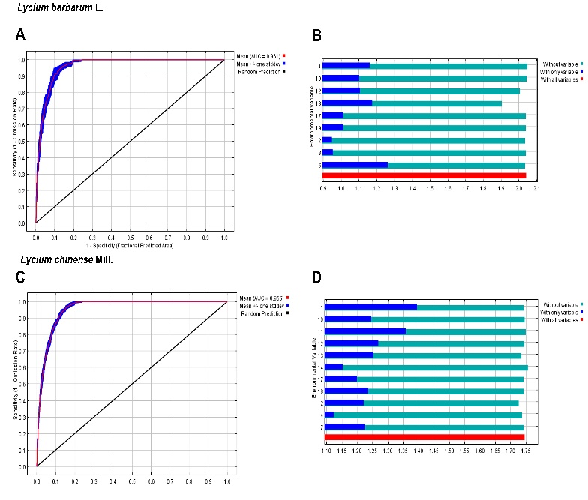
Figure S1 The AUC value (A) and jackknife test (B) of L. barbarum; The AUC value (C) and jackknife test (D) of L. Chinese.

Table S2 The different suitable quality areas of kukoamine B in different conditions.
Conditions | Highly suitable area/×10⁶ km² | Moderately suitable area/×10⁶ km² | Poorly suitable area/×10⁶ km² | The total suitable area/×10⁶ km²
Current | 0.2640 | 1.7840 | 1.2942 | 3.3422
RCP2.6-2050s | 0.2360 | 1.5904 | 1.3825 | 3.2089
RCP2.6-2070s | 0.1911 | 1.6891 | 1.3148 | 3.1950
RCP4.5-2050s | 0.2053 | 1.6708 | 1.3817 | 3.2579
RCP4.5-2070s | 0.2049 | 1.6738 | 1.3848 | 3.2635
RCP8.5-2050s | 0.2364 | 1.4895 | 1.4807 | 3.2066
RCP8.5-2070s | 0.2124 | 1.7440 | 1.2788 | 3.2352

Table S3 The different suitable quality areas of kukoamine A in different conditions.
Conditions | Highly suitable area/×10⁶ km² | Moderately suitable area/×10⁶ km² | Poorly suitable area/×10⁶ km² | The total suitable area/×10⁶ km²
Current | 0.1754 | 1.3532 | 1.1567 | 2.6853
RCP2.6-2050s | 0.1713 | 1.2461 | 1.1478 | 2.5652
RCP2.6-2070s | 0.1530 | 1.3277 | 1.0964 | 2.5772
RCP4.5-2050s | 0.1562 | 1.2802 | 1.1681 | 2.6045
RCP4.5-2070s | 0.1668 | 1.2802 | 1.1926 | 2.6396
RCP8.5-2050s | 0.1774 | 1.1677 | 1.2186 | 2.5637
RCP8.5-2070s | 0.1696 | 1.3682 | 1.0641 | 2.6018

