Supplementary Information for

Memristive blinking neuron enabling dense and scalable photonically-linked neural network

Sample fabrication
The atomic-scale memristive blinking neuron (MBN) devices are fabricated using the following steps illustrated in Fig. S1(a). We choose a 170 μm thick borosilicate glass as the substrate with low autofluorescence properties. Initially, 30 nm of silver and 15 nm of gold are deposited by e-beam evaporation to form the electrode metals for the MBN’s switching electrode and antenna, with silver facilitating ionic switching and gold serving as an oxidation barrier. HSQ is then spin-coated as a negative mask, and fine features are patterned using electron beam lithography. After development, Argon ion milling is employed to remove excessive metal, forming the fine features of the MBN’s switching electrode and antenna. 100 nm Au is deposited and is patterned using photolithography. The subsequent larger contact pads are finalized by a lift-off process. A 150 nm thick PMMA layer, serving as the switching medium, is spin-coated onto the substrate at ambient temperature. The device then undergoes a final annealing step in an air atmosphere at 180°C for 5 minutes to solidify and stabilize the film layers. Fig. S1(b) and S1(c) present microscope images of the 4 × 4 MBN array (with a vertical pitch of 5 μm and a lateral pitch of 10 μm), and the 2 × 2 MBN array with pitches of 1 μm, respectively. A zoom-in view is also placed on the right side with a reflection image of the electrodes.
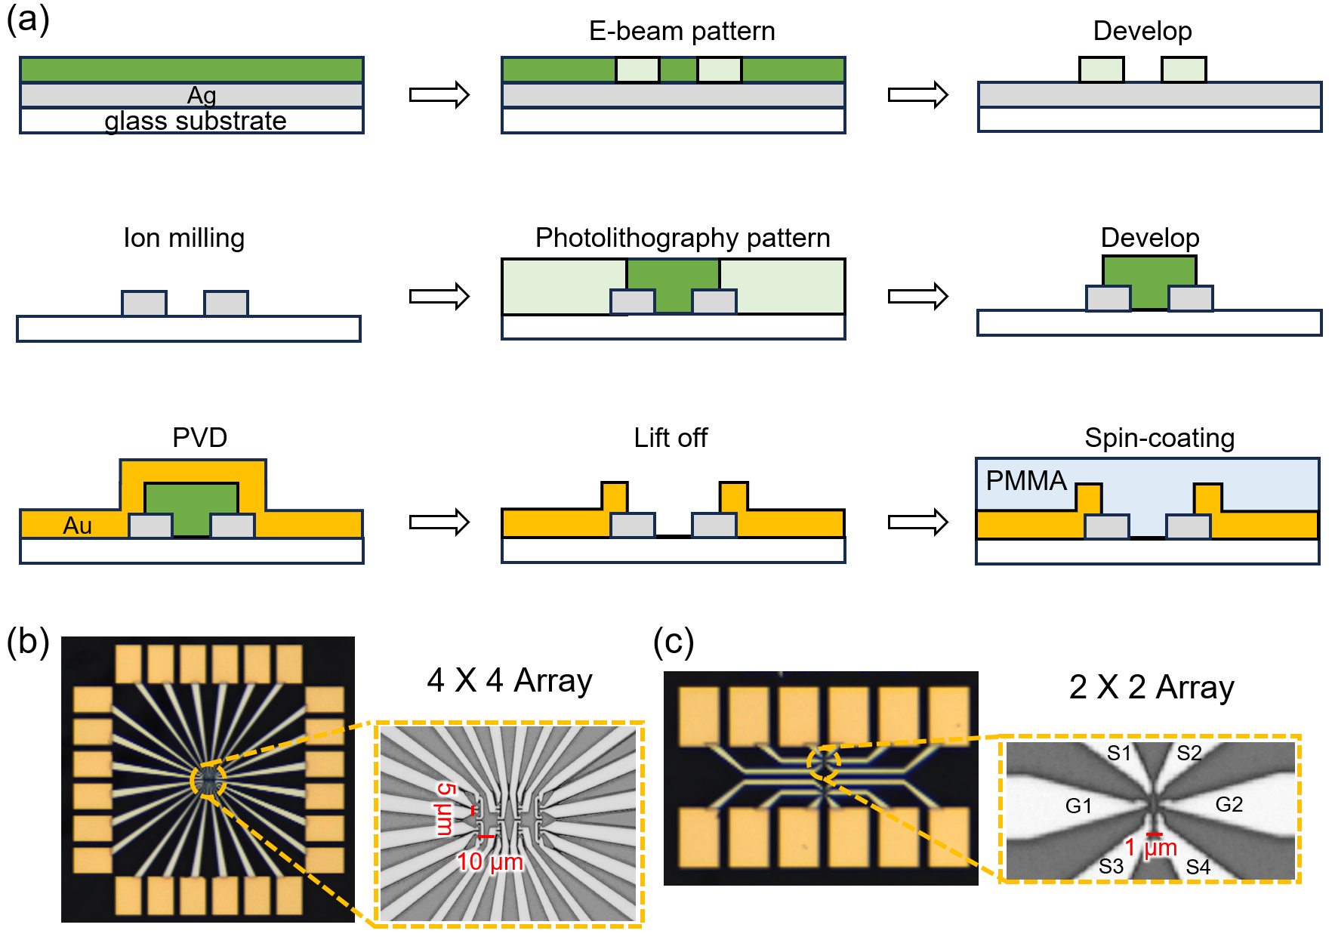
Fig. S1 | a, The fabrication process flow. b, Microscope image of 4 × 4 (with a width pitch of 5 μm and a height pitch of 10 μm) c, Microscope image of 2 × 2 MBNs array. The contact reflection microscopic image of the electrode is also annotated in the image, where G represents ground, and S represents the signal.

Antenna simulation
The plasmonic nanoantenna is designed and optimized to enhance the quantum efficiency of MBNs. The optimized geometry of the antenna is a symmetric bow-tie antenna. The base width of each triangle is 170 nm, and the height is 100 nm. Using finite difference time domain (FDTD) simulations in Ansys Lumerical, we have simulated the interaction between the antenna and electromagnetic waves. This analysis allows us to observe the antenna’s quantum efficiency and the enhancement of the local density of optical states (LDOS) between the antenna electrodes. The quantum efficiency of the emitter coupled to the antenna is a crucial metric for evaluating luminous efficiency. It can be expressed as $QE=γ_{r}/{(γ}_{r}+γ_{nr}+{γ_{nr}}^{0})$, where $γ_{r}$ denotes the radiative decay rate observable in the far field, $γ_{nr}$ is an additional non-radiative decay rate caused by coupling to non-radiative modes of the optical antenna and ${γ_{nr}}^{0}$ represents the intrinsic non-radiative decay rate. The fraction of the dipole’s power that does not contribute to radiation typically manifests as heat dissipation or is absorbed by structures in the near field. Considering the directive collection of photons, we focus on a directional quantum efficiency metric, which quantifies the efficiency of light emitted by a dipole in a specific downward direction ($z^{-}$). The radiation efficiency toward $z^{-}$ half-space is expressed by: $η_{z^{-}}=γ_{r,z^{-}}/(γ_{r}+γ_{nr})$^{1,2}, where $γ_{r,z^{-}}$ denotes the radiative decay rate observed in the far field within a downward direction. Thus, the quantum efficiency toward a specific $z^{-}$ direction can be estimated by³:
${QE}_{z^{-}}≈\frac{{γ_{r}}^{0}}{{γ_{nr}}^{0}}{∙η}_{z^{-}}∙L$ (S1)
where ${γ_{r}}^{0}$ represents the intrinsic radiative decay rate. $L$ links to the local density of optical states (LDOS) enhancement⁴, indicating the factor by which the local environment amplifies the radiative decay rate ($γ_{r }$) comparing the radiative decay rate in a vacuum.
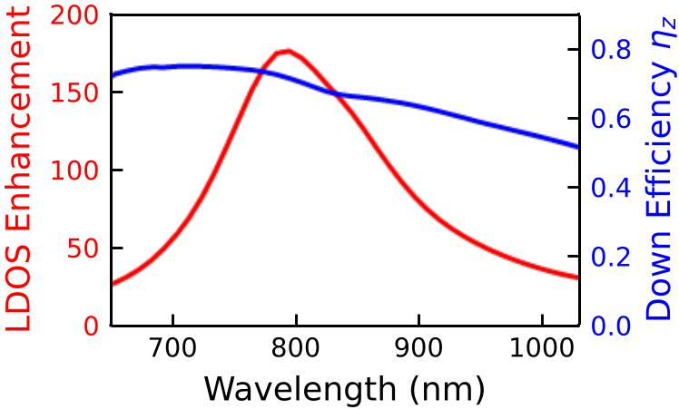
Fig. S2 | a, Simulated LDOS enhancement and quantum efficiency in the z⁻ direction ($η_{z^{-}}$) with a designed bow-tie nanoantenna structure with a PMMA coating layer.
We extract the $η_{z^{-}}$ and the $L$ from the simulation result, revealed in Fig. S2(a). This bow-tie geometric structure with a PMMA cover layer will achieve a $z^{-}$ radiation efficiency greater than 0.5 over an extensive wavelength span from 700 nm to 1000 nm. The nanoantenna results in an LDOS enhancement with a maximum value of 177.

Optical wide-field images
The image shown in Fig. 1d is the result of two images overlayed. The wide-field transmission optical image with external illumination is first taken without any voltage bias, as shown in Fig. S3(a). Then the electroluminescent image is recorded when voltage bias is applied. Notably, a bright spot appears at the gap between the antenna, as shown in Fig. S3(b).
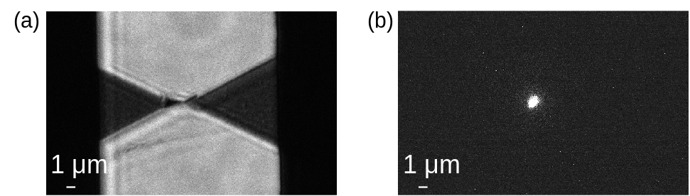
Fig. S3 | a, Transmission wide-field micrograph image of the MBN with external illumination and no voltage bias. b, Wide-field image of the MBN under operation.

MBN device working principle
The switching behavior of the MBN device is attributed to the redox reaction between the two silver electrodes, leading to a reproducible formation and spontaneous rupture of conducting filament in a resistive layer under an electric field. The operation mechanism is as follows (Fig. S4): A positive voltage is applied to a silver electrode (anode), causing silver atoms to oxidize into ions. These ions migrate across the PMMA layer and are reduced back to atoms upon reaching the other electrode (cathode). This oxidation-reduction cycle drives the migration of silver, forming conductive filaments that transition the device to a low resistance state (LRS). When the bias voltage is removed, the conductive filament breaks spontaneously, shifting the device back to a high resistance state (HRS)⁵. In our experiments, we note substantial photon emissions from the electrode gaps at the moment of conductive filament formation. Further exploration reveals that the transient EL phenomenon is linked to the dramatic current change. The photon bursts when the current fluctuates. The photon counts are high when the $dI/dt$ rate keeps a large value, indicating the photon could serve as a signal of the electrically introduced structure change. In prior studies, we explored the mechanism behind photon emission in detail, discovering that it is attributed to luminescent defects from oxygen vacancy clusters during filament formation³. The resulting changes in molecular configuration can vary significantly—by several orders of magnitude—compared to conductivity changes, primarily influenced by the device's material structure and the availability of ionic density. Additionally, a detailed analysis of the relationship between current intensity and emission efficiency revealed a weak positive correlation with a correlation coefficient of approximately 10⁻⁴ ^{6,7}.
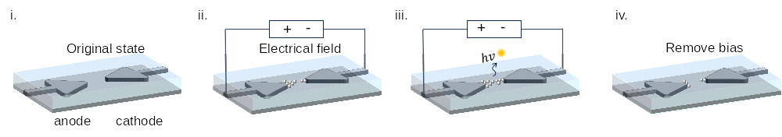
Fig. S4 | Schematic illustration of MBN working mechanism. Under the effect of an electrical field, the filament will repeat dissolute and reform, forming the luminescent defect.

Low Power and Volatile Operation of MBN
As shown in Fig. 2, unlike conventional electrical memristors that require high currents to determine the switching state, the MBN's photon-based readout allows for monitoring subtle electrical state changes prior to full activation. Here, we further demonstrate the MBN operates in volatile mode with pulsed experiments. We alternate between a 5 ms pulse of 5 V with a 0.5 V read voltage. With the 5V pulse, the device switches to LRS and emits photon. When the voltage returns to 0, the device returns to HRS every time after the set pulse. This is verified by the very low current and the absence of EL during the reading process.
It is also worth noting that the MBN operates in sub-μA region with still prominent electroluminescence, which is illustrated in the zoom-in plot in Fig. S5(b). This verifies that the MBN can operate in a faster, lower-power mode.
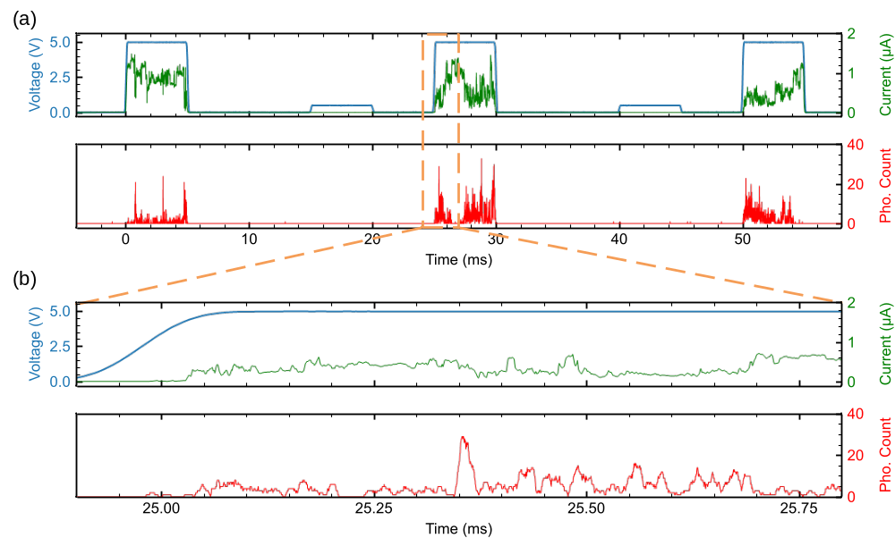
Fig. S5 | a, The transient electroluminescent behavior under a series of alternating 5 V, 5 ms and 0.5 V, 5 ms pulses. Upper: the applied voltage (blue) with the output current (green). Bottom: the photon counts binned every 10 μs. b, Zoomed-in plot of the second pulse from panel a.

Endurance Test
A 1000 consecutive pulse switching test with 0.75 V set voltage and 0.05 V read voltage is conducted to verify the reliability of the MBN device, as illustrated in Fig. S6. The compliance current is set at 10 nA to protect the device from damage. The device demonstrates the volatile characteristics well over 1000 switches and keeps an on/off ratio of 10³. In literature, similar resistive switching devices have shown lifetimes beyond 10¹⁰ cycles⁸.
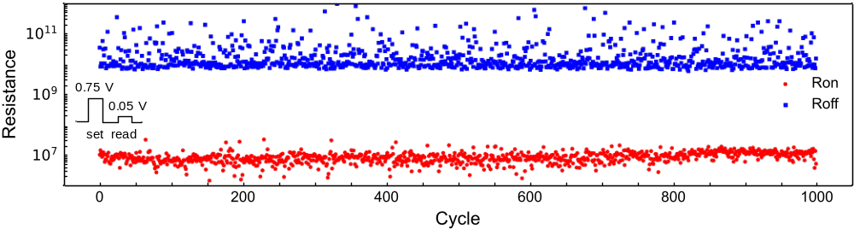
Fig. S6 | Results from 1000 consecutive volatile switching cycles, with a compliance current of 10 nA to protect the device.

Experiment Setup
The configuration for optical assessments and signal processing is illustrated in Fig. S6. Our setup features an inverted microscope (ECLIPSE, Nikon) as the sample stage. The photons are then directed through a selected output port to either an avalanche photodiode (SPCM-780-14-BR1, Excelitas) or a CMOS camera (C15550-20UP, HAMAMATSU) to capture temporal and spatial features, respectively. Emitted photons in the $z^{-}$ plane are captured using an oil immersion objective (100x, 1.49 NA, Nikon) for high-resolution imaging. Using index-matching gel eliminates reflection loss between the glass substrate and the objective. An arbitrary voltage train is generated by a pulse generator (UHFLI, Zurich Instruments), which applies arbitrary voltage signals directly to the sample's electrodes via GGB DC probes. To minimize the interference of ambient light on signal detection, we conduct our experiments in a specially designed darkroom to isolate all external light sources. After calibration, we achieve a dark photon count background of less than 50 counts per second, equating to a probability of less than 1 dark count within a 10 ms measurement window.
Detailed setup for various experiments are:
(1) Current measurement for single MBN device. Fig. S7(a) illustrates the setup for the electrical current and photonic emission measurement in Fig. 1e, Fig. 2 and Fig. 3b. Current detection in the experiment was performed using a current analyzer (CX3324, Keysight) or a transimpedance amplifier (TIA) (DHPCA-100, FEMTO) or an active probe (Model 35, GGB Industries).
(2) Photon response measurement for single MBN device. Fig. S7(b) shows the setup for electro-luminescence measurement (Fig. 3c, 3d and 3e in the main manuscript). Subsequently, the current sensing circuit is removed from the output terminal, and the device is directly grounded. In subsequent measurements, the current signal was no longer considered a measurement parameter.
(3) Photon response measurement for MBN array. Fig. S7(c) illustrates the setup for a multi-channel array test in the Section of Photonically-linked Spiking Neural Network and Ultra-compact Artificial Neuron Array (Fig. 4 and Fig.5 in the manuscript). The pulse generator generates 4-channel arbitrary voltage trains. The 4-channel voltage trains are then applied to the MBNs array. The emitted photons from the MBN array across the entire field of view are captured by a CMOS sensor. In both Fig. S7(b) and (c), the photonic emission detector replaces the traditional current readout circuit and equipment commonly used in the memristor measurement setup. Moreover, in our experiments, we directly stack the MBN chip in a CMOS image sensor (CIS) chip to verify the potential of direct intra-chip optical interconnection. The CIS surface covered with a 0.7 mm thick packaging glass on the surface prevents the light spot from focus accurately at the CIS focal plane, resulting in divergence and an increase in spot size. However, integrated manufacturing processes can effectively address this challenge.
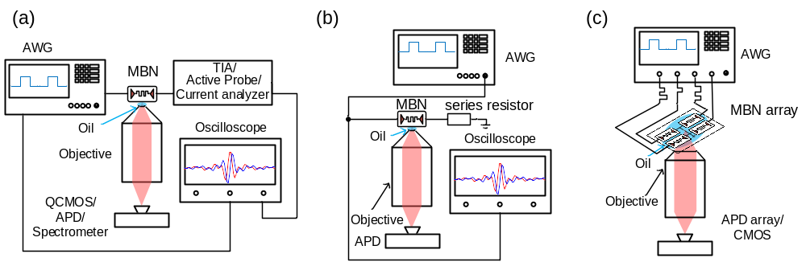
Fig. S7 | a, The setup for electro-optical device characterization in Fig 1f and Fig. 2. b, The setup used for electrical luminescence characterization. In the illustration, an APD or CMOS camera serves as the detector. The device's backend is connected to the ground without any current detector or current-to-voltage converter. c, The setup used for photonically-linked spiking neural networks. The pulse generator transforms the pre-layer signal into voltage trains across different channels, which then fed into devices respectively. The photons emitted by the MBNs layer are captured by a PD array, generating spikes that are visualized through an oscilloscope. A PC binarizes the photon counts into spikes and implements the weight MAC (Multiply-Accumulate) process. The PC communicates the following command to the pulse generator to generate the next layer of inputs. Here, we adopt a time-division multiplexing strategy for devices.

Neuron Modelling
This section provides a comprehensive explanation of the steps involved in fitting the mapping function $w\left(V\right)$ and the decay coefficient $τ$, as outlined in Eq. 1-2 of the main manuscript. Following the leaky integrate-and-fire (LIF) model, the neuron's membrane potential $U[t]$ is updated based on the input signal $ΔU\left[t\right]$ and the history of virtual membrane potential $U_{mem}[t-∆t]$, adjusted by a decay factor, as described by Eq. S2. When the neuron's membrane potential exceeds the firing threshold, typically set to 1 the neuron generates the spike according to the following rules:
$$U_{mem}[t]=\left(1-\frac{∆t}{τ}\right)U_{mem}[t-∆t]+ΔU\left[t\right] (S2)$$
$$s_{out}\left[t\right]=H\left(U_{mem}\left[t\right]-U_{th}\right) (S3)$$
$$H\left(x\right)=\left\{\begin{aligned}0, x<0 \\ 1, x>0\end{aligned}\right. (S4)$$
where $s_{out}\left[t\right]$ denotes the output of spiking neuron and $H\left(x\right)$ is the Heaviside step function for spike generation. The whole process can be formulated as:
$$s_{out}\left[t\right]=Spk\left(ΔU\left[t\right]\right) (S5)$$
In subsequent sections, we use $Spk\left(ΔU\left[t\right]\right)$ to symbolize the MBN neuron layer with MBN’s extracted decay factor and single spike behavior.
(1) Voltage to weight mapping function $w\left(V\right)$:
In the study of neurons, the response to stimuli varies with the intensity of the signal. Experiments are conducted to observe the optical response of MBN devices under different voltage amplitudes. Each device is activated and conditioned with an I-V sweep before testing to minimize device-to-device variations. To minimize the variables in extracting $w(V)$, we use a periodic square wave as input voltage trains, forcing $s_{in}\left[t\right]$≡1 at all timestep. Fig. S8(a) depicts the pulse number for firing N_{crit} at various voltage amplitudes, indicating a non-linear relationship between stimulus intensity and voltage amplitude. From N_{crit}, we extract the $w(V)=ΔU[t]$ as the increase of membrane potential at a given time $t$. We limit the input pulse voltage range from 5 V to 10 V in the following experiments of photonically-linked spiking neural network implementation.
We use the binary search-based method to find the optimum $w(V)$ matching our experiment findings extracted from Fig. S8. The process is described in Table S1. It initializes a weight range of [0,1]. The membrane potential updates based on Eq. S2. The target weight value, $w$, is computed as the midpoint of the current range limit, $w_{min}$ and $w_{max}$. The algorithm evaluates $U_{mem}[N_{crit}]$ to update $w_{min}$ and $w_{max}$ based on whether $U_{mem}[N_{crit}]$ is below or above the threshold.
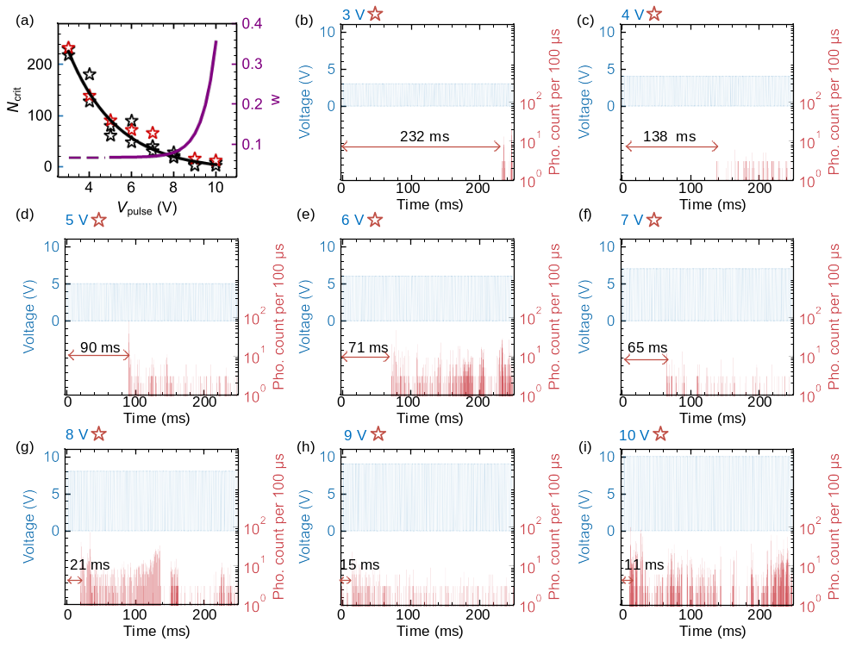
Fig. S8 | Response of MBN device with pulses under different voltages. Stimulus voltage trains are set with identical pulse width (t_{pulse}: 500 µs), guard time (t_{guard}: 500 µs), and different amplitude. (a) Three repeated tests under the same condition are illustrated with “✩” marks, and detailed data from one group is shown with a red star. The purple line represents the mapping function of the corresponding weight with varying voltage amplitude. The partial showcase of light emission response is shown under (b) 3 V (c) 4 V (d) 5 V (e) 6 V (f) 7 V (g) 8 V (h) 9 V (i) 10 V. The number of pulses needed for photon emission N_{crit} exhibits a nonlinear relationship with the applied voltage amplitude V_{pulse}.
Table S1. Algorithm 1: Weight extraction for MBN
Input: Parameters N_{cirt}, U_{th}, $w_{min}$, $w_{max}$, $resolution$
Output: $w$
1: | Initialize: $w_{min}=0$, $w_{max}=1$
2: | $U_{mem}[t]$ current membrane potential (Eq. S2)
3: | $w←(w_{min}+w_{max})/ 2$
4: | While(1):
 | if ($U_{mem}[N_{crit}]<U_{th}$ and $w_{max}-w_{min}>resolution$), then
 | $w_{min}←w$
 | $w←(w_{min}+w_{max})/ 2$
 | else if ($U_{mem}[N_{crit}]>U_{th}$ and $w_{max}-w_{min}>resolution$), then
 | $w_{max}←w$
 | $w←(w_{min}+w_{max})/ 2$
 | end if $w_{max}-w_{min}<resolution$
5: | Return $w$

(2) Decay coefficient $τ$:
In artificial neurons, the forgetting characteristic is often quantified by the parameter $τ$, which represents the conductance relaxation time. In memristive-based artificial neurons, this relaxation time is determined by the diffusion and dissolution of silver (Ag) conductive bridges within the device. Using experimental data demonstrated in Fig. S9, we simulate the leaky integrate-and-fire process with various intervals guard time. By integrating and evaluating the device response, we identify the optimal decay coefficient as $τ=$29.7 (decay factor $λ=1-\frac{1}{τ}=0.966$), which is subsequently used in our atomic memristive blinking neuron model.
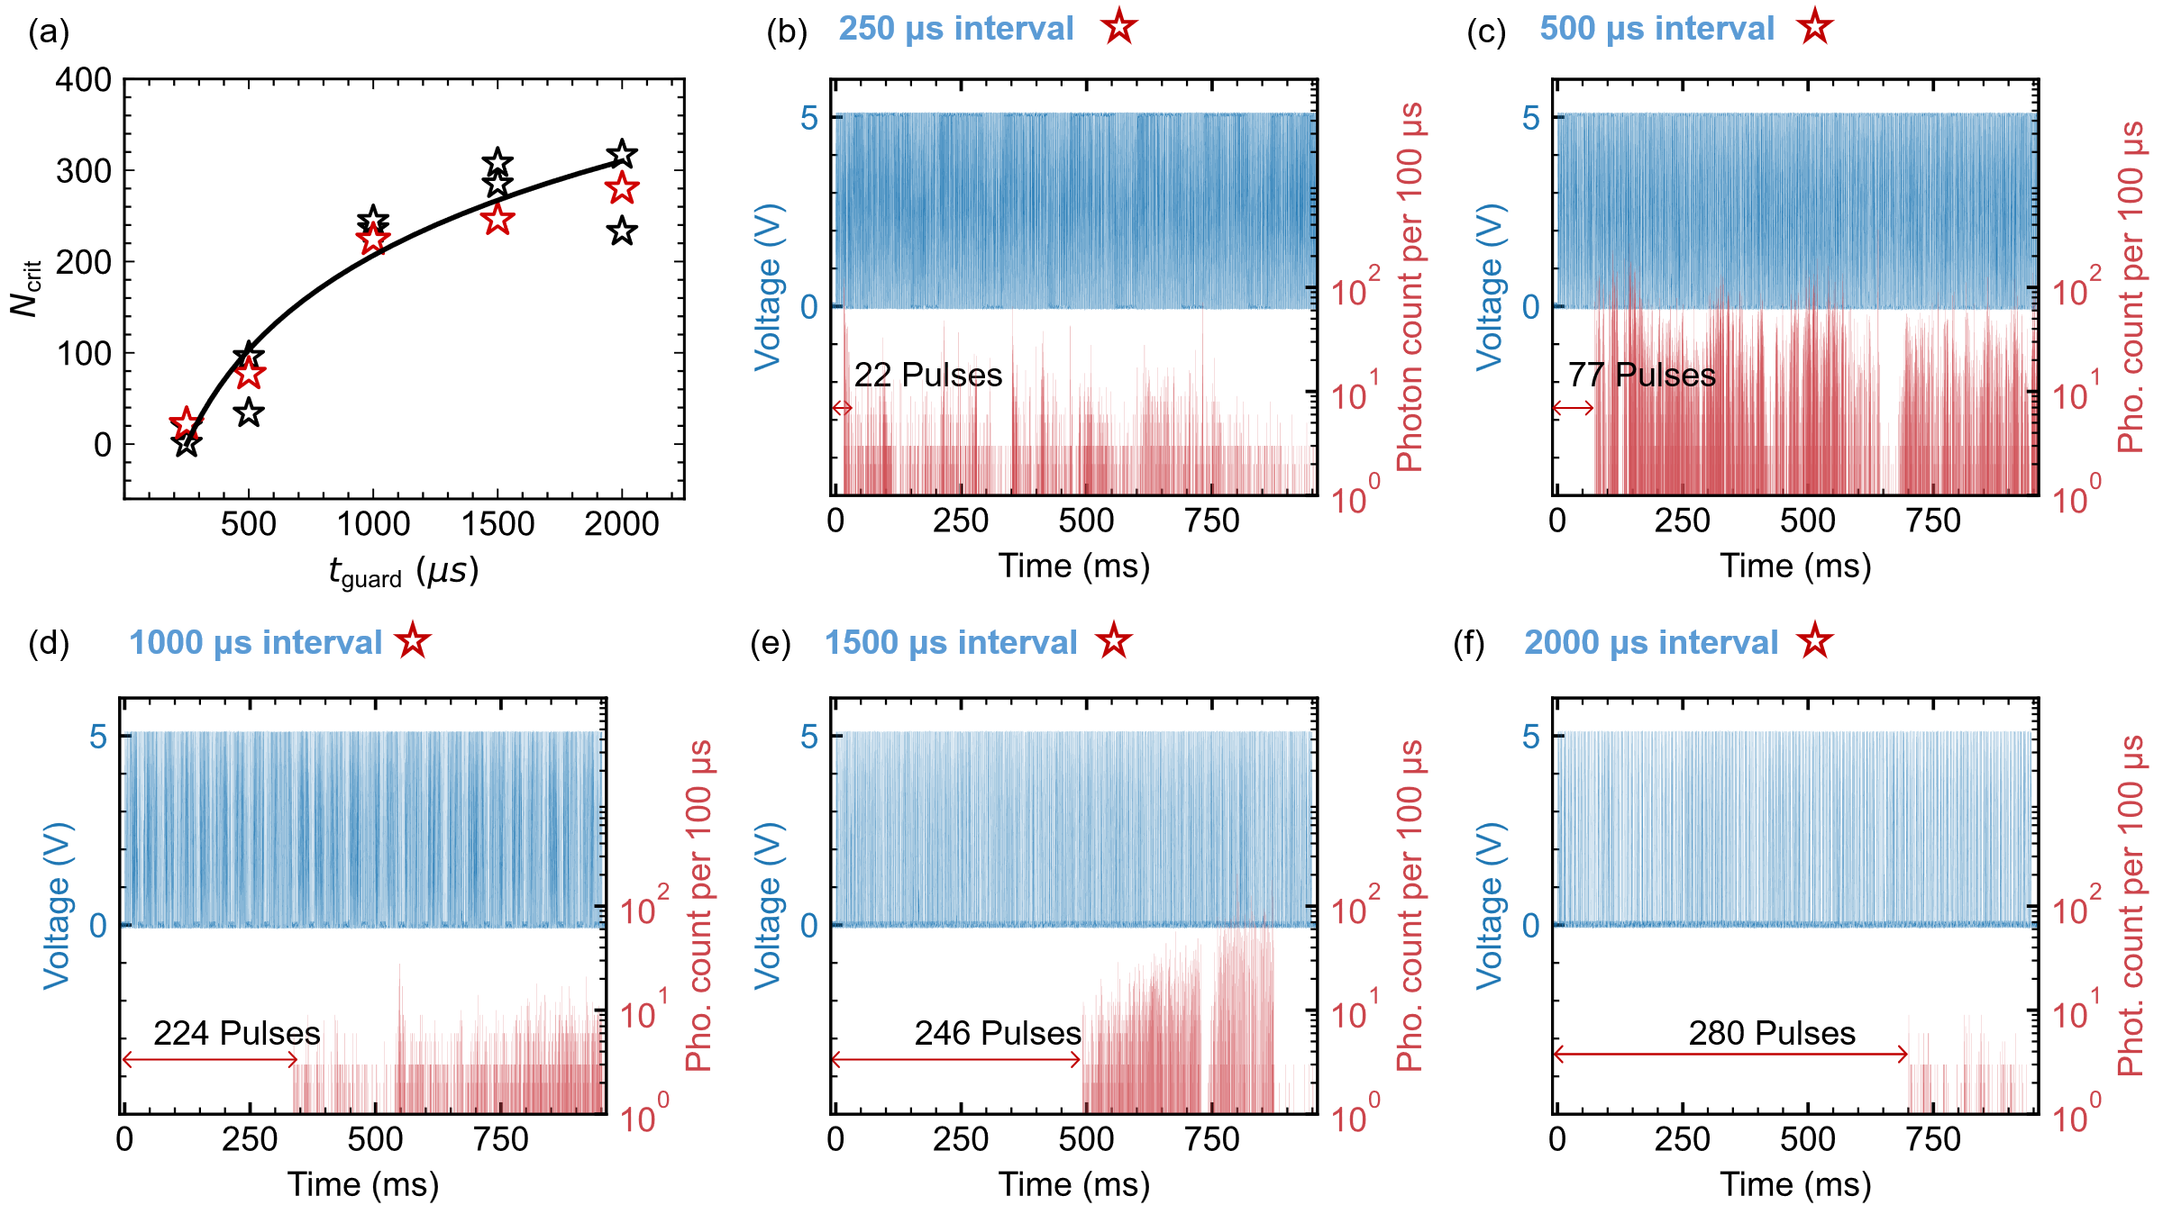
Fig. S9 | Activation of MBN device fed with pulses under different guard times. Stimulus voltage trains are set with identical amplitude (5 V), pulse width (t_{pulse}: 500 µs), and different guard time t_{guard}. (a) Three repeated tests under the same condition are illustrated with “✩” marks, and detailed data from one group is shown with a red star. The partial showcase of light emission response is shown under (b) 250 µs (c) 500 µs (d) 1000 µs (e) 1500 µs (f) 2000 µs. The device's requirement for varying numbers of pulses to be activated with optical response at different intervals indicated its leaky behavior. As the interval increases, the more pulses needed to activate the device demonstrate the more leak of membrane potential.
We use an incremental search method to find the optimal decay coefficient $τ$ matching our experimental findings from Fig. S9. The extraction process flow is described in Table S2. The membrane potential is updated based on Eq. S2. The algorithm starts with an initial estimated decay coefficient $τ$. The algorithm proceeds by incrementing $τ$ by a $step$ size if $U_{mem}[N_{crit}]<U_{th}$. Until $U_{mem}[N_{crit}]$ reaches the threshold, the algorithm will return the final $τ.$
Table S2. Algorithm 2: MBN Neuron decay coefficient extraction
Input: Parameters N_{cirt}, U_{th}, $τ$, $step$
Output: optimal $τ$
1: | Initialize: $τ$
2: | $U_{mem}[t]$ current membrane potential (Eq. S2)
3: | While(1):
 | if ($U_{mem}[N_{crit}]<U_{th}$), then
 | $τ←τ+step$
 | end if $U_{mem}[N_{crit}]≥U_{th}$
4: | Return $τ$
(3) Neuron model verification implementation:
By analyzing the device's behavior under varying voltage amplitudes and guard times, we extracted the MBN’s decay coefficient and established a function mapping voltage to synaptic weights. To validate this model, we simulated a leaky integrate-and-fire (LIF) system using the MBN in a single-layer neural network. This network consisted of one neuron connected to four synapses with varying weights. A conceptual image is illustrated in Fig. S10 (a). Inputs from the preceding layer were represented as binary spikes, with each synapse weighted accordingly. The matrix multiplication of inputs and weights produced an accumulated signal, which was then translated into a voltage sequence. This voltage train is subsequently fed into the MBN and triggers the photon emission. An experimental demo is performed with specific weight value and input, illustrated in Fig. S10 (b). The weight value are randomly picked. At each time step, the weighted input are summed then converted into voltage pulse according to voltage-weight mapping function. This weight and inputs multiplication process is realized in computer in our experiment.
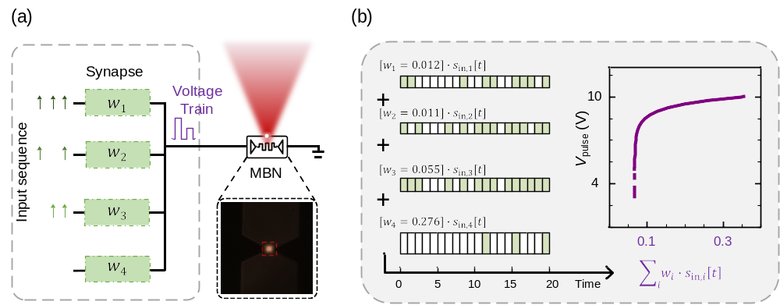
Fig. S10 | (a) A scheme of combining input spikes from multiple channels into a voltage train for one neuron. (b) An experimental illustration with 4 synaptic input channels that have different weighted inputs. The inputs of different channels are weighted first, where w₁=0.012, w₂=0.011, w₃=0.055, w₄=0.276, then are summed at each time step. The accumulated signal is then translated into voltage amplitude according to mapping function.

Spiking Neural Network Implementation of Keywords Spotting Encoding (KWS)
(1) Encoding
In KWS task, we encode voice recordings into spike trains using a layer of spiking neurons. We select the words "Cat," "Dog," "House," and "Tree" from the Google Speech Commands dataset for a 4-class keyword task. The original signals initially pass through a butter filter bank with 32 Mel-scaled filters, dividing the original time-series into 32 band-passed time-series signals. These filters are evenly spaced covering frequencies from 100 Hz to 16 kHz. The time series signals are then down-sampled to 1 kHz (1 ms resolution) and fed into LIF layer defined in Eq. S2-S4 (U_{th}=0.4, $λ$=0.25) to generate spike trains, as shown in Fig. S11(a). The membrane potential $U_{mem}$ is updated according to Eq. S2 and give out a spike once it exceeds the threshold, as described in Eq. S3-S4. Each channel takes one LIF neuron for signal conversion.
(2) Architecture
The network comprises three modules: the encoding module, preprocessing module and fully-connected module. The encoding module is introduced in the previous section. The preprocessing module consists of 8 convolutional layers to extract high-dimensional features from the frequency-sampled spike trains. This is followed by two 4 × 4 fully-connected layers with MBN neurons for classification. In this study, MBN neurons are deployed only in the final two fully-connected layers. The MBN with the highest firing rate in the output layer determines the network's output class. Fig. S11(b) gives a detailed demonstration of the inference process from the first MBN layer and second MBN layer optical output.
(3) Training Method
During the training process, a surrogate gradient function is applied to the non-differentiable spiking output, and the backpropagation-through-time algorithm is used to calculate the error of the hidden layers⁹. With the LIF described in Eq. S2-S4 can only generate up to one spike per timestep, the encoding module converts raw input to sparse spike train. While this low firing rate improves inference energy efficiency, the sparsity poses a challenge in training the SNN. To address this, we start by pretraining a model with LIF neurons (U_{th}=1.0, $λ$=0.25) featuring multi-spike dynamics¹⁰. The multi-spike behavior allows multiple spikes per time step and effectively enhances the spike rate from frequency-sampled audio signals. This pretraining accelerates convergence and prepares the model for hardware-compatible voice recognition.
After pretraining, we replace the multiple spike LIF neurons in the last two fully-connected layers with MBN neurons configured for single spiking, aligning with the physical MBN model. We then finetune the entire model over 50 epochs, achieving a peak accuracy of 91.51%. The SNN is trained on a NVIDIA A30 GPU and then map the network onto MBN arrays.
(4) Weight Quantization. In our work, weights are quantized from floating-point values to 32 discrete conductance levels¹¹ using the additive power-of-two quantization method from prior study¹². This method, as shown in Eq. S6, quantizes a real number by expressing it as a sum of signed powers of two, with each power assigned a binary coefficient (-1, 0, or 1). These coefficients are determined by iteratively selecting the largest power of two that fits within the remaining difference between the original number and the sum of previously selected powers. Figure S8(b) shows the weight values before and after quantization.
$Q^{p}\left(a,b\right)=a×\left\{0,±2^{-2^{b-1}+1},±2^{-2^{b-1}+2},±2^{-1},±1 \right\}$ $(S6)$
where $a$ adjusts the range of the quantized weight values, $b$ determines the number of discrete levels of the quantized weight and $Q^{p}$ refers to the quantized weight value. The quantization process uses a greedy algorithm to select a combination of discrete levels from a set defined by $b$ to approximate each weight value. These selected levels are represented as a weighted sum with coefficients of -1, 0, or 1. Finally, the quantized weight values are scaled by a to obtain the final quantized weights. By tuning $a$ and $b$, one can balance the trade-off between quantization precision and hardware resource utilization.
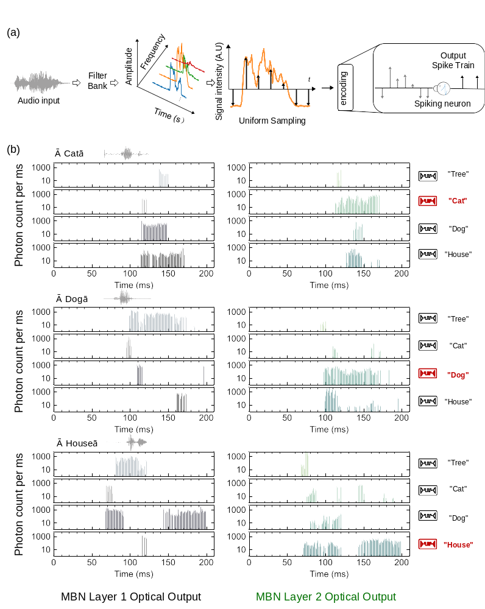
Fig. S11 | a, The encoding method of the KWS task, which transfers the audio spectrums into temporal spike train. b, A zoomed-in view of Fig. 4(d), providing a detailed inference example for the left three labels The gray section indicates the optical output from the first MBN layer, while the green section represents the optical output from the second MBN layer.

Spiking Neural Network Implementation of MNIST Classification
The network comprises three modules: encoding module, feature extractor and fully connected classifier. The neuron model in the network all adopt our physical extracted MBN model.
- First Convolution Layer and Encoding
In the handwritten digit recognition task, to process static grayscale images in SNNs, each image is repeated T times to create a temporal sequence¹³. For this MNIST classification task, we select T=16 to achieve a balance between accuracy and energy efficiency. We first pass the T copies of grey scale image through a convolution layer to extract preliminary features. With an $n × n$ kernel on the original 2D gray scale input image $I_{in}(u,v)$, the convolved result after the first convolution layer is $R_{out, m}^{layer 0}(u,v,t)$:
$R_{out, m}^{layer 0}(u,v,t)=\sum_{j=0}^{j=n}{\sum_{i=0}^{i=n}{I_{in}\left(u+i,v+j,t\right){∙w}_{ m}^{layer 0}\left(i,j\right)}}$ $(S7)$
Whereas $m$ is the channel number in convolutional kernel $w_{ m}^{layer 0}$. $(u,v)$ is the coordinate. This convolved result is converted into a spike train through MBNs, described in Eq S8 and S9. Each pixel in the feature map is represented by one spiking neuron, as illustrated in Fig. S12. The spike train serves as the feature map input for next layer further processing, denoted as $I_{in, m}^{layer 1}$.
$$U_{mem,m}^{layer 0}\left(u,v,t\right)=U_{mem,m}^{layer 0}\left(u,v,t-∆t\right)+R_{out, m}^{layer 0}(u,v,t) (S8)$$
$$I_{in, m}^{layer 1}\left(u,v,t\right)=H\left(U_{mem,m}^{layer 0}\left(u,v,t\right)-U_{th}\right) (S9)$$
- Feature extraction layer
The feature extractor consists of three spiking convolutional layers, each with 64 input and output channels of a 3 × 3 kernel size. For all subsequent layers$, I_{in, m}^{l}$ is the Heaviside function output and constrained into 0 or 1 which is a spike input for next layer. For the subsequent convolution layer $1≤l≤3$, the convolved result $R_{out, m}^{l}(u,v)$ is given by,
$$R_{out, m}^{l}(u,v,t)=\sum_{j=0}^{j=n}{\sum_{i=0}^{i=n}{I_{in, m}^{l}\left(u+i,v+j,t\right){∙w}_{m}^{l}\left(i,j\right)}} (S10)$$
After convolution operation, the value would feed into a spiking layer. The membrane potential is update according to Eq. S11. Once the membrane potential exceeds the threshold the neuron will output the spike and generate the binarized feature map for next layer input, as describe in Eq. S12,
$U_{mem,m}^{l}\left(u,v,t\right)=U_{mem,m}^{l}\left(u,v,t-∆t\right)+R_{out, m}^{l}(u,v,t)$ $(S11)$
$I_{in, m}^{l}\left(u,v,t\right)=H\left(U_{mem,m}^{l}\left(u,v,t\right)-U_{th}\right)$ $(S12)$
- Differential Neuron Bank.
Compared to speech recognition, visual tasks require more complex feature extractors and network structures. To address this challenge, we introduce inhibitory signals into the neuron inputs, enhancing network flexibility. We design a differential convolution module that supports both positive and negative neurons. Inputs are sent into two paths: one path with excitatory weights and the other with inhibitory weights. Output pulses are generated only if the positive MBN outputs "1" and the negative MBN outputs "0", equivalent to the Heaviside function,
$$S_{j-pos}=Spk\left(\sum_{i}{\left[V_{i}G_{i,j}^{-}\right]}\right) \left(S13\right)$$
$$S_{j-neg}=Spk\left(\sum_{i}{\left[V_{i}G_{i,j}^{+}\right]}\right) (S14)$$
$$S_{out,j}=H(\sum_{i}{[S_{j-pos}-S_{j-neg}]}) (S15)$$
where 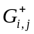, 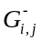 represent the positive and negative weight elements in the i-th row and j-th column, respectively. The weighted input stimulus alters the membrane potential state of the MBN neuron, and the The corresponding positive and negative spiking outputs, $S_{j-pos}$ and $S_{j-neg}$, are then processed by a Heaviside function to determine the final output value, where $H(x)=1$ when $x>0$ and remains inactive otherwise. During training, we replace the Heaviside function with the $ReLU$ activation function to ensure differentiability.
- Training Method
For this more complex task, we use the differential neural bank, eliminating the need for pretraining without compromising performance. This method maintains high accuracy while simplifying the training process. It also allows for the direct use of the extracted MBN model throughout all experiments. Besides, we adopt the same weight quantization as in the KWS task.

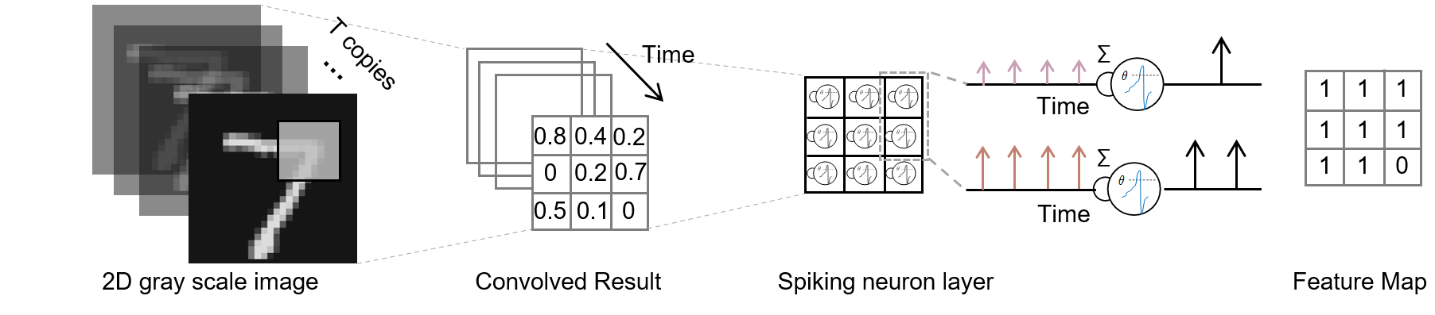
Fig. S12 | The encoding method of the image classification task, which transfers the statistic image’s spatial information into a temporal spike train.

References
1 Agio, M. Optical antennas as nanoscale resonators. Nanoscale 4, 692-706, doi:10.1039/C1NR11116G (2012).
2 Parzefall, M. & Novotny, L. Optical antennas driven by quantum tunneling: a key issues review. Reports on Progress in Physics 82, 112401, doi:10.1088/1361-6633/ab4239 (2019).
3 Cheng, B. et al. Atomic scale memristive photon source. Light: Science & Applications 11, 78, doi:10.1038/s41377-022-00766-z (2022).
4 Malchow, K. et al. Self-induced light emission in solid-state memristors replicates neuronal biophotons. (2024).
5 Yang, R., Huang, H.-M. & Guo, X. Memristive Synapses and Neurons for Bioinspired Computing. Advanced Electronic Materials 5, 1900287, doi:https://doi.org/10.1002/aelm.201900287 (2019).
6 Cheng, B. et al. Atomic scale memristive photon source. 11, 78 (2022).
7 Hamdad, S. et al. Overbias and Quantum Tunneling in Light-Emitting Memristors. 20, 024057 (2023).
8 Kozicki, M. N., Mira, P. & Mitkova, M. Nanoscale memory elements based on solid-state electrolytes. IEEE Transactions on Nanotechnology 4, 331-338, doi:10.1109/TNANO.2005.846936 (2005).
9 Wu, Y., Deng, L., Li, G., Zhu, J. & Shi, L. J. F. i. n. Spatio-temporal backpropagation for training high-performance spiking neural networks. 12, 331 (2018).
10 Gütig, R. Spiking neurons can discover predictive features by aggregate-label learning. Science 351, aab4113, doi:10.1126/science.aab4113 (2016).
11 Przewlocka-Rus, D., Sarwar, S. S., Sumbul, H. E., Li, Y. & De Salvo, B. J. a. p. a. Power-of-two quantization for low bitwidth and hardware compliant neural networks. (2022).
12 Przewlocka-Rus, D., Sarwar, S. S., Sumbul, H. E., Li, Y. & Salvo, B. d. J. A. Power-of-Two Quantization for Low Bitwidth and Hardware Compliant Neural Networks. abs/2203.05025 (2022).
13 Zhou, Z. et al. Spikformer: When spiking neural network meets transformer. (2022).

