Table S1 The summary of reads from PacBio single-molecule long-read sequencing
 | Subreads | CCS | FLNC | Polished  consensus | Corrected transcript
Number | 17,627,889 | 689,344 | 558,845 | 345,616 | 47,860
Average Length | 978 | 1,882 | 1,749 | 1,743 | 2,349
N50 | 1,759 | 2,629 | 2,467 | 2,687 | 2,839

Table S2 Completeness assessment of the unique transcript isoforms using Benchmarking Universal Single-Copy Orthologs (BUSCO)
Types of BUSCOs | Number of genes | Percent completeness (%)
Complete BUSCOs | 709 | 49.3
Complete and single-copy BUSCOs | 283 | 19.7
Complete and duplicated BUSCOs | 426 | 29.6
Fragmented BUSCOs | 30 | 2.1
Missing BUSCOs | 701 | 48.6

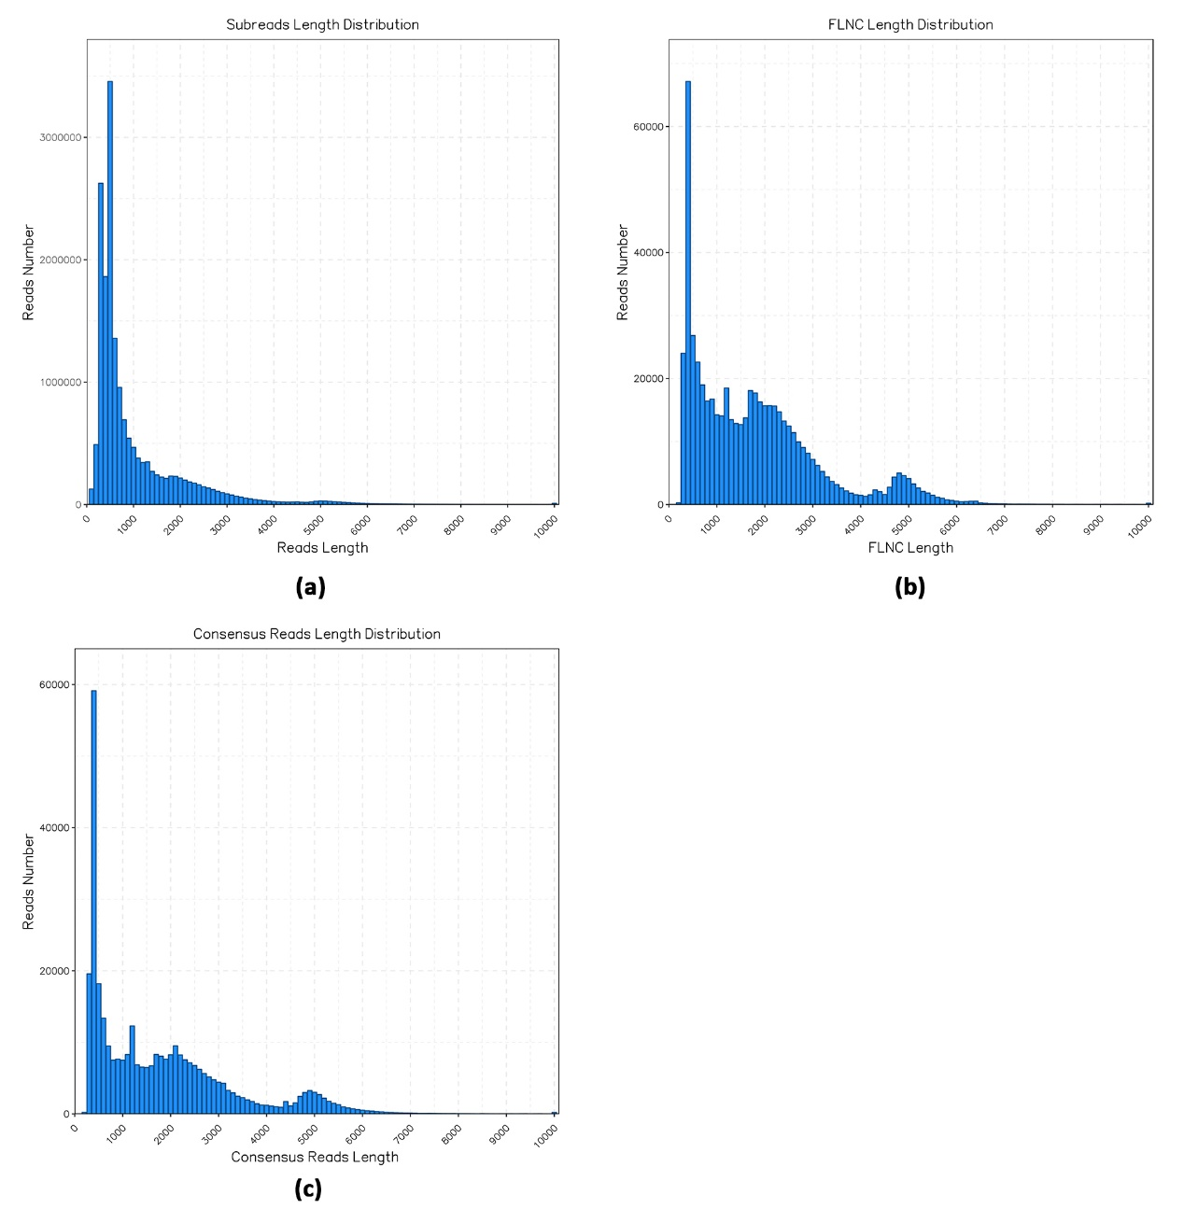
Figure S1 Length distributions of PacBio SMRT sequencing. (a). Distribution of read length of subreads; (b). Distribution of read length of FLNC; (c). Distribution of read length of consensus isoforms.

