Table 1. Mean abundance (± s.e.) of 12 invertebrate taxa, grouped by site and grass species.
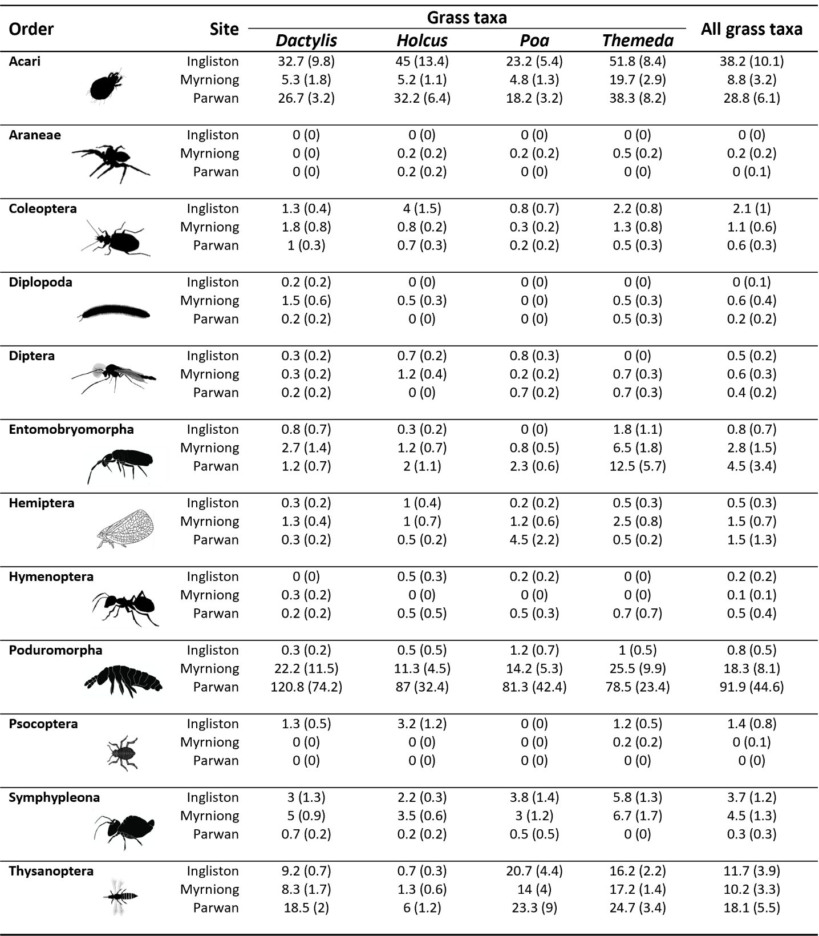

Table 2. Similarity percentage (SIMPER) partitions comparing taxa dissimilarity among sites.
