Supplementary information for the manuscript ‘Litter invertebrates display greater differences among locations than grass species in a temperate grassland’
Allison M. Wall, Philip S. Barton, Nick L. Schultz
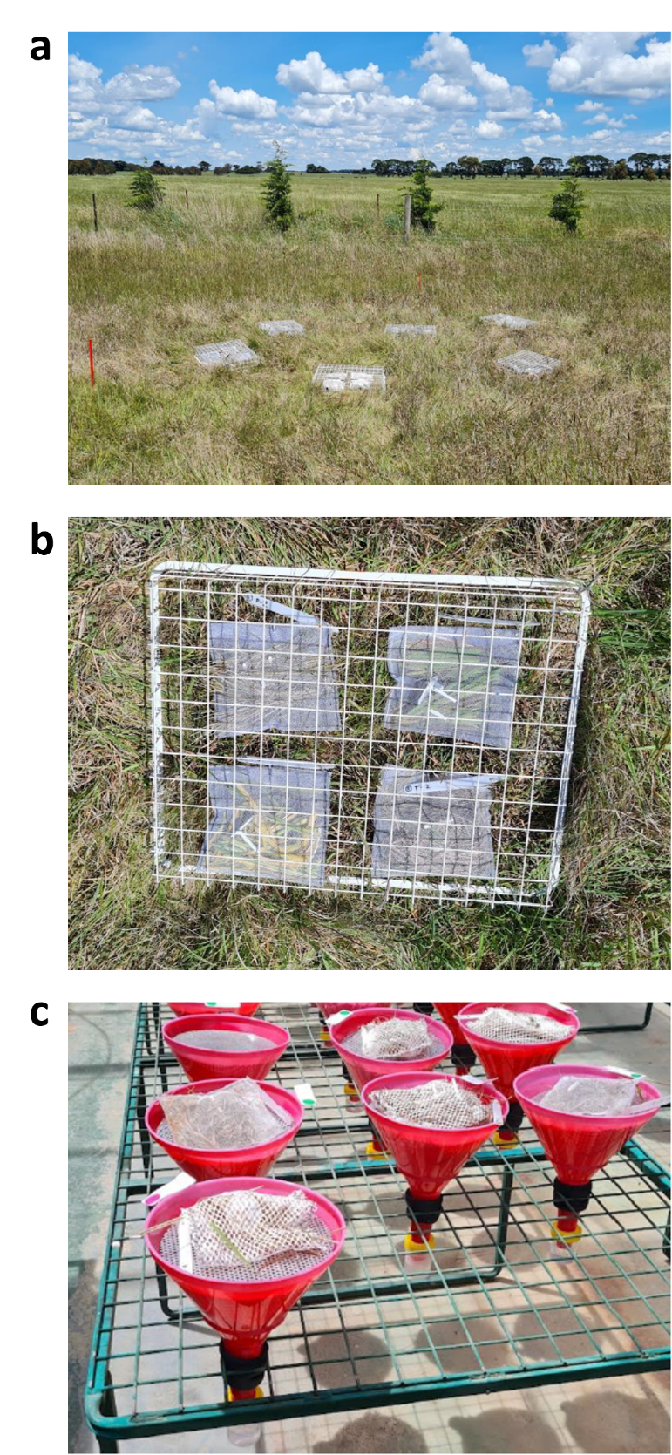
Supplementary Figure S1. (a) The plot arrangement of the Ingliston site. (b) Arrangement of four litterbag samples. Each is secured individually tagged to denote the treatment replica and grass species. The litter bags and mesh tray are attached to the ground with metal weed mat pins. (c) The funnel set-up for invertebrate extraction.

