Supplementary information for “The cost of soil degradation in one of the major breadbaskets in the world” by Monzon et al.

Supplementary Figure 1 to 9……………………………….……………..………2-10
Supplementary Table 1 to 5……………..……..…………………………………. 11-15

Supplementary Figures

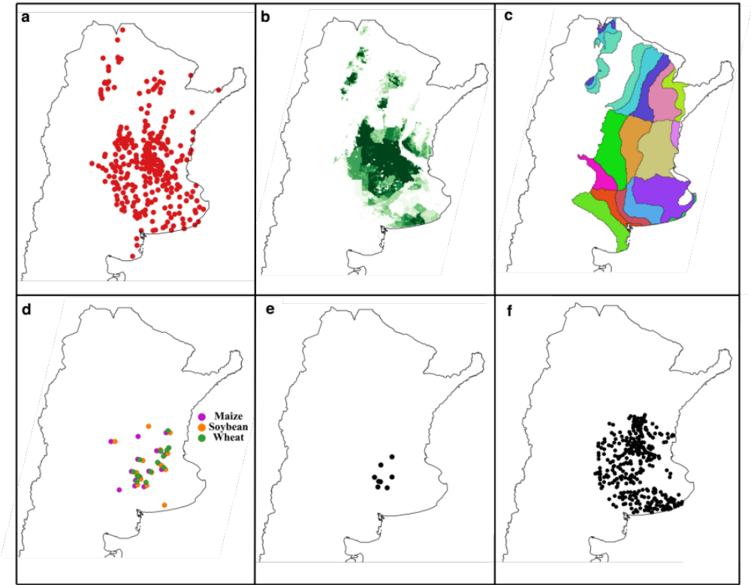

Supplementary Figure S1. Data sources used for assessing the effect of nutrient fertilizer use on yield gaps in Argentina. (a) Data on yield and fertilizer collected through 350 to 400 collaborators annually ³². (b) Crop harvested area for the three crops (maize, wheat, and soybean)¹. (c) Agroecological zones delineating areas with different annual growing-degree days, aridity index, and temperature seasonality³⁴. (d) On-farm fertilizer short-term experiments evaluating improved nutrient management. (e) On-farm fertilizer long-term experiments. (f) Sampling sites for soil monitoring¹³.

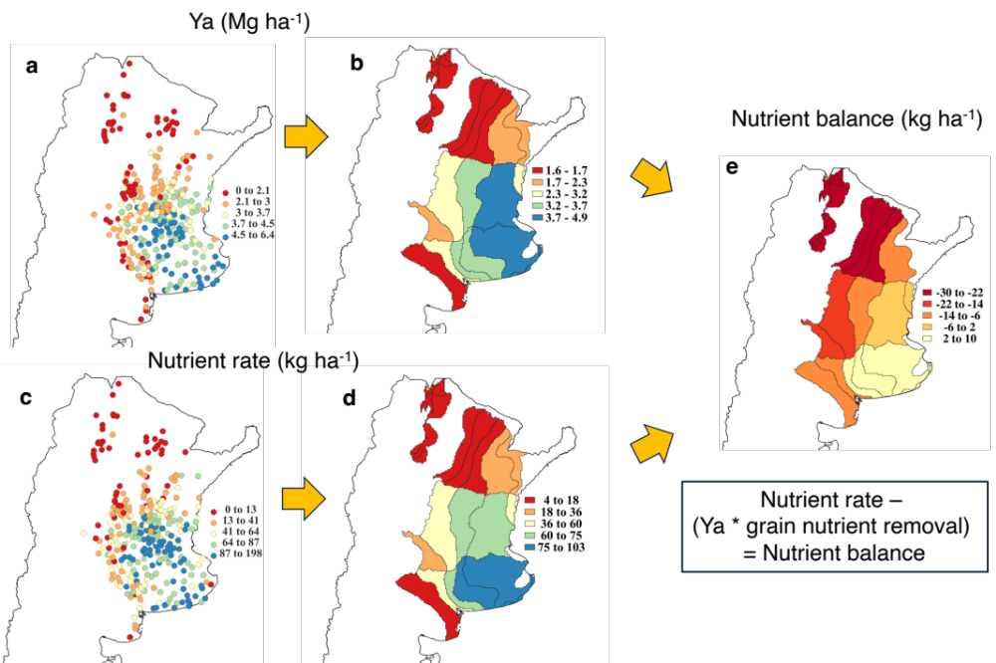
Supplementary Figure S2. Approach to estimate nutrient balance. Example of estimation of nutrient balance for nitrogen in wheat. Average farmer yields (Ya) and nutrients rates collected through 350-400 enumerators annually³² were aggregated to agroecological zones³⁴. Subsequently, the nutrient balance was estimated as the difference between current nutrient rates and grain nutrient removal. Nutrient values are expressed in kilograms of elemental nutrient per hectare.

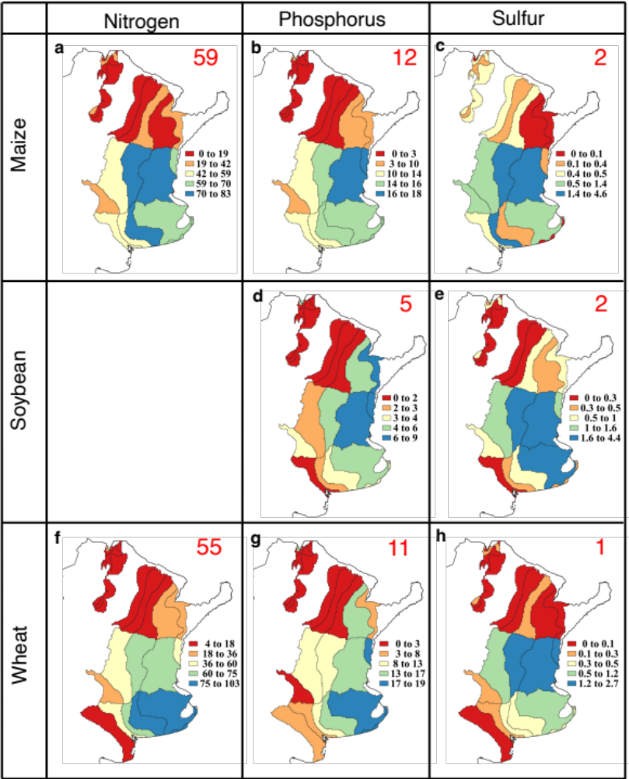
Supplementary Figure S3. Average current nutrient fertilizer rates per crop for main producing areas. Separate maps are shown for maize (a, b, c), soybean (d, e), and wheat (f, g, h) for nitrogen (left), phosphorous (center), and sulfur (right). In all cases, values are in kg of nutrient per hectare per crop. Results were aggregated to agroecological zones ³⁴. Nutrient fertilizer rates are expressed in kilograms of elemental nutrient per hectare per crop, and red numbers indicate average values at the country level. See Methods for estimation of nutrient balances.

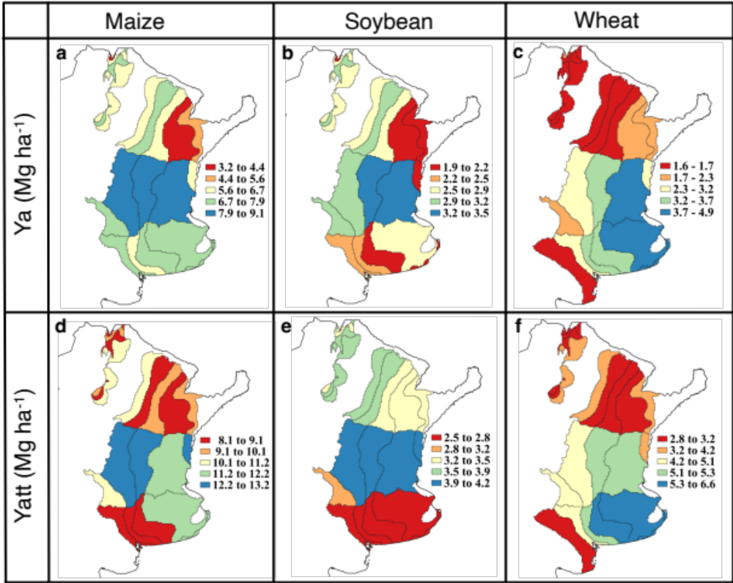
Supplementary Figure S4. Average farmer yield (Ya) and attainable yield (Yatt) for main producing areas. Separate maps of Ya (a, b, c) and Yatt (d, e, f) are shown for maize (left), soybean (center), and wheat (right). Data on Ya were collected through 350-400 enumerators annually³², while Yatt was estimated as 80% of the simulated water-limited yield potential retrieved from the Global Yield Gap Atlas⁵⁴. Yields are expressed at standard grain moisture content for each crop: 14.5% (maize), 13.5% (soybean), and 14% (wheat). Data were aggregated to agroecological zonesl³⁴.

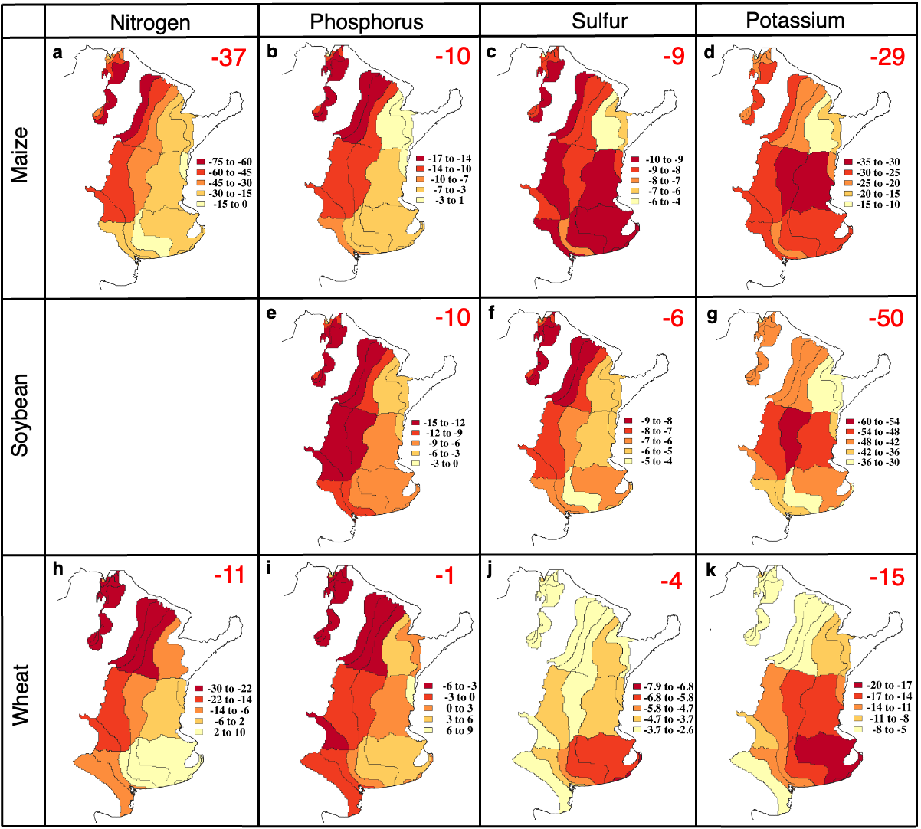

Supplementary Figure S5. Average nutrient balances per crop for main producing areas. Separate maps are shown for maize (a, b, c, d), soybean (e, f, g), and wheat (h, i, j, k), and from left to right they show nitrogen, phosphorous, sulfur and potassium. Nutrient values are expressed in kilograms of elemental nutrient per hectare per crop, and red numbers indicate average values at the country level. Data were aggregated to agroecological zones³⁴. See Methods for estimation of nutrient balances.

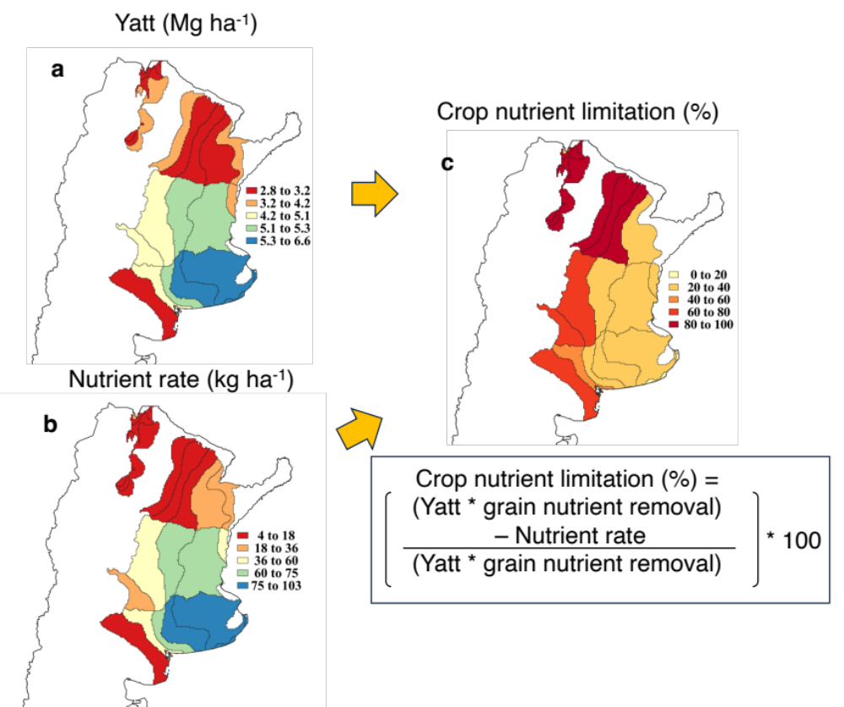

Supplementary Figure S6. Approach to estimate crop nutrient limitation and nutrient gap. Example for nitrogen in wheat. The attainable yield (Yatt) was estimated as 80% of the simulated water-limited yield potential retrieved from the Global Yield Gap Atlas⁵⁴. Data were aggregated to agroecological zones³⁴.

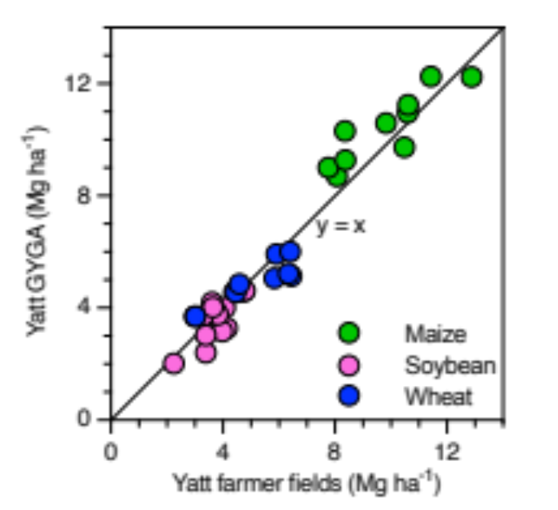
Supplementary Figure S7. Validation of the attainable yield (Yatt) used for estimating nutrient requirements. Comparison between Yatt derived from crop models⁵⁴ (Yatt GYGA) versus that retrieved from farmer fields with high technology adoption (Yatt farmer fields)³². The Yatt was estimated as 80% of the simulated water-limited yield potential retrieved from the Global Yield Gap Atlas (GYGA)⁵⁴ or from the 95% percentile of the farmer yield distribution in each agroecological zone⁵¹. Datapoints represent averages for maize (green), soybean (pink), and wheat (blue) per agroecological zone across three crops seasons (2016/17, 2017/18, and 2018/19).

Supplementary Figure S8. Average crop nutrient limitation for main producing areas. Separate maps are shown for maize (a, b, c), soybean (d, e), and wheat (f, g, h) for nitrogen (left), phosphorous (center), and sulfur (right). In all cases, values are shown as percentage of the crop nutrient requirement. and data were aggregated to agroecological zones³⁴. See Methods for estimation of crop nutrient limitation.

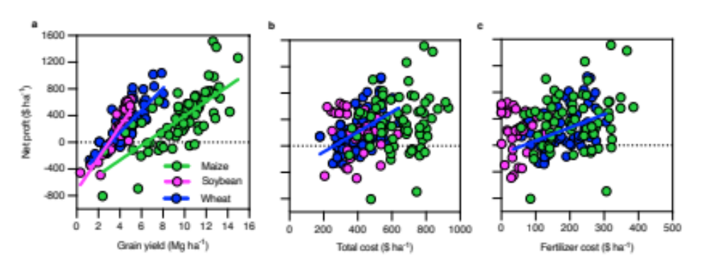
Supplementary Figure S9. Relationships between net profit, crop yield, total production cost, and fertilizer cost. The database included 300 farms across the Pampas during the 2020/21 and 2021/22 crops seasons belonging to a local farmer association (www.crea.org.ar). Each datapoint is the average for each crop for a given farm. Regression lines are shown only when statistically significant (p<0.05).

Supplementary Tables

Supplementary Table S1. Grain nutrient removal for maize, soybean and wheat. Values correspond to global (maize and wheat) or local averages (soybean) ¹⁸ ³⁶ and are expressed in kilograms of elemental nutrient per Mg of grain at standard commercial moisture of 14.5% (maize), 13.5% (soybean), and 14% (wheat).
 | Maize | Soybean | Wheat
Nitrogen | 12.3 | ª | 20.7
Phosphorus | 2.9 | 5.0 | 3.8
Potassium | 3.9 | 15.8 | 4.6
Sulfur | 1.4 | 2.8 | 1.7

ª Nitrogen nutrient balance for soybean was assumed to be neutral based on recent literature review of local values for the region^{37,38}

Supplementary Table S2. Summary of nutrient inputs in the on-farm fertilizer response trials. Average fertilizer rates for nitrogen (N), phosphorous (P), and sulfur (S) following farmer reference management (REF) and balanced nutrient management (BN). Nutrient rates are expressed as kilograms of elemental nutrient per hectare per crop. For comparison purposes, the average nutrient fertilizer rates in Argentina reported by ReTAA-Buenos Aires Grain Exchange are shown ³²

 | Experiments |  | ReTAA
 | REF | BN
Maize (n = 20)
N | 55 | 125 | 73
P | 13 | 33 | 15
S | 1 | 19 | 3
Soybean (n = 26)
P | 7 | 24 | 7
S | 2 | 16 | 3
Wheat (n = 25)
N | 59 | 119 | 73
P | 17 | 30 | 16
S | 1 | 13 | 2

Supplementary Table S3. Average farmer yields (Ya), attainable yield (Yatt), crop area, current nitrogen (N), phosphorous (P), potassium (K), and sulfur (S) fertilizer rates, and crop nutrient limitation. Parenthetic values indicate the ratio between the crop nutrient requirement and the current nutrient fertilizer rate. Values are averages over three crop growing seasons (2016/17, 2017/18, and 2018/19).

Crop | Ya  (Mg ha⁻¹) ª | Yatt  (Mg ha⁻¹) ^{b} | Crop area  (million ha) | Current nutrient rates (kg ha⁻¹) ^{a, d} |  |  |  | Crop nutrient limitation  (%) ^{c}
 |  |  |  | N | P | K | S | N | P | S
Maize | 7.9 | 11.5 | 5.8 | 59 | 12 | 0 | 2 | 58 (2.4x) | 63 (2.7x) | 88 (8.5x)
Soybean | 3.0 | 3.7 | 18.1 | 0 | 5 | 0 | 2 | 0 ^{e} | 74 (3.9x) | 77 (4.4x)
Wheat | 3.2 | 5.2 | 5.6 | 55 | 11 | 0 | 1 | 49 (2x) | 43 (1.7x) | 89 (9.1x)
Overall |  |  | 24.1 | 27 | 9 | 0 | 2 | 54 (2.2x) | 66 (3.1x) | 83 (6.5x)

ª Average farmer yield at standard commercial grain moisture (14.5%, 13.5%, and 14% for maize, soybean, and wheat, respectively) and nutrient fertilizer rates (in elemental nutrient) were retrieved from ReTAA- Buenos Aires Grain Exchange ³²
^{b} The Yatt was estimated as 80% of the simulated water-limited yield potential retrieved from the Global Yield Gap Atlas (www.yieldgap.org) based on crop modeling and locally measured data on weather, soils, and crop sequences⁵⁴
^{c} The crop nutrient requirements (kilograms of elemental nutrient) were estimated by multiplying the estimated Yatt by the nutrient removal per unit of yield and the crop nutrient limitation as the difference between crop nutrient requirement and current nutrient inputs for each crop, expressed as a percentage of crop nutrient requirement. Crop nutrient limitation was not estimated for K as current soil K is sufficient to meet crop requirements without need to apply K fertilizer.
^{d} Overall values estimated for the entire country, considering that 30% of the national soybean area is planted as a second crop after wheat.
^{e} The N balance for soybean was assumed to be neutral based on recent literature reviews for the region^{37,38}

Supplementary Table S4. Global warming potential (GWP) associated with different scenarios of intensification. The GWP during the study period (2016–2018) was estimated for three scenarios and three crops. Scenarios include current business as usual (BAU) trajectory of nutrient use, and higher nutrient use with high efficiency (HN-HE) or low nutrient-use efficiency (HN-LE). See Methods for details on the scenario assessment.

Scenario | Maize |  |  | Soybean |  |  | Wheat |  |  | Overall ª
 | BAU | HN-HE | HN-LE | BAU | HN-HE | HN-LE | BAU | HN-HE | HN-LE | BAU | HN-HE | HN-LE
GWP  (kg CO₂e ha⁻¹) | 2012 | 2552 | 3285 | 987 | 1838 | 2397 | 400 | 492 | 520 | 830 | 1155 | 1422
Crop yield ª  (Mg ha⁻¹) | 7.9 | 11.5 | 11.5 | 3.2 | 5.2 | 5.2 | 3.0 | 3.7 | 3.7 | 4.0 | 5.5 | 5.5
GWP  (kg CO₂ e Mg⁻¹) | 256 | 222 | 286 | 309 | 353 | 461 | 133 | 133 | 141 | 191 | 192 | 230

ª Weighted average across crops based on the associated crop area (Supplementary Table S3).

Supplementary Table S5. Summary of production, economic, and environmental outcomes for different nutrient management scenarios. Scenarios include the business as usual following the current trajectory of nutrient use (business as usual, BAU), higher nutrient use with high efficiency (HN-HE) or low nutrient use and low efficiency (HN-LE). Estimations of global warming potential (GWP) per t of grain (kg CO₂eq t⁻¹) include N and carbon (C) cost of soil organic carbon (SOC) loss due to negative nutrient balances. Values are expressed on an annual basis. See Methods for calculations.

Variable | Scenarios
 | BAU | HN-HE | HN-LE
Crop production (Mt) ª | 122 | 163 ª | 163 ª
Fertilizer use (Mt) ^{b} | 2.8 | 8.5 | 11
SOC change (Mt C y⁻¹) ^{c} | -2.9 | 0 | 0
Profit (billion US$) | 24.6 | 31.9 | 31.9
Social cost of carbon (billion US$) ^{d} | -0.54 | 0 | 0
Nutrient mining cost (billion US$) | -1.1 | 0 | 0
Extra fertilizer cost (billion US$) | 0 | 2.4 | 3.9
Net profit (billion US$) | 23.0 | 29.3 | 27.8
GWP per t of grain | 191 | 190 | 226
Nitrogen balance (kg ha⁻¹) | -10 | 25 | 59
Phosphorous balance (kg ha⁻¹) | -10 | 0 | 10
Sulfur balance (kg ha⁻¹) | -8 | 0 | 10

ª Overall grain and seed production after closure of the current yield gap between average farmer yield and attainable yield on existing cropland.
^{b} Fertilizer use estimated based on dominant fertilizer sources: urea (N), triple super phosphate (P), and calcium sulfate (S).
^{c} Changes in SOC were estimated based on the nitrogen balance and the stoichiometry of SOC as follows: 10,000 (C):833 (N) ⁵⁸ and assuming a zero N balance for soybean³⁷. Conversely, we assumed that achieving balanced nutrient inputs and outputs will stop current trends of SOC decrease and avoid further degradation.
^{d} We assumed a social cost of carbon of 51 US$ per t of CO₂⁵⁷.

