Supplementary Materials
Supplementary Material 1: Performance of the Memory Decoding Model
Table 1: Modeling performances (MCC values) across all subjects (n=24) and categories in the Sample Response decoding case.
Subject ID | Animal | Building | Plant | Tool | Vehicle
S1 | 0.168 | 0.051 | 0.411 | 0.271 | 0.378
S2 | 0.300 | 0.345 | 0.559 | 0.231 | 0.452
S3 | 0.360 | 0.633 | 0.651 | 0.303 | 0.498
S4 | 0.144 | 0.368 | 0.490 | 0.101 | 0.135
S5 | 0.225 | 0.233 | 0.438 | 0.663 | 0.662
S6 | 0.721 | 0.747 | 0.526 | 0.330 | 0.607
S7 | 0.381 | 0.468 | 0.421 | 0.275 | 0.680
S8 | 0.141 | 0.367 | 0.569 | 0.362 | 0.222
S9 | 0.422 | 0.518 | 0.293 | 0.343 | 0.069
S10 | 0.164 | 0.516 | 0.534 | 0.411 | 0
S11 | 0.252 | 0 | 0.531 | 0.282 | 0.435
S12 | 0.156 | 0.268 | 0.169 | 0.210 | 0.271
S13 | 0.074 | 0.583 | 0.582 | 0.226 | 0.400
S14 | 0.567 | 0.686 | 0.685 | 0.538 | 0.521
S15 | 0.492 | 0.703 | 0.660 | 0.598 | 0.469
S16 | 0.254 | 0.474 | 0.610 | 0.022 | 0.230
S17 | 0.170 | 0.189 | 0.560 | 0.310 | 0.493
S18 | 0.289 | 0.484 | 0.246 | 0.287 | 0.431
S19 | 0.079 | 0.067 | 0 | 0.016 | 0.258
S20 | 0.361 | 0.711 | 0.819 | 0.318 | 0.528
S21 | 0.196 | 0.123 | 0.370 | 0.368 | 0.527
S22 | 0.412 | 0.358 | 0.192 | 0.147 | 0.300
S23 | 0.373 | 0.432 | 0.543 | 0.052 | 0.497
S24 | 0.319 | 0.147 | 0.431 | 0.379 | 0.546

Table 2: Modeling performances (MCC values) across all subjects (n=24) and categories in the Match Response decoding case.
Subject ID | Animal | Building | Plant | Tool | Vehicle
S1 | 0.368 | 0.147 | 0.536 | 0.380 | 0.265
S2 | 0.300 | 0.393 | 0.552 | 0.509 | 0.490
S3 | 0.603 | 0.572 | 0.674 | 0.556 | 0.601
S4 | 0.231 | 0.367 | 0.390 | 0.154 | 0.179
S5 | 0.544 | 0.461 | 0.375 | 0.319 | 0.508
S6 | 0.437 | 0.465 | 0.590 | 0.629 | 0.367
S7 | 0.347 | 0.583 | 0.549 | 0.468 | 0.308
S8 | 0.160 | 0.490 | 0.491 | 0.506 | 0.258
S9 | 0.598 | 0.416 | 0.578 | 0.302 | 0.492
S10 | 0.050 | 0.578 | 0.551 | 0.518 | 0.015
S11 | 0.227 | 0 | 0.267 | 0.429 | 0.132
S12 | 0.241 | 0.299 | 0.413 | 0.249 | 0.332
S13 | 0.547 | 0.583 | 0.518 | 0.569 | 0.589
S14 | 0.485 | 0.687 | 0.727 | 0.544 | 0.694
S15 | 0.441 | 0.676 | 0.705 | 0.560 | 0.402
S16 | 0.611 | 0.170 | 0.236 | 0.392 | 0.347
S17 | 0.514 | 0.610 | 0.525 | 0.861 | 0.411
S18 | 0.152 | 0.314 | 0.406 | 0.192 | 0.431
S19 | 0.188 | 0.159 | 0.245 | 0.200 | 0.333
S20 | 0.610 | 0.610 | 0.749 | 0.700 | 0.743
S21 | 0.372 | 0.476 | 0.508 | 0.261 | 0.103
S22 | 0.184 | 0.252 | 0.394 | 0.082 | 0
S23 | 0.447 | 0.464 | 0.727 | 0.414 | 0.461
S24 | 0.412 | 0.461 | 0.322 | 0.414 | 0.215

Table 3: Modeling performances (MCC values) across all subjects (n=24) and categories in the Time-shifted control case.
Subject ID | Animal | Building | Plant | Tool | Vehicle
S1 | 0 | 0 | 0 | 0 | 0
S2 | 0 | 0.086 | 0.272 | 0.155 | 0
S3 | 0 | 0.029 | 0 | 0 | 0
S4 | 0.028 | 0.073 | 0 | 0.027 | 0.002
S5 | 0.106 | 0.015 | 0 | 0.074 | 0
S6 | 0 | 0 | 0 | 0 | 0
S7 | 0 | 0.119 | 0 | 0 | 0.002
S8 | 0.245 | 0.115 | 0.027 | 0 | 0.261
S9 | 0 | 0 | 0 | 0 | 0
S10 | 0.183 | 0.006 | 0.024 | 0 | 0
S11 | 0 | 0 | 0 | 0.141 | 0
S12 | 0 | 0 | 0.105 | 0.135 | 0
S13 | 0.082 | 0 | 0.135 | 0 | 0.071
S14 | 0.035 | 0 | 0 | 0 | 0.039
S15 | 0 | 0 | 0 | 0 | 0.156
S16 | 0 | 0.144 | 0.017 | 0.068 | 0
S17 | 0.019 | 0.065 | 0 | 0 | 0
S18 | 0.174 | 0.077 | 0 | 0.058 | 0
S19 | 0.016 | 0.222 | 0 | 0 | 0
S20 | 0.263 | 0 | 0.102 | 0 | 0
S21 | 0.086 | 0 | 0 | 0 | 0
S22 | 0.181 | 0 | 0 | 0 | 0.086
S23 | 0.070 | 0.051 | 0 | 0.106 | 0.043
S24 | 0.013 | 0 | 0.080 | 0.170 | 0

Supplementary Material 2: Memory Decoding Model
Model Configuration and Estimation
The memory decoding model has a two-layer structure.
The first layer contains a bank of base-learners $f\left(·\right)$. Each base-learner utilizes a B-spline basis function $b_{j}$ with $m$ interior knots. B-splines, known for their piecewise polynomial structure with smooth transitions at specified interior knot points, allow for effective feature extraction. Spatio-temporal features of the spike patterns are generated as
$$z^{(n)}(j)=\sum_{τ=0}^{M}{b_{j}(τ)x_{n}(τ)}$$
where $M$ represents the decoding window length (2 seconds in this study); $x_{n}$ represents the spike patterns for the $n^{th}$ neuron. The resulting spatio-temporal feature vector $z$ has a dimensionality of $1×JN$, where $J$ is the total number of B-spline interior knots, and $N$ is the total number of input neurons. With a fixed degree $d$ (3 in this study) and a sequence of $m$ interior knots, $J$ is equal to $m+d+1$. In this study, the $m$ interior knots are evenly distributed in the decoding window [$-\frac{M}{2}$, $\frac{M}{2}$]. Thus, for a given set of interior knots, the temporal resolution of the B-spline basis is $M/(m+1)$.
The feature dimension is controlled by the B-spline resolution $m$. A larger $m$ leads to a higher feature dimension and a finer temporal resolution. By adjusting $m$, B-spline features can range from representing rate code to temporal code with varying temporal resolutions. In the first layer, a broad range of $m$ values are used to examine the temporal characteristics of neural activity, with each value corresponding to a distinct feature vector $z$ used to train a separate base-learner.
Each base-learner takes the form of a logistic regression classifier as
$$P(y=1|X)=[{1+exp(-w_{0}-\sum_{n=1}^{N}{\sum_{j=1}^{J}{w^{(n)}(j)z^{(n)}(j)}})]}^{-1}$$
$$P(y=0|X)=1-P(y=1|X)$$
Since the number of features (i.e., $JN$) is large (can exceed the number of samples), L1-regularized estimation is used to obtain sparse base-learner coefficients $w$ to avoid overfitting. The minimizer $S$ is defined as
$$S(w)= -l(w)+λ(\sum_{n=1}^{N}{|w^{(n)}|})$$
where -$l$ represents the negative log-likelihood
$$-l(w)=\sum_{i=1}^{I}{[y(i)*logP(y(i)=1|X)+(1-y(i)*log(1-P(y(i)=1|X)))]}$$
$λ$ is the regularization hyper-parameter, with larger values leads sparser model estimations.
The second layer of the model is a meta-learner $g(·)$ combining outputs of all base-learners with another L1-regularized logistic regression classifier as
$$P'(y=1|X)=[{1+exp(-w_{0}'-\sum_{q=1}^{Q}{w'(q)P(q,y=1|X)})]}^{-1}$$
where $q$ represents each of the $Q$ base-learner with a specific temporal resolution, and $w'$ denotes the meta-learner’s coefficients.
A bagging-based strategy is used to reduce the large variances in base-learner estimation due to the small sample size [1, 2]. Within the inner loop of the nested cross-validation, data are partitioned $R$ times to obtain $R$ replicas of training and validation datasets. A separate base-learner is trained on each replica. Hyper-parameters are optimized using all replicas, resulting in an ensemble estimate with reduced variance of the model coefficients. Due to the imbalanced data (much more 0s than 1s in labels), stratified k-fold nested cross-validation is used to ensure that each partition contains both 1 and 0 labels in both inner and outer loops [3, 4].
Model Interpretation
For each base-learner, sparse classification functional matrix (SCFM) is calculated as
$$F^{m}(n,τ)=\sum_{j=1}^{J}{b_{j}^{m}(τ)w(n,j)}$$
The SCFM has the same dimensions as the input spatio-temporal spike patterns $X$. It provides a functional map that relates spike patterns to the target classification label, and can be directly used to calculate the conditional probability of a label given $X$ as
$$θ(\hat{y}(i)=1|X(t_{i}-τ))=[{1+exp(-w_{0}-\sum_{n=1}^{N}{\sum_{-\frac{M}{2}≤τ≤\frac{M}{2}}{F^{m}(n,τ)x^{(n)}(t_{i}-τ)}})]}^{-1}$$
For each neuron $n$, the $j^{th}$ B-spline basis function, modeled at a single resolution $m$, can be converted into probabilities using the associated model coefficients as
$$B_{j}^{m}(τ)=[{1+exp(-w_{0}-b_{j}^{m}(τ)w(n,j))]}^{-1}$$
It demonstrates how each B-spline basis function, in combination with the model coefficients, contributes to the conditional probability $θ$. The baseline probability is computed as $B_{j}^{m}(τ)=[{1+exp(-w_{0})]}^{-1}$ when $b_{j}^{m}(τ)=0$. Regions where $b_{j}^{m}(τ)$ exceeds $b_{j}^{m*}$ indicate areas where spikes increase the probability of belonging to a specific label (i.e., $θ(\hat{y}(i)=1|X(t_{i}-τ))$), whereas regions with values below $b_{j}^{m*}$ indicate a decrease in this probability.
With the meta-learner, an ensemble SCFM is generated by combining SCFMs from all base-learners, weighted by the second-layer coefficients as
$$F'(n,τ)=[{1+exp(-w_{0}'-\sum_{q=1}^{Q}{F^{q}(n,τ)w'(q)})]}^{-1}$$
Similarly, B-spline basis functions, represented as probabilities, can be calculated using the second-layer coefficients as
$$B_{j}'=[{1+exp(-w_{0}'-\sum_{k≠q}^{Q}{w'(k)B_{j}^{k*}-B_{j}^{q}(τ)w'(q)})]}^{-1}$$
Model Evaluation
The memory decoding model has been extensively tested with synthetic data and rodent data [5]. In the synthetic data test, spatio-temporal spike patterns are simulated with 30 neurons across 5 categories, chosen to reflect typical values encountered in human experiments. Each neuron had a 0.5 probability of having no Gaussian peaks (i.e., spatial sparseness is 0.5) and a 0.25 probability of exhibiting either 1 or 2 peaks in its probability intensity function (PIF). The Gaussian peaks had randomly assigned locations, widths, and intensities. To better illustrate the model’s ability to capture varying temporal resolutions, neurons were simulated with both low and high temporal resolutions, represented by the wide and narrow patterns (Supplementary Fig. 1A, B). For each category, 200 instances were generated.
Five memory decoding models are constructed for the five categories. Results show that these models can perfectly decode the population patterns into correct categories (MCC = 1 in all categories). SCFMs accurately recover PIFs with correct spatial sparseness and temporal resolutions (Supplementary Fig. 3A, C). SCFMs identify the spatio-temporal regions that are critical for predicting the categories (Supplementary Fig. 3D).

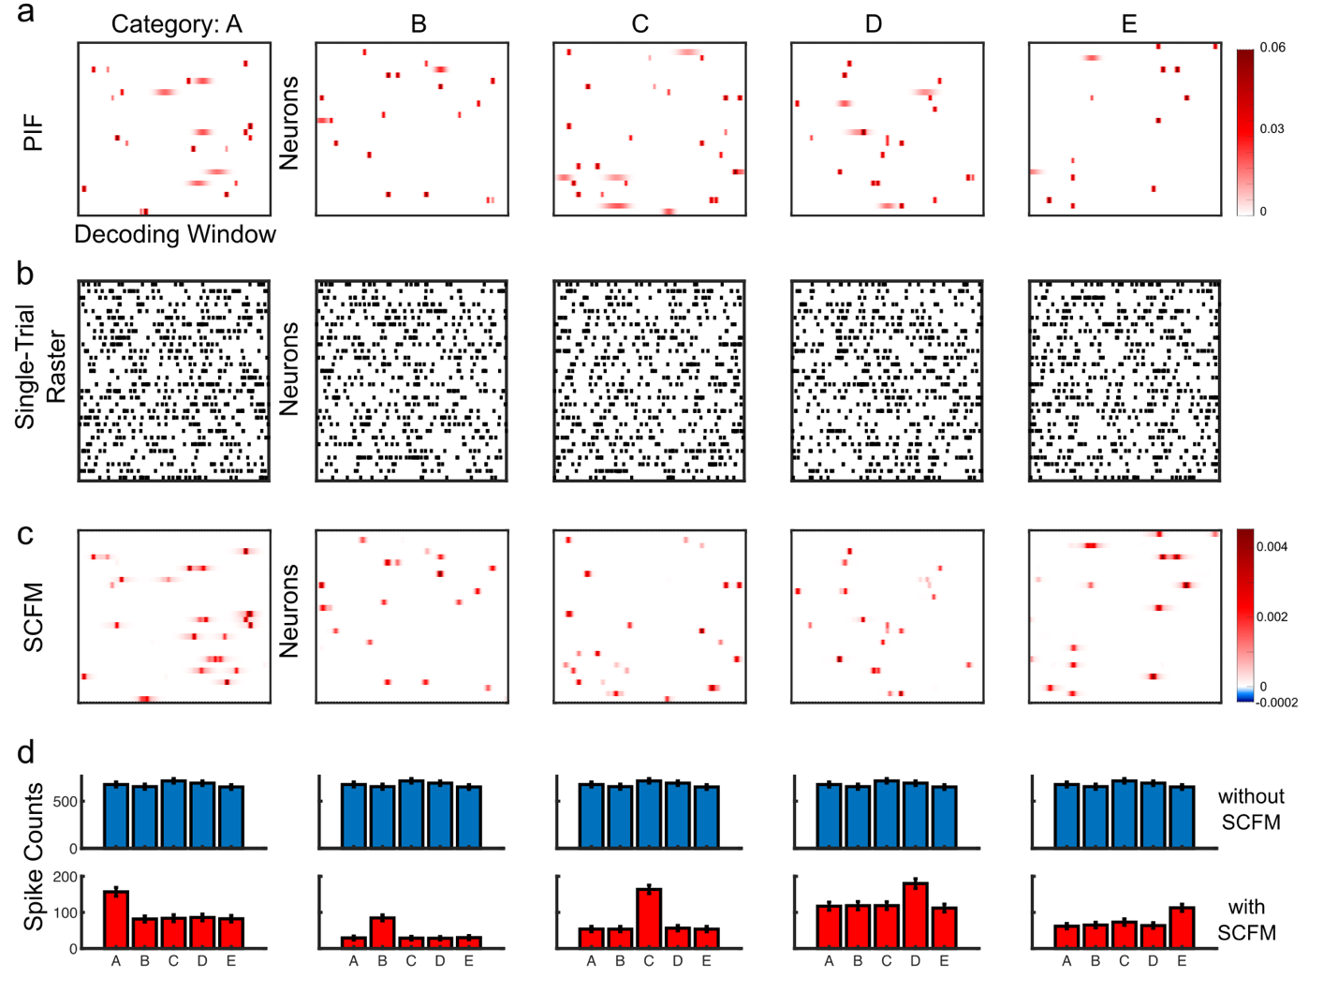
Supplementary Figure 1: Decoding population patterns. a: PIFs of the five categories; b: raster plots of one example of spatio-temporal patterns of spikes simulated based on PIFs; c: SCFMs of double-layer decoding models. In a, b, and c, x-axis is the decoding time window (-2 sec to 2 sec); y-axis is indices of neurons. PIF, raster and SCFM all have the same dimensionality. d: spike counts of each category with (top panel) and without (bottom panel) using SCFMs as masks. SCFMs reveal the spatio-temporal regions of the spike patterns that encode the category information.

Reference:
[1] Breiman, L. (1996). Bagging predictors. Machine Learning. https://doi.org/10.1007/BF00058655
[2] Rindskopf, D. (1997). An introduction to the bootstrap - Efron,B, Tibshirani,RJ. Journal of Educational and Behavioral Statistics.
[3] Abma, B. (2009). Evaluation of requirements management tools with support for traceability-based change impact analysis. Master’s Thesis, University of Twente, Enschede.
[4] Diamantidis, N. A., Karlis, D., & Giakoumakis, E. A. (2000). Unsupervised stratification of cross-validation for accuracy estimation. Artificial Intelligence. https://doi.org/10.1016/S0004-3702(99)00094-6
[5] She, X., Berger, T. W., & Song, D. (2022). A double-layer multi-resolution classification model for decoding spatiotemporal patterns of spikes with small sample size. Neural computation, 34(1), 219-254

