Supplementary Information
Supplementary Figure 1. Frequencies of TIM-3⁺ T cells following repeated SARS-CoV-2 vaccination. Flow cytometry was used to assess the frequencies of unstimulated CD4⁺ T cells expressing TIM-3 in each cohort (a-c), and the frequencies of CD8⁺ T cells expressing TIM-3 in each cohort (d-f). LTC: 3mo2 n=14, 3mo3 n=22, 3mo4 n=15. RA: 3mo2 n=7, 3mo3 n=9, 3mo4 n=8. HA: 3mo2 n=41, 3mo3 n=19, 3mo4 n=5. 3moX denotes 3 months post dose X. Multivariable linear mixed models accounting for age and sex were used to assess changes in the frequencies of each T cell subset within a given cohort following additional SARS-CoV-2 vaccinations. If not displayed, result was not significant. p<0.05 *.
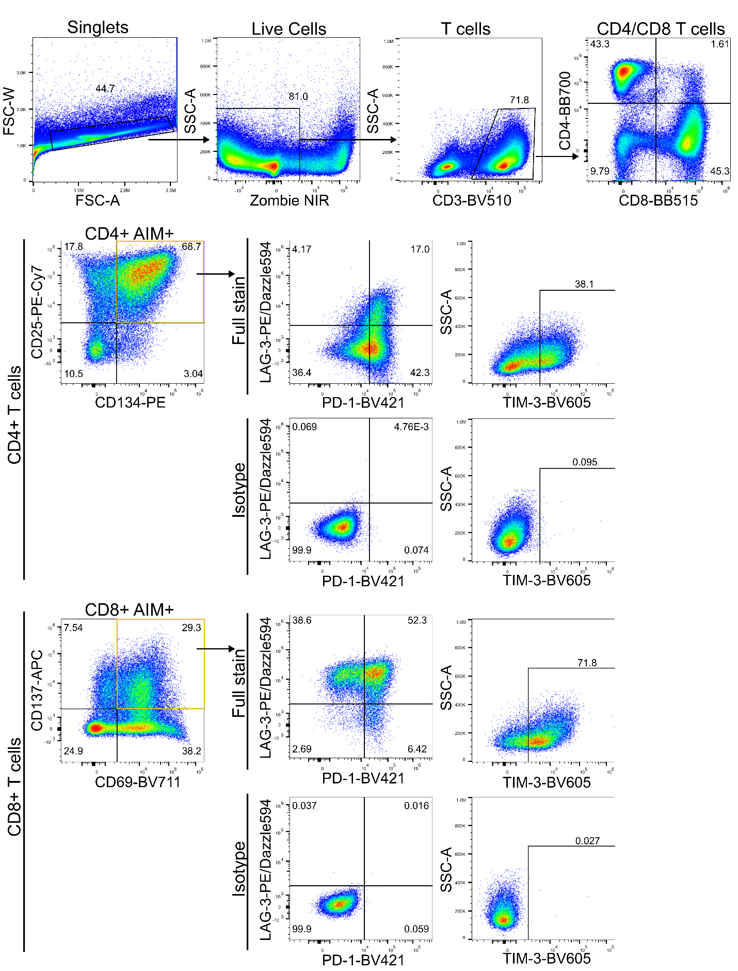
Supplementary Figure 2. AIM assay gating strategy shown using Cytostim stimulation condition. Doublets and debris were first excluded, followed by gating on live cells. T cells were then identified as CD3⁺ events. Within the T cell compartment, cells were divided into CD4⁺ or CD8⁺ single positive events. In the CD4⁺ T cell compartment, AIM+ cells (those responding to the stimulus) were detected as CD25⁺CD134⁺. In the CD8⁺ T cell compartment, AIM+ cells were detected as CD137⁺CD69⁺. The unstimulated well was used to help determine the position of this gate. Within the AIM+ CD4⁺ or CD8⁺ T cell compartment, quadrant gating for PD-1⁺LAG-3⁺, PD-1⁺LAG-3⁻, PD-1⁻LAG-3⁻, and PD-1⁻LAG-3⁺ events was conducted based on an isotype control (shown above). Each of these quadrants was then further gated into TIM-3⁺ and TIM-3⁻ events based on an isotype control, to obtain each possible exhaustion marker combination.

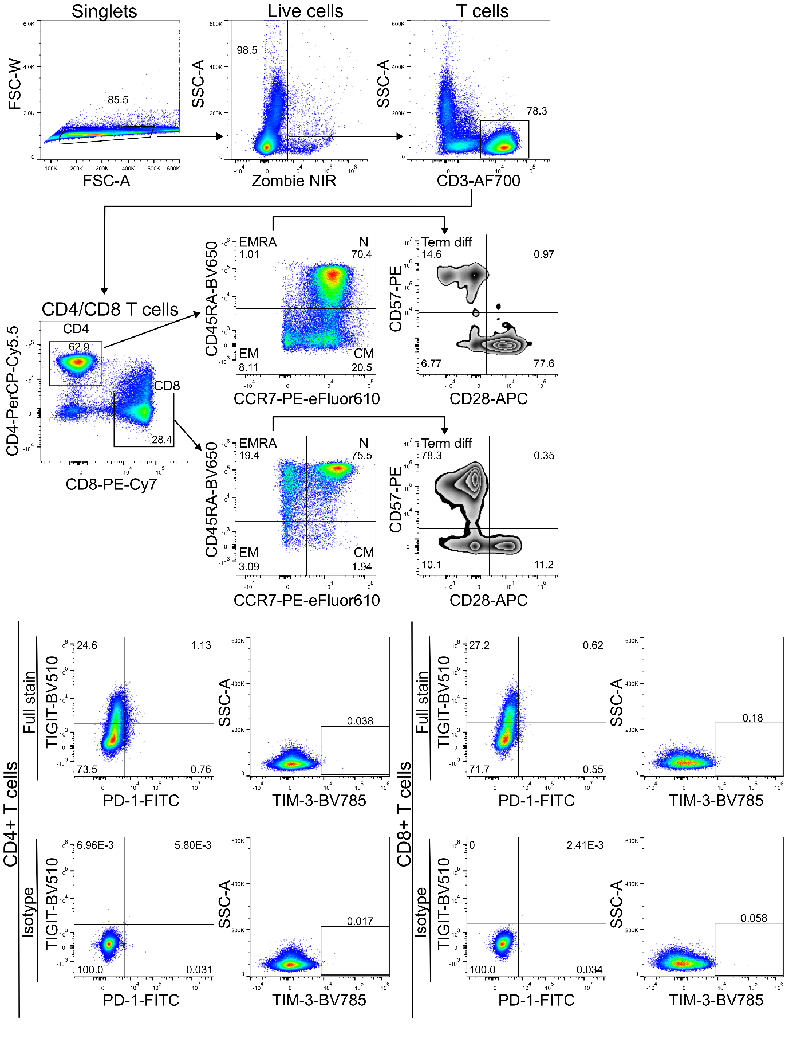
Supplementary Figure 3. Surface immunophenotyping gating strategy. Doublets and debris were first excluded, followed by gating on live cells. T cells were then detected as CD3⁺ events. T cells were divided into CD4⁺ or CD8⁺ single positive events. Within the CD4⁺ and within the CD8⁺ T cell compartments, naïve T cells were CCR7⁺CD45RA⁺, central memory were CCR7⁺CD45RA⁻, effector memory were CCR7⁻CD45RA⁻, and EM re-expressing CD45RA (EMRA) were CD45RA⁺CCR7⁻. Terminally differentiated cells were classified as EMRA⁺CD57⁺CD28⁻. CD4⁺ T cells, and CD8⁺ T cells, were also assessed for co-expression of PD-1 and TIGIT, and expression of TIM-3. Gates for each exhaustion marker were set using isotype controls (shown above).

