Supplemental Information
Supplementary Figures
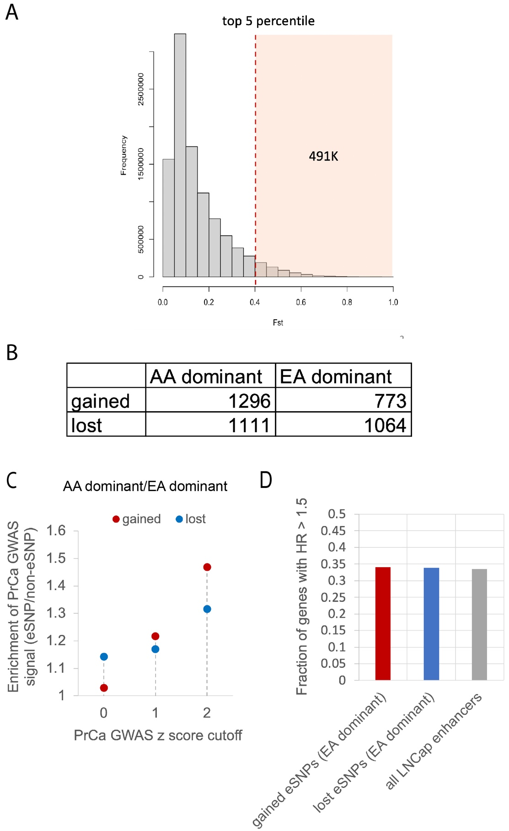

Fig. S1. eSNPs with AA dominant alternate alleles are associated with PrCa risk. A) Distribution of F_{ST} of SNPs that are common (MAF ≥ 0.05) in either EA or AA. The shaded part is the top 5% of SNPs with the highest F_{ST}. B) Number of gained and lost eSNPs that are dominant either in AA or EA. C) Enrichment of both gained and lost eSNPs with AA-dominant alleles in PrCa GWAS traits compared to gained and lost eSNPs with EA-dominant alleles, respectively. For gained and lost eSNPs the y-axis shows the ratio of the fraction of AA-dominant alleles with PrCa GWAS signal above the cutoff (x-axis) to the fraction of EA-dominant alleles with PrCa GWAS signal above the cutoff. D) Fraction of genes with HR > 1.5 associated with gained eSNPs with EA-dominant alternate alleles, lost eSNPs with EA-dominant alternate alleles, and all LNCaP enhancers.

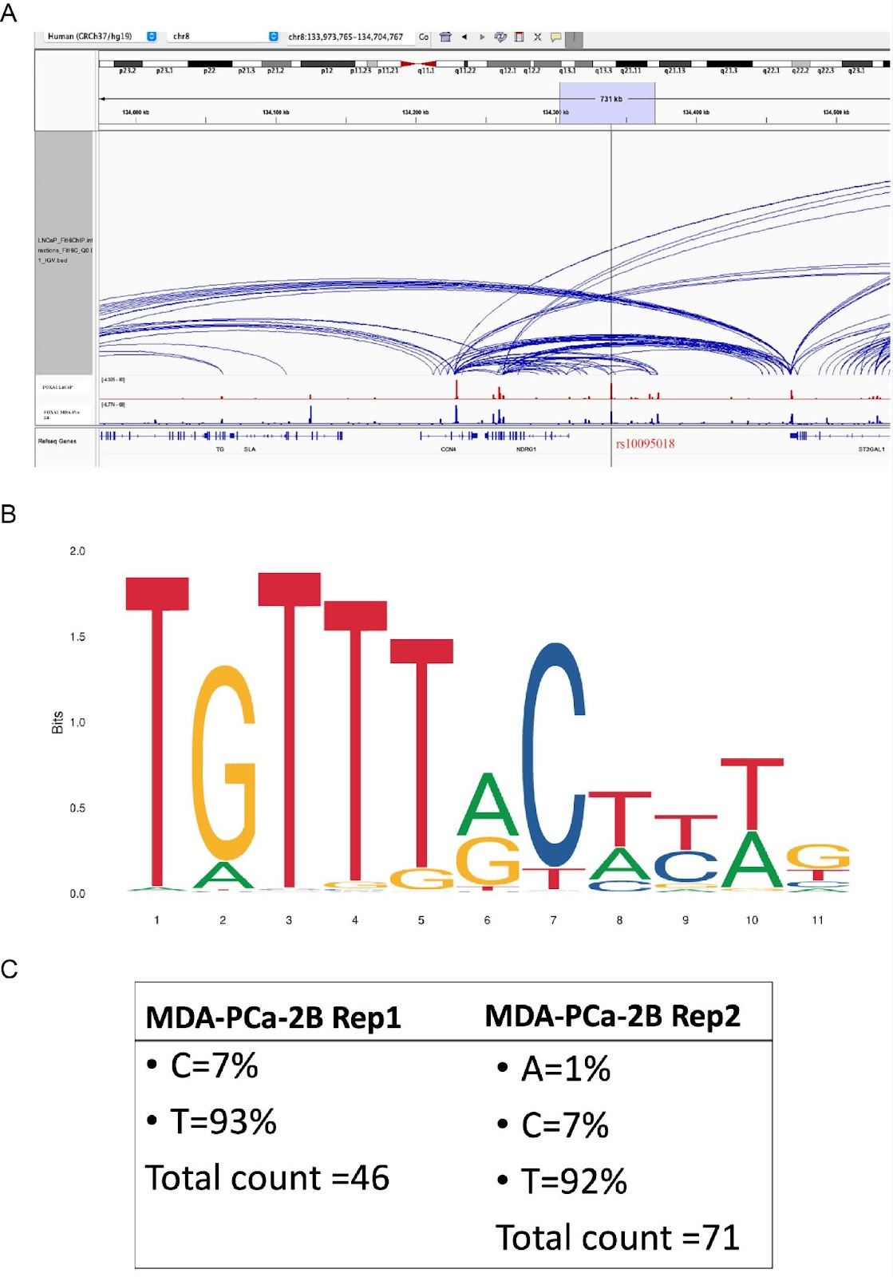

Fig. S2. An example of lost eSNP rs10095018. A) LNCaP Hi-C data near the rs10095018 SNP locus. B) An enlarged binding motif logo of FOXA1 (MA0148.1) from JASPAR⁵⁴, where the 6th position corresponds to the eSNP. C). Percentage of FOXA1 ChIP-seq reads coverage of both T and C alleles at the rs10095018 SNP site in MDA PCa 2B cell line.

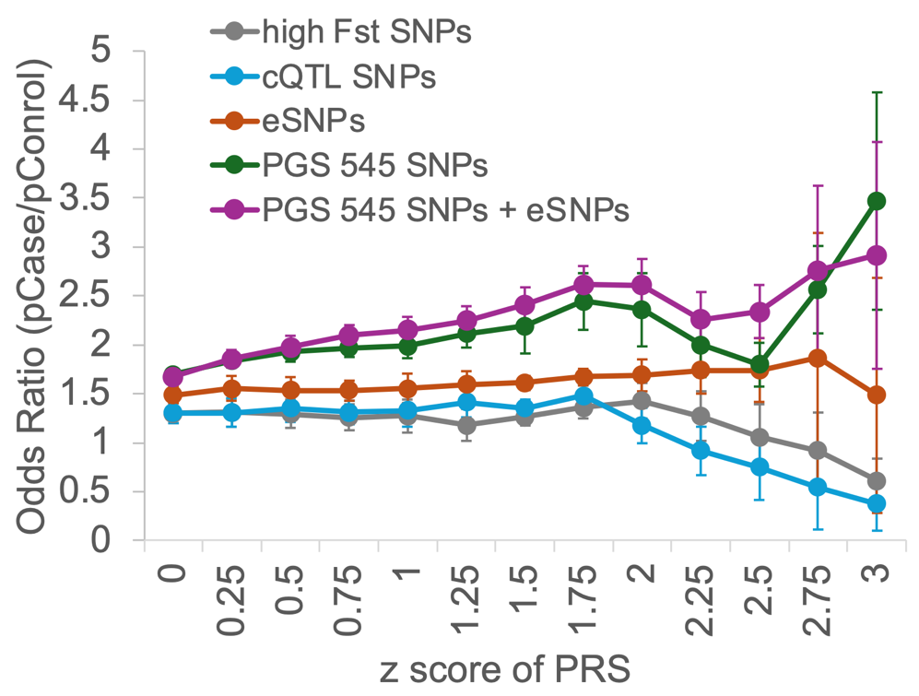
Fig. S3. Odds ratio (y-axis) related to different SNP sets based on contrast PRS against PRS score threshold (x-axis) in EA cohort. The odds ratio is the ratio of the fraction of PrCa patients with PRS above a certain threshold to that of control individuals with PRS above the same threshold. All PRSs based on different SNP sets are z-score normalized for comparison. Error bars show the standard deviation of the 10-fold cross validation.

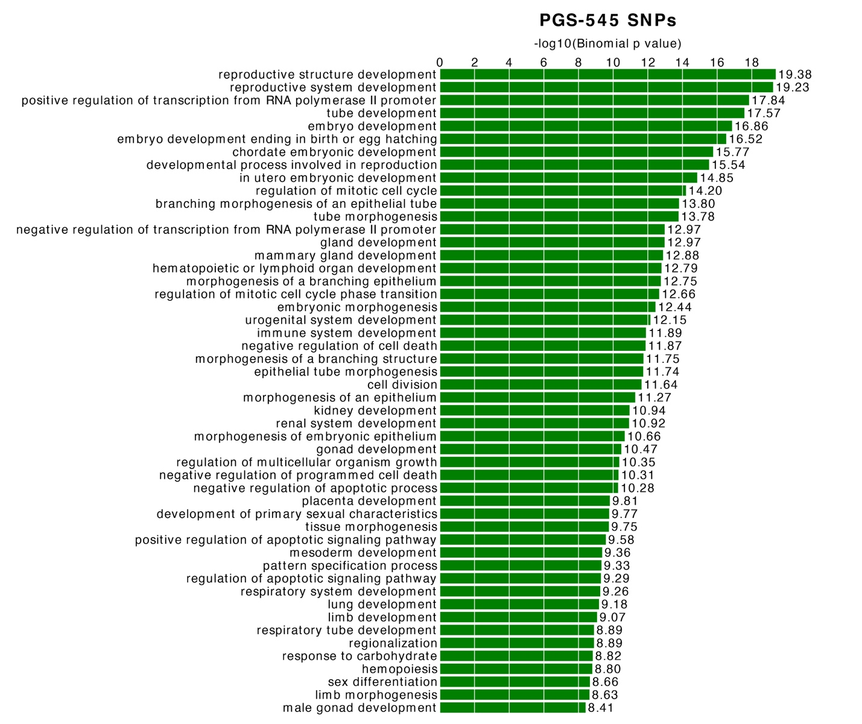
Fig. S4. Biological processes associated with gained activity PGS-545 SNPs using the GREAT tool

