Supplementary Table 1. Previous nomenclature used to describe the Sanje mangabey as either species level (Cercocebus sanjei) or subspecies level (Cercocebus galeritus sanjei) in its first description, systematic reviews including the Mangadrills and in previous IUCN Red List reports.
* First description; ** IUCN Red List Assessment
Study |  | Nomenclature
Homewood et al. (1981) * | ^{[8]} | Cercocebus galeritus sanjei
Mittermeier (1986) |  | Cercocebus galeritus sanjei
Groves (1996) | ^{[75]} | Cercocebus sanjei
Kingdon (1997) | ^{[5]} | Cercocebus sanjei
Butynski et al. (2000) ** | ^{[76]} | Cercocebus galeritus sanjei
Groves (2001) | ^{[15]} | Cercocebus sanjei
Grubb et al. (2003) | ^{[13]} | Cercocebus galeritus sanjei
Groves (2005) | ^{[77]} | Cercocebus sanjei
Ehardt et al. (2008) ** | ^{[78]} | Cercocebus galeritus sanjei
Mittermeier et al. (2013) | ^{[14]} | Cercocebus sanjei
McCabe et al. (2019) ** | ^{[7]} | Cercocebus sanjei

Supplementary Table 2. Genbank accession numbers for sequences used in this study: one autosomal marker (CD4), one nuclear Y-chromosome marker (TSPY), and two mitochondrial genes; control region (CR) and cytochrome oxidase subunit II (COII).

ªUsed in nuclear and full concatenated sequence; ^{b}Used in mtDNA and full concatenated sequence

 | CD4 | TSPY | COII | CR
Cercocebus sanjei | Generated in this study
Cercocebus galeritus |  | AY195576ª | AY686132^{b}  M74004
Cercocebus agilis | FJ750597 ª | FJ560633 ª | FJ750650 ^{b}
Cercocebus chrysogaster | AF057382 ª | AF057410 ª | NC021943 ^{b} | NC021943 ^{b}
Cercocebus lunulatus |  |  | AY686134 ^{b}
Cercocebus torquatus |  | AY195577 ª | NC023964 ^{b}  AY686133  FJ713422 | NC023964 ^{b}
Cercocebus atys | AF057383ª  AF057384 | AF057411  AF057412  AF057413 ª | AY686135  KP090062  KT159932  NC028592 ^{b} | KP090062  NC028592 ^{b}
Mandrillus sphinx | AF057386 ª  FJ750596 | FJ750632 ª | FJ713421 ^{b}  FJ750651 | KC757403 ^{b}  KJ434963
Mandrillus leucophaeus | AF057387 ª | AF057421 ª | M74006 ^{b} | KT696596 ^{b}
Lophocebus aterrimus | AF057390 ª  FJ750595 | AF057423 ª  FJ750631 | FJ713415 ^{b}
Lophocebus albigena | AF057391 ª | AF057425 ª
Theropithecus gelada | AF057389 ª  FJ750594 | AF057415 ª | EU293079 ^{b}  M74009 | NC019802 ^{b}
Rungwecebus kipunji | EU600174 ª | DQ381472 ª | DQ381471 ^{b}
Papio papio | FJ750590 ª  AF057388 | FJ750626 ª | EU293078 ^{b} | NC020009 ^{b}
Macaca mulatta | AF057385 ª | AF057416 ª  AF425276 | M74005 ^{b} | KJ567051 ^{b}

Supplementary Figure 1. A compilation of the most recent craniodental morphological study ^{[12]} and the past phylogenetic studies that included at least one Cercocebus and one Mandrillus species for comparison to the phylogenies from this study.

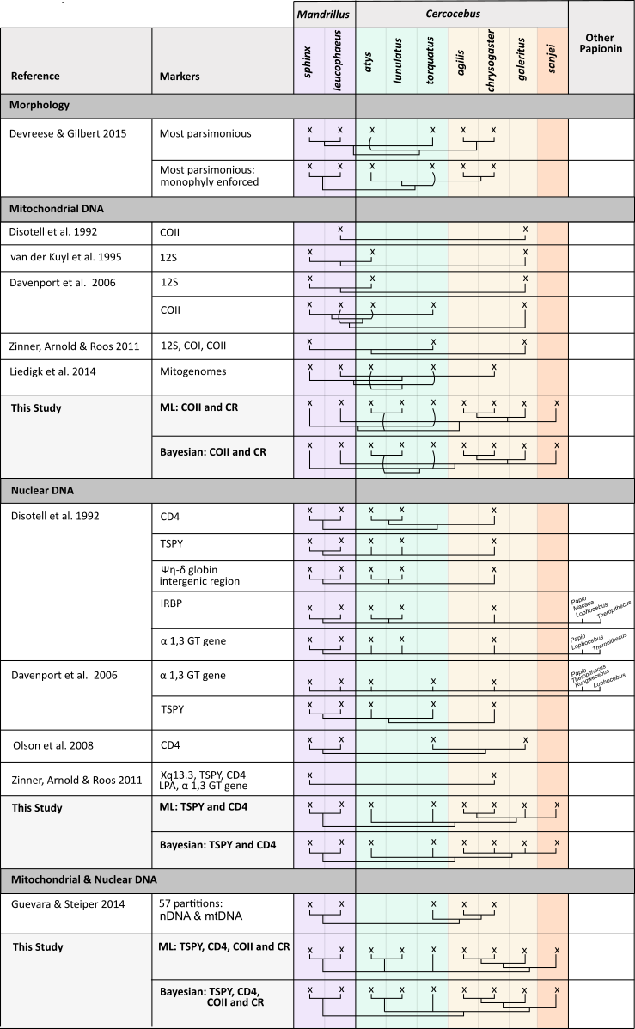

Supplementary Figure 2. Phylogenetic trees for Papionin species using two concatenated sequences: a) mitochondrial cytochrome c oxidase subunit II (COII) and control region concatenated (849 bp) and b) nuclear CD4-TSPY concatenated (988 bp). Both the Maximum Likelihood phylogeny (left of species names; bootstrap values shown at the nodes) and the Bayesian phylogeny (right of the species names; posterior probabilities shown at the nodes) are presented. Sequences used in the phylogeny are available in Supplementary Table 2. Cercocebus species in Central/East Africa, each previously considered subspecies of Cercocebus galeritus, are coloured in yellow, the remaining Cercocebus species, found in Central/West Africa, are coloured green, Mandrillus species coloured purple and other Papionin species coloured in grey.
