Supplementary material

Supplementary Table 1 : Area measurements for each defined variable. The area size of each variable covered by MMA and fished area within the study area.
Variable | Overall, Area (km²) | Size of area cover by MMA (km²) | Size of Area covered by Fished Areas (km²)
Study Area | 1,916,129 | 309,659 | 157,850
Highly Vulnerable Habitat | 20.3% (388,854) | 33.4 % (129,730) | 6.0 % (23,488)
High Combined Risk | 9.5% (182,087) | 50.0 % (91,000) | 0.1 % (150)

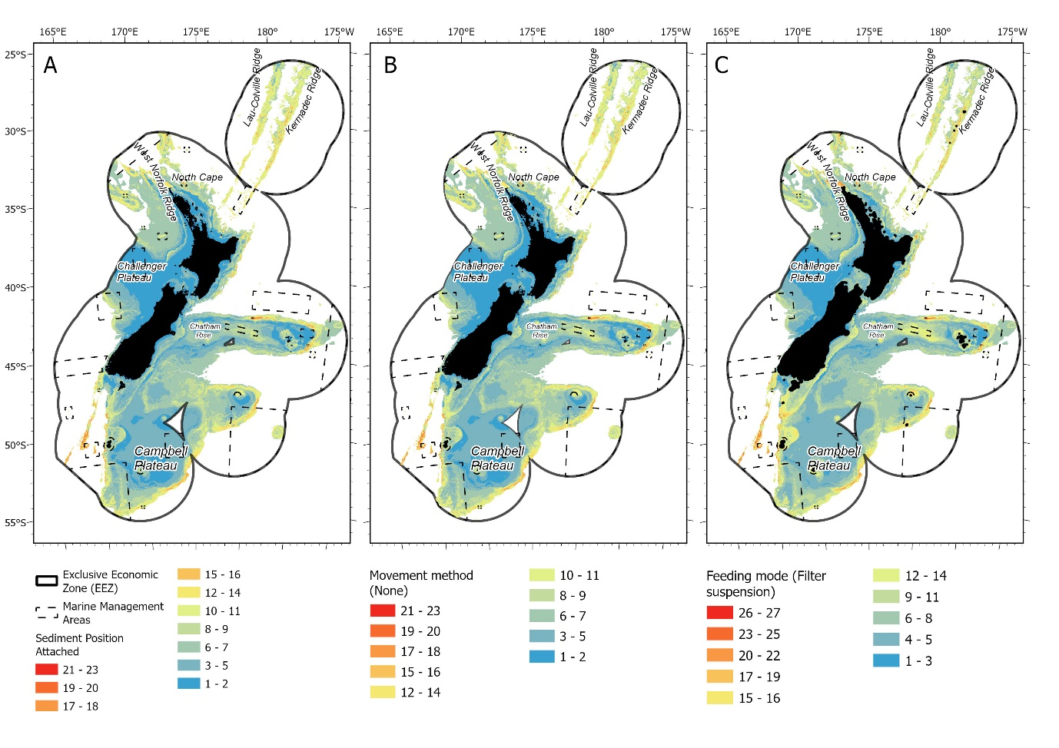
Supplementary Figure 2. Modalities expression for A) Sediment Position - Attached B) Movement Method - None C) Feeding Mode – Filter & Suspension within the study area (blue is low and red is high modality expression). Marine management areas are shown as dashed black lines.

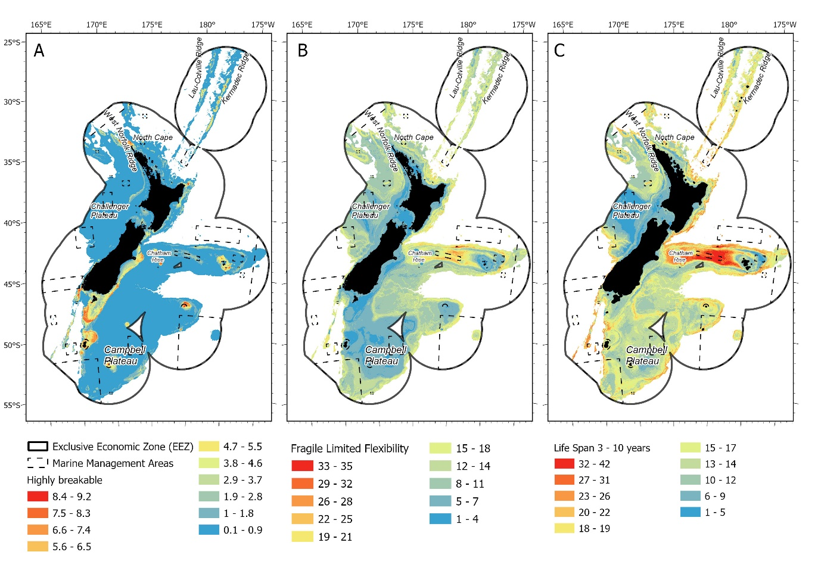
Supplementary Figure 3. Modalities expression for A) Structural Fragility – Highly breakable B) Structural Fragility – Limited Flexibility C) Life Span – 3-10 years within the study area (blue is low and red is high modality expression). Marine management areas are shown as dashed black lines.

