Supplementary Information: Soil-moisture-atmosphere coupling hotspots and their representation in seasonal forecasts of boreal summer

Authors: Jonathan Day¹, Frederic Vitart¹, Tim Stockdale¹, Patrica de Rosnay¹, Constantin Ardilouze², Daniele Peano³, Antonella Sanna³, Kristina Fröhlich⁴, Martin Andrews⁵

- European Centre for Medium-Range Weather Forecasts, Reading, UK.
- CNRM, Université de Toulouse, Météo-France, CNRS, Toulouse, France
- Fondazione Centro Euro-Mediterraneo sui Cambiamenti Climatici, CMCC, Bologna, Italy
- Deutscher Wetterdienst, Offenbach, Germany
- Met Office Hadley Centre, Exeter, UK
Contact: jonathan.day@ecmwf.int

S1 Composites conditioned on wet/dry initial conditions for C3S systems
We can make similar composites to those shown in Fig 4 for the seasonal hindcasts by plotting the difference between the average ensemble mean for the same dry and wet years used in the observational composite (see Fig S1-S4). It shows that for example, the temperature anomalies extend too far to the East in the USA in many of the systems (Fig S2), consistent with Figs 10c & d and 11c &d and the temperature anomalies over India are generally too high and show a strong north south dipole not seen in BEST or ERA5, that likely contributes to the negative CRPSS values seen in this region in Fig 8.

Differences between the observed and forecast composites can occur for a number of reasons: errors in initial conditions, differences in the timescales of soil-moisture persistence, and errors in land-atmosphere coupling strength.

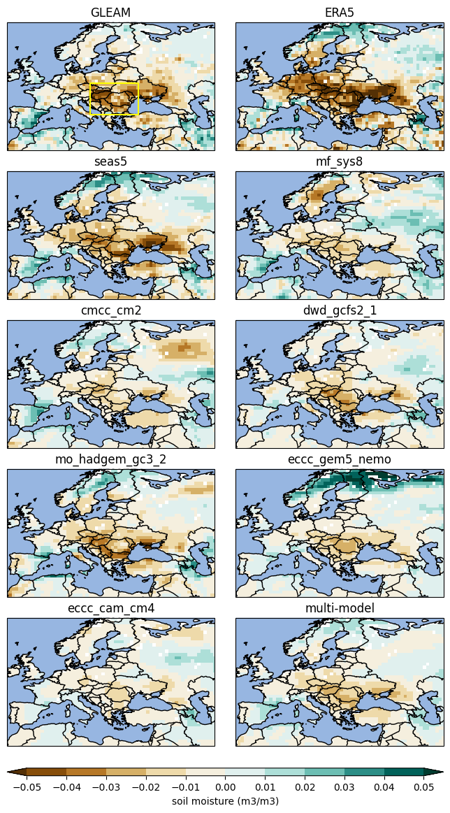
Fig S1. Difference between composites of JJA mean 100cm soil moisture (filled contours), evaporation (hatches where difference is more than 0.3mm/day), temperature (red and blue contours at 0.2 (light) and 0.7 (dark)) and z500 (black contour) based on whether the observed 1 May soil moisture inside each the yellow box was in the dryest or wettest terciles in the Western-USA (see Table 2 for a list of years). The observed composite utilises GLEAM for SM and erate, BEST for T2m and GPCP for precipitation. For the ERA5 composite all variables are from ERA5. For the C3S models the composite is calculated similarly from the JJA hindcast ensemble mean.
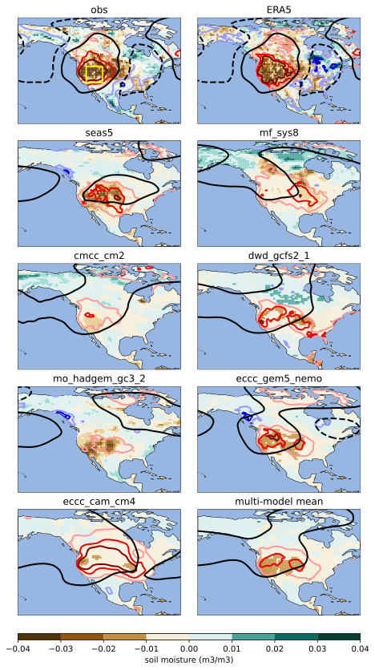
Fig S2. As Fig S1 but for the Western USA hotspot.
Fig S3. As Fig S1 but for the AfPak hotspot.
Fig S4. As Fig S1 but for the EuPl hotspot.

S2 Soil moisture initial conditions
In figures S5-8 we show the difference between the of May 1st soil moisture, based on whether the GLEAM 1st May soil-moisture is in the dryest or wettest terciles in the yellow box in each region (see Table 2 for a list of years). The spatial patterns of soil-moisture variability are also quite consistent between C3S hindcast initial conditions, ERA5 and GLEAM. For example, the dipoles between W-USA and central America (Fig S6) and between AfPak and SE-Asia (Fig S7). However, some exceptions can be seen, for example the CMCC and DWD initial conditions have quite a different pattern in S8, as might be expected from the low cross-correlation shown in Fig 7.

Differences in the amplitude of anomalies compared to the GLEAM, are to be expected due to soil-moisture being a very model dependent quantity and is not necessarily indicative of a deficiency in the models used to generate the initial conditions for the C3S models, compared to GLEAM. See Koster et al., 2009 for a detailed discussion of this topic.

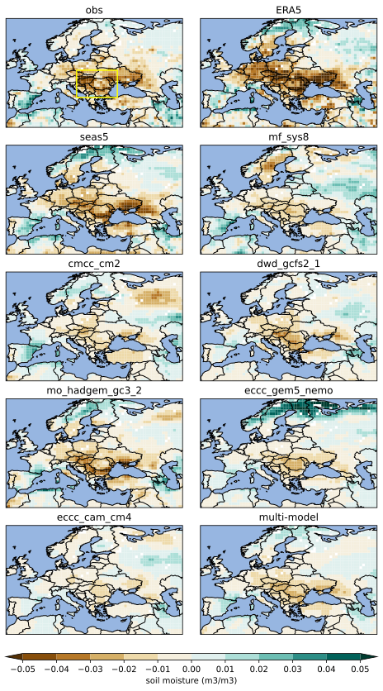
Fig S5: Difference between composites of JJA mean 100cm soil moisture (filled contours), based on whether the observed 1 May soil moisture inside each the yellow box was in the dryest or wettest terciles in the Western-USA (see Table 2 for a list of years).
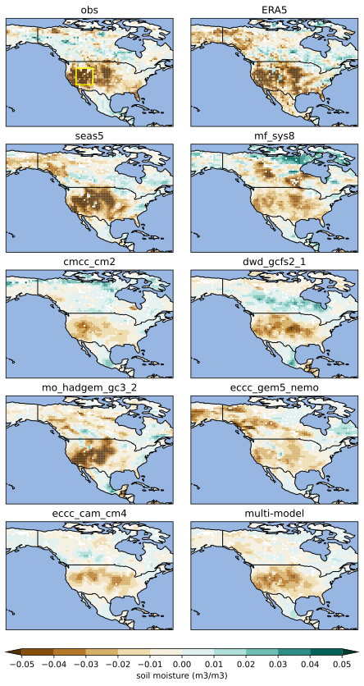
Fig S6. As Fig S5 but for the Western USA hotspot
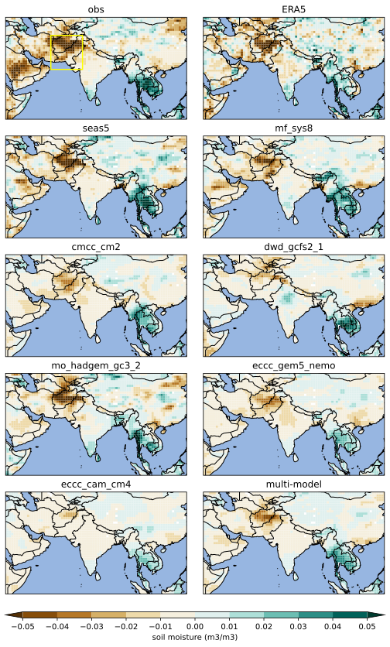
Fig S7. As Fig S5 but for the AfPk hotspot
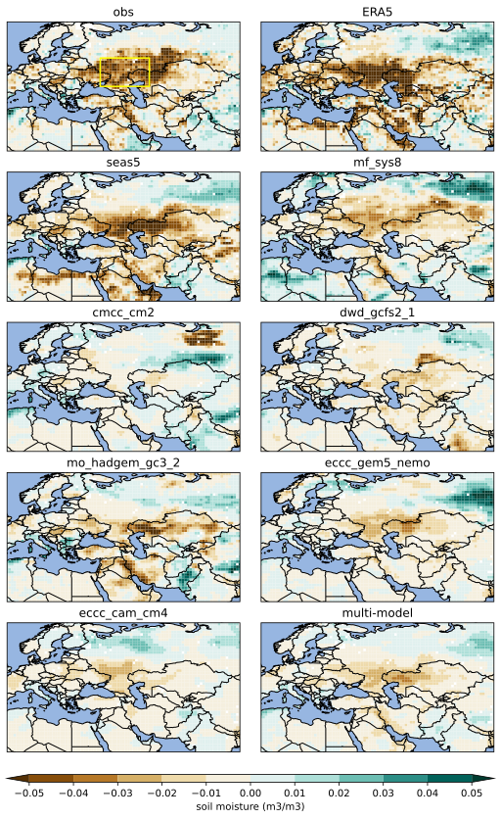
Fig S8. As Fig S5 but for the EuPl hotspot.

