Appendix A. Supplementary data
Pseudomonas nanhaiensis sp. nov., a lipase-producing bacterium isolated from deep-sea sediment of the South China Sea
Yu Pang, Yage Zhang, Mengru Chen, Wei Lu, Ming Chen, Yongliang Yan, Min Lin, Wei Zhang*, Zhengfu Zhou*

Biotechnology Research Institute, Chinese Academy of Agricultural Sciences, Beijing 100081, China;
* Corresponding author.
E-mail address: zhouzhengfu@caas.cn (Z. Zhou), zhangwei01@caas.cn (W. Zhang).

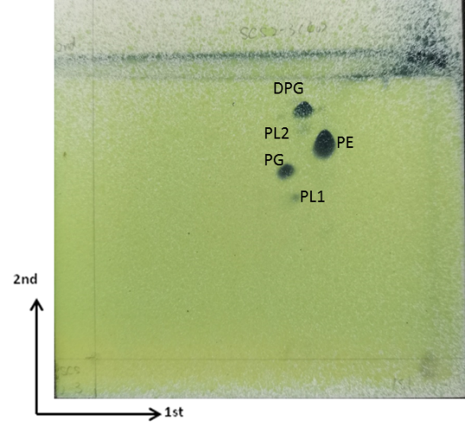
Fig. S1. Polar lipids of strain SCS 2-3.

Table S1
Fatty acid composition of strain SCS 2-3 and the two closely related type strains.
All data are from this study.
Strains: 1, SCS 2-3; 2, P. xinjiangensis NRRL B-51270^{T}; 3, P. sabulinigri JCM 14963^{T}.
ND, Not detected.
Fatty acids | 1 | 2 | 3
C_{10:0} | ND | 0.23 | 0.24
C_{11:0} | ND | 0.33 | ND
C_{12:0} | 9.38 | 10.11 | 9.10
C_{13:0} | ND | 0.58 | 0.19
C_{14:0} | 0.92 | 0.50 | 0.83
C_{15:0} | 0.73 | 1.05 | 0.81
C_{16:0} | 13.35 | 14.21 | 19.64
C_{17:0} | 0.55 | 1.81 | 0.65
C_{18:0} | 2.45 | 1.01 | 3.83
C_{9:0} 3-OH | ND | 0.28 | ND
C_{10:0} 3-OH | 3.14 | 4.79 | 4.31
C_{11:0} 2-OH | ND | ND | 0.38
C_{11:0} 3-OH | ND | 0.66 | ND
C_{12:0} 3-OH | 3.97 | 4.77 | 3.89
C_{15:0} anteiso | ND | 0.16 | ND
C_{17:0} anteiso | ND | ND | 0.78
C_{17:1} anteiso A | ND | ND | 0.23
C_{17:1} anteiso ω9c | 0.72 | ND | ND
cyclo-C_{17:0} | 2.18 | 1.17 | 2.40
cyclo-C_{19:0} ω8c | 2.34 | 1.44 | 0.50
iso-C_{12:0} | ND | 0.13 | ND
iso-C_{16:0} | ND | 1.20 | 0.49
iso-C_{17:0} | ND | ND | 0.70
iso-C_{18:0} | ND | 0.14 | 0.23
C_{15:0} ω6c | ND | 0.53 | ND
C_{17:1} ω8c | ND | 0.63 | 0.40
11-methyl-C_{18:0} ω7c | ND | 0.14 | ND
C_{18:1} ω9c | ND | ND | 0.99
C_{16:1} ω6c/_{16:1} ω7c  (Summed feature 3) | 25.77 | 17.63 | 15.84
C_{18:2} ω6, 9c/_{18:0} ante  (Summed feature 8) | ND | ND | 0.31
C_{18:1} ω6c/ω7c  (Summed feature 8) | 34.51 | 36.51 | 33.25

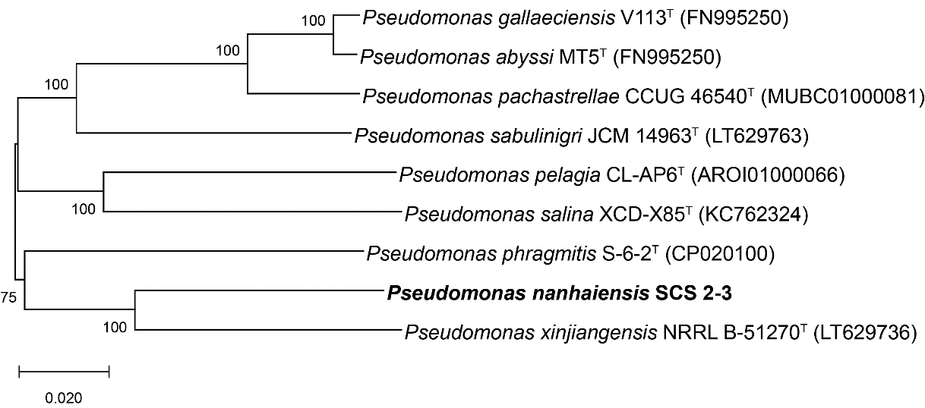
Fig. S2. Phylogenetic tree reconstructed from analysis of the sequences of four housekeeping genes (dnaK, gyrA, recA, and rpoB) and showing the relationships between strain SCS 2-3 and closely related Pseudomonas species.

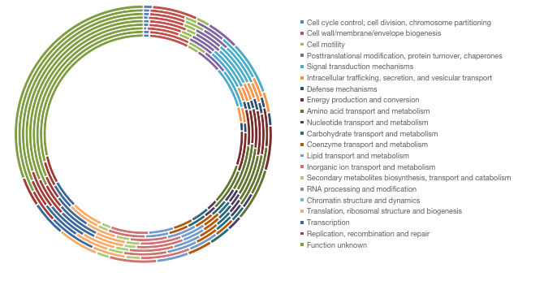
Fig. S3. Distribution of functional classes of predicted genes according to the clusters of orthologous groups of proteins of Strain SCS 2-3 with closed related strains. From inside to outside: SCS 2-3, P. xinjiangensis NRRL B-51270^{T}, P. sabulinigri JCM 14963^{T}, P. populi KBL-4-9^{T}, P. gallaeciensis V113^{T}, P. pelagia CL-AP6^{T}, P. pachastrellae JCM 12285^{T}, P. phragmitis S-6-2^{T}, P. abyssi MT5^{T} and P. salina XCD-X85^{T}.

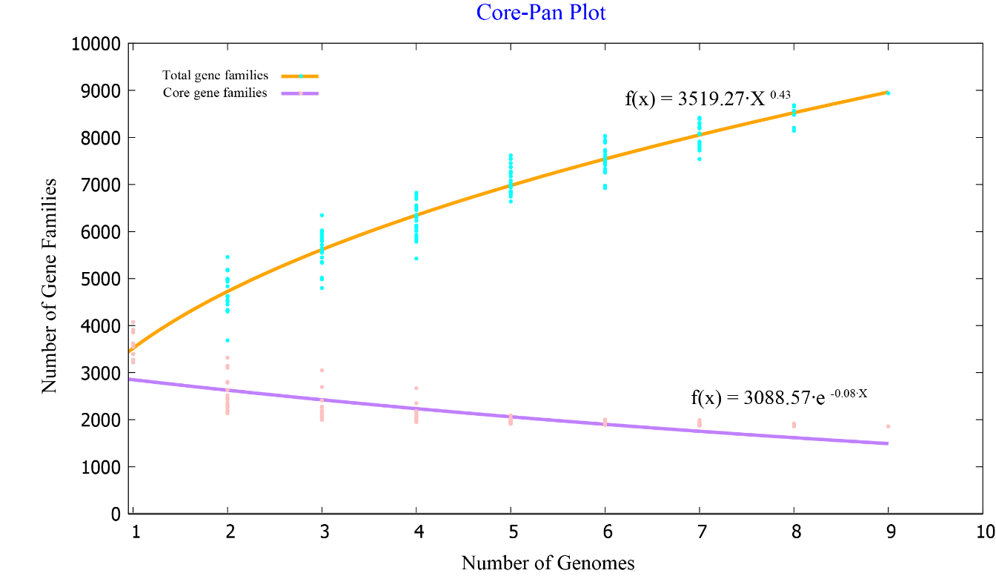
Fig. S4. Mathematical modeling of the pan genome and core genome of strain SCS2-3 and closely related type strains.

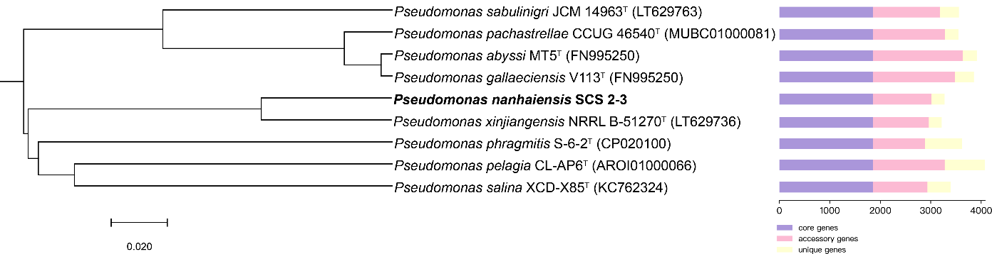
Fig. S5. Neighbor-joining tree derived from 1857 core orthologous proteins showing the phylogenetic position of strain SCS2-3 and closely related type strains (left) and the distribution of core genes, accessory genes and unique genes of above the strains (right).

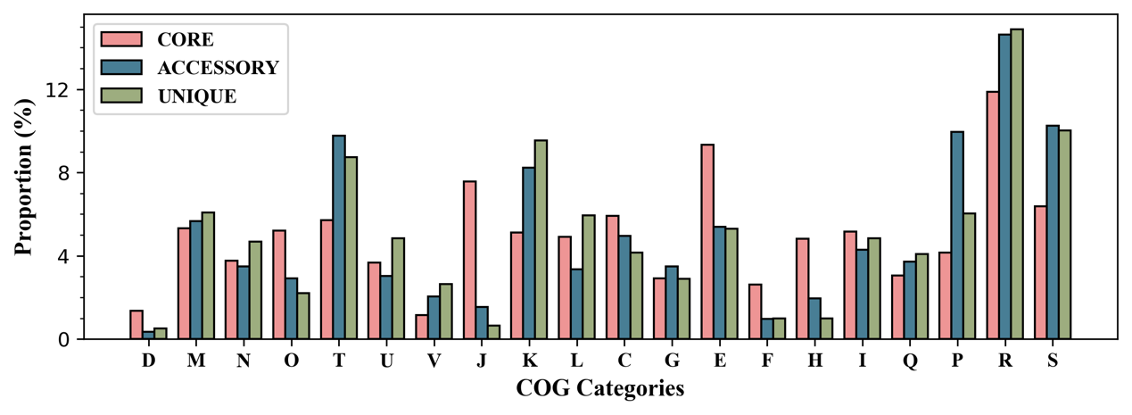
Fig. S6. Bar chart showing functional proportions (based on COG categories) of different parts of the Pseudomonas pangenome (i.e., core, accessory, unique).

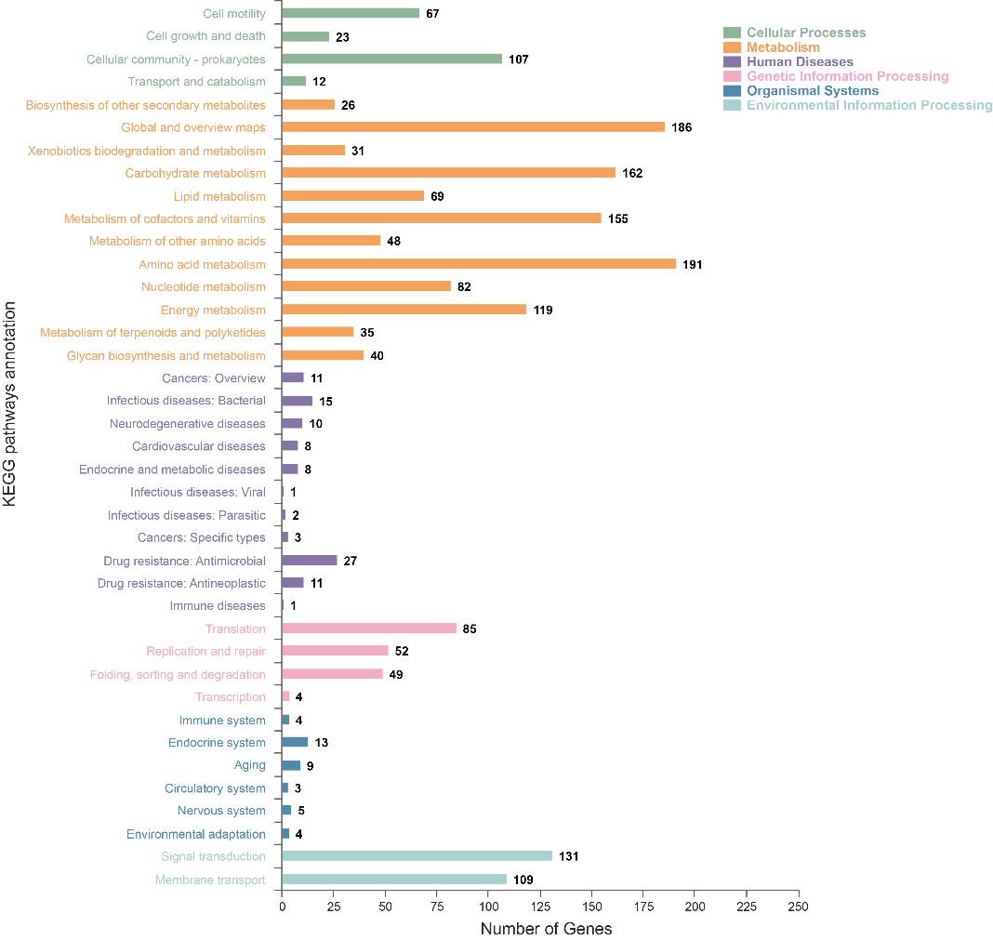
Fig. S7. KEGG classification and functional categories of strain SCS 2-3.

GO terms annotations of SCS 2-3
To explain the relevance of the genome of strain SCS 2-3, GO analysis was used to categorize genes into three categories according to matches with known sequences. In three categories, molecular function contained most numerous GO terms and gene number (1823), followed by biological process (gene number: 1737) and cellular component (gene number: 1157) (Supplementary Fig. S8). In molecular function, the most three pathways were ATP binding (GO:0005524; 261genes), DNA binding (GO:0003677; 174 genes) and metal ion binding (GO:0046872; 126 genes). In biological process, oxidation-reduction process (GO:0055114) and regulation transcription, DNA-emplated (GO: 0006355) were main pathways. And integral component of membrane (GO:0016021) and cytoplasm (GO:0005737) were most pathways in cellular component.
Furthermore, we analyzed the GOs that are associated with lipid metabolism. We identified 55 GO items associated with lipid metabolism, including GO:0006629 (lipid metabolic process), GO:0004806 (triglyceride lipase activity), GO:0016042 (lipid catabolic process), and GO:0016298 (lipase activity).
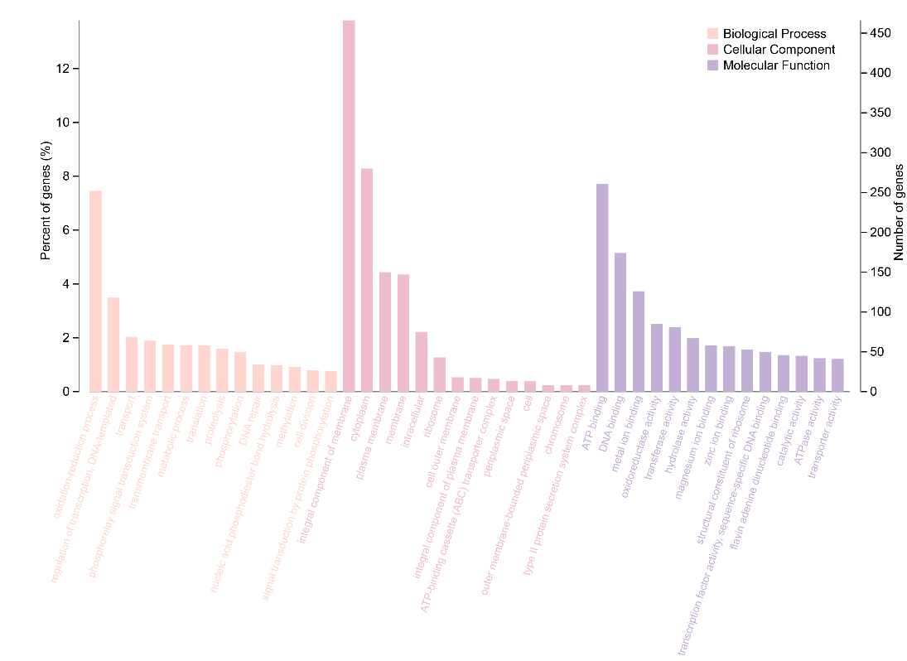
Fig. S8. Clusters of Gene Ontology (GO) annotation of strain SCS 2-3.

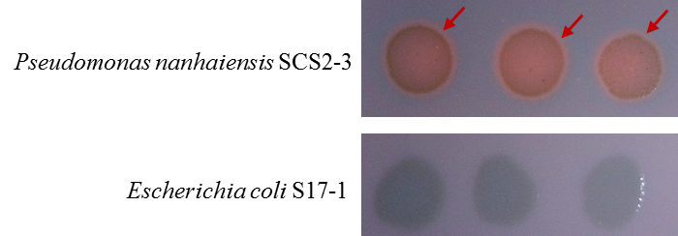
Fig. S9. Orange fluorescence zone of strain SCS2-3 on rhodamine B plate. Rhodamine B combines with various products of lipase hydrolysis and can produce orange fluorescence under 365 nm ultraviolet light.

Table S2
The information of lipases reviewed in UniProtKB database
Entry ID | Entry name | Protein Name | Gene Name | Length | Family | Organism
P26876 | LIP_PSEAE | Triacylglycerol lipase | lip | 311 | I.1 | Pseudomonas aeruginosa
P22088 | LIP_BURCE | Triacylglycerol lipase | lip | 364 | I.2 | Burkholderia cepacia
Q05489 | LIP_BURGL | Triacylglycerol lipase | lip | 358 | I.2 | Burkholderia glumae
P08658 | LIP_PSEFR | Triacylglycerol lipase | lips | 293 | I.1 | Pseudomonas fragi
P26877 | LIP_PSEU0 | Triacylglycerol lipase | lipL | 311 | I.1 | Pseudomonas sp.(strain 109)
P25275 | LIP_PSES5 | Triacylglycerol lipase | lip | 364 | I.2 | Pseudomonas sp. (strain KWI-56)
P26504 | LIPA_PSEFL | Lipase | N/A | 449 | I.3 | Pseudomonas fluorescens
P41773 | LIPB_PSEFL | Lipase, thermostable | N/A | 476 | I.3 | Pseudomonas fluorescens
P29605 | LIPT_BURCE | Lipase, thermostable | N/A | 56 | I.2 | Burkholderia cepacia

