TABLE OF CONTENTS

Supplementary Notes

Supplementary Results
Systematic review 3

Supplementary Tables

Supplementary Tables from Main Text
Table S1. Description of the selected datasets 4
Table S2. Sex differential activated effectors in secondary progressive multiple sclerosis.. 8
Table S3. General classification of female enriched functions from cluster 4 of the astrocyte-microglia-neuron triad in secondary progressive multiple sclerosis (main manuscript Fig. 2A). 9
Table S4. General classification of male enriched functions from cluster 1 of the astrocyte-microglia-neuron triad in secondary progressive multiple sclerosis (main manuscript figure 2B).. 12
Table S5. Sex differentially expressed genes in oligodendrocytes and OPCs.. 13
Table S6. Human leukocyte antigens dysregulated in multiple sclerosis. 14
Table S7. List of R packages and versions implemented in the bioinformatic workflow. 15
Table S8. Signalling pathways analysed based on the type of sample examined: nervous tissue (USCS-MS dataset) and blood (GSE144744C1 and GSE144744C3 datasets). 16

Supplementary Tables from Supplementary Notes
Table S9. Characteristics of GSE144744 cohorts.. 17

Supplementary Figures

Supplementary Figures from Main Text
Figure S1. Systematic review workflow following PRISMA guidelines. 18
Figure S2. UCSC-MS dataset preprocessing.. 19
Figure S3. GSE144744c1 dataset preprocessing.. 21
Figure S4. GSE144744c3 dataset preprocessing.. 23
Figure S5. Summary of significant sex differences in secondary progressive multiple sclerosis. 25
Figure S6. Astrocyte sex-differential atlas in secondary progressive multiple sclerosis.. 26
Figure S7. Microglia sex-differential atlas in secondary progressive multiple sclerosis. 28
Figure S8. Neurons sex-differential atlas in secondary progressive multiple sclerosis.. 31
Figure S9. Oligodendrocytes sex-differential atlas in secondary progressive multiple sclerosis.. 32
Figure S10. Oligodendrocyte precursor cells sex-differential atlas in secondary progressive multiple sclerosis. 33
Figure S11. Intersection of significant results among brain cell types for secondary progressive multiple sclerosis.. 34
Figure S12. Significant results in the analyses of (A) signaling pathway effector activation and (B) cell-cell communication for the secondary progressive form of multiple sclerosis.. 35
Figure S13. Sex differential signaling pathways of (A) cholinergic, (B) serotonergic and (C) dopaminergic synapses in neurons from secondary progressive multiple sclerosis.. 36
Figure S14. Significant functions in oligodendrocytes and oligodendrocyte precursor cells (OPCs) in secondary progressive multiple sclerosis.. 37
Figure S15. Significant sex differences summary in relapsing-remitting multiple sclerosis. 38
Figure S16. CD4+ T cells sex-differential atlas in relapsing-remitting multiple sclerosis.. 40
Figure S17. CD8+ T cells sex-differential atlas in relapsing-remitting multiple sclerosis. 42
Figure S18. Monocytes sex-differential atlas in relapsing-remitting multiple sclerosis.. 44
Figure S19. Monocytes sex-differential atlas in relapsing-remitting multiple sclerosis.. 45
Figure S20. (A) B cells and (B) dendritic cells sex-differential atlas in relapsing-remitting multiple sclerosis.. 47
Figure S21. Detailed sex-differential significant changes in the activation of signaling pathways and interaction strengths in cell-cell communication for relapsing-remitting multiple sclerosis 48
Figure S22. Upset plot for genes more expressed in males than females by cell type in relapsing-remitting multiple sclerosis…………………………………………………….………..49
Figure S23. Summary of sex differences summary in primary progressive multiple sclerosis……………………………………………………………………………………………....50
Figure S24. CD4+ T cells sex-differential atlas in primary progressive multiple sclerosis.. 52
Figure S25. CD8+ T cells sex-differential atlas in primary progressive multiple sclerosis.. 54
Figure S26. NK cells sex-differential atlas in primary progressive multiple sclerosis.. 56
Figure S27. Monocytes sex-differential atlas in primary progressive multiple sclerosis.. 58
Figure S28. (A, C) B cells and (B, D) dendritic cells sex-differential atlas in primary progressive multiple sclerosis. 60
Figure S29. Detailed sex-differential significant changes in the activation of signaling pathways for primary progressive multiple sclerosis. 62
Figure S30. Detailed sex-differential significant changes in the cell-cell communication interaction strengths for primary progressive multiple sclerosis. 63
Figure S31. Protein-protein interaction network of the genes that provide clustering of RRMS and PPMS immune system cell types according to their differential sex profile……………………………………………………………………………………….…….…..64

Supplementary Results

Systematic review
By implementing inclusion criteria in public databases and web browsers, our search identified 31 distinct studies. We discarded 29 studies due to exclusion criteria: i) data type (n=14), ii) disease examined (n=4), iii) experimental design (n=3), iv) sample count (n=6), and v) unavailability of data (n=2). Finally, we included two studies in our analysis: UCSC-MS (from the Multiple sclerosis identifier in the UCSC Cell Browser database) and GSE144744 (from the GEO database) (Fig. S31). The UCSC-MS study stores an snRNA-seq dataset from SPMS post-mortem brain tissues, while the GSE144744 study contains three independent cohorts of scRNA-seq data from peripheral blood mononuclear cells (Table SS1). We partially incorporated cohort 1 (GSE144744c1, RRMS subtype) into the analysis as we excluded samples from drug-treated patients; we discarded cohort 2 (GSE144744c2, RRMS subtype) due to the absence of male data; and we incorporated cohort 3 (GSE144744c3, PPMS subtype) as it fulfilled the established criteria.

 | UCSC-MS | GSE144744c1 | GSE144744c3
Database | UCSC Cell Browser | GEO | GEO
Sequencing type | snRNA-seq | scRNA-seq | scRNA-seq
Sequencing method | 10x Genomics | 10x Genomics | 10x Genomics
Sequencing platform | Illumina HiSeq 2500 | Illumina Nextseq 500 | Illumina Nextseq 500
Sample type | Post-mortem brain tissue | PBMCs | PBMCs
MS subtype | SPMS | RRMS | PPMS
Patients by condition * | 4:8:5:4 | 5:4:5:5 | 3:3:6:6
Status of the accessible data | unfiltered raw counts | filtered raw counts | filtered raw counts
Cell count | 48,919 | 71,592 | 265,342
Gene count | 65,217 | 15,354 | 15,354
PMID | 31316211 | 33748804 | 33748804
Table S1. Description of the selected datasets. *Female control:female case:male control:male case. MS: multiple sclerosis; PBMCs: peripheral blood mononuclear cells; PMID: PubMed ID; PPMS: primary progressive MS; SPMS: secondary progressive MS; RRMS: relapsing-remitting MS.

Cell type | Pathway | Effectors more activated in females | Effectors more activated in males
Astrocytes | Adherens junction | CTNND1**
Astrocytes | Amphetamine addiction | GRIA1
Astrocytes | AMPK signaling pathway | ACACA, ACACB
Astrocytes | Amyotrophic lateral sclerosis (ALS) | SLC1A2
Astrocytes | Apoptosis |  | TUBA1B
Astrocytes | Axon guidance | FYN
Astrocytes | cAMP signaling pathway | PTCH1
Astrocytes | cGMP-PKG signaling pathway | PDE3A
Astrocytes | Epstein-Barr virus infection |  | HLA-A
Astrocytes | Glutamatergic synapse | ADRBK1, GRIA1,  GRM3
Astrocytes | Hedgehog signaling pathway | GLI1*
Astrocytes | Retrograde endocannabinoid signaling | GRIA1
Astrocytes | Taste transduction | GABBR1
Oligodendrocytes | Tight junction |  | CTNNA1 ACTB ACTN4
Neurons | Adherens junction |  | ACTB, ACTB ACTN4 CTNNA1, CTNND1, CTNND1**, NLK, RHOA
Neurons | Alzheimer's disease |  | ATF6, GAPDH, MAPT
Neurons | Amphetamine addiction | GRIA1, GRIN3A, GRIN3A* | MAOA, MAOA*
Neurons | AMPK signaling pathway | ACACA, CFTR, FOXO1, GYS1 | EEF2, PFKL
Neurons | Amyotrophic lateral sclerosis (ALS) |  | DERL1, H2O, PPP3CA, RAB5A, SLC1A2, TOMM40
Neurons | Apoptosis |  | MCL1, TUBA1B
Neurons | Axon guidance | FYN, RASA1, UNC5D DCC | CDC42*, CFL1, MAPK1*, PAK4, RAC1****, RHOA***, ROCK1, ROCK1*, UNC5D PTPN11
Neurons | Calcium signaling pathway | 3,5-Cyclic AMP, Sodium cation, Sodium cation* | ADCY1, MYLK4, PDE1A, Sphingosine 1-phosphate
Neurons | cAMP signaling pathway |  | BAD, JUN, PAK1
Neurons | Cell cycle |  | RB1*
Neurons | cGMP-PKG signaling pathway | 3,5-Cyclic AMP, GTF2I | ATP1B4, ATP2B1, BAD, CREB3, ITPR1, PDE2A, PPIF, SLC8A2
Neurons | Chemokine signaling pathway | PRKACA | PAK1
Neurons | Cholinergic synapse | CACNA1A, CHRM1*, ITPR1, PRKCA | BCL2, CHRNA7, CREB3, FOS, KCNJ3
Neurons | Circadian rhythm |  | BHLHE41, CRY1
Neurons | Dopaminergic synapse | CACNA1A | CACNA1C, CAMK2A, CREB3, FOS, GRIN2A, KCNJ3, KIF5A GRIA1
Neurons | Epstein-Barr virus infection | GSK3B | HLA-A
Neurons | ErbB signaling pathway | GSK3B | BAD, CDKN1B
Neurons | Focal adhesion |  | BAD, BIRC2, CCND1, ZYX ACTB
Neurons | FoxO signaling pathway |  | CDKN2D, PLK4
Neurons | GABAergic synapse | ADCY1, CACNA1A, CACNA1A*, GABRA1 GPHN, PRKACA | KCNJ6
Neurons | Glucagon signaling pathway |  | PFKL
Neurons | Glutamatergic synapse | GRIA1, PRKACA* | ADRBK1, GRIN3A DLG4, GRM3, ITPR1 HOMER3 HOMER3, MAPK1, PRKACA, TRPC1
Neurons | Hedgehog signaling pathway |  | CCND1, SMO
Neurons | HIF-1 signaling pathway |  | PDHA1
Neurons | Hippo signaling pathway |  | SAV1
Neurons | Huntington's disease |  | DLG4 HTT
Neurons | Inflammatory mediator regulation of TRP channels | ASIC2, TRPV1, TRPV1**
Neurons | Long-term potentiation |  | ITPR1
Neurons | Longevity regulating pathway - mammal | NFKB1 | RPS6KB1, SOD2
Neurons | MAPK signaling pathway |  | MAP3K2, MAP3K4
Neurons | Morphine addiction | ADCY1, CACNA1A, GABRR3, GABRR3*, GABRR3**, PRKACA | 3,5-Cyclic AMP*, KCNJ3, KCNJ6, KCNJ6*, KCNJ6**
Neurons | Olfactory transduction |  | PDE1A
Neurons | PI3K-Akt signaling pathway |  | PKN3, C8orf44-SGK3
Neurons | PPAR signaling pathway |  | UBC
Neurons | Ras signaling pathway |  | ELK1, MAPK8, MLLT4, MLLT4*, PAK4, PIK3R5*, RAF1*, RALGDS*, RAPGEF5*, RHOA, RIN1*, TIAM1*
Neurons | Regulation of actin cytoskeleton |  | CFL1 ACTB
Neurons | Retrograde endocannabinoid signaling | ADCY1, CACNA1A, CACNA1A*, GRIA1, ITPR1, PRKACA, PRKCA
Neurons | Serotonergic synapse | CACNA1A, PRKCA, TRPC1 | CACNA1C, KCNJ3, PLA2G4B
Neurons | Sphingolipid signaling pathway |  | SMPD1
Neurons | Taste transduction | GABBR1, GABRA1 | PLCB2
Neurons | TGF-beta signaling pathway |  | SMAD4***
Neurons | Tight junction | AKT3, IGSF5 IGSF5 | ACTB MLLT4, ACTB MYL12B, ACTB SHROOM1, CTNNA1 ACTB ACTN4, IGSF5 MAGI1, IGSF5 MPDZ
Neurons | TNF signaling pathway |  | DNM1L, JUN
Neurons | VEGF signaling pathway |  | BAD
Neurons | Wnt signaling pathway |  | MAPK8, ROCK2

Table S2. Sex differential activated effectors in secondary progressive multiple sclerosis. * Indicates different proteins from the same complex.

GO ID parent term | Description parent term | GO ID | Description
GO:0006491 | N-glycan processing | GO:0006491 | N-glycan processing
GO:1902430 | negative regulation of amyloid-beta formation | GO:1902430 | negative regulation of amyloid-beta formation
GO:1902430 | negative regulation of amyloid-beta formation | GO:0034205 | amyloid-beta formation
GO:0045892 | negative regulation of transcription, DNA-templated | GO:0045892 | negative regulation of transcription, DNA-templated
GO:0045892 | negative regulation of transcription, DNA-templated | GO:0000381 | regulation of alternative mRNA splicing, via spliceosome
GO:0045892 | negative regulation of transcription, DNA-templated | GO:0048024 | regulation of mRNA splicing, via spliceosome
GO:0006511 | ubiquitin-dependent protein catabolic process | GO:0006511 | ubiquitin-dependent protein catabolic process
GO:0006511 | ubiquitin-dependent protein catabolic process | GO:0018105 | peptidyl-serine phosphorylation
GO:0006511 | ubiquitin-dependent protein catabolic process | GO:0000209 | protein polyubiquitination
GO:0006511 | ubiquitin-dependent protein catabolic process | GO:0046777 | protein autophosphorylation
GO:0006511 | ubiquitin-dependent protein catabolic process | GO:0035335 | peptidyl-tyrosine dephosphorylation
GO:0006511 | ubiquitin-dependent protein catabolic process | GO:0018107 | peptidyl-threonine phosphorylation
GO:0006511 | ubiquitin-dependent protein catabolic process | GO:0070936 | protein K48-linked ubiquitination
GO:0006511 | ubiquitin-dependent protein catabolic process | GO:0018401 | peptidyl-proline hydroxylation to 4-hydroxy-L-proline
GO:0006511 | ubiquitin-dependent protein catabolic process | GO:0033135 | regulation of peptidyl-serine phosphorylation

Table S3. General classification of female enriched functions from cluster 4 of the astrocyte-microglia-neuron triad in secondary progressive multiple sclerosis (main manuscript Fig. 2A). Classification performed with the rrvgo R package setting medium threshold (value=0.7). GO: Gene Ontology.

GO ID parent term | Description parent term | GO ID | Description
GO:0006198 | cAMP catabolic process | GO:0006198 | cAMP catabolic process
GO:0006198 | cAMP catabolic process | GO:0019673 | GDP-mannose metabolic process
GO:0002181 | cytoplasmic translation | GO:0002181 | cytoplasmic translation
GO:0002181 | cytoplasmic translation | GO:0045727 | positive regulation of translation
GO:0002181 | cytoplasmic translation | GO:0006446 | regulation of translational initiation
GO:0002181 | cytoplasmic translation | GO:1990440 | positive regulation of transcription from RNA polymerase II promoter in response to endoplasmic reticulum stress
GO:0043968 | histone H2A acetylation | GO:0043968 | histone H2A acetylation
GO:0043968 | histone H2A acetylation | GO:0000338 | protein deneddylation
GO:0006120 | mitochondrial electron transport, NADH to ubiquinone | GO:0006120 | mitochondrial electron transport, NADH to ubiquinone
GO:0006120 | mitochondrial electron transport, NADH to ubiquinone | GO:0006096 | glycolytic process
GO:0006120 | mitochondrial electron transport, NADH to ubiquinone | GO:0006123 | mitochondrial electron transport, cytochrome c to oxygen
GO:0006120 | mitochondrial electron transport, NADH to ubiquinone | GO:0006119 | oxidative phosphorylation
GO:0006120 | mitochondrial electron transport, NADH to ubiquinone | GO:0006122 | mitochondrial electron transport, ubiquinol to cytochrome c
GO:0000398 | mRNA splicing, via spliceosome | GO:0000398 | mRNA splicing, via spliceosome
GO:0000398 | mRNA splicing, via spliceosome | GO:0000381 | regulation of alternative mRNA splicing, via spliceosome
GO:0000398 | mRNA splicing, via spliceosome | GO:0048026 | positive regulation of mRNA splicing, via spliceosome
GO:0000398 | mRNA splicing, via spliceosome | GO:0048025 | negative regulation of mRNA splicing, via spliceosome
GO:0000398 | mRNA splicing, via spliceosome | GO:0000956 | nuclear-transcribed mRNA catabolic process
GO:0043154 | negative regulation of cysteine-type endopeptidase activity involved in apoptotic process | GO:0043154 | negative regulation of cysteine-type endopeptidase activity involved in apoptotic process
GO:0043154 |  | GO:0031397 | negative regulation of protein ubiquitination
GO:0043154 |  | GO:0032148 | activation of protein kinase B activity
GO:0043154 |  | GO:0045737 | positive regulation of cyclin-dependent protein serine/threonine kinase activity
GO:0043154 |  | GO:0031954 | positive regulation of protein autophosphorylation
GO:0043154 |  | GO:0031396 | regulation of protein ubiquitination
GO:0043154 |  | GO:0032515 | negative regulation of phosphoprotein phosphatase activity
GO:0043154 |  | GO:1905907 | negative regulation of amyloid fibril formation
GO:0043154 |  | GO:1904667 | negative regulation of ubiquitin protein ligase activity
GO:0043154 |  | GO:1902949 | positive regulation of tau-protein kinase activity
GO:0010894 | negative regulation of steroid biosynthetic process | GO:0010894 | negative regulation of steroid biosynthetic process
GO:0010894 | negative regulation of steroid biosynthetic process | GO:0150172 | negative regulation of steroid biosynthetic process
GO:0051092 | positive regulation of NF-kappaB transcription factor activity | GO:0051092 | positive regulation of NF-kappaB transcription factor activity
GO:0051092 |  | GO:0032092 | positive regulation of protein binding
GO:0051092 |  | GO:0043392 | negative regulation of DNA binding
GO:0008216 | spermidine metabolic process | GO:0008216 | spermidine metabolic process
GO:0006511 | ubiquitin-dependent protein catabolic process | GO:0006511 | ubiquitin-dependent protein catabolic process
GO:0006511 | ubiquitin-dependent protein catabolic process | GO:0043161 | proteasome-mediated ubiquitin-dependent protein catabolic process
GO:0006511 | ubiquitin-dependent protein catabolic process | GO:0030433 | ubiquitin-dependent ERAD pathway
GO:0006511 | ubiquitin-dependent protein catabolic process | GO:0032436 | positive regulation of proteasomal ubiquitin-dependent protein catabolic process
GO:0006511 | ubiquitin-dependent protein catabolic process | GO:0016241 | regulation of macroautophagy
GO:0006511 | ubiquitin-dependent protein catabolic process | GO:0032435 | negative regulation of proteasomal ubiquitin-dependent protein catabolic process
GO:0006511 | ubiquitin-dependent protein catabolic process | GO:0061136 | regulation of proteasomal protein catabolic process
GO:0006511 | ubiquitin-dependent protein catabolic process | GO:0019941 | modification-dependent protein catabolic process

Table S4. General classification of male enriched functions from cluster 1 of the astrocyte-microglia-neuron triad in secondary progressive multiple sclerosis (main manuscript Fig. 2B). Classficacion performed with the rrvgo R package setting medium threshold (value=0.7). GO: Gene Ontology.

Oligodendrocytes
Increased in females | AMER2, RASGEF1B, SLC26A3, TMEM144, ANK3, ANO4, CADM2, CLDN11, CTNND2, DYSF, FCHSD2, GPRC5B, IL1RAPL1, L3MBTL4, MALAT1, MARCH1, NCAM2, NLGN1, OLMALINC, PLXDC2, SPOCK1, LINC00685, LPHN3
Increased in males | BCYRN1, CAMK2B, CCK, CHN1, DPYSL5, ENC1, MAP1B, MIR219A2, NRGN, TUBB2B, AATK, BCAS1, CERCAM, MGAT5, MIR325HG, PDE4D, RBFOX1, SLC5A11
OPCs
Increased in females | HIF3A, GPNMB, KAZN, PARD3, QKI, SMOC1, TNR, VCAN
Increased in males | MAP1B, NRGN, SYT1

Table S5. Sex differentially expressed genes in oligodendrocytes and OPCs. Listed genes are significant in all 3 comparisons: IDF: impact of disease in females (MS females vs control females); IDM: impact of disease in males (MS males vs control males); SDID: sex differential impact of disease ((MS females vs control females) - (MS males vs control males)). OPCs: oligodendrocyte precursor cells.

 | RRMS |  | PPMS
 | Females | Males | Females | Males
B cells |  |  | HLA-DRB5 | HLA-DRB1
CD4+ T cells
CD8+ T cells |  |  |  | HLA-DPA1, HLA-DPB1
NK cells |  |  |  | HLA-DPA1, HLA-DPB1
Monocytes | HLA-DQB1, HLA-DQA1 | HLA-DRB5 |  | HLA-A, HLA-DRA, HLA-DRB1,  HLA-DPB1
Dendritic cells |  |  |  | HLA-A

Table S6. Human leukocyte antigens dysregulated in multiple sclerosis. ‘HLA-’ genes have been filtered out among those significant in all 3 comparisons: IDF: impact of disease in females (MS females vs control females); IDM: impact of disease in males (MS males vs control males); SDID: sex differential impact of disease ((MS females vs control females) - (MS males vs control males)). RRMS: relapsing-remitting multiple sclerosis; PPMS: primary progressive multiple sclerosis; NK: natural killer.

Package | Version
SingleCellExperiment | 1.16.0
scuttle | 1.4.0
scDblFinder | 1.8.0
scran | 1.22.1
scater | 1.22.0
PCAtools | 2.6.0
igraph | 1.2.11
bluster | 1.4.0
BRETIGEA | 1.0.3
SingleR | 1.8.1
celldex | 1.4.0
MAST | 1.20.0
STRINGdb | 2.6.5
topGO | 2.46.0
org.Hs.eg.db | 3.14.0
hipathia | 2.10.0
ggplot2 | 3.4.0
dplyr | 1.0.8
Matrix | 1.5.1
BiocParallel | 1.28.3
pheatmap | 1.0.12
reshape2 | 1.4.4
ggpubr | 0.4.0
simplifyEnrichment | 1.4.0
gridExtra | 2.3.0
ComplexHeatmap | 2.13.4
circlize | 0.4.14
CellChat | 1.6.1
rrvgo | 1.6.0

Table S7. List of R packages and versions implemented in the bioinformatic workflow.

Sample type | KEGG ID pathways
Nervous tissue | hsa03320, hsa04010, hsa04012, hsa04014, hsa04015, hsa04020, hsa04022, hsa04024, hsa04062, hsa04064, hsa04066, hsa04068, hsa04071, hsa04072, hsa04110, hsa04115, hsa04150, hsa04151, hsa04152, hsa04210, hsa04211, hsa04218, hsa04310, hsa04330, hsa04340, hsa04350, hsa04360, hsa04370, hsa04390, hsa04510, hsa04520, hsa04530, hsa04540, hsa04612, hsa04620, hsa04621, hsa04622, hsa04623, hsa04630, hsa04668, hsa04710, hsa04713, hsa04720, hsa04722, hsa04723, hsa04724, hsa04725, hsa04726, hsa04727, hsa04728, hsa04730, hsa04740, hsa04742, hsa04750, hsa04810, hsa04915, hsa04917, hsa04921, hsa04922, hsa05010, hsa05012, hsa05014, hsa05016, hsa05020, hsa05030, hsa05031, hsa05032, hsa05169
Blood | hsa03320, hsa04010, hsa04012, hsa04014, hsa04015, hsa04020, hsa04022, hsa04024, hsa04062, hsa04064, hsa04066, hsa04068, hsa04071, hsa04072, hsa04115, hsa04150, hsa04151, hsa04152, hsa04210, hsa04211, hsa04218, hsa04310, hsa04330, hsa04340, hsa04350, hsa04370, hsa04390, hsa04510, hsa04520, hsa04530, hsa04540, hsa04610, hsa04612, hsa04620, hsa04621, hsa04622, hsa04623, hsa04630, hsa04650, hsa04660, hsa04662, hsa04666, hsa04668, hsa04670, hsa04710, hsa04713, hsa04750, hsa04810, hsa04915, hsa04917, hsa05169

Table S8. Signalling pathways analysed based on the type of sample examined: nervous tissue (USCS-MS dataset) and blood (GSE144744C1 and GSE144744C3 datasets).
KEGG: Kyoto Encyclopedia of Genes and Genomes; ID: identifier.

Identifier | MS subtype | Control subtype | Patients by condition *
GSE144744c1 | RRMS | healthy individuals | 10 (5 -nat, 5 +nat) : 9 (4 -nat, 5 +nat) : 5 : 5
GSE144744c2 | RRMS | healthy individuals | 13 : 0 : 13 : 0
GSE144744c3 | PPMS | healthy individuals | 3 : 3 : 6 : 6

Table S9. Characteristics of GSE144744 cohorts. * Female case : male case : female control : male control. MS: multiple sclerosis; RRMS relapsing-remitting MS; PPMS: primary progressive MS; -nat: not treated with natalizumab; +nat: treated with natalizumab.

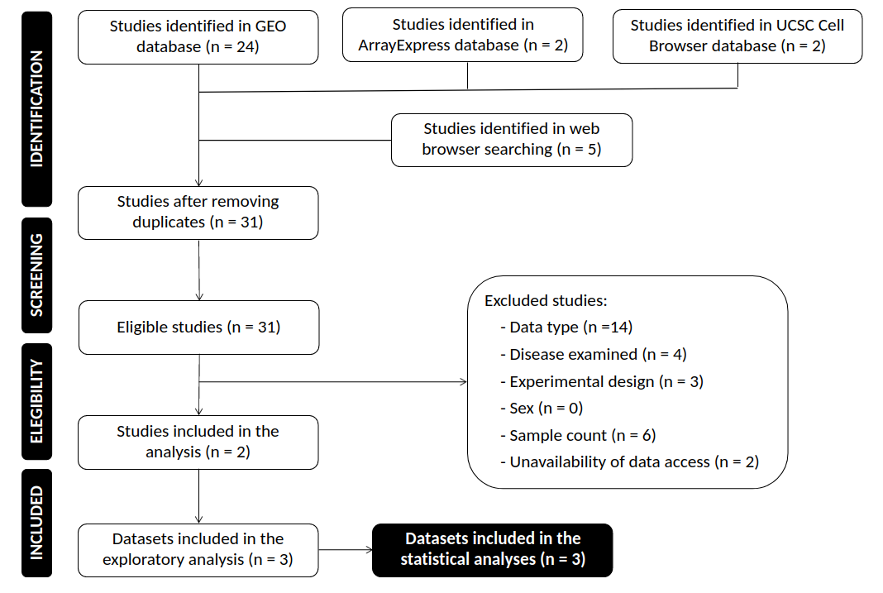Figure S1. Systematic review workflow following PRISMA guidelines. Specification of remaining study number (n) through the identification, screening, eligibility, and inclusion phases, along with the corresponding exclusion justifications. PRISMA: Preferred Reporting Items for Systematic Reviews and Meta-Analyses.

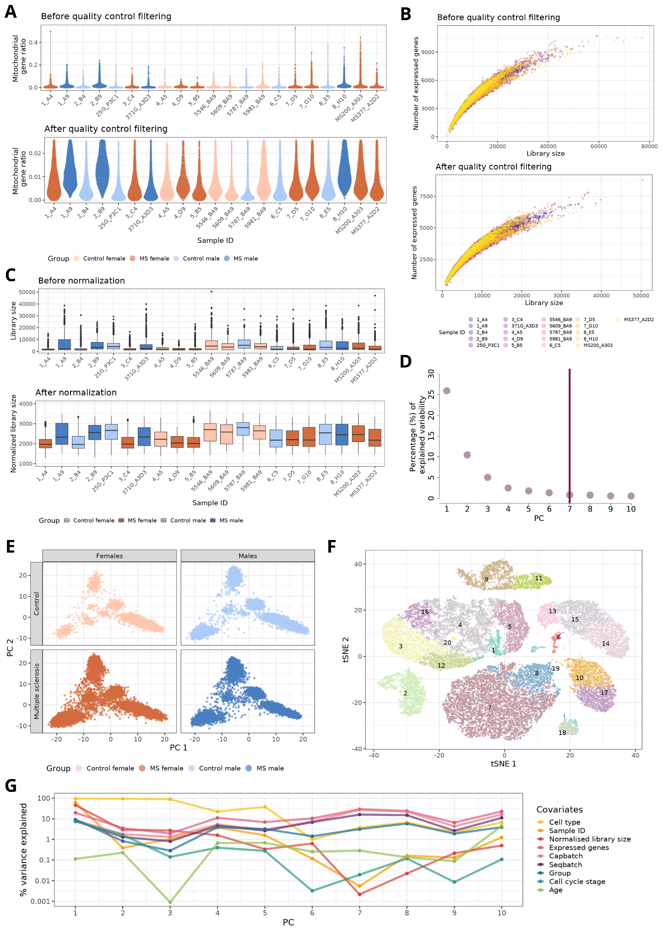

Figure S2. UCSC-MS dataset preprocessing. (A) Violin plots before and after quality control filtering. Representation of the mitochondrial gene ratio (Y-axis) for each sample (X-axis). Each dot represents a cell, coloured according to the condition and sex of the subject. (B) Number of expressed genes (Y-axis) versus the library size (X-axis) for each sample before (top) and after (bottom) the quality control filtering step. Each dot represents a cell, coloured according to the sample identification. (C) Boxplots of the sample library size before and after normalisation. (D) Percentage of explained variability for each principal component. Horizontal bar marks the number of principal components selected for further dimensionality reduction analyses. PC: Principal Component. (E) Cell distribution in the first and second principal components. Each dot represents a cell, separated and coloured by the condition and sex of the subjects. PC: Principal Component. (F) tSNE embedding where each dot represents a cell type, coloured according to the assigned cluster which are also denoted by numbers. t-Distributed Stochastic Neighbour Embedding (G) Percentage of variance explained by each covariate reported in the original dataset (Y-axis) for each principal component (X-axis).

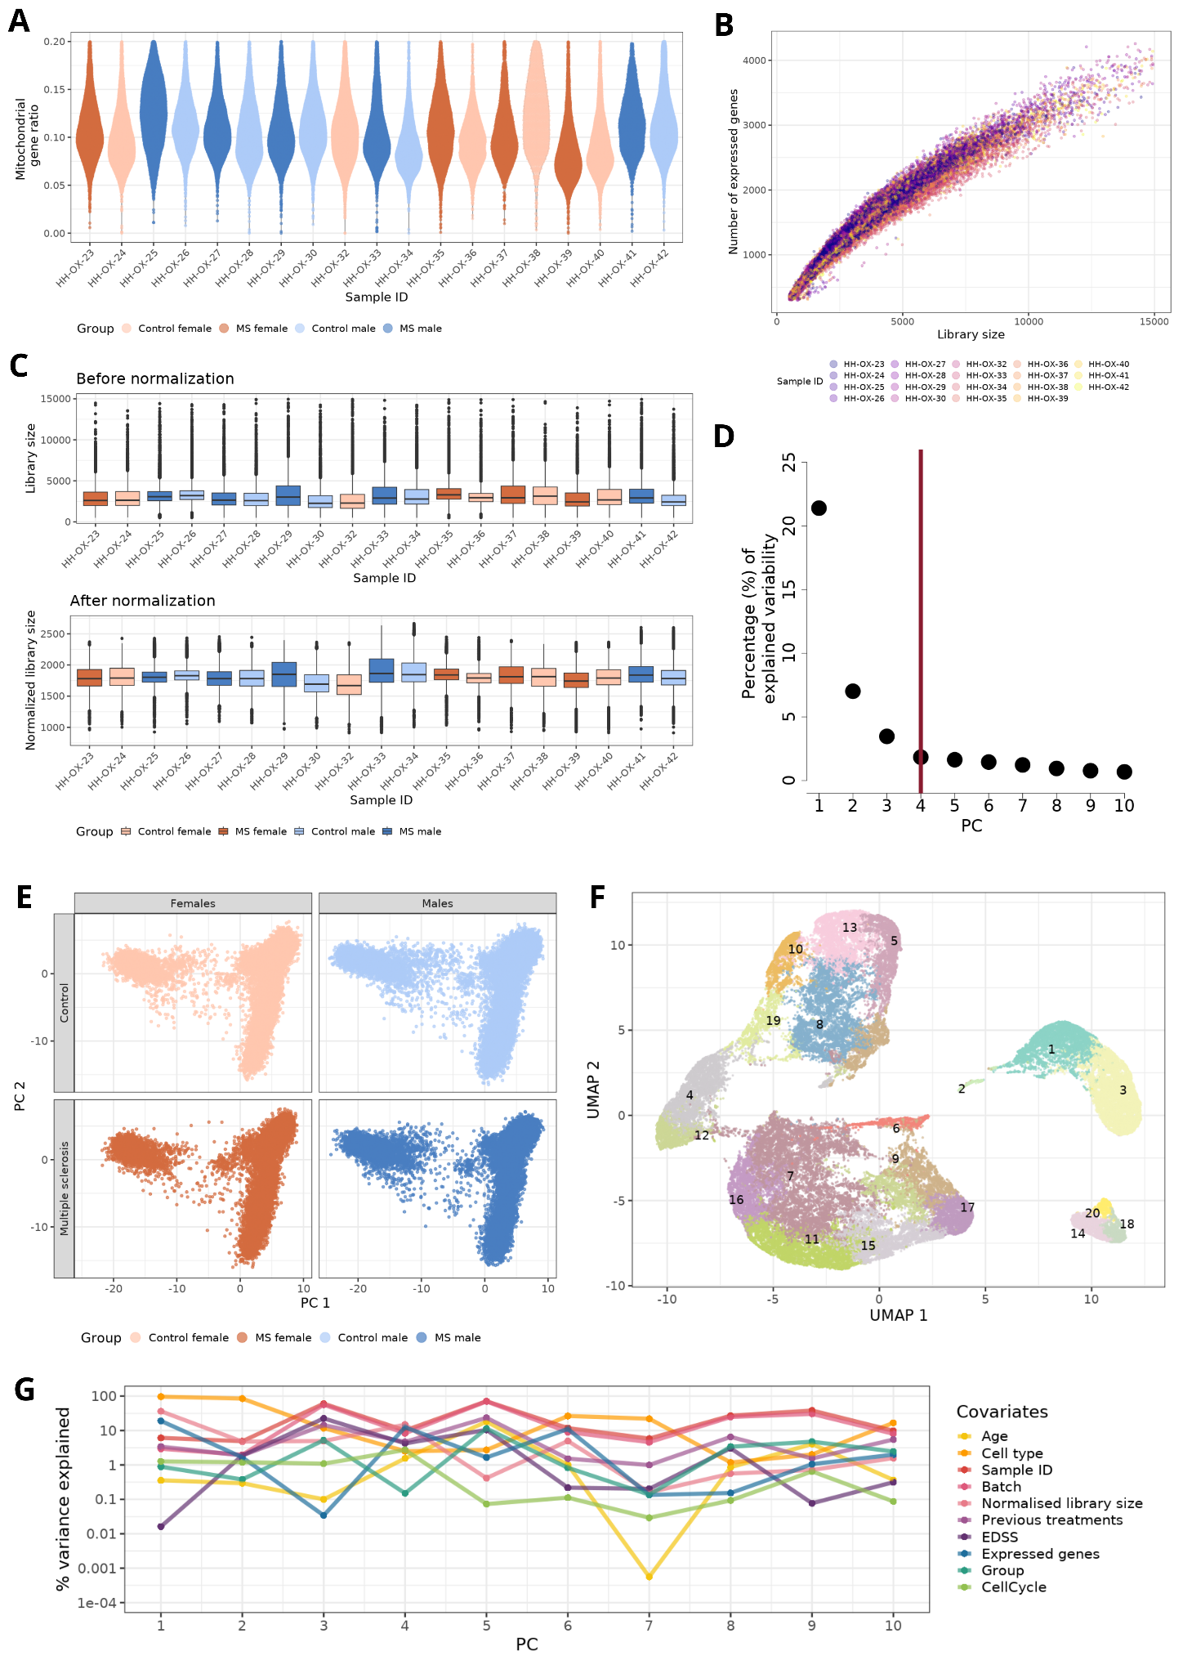

Figure S3. GSE144744c1 dataset preprocessing. (A) Violin after quality control filtering from the original authors. Representation of the mitochondrial gene ratio (Y-axis) for each sample (X-axis). Each dot represents a cell, coloured according to the condition and sex of the subject. (B) Number of expressed genes (Y-axis) versus the library size (X-axis) for each sample after the quality control filtering step. Each dot represents a cell, coloured according to the sample identification. (C) Boxplots of the sample library size before and after normalization. (D) Percentage of explained variability for each principal component. Horizontal bar marks the number of principal components selected for further dimensionality reduction analyses. PC: Principal Component. (E) Cell distribution in the first and second principal components. Each dot represents a cell, separated and coloured by the condition and sex of the subjects. PC: Principal Component. (F) tSNE embedding where each dot represents a cell type, coloured according to the assigned cluster which are also denoted by numbers. t-Distributed Stochastic Neighbour Embedding (G) Percentage of variance explained by each covariate reported in the original dataset (Y-axis) for each principal component (X-axis).

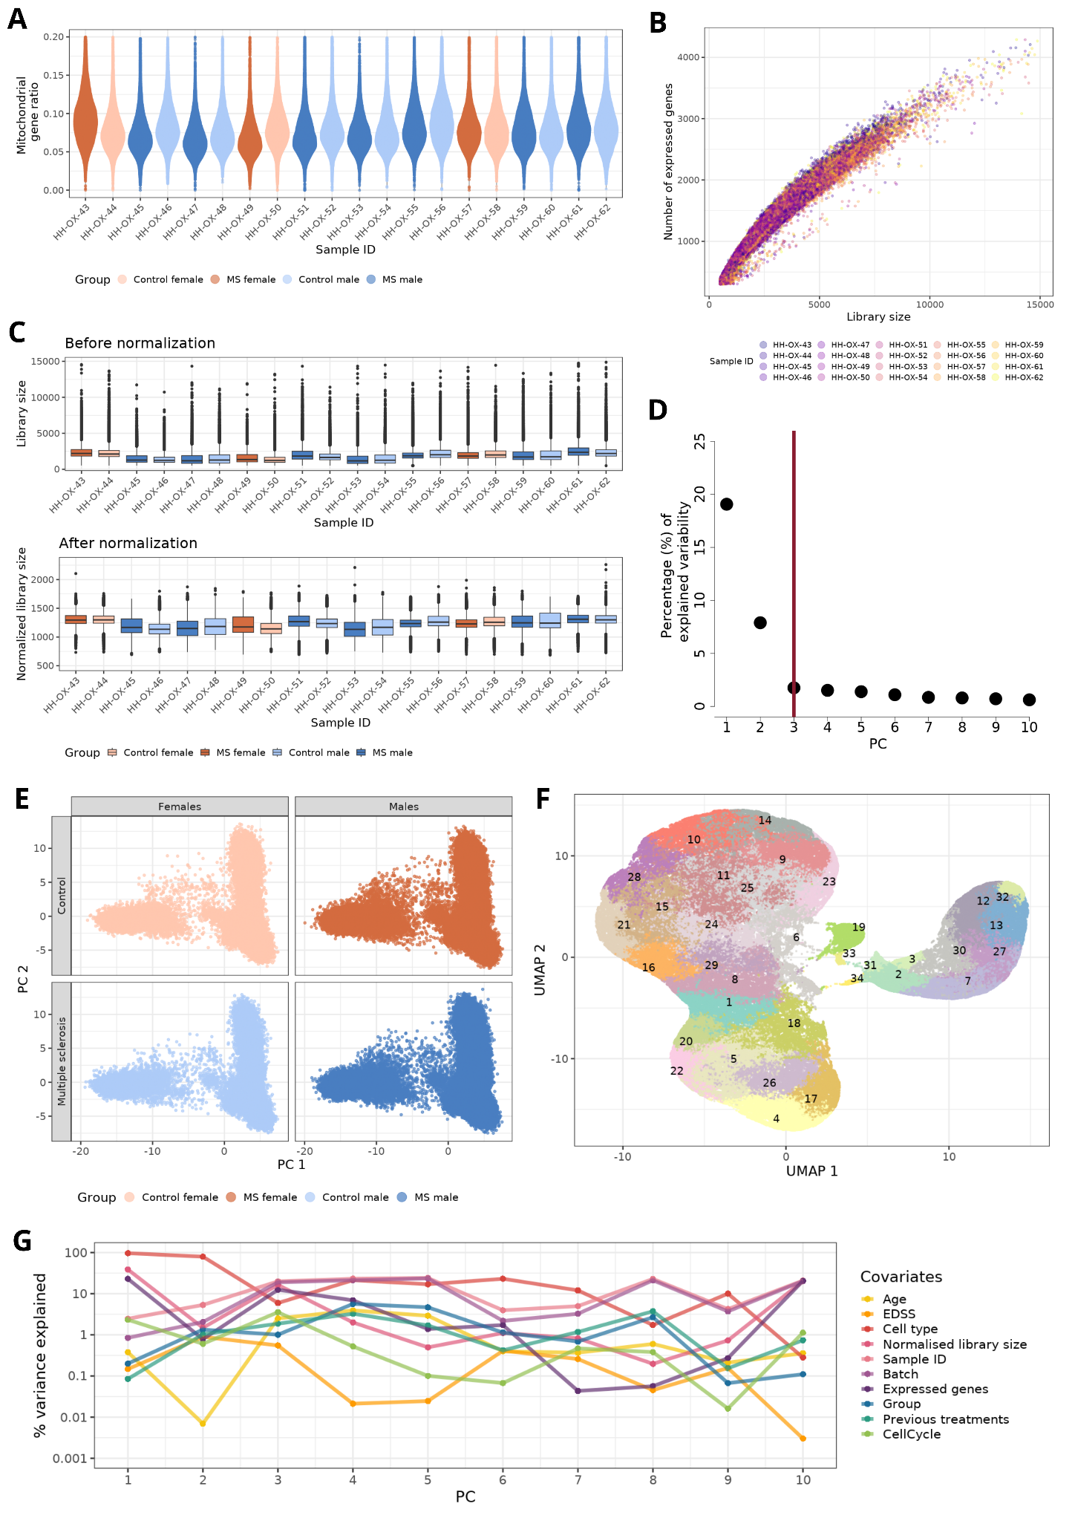

Figure S4. GSE144744c3 dataset preprocessing. (A) Violin after quality control filtering from the original authors. Representation of the mitochondrial gene ratio (Y-axis) for each sample (X-axis). Each dot represents a cell, coloured according to the condition and sex of the subject. (B) Number of expressed genes (Y-axis) versus the library size (X-axis) for each sample after the quality control filtering step. Each dot represents a cell, coloured according to the sample identification. (C) Boxplots of the sample library size before and after normalization. (D) Percentage of explained variability for each principal component. Horizontal bar marks the number of principal components selected for further dimensionality reduction analyses. PC: Principal Component. (E) Cell distribution in the first and second principal components. Each dot represents a cell, separated and coloured by the condition and sex of the subjects. PC: Principal Component. (F) tSNE embedding where each dot represents a cell type, coloured according to the assigned cluster which are also denoted by numbers. t-Distributed Stochastic Neighbour Embedding (G) Percentage of variance explained by each covariate reported in the original dataset (Y-axis) for each principal component (X-axis).

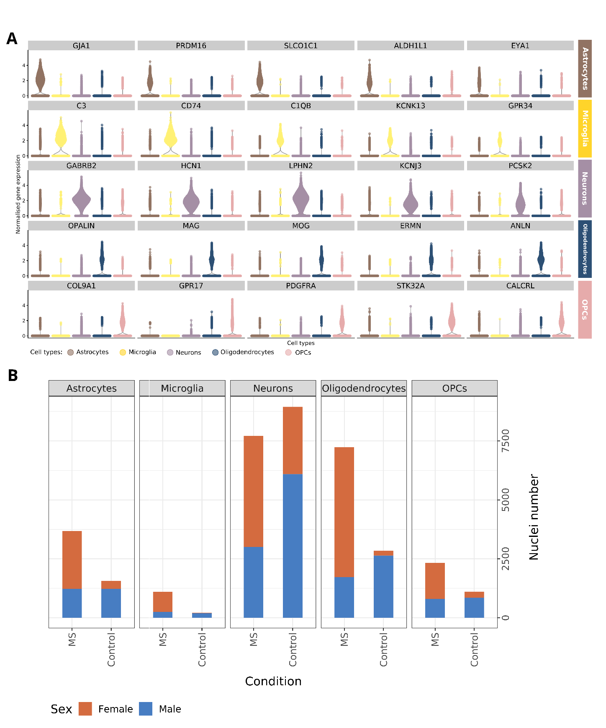

Figure S5. Summary of significant sex differences in secondary progressive multiple sclerosis. (A) Expression pattern of marker genes (Y-axis) in astrocytes, microglia, neurons, oligodendrocytes and oligodendrocyte precursor cells (OPCs) (Y-axis). Each dot represents a cell, coloured according to the cell type noted. Marker genes have been selected from bibliographic research. (B) Number of cells identified for each cell type (X-axis) based on condition (Y-axis) and sex (colour). MS: multiple sclerosis; OPCs: oligodendrocyte precursor cells.

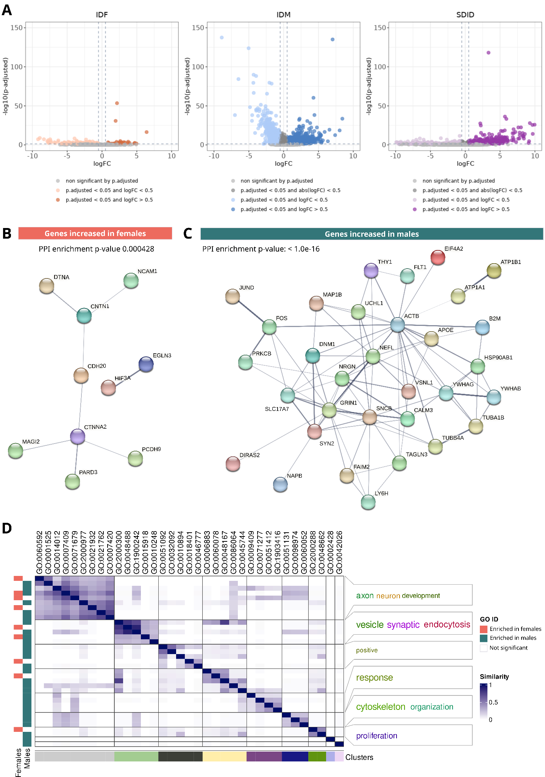

Figure S6. Astrocyte sex-differential atlas in secondary progressive multiple sclerosis. (A) Volcano plots of differential gene expression results. Each point represents a gene distributed by its magnitude of change (logFC, X-axis) and its significance (-log10(p.fitted value), X-axis) for each comparison. IDF: impact of disease in females (MS females vs control females); IDM: impact of disease in males (MS males vs control males); SDID: sex differential impact of disease ((MS females vs control females) - (MS males vs control males)). Protein-protein interaction network of genes increased in females (B, orange) and males (C, green) from those significant in all three comparisons. Edge thickness is directly proportional to the structural and functional confidence of the interaction. PPI: protein-protein interaction. (D) Degree of similarity between sex-differential enriched functions in females (left horizontal orange bars) and males (left horizontal green bars). Each row and column corresponds with a significant function. Blue intensity indicates the degree of similarity. Clusters are shown at the bottom, with the associated word cloud on the right of the plot.

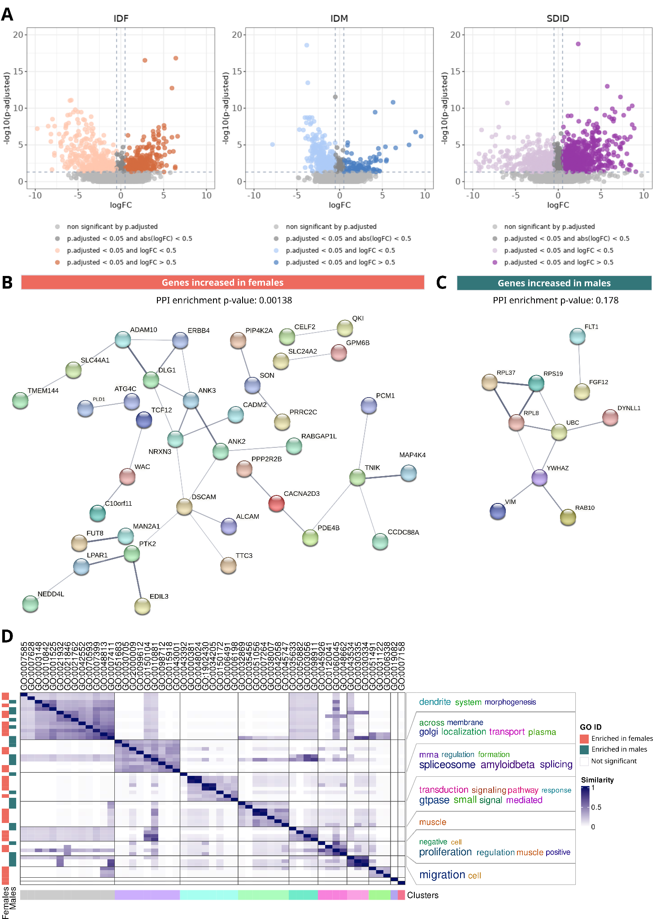

Figure S7. Microglia sex-differential atlas in secondary progressive multiple sclerosis. (A) Volcano plots of differential gene expression results. Each point represents a gene distributed by its magnitude of change (logFC, X-axis) and its significance (-log10(p.fitted value), X-axis) for each comparison. IDF: impact of disease in females (MS females vs control females); IDM: impact of disease in males (MS males vs control males); SDID: sex differential impact of disease ((MS females vs control females) - (MS males vs control males)). Protein-protein interaction network of genes increased in females (B, orange) and males (C, green) from those significant in all three comparisons. Edge thickness is directly proportional to the structural and functional confidence of the interaction. PPI: protein-protein interaction. (D) Degree of similarity between sex-differential enriched functions in females (left horizontal orange bars) and males (left horizontal green bars). Each row and column corresponds with a significant function. Blue intensity indicates the degree of similarity. Clusters are shown at the bottom, with the associated word cloud on the right of the plot.

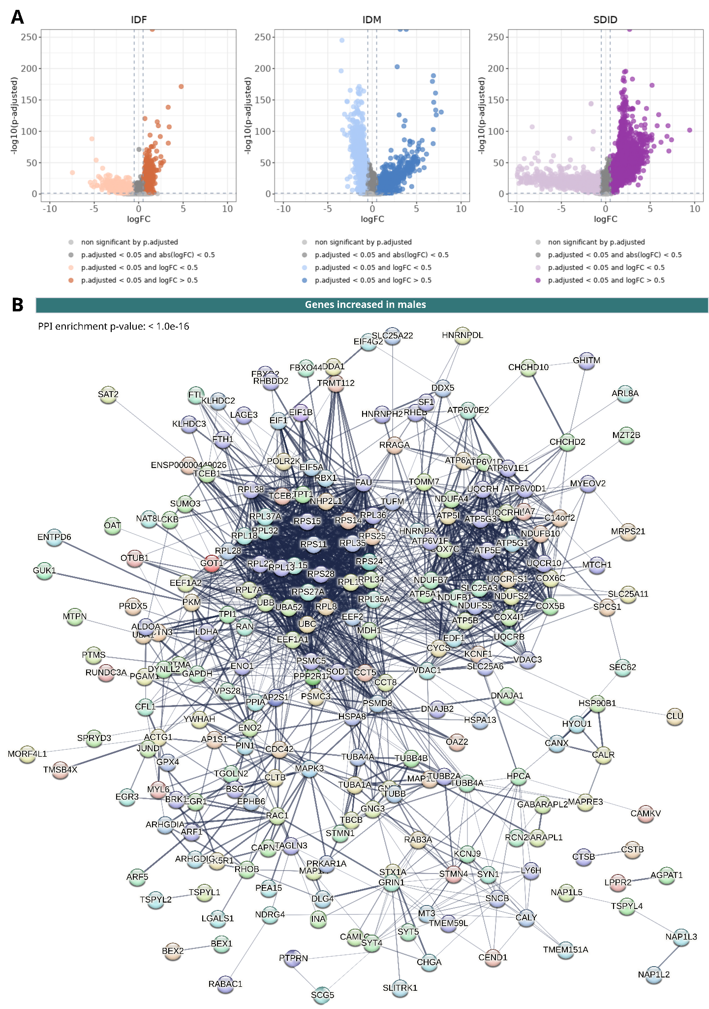

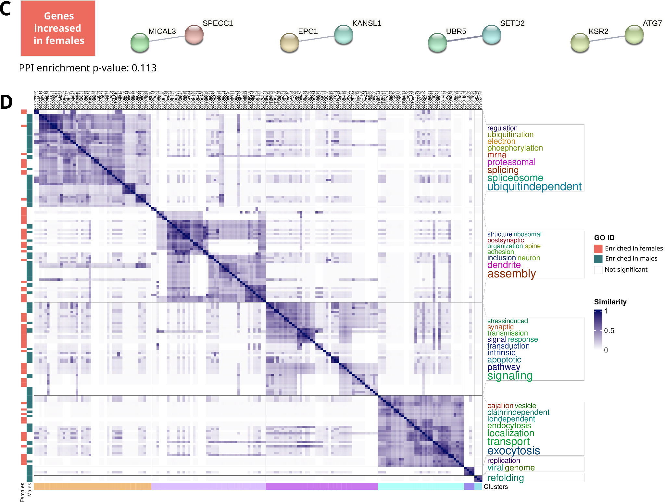

Figure S8. Neurons sex-differential atlas in secondary progressive multiple sclerosis. (A) Volcano plots of differential gene expression results. Each point represents a gene distributed by its magnitude of change (logFC, X-axis) and its significance (-log10(p.fitted value), X-axis) for each comparison. IDF: impact of disease in females (MS females vs control females); IDM: impact of disease in males (MS males vs control males); SDID: sex differential impact of disease ((MS females vs control females) - (MS males vs control males)). Protein-protein interaction network of genes increased in males (B, green) and females (C, orange) from those significant in all three comparisons. Edge thickness is directly proportional to the structural and functional confidence of the interaction. PPI: protein-protein interaction. Due to the high number of significant results, subclusters were calculated with the following specifications: 1) community search with the fastgreedy algorithm, 2) discarding of subclusters with a size smaller than 0.7, 3) disable text mining option and 4) genes set with a absolute magnitude of change higher of 4. (D) Degree of similarity between sex-differential enriched functions in females (left horizontal orange bars) and males (left horizontal green bars). Each row and column corresponds with a significant function. Blue intensity indicates the degree of similarity. Clusters are shown at the bottom, with the associated word cloud on the right of the plot.

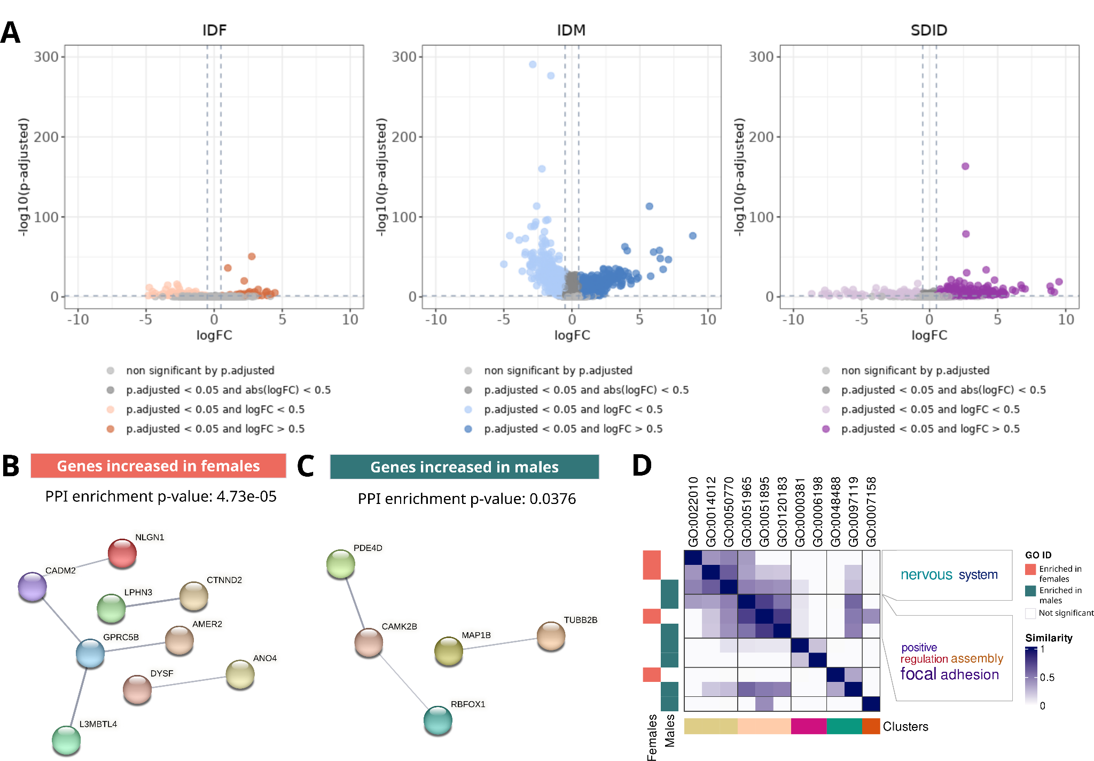

Figure S9. Oligodendrocytes sex-differential atlas in secondary progressive multiple sclerosis. (A) Volcano plots of differential gene expression results. Each point represents a gene distributed by its magnitude of change (logFC, X-axis) and its significance (-log10(p.fitted value), X-axis) for each comparison. IDF: impact of disease in females (MS females vs control females); IDM: impact of disease in males (MS males vs control males); SDID: sex differential impact of disease ((MS females vs control females) - (MS males vs control males)). Protein-protein interaction network of genes increased in females (B, orange) and males (C, green) from those significant in all three comparisons. Edge thickness is directly proportional to the structural and functional confidence of the interaction. PPI: protein-protein interaction. (D) Degree of similarity between sex-differential enriched functions in females (left horizontal orange bars) and males (left horizontal green bars). Each row and column corresponds with a significant function. Blue intensity indicates the degree of similarity. Clusters are shown at the bottom, with the associated word cloud on the right of the plot.

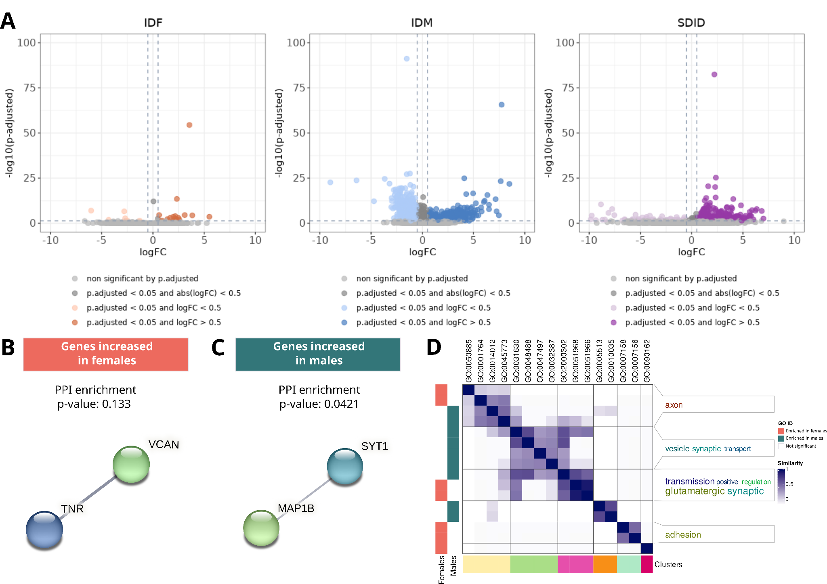

Figure S10. Oligodendrocyte precursor cells sex-differential atlas in secondary progressive multiple sclerosis. (A) Volcano plots of differential gene expression results. Each point represents a gene distributed by its magnitude of change (logFC, X-axis) and its significance (-log10(p.fitted value), X-axis) for each comparison. IDF: impact of disease in females (MS females vs control females); IDM: impact of disease in males (MS males vs control males); SDID: sex differential impact of disease ((MS females vs control females) - (MS males vs control males)). Protein-protein interaction network of genes increased in females (B, orange) and males (C, green) from those significant in all three comparisons. Edge thickness is directly proportional to the structural and functional confidence of the interaction. PPI: protein-protein interaction. (D) Degree of similarity between sex-differential enriched functions in females (left horizontal orange bars) and males (left horizontal green bars). Each row and column corresponds with a significant function. Blue intensity indicates the degree of similarity. Clusters are shown at the bottom, with the associated word cloud on the right of the plot.

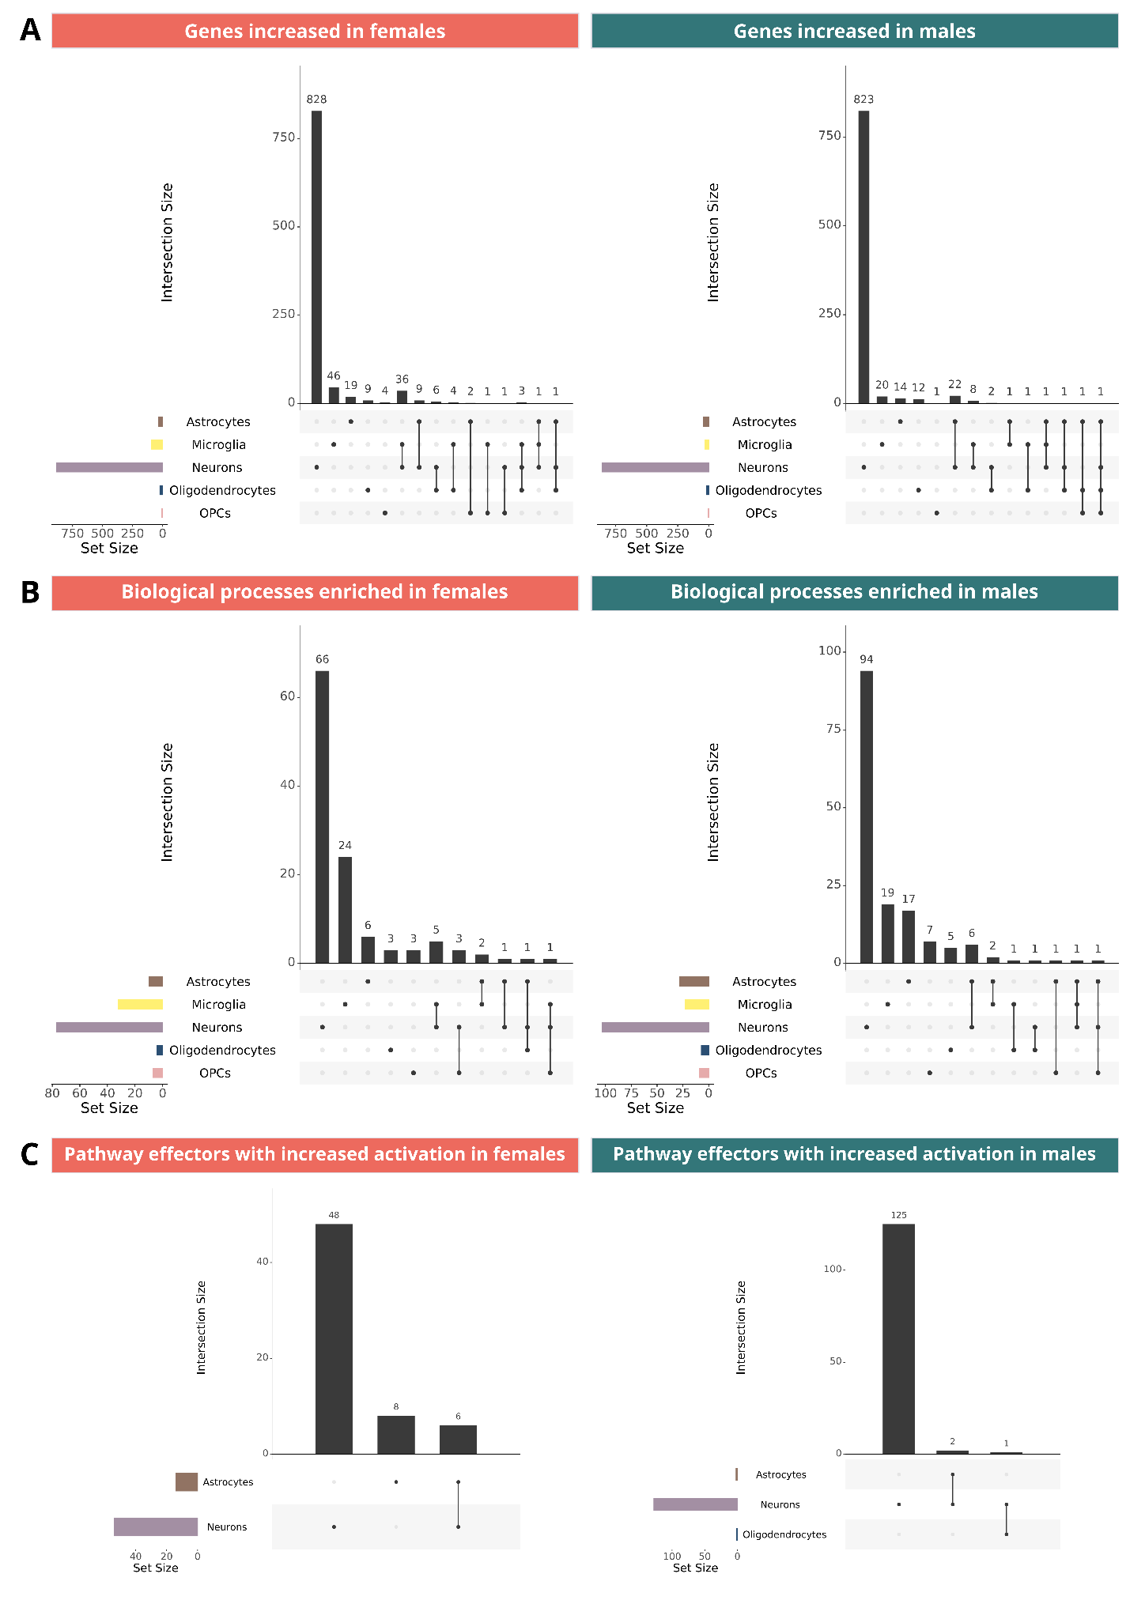
Figure S11. Intersection of significant results among brain cell types for secondary progressive multiple sclerosis. Upset plots for significant sex-differential (A) genes, (C) functions and (C) effectors of signaling pathways in the three assessed comparisons: IDF: impact of disease in females (MS females vs control females); IDM: impact of disease in males (MS males vs control males); SDID: sex differential impact of disease ((MS females vs control females) - (MS males vs control males)). OPCs: oligodendrocyte precursor cells.

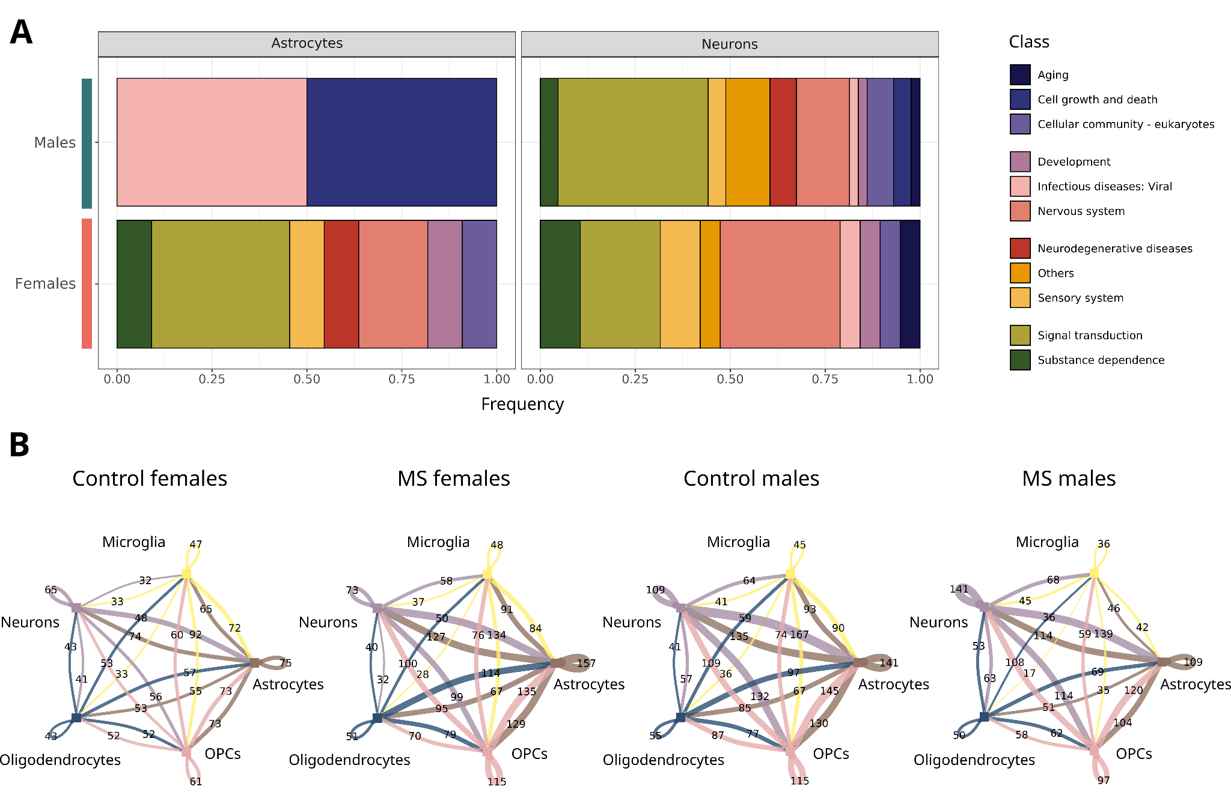

Figure S12. Significant results in the analyses of (A) signaling pathway effector activation and (B) cell-cell communication for the secondary progressive form of multiple sclerosis. (A) Relative frequency distribution of KEGG signaling pathways significantly activated in females (orange) and males (green) by cell type. Individual terms have been classified into general categories (see legend). No significant results have been obtained for microglia and oligodendrocyte precursor cells. Oligodendrocytes presented more activated the Tight junction pathway in males. (D) Number of significant cell-cell interactions by group. Colour indicates the cell type providing the ligand protein. The thickness of the interaction corresponds to the magnitude of interactions. OPCs: oligodendrocyte precursor cells; KEGG: Kyoto Encyclopedia of Genes and Genomes.

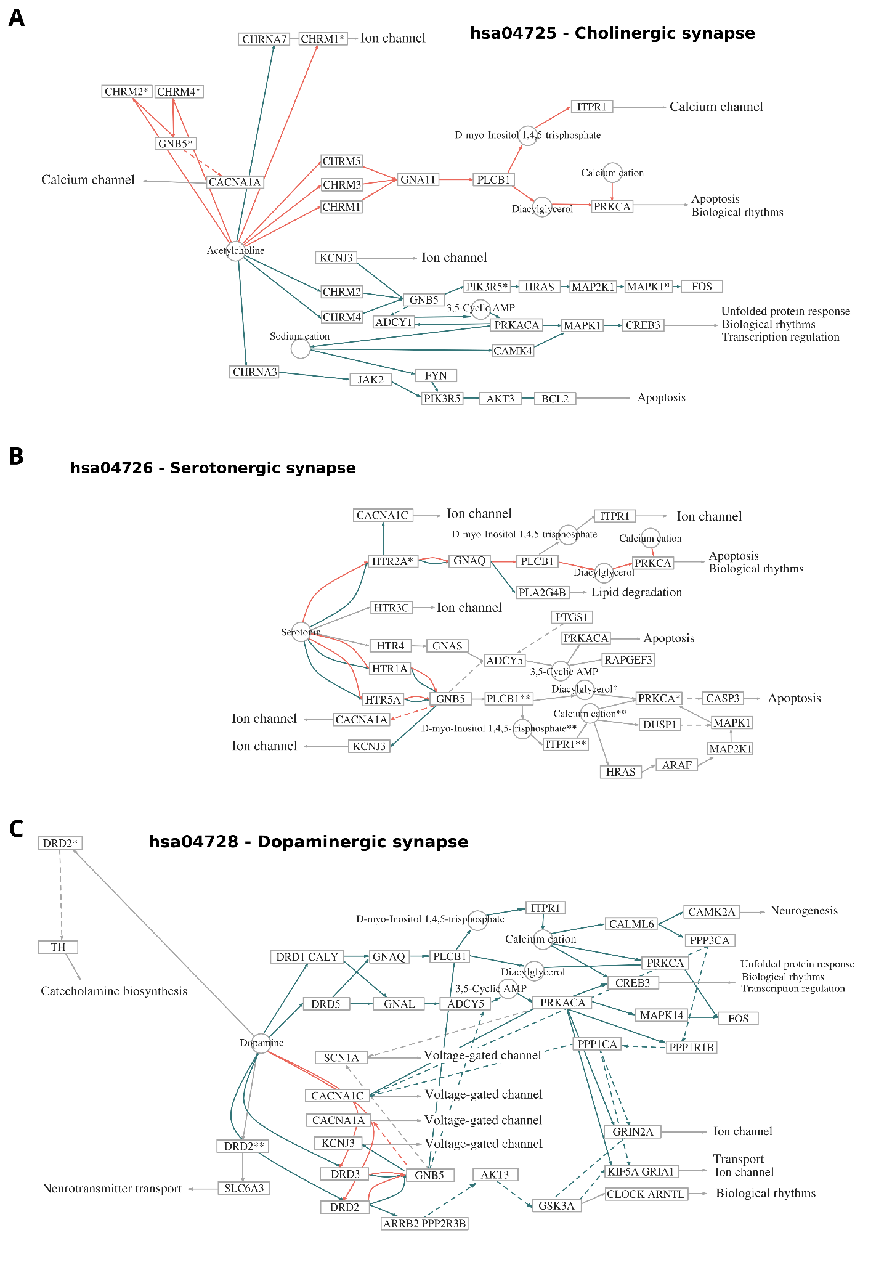

Figure S13. Sex differential signaling pathways of (A) cholinergic, (B) serotonergic and (C) dopaminergic synapses in neurons from secondary progressive multiple sclerosis. Nodes represent proteins of the signalling pathway and edges the interactions between nodes. Effector proteins are the last node in each subpathway (arrow point). The effector nodes point to the biological functions they exerted. GO: Gene Ontology; GABA: Gamma-aminobutyric acid. Orange edges: subpathways with increased activation in females; green edges: subpathways with increased activation in males.

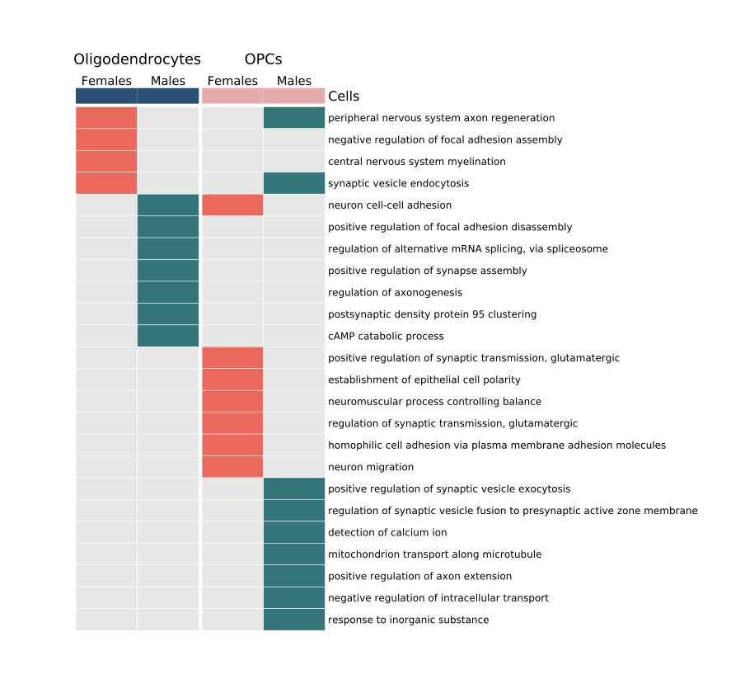

Figure S14. Significant functions in oligodendrocytes and oligodendrocyte precursor cells (OPCs) in secondary progressive multiple sclerosis. Heatmap of oligodendrocytes and oligodendrocyte precursor cells by sex (columns) from the corresponding enriched functions (rows). Orange: functions enriched in females; green: functions enriched in males; grey: non significant enriched function.
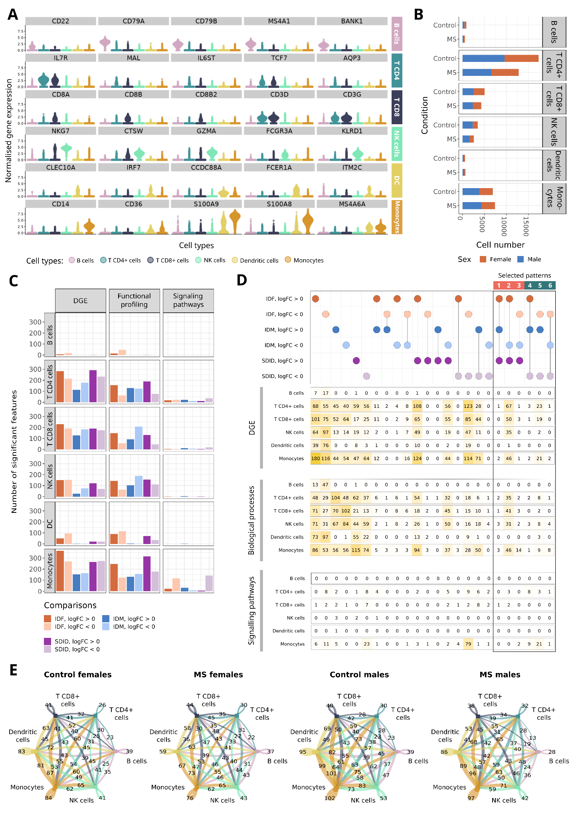

Figure S15. Summary of significant sex differences in relapsing-remitting multiple sclerosis. (A) Expression pattern of marker genes (Y-axis) in B cells, CD4+ T cells, CD8+ T cells, NK cells, monocytes and dendritic cells (Y-axis). Each dot represents a cell, coloured according to the cell type noted. Marker genes have been selected from bibliographic research. (B) Number of cells identified for each cell type (X-axis) based on condition (Y-axis) and sex (color). MS: multiple sclerosis. (C) Number of significant features by cell type, analysis and comparison tested. (D) Upset map of significant features for each cell type separated by comparison and direction of change (logFC). Dots display whether the feature is significant, with specific colors indicating the comparison and logFC sign. Each row of numbers indicates, for each cell type and specific analysis, the number of significant features corresponding to the evaluated column in the dot map. Coloured squares highlight the significant features in the three comparisons IDF, IDM and SDID. (E) Number of significant cell-cell interactions by group. Colour indicates the cell type providing the ligand protein. The thickness of the interaction corresponds to the magnitude of interactions. IDF: impact of disease in females (MS females vs control females); IDM: impact of disease in males (MS males vs control males); SDID: sex differential impact of disease ((MS females vs control females) - (MS males vs control males)).

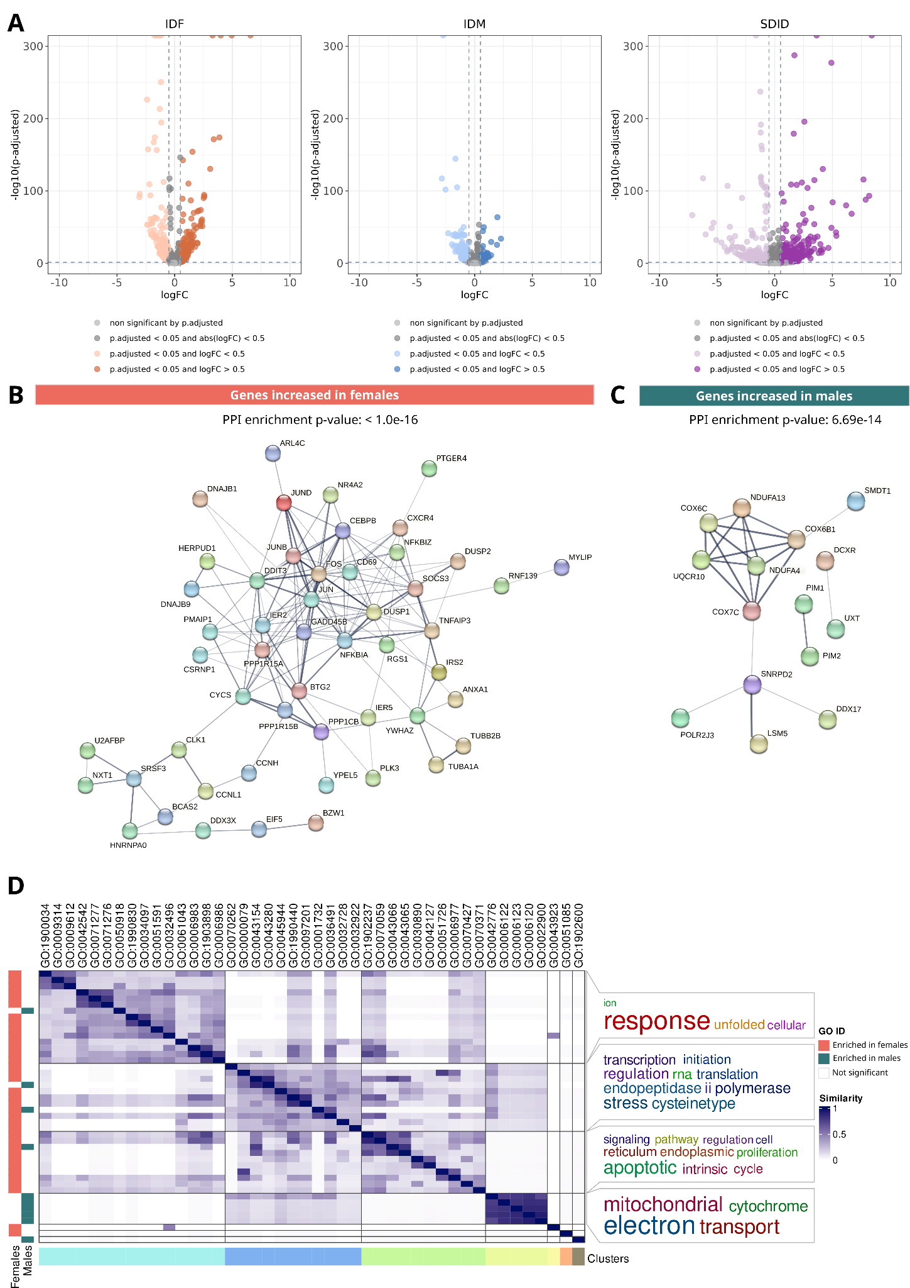

Figure S16. CD4+ T cells sex-differential atlas in relapsing-remitting multiple sclerosis. (A) Volcano plots of differential gene expression results. Each point represents a gene distributed by its magnitude of change (logFC, X-axis) and its significance (-log10(p.fitted value), X-axis) for each comparison. IDF: impact of disease in females (MS females vs control females); IDM: impact of disease in males (MS males vs control males); SDID: sex differential impact of disease ((MS females vs control females) - (MS males vs control males)). Protein-protein interaction network of genes increased in females (B, orange) and males (C, green) from those significant in all three comparisons. Edge thickness is directly proportional to the structural and functional confidence of the interaction. PPI: protein-protein interaction. (D) Degree of similarity between sex-differential enriched functions in females (left horizontal orange bars) and males (left horizontal green bars). Each row and column corresponds with a significant function. Blue intensity indicates the degree of similarity. Clusters are shown at the bottom, with the associated word cloud on the right of the plot.

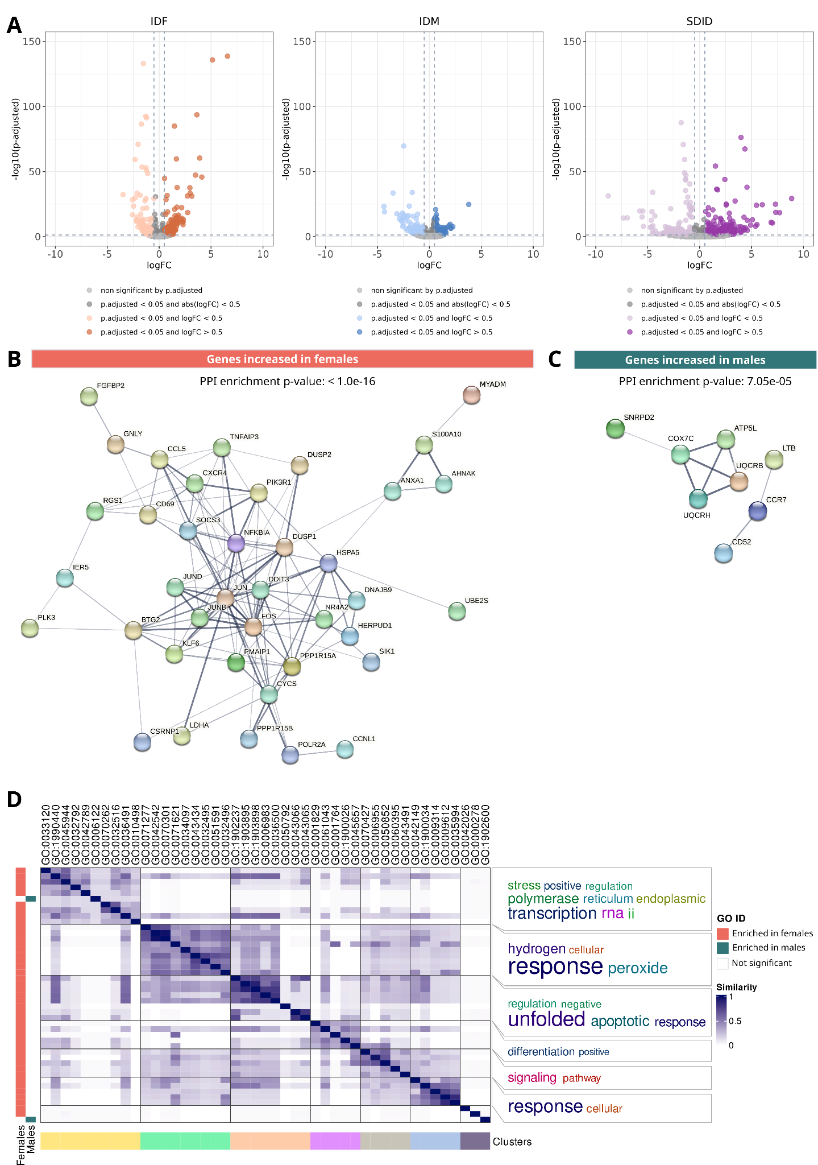

Figure S17. CD8+ T cells sex-differential atlas in relapsing-remitting multiple sclerosis. (A) Volcano plots of differential gene expression results. Each point represents a gene distributed by its magnitude of change (logFC, X-axis) and its significance (-log10(p.fitted value), X-axis) for each comparison. IDF: impact of disease in females (MS females vs control females); IDM: impact of disease in males (MS males vs control males); SDID: sex differential impact of disease ((MS females vs control females) - (MS males vs control males)). Protein-protein interaction network of genes increased in females (B, orange) and males (C, green) from those significant in all three comparisons. Edge thickness is directly proportional to the structural and functional confidence of the interaction. PPI: protein-protein interaction. (D) Degree of similarity between sex-differential enriched functions in females (left horizontal orange bars) and males (left horizontal green bars). Each row and column corresponds with a significant function. Blue intensity indicates the degree of similarity. Clusters are shown at the bottom, with the associated word cloud on the right of the plot.

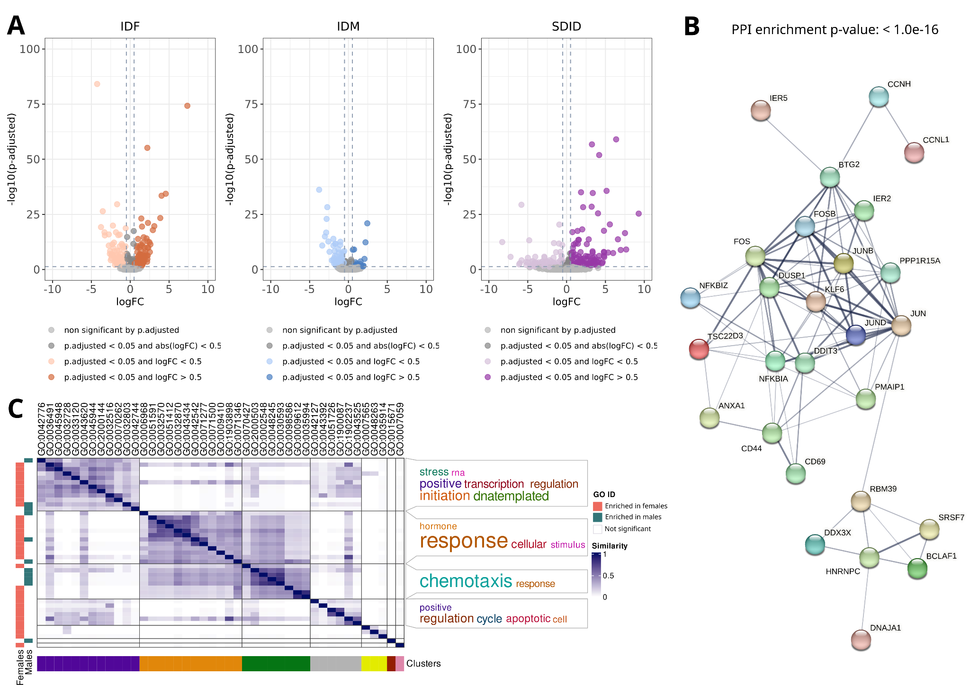
Figure S18. NK cells sex-differential atlas in relapsing-remitting multiple sclerosis. (A) Volcano plots of differential gene expression results. Each point represents a gene distributed by its magnitude of change (logFC, X-axis) and its significance (-log10(p.fitted value), X-axis) for each comparison. IDF: impact of disease in females (MS females vs control females); IDM: impact of disease in males (MS males vs control males); SDID: sex differential impact of disease ((MS females vs control females) - (MS males vs control males)). Protein-protein interaction network of genes increased in females (B) from those significant in all three comparisons. Edge thickness is directly proportional to the structural and functional confidence of the interaction. PPI: protein-protein interaction. Males only have increased CCL4 and HBA2 genes. (C) Degree of similarity between sex-differential enriched functions in females (left horizontal orange bars) and males (left horizontal green bars). Each row and column corresponds with a significant function. Blue intensity indicates the degree of similarity. Clusters are shown at the bottom, with the associated word cloud on the right of the plot. NK: natural killer.

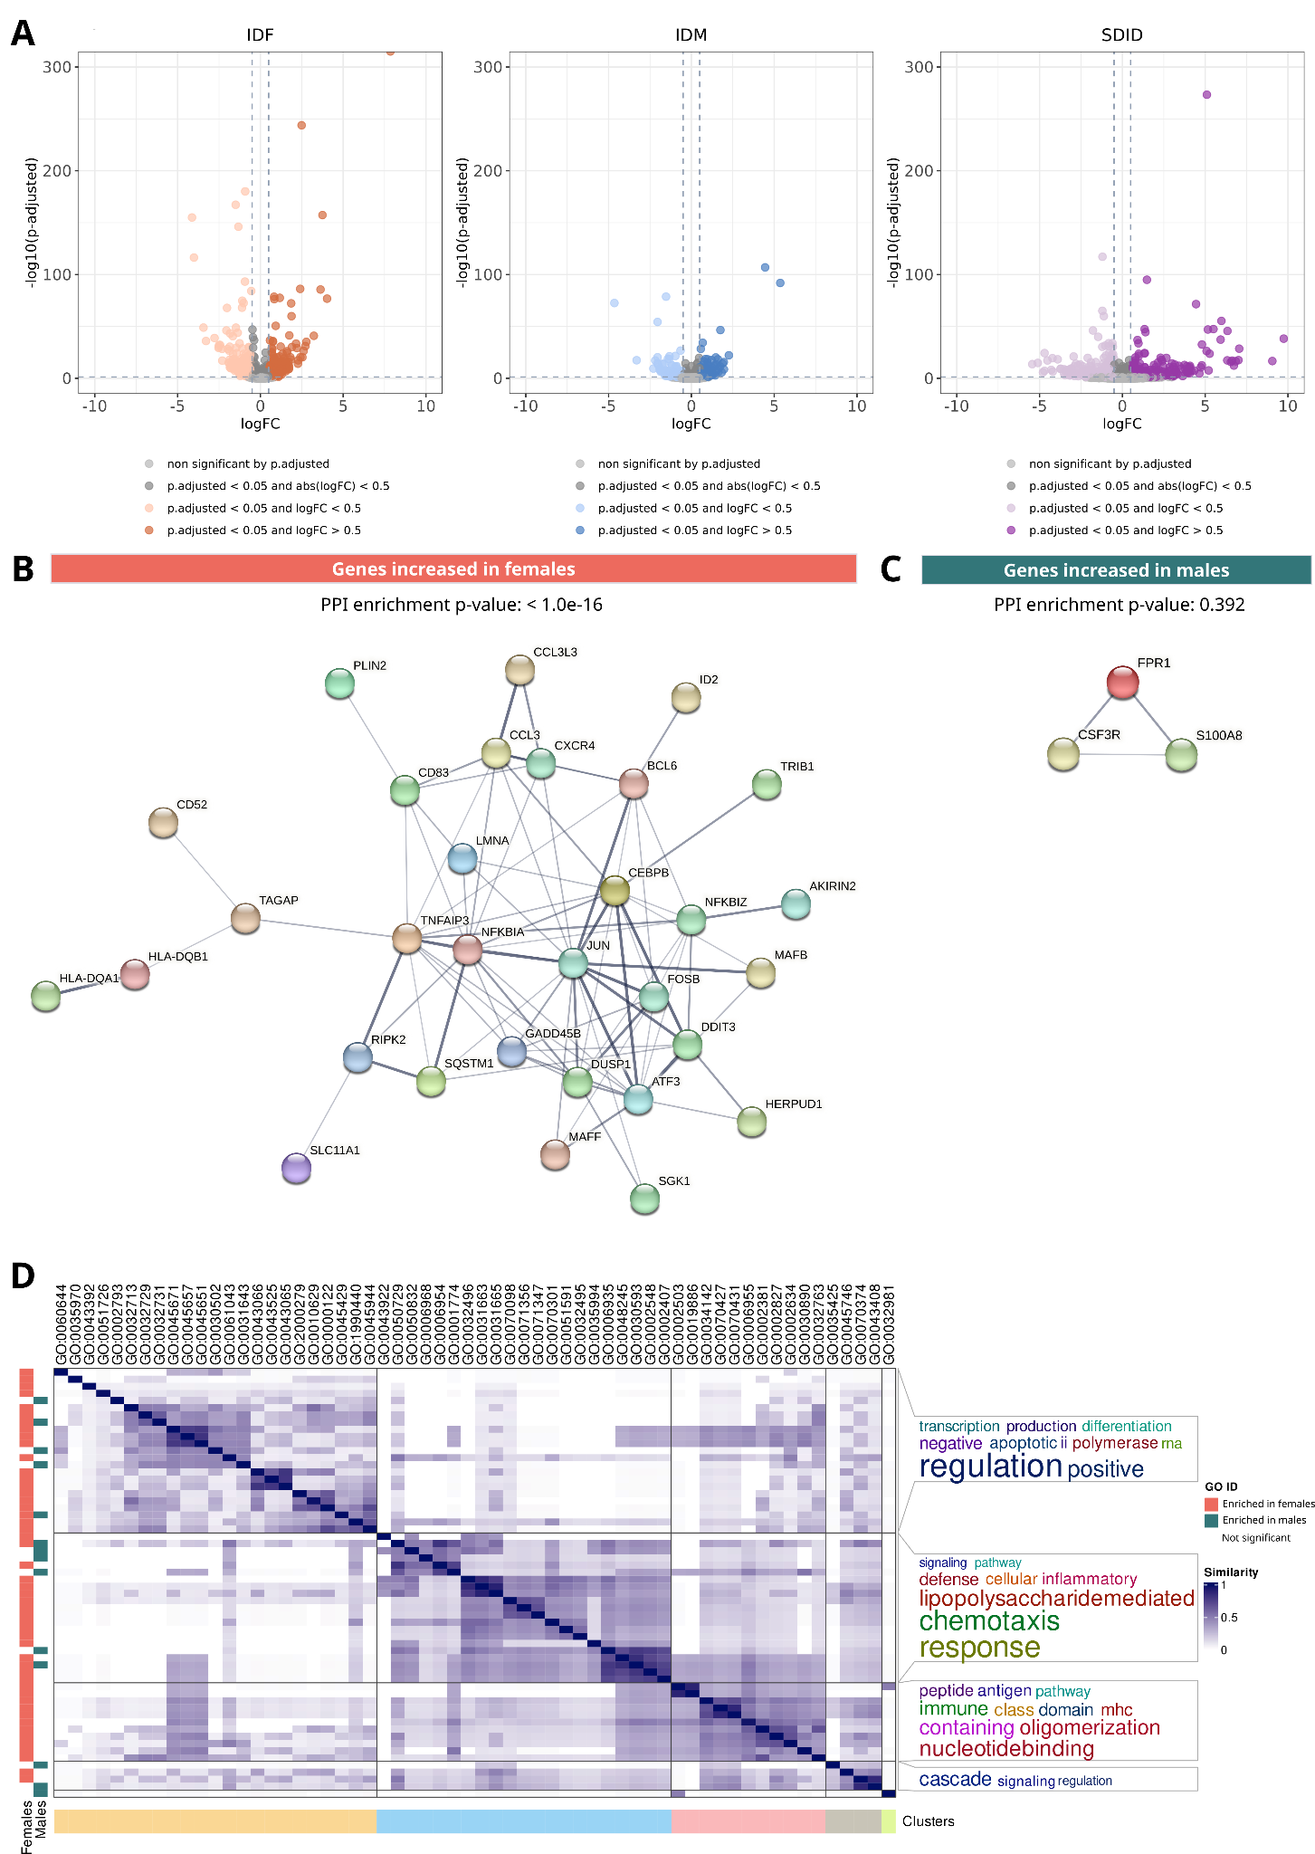

Figure S19. Monocytes sex-differential atlas in relapsing-remitting multiple sclerosis. (A) Volcano plots of differential gene expression results. Each point represents a gene distributed by its magnitude of change (logFC, X-axis) and its significance (-log10(p.fitted value), X-axis) for each comparison. IDF: impact of disease in females (MS females vs control females); IDM: impact of disease in males (MS males vs control males); SDID: sex differential impact of disease ((MS females vs control females) - (MS males vs control males)). Protein-protein interaction network of genes increased in females (B, orange) and males (C, green) from those significant in all three comparisons. Edge thickness is directly proportional to the structural and functional confidence of the interaction. PPI: protein-protein interaction. (D) Degree of similarity between sex-differential enriched functions in females (left horizontal orange bars) and males (left horizontal green bars). Each row and column corresponds with a significant function. Blue intensity indicates the degree of similarity. Clusters are shown at the bottom, with the associated word cloud on the right of the plot.

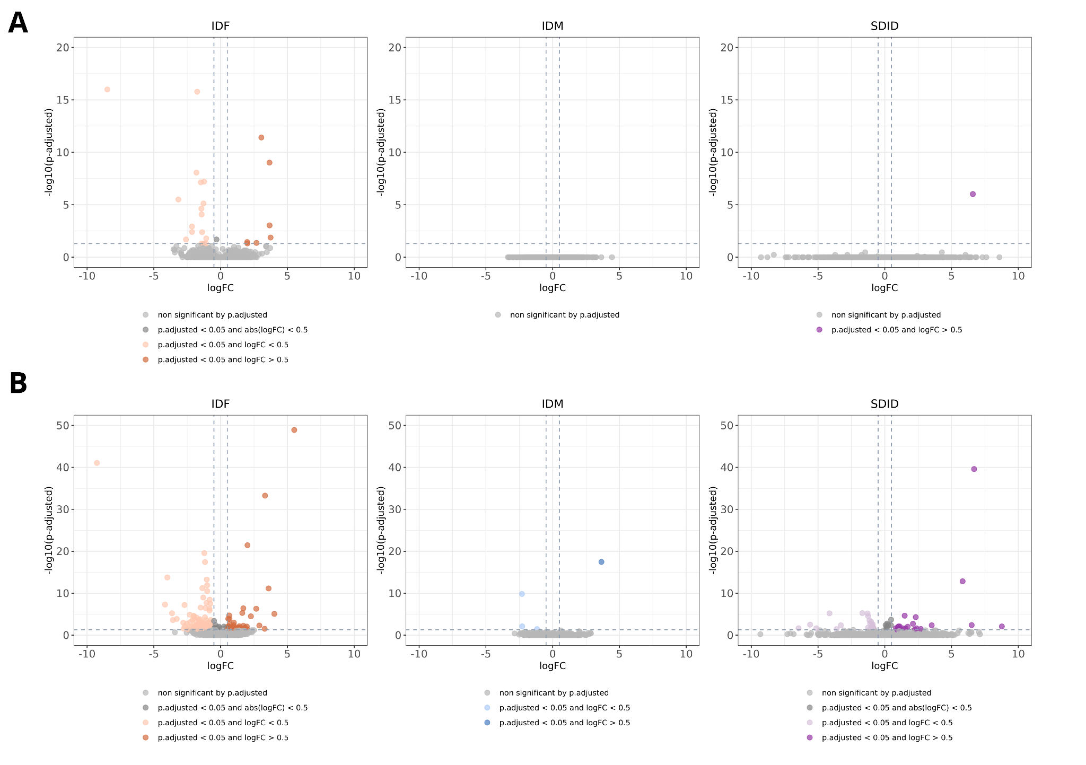

Figure S20. (A) B cells and (B) dendritic cells sex-differential atlas in relapsing-remitting multiple sclerosis. Volcano plots of differential gene expression results. Each point represents a gene distributed by its magnitude of change (logFC, X-axis) and its significance (-log10(p.fitted value), X-axis) for each comparison. IDF: impact of disease in females (MS females vs control females); IDM: impact of disease in males (MS males vs control males); SDID: sex differential impact of disease ((MS females vs control females) - (MS males vs control males)).

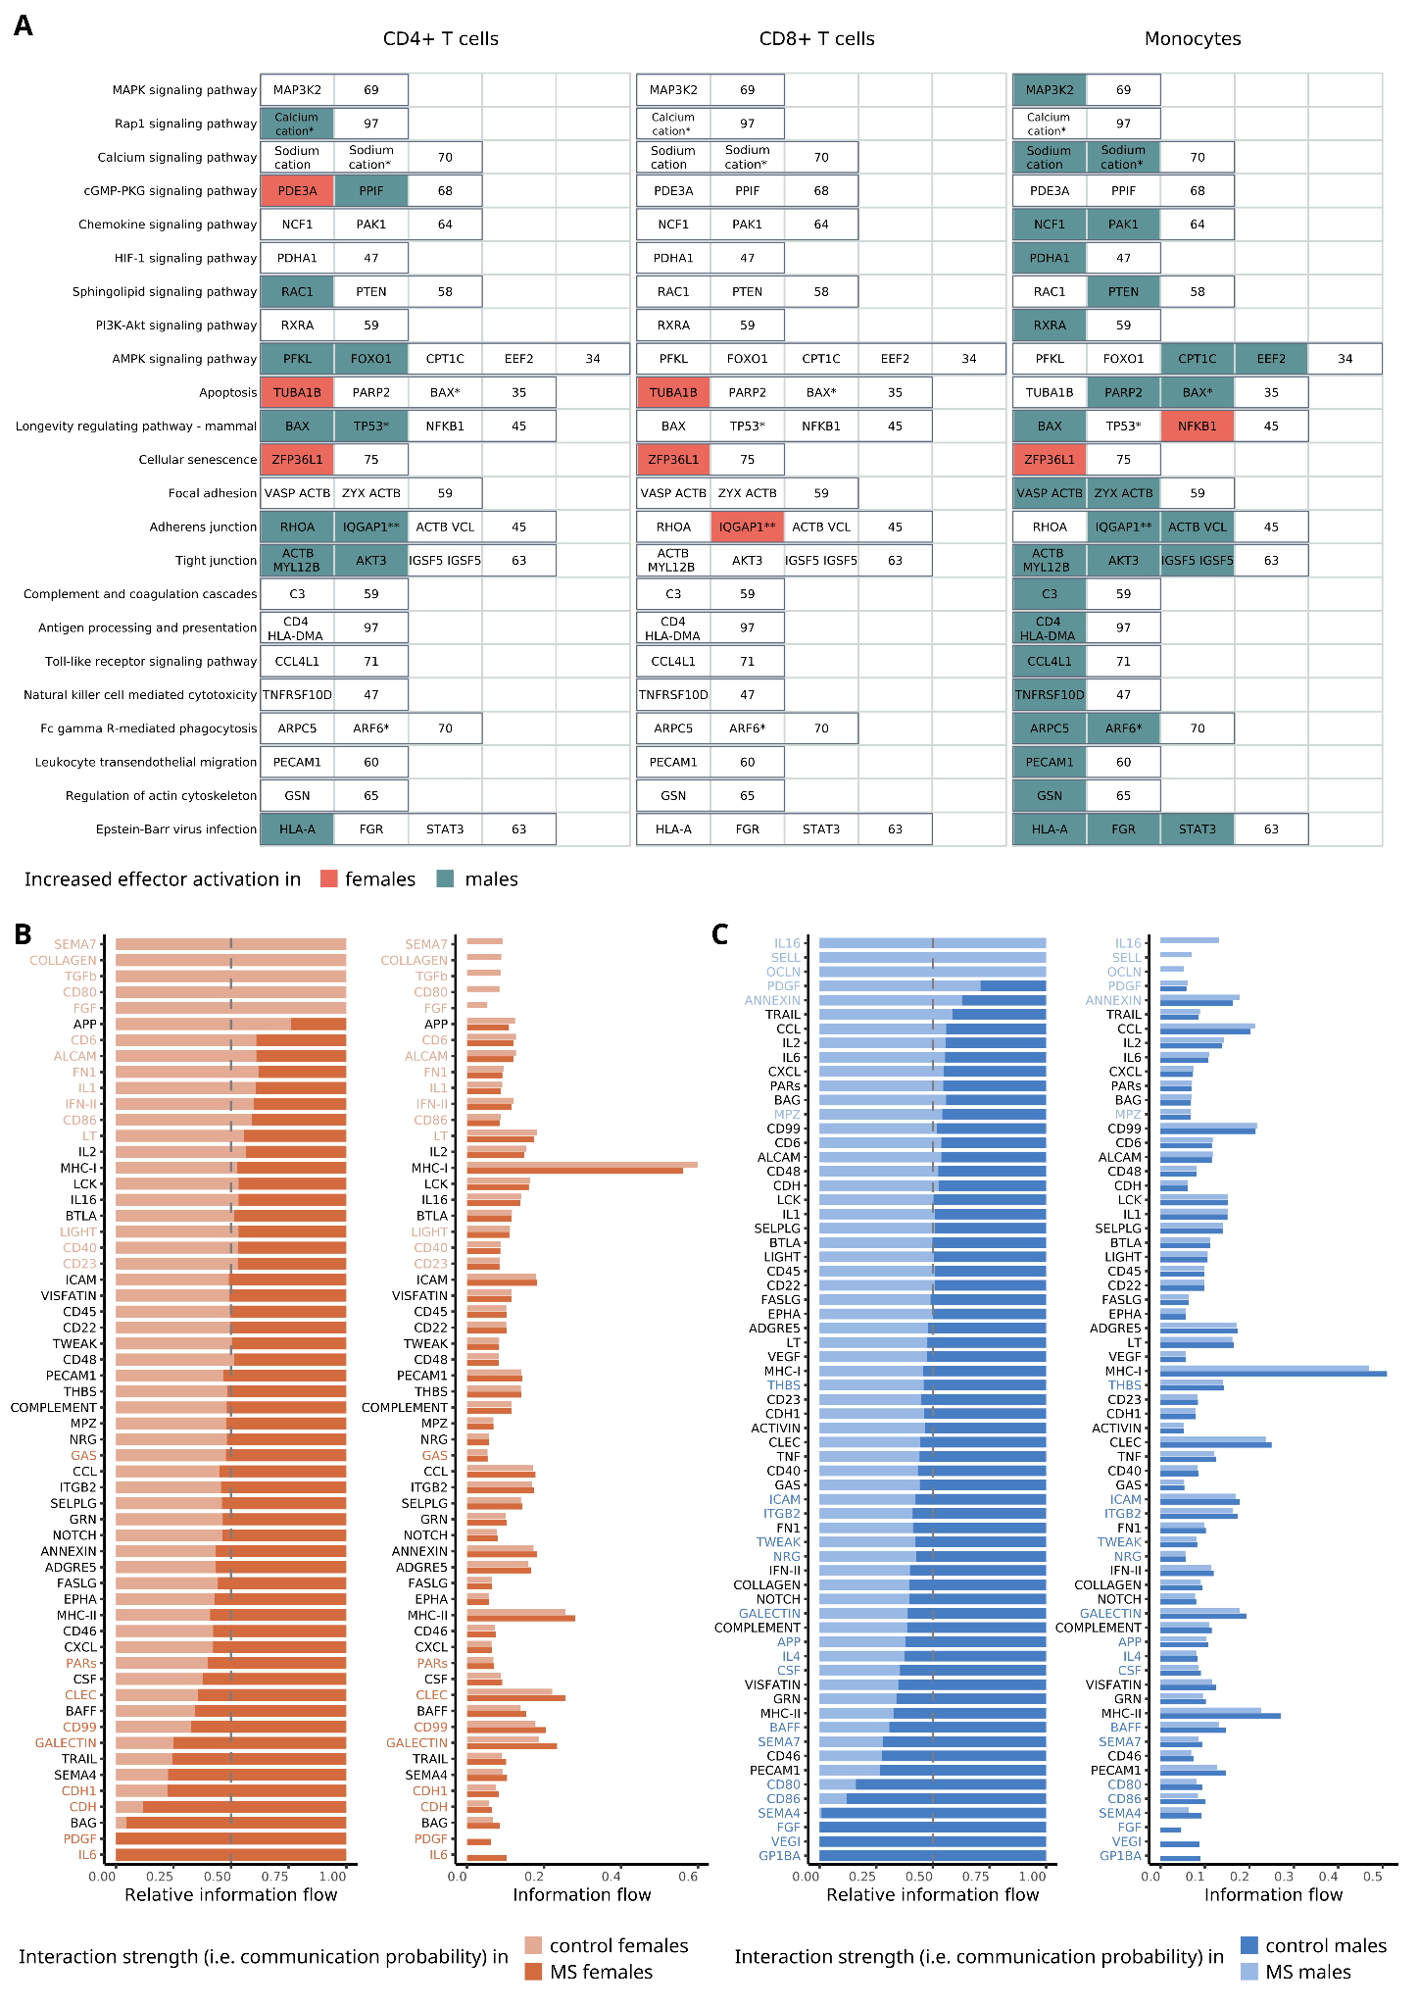

Figure S21. Detailed sex-differential significant changes in the activation of signaling pathways and interaction strengths in cell-cell communication for relapsing-remitting multiple sclerosis. (A) Effectors with increased activation in females (orange boxes) and males (green boxes). Each column represents a different cell type, and each row corresponds to a signaling pathway. Within each pathway, significant effectors for at least one cell type are highlighted. The numeric value at the end of each row denotes the count of subpathways within the pathway that lack significance in any cell type. (B-C) Relative (right) and absolute (left) information flow of pathways in females (B) and males (C) when comparing multiple sclerosis to control samples. Cell types evaluated: CD4+ T cells, CD8+ T cells, monocytes and NK cells. Information flow was calculated as the sum of communication probability (i.e. interaction strengths) among all ligand-receptor pairs in each group. Paired Wilcoxon test was implemented to determine significant differences, which are highlighted by coloring their names.

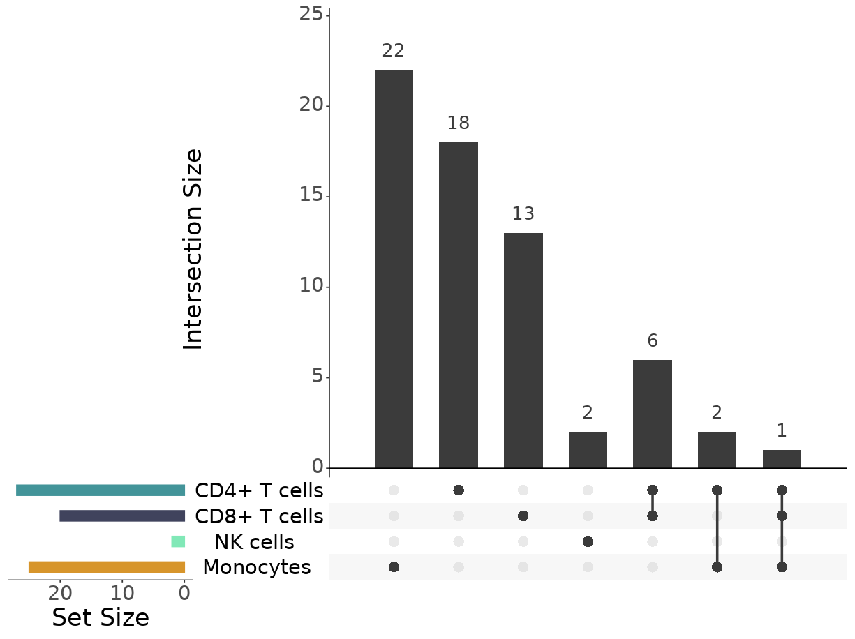
Figure S22. Upset plot for genes more expressed in males than females by cell type in relapsing-remitting multiple sclerosis. Horizontal bars represent the number of significant genes in each cell type. Dots indicate the combinations of intersections tested, with the top vertical bars denoting the number of significant genes of the corresponding intersection.

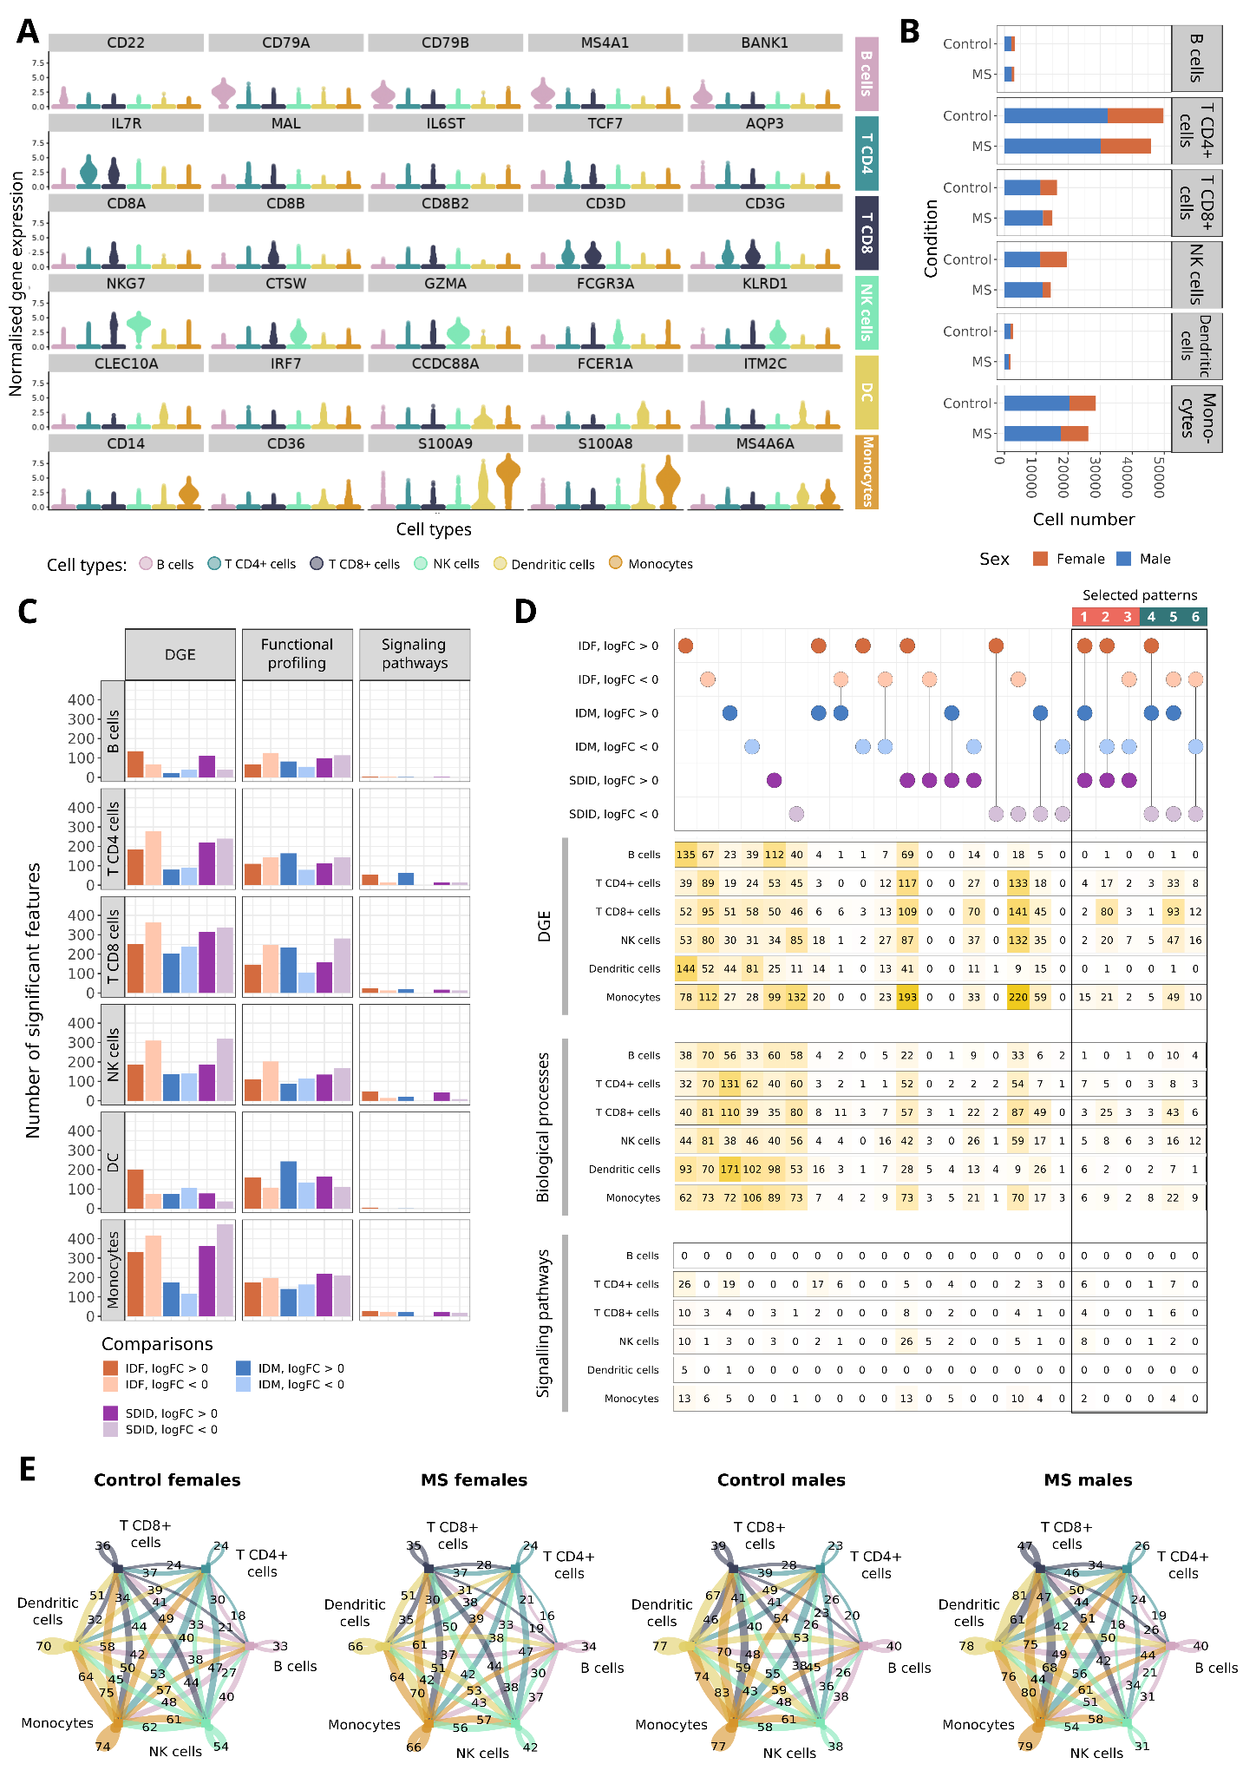

Figure S23. Summary of significant sex differences in primary progressive multiple sclerosis. (A) Expression pattern of marker genes (Y-axis) in B cells, CD4+ T cells, CD8+ T cells, NK cells, monocytes and dendritic cells (Y-axis). Each dot represents a cell, coloured according to the cell type noted. Marker genes have been selected from bibliographic research. (B) Number of cells identified for each cell type (X-axis) based on condition (Y-axis) and sex (colour). MS: multiple sclerosis. (C) Number of significant features by cell type, analysis and comparison tested. (D) Upset map of significant features for each cell type separated by comparison and direction of change (logFC). Dots display whether the feature is significant, with specific colours indicating the comparison and logFC sign. Each row of numbers indicates, for each cell type and specific analysis, the number of significant features corresponding to the evaluated column in the dot map. Coloured squares highlight the significant features in the three comparisons IDF, IDM and SDID. (E) Number of significant cell-cell interactions by group. Colour indicates the cell type providing the ligand protein. The thickness of the interaction corresponds to the magnitude of interactions. IDF: impact of disease in females (MS females vs control females); IDM: impact of disease in males (MS males vs control males); SDID: sex differential impact of disease ((MS females vs control females) - (MS males vs control males)). NK: natural killer.

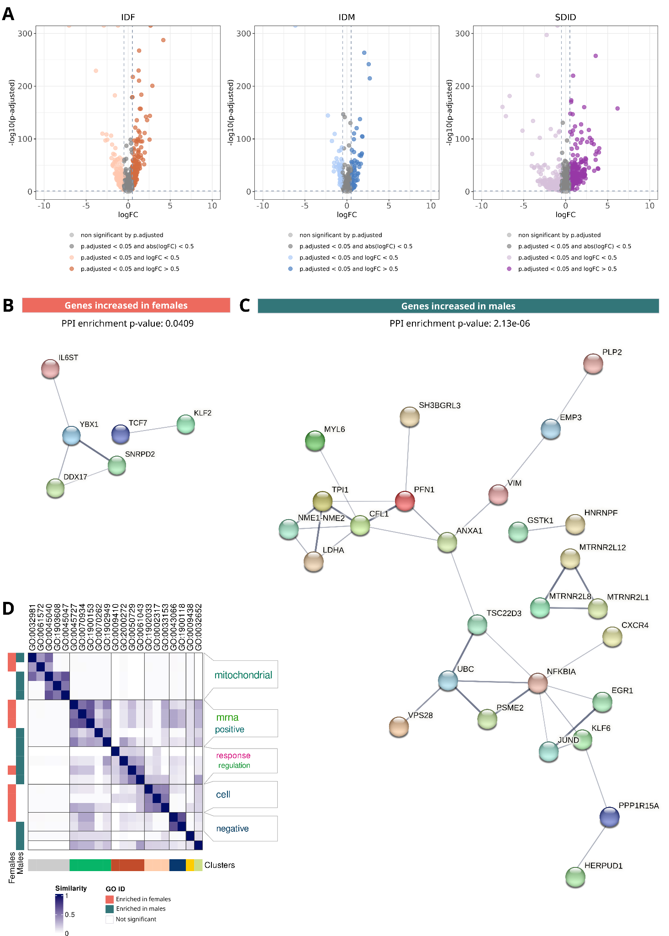

Figure S24. CD4+ T cells sex-differential atlas in primary progressive multiple sclerosis. (A) Volcano plots of differential gene expression results. Each point represents a gene distributed by its magnitude of change (logFC, X-axis) and its significance (-log10(p.fitted value), X-axis) for each comparison. IDF: impact of disease in females (MS females vs control females); IDM: impact of disease in males (MS males vs control males); SDID: sex differential impact of disease ((MS females vs control females) - (MS males vs control males)). Protein-protein interaction network of genes increased in females (B, orange) and males (C, green) from those significant in all three comparisons. Edge thickness is directly proportional to the structural and functional confidence of the interaction. PPI: protein-protein interaction. (D) Degree of similarity between sex-differential enriched functions in females (left horizontal orange bars) and males (left horizontal green bars). Each row and column corresponds with a significant function. Blue intensity indicates the degree of similarity. Clusters are shown at the bottom, with the associated word cloud on the right of the plot.

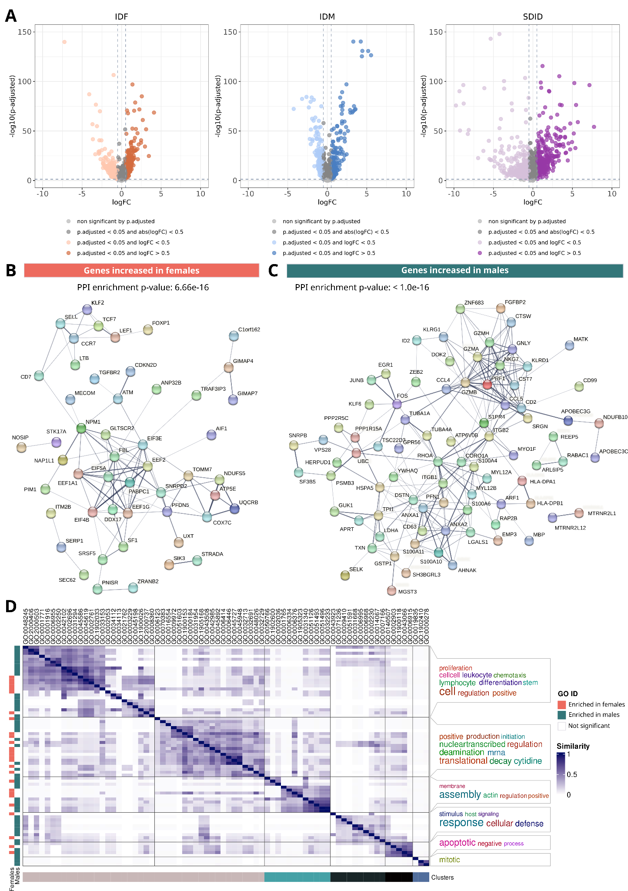

Figure S25. CD8+ T cells sex-differential atlas in primary progressive multiple sclerosis. (A) Volcano plots of differential gene expression results. Each point represents a gene distributed by its magnitude of change (logFC, X-axis) and its significance (-log10(p.fitted value), X-axis) for each comparison. IDF: impact of disease in females (MS females vs control females); IDM: impact of disease in males (MS males vs control males); SDID: sex differential impact of disease ((MS females vs control females) - (MS males vs control males)). Protein-protein interaction network of genes increased in females (B, orange) and males (C, green) from those significant in all three comparisons. Edge thickness is directly proportional to the structural and functional confidence of the interaction. PPI: protein-protein interaction. (D) Degree of similarity between sex-differential enriched functions in females (left horizontal orange bars) and males (left horizontal green bars). Each row and column corresponds with a significant function. Blue intensity indicates the degree of similarity. Clusters are shown at the bottom, with the associated word cloud on the right of the plot.

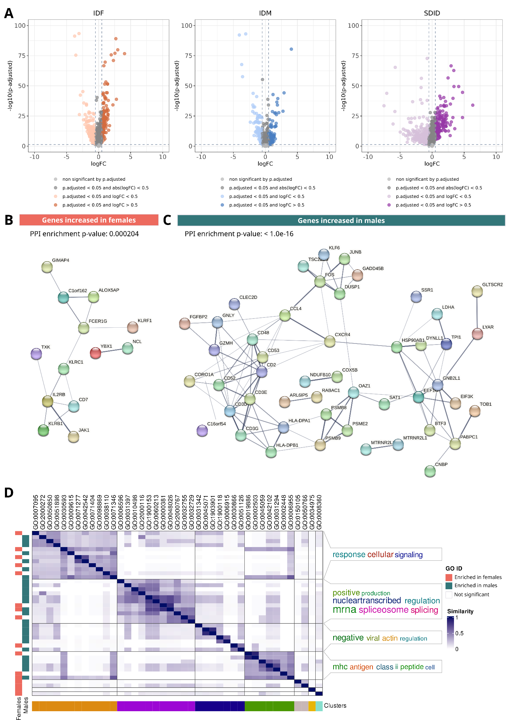

Figure S26. NK cells sex-differential atlas in primary progressive multiple sclerosis. (A) Volcano plots of differential gene expression results. Each point represents a gene distributed by its magnitude of change (logFC, X-axis) and its significance (-log10(p.fitted value), X-axis) for each comparison. IDF: impact of disease in females (MS females vs control females); IDM: impact of disease in males (MS males vs control males); SDID: sex differential impact of disease ((MS females vs control females) - (MS males vs control males)). Protein-protein interaction network of genes increased in females (B, orange) and males (C, green) from those significant in all three comparisons. Edge thickness is directly proportional to the structural and functional confidence of the interaction. PPI: protein-protein interaction. (D) Degree of similarity between sex-differential enriched functions in females (left horizontal orange bars) and males (left horizontal green bars). Each row and column corresponds with a significant function. Blue intensity indicates the degree of similarity. Clusters are shown at the bottom, with the associated word cloud on the right of the plot.

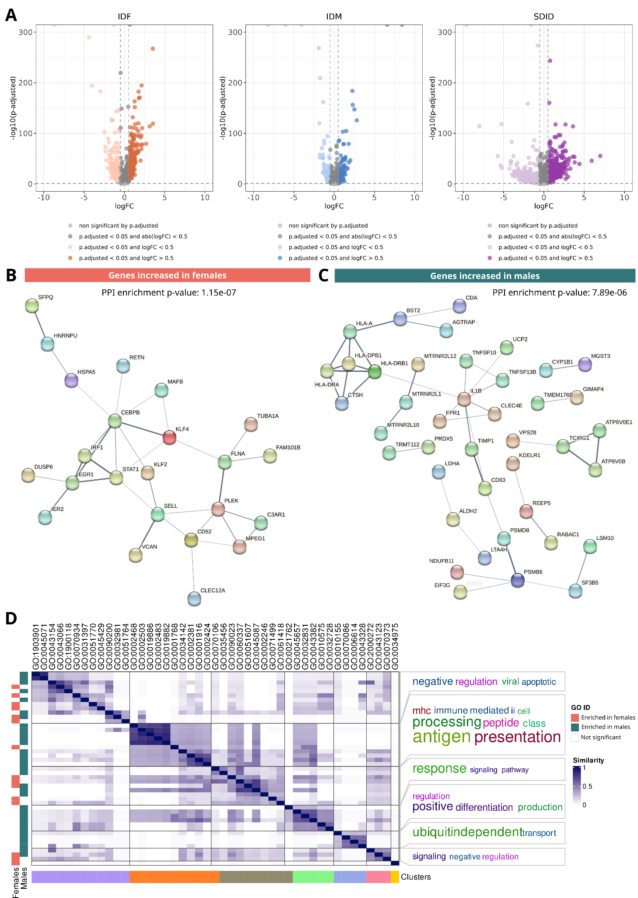

Figure S27. Monocytes sex-differential atlas in primary progressive multiple sclerosis. (A) Volcano plots of differential gene expression results. Each point represents a gene distributed by its magnitude of change (logFC, X-axis) and its significance (-log10(p.fitted value), X-axis) for each comparison. IDF: impact of disease in females (MS females vs control females); IDM: impact of disease in males (MS males vs control males); SDID: sex differential impact of disease ((MS females vs control females) - (MS males vs control males)). Protein-protein interaction network of genes increased in females (B, orange) and males (C, green) from those significant in all three comparisons. Edge thickness is directly proportional to the structural and functional confidence of the interaction. PPI: protein-protein interaction. (D) Degree of similarity between sex-differential enriched functions in females (left horizontal orange bars) and males (left horizontal green bars). Each row and column corresponds with a significant function. Blue intensity indicates the degree of similarity. Clusters are shown at the bottom, with the associated word cloud on the right of the plot.

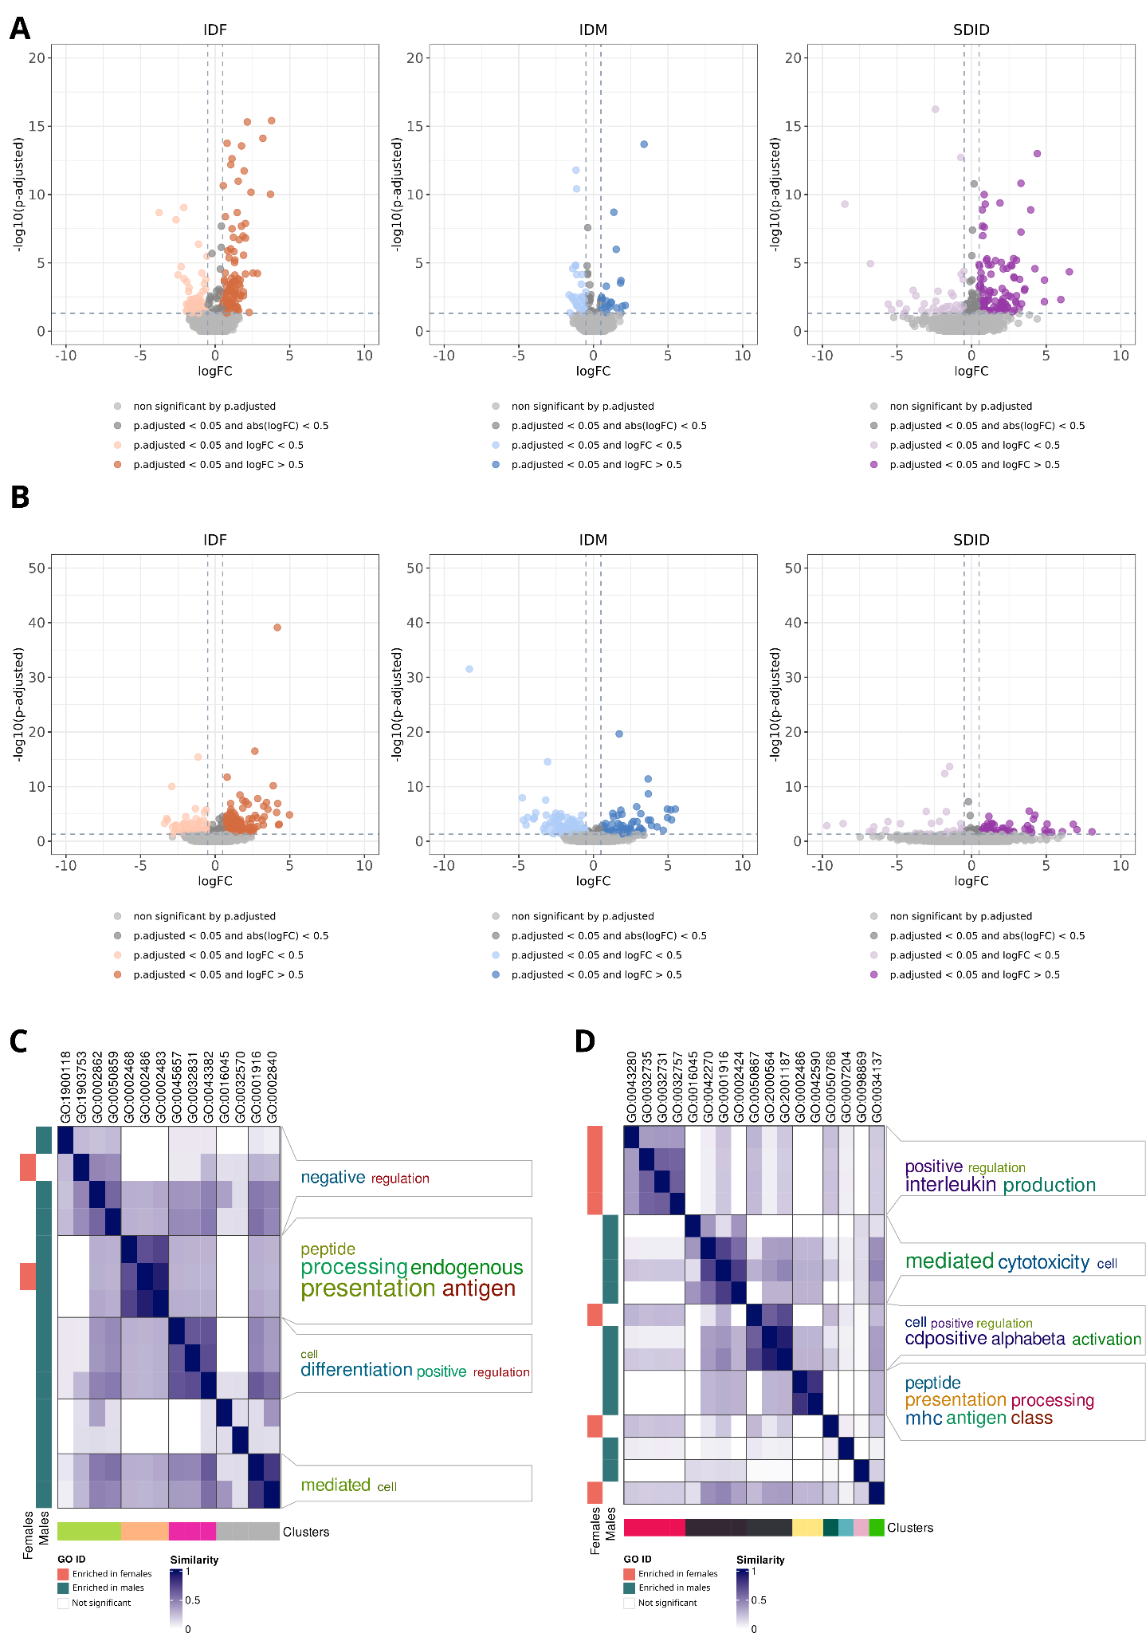

Figure S28. (A, C) B cells and (B, D) dendritic cells sex-differential atlas in primary progressive multiple sclerosis. (A,B) Volcano plots of differential gene expression results. Each point represents a gene distributed by its magnitude of change (logFC, X-axis) and its significance (-log10(p.fitted value), X-axis) for each comparison. IDF: impact of disease in females (MS females vs control females); IDM: impact of disease in males (MS males vs control males); SDID: sex differential impact of disease ((MS females vs control females) - (MS males vs control males)). (C,D) Degree of similarity between sex-differential enriched functions in females (left horizontal orange bars) and males (left horizontal green bars). Each row and column corresponds with a significant function. Blue intensity indicates the degree of similarity. Clusters are shown at the bottom, with the associated word cloud on the right of the plot.

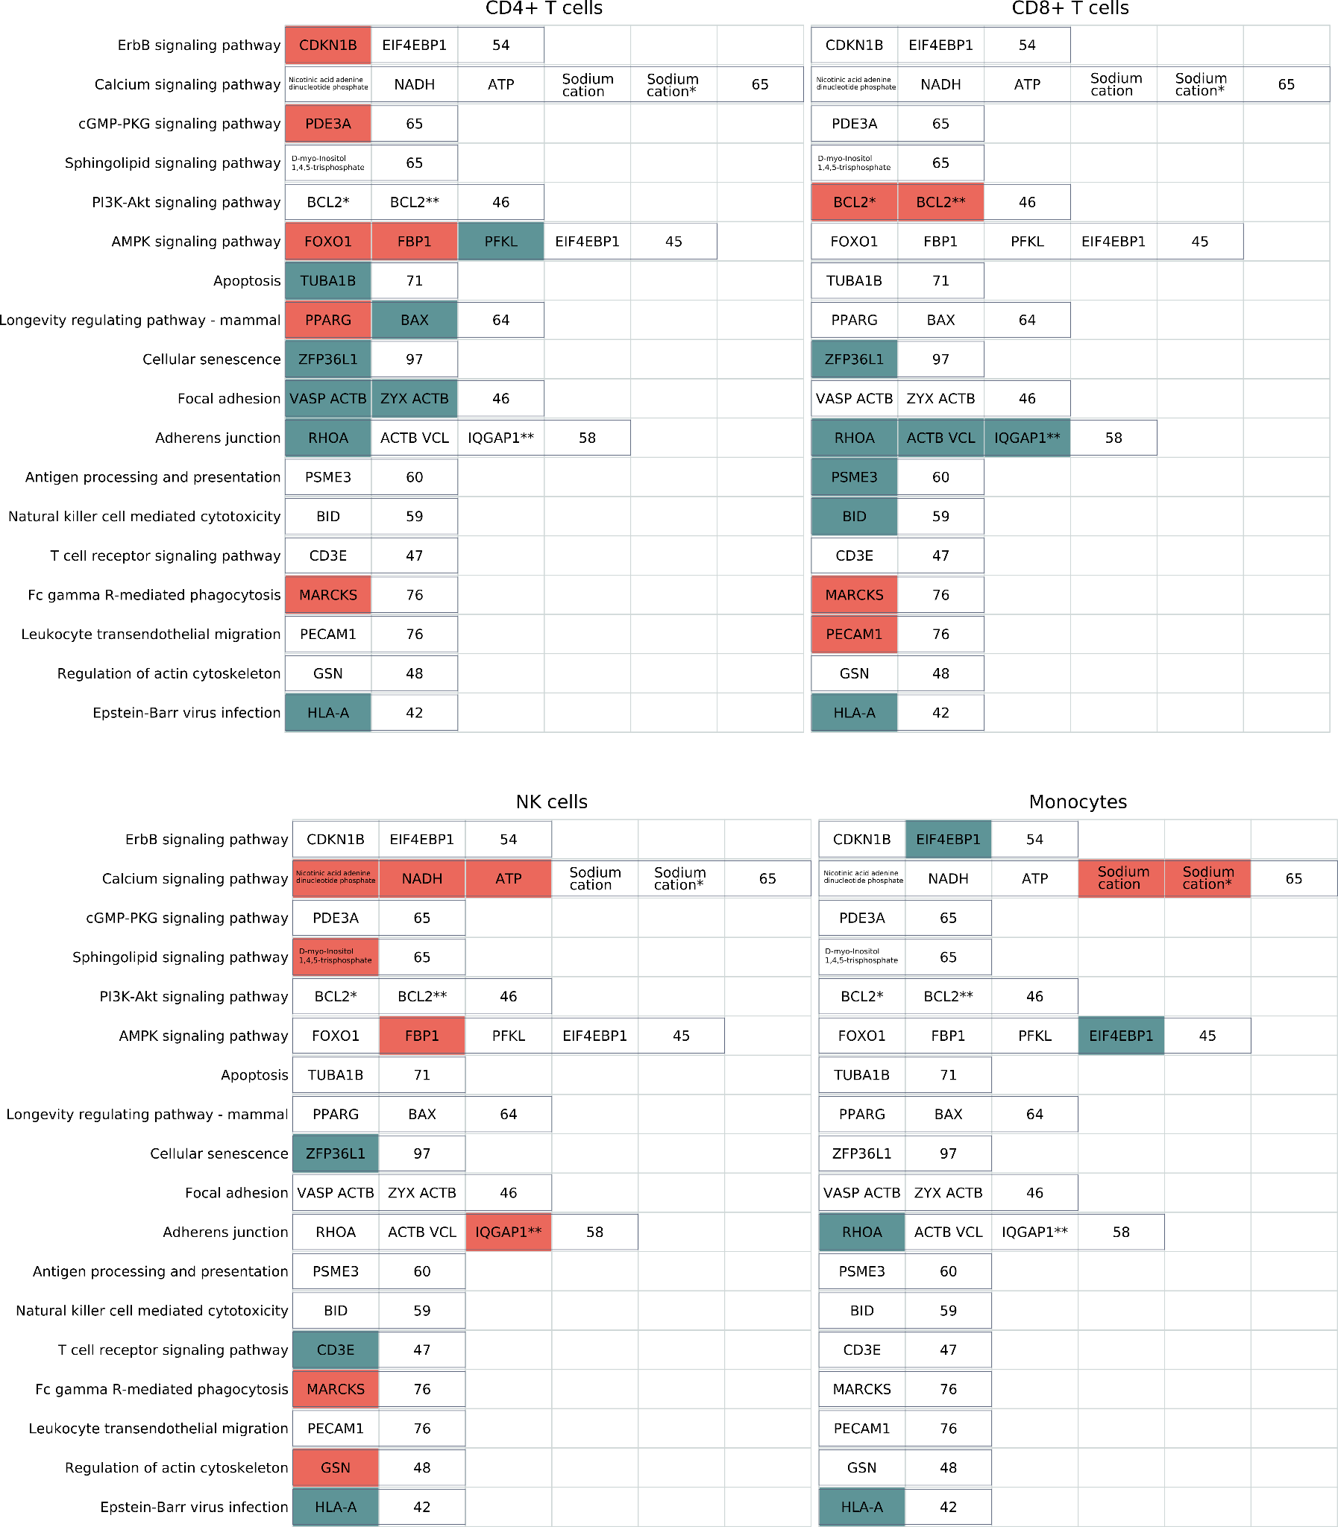

Figure S29. Detailed sex-differential significant changes in the activation of signaling pathways for primary progressive multiple sclerosis. Effectors with increased activation in females (orange boxes) and males (green boxes). Each column represents a different cell type, and each row corresponds to a signaling pathway. Within each pathway, significant effectors for at least one cell type are highlighted. The numeric value at the end of each row denotes the count of subpathways within the pathway that lack significance in any cell type.

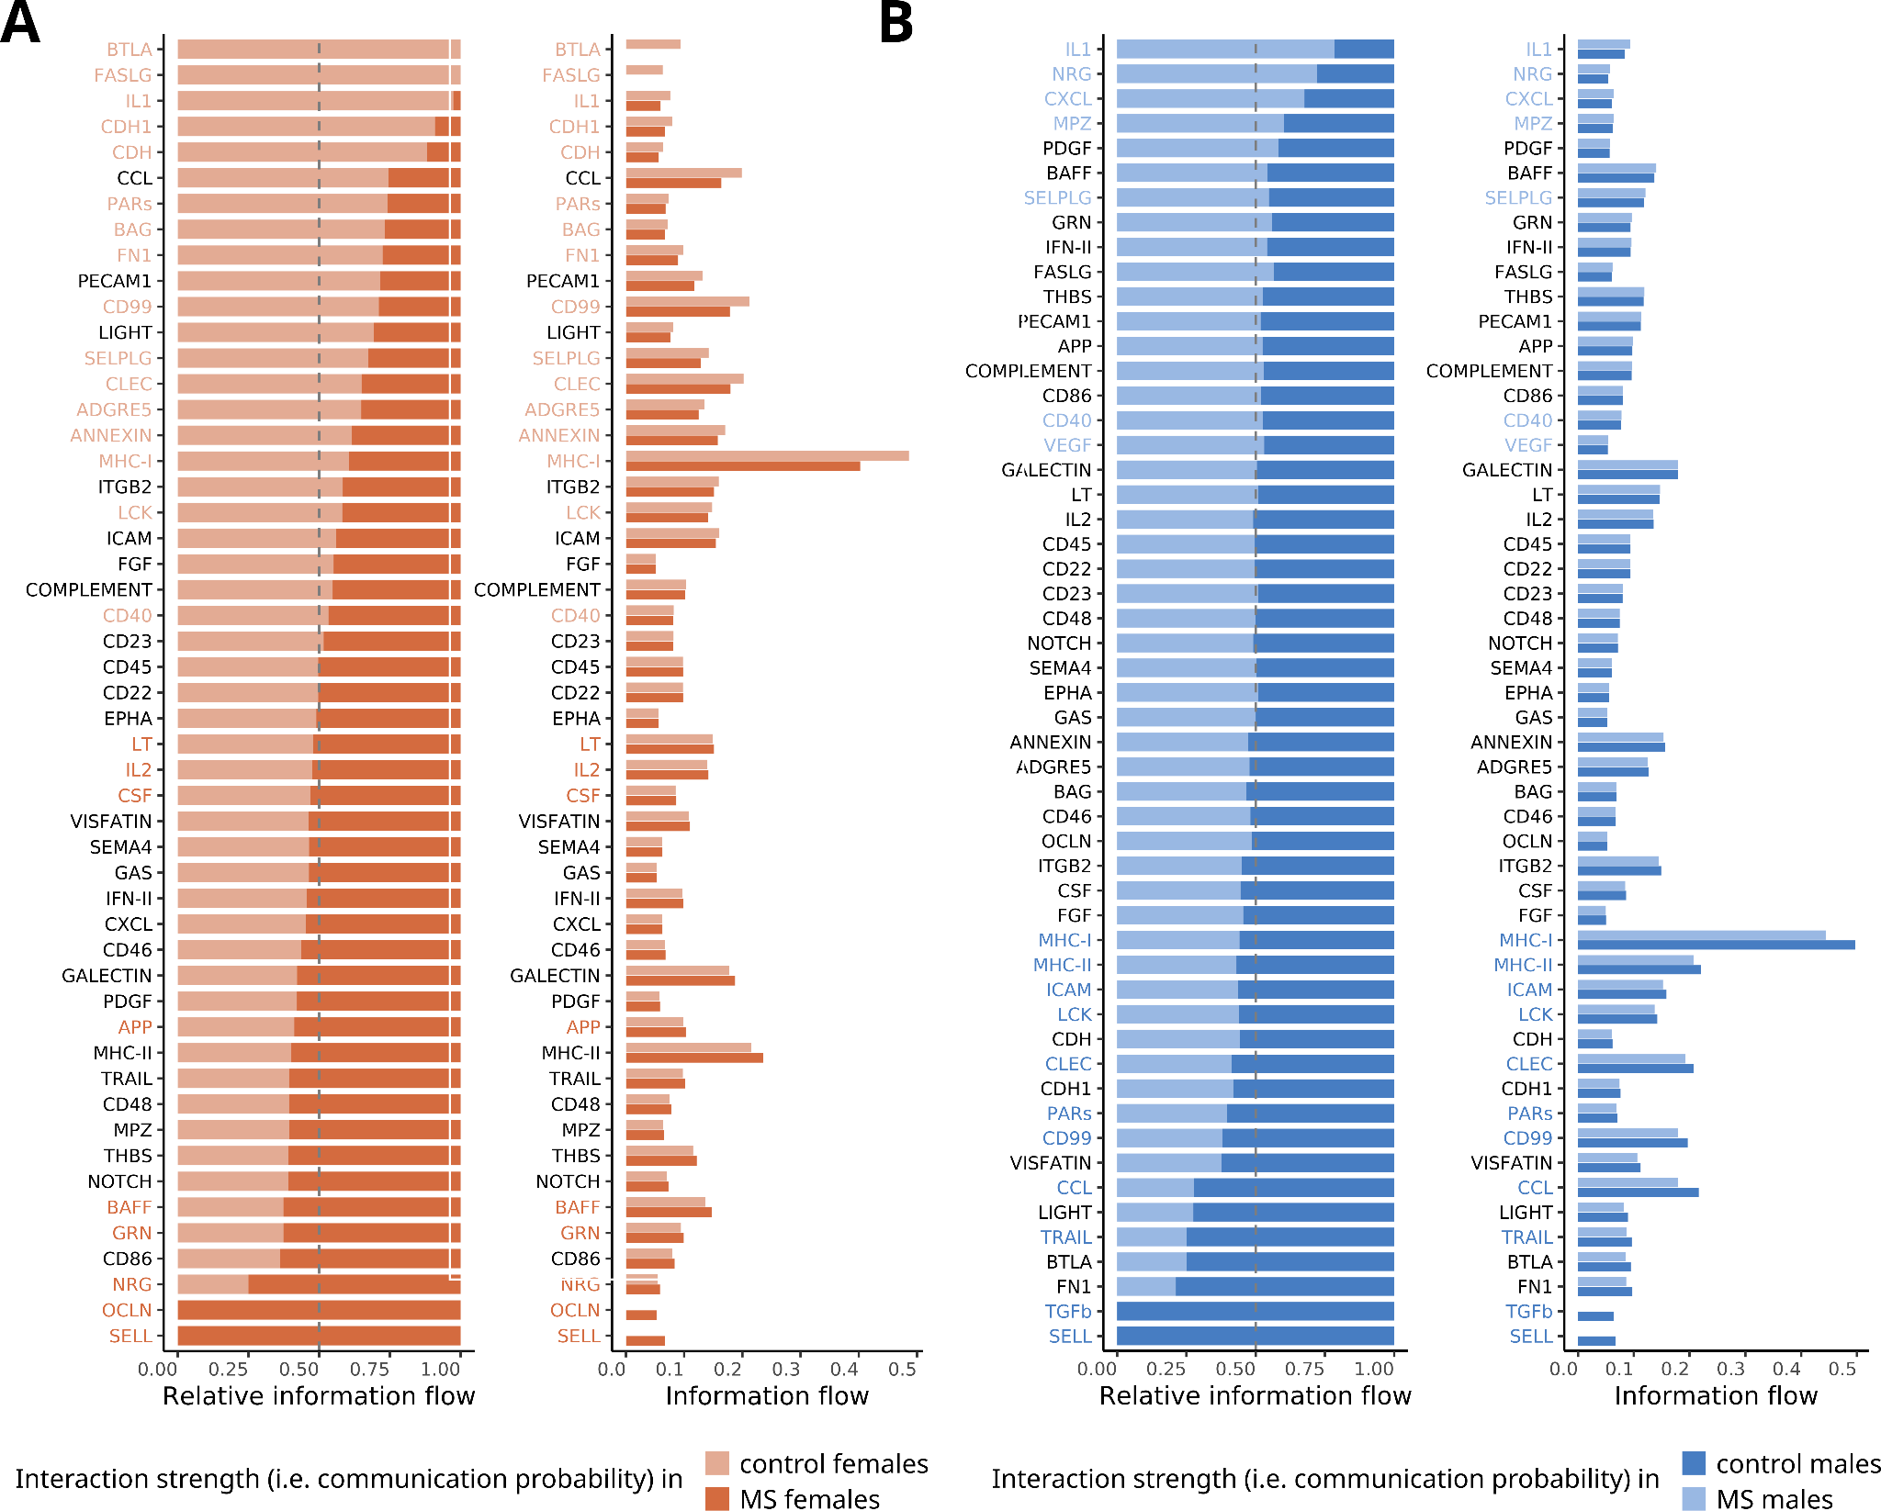

Figure S30. Detailed sex-differential significant changes in the cell-cell communication interaction strengths for primary progressive multiple sclerosis. Relative (right) and absolute (left) information flow of pathways in females (A) and males (B) when comparing multiple sclerosis to control samples. Cell types evaluated: CD4+ T cells, CD8+ T cells, monocytes and NK cells. Information flow was calculated as the sum of communication probability (i.e. interaction strengths) among all ligand-receptor pairs in each group. Paired Wilcoxon test was implemented to determine significant differences, which are highlighted by coloring their names. NK: natural killer.

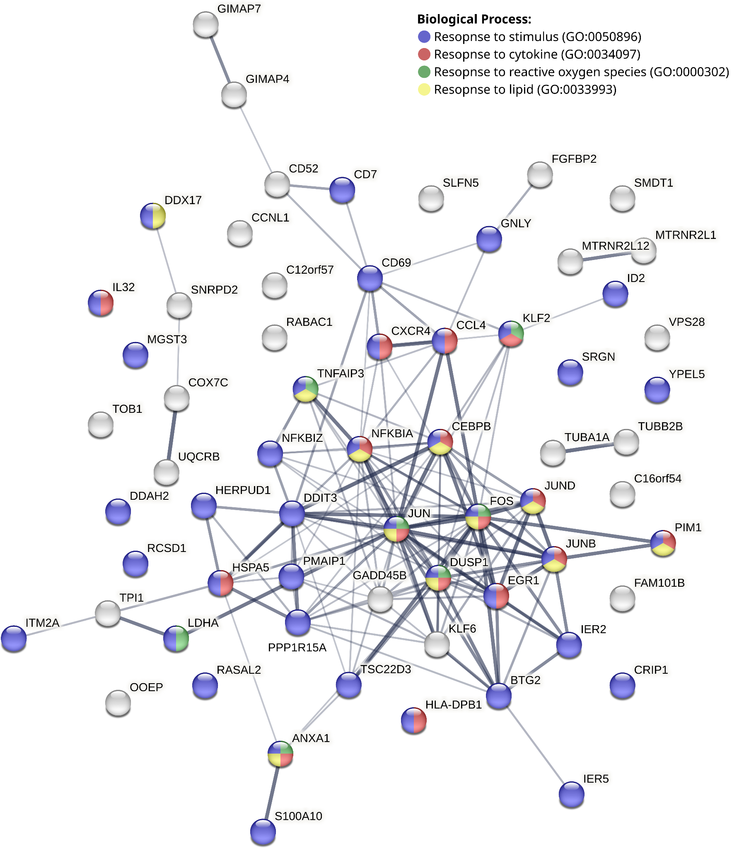

Figure S31. Protein-protein interaction network of the genes that provide clustering of RRMS and PPMS immune system cell types according to their differential sex profile. Network showing the connection of CD4+ T cells, CD8+ T cells, NK cells and monocytes in RRMS and PPMS subtypes from genes with significant expression by sex in at least three of the eight genes evaluated. Edge thickness indicates the structural and functional confidence of the interaction. Colour established based on the functions the genes are involved in. RRMS: relapsing-remitting multiple sclerosis; PPMS: primary progressive multiple sclerosis; NK: natural killer.

