Investigation of Shear Lag Effect in Reinforced Concrete Tubular Tall Buildings Considering Creep and construction stages
Vahid Gholizadeh, Ali Kheyroddin, and Davood Mostofinejad

Authors’ information

Vahid Gholizadeh: Ph.D. Candidate, Semnan University, Semnan, Iran, Vahid_Gholizadeh@semnan.ac.ir.

Ali Kheyroddin: Distinguished Professor, Semnan University, Semnan, Iran,
Kheyroddin@semnan.ac.ir.

Davood Mostofinejad: Professor, Isfahan University of Technology (IUT), Isfahan, Iran,
dmostofi@iut.ac.ir.

ABSTRACT
The phenomenon of shear lag in tubular structures is a critical aspect that influences their performance, particularly under external loads. This study investigates the effects of creep and differential shortening of columns on shear lag in high-rise reinforced concrete tubular structures. The analysis was conducted using a 20-story structural model with a square plan, employing both conventional and step-by-step methods to account for creep effects. Key findings indicate that the shear lag index, which measures the distribution of axial stress across the structure, is significantly affected by the time-dependent behavior of columns. Specifically, the study found that in the compression flange of the structure, the shear lag index increased by 10%, demonstrating the necessity of considering creep when analyses shear lag phenomena. Additionally, it was observed that creep strains can lead to a substantial increase in axial forces within web of structure. The results highlight a non-linear distribution of axial stress due to uneven vertical displacement caused by differential column shortening. This unevenness results in higher stresses in corner columns compared to intermediate ones, which is critical for structural integrity and design considerations. The study emphasizes the importance of accounting for these factors in future designs and analyses of high-rise reinforced concrete structures to ensure safety and performance under sustained loads. In conclusion, this research contributes valuable insights into how creep and differential shortening influence shear lag, providing a foundation for improved design practices in tubular structures.

KEYWORDS: Shear lag, Creep, tubular structure, Reinforced concrete, Axial stress, time-dependent, compression flange of the structure, web of structure.

INTRODUCTION
The most common type of perimeter frame consists of four rigid frame elements perpendicular to each other, forming a closed perimeter. The columns of each face are closely spaced and connected by deep beams at the level of the floors. In these structures, unlike moment frame systems, the columns are oriented to resist bending in the direction of the building's exterior face. Therefore, to increase the structural section's inertia, the majority of the load-bearing members are concentrated in the perimeter of the structure. With this description, in many perimeter frame structures, all lateral loads are only transferred to the exterior frames. Some tube systems are combined with a core wall, referred to as a core in tube system. A portion of the lateral loads will be resisted by the core. Parallel frame whit the direction of lateral force Performs the function of perimeter cantilever web, And the frames perpendicular to them act as structure flanges. Some of the gravity loads are borne by perimeter frames, while others are borne by internal structural members such as columns or cores. Although most pipe structures have square or rectangular plans, this type of structure can also be used for plans with triangular, circular, and trapezoidal shapes.
Significant numbers of tall buildings worldwide have utilized the tube system. The first analysis of the tube system concept was presented by Fazlur Rahman Khan. The tube system has such capability that, in many cases, the amount of structural materials used in this system is reduced by half compared to buildings with a modular frame system. Subsequently, studies on the tube system were developed by structural engineers, as it still remains an economical, reliable system with suitable operational capabilities for tall buildings.
The uniformity of this structural system has provided the opportunity to use advanced construction methods. In steel structures, perimeter frames can be manufactured as large components in factories and then assembled on-site. In reinforced concrete structures, the use of slip forms in the core walls significantly increases construction speed. As closely spaced columns obstruct access to large public spaces on lower story, in many buildings, the use of transfer beams is employed to collect the loads of closely spaced columns and distribute them among fewer, more widely spaced columns at the base of the structure, solving the access problem [1,2,3]. The perimeter frames bear all lateral loads, creating larger interior spaces and providing greater architectural freedom. For example, a central core with large-span floors between the perimeter frame and the core will create very large open spaces, which will be very useful for office and commercial buildings. On the other hand, numerous interior columns and walls create small spaces suitable for residential buildings.

Creep Phenomenon in Reinforced Concrete Structures (RCS)
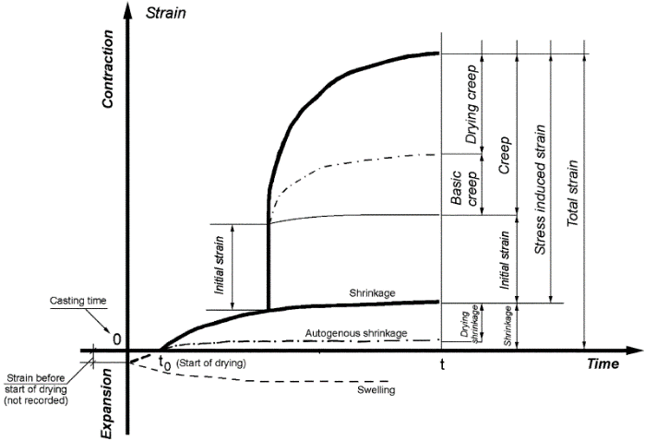
Analytically, one of the major differences between steel and concrete systems (which are the most commonly used materials worldwide) lies in the different behavior of concrete over time. This behavior is always reminiscent of the statement that "concrete is a living material." Therefore, time-dependent parameters of concrete change, and what is now of great importance is considering time-dependent changes in structural analysis, especially for high-rise structures. Deformations independent of stress in concrete, which are created for various reasons, are called shrinkage. On the other hand, the presence of constant stress in the long term also creates additional strain in concrete, known as creep. Such deformation increases rapidly in the first 4 months after loading [4]. As shown in Figure 1, total strain consists of strain due to no load (shrinkage) and strain due to load (elastic strain and creep strain).
Figure 1: Relationship between various measured and derived strain values [4];
In reinforced concrete structures, in addition to elastic deformations, non-elastic deformations occur over time due to time-dependent parameters (shrinkage, creep, modulus of elasticity), which cause shortening of the vertical members and affect the horizontal members. In the presence of constraints in a concrete member, such deformations lead to additional internal forces. It is noteworthy that besides the amount of constant stress applied to the concrete, other factors such as: a) Moisture changes and weather conditions, b) Surface-to-volume ratio of elements, c) Different percentages of reinforcement in members, and d) Concrete age at the time of loading, affect the level of creep strain in reinforced concrete. Changes in these parameters in concrete members result in uneven shortening, which affects the behavior of the beam-column connections and internal forces. Neglecting these factors can lead to several problems in structural elements, including the generation of additional internal forces, underutilization of design capacity, diaphragm shear sliding, and the propagation of cracks due to differential settlements.
In this scenario, it may be necessary for the design engineer to accurately determine the probable relative motion values and provide suitable architectural and structural details for the desired efficiency of the building [5].

Shear lag phenomenon Phenomenon in Tubular Structures
The shear lag effect has been identified long time ago. As early as the 1950’s researches had been conducted to study the shear lag effect in box beams, it was first examined by aeronautical engineers and was later studied for bridge structures with reference to the elementary case of the rectangular thin-walled box beam. Shear lag effect is relevant to any slender box element that is loaded laterally such as airplane wing structures and box girder bridges. This also includes the structural elements of buildings such as the core walls and the framed tube system [6].
Although tubular structures resemble hollow section, their behavior is much more complex than that of a simple hollow section without perforations, and their stiffness is also much lower. When a structure is subjected to lateral forces causing bending, its initial mode of behavior is similar to that of a vertically cantilever tube. The opposing-face columns on both sides of the structure neutral axis act in tension and compression (Figure 2). Furthermore, parallel frames to lateral loads are subjected causing bending in the inside of plane, and they behave in shear or cantilever mode similar to a rigid frame. However, this initial behavior becomes complicated due to the intervention of the flexible effects of the side beams, which lead to shear deformation, an increase in stress in corner columns, and a decrease in stress in intermediate columns of web and flange, making the behavior complex. Sometimes, in upper floors of the structure, the opposite of what was mentioned occurs. Usually, the axial stress of corner columns is less than that of intermediate columns, resulting in negative shear lag [7].
This type of behavior may be advantageous during the structure's performance against lateral forces. The initial resistance of the structure is provided by the web panels. In this case, the deformation occurs in such a way that columns B and A are in tension, while columns C and D are in compression. Interaction between the web and flange frames is manifested by vertical displacements of the corner columns. These displacements are related to the vertical shear of the beam frame flanges, which result in axial forces in the flange's columns. For example, in Figure 3, when column C undergoes compressive deformation, it puts the adjacent column (C1) under compression via the lateral connecting beams. Since the lateral flexible beam bends, the compressive deformations of the two columns are not the same, and column C1 will experience less deformation, depending on the stiffness of the lateral beam. In theory, pure and complete behavior of a tube or hollow section requires infinitely stiff lateral beams. The deformation of column C1 results in the deformation of column C2. However, its magnitude will be less than the deformation of column C1. Therefore, each internal column will have less deformation and stress compared to the external column on its side. Since external applied moments must be resisted by internal couples caused by tension and compression forces on both sides of the structure's neutral axis, the stresses in the corner columns will be higher than those resulting from pure tube behavior, and the stresses in the intermediate columns will be lower.
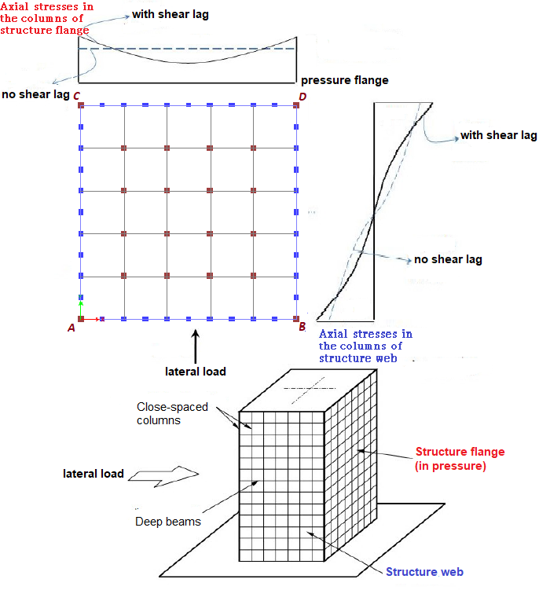
Figure 2: The distribution of axial stress in the columns of the flange and web of the structure and the occurrence of shear lag phenomenon under lateral loading [8];
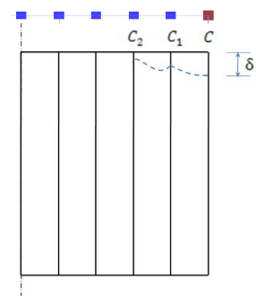
Figure 3: The deformation of the frame forming the flange of the structure and the occurrence of shear lag [9];
The difference between the stress distribution of a pure tube derived from conventional beam theory and the actual stress distribution shown in Figure 2 is illustrated. Due to the fact that the actual stress distribution in the columns is less effective compared to the stress distribution of the pure tube state, the moment and flexural stiffness decrease. Therefore, although an unbraced perimeter frame is a very effective structural form for tall buildings, the effects of shear lag in perimeter frames limit the use of maximum stiffness and structural resistance.
Due to the non-planar remaining cross-sections of the structure after the occurrence of shear lag, the floors are subjected to bending. As a result, internal separators and secondary structural elements will deform, and these deformations will accumulate with each other throughout the height of the building, forming a significant amount. Therefore, for a suitable and acceptable design, it is necessary to carefully study and understand the structural behavior of the system.

The Combined Effect of Creep and Shear lag in RCS
Since earthquakes may occur after an uncertain period following the structure's commissioning, or even during construction, considering time-dependent effects, especially creep effects, in high-rise RC structures is naturally important. Typically, a significant percentage of creep occurs in the short term after the application of dead loads, which are often caused by the weight of the structure. Additionally, creep continues with the application of live and sustained loads during operation. Although with time, the rate of shortening of the vertical members decreases.
Since the behavior of reinforced concrete structures, especially high-rise structures, is time-dependent, the shear lag phenomenon in high-rise reinforced concrete structures with a tubular system will also be time-dependent regarding the time of application of lateral loads. Therefore, it is expected that the shear lag index under the effects of creep will change after some time of operation compared to not considering time-dependent shortening.
The purpose of this article is to investigate the effect of creep and differential shortening of columns on the shear lag phenomenon in high-rise reinforced concrete tubular structures. A 20-story structural model with a square rectangular plan was used in the analyses. To examine the results of the structural analyses, a dimensionless parameter called the shear lag index was defined. The structure was analyzed conventionally and step by step to consider the effect of creep. The study is based on the long-term differential shortening effects of columns on the shear lag index.

tubular Structure Analysis
In the analysis, it is usually assumed that the stiffness of the floors is large enough to act as rigid diaphragms. Therefore, the shape of the cross-sectional surfaces on each floor remains unchanged, and only displacement changes, similar to a rigid body, occur. Thus, all horizontal displacements can be defined in terms of two perpendicular translations and one rotation.
Additionally, it is assumed that the stiffness outside the plane of the floors is small enough that they In addition to the mentioned assumptions, it is assumed that the stiffness out of the plane of the floors is small enough that they cannot withstand bending or rotation. It is also assumed that the floor system is unable to apply a couple between the frames perpendicular to the lateral loading direction, which are considered as the flanges of the side frames. Therefore, the side frames and the frames perpendicular to them are subjected to significant in-plane forces, while out-of-plane forces are neglected.
When the structure is subjected to lateral forces, the main function of the floor system is to transfer horizontal forces to the vertical structural elements. Because the floor system does not participate in bearing lateral loads, and considering that the floor loading remains constant in height, the repetitive design and construction of stories will be economically efficient.

Investigating the Combined Effect of Creep and Shear Cracking in Reinforced Concrete Pipe Structures
In order to investigate the simultaneous effects of creep and shear lag phenomena on the structure, a building with the plan and three-dimensional view shown in Figure 4 is considered. The plan dimensions are square with a length of 30 meters on each side and are defined in a way that satisfies the characteristics of a pipe system well. In this system, the perimeter pipe frames play a fundamental role in resisting lateral loads.
To examine the parametric and accurate effects of the simultaneous creep and shear lag phenomenon, which is the main goal of this study, a main structure with 20 stories and a total height of 80 meters is investigated. The building is symmetrical in two directions, and the structural sections are identical in both directions. A one-way slab is used as the floor diaphragm system.
By carefully examining the structure plan and the direction of gravitational loads, it is observed that the amount of gravitational load bearing differs between frame columns 1 and frame columns A.
To standardize the results obtained from the structural analysis, a dimensionless parameter called the shear lag index is defined. The shear lag index is the ratio of the axial force of each column in the desired direction to the axial force of the central column (the central column in the frame under consideration).
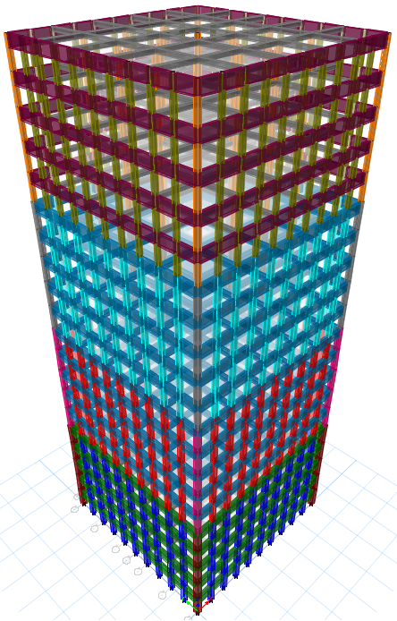
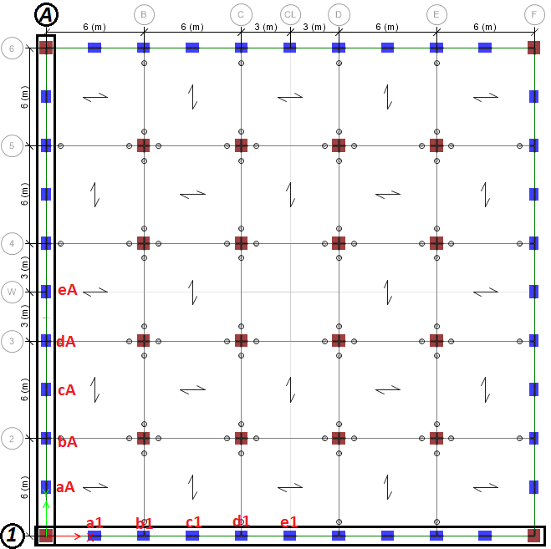

Figure 4: studied building plan and 3D view;
The structure has been analyzed using both conventional and staged construction methods to incorporate creep effects with the software ETABS 20.1.0. In conventional analyses, all the floors of the structure are loaded and analyzed simultaneously and collectively. While dead loads resulting from the weight of the structure and sometimes floor construction gradually apply to the constructed elements in the preceding stages as construction progresses. The lower floors of the structure deform under these mentioned dead loads, and the upper floors are placed on the deformed structure below. The final deformations of the structure are obtained by summing up all deformations that occurred at each stage until the final completion of the structure.
In the analysis of the structure above, considering the creep effect, a concrete strength class of C40 is assumed, with a relative humidity of 50% for Environment. The completion period of each story (from the beginning of construction operations to the day of concrete casting for slabs and beams) is assumed to be 20 days, including reinforcement, formwork, concrete pouring, curing, and formwork removal. The age of the concrete during the curing period was assumed to be 10 days, after which the weight of the structural members is applied to it. Additionally, the dead load, including the loads resulting from floor construction, etc., is 100 days after the construction of each story (concreting). For example, at the beginning of the construction of the sixth floor, half of the dead load of the first floor is applied to it, and similarly, at the beginning of the construction of the twentieth floor, half of the dead load of the fifteenth floor is applied to it.
Moreover, considering the construction sequence, other finishing operations during construction are carried out again after the structure complete. Therefore, the remaining dead loads of the stories (resulting from finishing operations), along with 50% of the live load as sustained load due to occupancy on the 500th day, are fully applied to all floors. Figure 5 illustrates the distribution of sustained dead loads in the floors.
In the analysis of construction sequence without considering creep, only the magnitude of the loads at each construction stage is important. However, in the analysis of construction sequence with time-dependent effects (creep), in addition to the load magnitude at each stage, the timing of load application is also crucial.
Creep analyses were conducted under sustained permanent loads, combining dead load (D) with half of the live load (0.5L) and in accordance with the creep model specified in the New Zealand code (NZS3101-2006). Certain necessary parameters in this model, such as the surface-to-volume ratio of structural members, were determined based on the specifications of the model. For other parameters, the values previously stated were assumed. Additionally, for the factor of the aggregate type effect on the basic creep, a value of one was considered.

Figure 5: distribution of sustained dead loads in the floors;

Investigation of Shear lag Phenomenon without Creep Effect
In the conventional analysis, the shear lag index under lateral load is calculated and plotted. Figure 6 illustrates the Langley shear index diagram for the designated columns in frames 1 and A, respectively under earthquakes EY and EX, at stories 1st, 5th, 10th, 15th, and 20th. Additionally, Figure 7 depicts the distribution of axial forces in the columns located in frames F and 6, respectively under earthquakes EY and EX, as web of structural at the same stories.

Figure 6: Shear lag index diagram under load cases (EX) and (EY) in Frames 1,6,A and F- without creep effect;
in Figure 6, the shear lag effect often causes a concave shape. This condition is sometimes referred to as positive shear lag, meaning that the shear lag index exceeds 1 (refer to the definition of shear lag and Figure 4). In Figure 4, the condition is plotted based on a shear lag index greater than 1. Concave shear lag occurs when with the distance from the central column at the flange of the structure increases the stress in the columns, and the shear lag index, calculated based on the central column, will be greater than 1.
Convex shear lag is, in fact, the reduction of the shear lag index to less than 1. This means that by moving away from the central column at the flange of the structure (the central column in frames A and 1), the axial stress in the perimeter and corner columns decreases. This condition is also referred to as negative shear lag.
The negative sign in the shear lag index also indicates a change in the sign of axial stress between the column under consideration and the central column. However, under lateral loads alone, columns located at upper levels are all under tension or compression, and the stresses and shortenings of all columns are in the same direction. Therefore, the sign of the shear lag under lateral loads cannot be negative.
Considering that shear lag is investigated without the effect of creep, and on the other hand, the structure is completely symmetric, and also the structural sections are completely the same in both directions, therefore, Therefore, considering the equal entry of external forces in both directions, the shear lag value for frame 1 is exactly equal to frame A. Also, the shear lag in the tension and compression flanges of the structure will be equal to each other. This also applies to the distribution of axial force in the columns located web of structure to lateral loads. The distribution of force and axial stress in the columns located at the core of the structure under uniform lateral load is consistent across all four perimeter frames. Figure 7 results indicate that the middle column (the column located at the Symmetry axis of the structure) in a frame that acts as the main structural component will not bear any lateral force. The highest axial effort occurs in columns further away from the neutral axis and on lower stories.
An important point to note in the latest diagram is that the shear lag index (as the main parameter in judging the results) is significantly higher in the lower story (approximately 2.22 in the column just before the corner column, reaching its maximum value on the first story) and gradually decreases in the upper stories.

Investigation of Shear lag Phenomenon with Creep Effect
To investigate the phenomenon of creep, it is necessary to first address the behavior of the structure under creep phenomenon in general. Creep leads to shortening in the vertical members (inelastic vertical displacement), and each vertical member may experience differential shortening compared to its adjacent member. In general, cumulative creep in the vertical members results in the final absolute shortening in all levels of the structure. However, what matters is the relative shortening on each floor. Figure 8 illustrates the vertical elastic shortening, total shortening (elastic and inelastic) and the shortening due to creep and construction sequence (derived from subtracting elastic shortening from total shortening) in column e1 (as indicated in Figure 4), both relatively and absolutely.

Figure 8: Elastic, inelastic and total vertical displacement (absolute and relative) in column e1;

The greatest absolute elastic shortening occurred on the highest story, and all relative shortenings are positive. This holds true for elastic shortenings under gravitational loads. By absolute shortening, we mean the change in displacement of the upper node of the column relative to the designed axis. Since all stories of the structure experience shortening, the relative shortening on each story results from the difference in vertical displacement of two consecutive nodes at the top and bottom of the story. The greatest total shortening (the sum of elastic and non-elastic shortening including creep effects and construction stages) has occurred at story 13. As seen in Figure 8, column e1 experienced a reduction in length up to the 13th story (including the 13th story itself), leading to an increase in total vertical displacement (as indicated by the slope of the cumulative displacement curve). From the 13th to the 20th story, the relative displacement of each story has been assessed as positive, and column e1 has experienced an increase in length due to creep. This led to an overall decrease in cumulative vertical displacement from the 13th story upwards, resulting in the greatest vertical displacement relative to the initial structural axis occurring on the 13th story. In fact, up to the 13th story, the displacement of the upper node of the column was greater than the displacement of the lower node on column. From the 13th to the 20th story, the displacement of the lower node was greater than the displacement of the upper node of the story, leading to an increase in length in the column. On the other hand, in other vertical members, depending on the type and magnitude of sustained gravity loads and other conditions, the maximum absolute non-elastic vertical displacement may occur on a story other than the 13th floor. However, In the peripheral columns of this structure, the maximum absolute non-elastic vertical displacement is concentrated at story 13.
The inelastic shortening is estimated solely to account for creep effects, excluding the effects of shrinkage and variations in concrete compressive strength and modulus of elasticity. By subtracting the elastic vertical displacement from the total displacement, the inelastic displacement due to creep in construction stage analyse are obtained. Due to constraints in the structure, inelastic shortening leads to additional internal efforts in the members, especially in the beams. Figures 9 and 10 illustrates the inelastic shortening diagrams of columns in frames 1 and A. These displacements are solely due to creep in construction stage analyse. The amount of shortening in frames 1 and A is not identical in this structure. The difference arises due to variations in the distribution of gravity loads on the slabs.

Figure 9: Inelastic vertical displacement (absolute) in columns a1,b1,c1,d1,e1 (Frame 1);

Figure 10: Inelastic vertical displacement (absolute) in columns aA,bA,cA,dA,eA (Frame A);

The above explanations clarify the complexity of the structure's behavior under creep and its impact on horizontal members.
Therefore, the additional forces resulting from only the non-elastic vertical displacement in the columns were calculated. In Figures 11 and 12, the additional forces due to non-elastic vertical displacement in the columns of frames 1 and A in the first, fifth, tenth, fifteenth, and twentieth stories are shown.

Figure 11: Additional forces resulting from inelastic vertical displacement (Frame 1);

Figure 12: Additional forces resulting from inelastic vertical displacement (Frame A);

The very important point concerns the additional forces made in the columns. For these additional forces, irrespective of the displacement, are created. For example, in columns a1 and b1 in frame 1, as well as in columns aA and bA in frame A, which are adjacent to each other, non-elastic displacement at the lowest story result in additional axial forces in opposite directions (positive and negative).
To investigate the combined effect of creep along with the effect of shear lag, the same shear lag index was considered. To calculate the shear lag index while taking into account the creep phenomenon, additional stresses due to creep were considered in the columns. First, internal forces resulting from the combination of dead load (D) and 0.5 times the live load (L) without creep effects were extracted. The additional stresses in the columns are obtained by subtracting the stresses from sustained loads with creep effects after 5000 days from the stresses generated by these loads without creep effects. It is noteworthy that the additional stresses generated from creep-induced deformations cause shear in the perimeter beams, and this shear results in an increase or decrease in the stiffness of the perimeter beams.
Figures 13 and 14 show the shear lag index in the flange of the structure under compressive and tensile conditions, respectively, along axis 1, and the load pattern EY in the first, fifth, tenth, fifteenth, and twentieth stories. Additionally, Figure 15 illustrates the distribution of axial loads in the web of the structure (frames A and F acting as the web of structure) under the EY load pattern.

Figure 13: Shear lag index diagram under load case (-EY) in Frame 1 - with creep effect;

Figure 14: Shear lag index diagram under load case (EY) in Frame 1 - with creep effect;

Figure 15: Shear lag index diagram under load case (EX) in Frame A - with creep effect;

Figures 16 and 17 show the shear lag index in the flange of the structure under compressive and tensile conditions, respectively, along axis A, and the load pattern EX in the first, fifth, tenth, fifteenth, and twentieth stories. Additionally, Figure 18 illustrates the distribution of axial loads in the web of the structure (frames 1 and 6 acting as the web of structure) under the EX load pattern.

Figure 16: Shear lag index diagram under load case (-EX) in Frame A - with creep effect;

Figure 17: Shear lag index diagram under load case (EX) in Frame A - with creep effect;

Figure 18: Shear lag index diagram under load case (EY) in Frame 1 - with creep effect;

The shear lag index in the compression and tension flanges differ due to the consideration of axial stresses resulting from creep. Examination results indicate that in frame A under lateral load pattern EY, the shear lag index in the lowest floor for the compression flange increased by about 10% when considering the effect of creep compared to not considering it. The shear lag index also increased in other floors for the compression flange. Conversely, creep caused a decrease in the shear lag index in frame A when it acted as the tension flange of the structure. Generally, in the lower floors, creep caused an increase in the shear lag index in the compression flange and a decrease in the shear lag index in the tension flange of the structure. These observations are similar for frame 1 as well.
The difference in results and the values of the shear lag index between frames 1 and A is more noticeable in the upper stories. The effects of creep and differential shortening are more pronounced in the upper stories, and the difference between the two frames is evident in stories 15 and 20. Additionally, the shear lag index chart between frames 1 and A sometimes shows significant variations in the upper stories. The value of the shear lag index in the upper stories alone cannot be a criterion for judgment, as in the upper stories, the axial stresses influenced by external moments are negligible, and their accumulation with the stresses caused by creep will result in the axial stress of the central column tending towards zero. Therefore, sometimes the shear lag index in the upper stories, with the effect of creep, may lead to very large values for the adjacent columns.
The distribution of axial force in the web of the structure shows that creep in the lowest story sometimes causes an increase or decrease in the axial force in the compression columns of the lowest story. This is due to the axial stresses created in the columns due to constraints against time-dependent deformations. Additionally, constraints cause additional tensile axial stresses in the penultimate corner column, and the axial force in column Aa under lateral load pattern EY in the web of the structure increased by about 18% in tension and decreased by the same amount in compression. Furthermore, the axial force in column 1a in frame 1 also decreased and increased by about 6% in compression and tension, respectively, under lateral load pattern EX in the lowest story.

conclusion
In general, creep strains lead to the vertical shortening of columns. Vertical shortening of the columns relative to the main axis (the structural design axis) occurs in all stories. However, the maximum absolute shortening happens in a story below the top story.
The important factor is the relative shortening. The effect of creep in the columns of the lower stories (those below the story where the maximum vertical displacement occurs) always manifests as relative shortening. Although all axes experience absolute shortening relative to the main structural axis, in the upper stories (those above the story with the maximum vertical displacement), creep strains cause an increase in relative length. In fact, in the upper stories, the columns experience longitudinal elongation due to creep.
Part of the creep strains is manifested as deformation, while another part appears as internal stresses within the members. The phenomenon of shear lag, considering the effect of creep, is not identical between the tension and compression flanges of the structure in each direction. Creep strains occur under constant load, but shear lag under lateral load in both directions places the flanges under compression and tension. The creep phenomenon can sometimes even reduce the shear lag in the tension flange, leading to a change in the shear lag index from positive to negative in the upper stories of the tension flange. Since the lateral forces and the external couple applied to the structure are cyclic, examining the phenomenon of shear lag in the compression flange is more important.
In summary, the creep phenomenon, through the additional stresses it creates, causes changes in the shear lag index.

Declarations

Availability of data and materials
The datasets used and analysed during the current study are available from the corresponding author on reasonable request.

Competing interests
The authors declare that they have no competing interests

Funding
Not applicable

Authors' contributions
All authors read and approved the final manuscript.

Acknowledgements
Not applicable

Authors' information -Job status
Vahid Gholizadeh: Ph.D. Candidate, Semnan University, Semnan, Iran, Vahid_Gholizadeh@semnan.ac.ir.
Ali Kheyroddin: Distinguished Professor, Semnan University, Semnan, Iran, Kheyroddin@semnan.ac.ir.
Davood Mostofinejad: Professor, Isfahan University of Technology (IUT), Isfahan, Iran, dmostofi@iut.ac.ir.

Footnotes
Not applicable

REFERENCES
[1] Luo, Q.Z., Tang, J., Li, Q.S., and Liu, G.D., (2009). "A Finite Segment Model for Shear Lag Analysis", Engineering Structures, Vol. 26, pp. 2131-2124.
[2] Luo, Q.Z., Tang, J., and Li, Q.S., (2003). "Shear Lag Analysis of Beam-Columns", Engineering Structures, Vol. 25, pp. 1131-1138.
[3] Luo QZ, Tang J, and Li Q.S. (2001). "Negative Shear Lag Effect in Box Girders with Varying Depth", J. Struct. Engrg, ASCE, Vol. 127 No. 10, pp.1236–9.
[4] ACI Committee 209. (2008). Guide for Modeling and Calculating Shrinkage and Creep in Hardened Concrete (ACI 209.2R-08). Farmington Hills, Michigan, USA: American Concrete Institute.
[5] Khan, F.R., Fintel, M. (1971). Conceptual details for creep, shrinkage, and temperature in ultra high-rise buildings. Special Publication, 27: 215-228.
[6] Dalbiso, A. D. (2013). STUDY OF SHEAR LAG EFFECT IN BOX GIRDER BRIDGES.‏
[7] Naderpour, H., Kheyroddin, A. Investigation on the shear lag phenomenon in concrete tall buildings with tube systems. [Journal of modeling in engineering]. Semnan. Iran. 2010. Vol. 26. Pp. 33–48 (Persian).
[8] Stafford Smith, B. and Coull, A., (1991). Tall Building Structures: Analysis and Design. John Wiley & Sons, New York.
[9] Stafford Smith, B., Coull, A., and Cruvellier, M. (1988). "Planar Models for Analysis of Intersecting Bent Structures", Computers and Structures, Vol. 29, pp. 257-263.

