Supplementary Material for
Limited consensus of marine viral diversity observed across techniques

Marina Vila-Nistal^{1,2}, Francisco Martinez-Hernandez^{1,2}, Monica Lluesma-Gomez^{1,2}, Oscar Fornas^{3,4}, Simon Roux⁵, Manuel Martinez-Garcia^{*1,2}

¹Department of Physiology, Genetics, and Microbiology, University of Alicante, Carretera San Vicente del Raspeig, San Vicente del Raspeig, Alicante, 03690, Spain
²Multidisciplinary Institute for Environmental Studies (IMEM), University of Alicante, Carretera San Vicente del Raspeig, San Vicente del Raspeig, Alicante, 03690, Spain
³Centre for Genomic Regulation (CRG), The Barcelona Institute for Science and Technology (BIST), Carrer del Doctor Aiguader, 88, PRBB Building, Barcelona, 08003, Spain
⁴Universitat Pompeu Fabra (UPF), Carrer del Doctor Aiguader, 88, PRBB Building, Barcelona, 08003, Spain
⁵Joint Genome Institute. Department of Energy of EEUU, California, EEUU

*Correspondence to: m.martinez@ua.es
phone +34 965902161
The authors declare no competing interests.

This supplementary material contains five supplementary figures and two supplementary tables

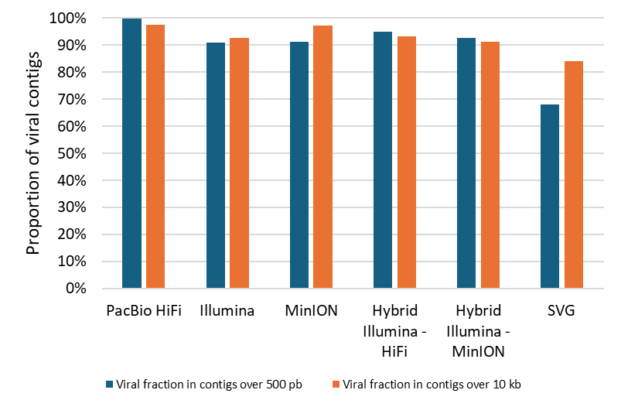
Supplementary Figure 1. Proportion of contigs identified as viruses (see Methods) recovered by each methodology, relative to the total of recovered contigs over 500 pb (blue) or over 10 kb (orange).

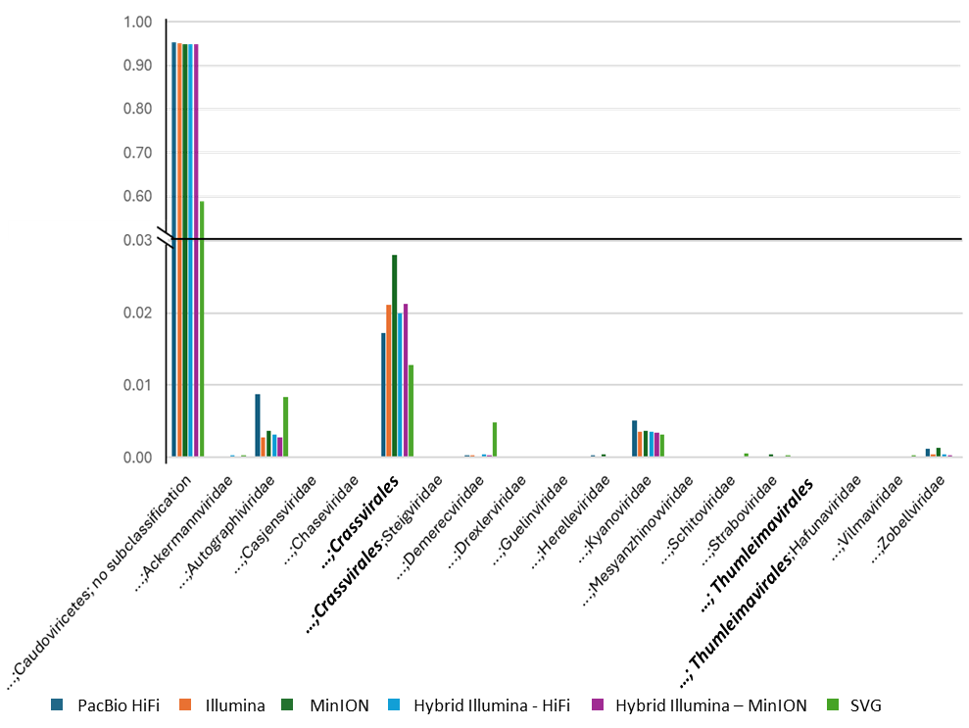
Relative frequency
Supplementary Figure 2. Taxonomic breakdown of the viral contigs recovered from each method, considering only those inside the Caudoviricetes class as they constitute over the 80% of the contigs and present the true differences between methods. Orders are marked in boldface type to distinguish them from the families, most of which currently remain unassigned to an order.

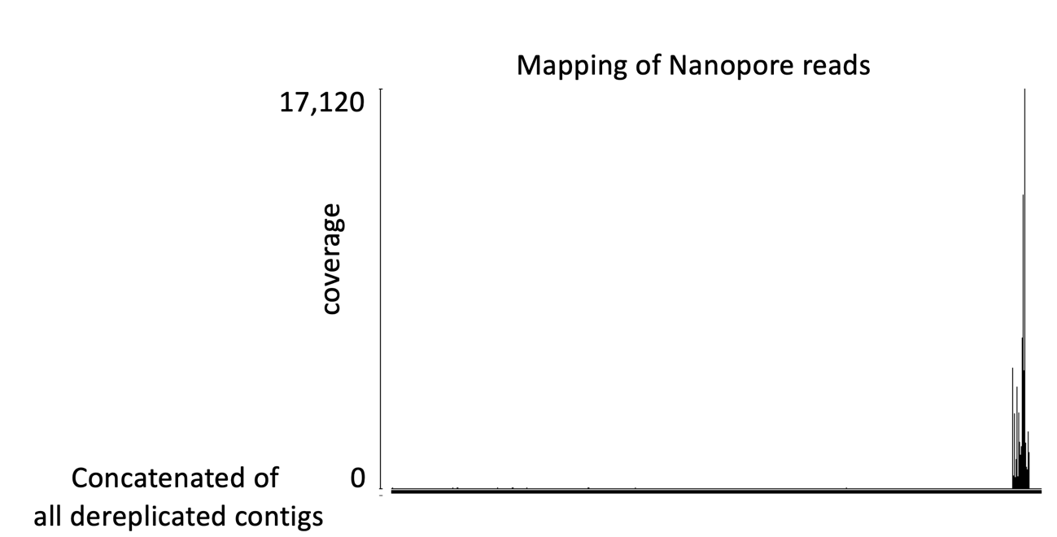
Supplementary Figure 3. Read mapping of Nanopore data (MinION platform) against all concatenated, dereplicated viral contigs (≥10 kb) obtained from all methods (X axis). Mapping was performed with Geneious bioinformatic program using the Geneious mapper with custom sensitivity employing a minimum read overlap of 500 bp and 80% of nucleotide identity.

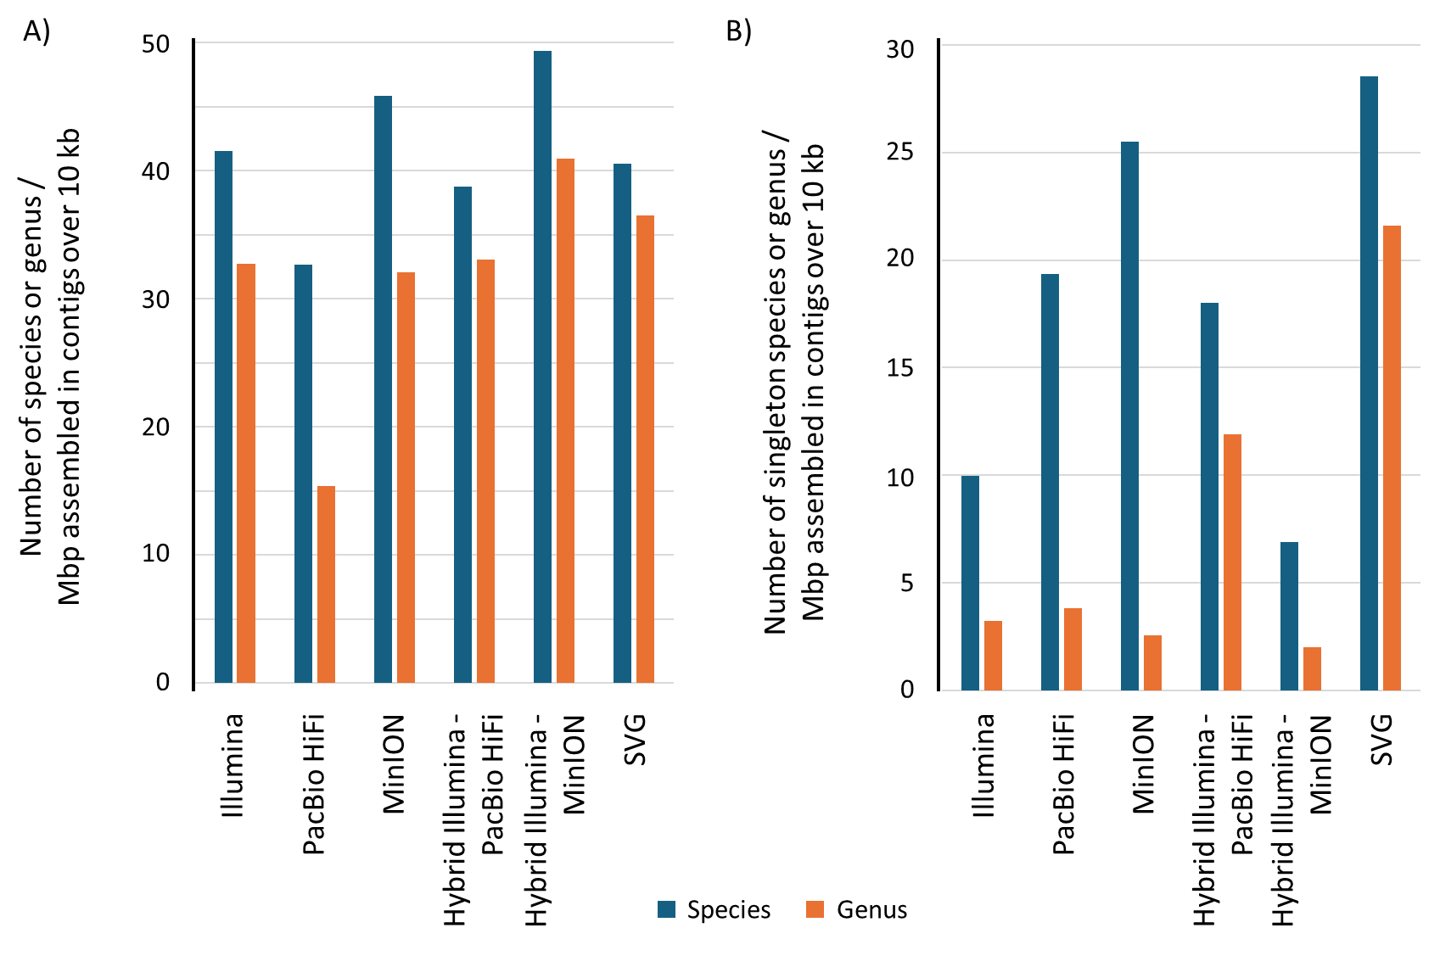

Supplementary Figure 4. Proportion of species (blue) and genera (orange) recovered by each method, normalized by the number of base pairs (Mbp) assembled in contigs over 10 kb. A) All species and genera detected by each method. B) Species and genera with only one recovered member (singletons) detected by each method.

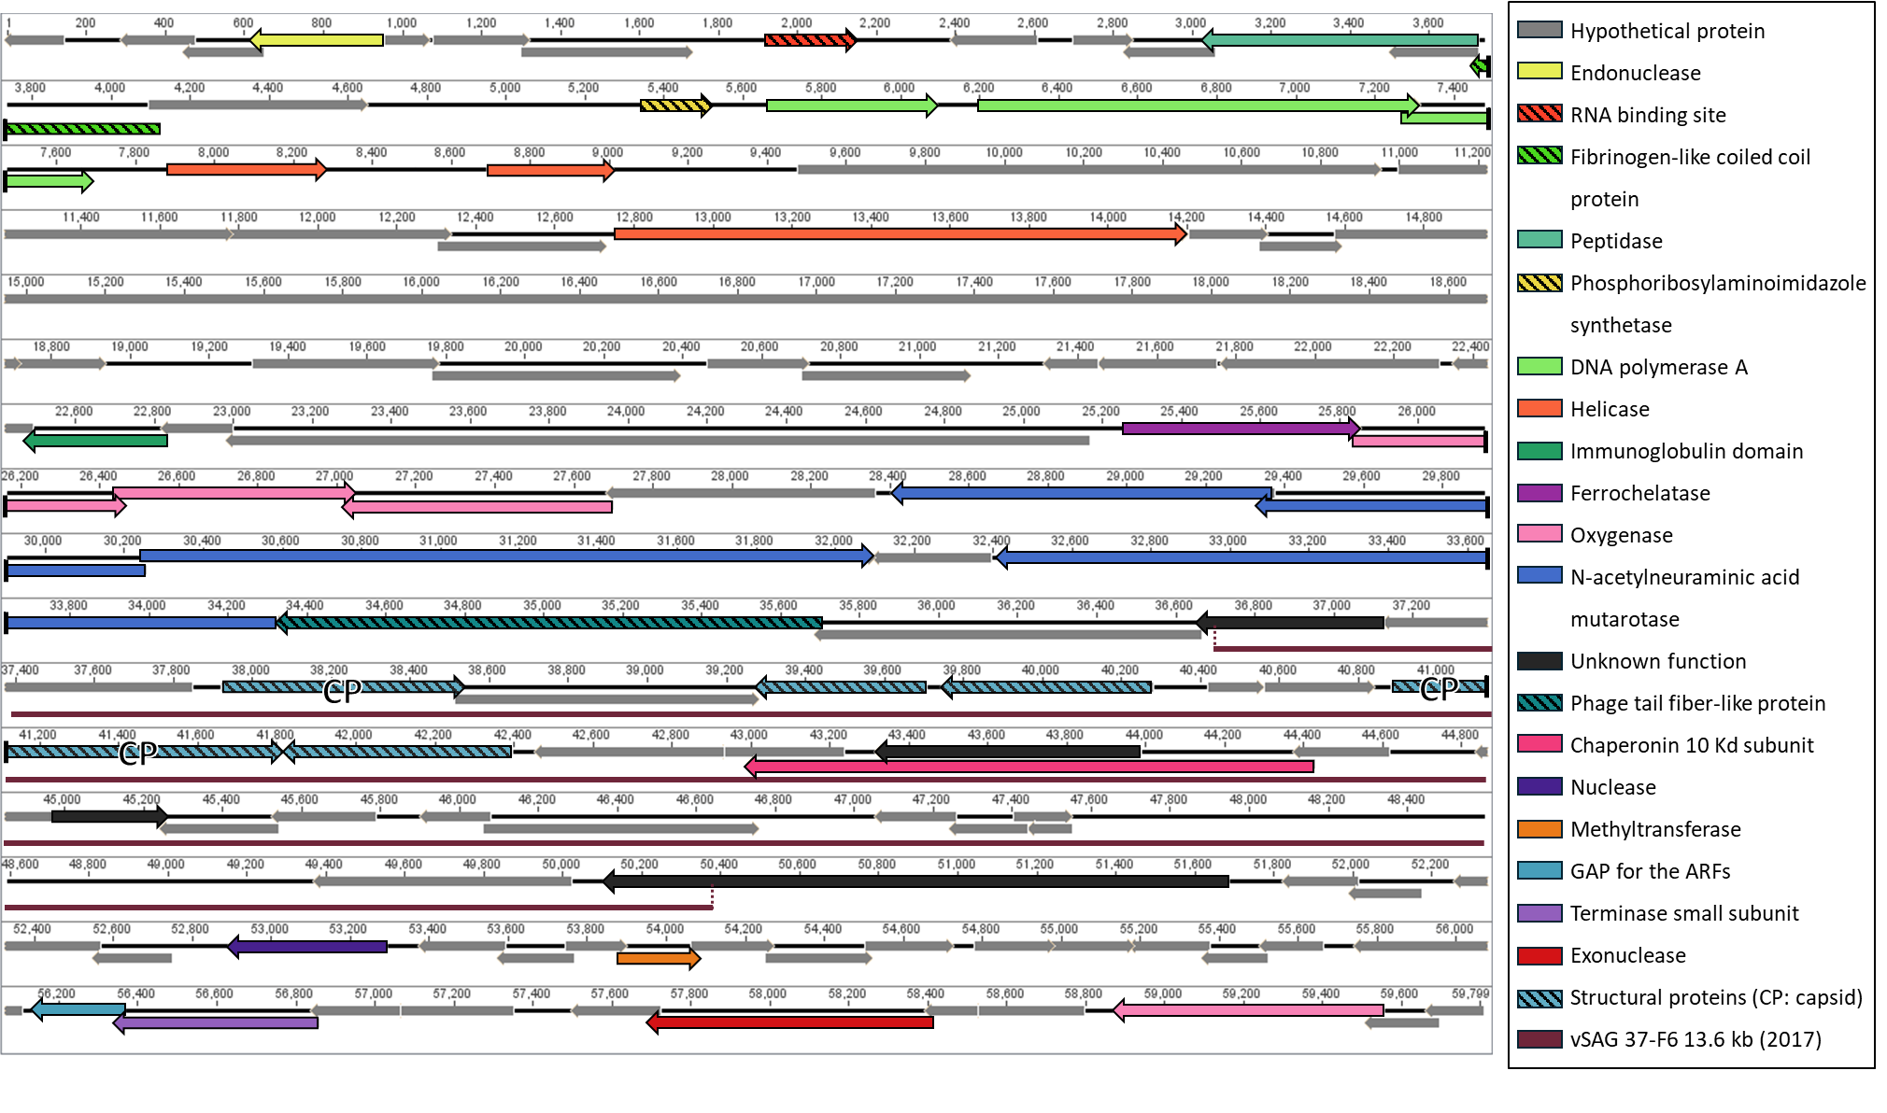
Supplementary Figure 5. Annotation of the vSAG 37-F6 complete genome and alignment with the fraction corresponding to the partial 13.589 pb genome recovered by Francisco Martinez-Hernandez et al. (2017). ARFs: ADP ribosylation factors , CP: capsid protein, GAP: GTPase-activating protein

Supplementary Table 1. Sequencing process and posterior treatment followed for each sample. MV: metavirome; SV: single virus
Sample | Library | Sequencing platform – company (country) | Read treatment | Assembly
MV | Illumina DNA Prep – University of Alicante (Spain) | Illumina HiseqX 150PE (150 x 2bp) – Macrogen (Republic of Korea) | Fastp v.0.23.0 | SPAdes (v. 3.13.0) (Nurk et al., 2013) with the options: --meta -k 21,33,55,77,99,127 --only-assembler.
MV | VirION2 protocol (Warwick-Dugdale et al., 2019) –University of Exeter (UK) | MinION Oxford Nanopore Technologies – Exeter University (UK) | Basecalling performed using Guppy (v.5) (Wick et al., 2019) with the superaccuracy mode | Flye (v.2.9) (Kolmogorov et al., 2019) with the options --meta --nano-raw
MV | PacBio Multiplexed 6-10kb with Blue Pippin Size Selection – JGI (USA) | HiFi PacBio Sequel II Multiplexed 6-10kb Ultra-Low Input – JGI (USA) | JGI QC pipeline to remove artifacts (Clum et al., 2021) | Flye (v.2.9) with the options --meta --pacbio-hifi  The resulting assembly was polished with racon (v.1.4.13) (Vaser et al., 2017) with the options -u -t 36.
SV | Illumina Nextera – JGI (USA) | Illumina NovaSeq S4 PE – JGI (USA) | JGI QC Pipeline to remove artifacts (Clum et al., 2021) | SPAdes (v. 3.15.3) (Nurk et al., 2013) with the options: -k 21,33,55,77,99,127 --only-assembler.

Supplementary Table 2. Proportion of the contigs over 10 kb recovered by each sequencing methodology classified according to the Uncultivated Virus Genome standards (Roux et al., 2016). SVG: single virus genomics
Sequencing method | Genome-fragment | High-quality
PacBio HiFi | 91.89% | 8.11%
Illumina | 97.57% | 2.43%
Hybrid Illumina - PacBio HiFi | 91.62% | 8.38%
Hybrid Illumina - MinION | 98.26% | 1.74%
MinION | 95.53% | 4.47%
SVG | 99.59% | 0.41%

Supplementary Table 3. Classification of viral assembled datasets (contigs ≥500 bp) using geNomad program
Taxonomy | Pacbio HiFi | Illumina | MinION | IlluHiFi | Illumina-MinION | SVG
Unclassified | 4.9 | 39.6 | 13.8 | 43.4 | 42.5 | 16.4
Classified viruses | 95.1 | 60.4 | 86.2 | 56.6 | 57.5 | 83.6
Unclassified viruses | 0.3 | 0.2 | 0.2 | 0.2 | 0.2 | 0.9
Caudoviricetes | 93.8 | 59.2 | 85.0 | 55.4 | 56.2 | 69.5
Fuselloviridae | <0.1 | <0.1 | 0.0 | <0.1 | <0.1 | 0.0
Monodnaviria | <0.1 | 0.2 | <0.1 | 0.2 | 0.1 | 0.2
Riboviria | 0.0 | <0.1 | 0.0 | <0.1 | <0.1 | 0.0
Nucleocytoviricota | 0.9 | 0.7 | 0.9 | 0.8 | 0.8 | 13.1
Preplasmiviricota | 0.1 | 0.1 | 0.1 | 0.1 | 0.1 | 0.0

