Table S1. Primer paris of Exophiala pisciphila melatonin synthase genes for qPCR
Genes | Primer paris (5’-3’)
EpTDC1 | Forward: TTCTACCGACCATCAAACCAG  Reverse: GGAATGATCTTGGACCCGATG
EpSNAT1 | Forward: ATGCTGACTGGAAGATTGGG  Reverse: TGCTTGGTTTTCGGGATGTAG
EpASMT1 | Forward: GCGAGTGGAATGATTTGGTTG  Reverse: CTTCGACCTTAGTTTCTCCCTC

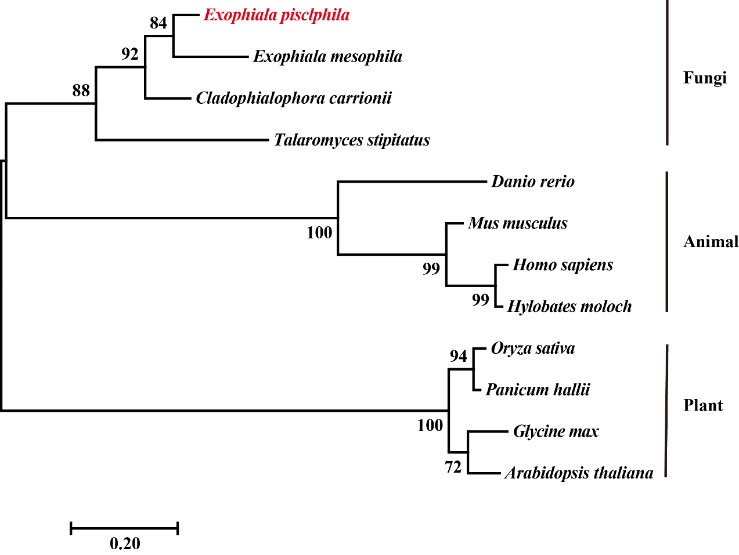
Fig. S1. A phylogenetic tree of SNATs based on amino acid sequences
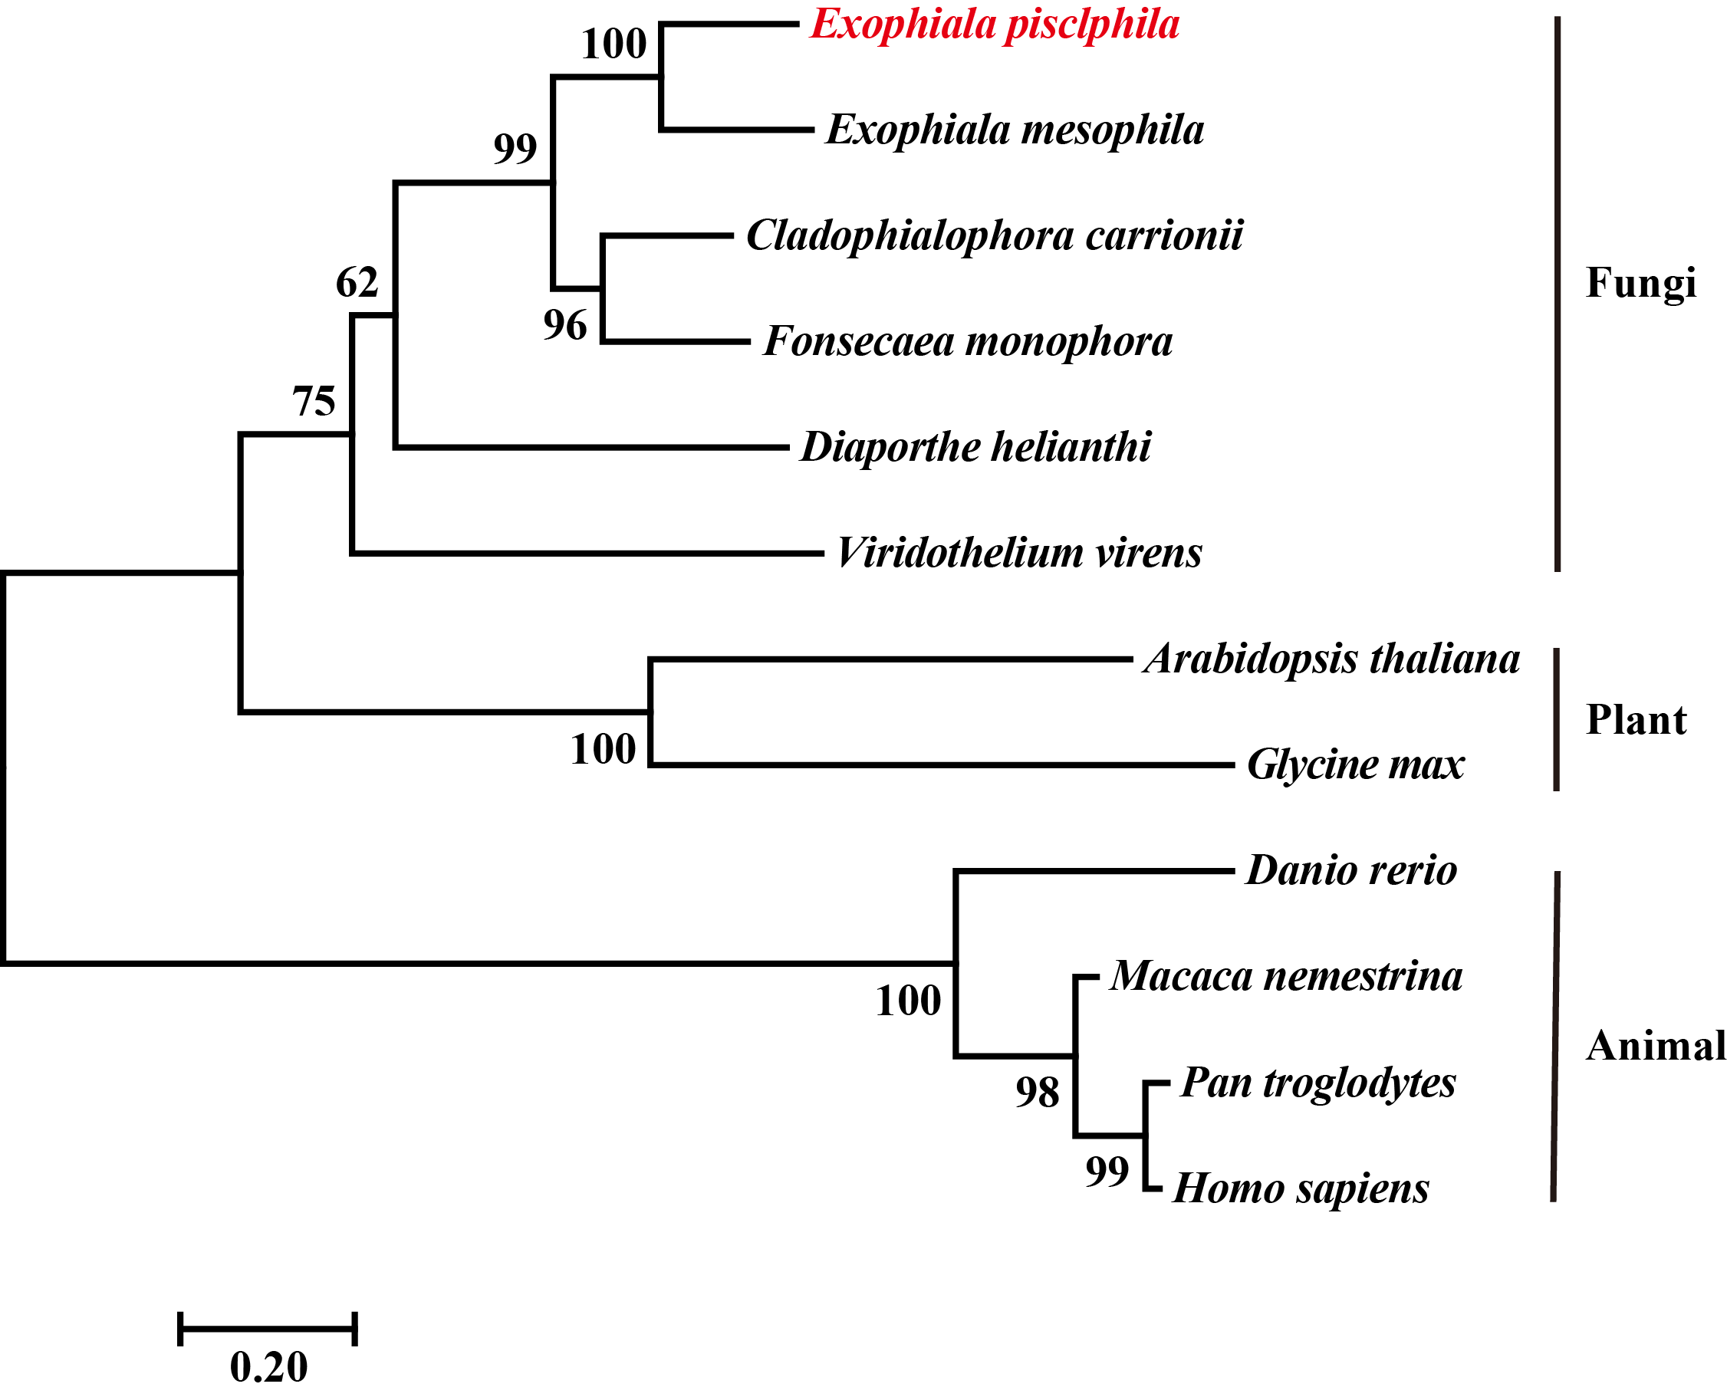
Fig. S2 A phylogenetic tree of ASMTs based on amino acid sequences

