Supplementary Table S1. The fly samples of different geographical strains
Species | Collection sites | Stage | Qualities
Bactrocera dorsalis | Guangdong-Guangzhou China (23.04 °N, 113.52 °E) | Adults | 95
Bactrocera dorsalis | Guangxi-Nanning, China (23.13 °N, 108.22 °E) | Adults | 62
Bactrocera dorsalis | Guangxi-Dongxing, China (21.31 °N, 107.85 °E) | Adults | 64
Bactrocera dorsalis | Yunnan-Jinghong, China (21.59 °N, 100.47 °E) | Adults | 33
Bactrocera dorsalis | Zhejiang-Hangzhou, China (30.22 °N, 120.11 °E) | Adults | 10
Bactrocera dorsalis | Hainan-Haikou, China (19.96 °N, 110.22 °E) | Adults | 33
Bactrocera dorsalis | Vietnam (21.96 °N, 106.62 °E) | Adults | 22
Bactrocera correcta | Yunnan-Jinghong, China (21.59 °N, 100.47 °E) | Adults | 10
Zeugodacus cucurbitae | Guangdong-Guangzhou China (23.04 °N, 113.52 °E) | Adults | 21
Zeugodacus tau | Guangdong-Guangzhou China (23.04 °N, 113.52 °E) | Adults | 13
Zeugodacus scutellata | Guangxi-Nanning, China (23.11 °N, 108.17 °E) | Adults | 51
Zeugodacus scutellata | Guangxi-Pingxiang, China (22.05 °N, 106.44 °E) | Adults | 55
Bactrocera rubiginus | Guangxi-Nanning, China (23.10 °N, 108.22 °E) | Adults | 10

Supplementary Table S2. The fly samples of Chinese Academy of Inspection and Quarantine
Species | Generations | Stages | Qualities
Bactrocera dorsalis | 18 | Eggs | ≈300
Bactrocera dorsalis | 18 | Larvae | 106
Bactrocera dorsalis | 18 | Pupae | 102
Bactrocera dorsalis | 18 | Adults | 135
Bactrocera correcta | 8 | Eggs | ≈200
Bactrocera correcta | 8 | Larvae | 116
Bactrocera correcta | 8 | Pupae | 100
Bactrocera correcta | 8 | Adults | 123
Zeugodacus cucurbitae | 8 | Eggs | ≈100
Zeugodacus cucurbitae | 8 | Larvae | 4
Zeugodacus cucurbitae | 8 | Pupae | 111
Zeugodacus cucurbitae | 8 | Adults | 97
Zeugodacus tau | 24 | Eggs | ≈200
Zeugodacus tau | 24 | Larvae | 3
Zeugodacus tau | 24 | Pupae | 97
Zeugodacus tau | 24 | Adults | 43

a
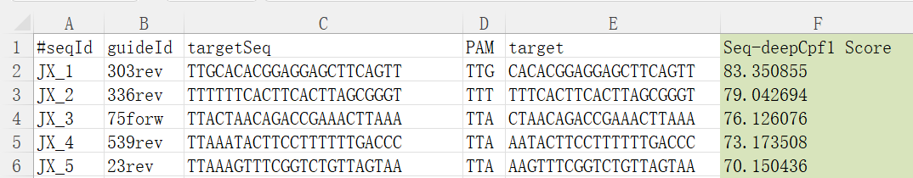
b
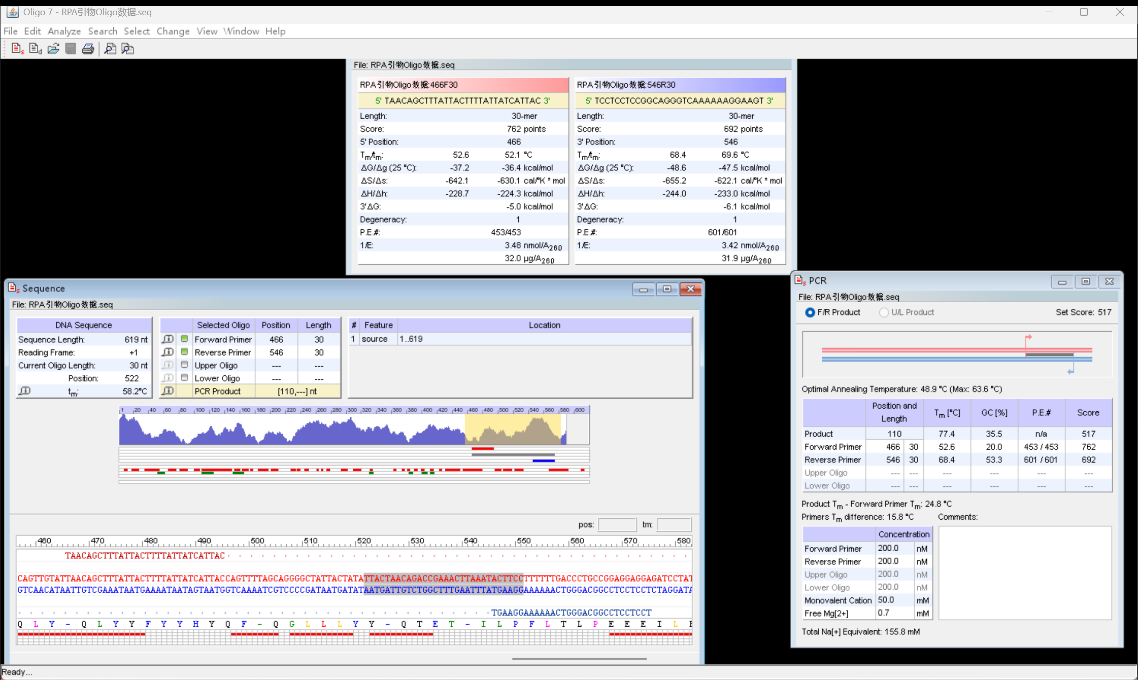
Supplementary Figure S1. The sequences screening results of localized CRISPOR tool and Oligo_v7.65. (a) Five specific target sequences that can be recognized by gRNAs were screened out by CRISPOR and arranged in descending order of scores. (b) The detailed information of the Oligo_v7.65 interface when screening RPA primers

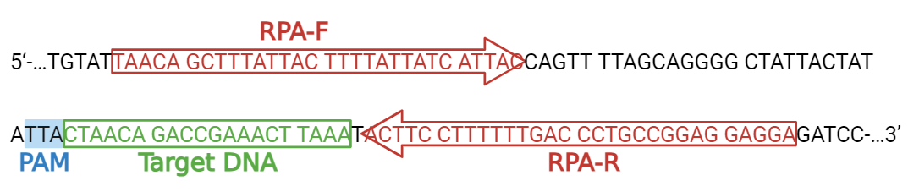
Supplementary Figure S2. RPA primers and gRNA binding sites on the mitochondrial sequences of B. dorsalis

Supplementary Table S3. The NCBI accession numbers of the plasmid of fruit fly.
Species | NCBI GenBank ID
Zeugodacus cucurbitae | NC_016056.1
Trypeta fujianica | AY788426.1
Bactrocera proprediaphora | KJ753951.1
Ceratitis rubivora | AY788438.1
Ceratitis rosa | AY788437.1
Bactrocera correcta | DQ116264.1
Ceratitis capitata | HQ677176.1
Bactrocera incisa | KJ753941.1
Bactrocera ruiliensis | KJ753925.1
Zeugodacus tau | KJ753947.1

Supplementary Table S4. The relevant information of the fruit fly samples selected for different experiments
Experients | Species | Stages | DNA extraction method
Probe concentration optimization experiment | Bactrocera dorsalis | Larvae | Silica spin column-based DNA extraction
RPA and CRISPR time optimization experiment | Bactrocera dorsalis | Larvae | Silica spin column-based DNA extraction
Sensitivity detection experiment | Bactrocera dorsalis | Larvae | Silica spin column-based DNA extraction
Specificity detection experiment | Bactrocera correcta | Eggs, larvae, pupae and adults | Rapid on-site DNA extraction
Specificity detection experiment | Zeugodacus cucurbitae | Eggs, larvae, pupae and adults | Rapid on-site DNA extraction
Specificity detection experiment | Zeugodacus tau | Eggs, larvae, pupae and adults | Rapid on-site DNA extraction
Specificity detection experiment | Zeugodacus scutellata | Eggs, larvae, pupae and adults | Rapid on-site DNA extraction
Specificity detection experiment | Bactrocera rubiginus | Eggs, larvae, pupae and adults | Rapid on-site DNA extraction
Detection experiment of different geographical strains | Bactrocera dorsalis | Eggs, larvae, pupae and adults | Rapid on-site DNA extraction
Detection experiment of different insect stages | Bactrocera dorsalis | Eggs, larvae, pupae and adults | Rapid on-site DNA extraction
Single egg detection experiment | Bactrocera dorsalis | An egg | Rapid on-site DNA extraction

Supplementary Table S5. Other gRNA sequences and RPA primers designed through the localized CRISPOR tool and Oligo 7 software
gRNA1 | GUCUAAAGGACAGAUUUUCAACGGGUGUGCCAAUGGCCACUUUCCAGGUGGCAAAGCCCGUUGAACUUCAAGCGAAGUGGCACCACACGGAGGAGCUUCAGUU
gRNA2 | GUCUAAAGGACAGAUUUUCAACGGGUGUGCCAAUGGCCACUUUCCAGGUGGCAAAGCCCGUUGAACUUCAAGCGAAGUGGCACUUUCACUUCACUUAGCGGGU
gRNA4 | GUCUAAAGGACAGAUUUUCAACGGGUGUGCCAAUGGCCACUUUCCAGGUGGCAAAGCCCGUUGAACUUCAAGCGAAGUGGCACAAUACUUCCUUUUUUGACCC
gRNA5 | GUCUAAAGGACAGAUUUUCAACGGGUGUGCCAAUGGCCACUUUCCAGGUGGCAAAGCCCGUUGAACUUCAAGCGAAGUGGCACAAGUUUCGGUCUGUUAGUAA
RPA-F2 | TGTATTAACAGCTTTATTACTTTTATTATC
RPA-R2 | AAGAATAGGATCTCCTCCTCCGGCAGGGTC
RPA-R3 | GATCTCCTCCTCCGGCAGGGTCAAAAAAGG

Supplementary Table S6. Comparison of single-reaction costs for RPA-CRISPR/Cas12b and other methods for detection of B. dorsalis
RPA-CRISPR/Cas 12b |  | RAPD |  | RFLP
Component | Single-reaction Costs ($) | Component | Single-reaction Costs ($) | Component | Single-reaction Costs ($)
DNA/RNA constant-temperature rapid amplification kit | 2.57 | Taq DNA Polymerase | 0.46-0.69 | Restriction Endonuclease | 0.43-0.71
AaCas12b protein | 2.85 | Primers | 0.003-0.007 | Agarose Gel Electrophoresis | 0.07-0.08
gRNA | 0.18 | dNTP Mix | 0.02-0.04 | Buffer | 0.09-0.3
Primers | 0.036 | MgCl₂ | 0.04
ssDNA reporter | 0.27 | Agarose Gel Electrophoresis Kit | 0.04-0.06
ddH₂O | 4 × 10⁻⁴ | Buffer | 0.02-0.17
Total | ≈5.906 | Total | 0.58-1.01 | Total | 0.59-1.09

