Extended Data Figure
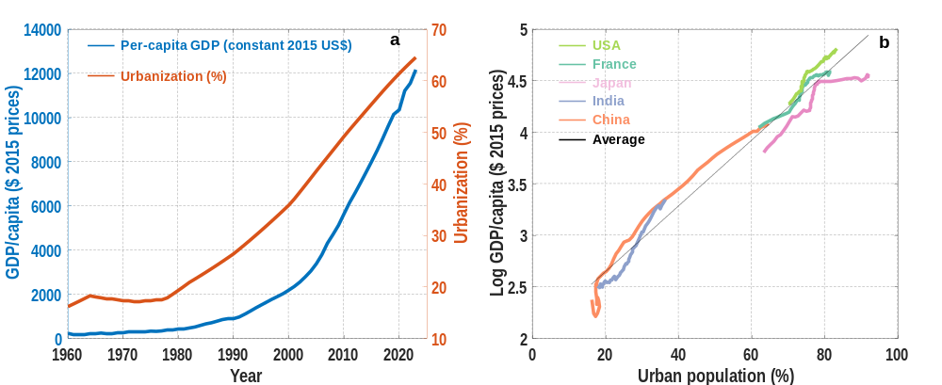
Extended Data Figure 1. Real GDP per capita and urbanization rate during 1960-2023. After an initial lag, real income per capita has been growing in tandem (and faster) with urbanization (a). Real GDP per capita versus urbanization rate for several nations. On average, a nations GDP per capita increases 4.0% (±0.05) with each percent of urbanization (black line). China’s GDP per capita has risen faster, at an average rate of 5.8% (±0.35) with each percent of additional urbanization (b). Real GDP per capita and urbanization in China are derived from World Bank data¹.
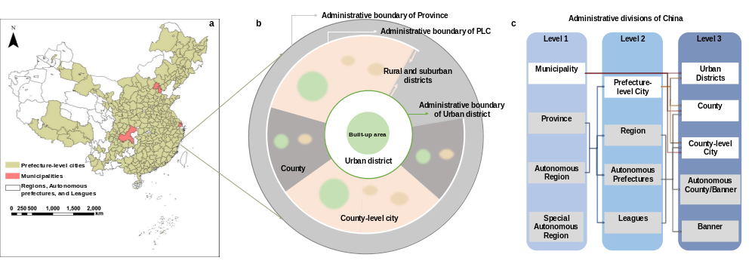
Extended Data Figure 2. The spatial units and their composition. The administrative boundaries of 293 Chinese prefecture-level cities (highlighted in yellow) and 4 municipalities (highlighted in red) selected for this study. The white parts on the map are regions, autonomous prefectures, and leagues, which are administrative units equivalent to prefecture-level cities, and are excluded from our study due to missing data (a). Schematic diagram of administrative divisions within a prefecture-level city. Prefecture-level cities are composed of urban districts as well as counties and county-level cities outside of the urban districts. Prefecture-level cities and urban districts are both national-level administrative units that do not necessarily correspond to metropolitan areas (b). Administrative divisions of China. This diagram only illustrates the structures relevant to this study (c).

