SCCD | Huaxi Village, Tongji Town, Pengzhou City, Chengdu City, Sichuan Province
GZZY | Zunnan Avenue, Bozhou District, Zunyi City, Guizhou Province
SCLS | Taoxi Village, Laoheba Township, Mabian County, Leshan City, Sichuan Province
SCYB | Ganxi Village, Qianxi Town, Xuzhou District, Yibin City, Sichuan Province
SCLS | Jiuhe Village, Jianban Town, Muchuan County, Leshan City, Sichuan Province
YNZT | Taiping Village, Taiping Town, Shuifu City, Zhaotong City, Yunnan Province
SCDY | Tianbao Village, Yinghua Town, Shifang City, Sichuan Province
HBLC | Maotian Village, Tuanbao Town, Lichuan City, Enshi Prefecture, Hubei Province
Table S1 Full name of different T. sagittata varieties

Table S1 Columbin standard product regression equation and its linear range.
Ingredient | Linear range (μg/ml) | Retention time (min) | Regression | Coefficient of determination (R²)
Columbin | 1000.000~15.625 | 8.516 | y=9.1399x+9.7932 | 0.9998

Table 2 Methodological investigation results
Ingredient | RSD/% |  |  |  | Sample recovery rate/%
Ingredient | Precision | Stability | Repeatability |  | Sample recovery rate/%
Columbin | 0.29 | 1.42 |  | 5.16 | 101.31
Tab.S3 Sequence of primers used in this study
Primer name | Primer sequence (5’-3’)
GAPDH-F | TCGAGAAGTTGCGGGATTTG
GAPDH-R | TCTCCTCACGCTTCCTCTTT
MVD3710-F | GACGAATTGGATATTGATGGTGAC
MVD3710-R | GAAATCTCCTTTCCATTAAGCCAC
HMGR6720-F | ATCAGATTCTGCTGCAGCAC
HMGR6721-R | AGAAATTCCCGGAAATGCCA
DXS6310-F | TTAGGCAGACTTCAGGACTC
DXS6310-R | AACAGCCATTCCAAGACCAG
TPS3080-F | CTGGCAAGAGTGTTCAACAC
TPS3081-R | GCATCCCACCTTTGAATAGCA
MDS4610-F | TCGCGTTTCCTCTTCTTTCC
MDS4611-R | ATCGCATCAACGACACAGTG
GGPPS7110-F | ACAGCAATTTCCGCTGTTCACA
GGPPS7111-R | GCATGGCCACCGATTCATCG
TPS5330-F | ACATACAGATACTGGTTGCAGG
TPS5330-R | TCAGGAAATGACTTGACCAGGA
TPS8230-F | TCGATCAGCCGTTTATGTGG
TPS8230-R | GAGGATGGGTATGAGGTAGAC
TPS9560-F | TCTTGCATATGTTGCAGAAGGA
TPS9560-R | ATTGTTGGAACTGCATCACCG
TPS4400-F | GCTGTGGAAGAAACATTTGGAG
TPS4400-R | AGATTGTTGGAACTGCATCACC
TPS6200-F | TTCACCATCCACAACTGCTG
TPS6200-R | AATTGTGGGAACTCCATCATCG
TPS1950-R | ATTCGATGATGGAGTTCCCAC
TPS1950-F | TCGGATAGTACATCTGAAGAGAC

Table S4 The descriptive statistical analysis of columbin content in the tuber of T. sagittata
index | Max | Min | Average | Range | SD | CV/%
Columbin | 46.09 | 5.40 | 16.05 | 40.69 | 8.89 | 55.39
 | Table S5 Transcriptome sequencing comparison results of T. sagittata
Samples |  | Clean reads | Clean bases | Content(%) | Q30(%) | Mapped Reads
HL-1 |  | 20,326,040 | 6,081,306,140 | 44.34 | 93.95 | 89.80
HL-2 |  | 20,803,948 | 6,225,081,358 | 44.47 | 94.33 | 89.40
HL-3 |  | 19,098,892 | 5,715,027,636 | 44.45 | 94.43 | 90.02
HR-1 |  | 20,430,317 | 6,111,983,076 | 44.10 | 94.41 | 91.13
HR-2 |  | 23,976,231 | 7,173,990,024 | 44.21 | 94.50 | 89.94
HR-3 |  | 19,099,438 | 5,714,474,452 | 44.12 | 94.47 | 89.25
LL-1 |  | 20,096,232 | 6,013,463,878 | 44.23 | 93.85 | 93.39
LL-2 |  | 21,092,792 | 6,311,384,446 | 44.20 | 94.09 | 93.96
LL-3 |  | 19,434,937 | 5,814,798,164 | 44.34 | 94.60 | 93.94
LR-1 |  | 21,375,564 | 6,395,525,810 | 43.96 | 93.79 | 93.19
LR-2 |  | 21,659,673 | 6,480,212,394 | 44.27 | 94.54 | 92.50
LR-3 |  | 19,526,432 | 5,842,121,840 | 44.20 | 94.14 | 93.59

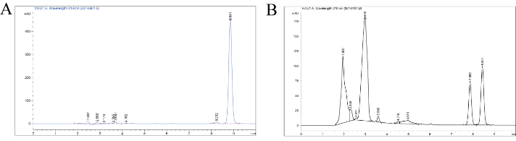
Figure S1 detection chromatogram of Colmbin; (A) HPLC chromatogram of Colmbin standard solution; (B) HPLC chromatogram of T. sagittata in tuber

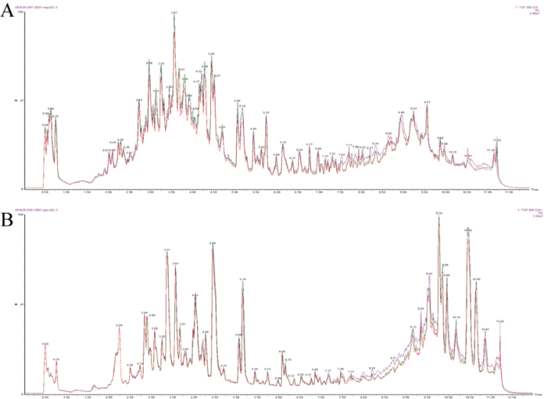
Figure S2 QC sample mass spectrometry detection TIC overlay; (A) Negative ion mode; (B) Positive ion mode.

