Conformation Validity and Rationality Evaluation of 3D Molecules Generated by Deep Learning Models Supplementary Information
Fan Fan^{1†}, Bin Xi^{2†}, Xianghu Meng^{1†}, Han Wang¹, Bowen Zhang¹, Qingbo Xu¹, Wei Feng¹, Xiaoman Wang¹, Hongbo Zhang¹*, Feng Zhou¹*, Zhenming Liu²*, Wenbiao Zhou¹*, and Bo Huang¹*
¹Beijing StoneWise Technology Co Ltd., Haidian Street #15, Beijing, 100080, China.
²State Key Laboratory of Natural and Biomimetic Drugs, School of Pharmaceutical Sciences, Peking University, Beijing, China.
†These authors contributed equally to this work.
*Corresponding author(s). E-mail(s):
huangbo@stonewise.cn
zhouwenbiao@stonewise.cn
zmliu@bjmu.edu.cn
zhoufeng@stonewise.cn
zhanghongbo@stonewise.cn

Contents
Part 1. Element Wise Energy Threshold Establishment
Part 2. Preparation of Pockets for Each AI Model
Part 3. Statistics of the Number of Molecules Generated by Each AI model U
Part 4. Speed Comparison of torsion energy prediction models trained with and with data augmentation
D-E Targets
Part 1. Element Wise Energy Threshold Establishment
Two steps were employed to establish element-wise energy threshold by firstly initializing the elemental energy thresholds and then optimizing the thresholds on GM-1K dataset. Specifically, at the first stage, we apply ANI2x on QMugs, OrbNet and QM9 datasets and extracted the atomic energies for atoms of each conformation. Then, these atomic energies were regrouped based on the element type, i.e., C, H, O, N, S, F, Cl. The atomic energy distributions are shown in Fig. S1 and Fig. S2. Next, the elbow point for each element was calculated from the sorted element-wise atomic energies in an ascending order. These elbow points were used as the initial points of each elemental energy threshold.
At the second stage, the initialized HEAD model was applied on GM-1K and the thresholds were optimized by grid search algorithm. Specifically, because each elemental energy threshold is independent on the others, each threshold was optimized individually by maximizing the weighted F1 score.
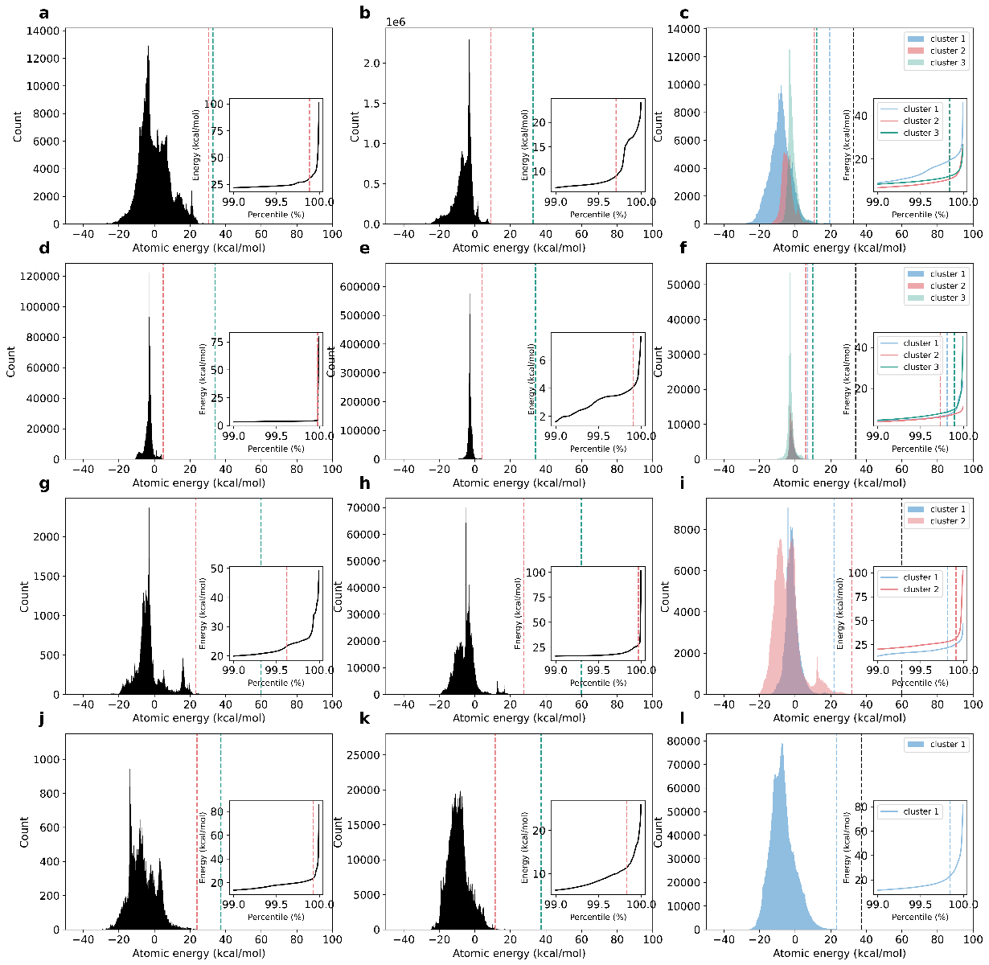
Figure S1. Atomic energy distribution of C, H, O, N for QM9, QMugs and OrbNet dataset calculated by ANI-2x. a, b, Atomic energies distribution of carbon atom for QM9 and QMugs with the energy threshold shown in green dashed line. Each subfigure shows corresponding sorted atomic energies (ascending order) ranging from 99.0% percentile to 100% percentile, where the red dashed line represents the calculated elbow point, where a significant change of atomic energy can be observed indicating the occurrence of rare implausible scenarios. c, Atomic energy distribution of different clusters for carbon atom for OrbNet dataset by using incremental principal component analysis and k-means clustering, where the black dashed line shows the energy threshold. d, e, As in a, b, but for hydrogen atom. f, As in c, but for hydrogen atom. g, h, As in a, b, but for oxygen atom. i, As in c, but for oxygen atom. j, k, As in a, b, but for nitrogen atom. ł, As in c, but for nitrogen atom, this k-means result only shows one cluster.
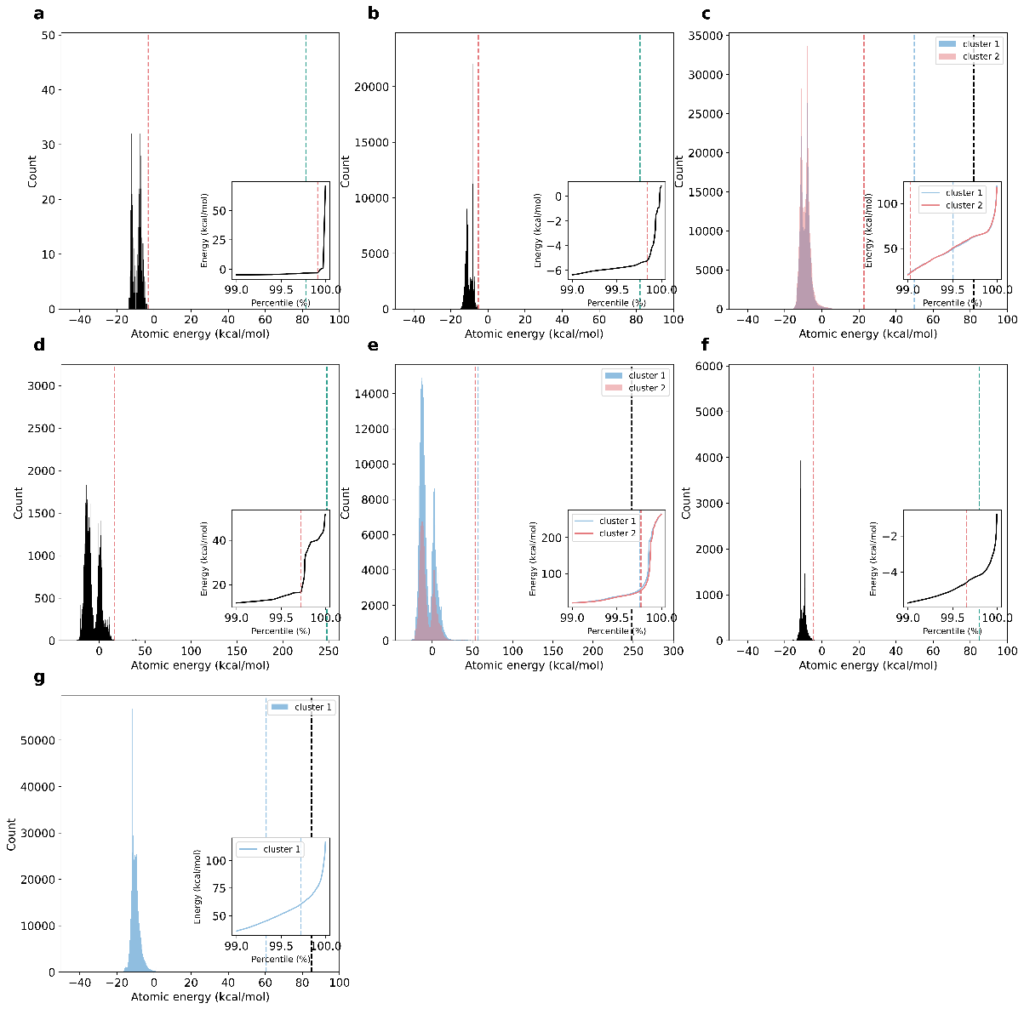
Figure S2. Atomic energy frequency distribution of F, S, Cl for QM9, QMugs and OrbNet dataset calculated by ANI-2x. a, b, Atomic energies distribution of fluorine atom for QM9 and QMugs with the energy threshold shown in green dashed line. Each subfigure shows corresponding sorted atomic energies (ascending order) ranging from 99.0% percentile to 100% percentile, where the red dashed line represents the calculated elbow point, where a significant change of atomic energy can be observed indicating the occurrence of rare implausible scenarios. c, Atomic energy distribution of different clusters for fluorine atom for OrbNet dataset by using incremental principal component analysis and k-means clustering, where the black dashed line shows the energy threshold. d, As in b, but for sulfur atom. e, As in c, but for sulfur atom. f, As in b, but for chlorine atom. g, As in c, but for chlorine atom.

Part 2. Preparation of Pockets for Each AI Model
The DUD-E dataset contains 102 targets. To generate molecules using AI models for these targets, all co-factors in the binding pockets were removed, as some models, such as Pocket2Mol, cannot process them. Subsequently, target proteins underwent preparation which involves removing solvent, adding explicit hydrogens, assigning protonation states, and performing restrained minimization. Binding pockets were extracted according to each model’s requirements; specific tools from original publications were used when available; otherwise, pymol program was employed. Details are provided in Table S1.
Table S1. Configurations of Pocket Preparation
Model | Radius for pocket definition ª (Å) | Need Explicit Hydrogens | Pocket Extraction Tools Provided
Lingo3DMolv2 | 6.0 | Yes | Yes
Pocket2Mol | 11.5 | No Matter | No
PockeFlow | 10.0 | No Matter | Yes
TargetDiff | 10.0 | No Matter | Yes
PMDM | 11.5 | No Matter | No
ª Protein residues within the specific range from the reference ligand are defined as pocket.

Part 3. Statistics of the Number of Molecules Provided by Each AI Model for DUD-E Targets
Due to variations in generation efficiency among the AI models tested, not all models can generate 1,000 unique molecules per target with reasonable resource consumption. For instance, PMDM generates fewer than 1,000 molecules for 6 out of 102 targets and fails to produce any for another 6 targets. The number of molecules generated by each model for each target, along with the counts of druglike and successfully minimized molecules, is provided in the Supplementary File Suppl_stat_num_mols.csv. A statistical overview is presented in Figure S3.
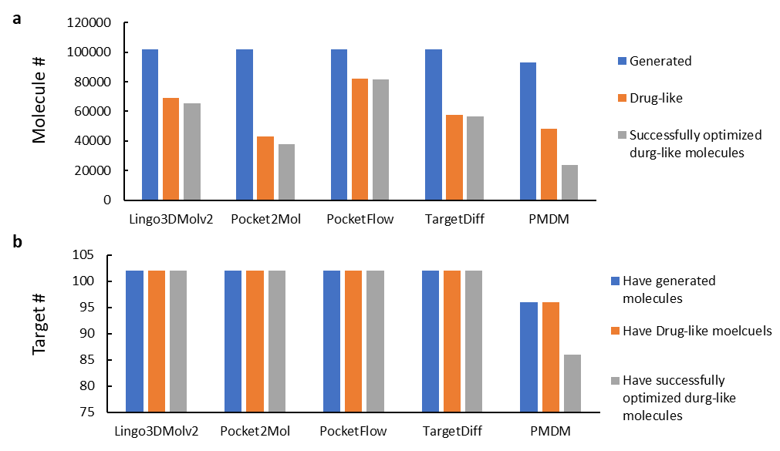
Figure S3. Statistical Overview of Molecule Generation by AI Models for 102 Targets from DUD-E. (a) Progressive funnels for each model in terms of molecule number. (b) Progressive funnels for each model in terms of target number.

Part 4. Speed Comparison of torsion energy prediction models trained with and without data augmentation
Table S3. Time consumption of completing torsion energy prediction for 2000 torsion fragments using 32 CPUs (Unit: Second).
 | TED-Model (torsion energy prediction model)
 | Trained without data augmentation | Trained with data augmentation
Initial sampling | 170 | 0
Torsion angle enumeration | 1,233 | 201
Minimum pooling | 29 | 0
Feature extraction | 115 | 111
Energy prediction | 6 | 6
Total time | 1,553 | 317

