SUPPLEMENTARY

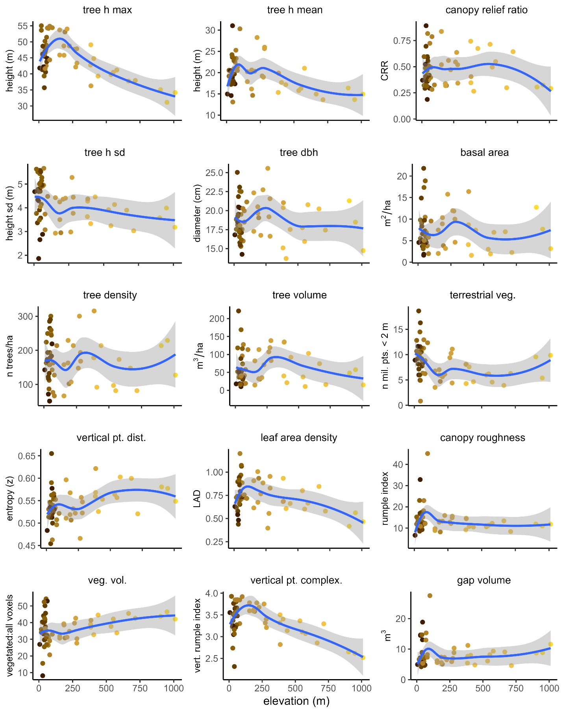
Figure S1. Structural metrics by elevation. Points are color-coded by forest type and match colors used in Figure 1.
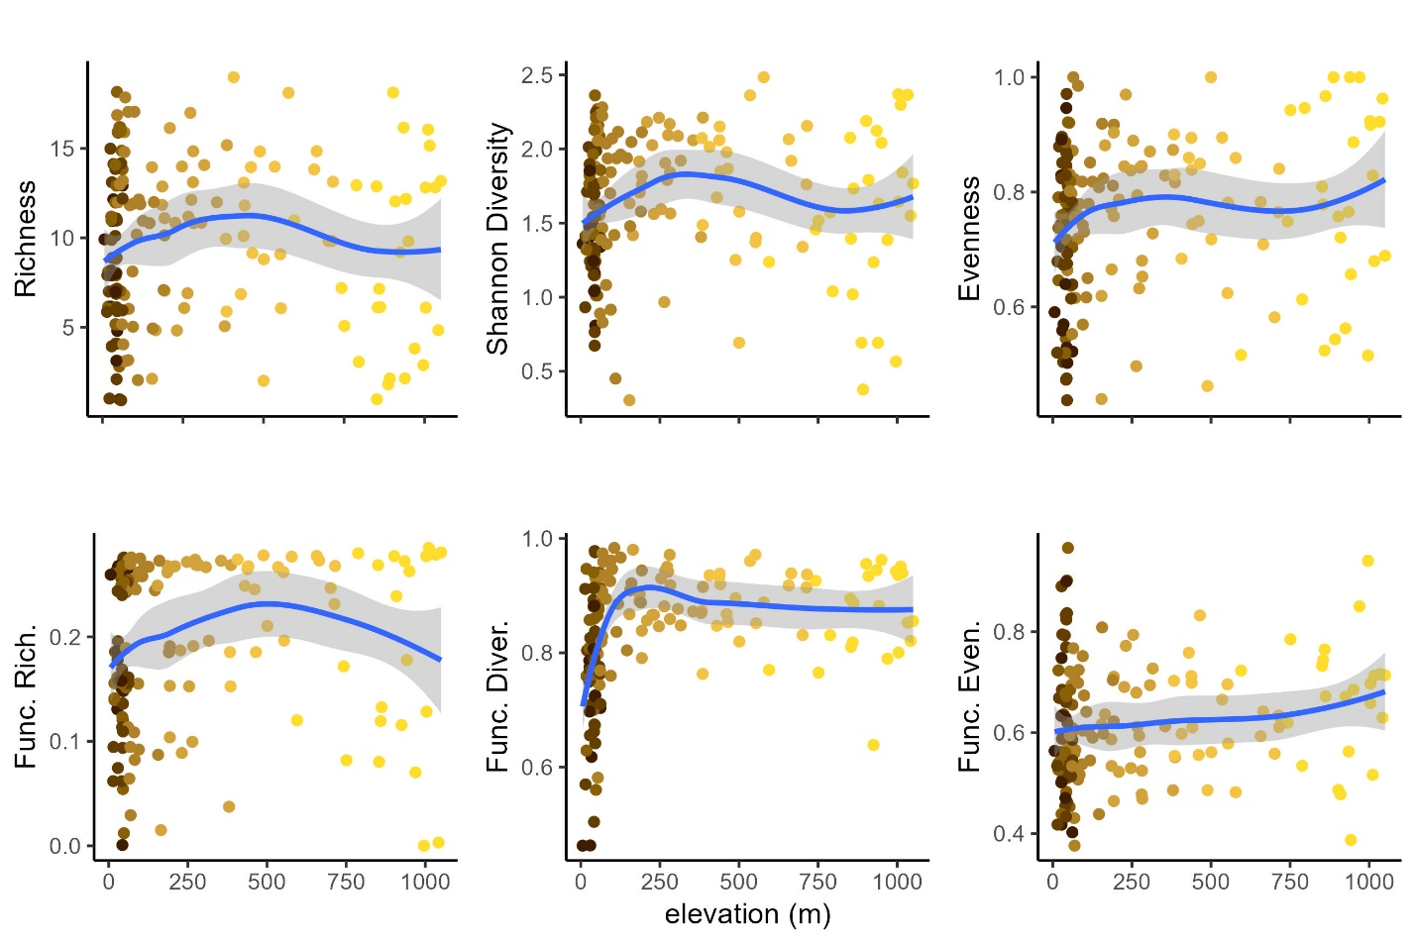
Figure S2. Diversity metrics by elevation. Points are color-coded by forest type and match colors used in Figure 1.
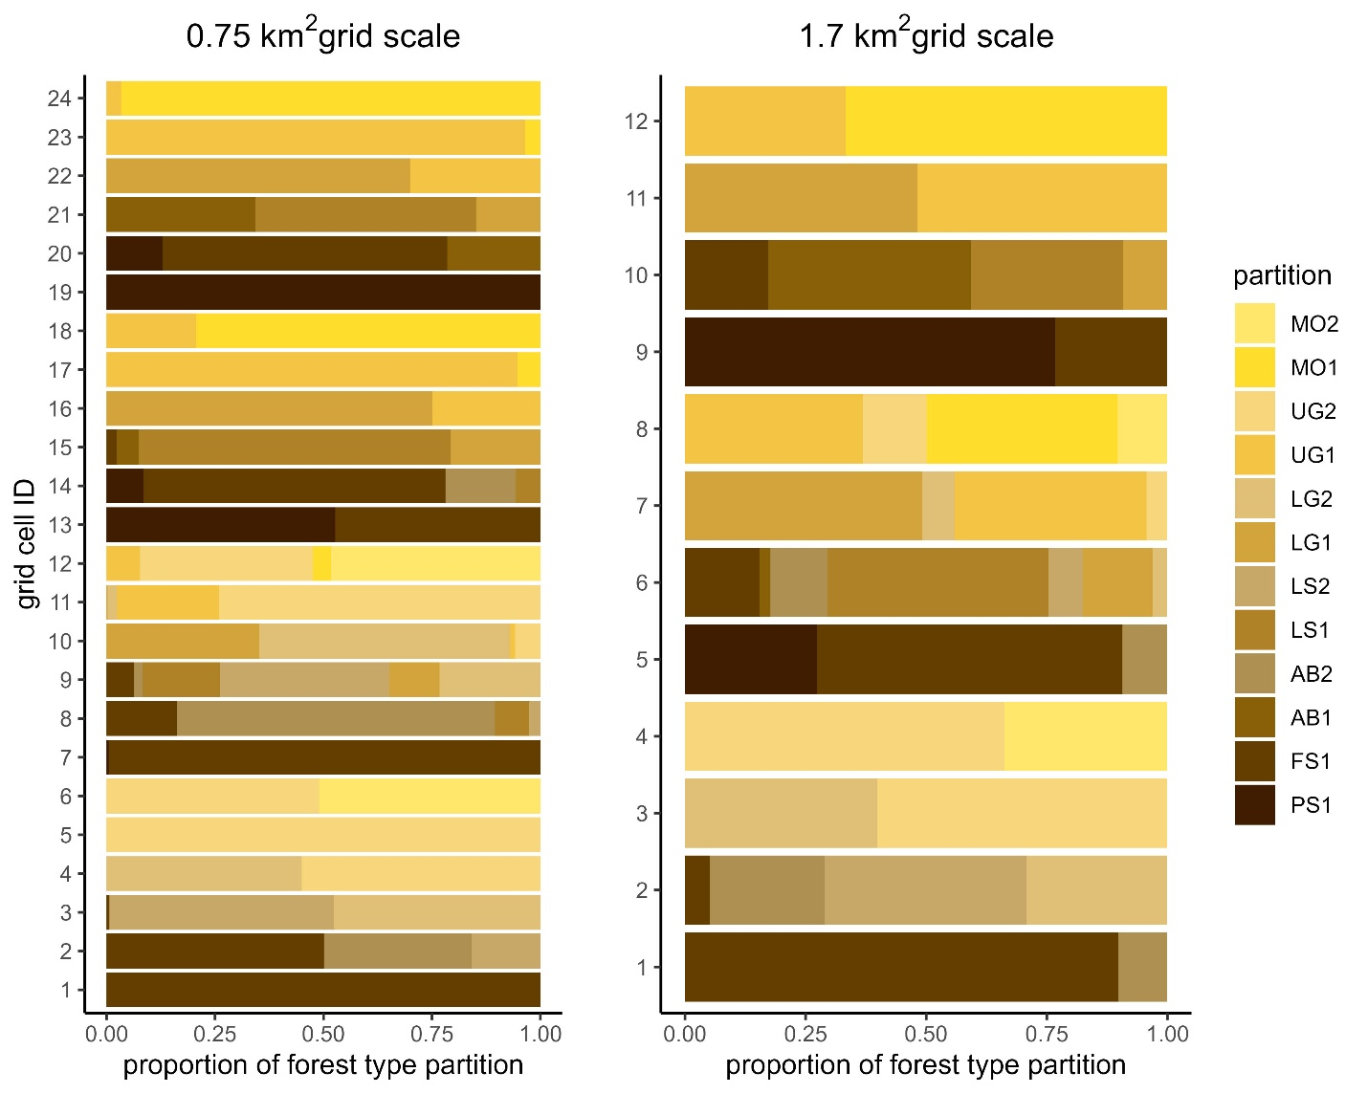
Figure S3. Spatial heterogeneity in grid scales. Stacked bar plots show the proportion of different forest type partitions within each cell of both the 0.75 km² and 1.7 km² grid scales. Twelve forest type partitions exist at GPNP, with all but the Peat Swamp (PS) and Freshwater Swamp (FS) forests divided into two partitions. Other forest types include Alluvial Bench (AB), Lowland Sandstone (LS), Lowland Granite (LG), Upland Granite (UG), and Montane (MO) forests.
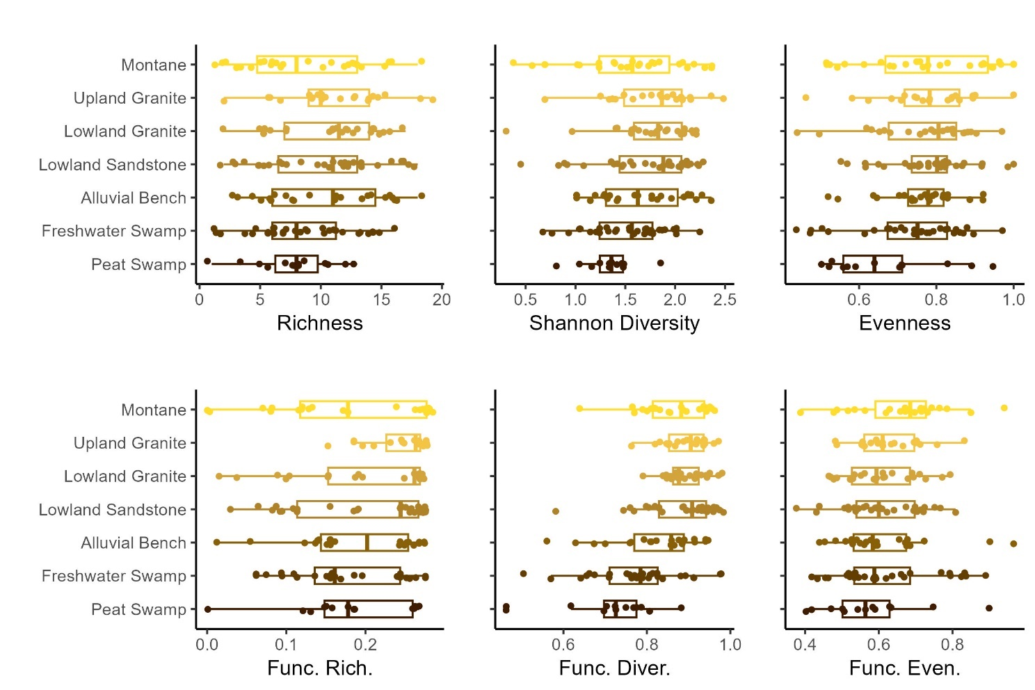
Figure S4. Diversity metrics across forest types. Six diversity metrics of terrestrial mammals were calculated for 177 camera trap locations (points) and aggregated by forest type (box plots). Metrics include species richness, Shannon diversity, species evenness, functional richness, functional divergence, and functional evenness.

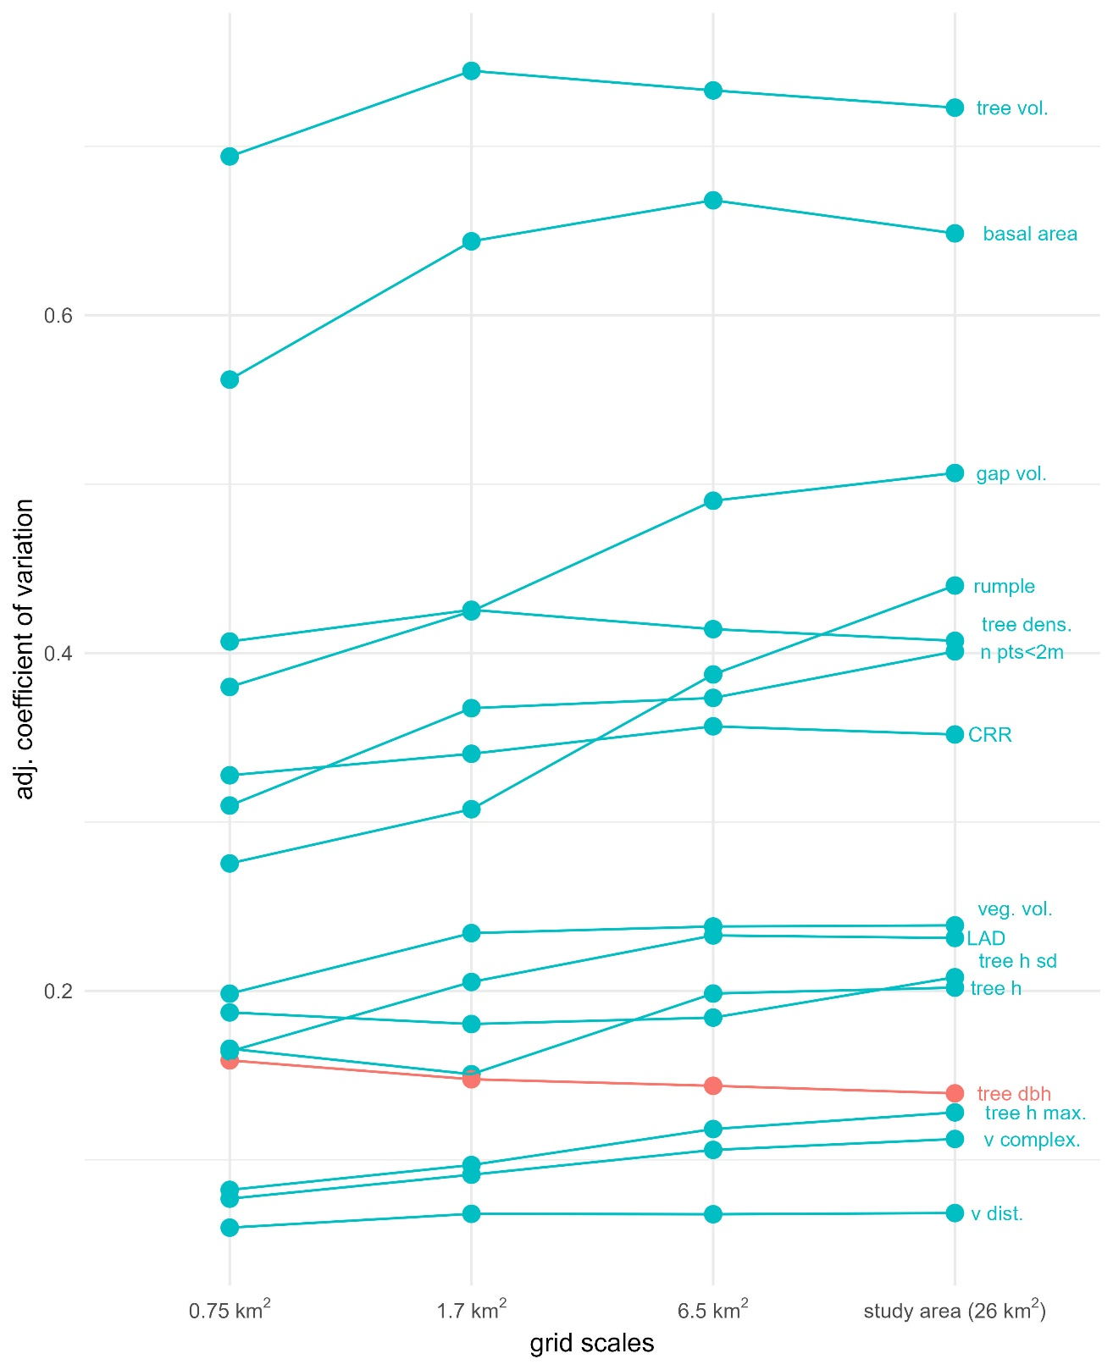
Figure S5. Forest structure variation increases at larger grid scales. Average adjusted coefficient of variation, which controls for number of survey locations contained in each cell, increases as grid resolution decreases (and as cell sizes increase) for all but one forest structure metric, tree dbh (highlighted).

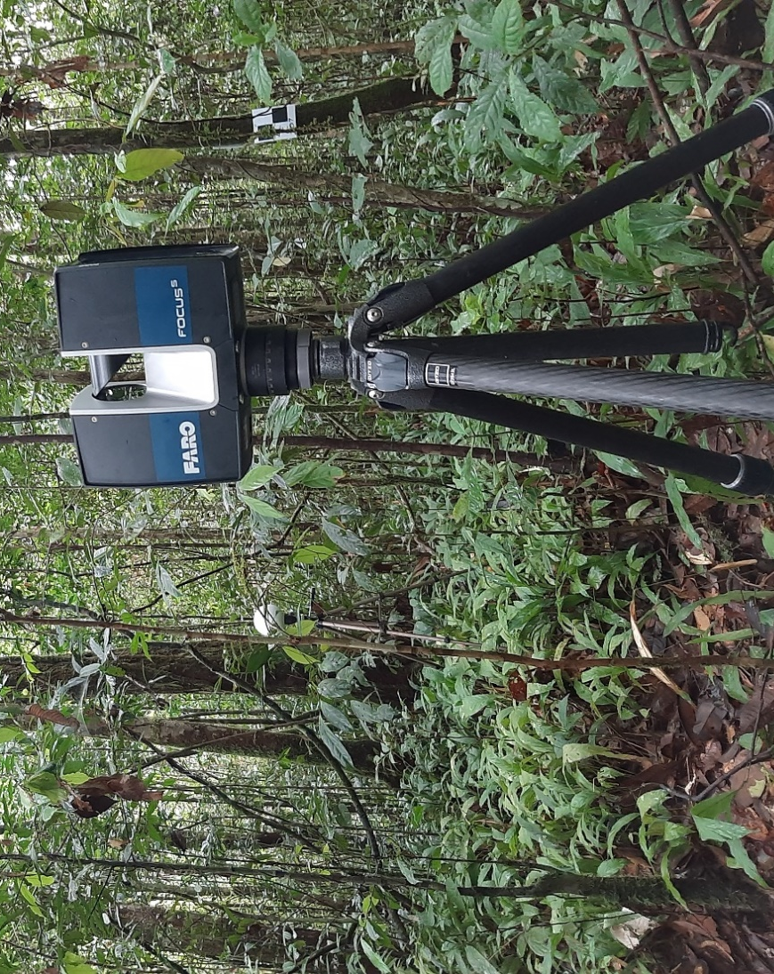
Figure S6. LiDAR survey equipment. The FARO Focus s350 scanner is shown here deployed at Cabang Panti Research Site. Targets used to aid in the scan registration process are seen in the background, including a tripod-mounted white sphere (left of LiDAR unit) and a checkerboard fixed to a tree (right).

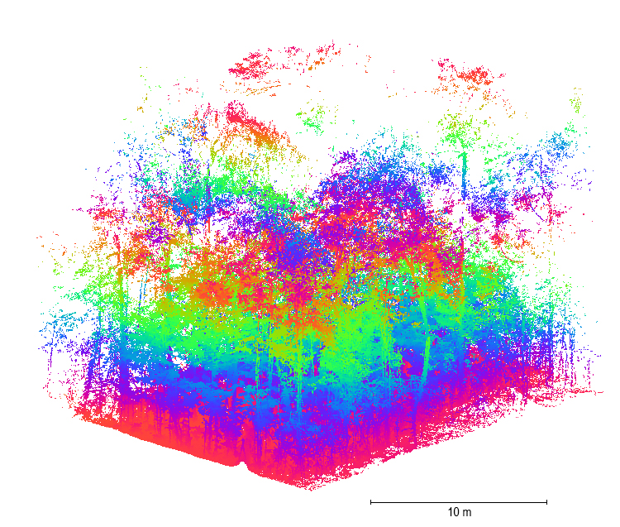
Figure S7. TLS Point cloud data. A 3D point cloud collected from the LiDAR surveys at Cabang Panti Research Site. Color-coding shows 10 m height bands. This point cloud is from the Lowland Sandstone I forest type partition (location BC 2.19) and is cropped for visibility.

Table S1. Species observations and characteristics. All terrestrial mammals observed and identified from camera trap surveys during the study period. Number of observations denotes the number of individual camera trap videos of species. Six characteristics were used for calculating functional diversity metrics. Metric values were assigned based on data from the PanTHERIA database (Jones et al., 2009) and the Phillips’ Field Guide to the Mammals of Borneo text (Phillips, 2016). Dietary breadth denotes the number of dietary categories eaten by a species (e.g., fruit, seeds, invertebrates). Group size was determined based on the camera trap data from CPRS. No characteristic data was included for Family Muridae.
Species name | Number Obs. | Activity Cycle | Adult Body Mass (g) | Trophic Level | Dietary Breadth | Litter Size | Group size
Family Muridae  (unid. rats) | 2,788 | NA | NA | NA | NA | NA | NA
Sus barbatus | 2,620 | crepuscular | 135806 | omnivore | 6 | 6.59 | 13
Viverra tangalunga | 1,440 | nocturnal | 7349.99 | omnivore | 6 | 1.92 | 2
Tragulus javanicus | 1,234 | nocturnal | 1889.93 | herbivore | 3 | 0.98 | 2
Macaca nemestrina | 956 | diurnal | 7820.78 | herbivore | 2 | 1.01 | 17
Muntiacus muntjak | 632 | crepuscular | 17611.59 | herbivore | 3 | 1 | 3
Hemigalus derbyanus | 600 | nocturnal | 1262.7 | omnivore | 6 | 1.73 | 2
Hystrix brachyura | 568 | nocturnal | 8000 | omnivore | 6 | 1.41 | 3
Muntiacus atherodes | 453 | crepuscular | 18939.1 | herbivore | 2 | 1.17 | 2
Lariscus insignis | 420 | diurnal | 174.41 | herbivore | 2 | 2 | 3
Neofelis nebulosa | 354 | crepuscular | 14945.05 | carnivore | 1 | 2.25 | 3
Tragulus napu | 271 | nocturnal | 5273.67 | herbivore | 3 | 0.96 | 2
Martes flavigula | 208 | diurnal | 2504.64 | carnivore | 1 | 3.53 | 3
Herpestes sp. | 207 | nocturnal | 1396.16 | carnivore | 1 | 3.49 | 2
Rheithrosciurus macrotis | 163 | diurnal | 1353.27 | herbivore | 2 | 2 | 2
Tupaia dorsalis | 146 | diurnal | 168.05 | omnivore | 4 | 2 | 2
Prionailurus bengalensis | 85 | nocturnal | 2780.97 | carnivore | 1 | 2.5 | 1
Helarctos malayanus | 80 | nocturnal | 57075.78 | herbivore | 3 | 1.1 | 2
Paradoxurus hermaphroditus | 76 | nocturnal | 3200 | omnivore | 6 | 3.29 | 1
Paguma larvata | 74 | nocturnal | 4300 | omnivore | 6 | 2.16 | 4
Echinosorex gymnurus | 57 | crepuscular | 756.53 | omnivore | 3 | 1.9 | 2
Prionodon linsang | 55 | nocturnal | 684.83 | omnivore | 6 | 2.3 | 1
Arctictis binturong | 46 | nocturnal | 12999.99 | herbivore | 3 | 2.5 | 2
Pardofelis marmorata | 45 | nocturnal | 2826.68 | carnivore | 1 | 2 | 1
Tupaia tana | 31 | diurnal | 182.33 | omnivore | 4 | 2.51 | 1
Tupaia montana | 29 | diurnal | 168.05 | omnivore | 4 | 2.01 | 4
Cynogale bennettii | 20 | crepuscular | 4246.57 | omnivore | 6 | 2.3 | 3
Tupaia splendidula | 13 | diurnal | 168.05 | omnivore | 4 | 2 | 1
Aonyx cinerea | 9 | nocturnal | 3527.59 | carnivore | 1 | 1.47 | 2
Mustela nudipes | 9 | diurnal | 569.42 | carnivore | 1 | 4 | 1
Arctogalidia trivirgata | 8 | nocturnal | 2323.79 | omnivore | 6 | 2.79 | 1
Catopuma badia | 7 | crepuscular | 3429.52 | carnivore | 1 | 1.3 | 1
Felis planiceps | 5 | nocturnal | 3533.76 | omnivore | 2 | 1.33 | 2
Hemigalus hosei | 5 | nocturnal | 2500 | omnivore | 6 | 1.5 | 1
Rhinosciurus laticaudatus | 4 | diurnal | 230.3 | omnivore | 3 | 1.39 | 1
Family Soricidae  (unid. shrews) | 4 | nocturnal | 43.76 | carnivore | 1 | 3.1 | 1

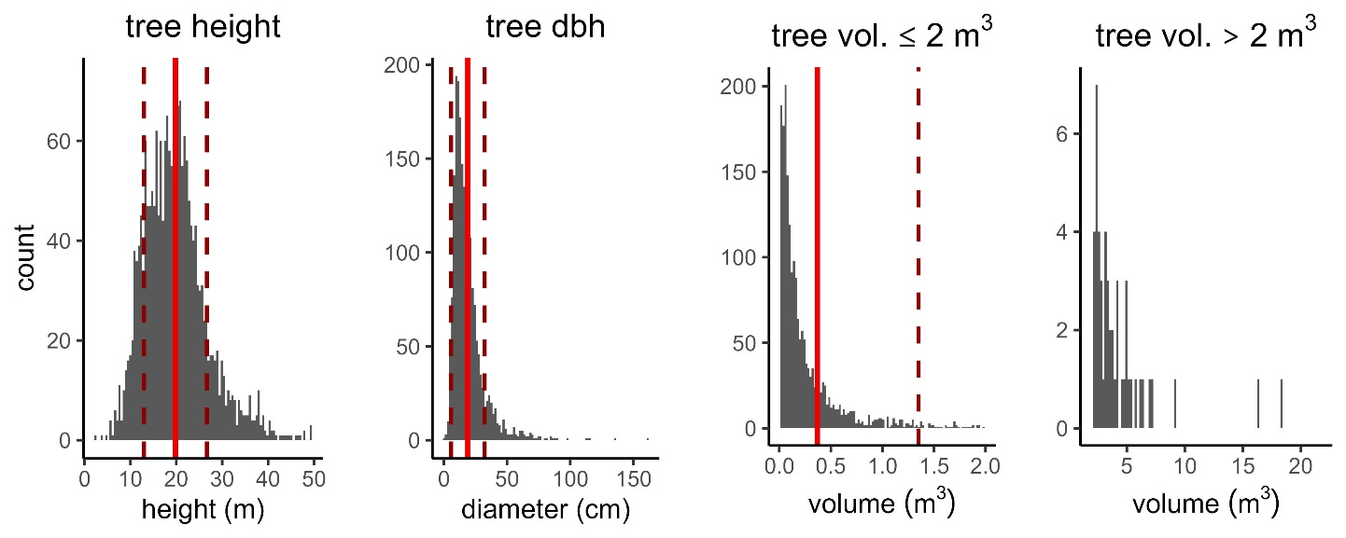
Figure S8. Summary of individual tree metrics. Distributions of three tree-level metrics from point cloud data collected at Cabang Panti Research Site. The dataset includes 2,010 detected trees across 58 point clouds. To account for the heavily right-skewed distribution, tree volumes are split into two panels, highlighting that most trees have volumes below 2 m³. Solid vertical lines represent mean values, while dashed vertical lines indicate standard deviations. In the third panel, the lower standard deviation is negative and not visible in the plotting space.

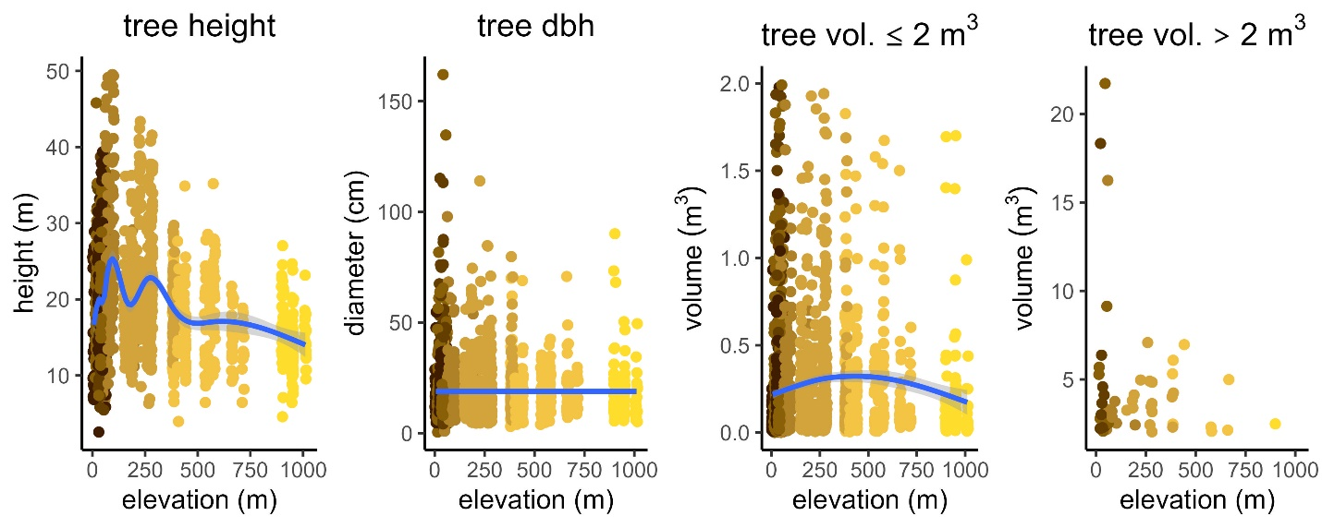
Figure S9. Individual tree metrics by elevation. Three tree-level metrics by elevation from point cloud data collected at Cabang Panti Research Site. To account for the heavily right-skewed distribution, tree volumes are split into two panels, highlighting that most trees (points) have volumes below 2 m³. Trend lines (blue) and confidence intervals (grey shading) are included to show patterns. Points are color-coded based on the forest type trees are in and match forest type colors in Figure 1.
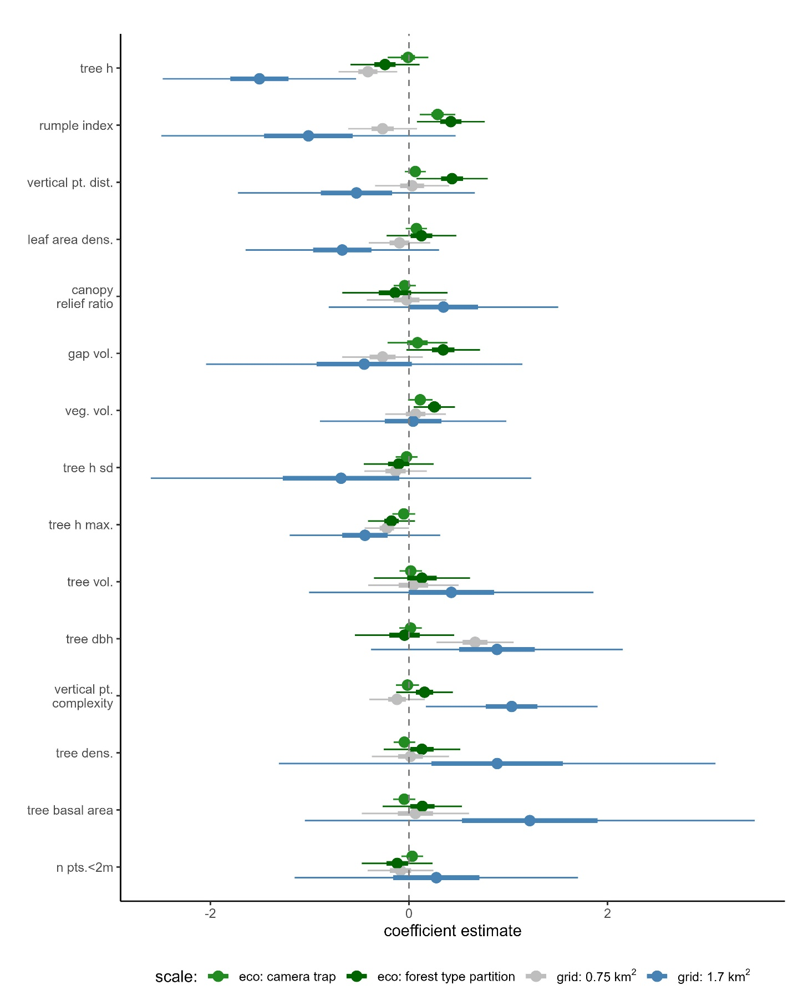
Figure S10. Species richness models.

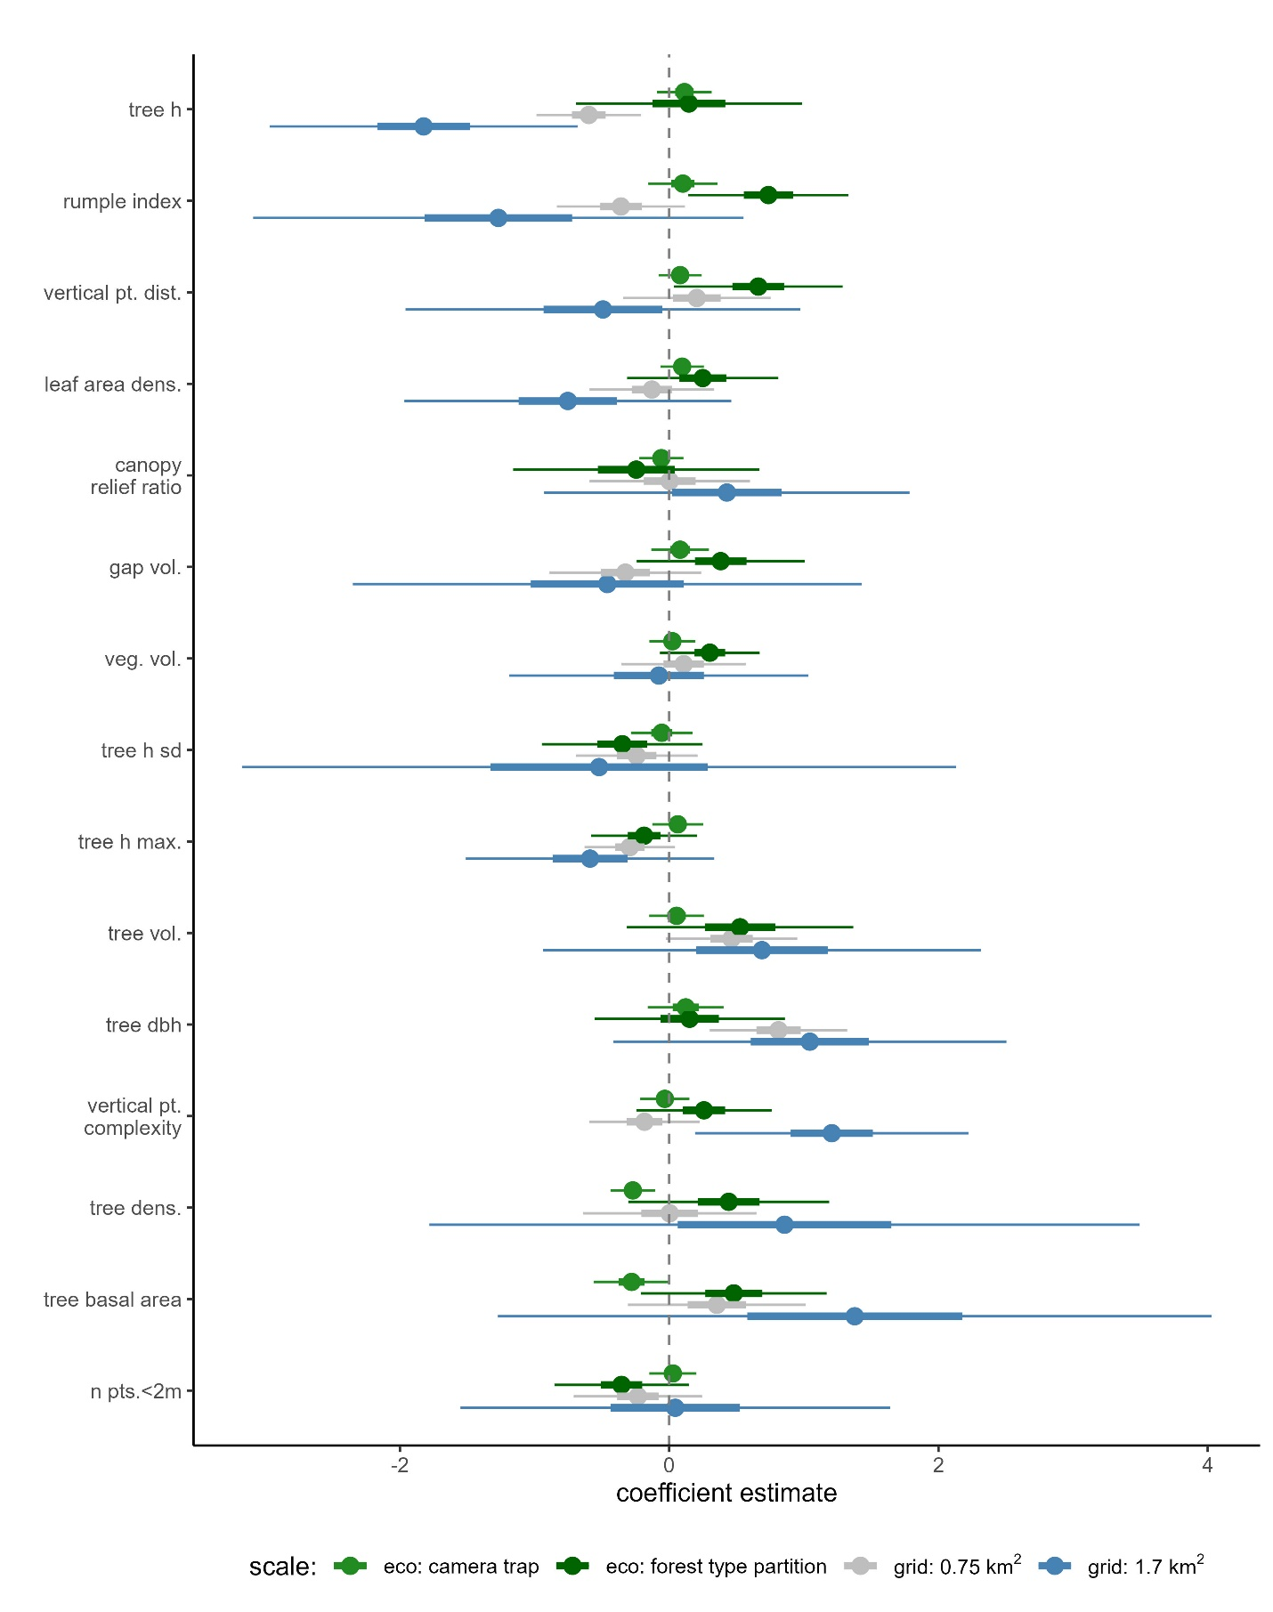
Figure S11. Species evenness models.

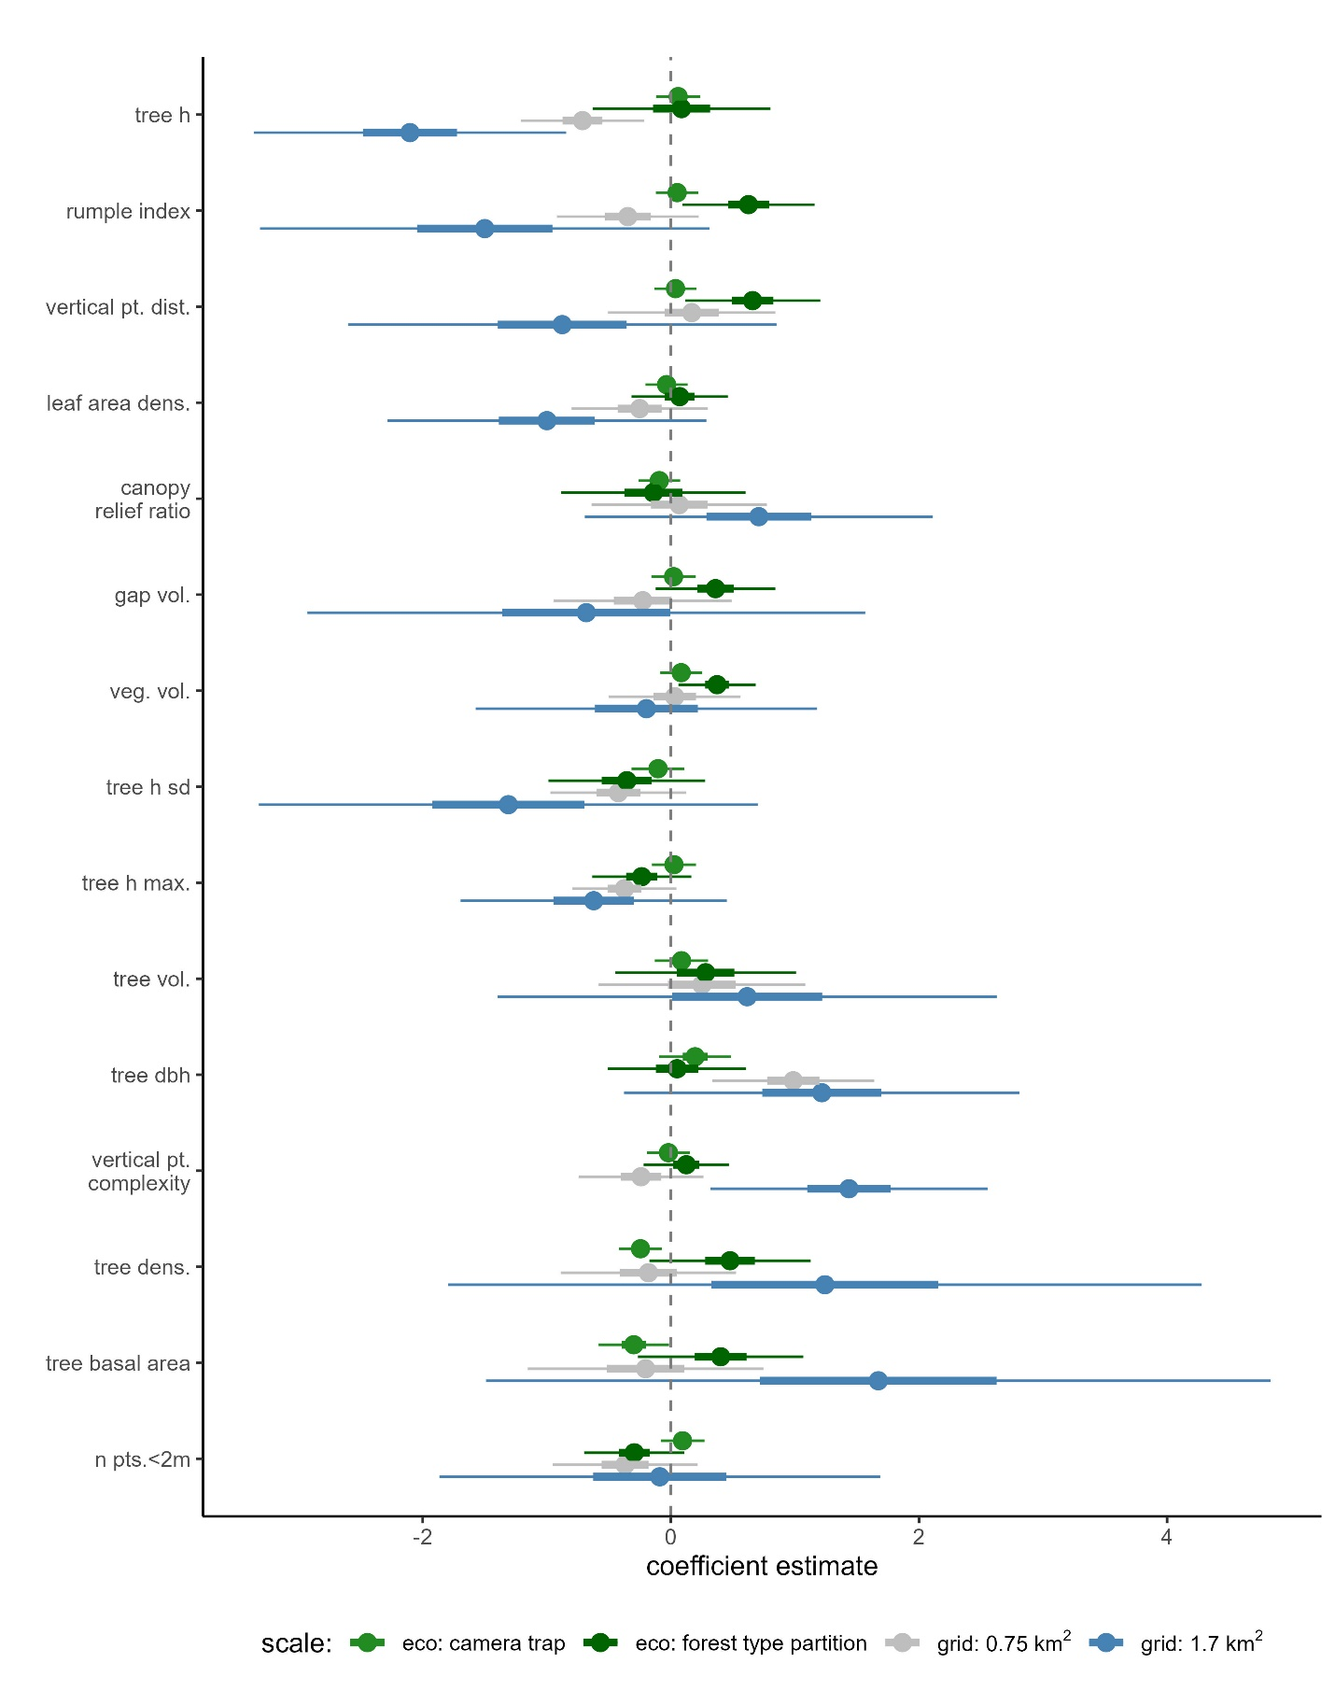
Figure S12. Functional evenness models.

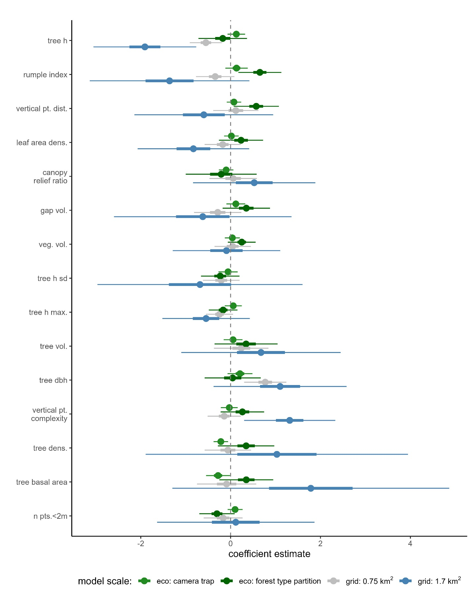Figure S13. Functional divergence models.

