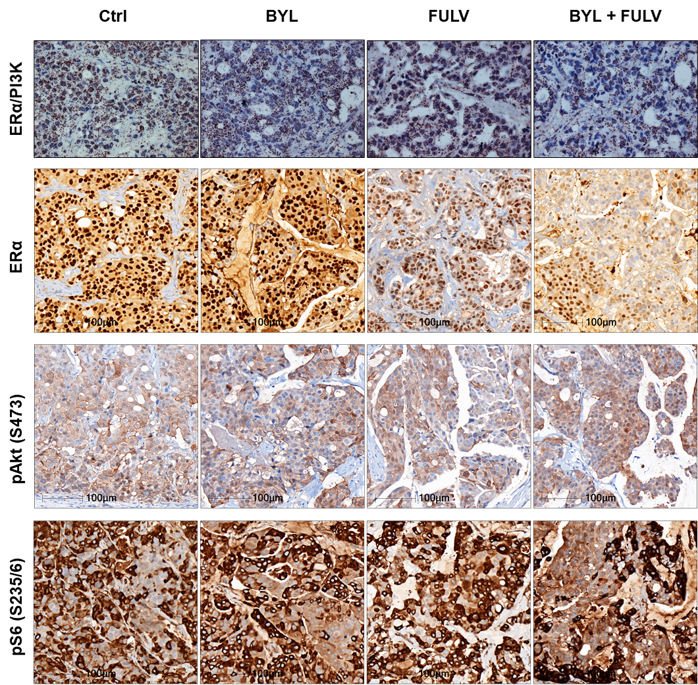

Figure S4: Proximity ligation assay (PLA) was performed on treated HBCx-3 tumours embedded in paraffin to study the interactions between ERα and PI3K. IHC staining was performed on the same PDX tumours using anti-ERα, P-AKT (S473) and anti-P-S6 riboprotein (S235/6) antibodies.

