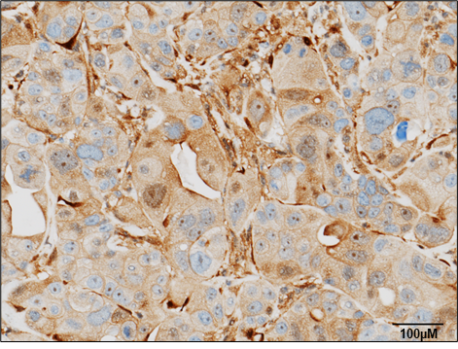
Figure S2. IHC staining was performed on formalin-fixed paraffin-embedded BC111 PDX tumour BC1111 using anti-PTEN antibody.

