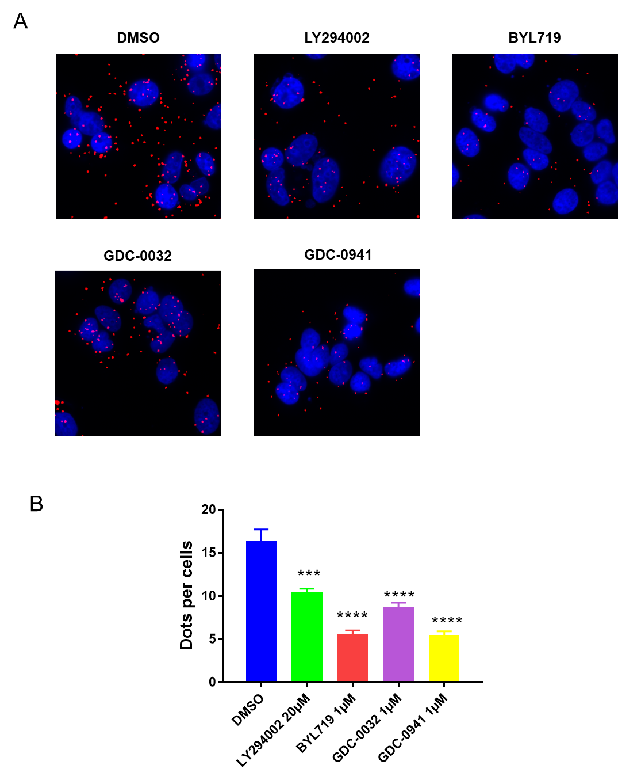

Figure S1. Effect of PI3kinase inhibitors on ERα/PI3K dimer formation. A. Oestrogen-deprived MCF-7 cells treated or not with PI3K inhibitors LY294002, BYL219, GDC-0032 and GDC-0941 (5 µM) 15 min before E₂ treatment were incubated with E₂ (10⁻⁸ M) for 5 min (see Additional supplementary methods). After fixation, in situ PLA for ERα/PI3K was performed. The detected dimers are represented by red dots. The nuclei were counterstained with DAPI (blue) (Obj:X63). B. Quantification of the number of dots per cell was performed using image J software and an automated analysis (see Additional supplementary methods). ). P-value: *** <0.01, **** < 0.001

