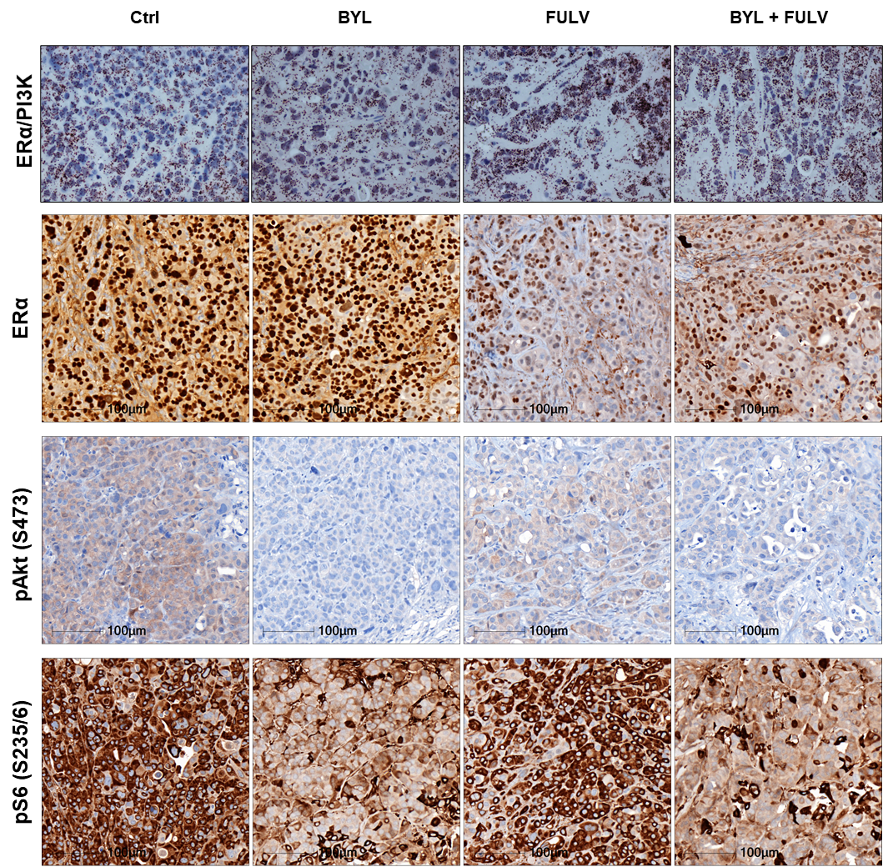

Figure S7: Proximity ligation assay (PLA) was performed on treated BC1111 tumours embedded in paraffin to study the interactions between ERα and PI3K. IHC staining was performed on the same PDX tumours using anti-ERα, P-AKT (S473) and anti-P-S6 riboprotein (S235/6) antibodies.

