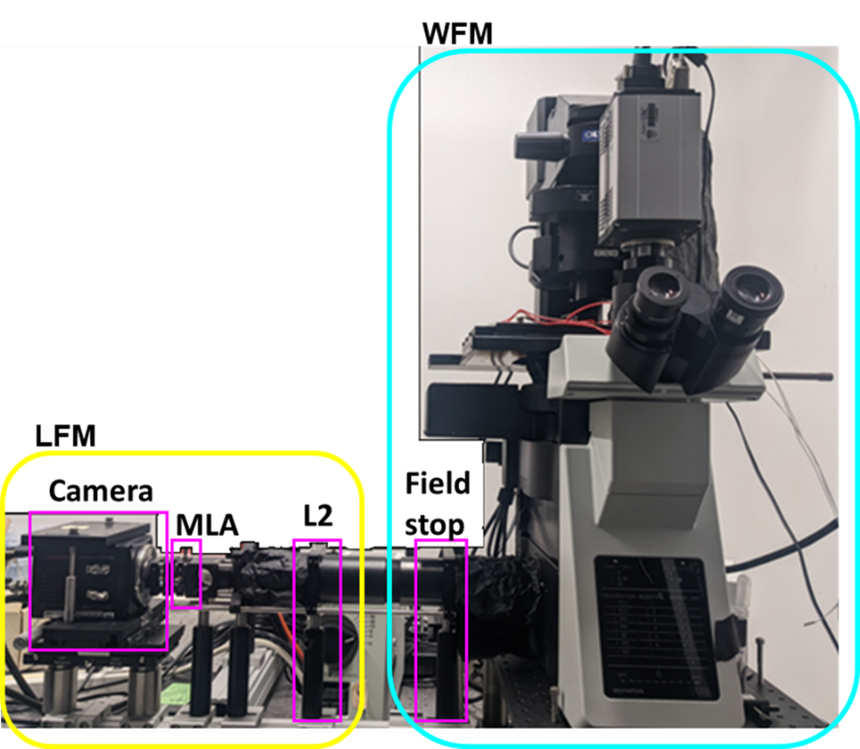
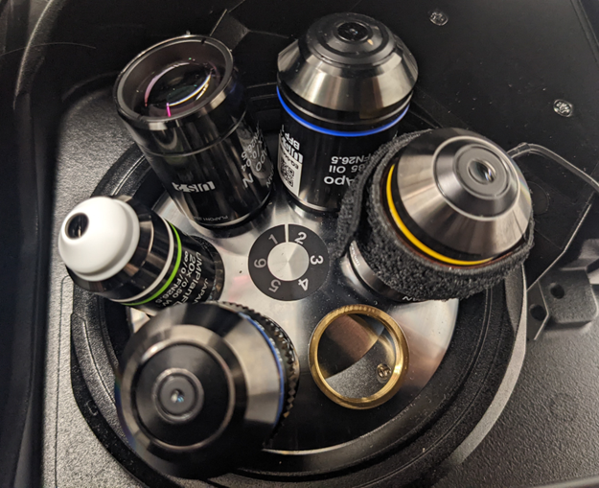
Supplemental Fig. 1

Supplemental Figure 1. Hardware set-up of the versatile LFM system
Light Field Microscopy (LFM) is implemented as an add-on module (yellow box) appended to a commercial Wide Field Microscope (WFM) body (cyan box). The red arrow is pointed to the objective turret integrated within the WFM. The nosepiece can house six objectives in total and is controlled automatically by the microscope controller. The field stop is mounted at the image plane of the standard camera port to control the field of view. In the LFM module, there are three main components: a relay lens (L2), a micro lenslet array (MLA), and a recording camera. The relay lens L2 has focal length f₂ = 180 mm, same as the tube lens in the WFM. The MLA is square shaped with each side of length 12 mm. Each lens-let is also square shaped with focal length f_{ML} = 29.9 mm and diameter of 1.5 mm. The camera is a scientific Complementary Metal–Oxide–Semiconductor (sCMOS) camera from Hamamatsu (ORCA-Flash4.0). The chip size is 13 × 13 mm with each pixel at 6.5 µm, rendering an image size of 2048 × 2048. A list of all the hardware models and parameters are listed in Supplementary table 1.

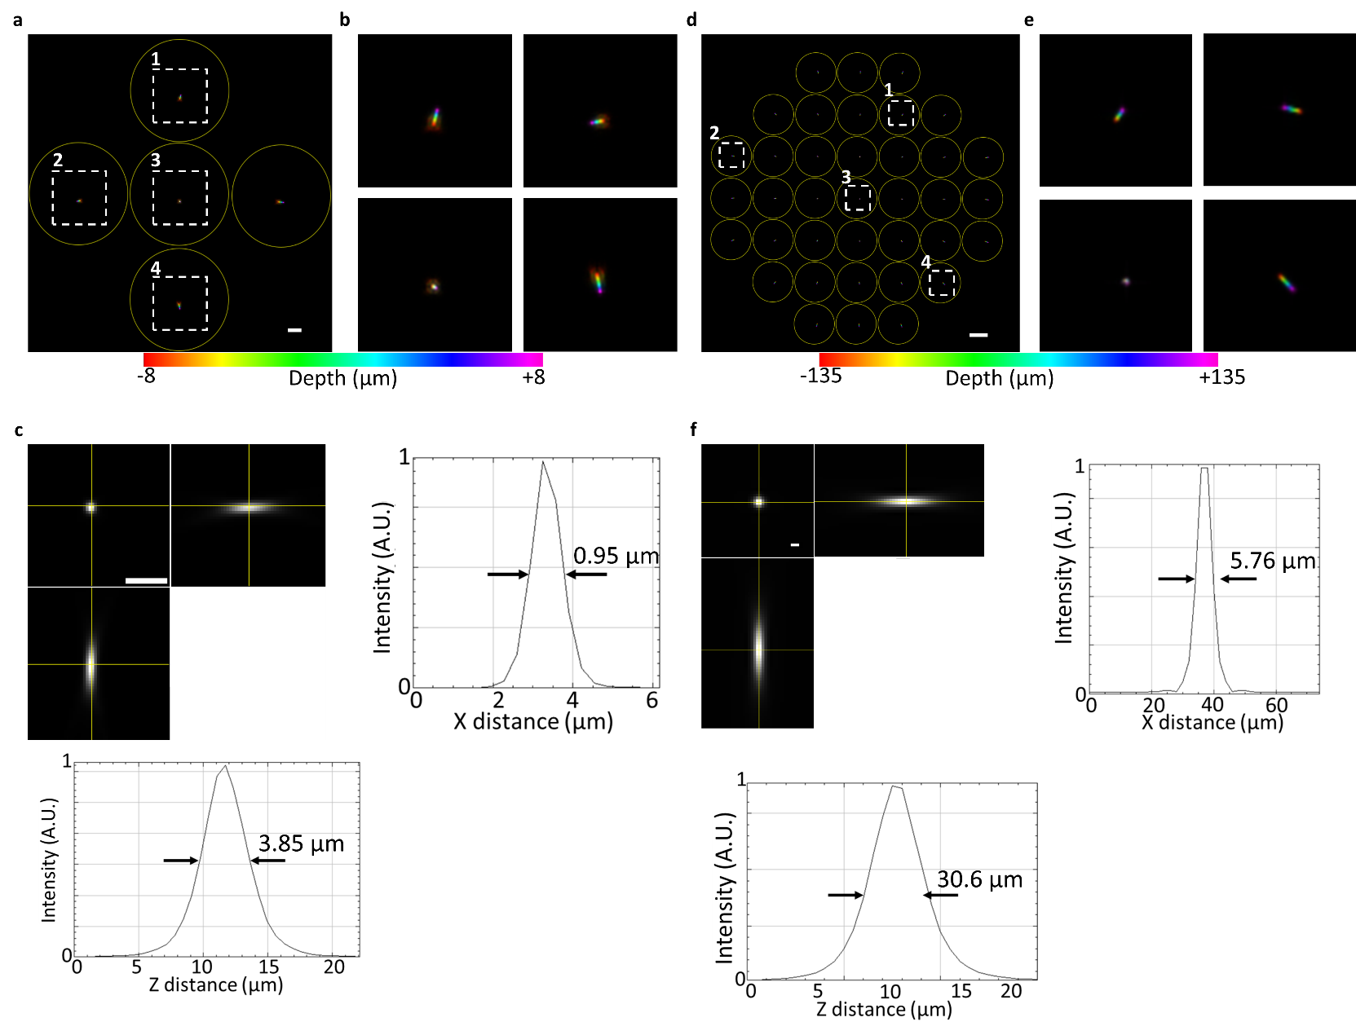
Supplementary Fig. 2

Supplementary Fig. 2. Resolution characterization for the LFM module, with 60x and 10x primary objectives.
(a) & (d) Maximum-Intensity Projection of an image z-stack, of a 1-µm-diameter fluorescent bead, taken with (a) 60x 1.35 NA Oil objective and 10x 0.4 NA Air objective, color-coded for z-depth over the depth-of-view from -8 µm to 8 µm and -135 µm to 135 µm, respectively. The angular views behind each lens-let are separated in yellow circles. (b) & (e) Zoomed-in view of white boxes in (a) & (d), respectively. (c) & (f) Lateral and axial profiles of the reconstructed bead from (a) & (d), respectively. A.U., Arbitrary Unit. Scale bars, (a, c) 5 µm, (d) 100 µm, (f) 10 µm.

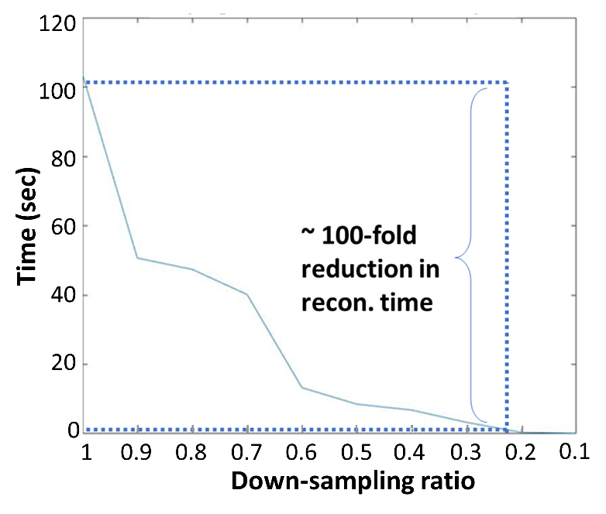
Supplementary Fig. 3
Supplemental Fig. 3. Reconstruction speed vs linear down sampling ratio
The reconstruction time is analyzed with respect to the size of a raw 2D light field image with 61 reconstructed z-slices. The linear down sampling ratio (LDSr) is defined as the down-sampling ratio for each side of an image. For a light field image of initial size 2048 × 2048 pixels, the down-sampled image would have size: (2048 × LDSr) × (2048 × LDSr) = LDSr² × 2048 × 2048 pixels. The number of the reconstructed z-slices would be round (61 × LDSr), where round (·) represents rounding to the nearest integer.
The reconstruction is performed at 5 iterations per image with the GPU Quadro P5000. As highlighted in the dotted blue lines in the plot, to have ~ 100-fold reduction in reconstruction time, the LDSr would be ~ 0.22. Without down-sampling, a 5-min recording, taken at 100 frames per seconds, requires 84 hours (3.5 days) to reconstruct. After the down-sampling with LDSr = 0.22, the reconstruction takes less than an hour.

Supplemental Video 1. Whole-Brain Seizure in Zebrafish Larva
Whole-brain LFM imaging of a 5-dpf zebrafish larva expressing a pan-neuronal calcium indicator, Tg(elavl3:GCaMP7f). The sample was immobilized in agarose and the seizure was chemically induced by administering 15 mM PTZ. The seizure event was recorded at 33 volumes/s.

Supplemental Video 2. Calcium Dynamics in Mouse Islet
LFM imaging of an ex vivo pancreatic islet, from a transgenic mouse where all the pancreatic beta cells express the calcium indicator GCaMP6f. The islet was in a medium with glucose concentration at 11 mM. The calcium dynamic activity was recorded at 20 volumes/s.

Supplemental Video 3. Protein Dynamics in Cultured Cell
LFM imaging of the 3D protein dynamics in a cultured U2OS cell expressing mNeonGreen fused to the human prolactin receptor. The dynamics was recorded at 20 volumes/s.

Supplementary Table 1. Part numbers and descriptions of key components of the LFM module
Item | Acronym  (Sup. Fig. 1) | Descriptions | Part number | Manufacturer/  Vendor
Wide Field Microscope | WFM | Inverted WFM with motorized stage  Light source: Olympus, U-HGLGPS  Filter cube set: Olympus, U-FF | IX-83 Inverted | Olympus
Field stop | Field stop | Ring-Actuated Iris Diaphragm  Aperture range: Ø1.4 - Ø25.0 mm | SM2D25D | Thorlabs
Relay lens | L2 | Focal length = 180 mm | AC508-180-A | Thorlabs
Micro-lens array | MLA | Pitch = 1.5 mm,  Focal length = 29.9 mm,  Area = 12 × 12 mm² | APD-GB-P1500-R13.8 | OKO Tech
LFM Camera | Camera | Scientific CMOS  Pixel size = 6.5 µm, 2048 × 2048 pixels | ORCA-Flash4.0 | Hamamatsu

Supplementary Table 2. Theoretical estimates of the imaging performance.
Performance Parameters | Governing Equations | Hardware Parameters
FOV | $$\frac{ⅆ_{ML}∙f_{2}}{f_{ML}∙M}$$ | $λ$ : Wavelength of fluorescence  $p$ : Linear size of camera pixel  $ⅆ_{ML}$ : Diameter of each lens-let of the MLA  $ⅆ_{max}$ : Distance from the lens-let with maximum angular view to the aperture center  N_{r} : $Ratio of effective pupil size at MLA over ⅆ_{ML}$  $f_{ML}$ : Focal length of each lens-let  $f_{2}$ : Focal length of Relay lens L₂  $M$ : Magnification of objective  $NA$ : NA of the objective
DOV | $$2(\frac{λ}{{NA}^{2}}{N_{r}}^{2}+\frac{p∙f_{2}}{NA∙f_{ML}∙M}N_{r})$$
$$R_{xy}$$ | $$max⁡(\frac{λN_{r}}{2NA} , 2p∙\frac{f_{2}}{{M∙f}_{ML}})$$
$$R_{z}$$ | $$R_{xy}∙\frac{f_{2}}{{M∙d}_{max}}$$

 | FLFM image size | Reconstructed number of Z slice | Number of frames | Acquisition time per frame  (milliseconds) | Reconstruction time per frame (seconds) | Total Reconstruction time  (hours) | Total acquisition time  (seconds)
Zebrafish brain  (Fig. 3) | 1775 × 1775 | 27 | 451 | 33.3 | 20 | 2.5 | 15
Mice islet  (Fig. 4) | 1395 × 1395 | 43 | 1400 | 50 | 23 | 9 | 70
Cultured cell  (Fig. 5) | 713 ×  713 | 21 | 1000 | 50 | 1.7 | 0.5 | 50
Supplementary Table 3. Imaging and reconstruction parameters of presented results

Supplementary Note 1 Calculation of performance parameters and determination of number of lens-lets in the MLA
To calculate the imaging performance, we expressed the imaging performance parameters with respect to the optical parameters of the setup (Supplementary Table 2). The performance parameters are field of view (FOV), depth of view (DOV), lateral resolution ($R_{xy}$) and axial resolution ($R_{z}$). FOV, DOV and $R_{z}$ follow the same form derived in the Appendix of previous literature¹. $R_{xy}$ is defined as the smallest resolvable distance between two point-sources. This distance is determined by two factors: the pixel pitch and diffraction limit of the FLFM system. Based on Nyquist sampling theory, which states the sample rate must be greater than twice the highest frequency component of interest in the measured signal, the minimum distance that can be resolved by the camera pixel should be at least twice the distance of the pixel pitch. Mathematically, this is expressed as $R_{xy} ≥ 2p∙\frac{f_{2}}{{M∙f}_{ML}}$ , ensuring that any signal variations over a distance greater than $R_{xy}$ can be sampled at least twice by the pixels. Additionally, the system's lateral resolution is constrained by the diffraction limit of light, which is expressed as $R_{xy} ≥ \frac{λN_{r}}{2NA}$. The final lateral resolution is the greater of these two distances.
The number of lens-lets in the MLA is determined by leveraging the trade-off between the reconstructed single voxel size and total number of voxels, which were computed from equation (1) and (2) respectively for all the objectives of interest.
$voxel size= R_{xy^{2}}∙R_{z}$ (1)
$\# of voxels= \frac{DoV}{voxel size}= \frac{DoV}{R_{xy^{2}}∙R_{z}}$ (2)
To evaluate these two criteria with respect to N (the number of Lens-lets on one side of the square MLA), we can rewrite the equations in Supplementary Table 2 by substituting $ⅆ_{ML}$ and $N_{r}$ with N using equation (3), (4), where $D_{MLA}$ is the diameter of the MLA, $D_{Bap}$ is the diameter of objective back aperture, n is the reflective index of the objective immersion media and f₁ is the focal length of tube lens L1 (Figure 1a) in the WFM.
$ⅆ_{ML}= \frac{D_{MLA}}{N}$ (3)
$N_{r}= \frac{D_{Bap}}{ⅆ_{ML}}=D_{Bap}∙ \frac{N}{D_{MLA}}=\frac{NA}{n} ∙ \frac{2f_{1}}{M} ∙ \frac{f_{2}}{f_{1}} ∙ \frac{N}{D_{MLA}} = \frac{2∙NA∙f_{2}}{n∙M∙D_{MLA}}∙N$ (4)
The results were plotted in Figure 1b in the main text. The optimum number of lens-let can be achieved with an MLA with 9 x 9 lens-lets. We chose an 8 x 8 MLA due to commercial availability. The final performance stayed close to optimum and have satisfied a wide range of bio-imaging applications (Table 1).

Supplementary Note 2 Experimental PSF processing and 3D reconstruction of LFM data.
The complete processing pipeline, from experimental PSF extraction to 3D reconstruction, was implemented in MATLAB and FIJI. It is open-source and publicly available on GitHub with a detailed step-by-step manual that does not require expert knowledge of LFM [https://github.com/yangyanb/FLFM-Processing-Pipeline.git]. FIJI was used for basic image pre-processing including background subtraction and generating binary masks for regions of interest (ROI). MATLAB scripts were written for extracting the experimental PSF from the beads’ image stack, cropping out the ROI in the raw LFM image then performing 3D reconstruction. The 3D reconstruction section was adapted from a previous package named oLaF^{2–4}. The reconstructed 3D data were generated in both TIF and MAT format for immediate visualization and downstream processing.
The pipeline consists of two processing stages: experimental PSF extraction and 3D reconstruction. The experimental PSF was collected from scanning a single bead axially over the DOV placed in the center of the FOV. The bead image at different axial plane shifts its center positions laterally in each angular projection view (Fig. 2a, b, Supplementary Fig. 2a, b, d, e). For this reason, a direct cylindrical cut-out across the entire bead image stack is not ideal since it includes large unrelated background volume that contains pure background shot noise and could contain contamination caused by other beads or fluorescent objects, such as dust and bubbles. A proper PSF extraction process ensures a clean and accurate PSF characterization of the system, reducing computational artifacts in downstream 3D reconstruction. Here, we develop a PSF extraction pipeline that is specifically tailored to the FLFM system. Given that the shift between adjacent axial slice does not change dramatically (around 1-2 pixels), the bead region in the current slice would still be contained in the masked region of the last slice. This property was exploited to iteratively update the PSF mask at every plane so that the mask is always positioned near the center of the bead image in each angular projection view. To initiate the iteration, the bead image stack was circled manually in the first axial plane. The iteration is written in MATLAB scripts and described in the following steps:
Step 1: Subtract background from the bead stack.
Step 2: Circle out Regions of Interest (ROIs) for a single bead in all angular projection views manually at the 1st slice of the bead stack.
Step 3:
- Create a bead mask from the ROIs.
- Mask out the 1st slice of the bead stack.
Use i to denote the slice number, then from i = 2 to the last slice:
Step 4:
- Read in the i^{th} slice.
- Find the maximum intensity position in each masked-out region.
Step 5:
- Shift the bead mask at i-1th slice in each angular projection view such that the center is the maximum intensity position in Step 3.
- Use the shifted mask as the bead image mask for i^{th} slice.
Step 6:
- Mask out the single bead light field image at i^{th} slice.
- i = i + 1.
The 3D reconstruction algorithm takes the extracted PSF and the raw light field image to iteratively reconstruct the 3D volume. As shown in the method section, the main operation in the iterations is multiple 2D convolutions for forward and backward projection between the 2D light field image space and 3D sample space. Graphics Processing Unit (GPU) computing was used to accelerate the iterations. We used one Nvidia Quadro p5000 GPU with 16 GB of RAM on a workstation for all the reconstructions. With a fix number of iteration of 10, the reconstruction time varied depending on the size of the light field images. The reconstruction time for each experiment is listed in Supplementary Table 3. Roughly speaking, the reconstruction time is at ~ 30 to 600 folds of the acquisition time, varying on the size of the light field image data as well as the reconstructed number of z slices. To speed up the reconstruction, we could improve on the hardware computing power as well as the software implementation. On the hardware side, apart from increasing the GPU processing speed and RAM volume, Cloud Computing Service offered by companies such as Amazon offers a cost-effective way to boost the data processing power for reconstructing large datasets. On the software side, since the reconstruction time goes down with decreasing the size of the raw 2D LFM image, down sampling the light field image before reconstruction can shorten the reconstruction time significantly (Supplementary Fig. 3). While this approach inevitably compromises resolution, it is often useful when the resolution exceeds the necessary requirements for imaging dynamics, producing redundant data that offers little additional insight.
References
1. Guo, C., Liu, W., Hua, X., Li, H. & Jia, S. Fourier light-field microscopy. Opt. Express 27, 25573–25594 (2019).
2. Stefanoiu, A., Page, J., Symvoulidis, P., Westmeyer, G. G. & Lasser, T. Artifact-free deconvolution in light field microscopy. Opt. Express 27, 31644 (2019).
3. Stefanoiu, A., Scrofani, G., Saavedra, G., Martínez-Corral, M. & Lasser, T. What about computational super-resolution in fluorescence Fourier light field microscopy? Opt. Express 28, 16554 (2020).
4. Stefanoiu, A., Scrofani, G., Saavedra, G., Martínez-Corral, M. & Lasser, T. Deconvolution in Fourier integral microscopy. in (SPIE, 2020). doi:10.1117/12.2558516.

