Dual-layered Mantle Lithosphere Beneath Southeastern Canadian Cordillera

Supplementary

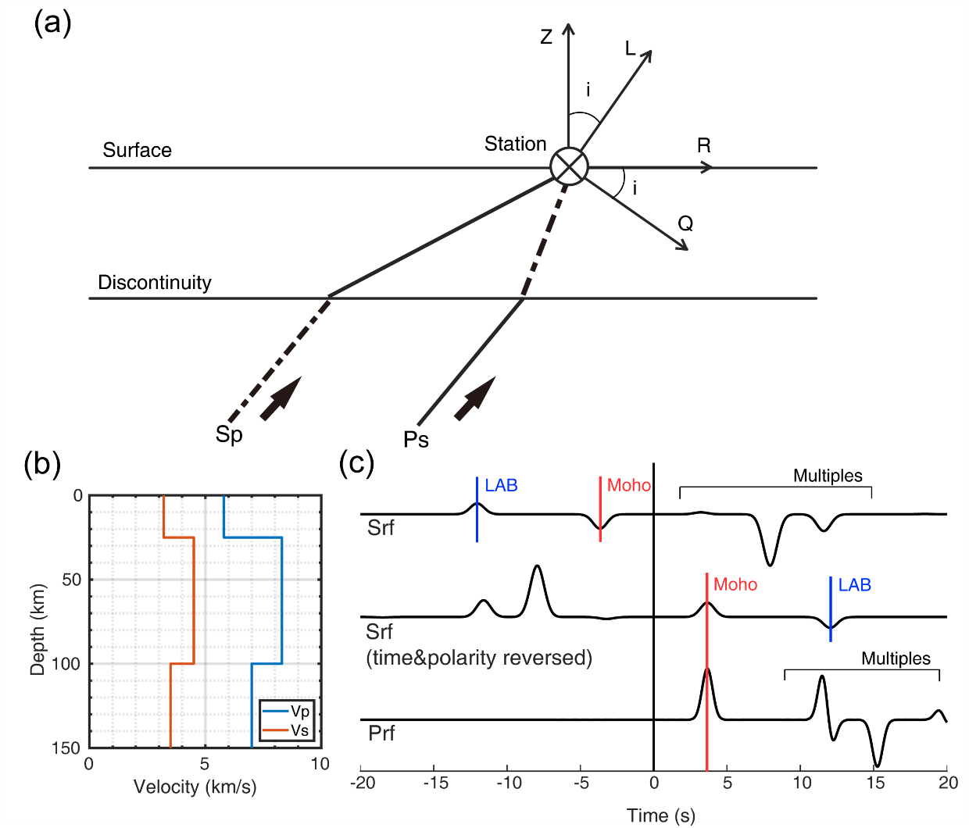
Fig.S1. (a) A schematic diagram showing P-to-S and S-to-P converted waves (modified after Kind et al., 2012). The particle motion of the S wave is perpendicular to the L direction (Kind et al., 2012). (b) A three-layer input model modified after PREM (Dziewonski & Anderson, 1981). (c) Synthetic receiver functions generated by the model in b, using the RAYSUM package (Frederiksen & Bostock, 2000). The Moho and Lithosphere-Asthenosphere Boundary (LAB) are indicated by red and blue lines, respectively.

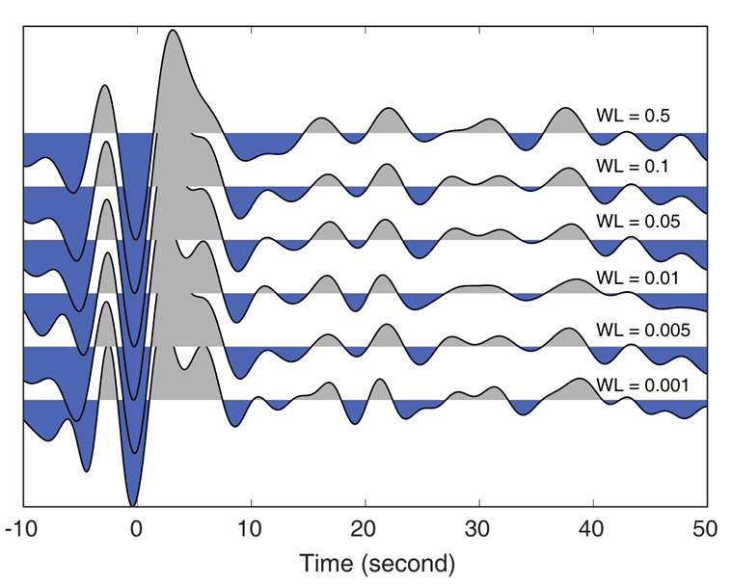
Fig.S2. Effect of water-level on stacked SRF. An example of stacked SRFs of station EDM from 34 individual estimates. While increasing the water-level parameter leads to minor resolution loss on the traces, the main features of interest (e.g., lithospheric conversions) are relatively stable.

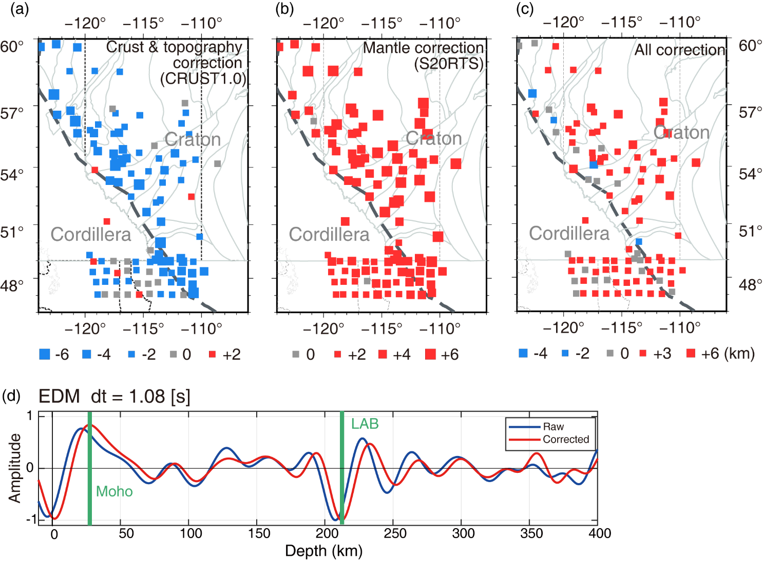
Fig.S3. Crustal and mantle heterogeneity correction values. The grey dashed lines indicate the Cordillera Deformation Front. (a) The crustal and topography corrections based on model CRUST1.0 (Laske et al., 2013). Most corrections are negative, showing above average elevation near the Rocky Mountains. (b) Mantle heterogeneity corrections based on model S20RTS (Ritsema et al., 1999), which are largely positive due to faster wave propagations in the North American mantle. (c) The combination of two corrections, which is then applied to the receiver functions. (d) A stacked S receiver function from station EDM, after applying a time shift. Deeper Moho and LAB depths are marked by green vertical lines.

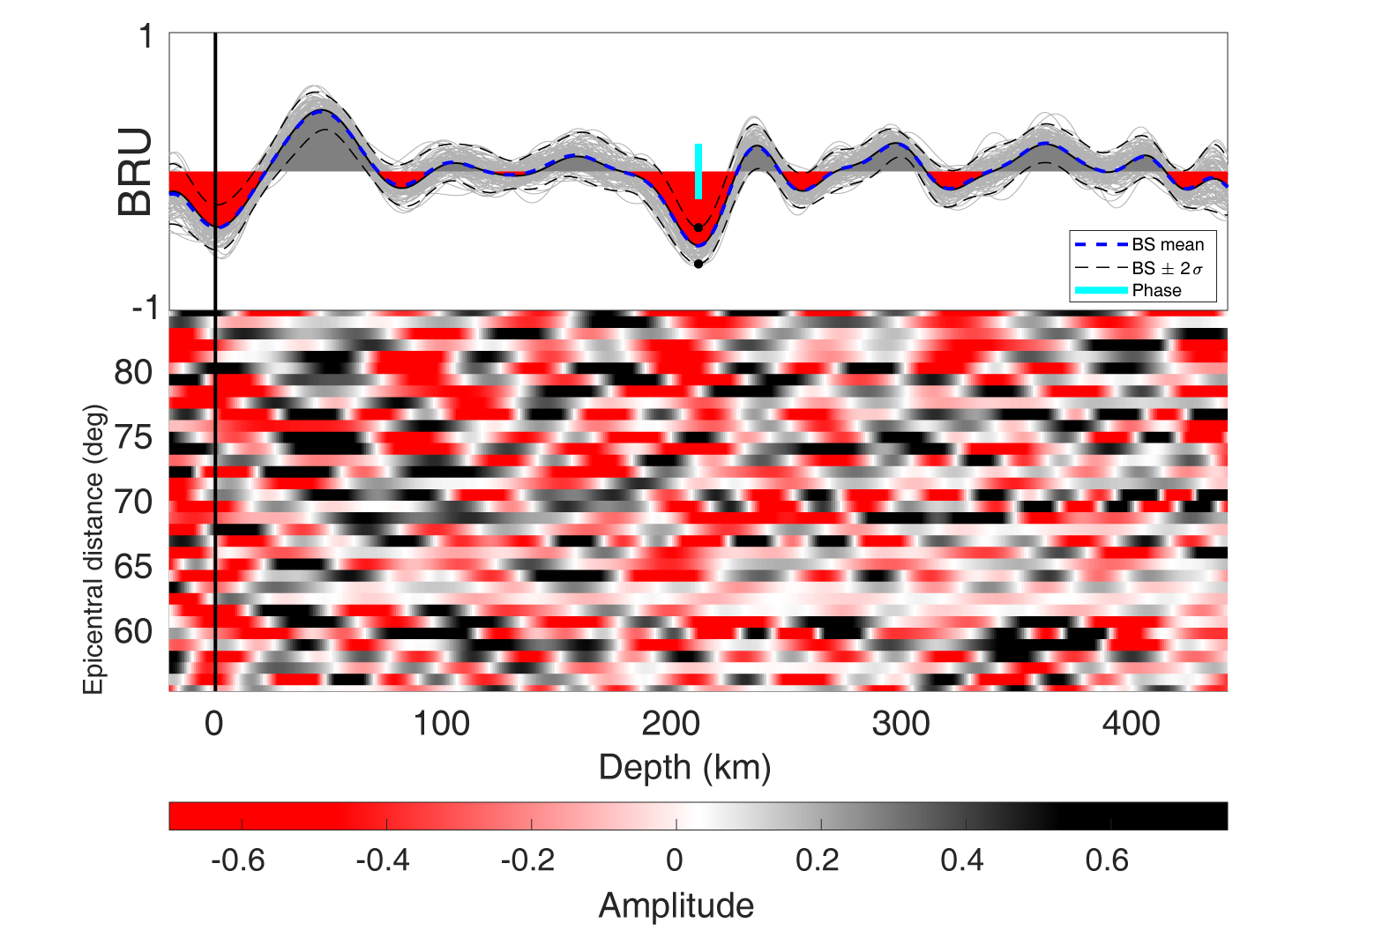
Fig.S4. S receiver functions of station BRU. The top panel shows the stacked SRF and two standard deviations from bootstrapping (grey lines; (Gu & Dziewonski, 2002)). The negative LAB conversion is indicated by the vertical line segment (cyan color). The bottom panel shows the individual SRFs in the order of increasing epicentral distances.

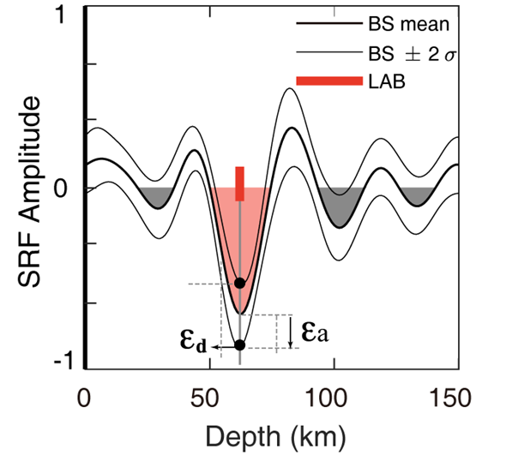
Fig.S5. A diagram showing stacked S receiver function error estimations. The thick black line is the averaged S receiver function from the bootstrapping analysis, and thinner lines above and below the mean are computed from 2 standard deviations (2σ). A negative phase colored in red is an example of a hand-picked LAB. Amplitude error is measured by using a 2σ value. Detailed error estimates for the actual stations can be found in Supplementary Table.

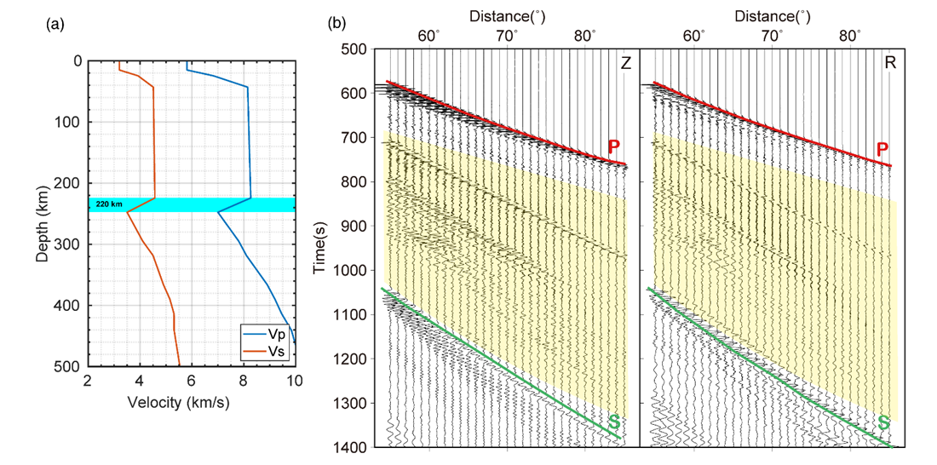
Fig.S6. Synthetic seismograms. (a) The velocity model used to compute the synthetics is based on a modified, flattened PREM model (Dziewonski & Anderson, 1981) where the LAB thickness is 24 km. (b) Synthetic seismograms computed using the Reflectivity method (Randall, 1994). Colored lines denote incident S and P waves, while the yellow area highlights the conversions.

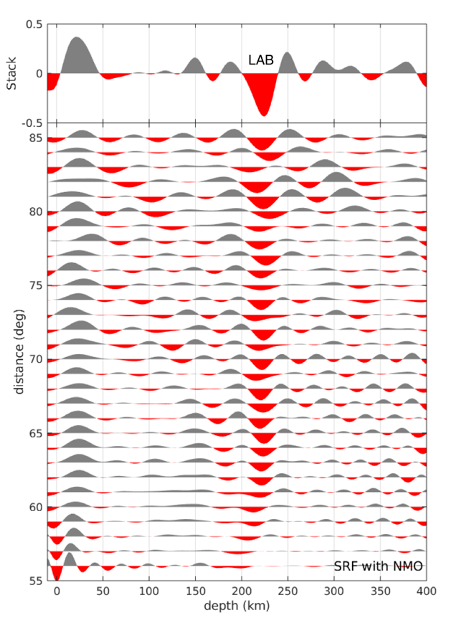
Fig.S7. Synthetic S receiver functions and a stack. The individual SRFs are aligned by epicentral distance (1° interval), and their amplitudes have been normalized. The top panel shows the stacked SRF, with the axis migrated into the depth domain. Moveout correction stretches the trace more severely near the critical distance, causing distortions. The positive phase at 25 km represents the Moho, and the negative phase at 220 km results from S-to-p conversions from the LAB.

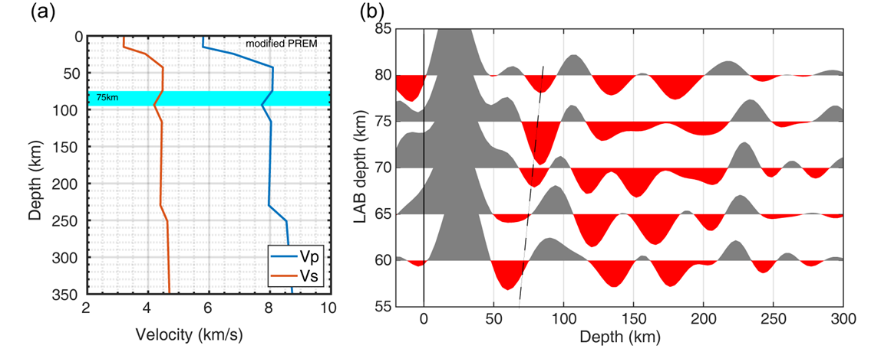
Fig.S8. Synthetic S receiver functions using a modified velocity model. The left panel displays one of the velocity models employed for synthetic calculations, which contains a low velocity anomaly positioned at 75 km depth. In the right panel, individual SRFs are aligned by the LAB depth at 5 km intervals. The black dashed line marks the negative phase associated with the velocity gradient.

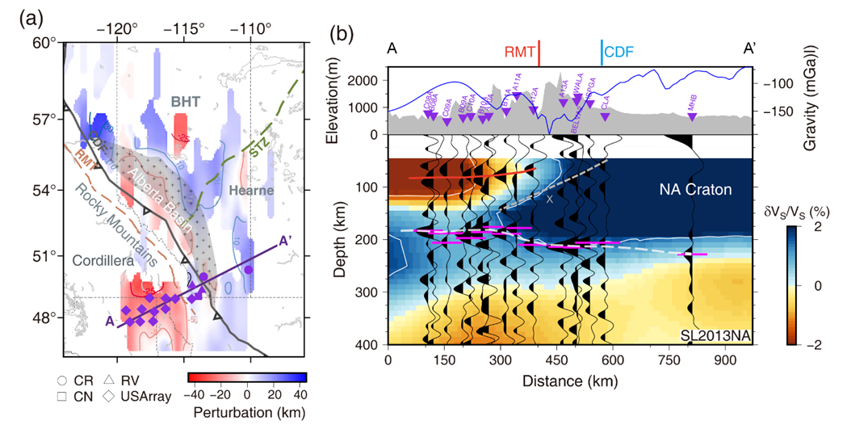
Fig.S9. Comparison between profile A and the velocity model SL2013NA (Schaeffer & Lebedev, 2013). (a) Depth perturbation of the LLAB. The purple line and symbols mark the location of profile A and the stations used for this comparison. (b) SRFs along the profile and the corresponding transect from SL2013NA. The top panel shows the topography and Bouguer gravity anomalies along the profile. The white lines denote the -1% and 1% velocity contours, while the red and white dashed lines highlight the CLAB and LLAB, respectively.

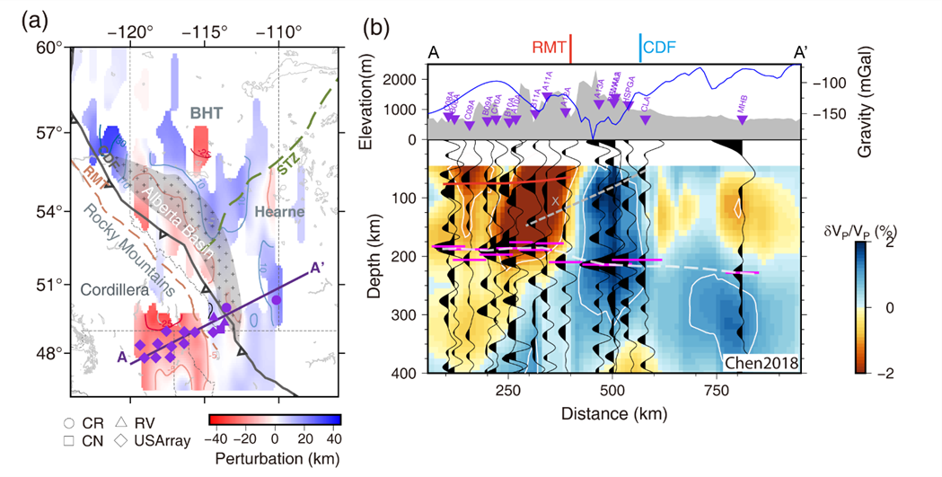
Fig.S10. Comparison between profile A (SRF) and P velocity model Chen2018 (Chen et al., 2018). The symbols and color choices are similar to those in Fig.S9. (a) LLAB depth perturbation. The purple line and symbols represent the location of profile A and stations used for comparison. (b) SRFs along the profile and the corresponding model cross-section from Chen2018.

S receiver function (SRF) computation and upper mantle discontinuities imaging
This study utilizes the frequency domain water-level S receiver function technique (Farra & Vinnik, 2000; Yuan et al., 2006) to analyze S-to-p converted waves resulting from mantle interfaces (see Fig.S1(a)). Since S-to-p converted waves travel faster than direct S, their waveforms are minimally affected by multiple-reflected S. This is a distinct advantage over P-to-s conversions, which are commonly used in crust and mantle imaging but suffer from contaminations from P wave coda at lithospheric depths (see Fig.S1(c); Rondenay, 2009; Rychert et al., 2007; Yuan et al., 2006).
Our S receiver function technique contains two initial steps: 1) signal partitioning that isolates the incident from scattered wavefields, and 2) deconvolution that minimizes source and propagation effects (Yuan et al., 2006). The resulting receiver functions are subsequently corrected for epicentral distance (via time shifts) and stacked according to the locations of the conversion points (see below).

Synthetics
- Laurentia Lithosphere-Asthenosphere Boundary (LLAB) synthetics
We utilize the reflectivity method (Aki & Richards, 1980; Kennett & Kerry, 1979; Randall, 1994) to generate a series of full-wavefield synthetic seismograms. A modified PREM (Fig.S6(a); Dziewonski & Anderson, 1981) and a generic strike-slip source mechanism are adopted for the waveform simulations. To enhance the amplitude of conversions for a better visual examination, we double the velocity gradient at 220 km and the resulting S receiver functions show distinct phases at the depths of 24 km and 220 km (Moho and LAB). Fig S6(b) shows the simulated waveforms for epicentral distances ranging from 55° to 85°, discretized in 1° intervals. The arrival times of individual phases are determined using the TauP travel time toolkit (Crotwell et al., 1999). The vertical and radial components of seismograms generated by a shallow earthquake (10 km) at a station with a back azimuth of 0° (pointing from source to station) (see Fig.S6). The direct S and P waves are indicated on the plots, and their arrival times are delayed according to epicentral distance.
Both individual and stacked SRFs contain the Moho and LAB conversions at the respective depths of 25 km and 220 km (see Fig.S7). The LAB signature remains stable within the distance range of 60°-70°. It is worth noting that at smaller distances, the SRFs exhibit low amplitudes and waveform distortions. Despite uncertainties from distance variations, summing the individual SRFs greatly suppresses minor phases and enhances the expected mantle conversions.
- Cordillera Lithosphere-Asthenosphere Boundary (CLAB) synthetics
To assess the stability of CLAB conversion, we simulate synthetic SRFs with a shallower velocity contrast. Utilizing the PREM (Dziewonski & Anderson, 1981), we introduce a series of 20-km thick, negative velocity anomalies at the depths 70 km, 75 km and 80 km. We reduce the P and S velocities by 4% and 5.88%, respectively, while other velocities are consistent with those of PREM. For each velocity model, we followed the procedure outlined in Section 1 of this document (see Fig.S8). The resulting SRFs show a robust negative phase resulting from the low-velocity zone. This result suggests that a negative gradient at ~70 km depth is capable of producing the negative phase observed from the actual data.

Comparisons with other velocity models
In addition to the NA14 velocity model, we compare SRFs with two other velocity models: SL2013NA (Schaeffer & Lebedev, 2013) and Chen2018 (Chen et al., 2018).
SL2013NA exhibits a low-velocity anomaly beneath the Cordillera (profile A, Fig.S9), characterized by a 3% reduction in velocity gradient. This anomaly extends vertically to approximately 150 km depth and terminates horizontally near the western margin of the Rocky Mountain Trench. The observed CLAB from SRF roughly aligns with the midpoint of this anomaly but extends by about 50 km farther west than the location suggested by SL2013NA. On the craton side, SL2013NA shows a lithosphere thickness of approximately 200 km. The lower contrast, which we interpret as LLAB, corresponds to the base of the high-velocity zone beneath the North American craton. Phase 'X' follows the 1% velocity gradient contour just above the western edge of the high-velocity craton lithosphere.
We compare the SRFs and P velocity model Chen2018 (Chen et al., 2018) along profile A (see Fig.S10). Similar to SL2013NA, Chen2018 depicts a low-velocity anomaly (1% velocity gradient reduction) beneath the Cordillera. However, it extends to a greater depth (~200 km) compared to those in SL2013NA and NA14. Chen2018 observes a near-vertical contrast between the Cordillera lithosphere and the craton, which is considerably steeper than the value extracted from the SRF. The high-velocity structure beneath the craton in Chen2018 is thicker (1% velocity gradient at ~300 km) that our SRF estimates, whereas the LLAB correlates well with the 2% contour beneath the western edge of the Cordilleran deformation front. There is no clear evidence of phase 'X' in the Chen2018 model. Vertical smearing from body wave ray paths (Chen2018) could be partly responsible for the observed discrepancies with our SRF study.

Reference
Aki, K., & Richards, P. G. (1980). Quantitative seismology. II, 932.
Chen, Y., Gu, Y. J., & Hung, S. H. (2018). A New Appraisal of Lithospheric Structures of the Cordillera-Craton Boundary Region in Western Canada. Tectonics, 37(9), 3207–3228. https://doi.org/10.1029/2018TC004956
Crotwell, H. P., Owens, T. J., & Ritsema, J. (1999). The TauP Toolkit: Flexible Seismic Travel-time and Ray-path Utilities. Seismological Research Letters, 70(2), 154–160. https://doi.org/10.1785/gssrl.70.2.154
Dziewonski, A. M., & Anderson, D. L. (1981). Preliminary reference Earth model. Physics of the Earth and Planetary Interiors, 25(4), 297–356. https://doi.org/10.1016/0031-9201(81)90046-7
Farra, V., & Vinnik, L. (2000). Upper mantle stratifcation by P and S receiver functions. Geophys. J. Int., 141, 699–712.
Frederiksen, A. W., & Bostock, M. G. (2000). Modelling teleseismic waves in dipping anisotropic structures. Geophysical Journal International, 141(2), 401–412. https://doi.org/10.1046/j.1365-246X.2000.00090.x
Gu, Y. J., & Dziewonski, A. M. (2002). Global variability of transition zone thickness. Journal of Geophysical Research: Solid Earth, 107(B7), ESE 2-1-ESE 2-17. https://doi.org/10.1029/2001jb000489
Kennett, B. L. N., & Kerry, N. J. (1979). Seismic waves in a stratified half space. Geophysical Journal of the Royal Astronomical Society, 57(3), 557–583. https://doi.org/10.1111/j.1365-246X.1979.tb06779.x
Kind, R., Yuan, X., & Kumar, P. (2012). Seismic receiver functions and the lithosphere-asthenosphere boundary. Tectonophysics, 536–537, 25–43. https://doi.org/10.1016/j.tecto.2012.03.005
Laske, G., Masters, G., Ma, Z., & Pasyanos, M. (2013). Update on CRUST1.0---A 1-degree global model of Earth’s crust. EGU General Assembly 2013, 15, 2658. http://meetingorganizer.copernicus.org/EGU2013/EGU2013-2658.pdf
Randall, G. E. (1994). Efficient calculation of complete differential seismograms for laterally homogeneous earth models. October, 245–254.
Ritsema, J., Van Heijst, H. J., & Woodhouse, J. H. (1999). Complex shear wave velocity structure imaged beneath Africa and Iceland. Science, 286(5446), 1925–1931. https://doi.org/10.1126/science.286.5446.1925
Rondenay, S. (2009). Upper mantle imaging with array recordings of converted and scattered teleseismic waves. Surveys in Geophysics, 30(4–5), 377–405. https://doi.org/10.1007/s10712-009-9071-5
Rychert, C. A., Rondenay, S., & Fischer, K. M. (2007). P-to-S and S-to-P imaging of a sharp lithosphere-asthenosphere boundary beneath eastern North America. Journal of Geophysical Research: Solid Earth, 112(8), 1–21. https://doi.org/10.1029/2006JB004619
Schaeffer, A. J., & Lebedev, S. (2013). Global shear speed structure of the upper mantle and transition zone. Geophysical Journal International, 194(1), 417–449. https://doi.org/10.1093/gji/ggt095
Yuan, X., Kind, R., Li, X., & Wang, R. (2006). The S receiver functions: Synthetics and data example. Geophysical Journal International, 165(2), 555–564. https://doi.org/10.1111/j.1365-246X.2006.02885.x

