Appendix A
Economic Feasibility Assessment

Total Revenue under each Scenario
Scenario 1 ~ Total revenue under gold label certification
$${TR}_{gold_cert}=\left(0.06-0.015\right)*\left(Price premium+base price\right)*\left(\frac{0.75}{2.5}\right)*Yield per acre*(160-8)$$ | (5.18)
Scenario 2 ~ Total revenue under silver label certification
$${TR}_{silver_cert}=\left(0.06-0.015\right)*\left(Price premium+base price\right)*\left(\frac{0.75}{2.5}\right)*yield per acre*[\left(160-4\right)]$$ | (5.19)
Scenario 3 ~ Total revenue for Non-certified
$${TR}_{non_cert}=0.06(base price)*\left(\frac{0.75}{2.5}\right)*yield per acre*[\left(160-0\right)]$$ | (5.20)

Total Cost under each Scenario
Scenario 1~ Total cost under gold certification label
$${TC}_{gold_{cert}}=Fixed cost*\left(160\right)+Variable costs*\left(152\right)+Restoration cost*(8)$$ | (5.22)
Scenario 2 ~ Total cost under silver certification label
$${TC}_{sliver_cert}=Fixed cost*(160)+Variable costs*\left(156\right)+Restoration cost*(4)$$ | (5.23)
Scenario 3 ~ Total cost for non-certified
$${TC}_{non_cert}=(Fixed costs+Variable costs)*\left(160\right)$$ | (5.24)

Table A1. Socio-demographic characteristics of the survey sample for the three prairie provinces as well as comparative information of these characteristics from the 2016 census for each province.
Socio-demographic characteristic |  | Percent of total
Socio-demographic characteristic |  | Alberta |  | Saskatchewan |  | Manitoba
Socio-demographic characteristic |  | Survey Sample | 2016 Census | Survey Sample | 2016 Census | Survey Sample | 2016 Census
Gender (%) | Male | 49.9 | 50.1 | 49.1 | 49.7 | 48.9 | 49.4
 | Female | 50.2 | 49.9 | 50.5 | 50.3 | 51.2 | 50.6
Age (years) | 18-34 | 31.9 | 28.2 | 30.0 | 26.7 | 29.6 | 19.9
 | 35-54 | 36.2 | 28.0 | 32.6 | 25.1 | 33.5 | 25.8
 | 55 & over | 31.9 | 24.6 | 32.5 | 28.6 | 37.0 | 28.5
Highest level of education completed | Below Bachelor’s degree | 40.9 | 54.5 | 56.9 | 61.6 | 57.5 | 55.5
Highest level of education completed | Bachelor’s degree | 27.2 | 16.5 | 2.4 | 13.2 | 24.9 | 14.4
 | Post graduate study | 14.6 | 4.9 | 15.1 | 3.4 | 12.3 | 3.5
Annual household income before taxes ($) | $39,999 & under | 16.8 | 17.3 | 25.2 | 24.5 | 25.3 | 26.6
Annual household income before taxes ($) | $40,000-$79,000 | 14.9 | 24.3 | 21.4 | 28.7 | 19.9 | 31.7
Annual household income before taxes ($) | $80,000-$124,999 | 29.7 | 23.4 | 25.2 | 22.5 | 26.6 | 22.8
 | $125,000 & over | 24.8 | 34.5 | 17.6 | 24.6 | 15.0 | 11.6
Number of people in family | 1~2 | 57.4 | 58.3 | 59.8 | 63.5 | 61.8 | 61.4
Number of people in family | 3~4 | 34.2 | 31.3 | 34.2 | 26.8 | 32.6 | 28.2
Number of people in family | 5 or above | 8.3 | 10.4 | 8.3 | 9.5 | 5.7 | 10.4
Number of children in family | 1 | 71.0 | 32.8 | 63.8 | 33.0 | 76.6 | 27.7
Number of children in family | 2 | 14.0 | 37.2 | 17.6 | 35.0 | 12.1 | 33.7
Number of children in family | 3 or more | 14.8 | 18.4 | 18.6 | 21.4 | 11.3 | 14.5

Table A2. Assumptions and parameter values for estimating producer net returns
Variable | Assumptions | Source
Wheat
Flour to wheat proportion | 75% | Ardent Mills
Number of 2.5 Kilogram of wheat flour per bushel | 14.5 units | Based on estimation
Price of wheat per bushel | $6.04 | Saskatchewan Crop Planning Guide, 2021
Yield per acre | 68.3 bushels | Saskatchewan Crop Planning Guide, 2021
Percentage of wheat flour sale the farmer receives | 6% of retail wheat flour price | Estimated value based on retail value of wheat flour and farm gate prices of wheat/bushel
Bag of wheat flour | 2.5kg | Based on the wheat flour used in the study
Average price of 2.5kg bag of wheat | $7.50 | Average market wheat price from Saskatoon, January 2021.
Variable Costs | $284.23/acre | Saskatchewan Crop Planning Guide, 2021
Fixed costs | $119.57/acre | Saskatchewan Crop Planning Guide, 2021
Restoration costs per year (per acre) | $50-$500 | Tyndall, J., and T. Bowman (2016)
Certification transaction costs | 1.5% of retail wheat flour price (25% of producer portion) | Rundgren, 2001
Canola
Price of canola per bushel | $11.25 | Saskatchewan Crop Planning Guide, 2021
Yield per acre | 56 bushels | Saskatchewan Crop Planning Guide, 2021
Variable Costs | $360.23 | Saskatchewan Crop Planning Guide, 2021
Fixed costs | $119.57 | Saskatchewan Crop Planning Guide, 2021

Appendix B Survey Instrument

SCREENER QUESTION

Do you ever buy wheat flour when shopping for groceries? Wheat flour includes all-purpose flour, bread flour, cake and pastry flour, and whole wheat flour.
- Yes
- No -> Screen out

In which province do you currently reside?
- Alberta
- Saskatchewan
- Manitoba
Other Canadian province or territory -> Screen out


You are invited to participate in a research study entitled: Canadian food preferences and wetlands
Researchers:
Valentina Ofori, Graduate student, Department of Agricultural and Resource Economics, University of Saskatchewan, vao459@usask.ca
Patrick Lloyd-Smith, Assistant Professor, Department of Agricultural and Resource Economics, University of Saskatchewan, patrick.lloydsmith@usask.ca
Ken Belcher, Professor, Department of Agricultural and Resource Economics, University of Saskatchewan,
Peter Boxall, Professor, Department of Resource Economics and Environmental Sociology, University of Alberta

Purpose and Objective of the Research: The purpose of this research is to expand knowledge on consumer preferences for food and to learn about public opinion on these issues in society.
Procedures: We are asking you to take part in a survey being held across Alberta, Manitoba, and Saskatchewan. The estimated time to complete this is about 20 minutes.

Funded by: The study is being funded by Smart Prosperity, a Canadian think tank, and the Global Institute for Water Security at the University of Saskatchewan.

Potential Risks: There are no known or foreseen risks associated with participation in this study.

Potential Benefits: Survey participants will help inform future decisions regarding wetland conservation and in the Canadian prairies.

Confidentiality: All information you provide is considered confidential and grouped with responses from other participants. Names will not be associated with survey responses. Access to the data will be restricted to the investigators. The survey is being collected using Voxco, a Canadian-owned and managed company whose data is securely stored in Canada. Information on Voxco’s privacy policy is available here https://www.voxco.com/privacy-policy/.

Storage of Data: Electronic survey data will be stored on a password-protected research-dedicated computer, with access restricted to the researchers. Anonymous survey response data will be stored indefinitely.

Right to Withdraw: Participation in this survey is voluntary. You can decide not to participate at any time by closing your browser. Survey responses will remain confidential. Once the survey has been completed you cannot withdraw the information you provided.

Questions or Concerns: Contact the researcher(s) using the information at the top of page. This research project has been approved on ethical grounds by the University of Saskatchewan Behavioural Research Ethics Board. Any questions regarding your rights as a participant may be addressed to that committee through the Research Ethics Office: ethics.office@usask.ca; 306-966-2975; out of town participants may call toll free 1-888-966-2975.

By completing and submitting this questionnaire, your free and informed consent is implied and indicates that you understand the above conditions of participation in this study.
Thank you for your assistance in this research project.

[Section 1]
In the following part of this survey, we are interested in your preferences regarding general food purchases.
S1Q1:
When you purchase any food product, how often do you read the label?
- Always or almost always
- Very Often
- Sometimes
- Rarely
- Never

S1Q2:
Which of the following labels have you seen before?
Please select all that apply.
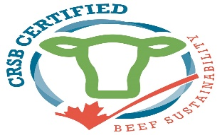 |  | 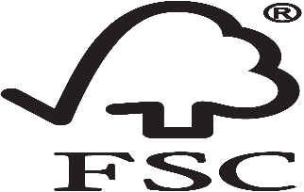 | 
 |  |  | 
None - I am not familiar with any of these labels

S1Q3:
When you purchase food, how often do you think about the environmental impact as a result of its production?
- Always or almost always
- Very Often
- Sometimes
- Rarely
- Never

[Section 2]
Now that we have asked your preferences in regard to food in general, let’s talk about wheat flour. In relation to wheat flour, please describe your food purchasing preferences in the following questions.

S2Q1:
On average, how many times do you buy wheat flour in a month?
Wheat flour includes all-purpose flour, bread flour, cake and pastry flour, and whole wheat flour.
- More than once per month
- Once per month
- Less than once per month

S2Q2:
In a typical week, how often do you use wheat flour at home?
Using wheat flour may include baking, cooking, or any other use.

- Less than once a week
- 1 to 2 times per week
- 3-7 times per week
- More than 7 times per week
- Never

S2Q3:
When you purchase a wheat flour, how often do you read the label?
- Always or almost always
- Very Often
- Sometimes
- Rarely
- Never

[Section 3]
S3Q1:
WETLANDS IN THE CANADIAN PRAIRIES
The Prairie Pothole Region spans Alberta, Saskatchewan, and Manitoba and parts of the United States. A map highlighting the Canadian and US portion is presented below. This survey is focused on the Canadian portion of the region.
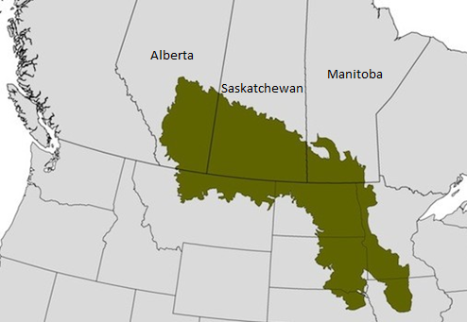

The Canadian Prairie Pothole Region contains 4.6 million hectares of wetlands.

Wetlands are areas where water is present above or near the surface of the soil for at least part of the year. The presence of water determines the type of soil, vegetation, and wildlife present.
- I have read and understood this information

S3Q2:
Do you know of any wetlands in your local area?
- Yes
- No
- Don’t know

S3Q3:
Have you ever visited any wetlands in your local area?
- Yes
- No
- Don’t know

[PROGRAMMER’S NOTE: Ask question 9 if they respond yes to question 8]
S3Q4
For what reason(s) have you visited wetlands in your local area?
Please select all that apply.

- Walking/Hiking
- Birdwatching
- Hunting
- Fishing
- Other (please specify) __________________

S3Q5:
ECOSYSTEMS SERVICES
Wetlands can provide benefits to society through ecosystems services such as controlling floods, filtering water pollutants, and providing habitat for wildlife.
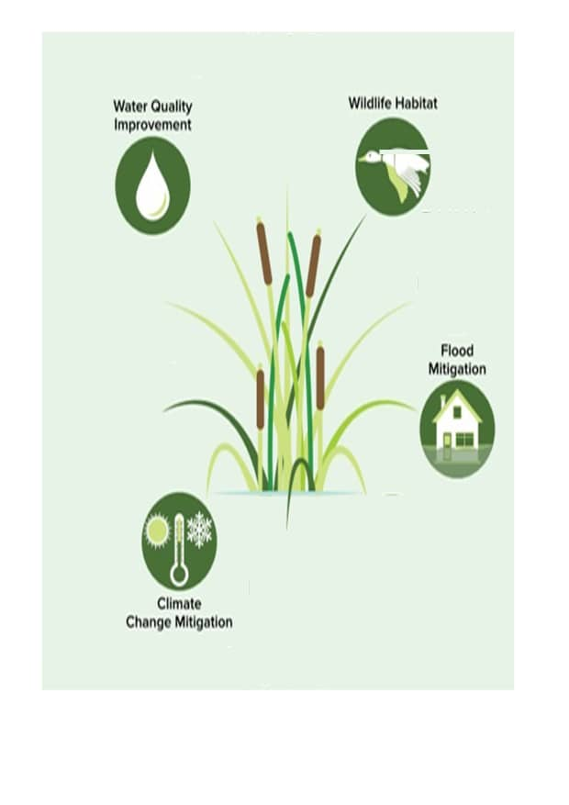
Researchers studying wetlands on the Canadian prairies have identified ecosystem services that are beneficial to humans. Some of these benefits are discussed below.
- Wildlife habitat: wetlands provide habitat to many plants and animals. They act as home to many species and also offer foraging and nesting opportunities to a wide range of amphibians, waterfowls, and reptiles.
- Climate change mitigation: wetlands can store carbon which can prevent these emissions from contributing to climate change.
- Water quality improvements: wetlands can act as filters, reducing the amount of nutrients and other pollutants that enter our streams, rivers, lakes and drinking water.
- Flood mitigation: wetlands help store water and regulate the flow of water on the landscape which can reduce flood risks to agricultural land and communities.

- I have read and understood this information

S3Q6:
Before starting this survey, did you know that wetlands provide ecosystem services that benefit humans?
- Yes
- No
- Don’t know

S3Q7:
How important are each of the following ecosystem services provided by wetlands to you?
- Extremely important
- Very important
- Moderately important
- Slightly important
- Not at all important

- Wildlife habitat
- Water quality improvements
- Climate change mitigation
- Flood mitigation

S3Q8:
Please indicate any other ecosystem services provided by wetlands that are important to you:
[textbox]
N/A – I have no comments to provide

S3Q9:
CHANGES IN PRAIRIE WETLANDS OVER TIME
We know that wetlands have been lost over time, but the exact amount is not known because there are not good records on how many wetlands existed. In parts of the Prairie Pothole Region, 70% of the wetlands have been lost. Each year it is estimated that around 12,000 hectares of wetlands are lost in the region representing 0.5% of all wetlands.
- I have read and understood this information

S3Q10
Before starting this survey, did you know that wetlands continue to be lost in the Canadian Prairie Pothole region?
- Yes
- No
- Don’t know

S3Q11:
Overall, how concerned are you, if at all, about these wetland changes in the Canadian Prairie Pothole region?
a) Extremely concerned
b) Very concerned
c) Moderately concerned
d) Mildly concerned
e) Not at all concerned

S3Q12
WHY ARE WETLANDS BEING LOST?
There are various factors contributing to the loss and degradation of wetlands including growing cities and industrial development. A major contributor is agricultural expansion.
Agricultural expansion is occurring in response to expanding human populations and the demand for more food.
A major challenge is that the prices farmers are paid to produce agricultural products do not cover the costs farmers must bear to maintain wetlands on their land. Thus, even though farmers may be good stewards of the land, they may choose to drain wetlands for financial reasons. The costs wetlands impose on farmers include:
- Farmers are usually unable to grow crops on wetland areas,
- The water from wetlands on a field can delay seeding, and
- Wetlands on a field can interfere with modern farming equipment thus increasing the costs of farming.
In response to these costs, landowners have drained and converted wetlands to agricultural production to manage water on the landscape.
Wetland conversion to agricultural production has also historically been encouraged by government policies.
- I have read and understood this information

S3Q13:
WHAT CAN BE DONE TO BETTER CONSERVE WETLANDS IN THE CANADIANS PRIARIES?

Wetland conservation efforts have focused on restoring previously lost wetlands on the landscape. Lost or degraded wetlands can be restored in a number of ways including:

- Plugging any drainage ditches which then allows water to pool,
- Recontouring areas back to natural wetland shapes, and
- Re-planting wetland species.

These wetland restoration projects work with local landowners to ensure that wetlands are restored with minimal impacts to agricultural production.

[PROGRAMMERS NOTE: RANDOMIZE ORDER OF THIS SECTION (GROUP 1: CERTIFICATION) AND GROUP 2: WETLAND POLICY; all participants see both; disabled for FG surveys]

[Group 1: CERTIFICATION]
S4Q1:
WETLAND CERTIFICATION FOR WHEAT FLOUR
One wetland conservation policy option being considered is a wetland certification program. In this program, farmers can voluntarily restore wetlands on their land and receive a special certification for their product. In this survey, we are considering wheat flour which would be labelled and sold to consumers.
Here is how it would work:
Eligible farmers would have to restore wetlands on a certain percentage of their land. They could then sell their products with a wetland certification. There are two levels of certification depending on the amount of wetlands restored.

Certification levels
- Gold label: 5% increase in land containing restored wetlands (i.e., 8 acres of wetland restored per 160-acre quarter section)
- Silver label: 2.5% increase in land containing restored wetlands (i.e., 4 acres of wetland restored per 160-acre quarter section)
- Non-Certified: Farmer does not restore any previously drained wetlands.

To ensure the success of the program, certified fields would be audited and verified by a third-party. Once the wetland is restored, it will be monitored by

- Provincial government,
- Ducks Unlimited Canada, a conservation non-for profit focused on wetlands and wildlife, or
- Producer-led organization.

These agencies will be responsible for providing an annual report for the purposes of auditing.

S4Q2_Intor:
INSTRUCTIONS
In this section, you will be presented with six different shopping scenarios with different purchase choice options for wheat flour. For each scenario, you are asked to indicate your preferred choice. The wheat flour products differ in terms of the wetland certification level, the certification verification organization, on-farm pesticide applied, and the price.
Please read the following carefully in order to answer the questions in the survey

 | Description
Wetland certification level | The level of certification for wheat that is grown on fields with restored wetlands.
Verification body | The organization responsible for ensuring the wetlands are being restored
Level of on-farm pesticide application  (% change from current) | Whether the farmer uses spot spraying technology that reduces pesticide use in production by 75%
Price | The price for the 2.5 kg (5.5 lb) bag of flour.

Assume that all other features of the product are identical in making your choices.

You may see a few options that seem counter-intuitive (e.g., a lower price but a higher quality in your personal opinion). Be assured that this is not an error but part of the design of the survey. Simply choose the option that you most prefer, based on its characteristics.

S4Q2_Ex:
An example
Below is an example. Please note that this is only an example. You should make your own choices based on your own preferences.

“Barb” is shopping at a grocery store. She wants to buy wheat flour. There are two options (see the table below). Option 1 is wheat flour which has a gold certification level, verified by the provincial government and it is grown on a farm that uses spot spraying technology and sold at $8.25; option 2 is a wheat flour which is not wetland certified and is grown on a farm that does uses spot spraying technology to reduce pesticide use by 75% and sold at $5.25. Barb likes some of the options more than the others. She compares options 1 and 2 carefully and decides whether to choose one (1 or 2) or none of these (Option 3).

 | Option 1 | Option 2 | Option 3
 | 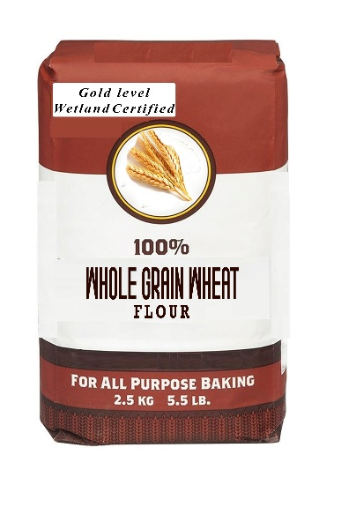 | 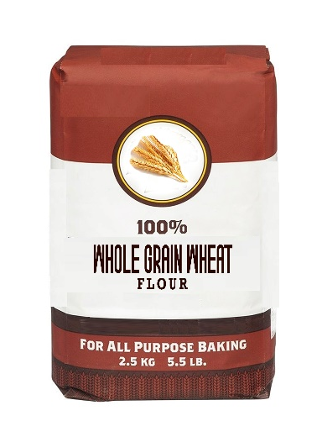 | I would not purchase any of these products
Wetland certification level | Gold level  (5% increase in restored wetlands on land) | None | I would not purchase any of these products
Verification body | Provincial government | None | I would not purchase any of these products
Level of on-farm pesticide application (% change from current) | No change | Reduced by 75% | I would not purchase any of these products
Price for 2.5 kg (5.5 lb) | $8.25 | $5.25 | I would not purchase any of these products
I would choose… |  |  | 

S4Q2_Comp
Before you continue:
Carefully reading and understanding the information on this screen is very important for the next part of this survey. Please take your time, and indicate below when you are ready to continue.
- I am ready to continue

Now suppose YOU are shopping for wheat flour. Please examine each choice below, keeping in mind that, in a real-life situation, you would be paying for the product that you choose, and if you spend more on this product you would have less money to spend on other things. Make the choice that most closely reflects what your decision would be in an actual shopping situation.

[PROGRAMMER’S NOTE: Include 6 choice sets]

 | Option 1 | Option 2 | Option 3
 |  |  | I would not purchase any of these products
Wetland certification level | Gold level  (5% increase in restored wetlands on land) | None | I would not purchase any of these products
Verification body | Ducks Unlimited Canada | None | I would not purchase any of these products
Level of on-farm pesticide application (% change from current) | Reduced by 75% | No change | I would not purchase any of these products
Price for 2.5 kg (5.5 lb) | $10.00 | $5.25 | I would not purchase any of these products
I would choose… |  |  | 

[PROGRAMMER’S NOTE: GROUP 2 WETLAND POLICY]
S5BidAmount:
[Hidden question; Randomly insert one of these numbers $[15, 50, 125, 250, 430, 865]]

S5WetlandPercent:
[Hidden question; Randomly insert one of these numbers [10, 20]%]

S5Wetlandamount:
[Hidden question; Include the following amount based on
if $province is Manitoba and $wetlandpercent is 10% then 20,000
if $province is Manitoba and $wetlandpercent is 20% then 40,000
if $province is Alberta and $wetlandpercent is 10% then 80,000
if $province is Alberta and $wetlandpercent is 20% then 160,000
if $province is Saskatchewan and $wetlandpercent is 10% then 160,000
if $province is Saskatchewan and $wetlandpercent is 20% then 320,000

S5Q1:
WETLAND POLICY ON THE PRAIRIES

What’s Your Opinion?

Suppose that the government of [$province] is proposing a Wetland Restoration Plan to increase the number of wetlands in the Prairie Pothole region of [$province] by [$wetlandpercent] by restoring [$wetlandamount] hectares of wetlands over the next 10 years.

Wetland restoration also costs money. The government of [$province] is considering several projects to restore wetlands. These projects would work with local communities and provide financial support to landowners to restore wetlands on their land.
The costs for this plan would be paid for by an increase in the provincial income taxes.

These costs are estimated to be [$bidamount] each year for every household in [$province] for the next 10 years.

The results of this survey are advisory. In other words, they will be used to inform the government of [$province] on the opinions and preferences of people to help them decide if and what projects should be funded in the Canadian Prairie Pothole region.

We would like to know your opinion on whether you think this initiative is worth the costs.

However, your honest answer is important because we will share the opinions we collect with policy makers and future policy in the area and any taxes you might actually pay will be influenced by your responses in this survey today.

There is no right or wrong answer. We have found some people would support these kinds of projects and others would not support them. Both kinds of voters have good reasons for why they would vote one way or the other.

If [$province] holds a provincial referendum to determine whether to put into place the Wetland Restoration Plan and you are asked to vote for or against the program, what would you choose?
Please read the following two statements and choose the one that indicates how you would vote.

___I vote Yes. I am willing to pay [$bidamount] more in annual provincial income taxes for my household for 10 years starting in January 2022 to pay for the Wetland Restoration Plan that increases the amount of wetlands by [$wetlandpercent] in the Prairie Pothole region of [$province].

___I vote No. I am not willing to pay [$bidamount] more in annual provincial income taxes for my household for 10 years starting in January 2022 to pay for the Wetland Restoration Plan that increases the amount of wetlands by [$wetlandpercent] in the Prairie Pothole region of [$province].

S5Q2:
When the [$province] government decides whether or not to implement the proposed plan you just voted on, how likely do you think it is that the provincial government will take into account your vote and that of the other respondents to this study in its decision-making?

Very likely likely Somewhat likely Somewhat unlikely unlikely Very unlikely
   

S5Q3:
Considering the proposed program outlined above, what do you think a typical person in your neighbourhood would choose if the following options were put to vote in a real referendum?
___ They would vote yes (i.e., for Wetland Restoration Plan)
___They would vote no (i.e., against Wetland Restoration Plan)

S5Q4:
Based on what you have read during this survey, overall, do you think the survey tried to push you to vote one way or the other, or let you make up your own mind about how to vote?

- Tried to push you to vote for Wetland Restoration Plan
- Tried to push you to not vote for Wetland Restoration Plan
- Let me make up my own mind

S5Q5:
For the wetland policy question you voted on, what was the additional provincial income tax your household would have to pay for 10 years starting in January 2022 for the Wetland Restoration Plan. Please enter the dollar amount below.

$_____ [PROGRAMMERS NOTE: Only allow numeric values in box]
- I do not remember

S5Q6:
Please indicate to what extent you agree with each of the following statements

Strongly Agree | Somewhat Agree | Neither Agree nor Disagree | Somewhat Disagree | Strongly Disagree

[PROGRAMMERS NOTE: Randomize statement order]

I voted as if my household would actually face the costs shown
I voted as if the Wetland Restoration Plan would actually achieve the results shown
I am against any more government spending
It is important to restore wetlands in the Canadian prairies no matter how high the cost

[End of Group 2]
[ALL SURVEY VERSIONS]

S6Q1:
Please indicate which of the following you think should be primarily responsible for the conservation of wetlands in the Canadian prairies.
Select all that apply.
- Government
- Landowners
- Crop and Livestock Industry groups
- Private conservation groups such as Ducks Unlimited
- None

S6Q2:
There are different ways for people to pay for new programs to protect the environment. One way is for the government to pay the cost. This will raise everyone's taxes. The other way is for farmers to pay the cost. This will make prices go up for everyone.

If you had to choose, would you prefer to pay for new environmental programs through higher taxes, or through higher prices?
__ Higher Taxes
__ Higher Prices
__ Either one, I don’t care which

ENVIRONMENTAL SCALES
Please indicate to what extent you agree with each of the following statements. This is a measure of your personal beliefs and there are no right or wrong answers.

S6Q3:

[PROGRAMMERS NOTE: Randomize statement order]

 | Strongly Agree | Somewhat Agree | Neither Agree nor Disagree | Somewhat Disagree | Strongly Disagree | Don’t know
We are approaching the limit of the number of people the Earth can support.
Humans have the right to modify the natural environment to suit their needs.
When humans interfere with nature it often produces disastrous consequences.
Human ingenuity will ensure that we do not make the Earth unlivable.
Humans are seriously abusing the environment.
The Earth has plenty of natural resources if we just learn how to develop them.
Plants and animals have as much right as humans to exist.
The balance of nature is strong enough to cope with the impacts of modern industrial nations.
Despite our special abilities, humans are still subject to the laws of nature.
The so-called “ecological crisis” facing humankind has been greatly exaggerated.
The Earth is like a spaceship with very limited room and resources.
Humans were meant to rule over the rest of nature.
The balance of nature is very delicate and easily upset.
Humans will eventually learn enough about how nature works to be able to control it.
If things continue on their present course, we will soon experience a major ecological catastrophe.

S6Q4:
Regarding the conservation of wetlands in Canada, we would like to know whether you trust individuals and organizations involved in the conservation of natural areas. Please indicate to what extent you agree with each of the following statements.

[PROGRAMMERS NOTE: Randomize statement order]

- Government
Statement | Strongly Agree | Somewhat Agree | Neither Agree nor Disagree | Somewhat disagree | Strongly disagree | Don’t know
The government has the competence to monitor the restoration of wetlands
The government has sufficient knowledge to guarantee the protection of wetlands
The government is honest about the success of wetland restoration programs
The government values wetlands
The government is responsible for the conservation of wetlands

- Farmer
S6Q5:
Statement | Strongly Agree | Somewhat Agree | Neither Agree nor Disagree | Somewhat disagree | Strongly disagree | Don’t know
The farmer has the competence to monitor the restoration of wetlands
The farmer has sufficient knowledge to guarantee the protection of wetlands
The farmer is honest about the success of wetland restoration programs
The farmer values wetlands
The farmer is responsible for the conservation of wetlands

Impact of COVID-19

S7Q1:
Have you or anyone in your family (including all household members, children, siblings, and parents) ever been diagnosed COVID 19?
Yes  No  I don’t know 

S7Q2:
Has COVID 19 affected your income?
Yes – my income is lower
Yes – my income is higher
No
I don’t know

S7Q3:
Do you think COVID 19 has affected any of your choices made in this survey?
Yes  No  I don’t know 

SOCIO DEMOGRAPHICS
This section of the survey will ask you questions about yourself in order to better understand the choices you made and also to make comparisons among groups. Be assured that your responses are confidential and will be reported at the aggregate (i.e., combined) level only.
S8Q1:
What is your relationship with agriculture?
- I currently work in agriculture
- I grew up on a farm, but do not currently work in agriculture
- I do not work in agriculture but many of my family do
- I have little to no relationship with agriculture

S8Q2:
Which gender do you prefer to identify with?
Male Female Gender non-binary/Third gender/Other

S8Q3:
How old are you? ______ years

S8Q5 :
Including yourself, how many people live in your household?
1 2 3 4 5 or more

S8Q6:
How many children in your household are less than 18 years of age?
1 2 3 4 or more

S8Q7:
Which of the following categories best describes your role in grocery shopping for your household?
Primary Shopper Shared responsibility Someone else is the primary shopper

S8Q8:
What is the highest level of education that you have completed?
Never attended school
Grade School (grades 1 to 9)
Some high school
High school graduate
Post-secondary trade/technical school certificate/degree
Some University or college
College diploma/degree
University undergraduate degree
Some post graduate university study
Post graduate university degree (e.g., Masters or Ph.D.)
Prefer not to say

S8Q9:
What is your total annual household income before taxes?
 Less than $25,000  $25,000 - $49,999  $50,000 - $74,999
 $75,000 - $99,999  $100,000 - $124,999  $125,000 - $149,999
 More than $150,000 Prefer not to say

S8Q10:
If a provincial election were held today, how would you vote provincially?

S8Q10_AB:
[PROGRAMMER’s NOTE if $province is Alberta]
___Alberta Party
___Alberta Liberal Party
___Alberta New Democratic Party
___United Conservative Party of Alberta
___I am not eligible to vote
___I would choose not to vote
___Other (please specify):
___Prefer not to say

S8Q10_SK
[PROGRAMMER’s NOTE if $province is Saskatchewan]
___Buffalo Party
___Green Party
___New Democratic Party
___Saskatchewan Party
___I am not eligible to vote
___I would choose not to vote
___Other (please specify):
___Prefer not to say

S8Q10_MB
[PROGRAMMER’s NOTE if $province is Manitoba]
___Green Party
___Liberal Party
___New Democratic Party
___Progressive Conservative Party
___I am not eligible to vote
___I would choose not to vote
___Other (please specify):
___Prefer not to say

S8Q11:
Finally, we know that this survey showed you a lot of information. What portion of the information would you say you read carefully?
Please answer honestly. Your answer helps us to understand our data, and will not impact your payment in any way.
- Less than half
- About half
- More than half
S8Q12:
How understandable did you find the information that you read?
- Not understandable at all
- Somewhat understandable
- Moderately understandable
- Very understandable
- Extremely understandable

Thank you! Please feel free to provide any comments or feedback about this survey:
[textbox]

