Supplementary file I: Showing a sample of cases for viva voce examination at UGHE

Case 1: Infective endocarditis (from the module Blood & Immunity. MED 104)

A 10-year-old male child with a history of recurrent throat pain presented to the pediatrician with fever, fatigue, and joint pain. The child has had these symptoms for the past one week. On examination, he was febrile with a temperature of 39°C, with a heart rate of 95 beats per minute. He had a heart murmur, and his joints were swollen and tender. There was no sign of respiratory distress. His tonsils were enlarged and red. An echocardiogram showed vegetations on the mitral valve. Blood tests revealed an elevated white blood cell count, elevated inflammatory markers, and positive blood culture.

- What is the most likely diagnosis?
Answer: Infective endocarditis

- Describe the pathophysiology of infective endocarditis?
Answer: Infective endocarditis is a microbial infection of the endocardium, which is the inner lining of the heart, including the heart valves. The pathophysiology of infective endocarditis involves the adherence and colonization of microorganisms, most commonly bacteria, to damaged or abnormal cardiac structures such as heart valves, resulting in the formation of vegetations. These vegetations are comprised of platelets, fibrin, and microbial cells, and can grow in size, causing obstruction of blood flow, embolic events, and valvular dysfunction.

In the case of a throat infection, bacteria can gain access to the bloodstream through the damaged mucosa of the tonsils. The bacteria then adhere to the heart valve surface that may have been previously damaged due to congenital defects, rheumatic fever, or other heart disease. Once adherence to the valve is achieved, bacteria grow and form vegetations which cause inflammation, valve destruction, and systemic complications such as emboli and sepsis.

- Mention any 2 major elements included in the modified Duke criteria for the diagnosis of infective endocarditis.

Answer: For examiners: (The Modified Duke criteria is a set of diagnostic criteria used to diagnose infective endocarditis. It includes major and minor criteria)

Major criteria include:
- Positive blood culture for infective endocarditis (Staphylococcus aureus most common followed by Streptococci)
- Evidence of endocardial involvement on echocardiography
- New valvular regurgitation

- Describe the anatomy of heart valves
Answer:
- Tricuspid valve
- It has three cusps, Three papillary muscles with chordae tendineae
- The three cusps: Anterior, Posterior and Septal

- Bicuspid/Mitral valve
- It has two cusps: Anterior and Posterior
- Both have chordae tendineae fixed to papillary muscles in left ventricle

- The pulmonary valve
- It has three half-moon shaped cusps, Anterior cusp (AC), Left cusp (LC), Right cusp (RC)

- The Aortic valve
- It has three cusps: Left coronary cusp (LCC), Right coronary cusp (RCC), Non-coronary cusp (NCC)

- What is the function of heart valves?

Answer:
The heart valves play a crucial role in maintaining unidirectional blood flow through the heart. They prevent blood from flowing backward into the chambers of the heart and ensure that it moves in the correct direction through the circulatory system. They open and close in response to pressure changes within the heart chambers, allowing blood to flow in one direction and preventing backflow. There are four valves in the heart - tricuspid and mitral valves between the atria and ventricles, and pulmonary and aortic valves between the ventricles and arteries. Heart valve dysfunction can lead to serious health complications.

- Mention any 4 pathogens important in the development of infective endocarditis considering subacute or acute forms of the disease?

Answer:
- In acute infective endocarditis: Staphylococcus aureus
- In subacute infective endocarditis: Streptococcus viridans group; Streptococcus sanguinis, Streptococcus mitis, Streptococcus mutans and HACEK group (Hemophilus, Eikinella, Kingella…), Enterococcus, or fungi: candida, aspergillus (any four of these will be sufficient).

- If left untreated, infective endocarditis can lead to heart failure.
Explain the difference between systolic heart failure and diastolic heart failure.
Answer:
- Systolic heart failure: defined by a decrease in contractility or inotropy. Heart failure with reduced ejection fraction (<40%) (HFrEF). A loss of FORWARD flow. The fundamental issue is a decreased ESPVR relating to poor contractility. Decreased SV results in increased end systolic volume. Thus overtime the heart moves up on the EDPVR and thus also has elevated filling pressures.

- Diastolic heart failure: defined by a decrease in diastolic compliance or lusitropy. Heart failure with preserved ejection fraction (HFpEF). Predominantly an upward and leftward shift of the end diastolic filling curve (a representation of ventricular stiffness).

- Mention 3 causes of right heart and 3 causes of left heart failure

Answer:
-Right heart failure: pulmonary embolism, pulmonary valve stenosis, mitral valve stenosis, left heart failure, cor pulmonale, ischemic heart disease, hypertension, cardiomyopathies, RV myocarditis, pericardial diseases
-Left heart failure: cardiomyopathies, ischemic heart disease, hypertension, aortic stenosis/regurgitation, myocarditis, pericardial diseases

- Mention any 4 adverse effects associated with ACE inhibitors

Answer: (students can mention any 4 of the following):
• Cough (dry cough)
• Angioedema (↑vascular permeability)
• Hypersensitivity reaction
• Renal failure
• Increase in serum potassium/hyperkalemia
• Low BP
• Change in taste (rare)

Image Station (from the module MED 104: Blood & Immunity)

1. Identify the structures labelled A, B, C & D as indicated in the image below (2 points)

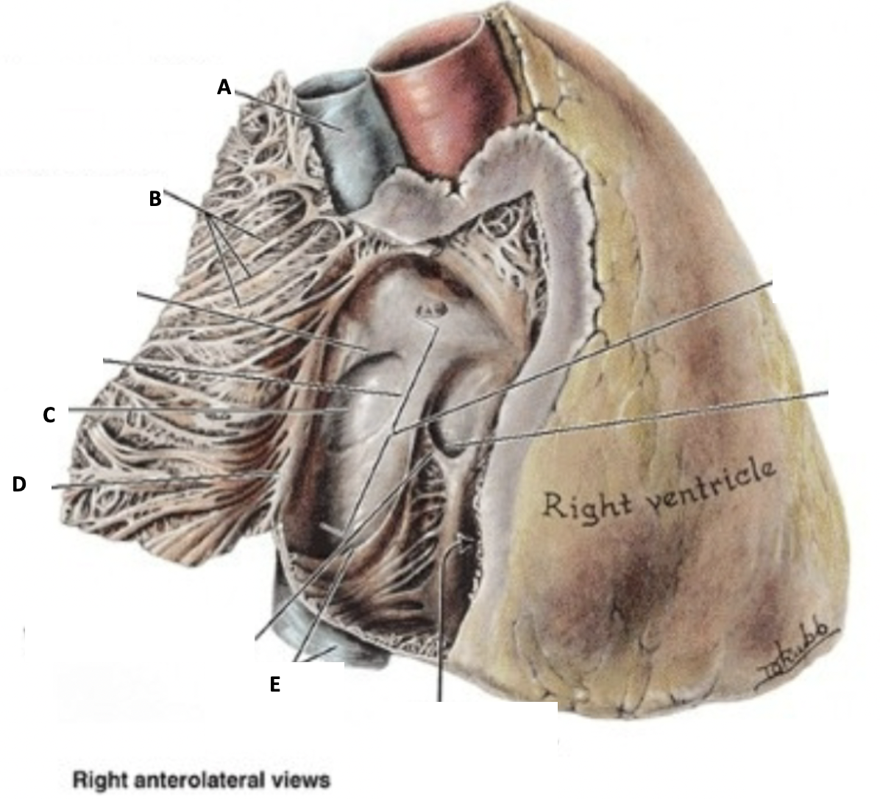

Answer:

A: Superior Vena Cava (SVC)
B: Pectinate muscles
C: Oval Fossa
D: Crista terminalis

2. Below is the culture characteristic of an organism isolated from a patient with Rheumatic fever

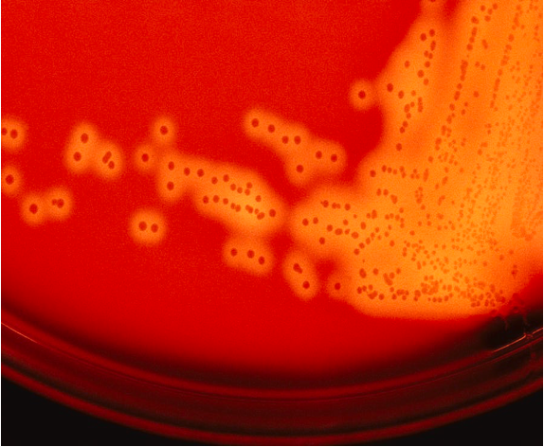

  - Identify the characteristic of the microorganisms shown in the picture above (1 point)
Answer: Beta hemolysis

  - Which organism is likely to present this property/characteristic (0.5 point)
Answer: Group A streptococcus or Streptococcus pyogenes

3. Identify the structures labelled 4, 8, 10 & 15 as indicated in the picture below (2 points)

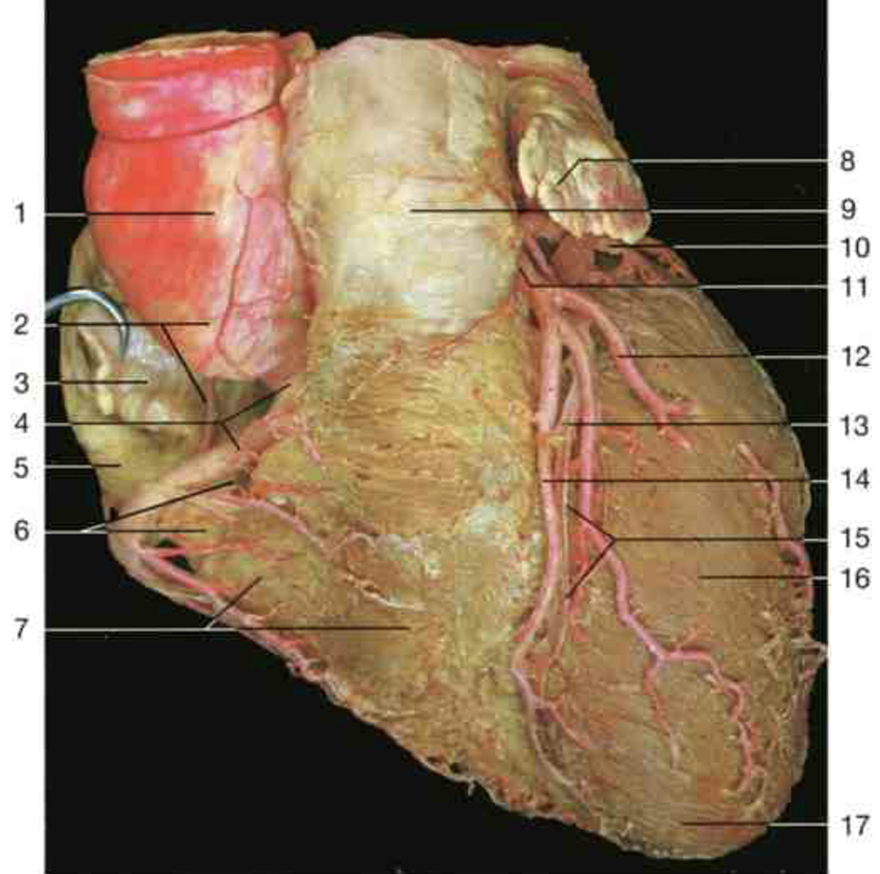

Answer:
4: Right Coronary Artery
8: Left auricle
10: Circumflex artery
14: Anterior interventricular artery

4. On the ECG below, determine the following: (1.5pts)
- Heart rate
- Rhythm
- Axis

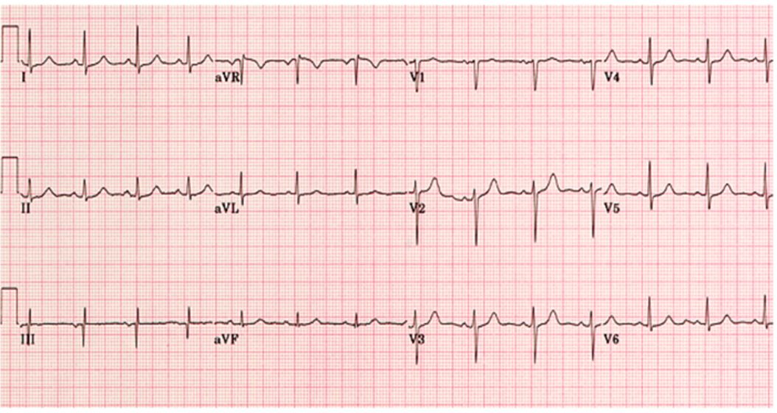

Answer:
Heart rate: 84-88 beats/minute
Rhythm: normal sinus rhythm
Axis: 60 degrees (normal)

5. Identify the structures labelled A, B, & C as indicated in the image below (1.5 points)

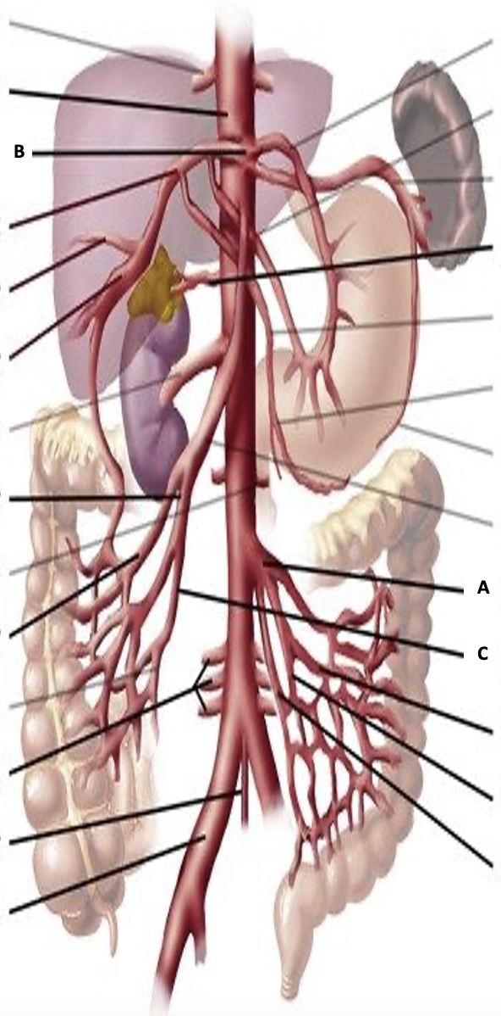

Answer:

A: Inferior Mesenteric Artery
B: Celiac Trunk
C: Ileocolic artery

6. Study the image below and answer the questions that follow:

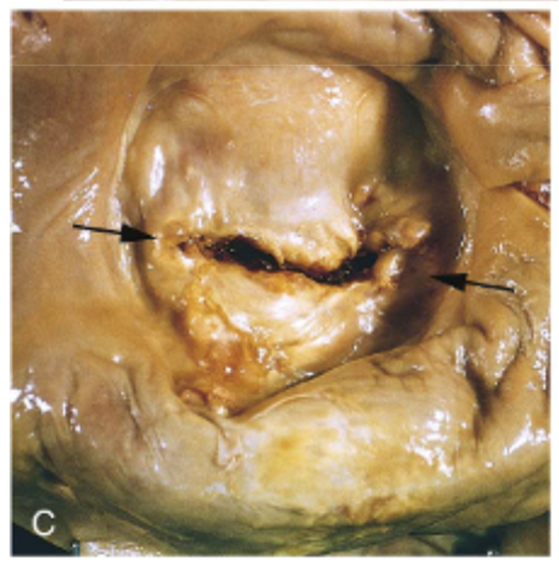

Q1: Describe the morphological changes shown between the arrows (0.5pt)
A: Mitral stenosis with fibrous thickening and commissural fusion (fish-mouth appearance)

Q2: What is the diagnosis? (0.5pt)
A: Mitral valve stenosis secondary to Chronic rheumatic heart disease

7. Describe the morphological changes circled in the image below: (0.5 points)

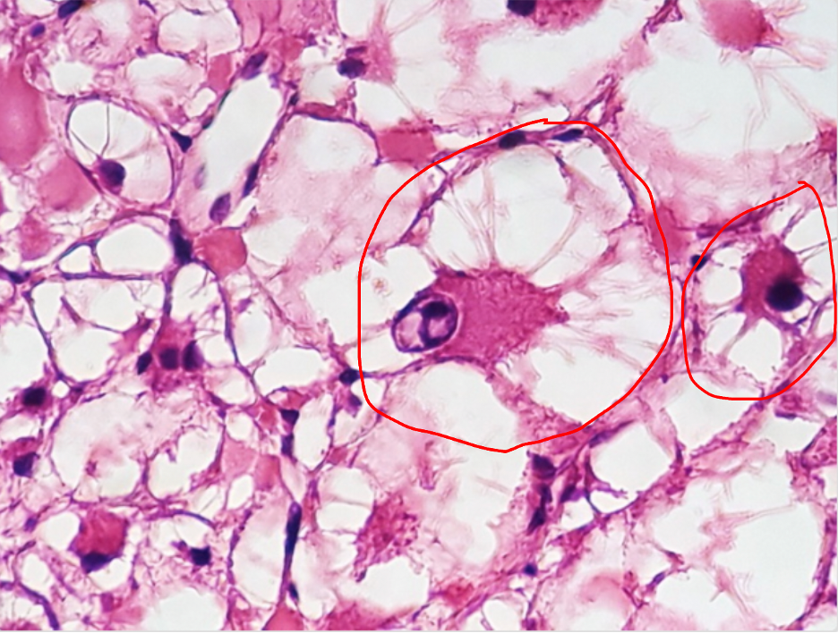

A: Spider cells of cardiac rhabdomyoma

Case 2: Spinal cord injury (From the module Neuroscience and Behavior. MED 207)

A 34-year-old male with a height of 180cm (about 5.9 ft), is brought into the emergency unit by an ambulance after falling on his back from the first floor of a building under construction. He has severe lower back pain and indicates that he has lost sensations from the lower parts of the body and has lost control of his legs.
The image below shows the site of his pain highlighted in red:
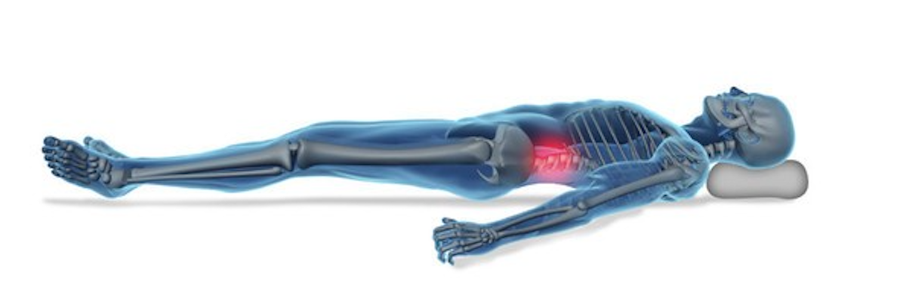

- What is the most likely diagnosis?
Answer: Spinal cord injury or trauma (the student may also say “spinal trauma”)

- Which spinal level has most likely been injured?
Answer: Lumbar region or lumbosacral region (L1-S1)

- Briefly describe the anatomy of the spinal cord in cross-section.
Answer: The spinal cord is composed of gray and white matter:
In its cross section there is-
- Central canal- which continues with the brain ventricular system; lined by ependymal cells; it also contains CSF [cerebrospinal fluid].
- Centrally located gray matter
- Peripherally located white matter
- Gray matter is nervous tissue consisting of neuronal cell bodies, dendrites, myelinated and unmyelinated axons, and glial cells, among other structures.
- White matter consists mainly of long, myelinated axons

- Describe the parts of the spinal cord gray matter and mention the function associated with each giving an example of a nucleus located there
Answer:
- Anterior gray horn: motor function/efferent (anterolateral, posterolateral, post-posterolateral, phrenic, accessory, ventromedial or dorsomedial nucleus)
- Lateral gray horn: sympathetic autonomic function (Intermediomedial, intermediomedian nucleus)
- Posterior gray horn: sensory function/ afferent (posteromarginal, substantia gelatinosa, nucleus proprius or dorsal nucleus)

(Examiners guide)
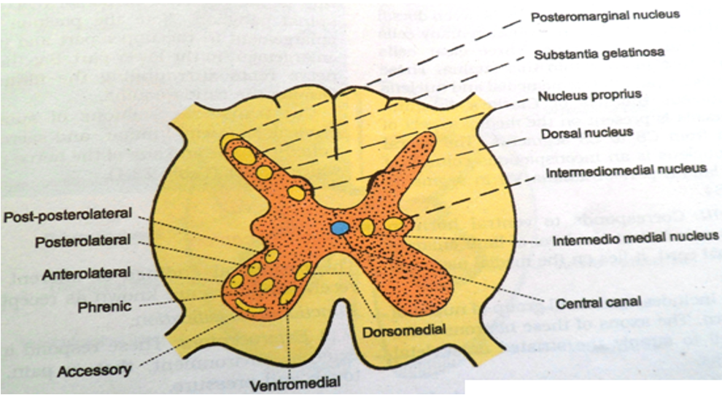

- Mention the types of somatosensory (or sensory) information conveyed by the dorsal column pathway?
Answer: fine touch, vibration, proprioception, fast pain

- a. Describe the Glasgow Coma Scale? (Rephrase the question if the student does not answer immediately: What are the components of a Glasgow Coma Scale?)

Answer: The Glasgow Coma Scale is a clinical assessment tool/scale used to objectively measure the neurologic status (or level of consciousness) of a patient with head trauma. It consists of/is scored according to 3 components: Eye opening, Speech and Language and Motor.
(see Examiner’s guide below)
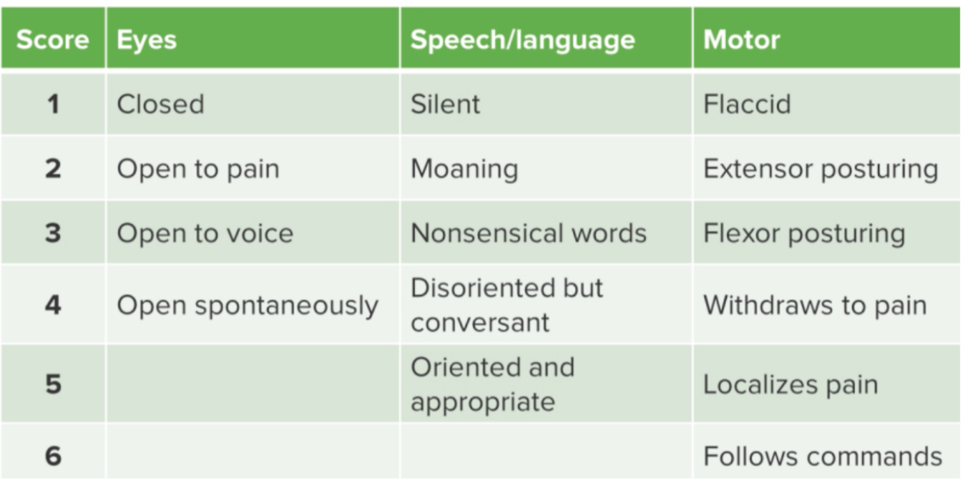

b. How does a Glasgow coma scale help in assessing the severity of head injury?
Answer: GCS of 15 to 13 is considered a mild injury.
GCS of 12 to 9 is considered moderate head injury.
GCS of 8 to 3 is considered severe head injury.

- Compare and contrast the pharmacodynamics of Barbiturates and Benzodiazepines and use it to deduce which class of drugs is safer
Answer: Both drug classes bind to different sites on the GABA receptor and potentiate GABA’s effect (increasing chloride entry into the neuron). Barbiturates increase the duration of Cl- channel opening while Benzodiazepines increase the frequency of Cl- channel opening. Benzodiazepines are safer because (unlike increasing the duration of channel opening), increasing the frequency of channel opening does not lead to hyperpolarization which can lead to life-threatening effects like respiratory depression and coma.

- Give two examples of benzodiazepines and mention any three clinical indications of this class of drugs.
Answer: Benzodiazepines include drugs such as; Midazolam, Diazepam, Clonazepam, Temazepam, Triazolam, Alprazolam, Estazolam, Nitrazepam, Flurazepam, Chlorazepate, Chlordiazepoxide etc.
Clinical indications of Benzodiazepines (any three):
- Treatment of acute seizure episodes
- As an antiepileptic e.g., clonazepam
- Treatment of insomnia (used as hypnotics)
- Treatment of anxiety
- Treatment of social phobias e.g., obsessive-compulsive disorders
- Treatment of acute alcohol withdrawal symptoms
- Useful as muscle relaxants (diazepam)

Imaging Station from module Neuroscience and Behavior (MED 207)

Image 1. Question 1: Name the structures A, B, C, D, E, F, and G. (3.5 points)
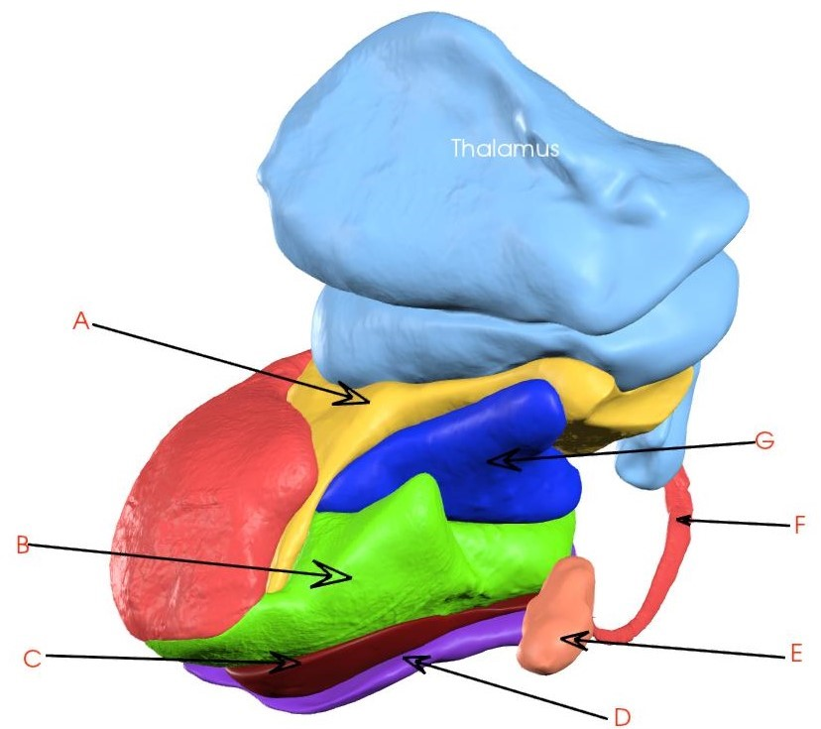
Answer:
A: Internal capsule
B: Putamen
C: External capsule
D: Claustrum
E: Amygdala
F: Caudate nucleus
G: Globus pallidus

Image 2. Identify this congenital abnormality associated with neural tissue. (1 point)
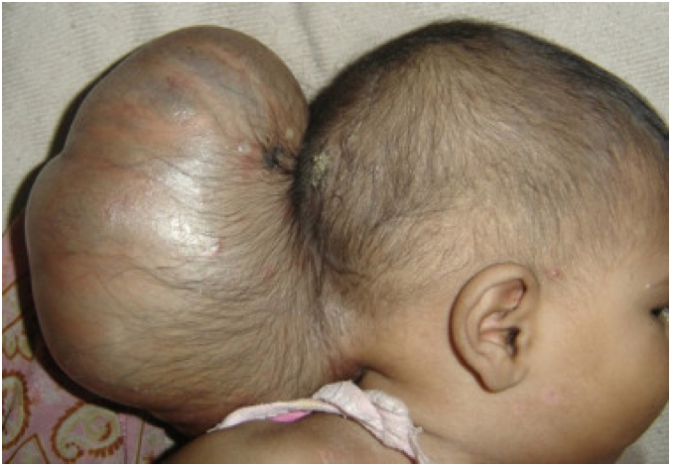
Answer: Encephalocele
Image 3: Large irregular and infiltrative brain tumor crossing the midline. What is the most likely diagnosis? (1pt)
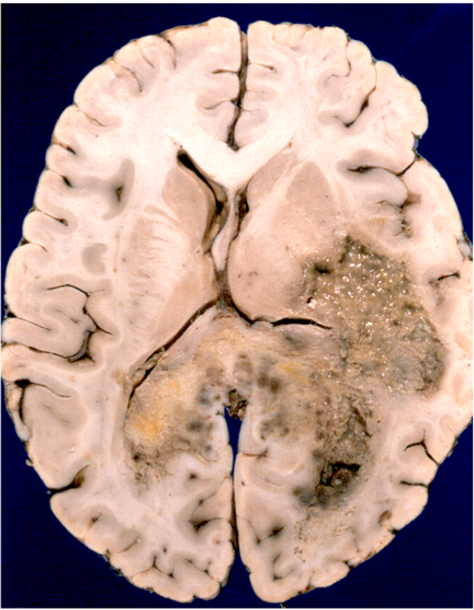

Answer: Glioblastoma multiforme

Image 4: What CNS infection can be suspected in the laboratory diagnosis below? (1 point)

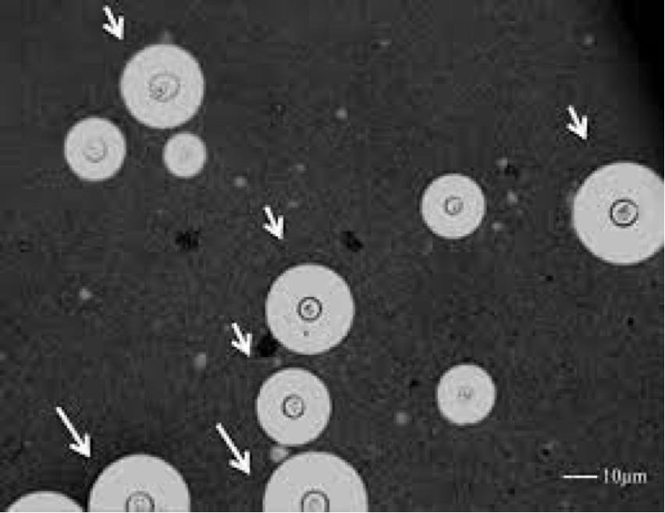

Answer: Cryptococcal meningitis

Image 5: Patient presented with persistent high-grade fever and elevated white cell count and died later. What is the diagnosis in this gross autopsy image? (1 point)

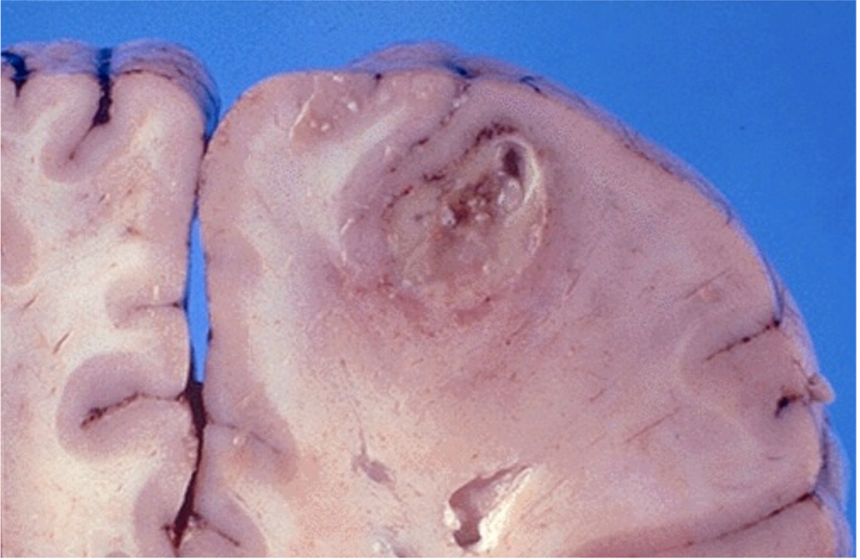

Answer: Brain abscess

Image 6a: What are those structures in the cytoplasm of this neuron? (0.5 points)

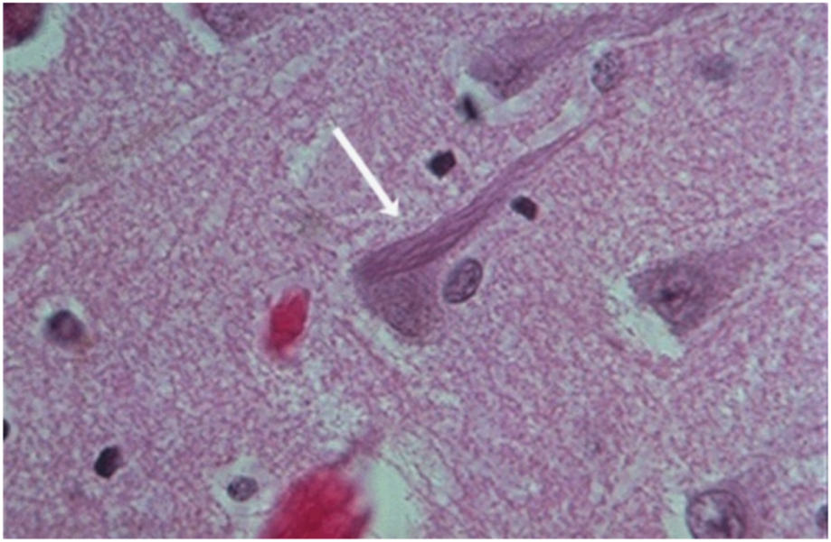

Answer 6a: Neurofibrillary tangles

6b: What is the most likely diagnosis based on above histological observations? (0.5 points)

Answer: Alzheimer’s disease

Image 7. Name the layers of the following specimen as A, B, and C. [1.5. points]
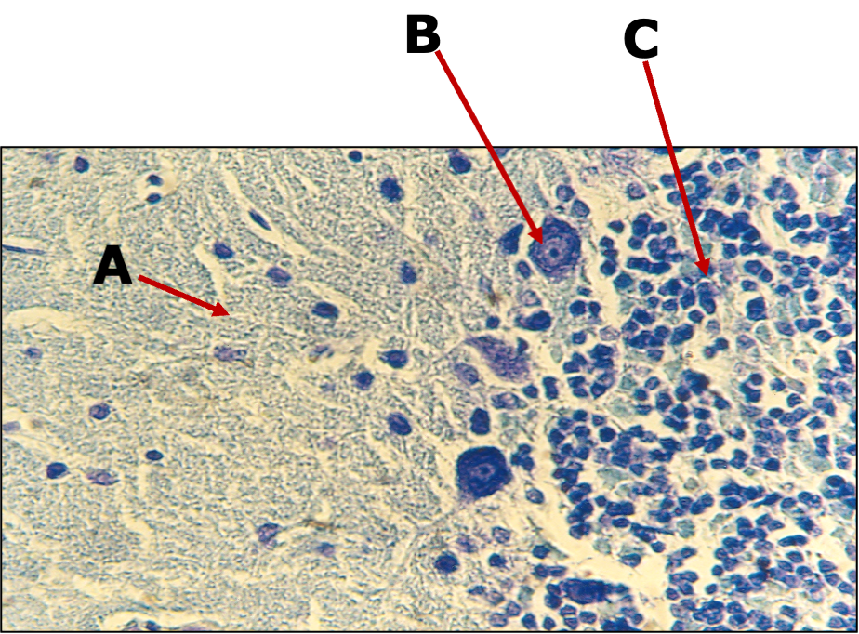

Answer:
A: Molecular layer
B: Purkinje layer [Purkinje cell]
C: Granular layer

Case 3: Benign prostatic hyperplasia (from the Renal and Urinary System module. MED 205)

A 67-year-old man visits the urology clinic, where you are rotating as a medical student. He reports experiencing lower urinary tract symptoms (LUTS) for the past 5 month. These include progressive weak urine stream, trouble initiating urination, and dribbling after urination. He also reports frequent urination especially at night. On physical exam, the senior physician observes that the patient’s vital signs are normal, and he performs a digital rectal exam, which revealed an enlarged prostate with a smooth surface. The patient’s urinalysis results come back normal, and PSA is 9ng/ml.

Q1. What is the most likely diagnosis?
Answer: Benign Prostatic Hyperplasia (BPH)

Q2. What causes BPH?
Answer: Benign prostatic hyperplasia is a cell proliferation arising from the transitional prostate zone. It commonly affects men older than 50 years. It is caused by epithelial cells senescence inhibition and stromal cells proliferation. Stromal cells produce dihydrotestosterone (DHT) from testosterone using 5α-reductase enzyme. DHT binds to androgen receptors and induces transcription of growth factor receptors (FGF & TGF-β) that stimulate proliferation of prostate stromal cells and inhibit senescence of prostate epithelial cells.

Q3: Mention any 2 specific clinical features or laboratory investigations would be crucial in distinguishing Urinary Tract Infections from BPH in the context of this case?
Answer:
- Specific clinical features that could help distinguish UTIs from BPH include the presence of systemic symptoms like fever, flank pain, and malaise, which are characteristic of UTIs but not typically seen in uncomplicated BPH. Additionally, the physical examination might reveal suprapubic tenderness (localized tenderness over the bladder area) in UTIs.
- On digital rectal exam, the prostate is not typically enlarged for UTIs but is enlarged and smooth in BPH.
- Laboratory investigations such as urinalysis, would show the presence of pyuria (white blood cells in urine), bacteriuria (bacteria in urine), and, in some cases, hematuria (blood in urine) in UTIs. These findings would be absent or minimal in uncomplicated BPH.

Q4: Describe the anatomy of the prostate gland.
Answer:
- The prostate gland is a fibromuscular gland which surrounds the commencement of the urethra in males
- It is conical in shape, having a base, an apex, anterior, posterior and two inferolateral surfaces
- It is the largest accessory gland of the male reproductive system
- The prostate gland is divided anatomically into five lobes: anterior and posterior lobes, two lateral lobes, and one median lobe.
- It is vascularized by the prostatic arteries (mainly branches of the internal iliac artery) and is drained by the prostatic veinous plexus through the internal iliac veins

Q5: Briefly describe the anatomy and histology of the 4 anatomical divisions of the male urethra
Answer:
The preprostatic urethra (about 1 cm long) which is associated with a circular cuff of smooth muscle fibers (the internal urethral sphincter). Its contraction prevents retrograde movement of semen into the bladder during ejaculation. It is lined with is transitional epithelium
The prostatic urethra begins at the neck of the bladder & passes through the substance of prostate. It is the widest and the most dilatable section of the urethra. This is here that the ejaculatory duct joins the urethra. It is also lined with transitional epithelium
The membranous urethra passes through the deep perineal pouch and perineal membrane. A rim of skeletal muscle surrounds the urethra at this level; this muscle is referred to as the external urethral sphincter. Its epithelium is pseudostratified columnar
The penile/spongy urethra, like the name suggests, is the segment inside the penis and opens at the urethral meatus. Proximally, it consists of pseudostratified columnar epithelium while distally consists of stratified squamous epithelium.

Q6: What is the function of the prostate?

Answer: The main function of the prostate gland is to secrete an alkaline fluid that comprises approximately 70% of the seminal volume. The secretions produce lubrication and nutrition for the sperm. The alkaline fluid in the ejaculate results in liquefaction of the seminal plug and helps to neutralize the acidic vaginal environment.

Q7: Mention two classes of drugs used in the treatment of BPH giving one example in each class
Answer:
𝛂₁-adrenoceptor antagonists e.g., Terazosin, Doxazosin, Tamsulosin, Silodosin
5 𝛂-reductase inhibitors e.g., Finasteride, Dutasteride

- Explain why Tamsulosin or Silodosin would be preferable over Terazosin / Doxazosin in the management of BPH
A7b: Tamsulosin & Silodosin are more selective for 𝛂_{1A} receptors and are thus associated with less side effects such as postural hypotension.

Q8: The senior physician chooses surgery as a treatment modality for this patient and sends prostatic tissue to the histopathology lab. Which histologic findings do you expect to confirm the clinical diagnosis of BPH?
A8: Proliferation of both stromal and epithelial components; while the basal layer is conserved and secretory cells may show papillary infoldings.

Image Station from the module Renal & Urinary system (MED 205)

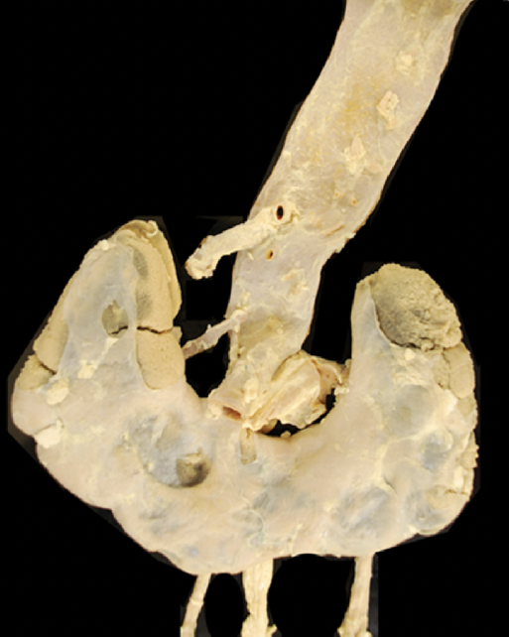

- Identify the congenital malformation seen in the above image? (1 point)

Answer: Horseshoe kidney

- Mention two of its common complications. (1 point)
Answer:
- Hydronephrosis (Obstruction)
- Renal stones
- Infections

- Study the image below:

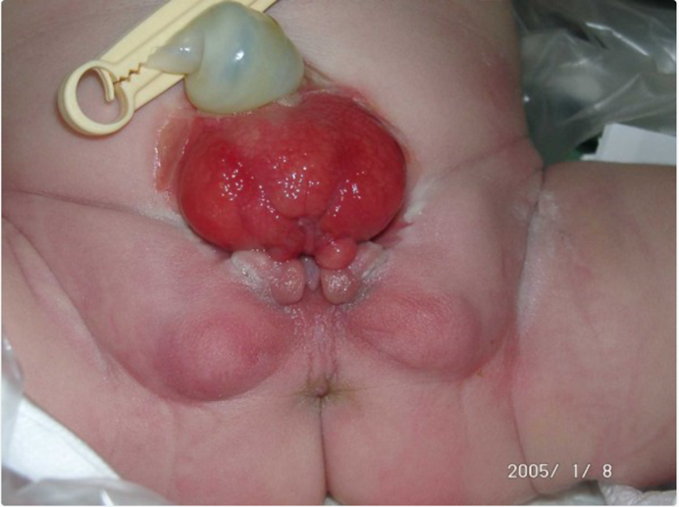

Q: What is the congenital abnormality seen in the above image? (1 point)

Answer: Bladder Exstrophy.

- Study the image below and answer the questions that follow:

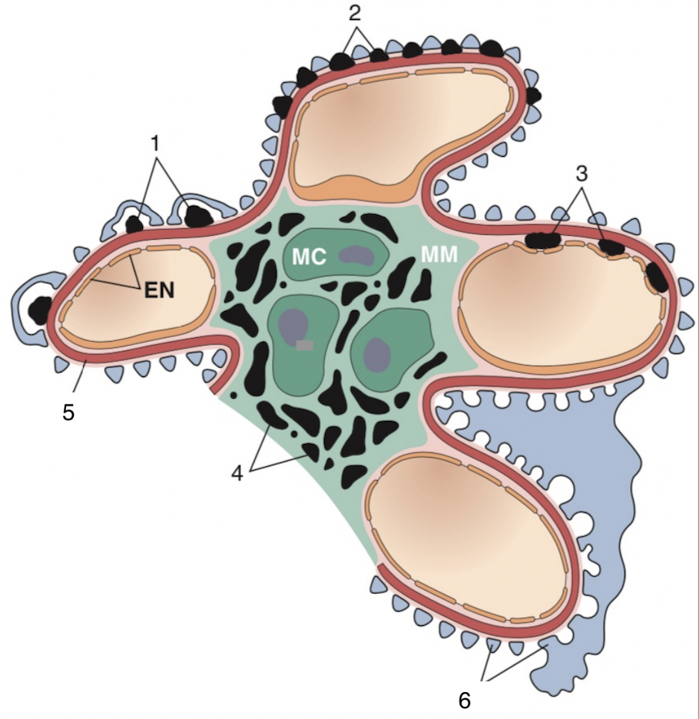

Q: Among the numbered structures, identify and name the locations where we can find immune complex deposits in the glomerulus (2 points)
Answer:
1: Sub-epithelial location (often called humps)
2: Membranous location
3: Subendothelial location
4: Mesangial location

- Study the gross pathological image shown below:

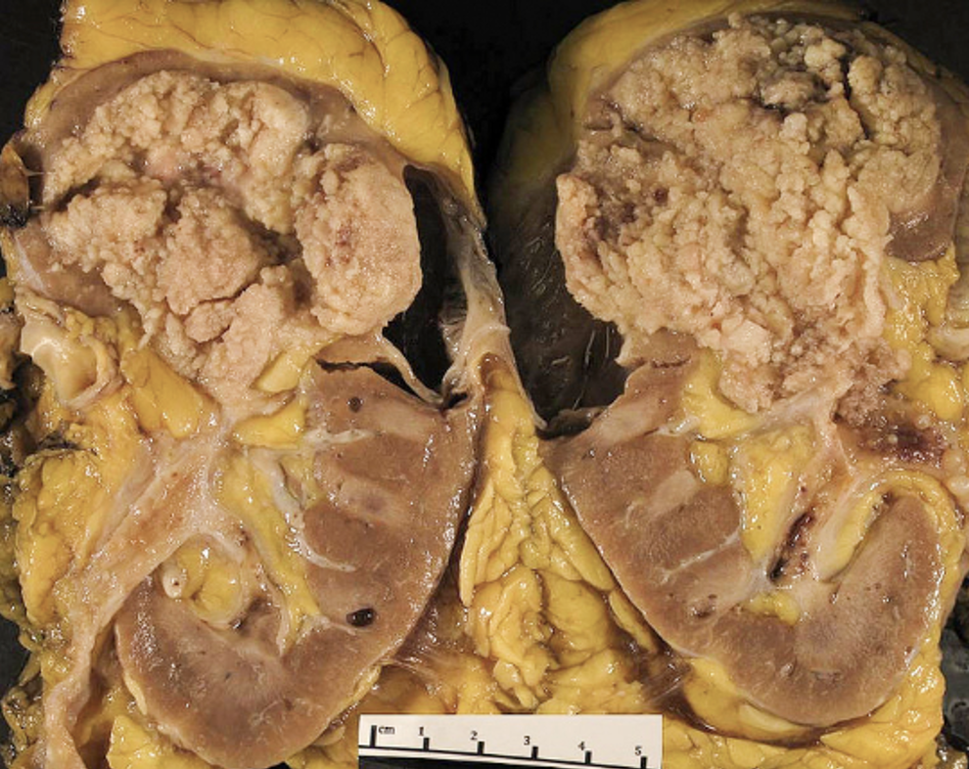

Q: Identify the pathology shown here (1 point)

Answer: Urothelial carcinoma of the renal pelvis

- Study the image shown below:
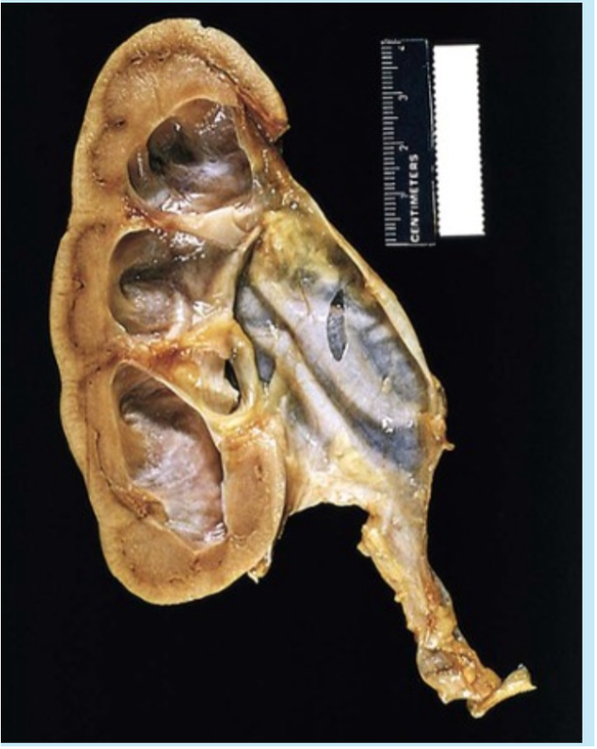

Q: (a) Identify the condition shown in the above image. (1 point)

Answer: Hydronephrosis

5(b). Briefly describe the pathologies/abnormalities you see in the image. (1 point)
Answer: dilation of renal pelvis and calyces + atrophy of the kidney cortex

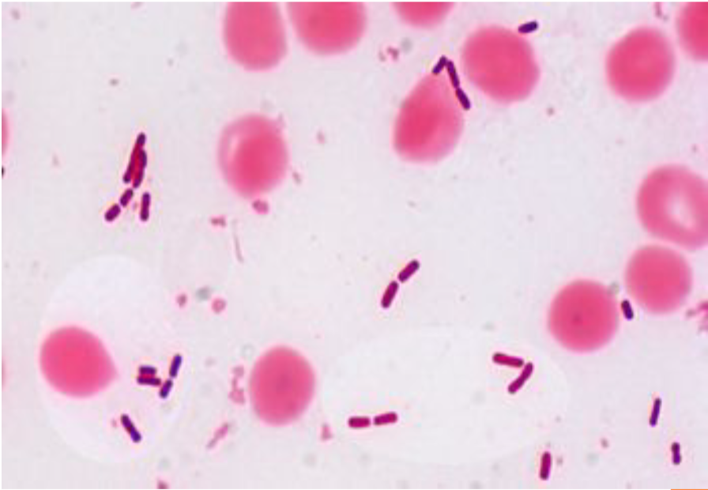

Q: Identify the gram characteristic shown by the organism above. (1 point)
Answer: Gram negative rods

- Study the image shown below:

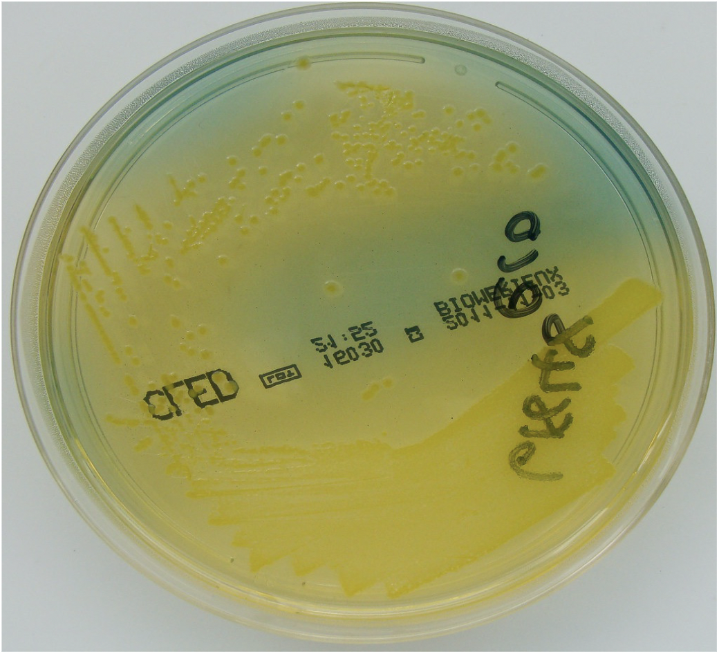

Q: Identify the culture characteristic shown by the organism above. (1pt)

Answer: Lactose fermenting organism

