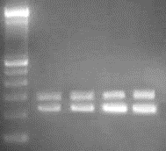
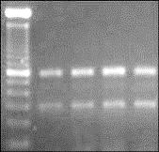
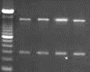
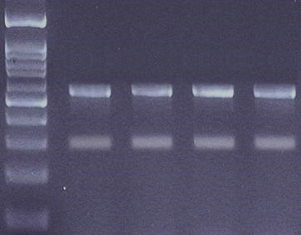
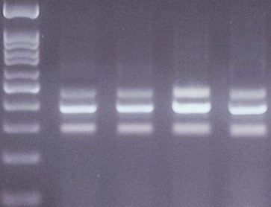
1 2 3 4 5
600 bp
GAPDH
A. FGF2
FGF2
100 bp
1500 bp
1 2 3 4 5
600 bp
GAPDH
MMP2
B. MMP2
1500 bp
100 bp
1 2 3 4 5
600 bp
GAPDH
MMP9
C. MMP9
100 bp
1500 bp
500 bp
1 2 3 4 5
GAPDH
NOS
D. NOS
1500 bp
100 bp
500 bp
GAPDH
VEGF C
E. VEGF A and VEGF C
1 2 3 4 5
1500 bp
100 bp
Additional file 1 represents the PCR products of (A) FGF2, (B) MMP2, (C) MMP9, (D) NOS3, (E) VEGF A, and (F) VEGF C from CAM after the incubation with 50, 100, and 150 µM concentrations of HMWH for 72 hours. Lane 1 – marker, lane 2- control, lane 3 – 50 μM HMWH, lane 4 – 100 μM HMWH, and lane 5- 150 μM HMWH.
Additional file 1

104, 443 Da
83, 240 Da
49, 273 Da
12, 256 Da
1 2 3 4 5
Addition file 2 represents the gel image of gelatine zymography of MMP2 activity after the incubation with 50, 100, and 150 concentrations of HMWH for 72 hours. Lane 1- protein marker, lane 2- control, lane 3 – 50 μM HMWH, lane 4 – 100 μM HMWH, and lane 5- 150 μM HMWH.
Additional file 2

