Supplementary Information for
Steering root-associated microbiomes via direct and soil legacy effects of neighbours
Authors:
Mireadili Kuerban, Sofia I.F. Gomes & T. Martijn Bezemer
Supplementary Figures

Supplementary Figure 1. Schematic representation of how the legacy soils for the four plant species were generated in Phase I.
Supplementary Figure 2. Microbial community composition in soil at the end of phase I.
Supplementary Figure 3. Explained variation in bacterial and fungal communities associated with the roots of the focal plant by neighbours and soil legacies.
Supplementary Figure 4. Compositional variation of bacteria associated with the roots of four focal plant species when they grow with different neighbour plants in different soil legacies.
Supplementary Figure 5. Compositional variation of fungi associated with the roots of four focal plant species when they grow with different neighbour plants in different soil legacies.
Supplementary Figure 6. Similarity in root-associated microbiomes for each focal plant and for all other combinations of soil legacies and neighbours.
Supplementary Figure 7. Schematic design for the identification of indicator taxa of soil legacies and neighbour effects.
Supplementary Figure 8. Effects of soil legacy origin and neighbouring plant identity on the growth of focal plants in Phase II.
Supplementary Figure 9. Focal host plant shoot biomass in Phase III. The isolated bacterial com-cultures from the roots of the host plant influence plant growth.
Supplementary Figure 10. Rarefication curve for bacteria and fungi for soil, roots, and com-cultures.
Supplementary Figure 11. Schematic overview of the process to calculate focal effects, soil legacy effects, neighbour effects, and soil legacy + neighbour effects.
Supplementary Tables
Supplementary Table 1 Results of redundancy analysis (RDA) and variance partitioning analysis (VPA) testing the effects of focal plant identity, soil legacy and neighbour identity on bacterial and fungal communities associated with the roots of focal plants.
Supplementary Table 2 Results of RDA and VPA testing the effects of soil legacy and neighbour identity on bacterial and fungal communities associated to the roots of each focal plant species.
Supplementary Table 3 Results of RDA and VPA testing the effects of soil legacy type and neighbour type on bacterial and fungal communities associated to the roots of each focal plant species.
Supplementary Table 4 Results of indicator taxa analyses to identify bacteria and fungi that are consistently affected by neighbour plants and soil legacies.
Supplementary Table 5 Results of two-way ANOVA testing the effects of neighbour identity, soil legacy and their interactions on the shoot biomass of focal plant in Phase II.
Supplementary Table 6 Results of redundancy analysis (RDA) testing whether bacterial and fungal communities associated with the roots of focal plants explain shoot biomass of the focal plant in phase II.
Supplementary Table 7 Results of one-way ANOVA testing the effects of inoculated bacterial com-cultures on the shoot biomass of inoculated plants in Phase III.
Supplementary Table 8 soil properties at the end of Phase I.

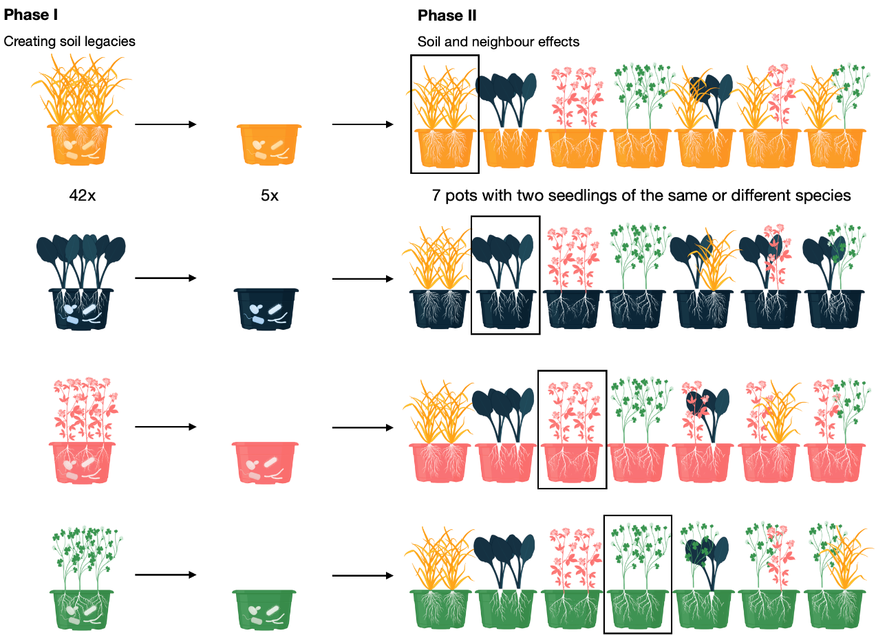

Supplementary Figure 1. Schematic representation of how the legacy soils were generated in Phase I by growing each species in 42 pots and pooling them after harvest into five replicates. In Phase II, the soil from each of the five replicates was distributed over seven pots. In each of the seven pots two seedlings were then planted that belonged to the same or to two different species.

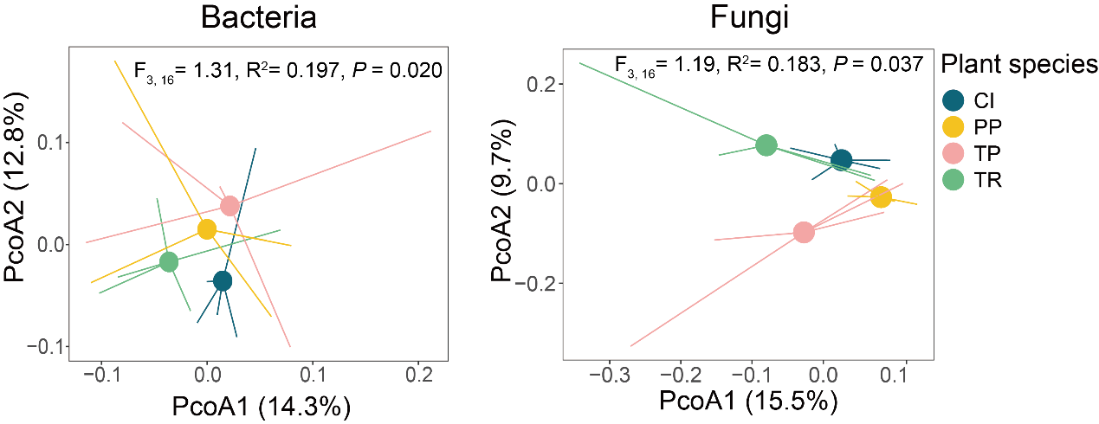
Supplementary Figure 2. Microbial community composition in soil at the end of Phase I. Compositional variation of bacteria and fungi in the soil among four different plant species based on Principal-component analysis (PcoA). Both bacterial and fungal community in soil conditioned by four plant species are distinct from each other. The abbreviations are Cichorium intybus (CI, blue), Phleum pratense (PP, yellow), Trifolium pratense (TP, pink) and Trifolium repens (TR, green).

Supplementary Figure 3. Explained variance in bacterial and fungal communities associated with the roots of the focal plant by neighbour type (growing with the same plant species versus different plant species) and soil legacies type (growing in focal soil legacies versus neighbour soil legacies). (A) Variance in the bacterial community of each focal plant explained by neighbor plant type and soil legacy type. Compared to soil legacy type, neighbor plant type explains significantly more variation in the bacterial community. (B) Variance in the fungal community of each focal plant explained by neighbor plant type and soil legacy type. Soil legacy type explained relatively more variation in the fungal community than neighbour plant type. The abbreviations for focal plant identity are CI Cichorium intybus, PP Phleum pratense, TP Trifolium pratense and TR Trifolium repens. Results given in panels A and B are derived from variance partitioning and redundancy analysis. *, ** represent significant levels at 0.05 and 0.01, respectively.

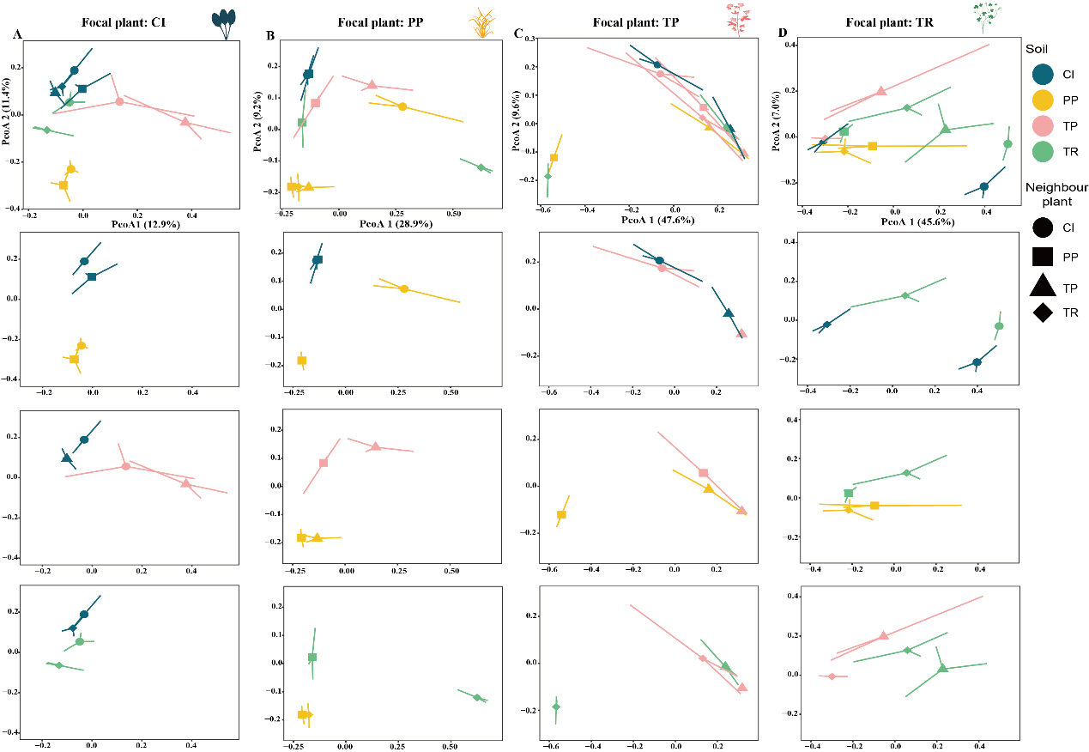
Supplementary Figure 4. Compositional variation of bacteria associated with the roots of four focal plant species when they grow with different neighbour plants in different soil legacies. Compositional variation of the bacterial community associated with the roots of the focal plant, Cichorium intybus (A), Phleum pratense (B), Trifolium pratense (C) and Trifolium repens (D) based on Principal-component analysis. Figures below the top panels show compositional differences of the bacterial community among one complete pair with its neighbour plant and neighbour plant soil legacy. For example, the second figure in panel A shows the complete combination for focal plant Cichorium intybus (CI, circle) and its neighbour plant, Phleum pratense (PP, square) in CI soil (dark blue）and PP soil (light yellow). The circles filled with dark blue and with light yellow represent the focal plant C. intybus grown with C. intybus (CI) in soil conditioned by CI and in soil conditioned by PP, respectively. Squares filled with dark blue and with light yellow represent the focal plant C. intybus grown with P. pratense (PP) in soil conditioned by CI and in soil conditioned by PP, respectively. Colors represent the soil legacy created by Cichorium intybus (CI, dark blue), Phleum pratense (PP, light yellow), Trifolium pratense (TP, light pink) and Trifolium repens (TR, light green). Shapes represent the neighbor plant identity. Circles, squares, triangles and diamonds represent Cichorium intybus (CI), Phleum pratense (PP), Trifolium pratense (TP) and Trifolium repens (TR) respectively.
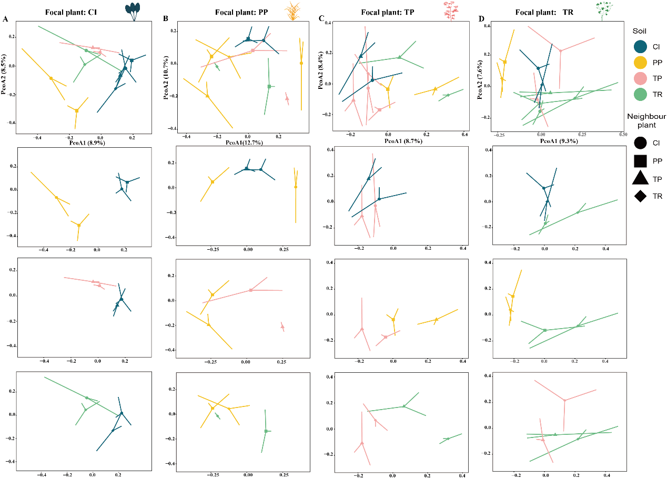
Supplementary Figure 5. Compositional variation of fungi associated with the roots of four focal plant species when they grow with different neighbour plants in different soil legacies. Compositional variation of the fungal community associated with the roots of the focal plant, Cichorium intybus (A), Phleum pratense (B), Trifolium pratense (C) and Trifolium repens (D) based on Principal-component analysis. Figures below the top panels show compositional differences of the fungal community among one complete pair with its neighbour plant and neighbour plant soil legacy. For example, the second figure in panel A shows the complete combination for focal plant Cichorium intybus (CI, circle) and its neighbour plant, Phleum pratense (PP, square) in CI soil (dark blue）and PP soil (light yellow). The circles filled with dark blue and with light yellow represent the focal plant C. intybus grown with C. intybus (CI) in soil conditioned by CI and in soil conditioned by PP, respectively. Squares filled with dark blue and with light yellow represent the focal plant C. intybus grown with P. pratense (PP) in soil conditioned by CI and in soil conditioned by PP, respectively. Colors represent the soil legacy created by Cichorium intybus (CI, dark blue), Phleum pratense (PP, light yellow), Trifolium pratense (TP, light pink) and Trifolium repens (TR, light green). Shapes represent the neighbor plant identity. Circles, squares, triangles and diamonds represent Cichorium intybus (CI), Phleum pratense (PP), Trifolium pratense (TP) and Trifolium repens (TR) respectively.
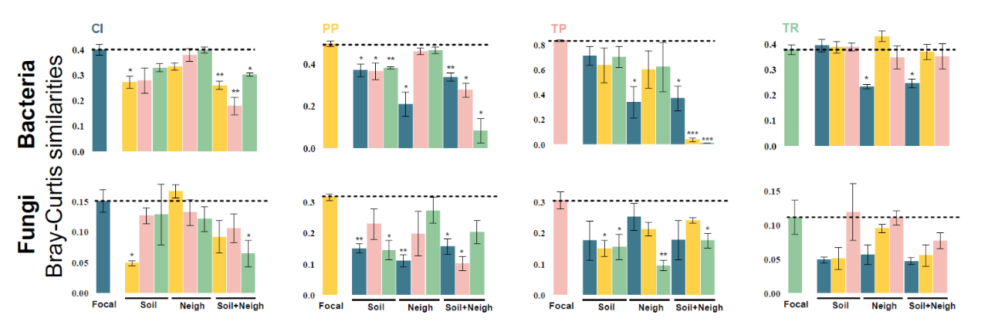
Supplementary Figure 6. Similarity in root-associated microbiomes for each focal plant and for all other combinations of soil legacies and neighbours. Data present Bray-Curtis similarities. Different colors of the bars indicate the different neighbours and soils (n=3 for each bar). For soil legacies, presented is the similarity between growing in soil of the focal species and soil of another species. For neighbour effects, presented is the similarity between growing with a neighbour of a different plant species in soil of the focal species. For soil+neighbour effects, presented is the similarity between growing with a neighbour of a different plant species in soil of a neighbour plant species. The abbreviations for focal plants are CI Cichorium intybus (dark blue), PP Phleum pratense (dark yellow), TP Trifolium pratense (light pink) and TR Trifolium repens (green). Asterisks indicate that Bray-Curtis similarities differ significantly from the similary amongst focal plants grown in focal soil (focal). *, **, *** represent significant levels at 0.05, 0.01 and 0.001 respectively.

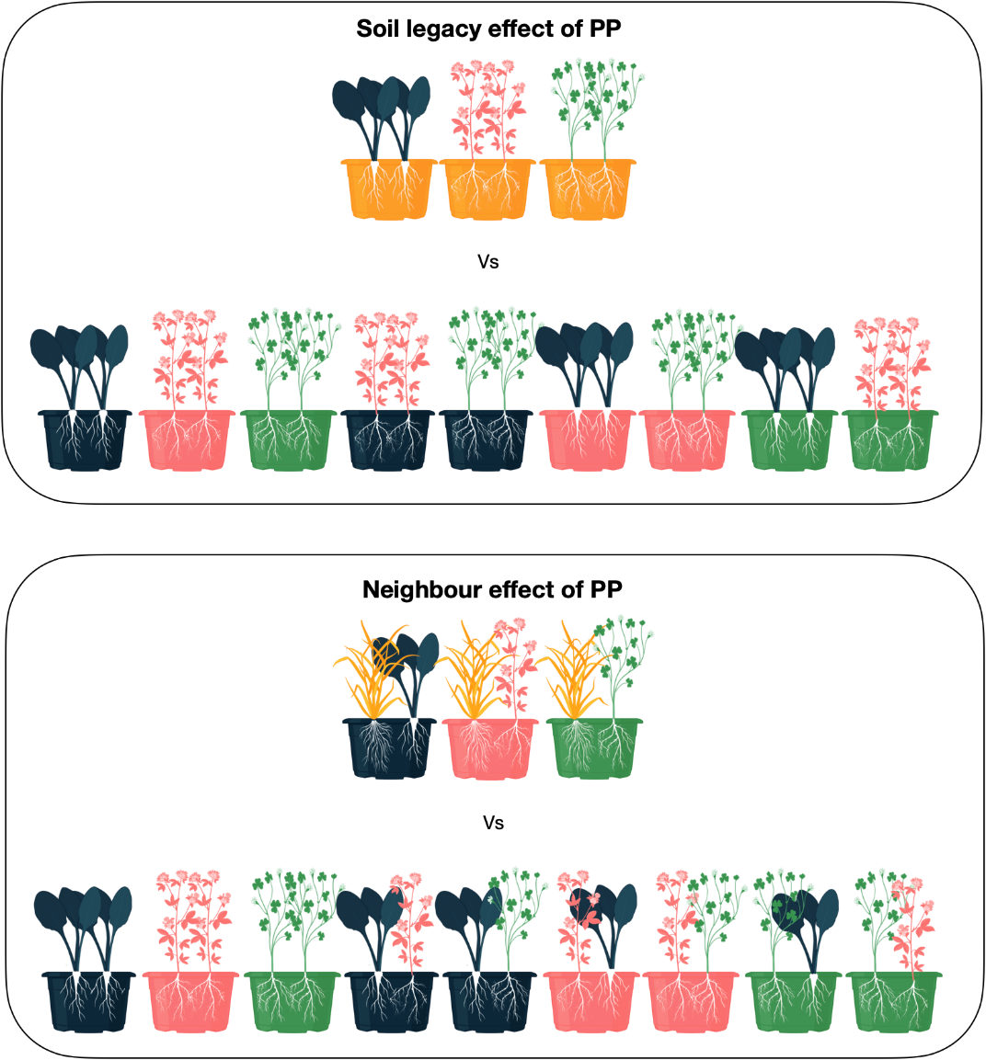
Supplementary Figure 7. Schematic example showing how indicator taxa of soil legacies and neighbour effect were identified. The example for PP as a neighbour is depicted. For soil legacy, the comparison is done between the monocultures of CI, TR and TP grown in PP soil against those monocultures grown in CI, TR and TP soils. For neighbour effect, the comparison is done between PP together with CI, TR or TP grown in the other plant species soil against the monocultures of CI, TR and TP grown in their own soils together with species pairs of these three species grown in both soils of the species pair.

Supplementary Figure 8. Effects of soil legacy origin and neighbour identity on the growth of focal plants in phase II. Shown is mean (+SE) shoot biomass of Cichorium intybus CI (A), Phleum pratense PP (B), Trifolium pratense TP (C) and Trifolium repens TR (D), when they grow with different neighbour plants in different soils with different legacies (N= 5). Results from two-way ANOVA tests with neighbour identity and soil legacy origin and their interactions is also presented. *, **, *** represent significant levels at 0.05, 0.01 and 0.001 respectively.

Supplementary Figure 9. Shoot biomass in Phase III. The bacterial com-cultures isolated from the roots of the host plant exposed to different legacies and neigbours influence plant growth. Mean (+SE) shoot biomass is shown of Cichorium intybus CI (A), Phleum pratense PP (B), Trifolium pratense TP (C) and Trifolium repens TR (D), when inoculated with bacterial com-cultures from the roots of plants of the same species that was growing with different neighbor plants in soils with different legacies (N= 5). Results from a one-way ANOVA (all com-cultures, excluding the control) are also presented. Controls were not inoculated.

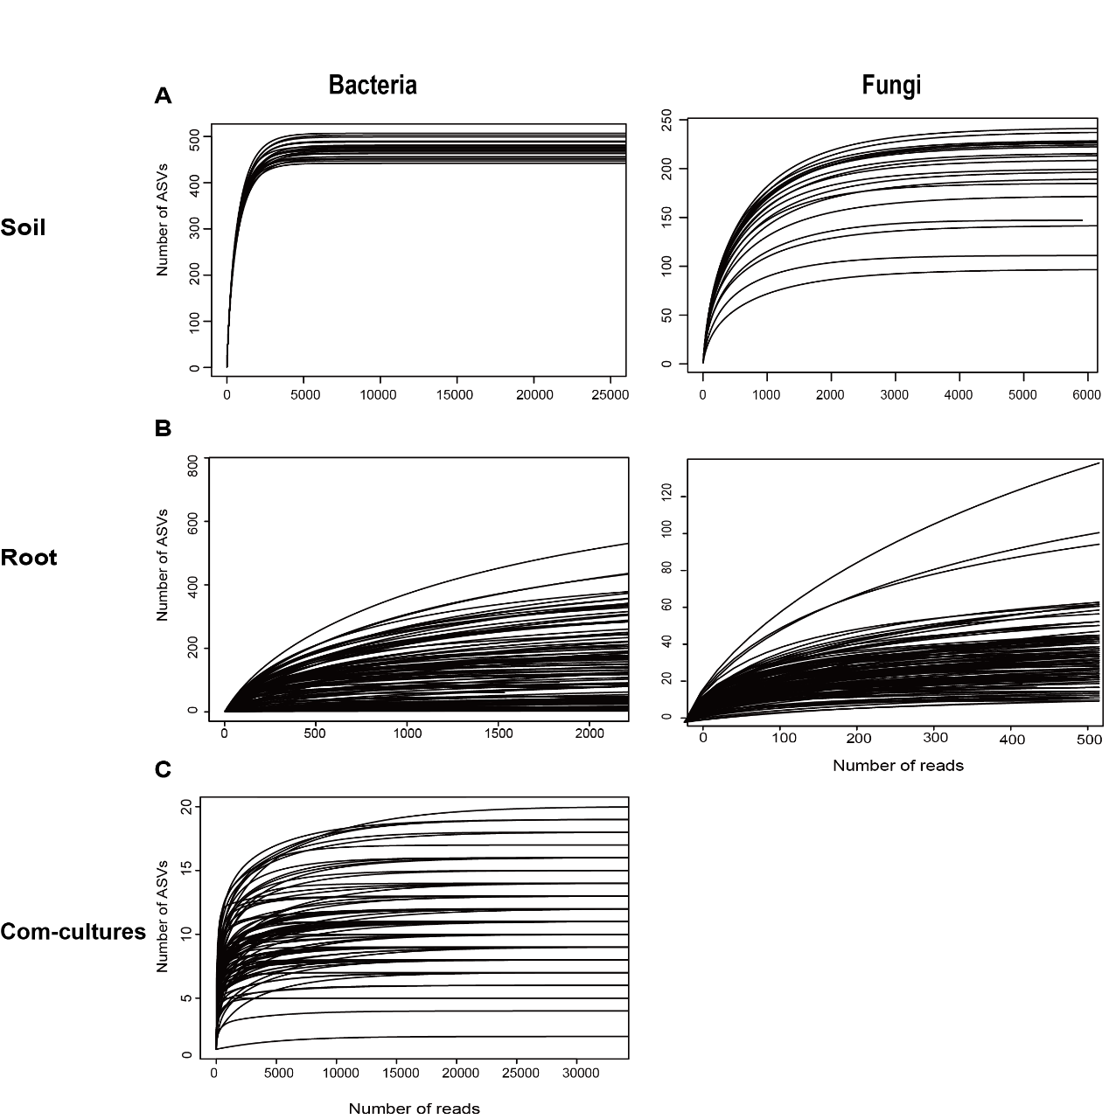
Supplementary Figure 10. Rarefication curves for bacteria in soils, roots, and com-cultures and for fungi in soils and roots. (A) shows the rarefaction curve for bacteria (25000 reads) and fungi (5912 reads) in soil at the end of phase I. (B) shows the rarefaction curve for bacteria (2035 reads) and fungi (508 reads) in roots at the end of phase 2. (C) show the rarefaction curve for bacteria (33328 reads) in isolated com-cultures.

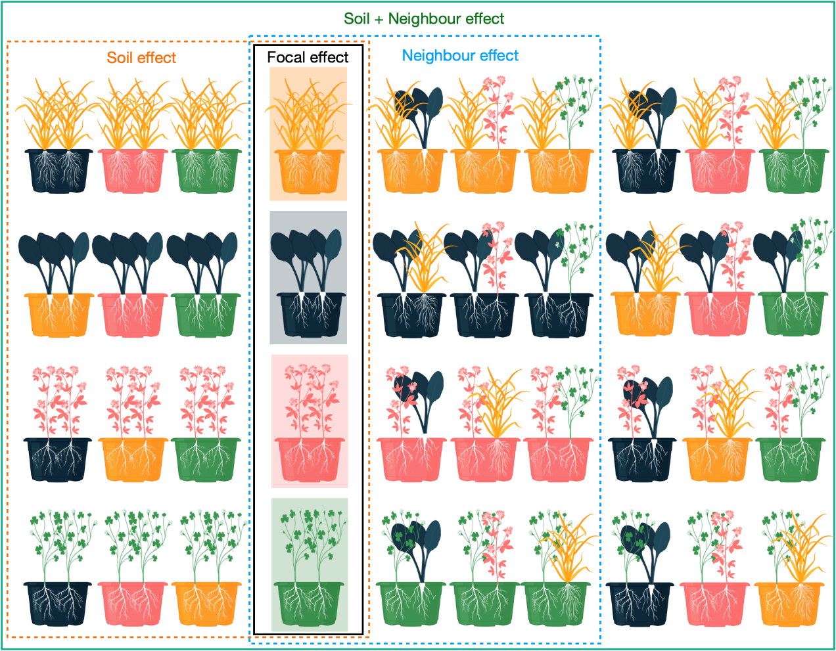
Supplementary Figure 11. Schematic overview explaining which treatments wwere included in calculating the focal effect, soil legacy effect, neighbour effect, and soil legacy + neighbour effect. The focal effect refers to the focal species growing in its own soil legacy and in the presence of a neighbour of the same species (black highlighted area). Soil legacy effects refer to four focal growing with neighbours with same identity as focal in four soil legacies (orange highlighted area). Neighbour effects refer to the four focal plants growing with four different neighbour in their own legacy soil (blue highlighted area). The combined effects of soil legacies and neighbours refer to the whole treatment that four plant species growing with four different neighbours in four different legacy soils (green highlighted area).

Supplementary Tables
Supplementary Table 1 Results of redundancy analysis (RDA) and variance partitioning analysis (VPA) testing the effects of focal plant identity (focal effect), soil legacy (soil effect) and neighbour identity on bacterial and fungal communities associated with the roots of the focal plant. The explained variance in bacterial and fungal communities shown in the table is the results of VPA and significance was tested by RDA. Degree of freedom (Df), F-values and p-values are presented. Significant p-values are presented in bold.

 |  | Bacteria |  |  |  | Fungi
 | Df | F | P-value | Explaned variance (%) |  | F | P-value | Explained variance (%)
Focal identity effect
Focal identity | 3, 8 | 6.42 | 0.0009 | 70.67 |  | 1.86 | 0.0009 | 42.87
Focal identity +soil legacy effect
Focal identity (F) | 3, 32 | 123.28 | <0.001 | 53.84 |  | 1.31 | 0.023 | 2.88
Soil legacy (S) | 3, 32 | 1.74 | 0.182 | 0.39 |  | 1.74 | 0.007 | 4.34
F*S | 9, 32 | 1.46 | 0.182 | -1.17 |  | 1.46 | 0.007 | -0. 46
Focal identity +Neigh identity
Focal identity (F) | 3, 32 | 36.97 | <0.001 | 36.93 |  | 1.37 | 0.002 | 5.80
Neigh identity (N) | 3, 32 | 1.63 | 0.197 | 1.22 |  | 1.42 | 0.231 | 0.19
F*N | 9, 32 | 7.19 | <0.001 | -2.44 |  | 1.26 | 0.081 | -0. 38
Focal identity +soil legacy + neighbour effect
Focal identity (F) | 3, 80 | 66.46 | <0.001 | 20.77 |  | 1.28 | 0.029 | 1.51
Neighbor Identity (N) | 3, 80 | 8.71 | <0.001 | 2.95 |  | 0.83 | 0.892 | 0.89
Soil legacy (S) | 3, 80 | 3.08 | 0.029 | 3.69 |  | 1.62 | 0.002 | 0.01

Supplementary Table 2 Results of redundancy analysis (RDA) and variance partitioning analysis (VPA) testing the effects of neighbour (Neigh) and soil legacy on bacterial and fungal communities associated with the roots of the focal plant. The explained variance in bacterial and fungal communities shown in the table is the results of VPA and significance was tested by RDA. Degree of freedom (Df), F-values and p-values are presented. Significant p-values are presented in bold. The abbreviations for soil legacy origin and plant species are CI Cichorium intybus, PP Phleum pratense, TP Trifolium pratense and TR Trifolium repens.
 | Bacteria |  |  |  |  |  | Fungi
 | Redundancy analysis |  |  |  | Explained variance by |  | Redundancy analysis |  |  |  | Explained variance by
 | Df | F-value | P-value | Variance | VPA (%) |  | Df | F-value | P-value | Variance | VPA (%)
CI
Neigh (N) | 3,20 | 1.42 | 0.011 | 13.12 | 4.77 |  | 3,20 | 1.07 | 0.257 | 11.05 | 0. 24
Soil legacy (S) | 3,20 | 1.65 | 0.001 | 15.21 | 12.16 |  | 3,20 | 0.93 | 0.637 | 9.55 | 3.37
N*S | 3,20 | 1.11 | 0.209 | 1.10 | 1.30 |  | 3,20 | 1.02 | 0.433 | 1.10 | 0. 18
PP
Neigh (N) | 3,20 | 7.84 | 0.002 | 26.03 | 11.83 |  | 3,18 | 1.27 | 0.112 | 12.64 | 4.73
Soil legacy (S) | 3,20 | 5.89 | 0.003 | 19.55 | 12.90 |  | 3,18 | 1.41 | 0.034 | 13.97 | 4.58
N*S | 3,20 | 9.73 | 0.001 | 32.30 | -3.36 |  | 3,18 | 1.40 | 0.028 | 1.10 | -2.15
TP
Neigh (N) | 3,20 | 19.06 | 0.001 | 37.69 | 23.78 |  | 3,20 | 0.90 | 0.784 | 9.16 | -0. 26
Soil legacy (S) | 3,20 | 12.55 | 0.001 | 24.82 | 15.84 |  | 3,20 | 1.35 | 0.012 | 13.76 | 3.41
N*S | 3,20 | 12.29 | 0.001 | 24.30 | -3.67 |  | 3,20 | 0.91 | 0.774 | 1.10 | 0. 45
TR
Neigh (N) | 3,20 | 13.46 | 0.001 | 63.45 | 28.10 |  | 3,20 | 1.06 | 0.317 | 10.26 | 1.31
Soil legacy (S) | 3,20 | 0.53 | 0.327 | 2.48 | 1.13 |  | 3,20 | 1.42 | 0.008 | 13.80 | 5.11
N*S | 3,20 | 0.56 | 0.517 | 2.65 | 2.84 |  | 3,20 | 1.15 | 0.128 | 1.10 | 0.56

Supplementary Table 3 Results of redundancy analysis (RDA) and variance partitioning analysis (VPA) testing the effects of neighbour type (growing with the same plant species versus different plant species) and soil legacies type (growing in focal soil legacies versus neighbour soil legacies) on bacterial and fungal communities associated with the roots of the focal plant. The explained variance in bacterial and fungal communities shown in the table was the results of VPA and significance tested by RDA. Degree of freedom (Df), F-values and p-values are presented. Significant p-values are presented in bold. The abbreviations for soil legacy origin and plant species are CI Cichorium intybus, PP Phleum pratense, TP Trifolium pratense and TR Trifolium repens.

 | Bacteria |  |  |  |  | Fungi
 | Redundancy analysis |  |  | Explained variance by VPA (%) |  | Redundancy analysis |  |  | Explained variance by VPA (%)
 | Df | F-value | P-value | Explained variance by VPA (%) |  | Df | F-value | P-value | Explained variance by VPA (%)
CI
Neighbour type | 1, 25 | 19.94 | 0.004 | 4.78 |  | 1, 25 | 1.07 | 0.340 | 0.2
Soil legacy type | 1, 25 | 1.39 | 0.129 | 5.2 |  | 1, 25 | 1.19 | 0.305 | 2.26
Interaction | 1, 25 | 1.35 | 0.209 | -0.00 |  | 1, 25 | 0.56 | 0.936 | 0
PP
Neighbour type | 1, 25 | 7.32 | 0.005 | 9.94 |  | 1, 23 | 1.34 | 0.128 | 0.09
Soil legacy type | 1, 25 | 0.87 | 0.407 | 3.85 |  | 1, 23 | 0.81 | 0.711 | 0.16
Interaction | 1, 25 | 0.85 | 0.411 | -1.48 |  | 1, 23 | 0.93 | 0.536 | 0
TP
Neighbour type | 1, 25 | 19.04 | <0.001 | 20.95 |  | 1, 25 | 1.07 | 0.347 | 0.1
Soil legacy type | 1, 25 | 10.01 | 0.008 | 11.55 |  | 1, 25 | 1.07 | 0.362 | 1.27
Interaction | 1, 25 | 2.27 | 0.142 | -7.3 |  | 1, 25 | 0.85 | 0.647 | 0.1
TR
Neighbour type | 1, 25 | 8.37 | 0.006 | 7.38 |  | 1, 25 | 1.13 | 0.276 | 0.04
Soil legacy type | 1, 25 | 2.03 | 0.139 | 0.5 |  | 1, 25 | 1.67 | 0.015 | 2.04
Interaction | 1, 25 | 2.38 | 0.118 | 2.1 |  | 1, 25 | 1.75 | 0.024 | -0.02

Supplementary Table 4 Information about indicator taxa identified for neighbour effects and soil legacy effects. Bacterial and fungal taxa identified as indicators for neighbour (neigh) and soil legacy (soil) effects were associated with Cichorium intybus (CI), Phleum pratense (PP), Trifolium pratense (TP) and Trifolium repens (TR). Significant Indicator taxa are presented, either enriched (enrich) or depleted (depl) (p < 0.05), were present in more than 50% of the samples. The log-fold change was calculated based on relative abundance (%), and taxonomic information is provided for each indicator taxon. Enriched taxa are highlighted in grey. Treat and contr represents the two-comparing groups.
Plants | Effect type | Taxanomy |  |  |  |  |  |  | Relative abund (%) |  | P value | Presence (%) |  | Fold change
Plants | Effect type | Kingdom | Phylum | Class | Family | Order | Genus | ASV | Treat | Contr | P value | Treat | Contr | Fold change
CI | Neigh | Bacteria | Proteobacteria | Gammaproteobacteria | Burkholderiales | Oxalobacteraceae | Rugamonas | ASV1033 | 0.21 | 0.01 | 0.002 | 66. 7 | 7.4 | 4.83 | Enrich
CI | Neigh | Bacteria | Proteobacteria | Gammaproteobacteria | Burkholderiales | Oxalobacteraceae | Duganella | ASV104 | 3.24 | 0.07 | 0.002 | 66. 7 | 14.8 | 5.55 | Enrich
CI | Neigh | Bacteria | Proteobacteria | Gammaproteobacteria | Burkholderiales | Comamonadaceae | Variovorax | ASV1050 | 0.11 | 0.02 | 0.011 | 55.5 | 11.1 | 2.45 | Enrich
CI | Neigh | Bacteria | Proteobacteria | Alphaproteobacteria | Caulobacterales | Caulobacteraceae | Caulobacter | ASV106 | 2.17 | 0.15 | 0.002 | 100 | 48.1 | 3.84 | Enrich
CI | Neigh | Bacteria | Proteobacteria | Gammaproteobacteria | Steroidobacterales | Steroidobacteraceae | Steroidobacter | ASV134 | 0.09 | 0.01 | 0.004 | 55.5 | 14.8 | 3.09 | Enrich
CI | Neigh | Bacteria | Proteobacteria | Alphaproteobacteria | Rhizobiales | Rhizobiaceae | Allorhizobium-Neorhizobium-Pararhizobium-Rhizobium | ASV1391 | 0.05 | 0.00 | 0.004 | 55.5 | 3.7 | 4.91 | Enrich
CI | Neigh | Bacteria | Proteobacteria | Gammaproteobacteria | Burkholderiales | Oxalobacteraceae | Noviherbaspirillum | ASV145 | 2.35 | 0.31 | 0.028 | 77.8 | 33.3 | 2.90 | Enrich
CI | Neigh | Bacteria | Proteobacteria | Gammaproteobacteria | Pseudomonadales | Pseudomonadaceae | Pseudomonas | ASV187 | 0.15 | 0.04 | 0.047 | 55.5 | 18.5 | 2.02 | Enrich
CI | Neigh | Bacteria | Bacteroidota | Bacteroidia | Sphingobacteriales | Sphingobacteriaceae | Mucilaginibacter | ASV214 | 0.75 | 0.03 | 0.019 | 55.5 | 14.8 | 4.61 | Enrich
CI | Neigh | Bacteria | Chloroflexi | Chloroflexia | Chloroflexales | Roseiflexaceae | NA | ASV236 | 0.04 | 0.30 | 0.048 | 22.2 | 51.8 | -2.78 | Depl
CI | Neigh | Bacteria | Proteobacteria | Gammaproteobacteria | Burkholderiales | Oxalobacteraceae | Massilia | ASV374 | 0.77 | 0.08 | 0.001 | 88.9 | 29.6 | 3.27 | Enrich
CI | Neigh | Bacteria | Proteobacteria | Alphaproteobacteria | Rhizobiales | Rhizobiaceae | Aminobacter | ASV418 | 0.11 | 0.03 | 0.011 | 66.7 | 25.9 | 1.98 | Enrich
CI | Neigh | Bacteria | Proteobacteria | Gammaproteobacteria | Burkholderiales | Comamonadaceae | Rhodoferax | ASV422 | 0.23 | 0.06 | 0.003 | 88.9 | 29.6 | 2.01 | Enrich
CI | Neigh | Bacteria | Proteobacteria | Alphaproteobacteria | Caulobacterales | Caulobacteraceae | Caulobacter | ASV514 | 0.48 | 0.06 | 0.006 | 66.7 | 18.5 | 2.92 | Enrich
CI | Neigh | Bacteria | Proteobacteria | Gammaproteobacteria | Burkholderiales | Comamonadaceae | Paucibacter | ASV63 | 2.00 | 0.47 | 0.01 | 88.9 | 66.7 | 2.08 | Enrich
CI | Neigh | Bacteria | Acidobacteriota | Thermoanaerobaculia | Thermoanaerobaculales | Thermoanaerobaculaceae | Subgroup 10 | ASV724 | 0.18 | 0.02 | 0.014 | 66.7 | 18.5 | 3.17 | Enrich
CI | Neigh | Bacteria | Proteobacteria | Gammaproteobacteria | Pseudomonadales | Pseudomonadaceae | Pseudomonas | ASV79 | 0.43 | 0.07 | 0.005 | 55.5 | 22.2 | 2.55 | Enrich
CI | Neigh | Bacteria | Proteobacteria | Gammaproteobacteria | Burkholderiales | Oxalobacteraceae | Massilia | ASV81 | 1.24 | 0.10 | 0.001 | 88.9 | 37 | 3.68 | Enrich
CI | Neigh | Bacteria | Myxococcota | Polyangia | Haliangiales | Haliangiaceae | Haliangium | ASV843 | 0.19 | 0.02 | 0.008 | 55.5 | 11.1 | 3.54 | Enrich
PP | Neigh | Bacteria | Proteobacteria | Gammaproteobacteria | Burkholderiales | Oxalobacteraceae | Massilia | ASV374 | 0.01 | 0.33 | 0.047 | 44.4 | 55.5 | -5.91 | Depl
PP | Neigh | Bacteria | Chloroflexi | Anaerolineae | SBR1031 | A4b | NA | ASV148 | 0.03 | 0.16 | 0.018 | 11.1 | 51.8 | -2.57 | Depl
PP | Neigh | Bacteria | Proteobacteria | Gammaproteobacteria | Burkholderiales | Comamonadaceae | Rhizobacter | ASV85 | 0.09 | 0.02 | 0.048 | 55.5 | 18.5 | 1.97 | Enrich
TP | Neigh | Bacteria | Bacteroidota | Bacteroidia | Cytophagales | Microscillaceae | Ohtaekwangia | ASV752 | 0.18 | 0.06 | 0.026 | 77.8 | 37 | 1.68 | Enrich
TP | Neigh | Bacteria | Proteobacteria | Gammaproteobacteria | Steroidobacterales | Steroidobacteraceae | Steroidobacter | ASV244 | 0.50 | 0.15 | 0.027 | 77.8 | 62.9 | 1.75 | Enrich
TP | Neigh | Bacteria | Proteobacteria | Gammaproteobacteria | Burkholderiales | Comamonadaceae | Hydrogenophaga | ASV264 | 0.57 | 0.11 | 0.021 | 66.7 | 55.5 | 2.32 | Enrich
TP | Neigh | Bacteria | Bacteroidota | Bacteroidia | Chitinophagales | Chitinophagaceae | Niastella | ASV243 | 0.70 | 0.13 | 0.003 | 77.8 | 37 | 2.41 | Enrich
CI | Soil | Bacteria | Proteobacteria | Gammaproteobacteria | Burkholderiales | Comamonadaceae | Hydrogenophaga | ASV264 | 0.02 | 0.12 | 0.033 | 11.1 | 55.5 | -2.92 | Depl
PP | Soil | Bacteria | Proteobacteria | Gammaproteobacteria | Burkholderiales | Comamonadaceae | Hydrogenophaga | ASV864 | 0.08 | 0.01 | 0.01 | 55.5 | 7.4 | 2.91 | Enrich
PP | Soil | Bacteria | Chloroflexi | Anaerolineae | SBR1031 | A4b | NA | ASV516 | 0.13 | 0.02 | 0.014 | 66.7 | 29.7 | 2.41 | Enrich
PP | Soil | Bacteria | Chloroflexi | Anaerolineae | SBR1031 | A4b | NA | ASV683 | 0.11 | 0.00 | 0.001 | 55.5 | 3.7 | 5.91 | Enrich
PP | Soil | Bacteria | Proteobacteria | Gammaproteobacteria | Burkholderiales | Comamonadaceae | Rhodoferax | ASV273 | 0.21 | 0.05 | 0.045 | 55.5 | 11.1 | 1.97 | Enrich
PP | Soil | Bacteria | Myxococcota | Polyangia | Polyangiales | BIrii41 | NA | ASV356 | 0.19 | 0.00 | 0.001 | 55.5 | 3.7 | 6.67 | Enrich
PP | Soil | Bacteria | Chloroflexi | Anaerolineae | SBR1031 | A4b | NA | ASV148 | 0.28 | 0.07 | 0.02 | 77.8 | 33.3 | 2.01 | Enrich
PP | Soil | Bacteria | Chloroflexi | Anaerolineae | SBR1031 | A4b | NA | ASV229 | 0.21 | 0.00 | 0.001 | 66.7 | 3.7 | 6.87 | Enrich
PP | Soil | Bacteria | Myxococcota | Polyangia | Polyangiales | BIrii41 | NA | ASV942 | 0.23 | 0.01 | 0.002 | 66.7 | 3.7 | 4.43 | Enrich
PP | Soil | Bacteria | Proteobacteria | Gammaproteobacteria | Gammaproteobacteria Incertae Sedis | Unknown Family | Acidibacter | ASV205 | 0.26 | 0.03 | 0.002 | 66.7 | 11.1 | 3.33 | Enrich
PP | Soil | Bacteria | Proteobacteria | Gammaproteobacteria | Burkholderiales | Comamonadaceae | NA | ASV224 | 0.38 | 0.08 | 0.046 | 55.5 | 25.9 | 2.25 | Enrich
PP | Soil | Bacteria | Proteobacteria | Gammaproteobacteria | Burkholderiales | Comamonadaceae | Hydrogenophaga | ASV338 | 0.37 | 0.03 | 0.004 | 66.7 | 11.1 | 3.74 | Enrich
PP | Soil | Bacteria | Proteobacteria | Gammaproteobacteria | Burkholderiales | Comamonadaceae | NA | ASV151 | 0.76 | 0.09 | 0.002 | 88.9 | 29.6 | 3.06 | Enrich
PP | Soil | Bacteria | Actinobacteriota | Actinobacteria | Pseudonocardiales | Pseudonocardiaceae | Lechevalieria | ASV83 | 1.36 | 0.10 | 0.036 | 66.7 | 22.2 | 3.78 | Enrich
TP | Soil | Bacteria | Proteobacteria | Gammaproteobacteria | Burkholderiales | Oxalobacteraceae | Pseudoduganella | ASV90 | 0.50 | 0.15 | 0.006989 | 11.1 | 74.1 | 1.71 | Enrich
TP | Soil | Bacteria | Proteobacteria | Gammaproteobacteria | Burkholderiales | Comamonadaceae | Hydrogenophaga | ASV140 | 3.50 | 0.10 | 0.004 | 7.4 | 70.4 | 5.15 | Enrich
TP | Soil | Bacteria | Verrucomicrobiota | Verrucomicrobiae | Opitutales | Opitutaceae | Lacunisphaera | ASV518 | 3.20 | 0.03 | 0.001 | 7.4 | 59.2 | 6.87 | Enrich
TP | Soil | Bacteria | Chloroflexi | Anaerolineae | SBR1031 | NA | NA | ASV734 | 2.30 | 0.01 | 0.000 | 3.7 | 51.8 | 8.72 | Enrich
CI | Neigh | Fungi | Ascomycota | Orbiliomycetes | Orbiliales | Orbiliaceae | Arthrobotrys | ASV191 | 1.41 | 0.34 | 0.028 | 55.5 | 3.3 | 2.07 | Enrich
PP | Neigh | Fungi | Ascomycota | Dothideomycetes | _Pleosporales | Lentitheciaceae | Poaceascoma | ASV58 | 2.53 | 0.18 | 0.016 | 55.6 | 18.5 | 3.84 | Enrich
CI | Soil | Fungi | NA | NA | NA | NA | NA | ASV19 | 0.22 | 0.74 | 0.05 | 33.3 | 62.9 | -1.77 | Depl
CI | Soil | Fungi | Ascomycota | Orbiliomycetes | Orbiliales | Orbiliaceae | Arthrobotrys | ASV39 | 0.13 | 6.77 | 0.032 | 44.4 | 59.3 | -5.69 | Depl
PP | Soil | Fungi | Ascomycota | Sordariomycetes | Sordariales | Podosporaceae | Cladorrhinum | ASV47 | 5.69 | 0.00 | 0.001 | 66.7 | 0 | 9.15 | Enrich
PP | Soil | Fungi | Ascomycota | Dothideomycetes | Pleosporales | Lindgomycetaceae | NA | ASV82 | 3.22 | 0.04 | 0.001 | 100 | 7.4 | 6.46 | Enrich
PP | Soil | Fungi | Ascomycota | Dothideomycetes | Pleosporales | Lentitheciaceae | Poaceascoma | ASV58 | 2.25 | 0.23 | 0.001 | 100 | 25.9 | 3.32 | Enrich
PP | Soil | Fungi | Ascomycota | Sordariomycetes | Sordariales | Podosporaceae | Cladorrhinum | ASV128 | 1.95 | 0.00 | 0.001 | 55.5 | 0 | 10.93 | Enrich
PP | Soil | Fungi | Ascomycota | Dothideomycetes | Pleosporales | Lindgomycetaceae | NA | ASV110 | 1.33 | 0.04 | 0.001 | 66.7 | 0 | 4.93 | Enrich
PP | Soil | Fungi | Ascomycota | Dothideomycetes | Pleosporales | Phaeosphaeriaceae | Ophiosphaerella | ASV592 | 0.52 | 0.01 | 0.002 | 55.5 | 7.4 | 5.17 | Enrich
PP | Soil | Fungi | Ascomycota | Pezizomycetes | Pezizales | NA | NA | ASV81 | 0.37 | 0.08 | 0.029 | 55.5 | 22.2 | 2.21 | Enrich
PP | Soil | Fungi | Ascomycota | Sordariomycetes | Hypocreales | Nectriaceae | Dactylonectria | ASV88 | 0.50 | 1.34 | 0.049 | 66.7 | 85.2 | -1.42 | Depl
TP | Soil | Fungi | Ascomycota | Sordariomycetes | Hypocreales | Nectriaceae | Dactylonectria | ASV88 | 2.17 | 0.74 | 0.013 | 29.6 | 85.2 | 1.56 | Enrich
TR | Soil | Fungi | Ascomycota | Dothideomycetes | Pleosporales | Lentitheciaceae | Poaceascoma | ASV58 | 0.37 | 1.92 | 0.037 | 11.1 | 74.1 | -2.37 | Depl

Supplementary Table 5 Results of two-way ANOVA testing the effects of neighbour identity (neigh), soil legacy and their interactions on shoot biomass of focal plants in Phase II. Degree of freedom (Df), F value, p-value and explained variance (%) are presented and significant p-values are presented in bold. The abbreviations for focal plant are CI Cichorium intybus, PP Phleum pratense, TP Trifolium pratense and TR Trifolium repens.
 | Df | F value | P-value | Explained variance (%)
CI shoot biomass
Neigh (N) | 3, 39 | 4.12 | 0.012 | 16.87
Soil legacy (S) | 3, 39 | 5.90 | 0.002 | 24.13
N*S | 3, 39 | 1.43 | 0.240 | 5.87
PP shoot biomass
Neigh (N) | 3, 39 | 2.17 | 0.107 | 8.49
Soil legacy (S) | 3, 39 | 6.97 | <0.001 | 27.26
N*S | 3, 39 | 3.43 | 0.026 | 13.41
TP shoot biomass
Neigh (N) | 3, 39 | 2.24 | 0.090 | 11.33
Soil legacy (S) | 3, 39 | 1.18 | 0.324 | 5.97
N*S | 3, 39 | 3.35 | 0.028 | 16.98
TR shoot biomass
Neigh (N) | 3, 38 | 1.07 | 0.372 | 7.22
Soil legacy (S) | 3, 38 | 1.08 | 0.367 | 7.30
N*S | 3, 38 | 0.03 | 0.994 | 0.18

Supplementary Table 6 Results of redundancy analysis (RDA) testing whether bacterial and fungal communities associated with the roots of focal plants explain shoot biomass of the focal plant inPphase II. Degrees of freedom (Df), F-value, p-value and explained variance (%) are presented and significant p-values are presented in bold. The abbreviations for focal plant identity are CI Cichorium intybus, PP Phleum pratense, TP Trifolium pratense and TR Trifolium repens.
Focal plant | Df | Bacteria |  |  |  | Fungi
Focal plant | Df | F value | P-value | Explained variance (%) |  | F value | P-value | Explained variance (%)
CI | 1, 24 | 1.06 | 0.32 | 4.58 |  | 0.74 | 0.78 | 1.89
PP | 1, 24 | 7.25 | 0.003 | 24.78 |  | 0.46 | 0.80 | 3.25
TP | 1, 24 | 5.19 | 0.027 | 19.1 |  | 0.86 | 0.66 | 4.73
TR | 1, 24 | 0.59 | 0.46 | 2.61 |  | 0.89 | 0.57 | 3.58

Supplementary Table 7 One-way ANOVA results for testing the effect of inoculated bacterial com-cultures on the shoot biomass of the inoculated plant in phase III. Degrees of freedom (Df), F-value, p-value and explained variance (%) are presented and significant p-values are presented in bold. The abbreviations for inoculated plant are CI Cichorium intybus, PP Phleum pratense, TP Trifolium pratense and TR Trifolium repens.
Inoculated plant identity | Df | F | P-value | Explained variance (%)
CI | 9,35 | 2.82 | 0.013 | 42.07
PP | 8,36 | 2.26 | 0.045 | 33.45
TP | 9,39 | 6.05 | <0.001 | 58.26
TR | 6,19 | 0.96 | 0.477 | 23.27

Supplementary Table 8 Results of soil properties at the end of Phase I. SOM: soil organic matter; PO₄₋: available phosphorus; NO₃₋ : nitrate; NH₄₊: ammonium; Nmin: inorganic nitrogen. Values are mean ± 1 SE, n=5). The abbreviations for plant species are CI Cichorium intybus, PP Phleum pratense, TP Trifolium pratense and TR Trifolium repens.
 | SOM | pH | PO₄₋ (mg/kg) | NO₃₋ (mg/kg) | NH₄₊ (mg/kg) | Nmin (mg/kg)
CI | 2.15±0.02 | 7.42±0.01 | 3.23±0.14 | 1.56±0.44 | 3.61±0.42 | 5.17±0.82
PP | 2.15±0.05 | 7.47±0.01 | 3.19±0.09 | 1.40±0.21 | 3.30±0.22 | 4.70±0.27
TP | 2.08±0.1 | 7.40±0.03 | 3.04±0.3 | 3.23±0.30 | 4.28±0.28 | 7.51±0.68
TR | 2.15±0.03 | 7.44±0.02 | 3.57±0.21 | 2.26±0.50 | 4.61±0.44 | 6.87±0.65

