Supplemental Information
Table S1 Two-way analysis of variance (ANOVA) on all measured indicators of Q. dentata seedlings under fungus inoculation and salt treatment
Plant traits | F value and its significance
Plant traits | Fungus inoculation | Soil salinity | Interaction effects
Height (cm) | 0.094 | 1.798 | 0.161
Basal diameter (mm) | 0.661 | 17.46*** | 2.733
Leaf water content (%) | 5.547* | 485.198*** | 3.277
SLA (cm² g⁻¹) | 16.562*** | 6.131** | 0.652
Total biomass (g) | 8.486*** | 115.954*** | 6.165***
Root biomass (g) | 31.085*** | 251.122*** | 14.307***
Stem biomass (g) | 1.096 | 38.333*** | 1.185
Leaf biomass (g) | 0.952 | 29.783*** | 1.934
RMR | 4.305* | 17.907*** | 0.070
SMR | 0.663 | 0.163 | 0.194
LMR | 4.096 | 30.781*** | 0.173
R/S | 5.920*** | 24.919*** | 0.383
Net photosynthetic rate (μmol m⁻² s⁻¹) | 0.568 | 40.001*** | 1.506
Transpiration rate (mmol m⁻² s⁻¹) | 0.375 | 40.475*** | 0.573
Instantaneous water use efficiency  (mmol mol⁻¹) | 0.381 | 3.000 | 1.003
Stomatal conductance (mol m⁻² s⁻¹) | 1.668 | 54.428*** | 1.571
Chlorophyll a (mg g⁻¹) | 3.391* | 31.083*** | 2.083
Chlorophyll b (mg g⁻¹) | 4.534* | 3.657* | 0.501
Total chlorophyll (mg g⁻¹) | 4.428* | 17.895*** | 1.508
Chlorophyll a/b | 0.486 | 34.169*** | 0.419
Maximum quantum yield of photosystem Ⅱ | 1.353 | 11.559*** | 1.705
Photochemical quenching | 12.054** | 140.885*** | 15.256***
Relative electron transport rate of photosystem I (µmol m⁻² s⁻¹) | 1.259 | 51.444** | 2.002
Actual quantum yield of photosystem I | 1.292 | 51.809*** | 1.995
Relative electron transport rate of photosystem Ⅱ (µmol m⁻² s⁻¹) | 0.441 | 42.891*** | 0.093
Actual quantum yield of photosystem Ⅱ | 0.447 | 42.682*** | 0.093
Root Na⁺ content | 0.393 | 23.507*** | 0.197
Stem Na⁺ content | 2.779 | 93.984*** | 0.198
Leaf Na⁺ content | 19.099** | 219.260*** | 5.476*
Root K⁺ content | 2.749 | 2.621 | 0.539
Stem K+ content | 1.616 | 4.605* | 3.282
Leaf K⁺ content | 3.831 | 3.138 | 2.795
Root Ca²⁺ content | 0.453 | 2.890 | 2.382
Stem Ca²⁺ content | 2.239 | 6.655* | 1.624
Leaf Ca²⁺ content | 0.338 | 2.890 | 1.367
Root Mg²⁺ content | 0.031 | 0.819 | 0.043
Stem Mg²⁺ content | 2.165 | 1.771 | 0.277
Leaf Mg²⁺ content | 0.748 | 1.560 | 0.374
sodium-potassium ratio | 0.061 | 43.960*** | 1.858
Root nitrogen content | 1.130 | 4.922* | 4.541*
Root phosphorus content | 2.221 | 6.621** | 0.025
Stem nitrogen content | 0.140 | 4.511* | 2.253
Stem phosphorus content | 0.004 | 3.489 | 0.040
Leaf nitrogen content | 0.571 | 2.949 | 1.756
Leaf phosphorus content | 0.569 | 0.237 | 2.136
The abbreviations in the table represent as follows: specific leaf area (SLA), root mass radio (RMR), stem mass ratio (SMR), leaf mass ratio (LMR), root-shoot ratio(R/S). The significance of each effect is indicated by *: * indicates P < 0.05, ** indicates P < 0.01, and *** indicates P < 0.001.
Table S2 Growth changes of L. bicolor in solid culture under different salt stress
Growth time | NaCl content in the culture medium
Growth time | 0 | 0.4% | 0.8%
One day | 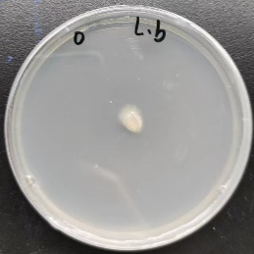 | 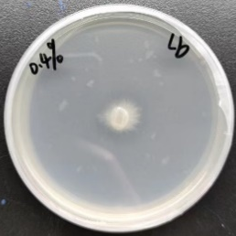 | 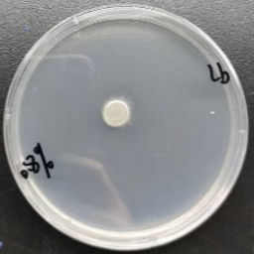
Three days | 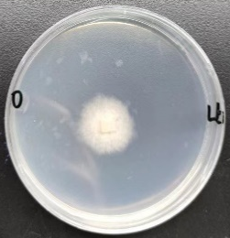 | 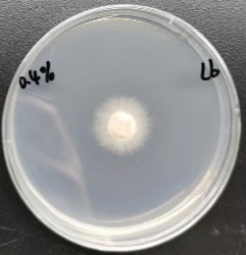 | 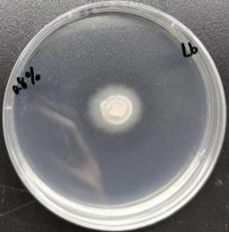
Five days | 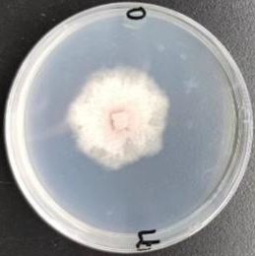 | 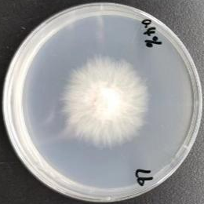 | 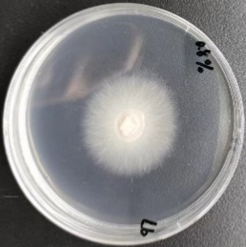
Seven days | 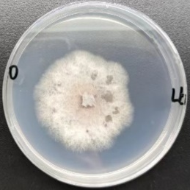 | 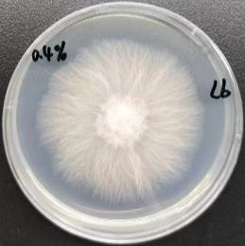 | 