Multifunctional electrolyte additive for high power lithium metal batteries at ultra-low temperatures
Weili Zhang*^{1,2}, Qingqing Feng², Yang Lu¹, Hao Wang², Guangyu Cheng³, Hao Liu², Qingbin Cao⁴, Zhenjun luo², Pan Zhou¹, Yingchun Xia¹, Wenhui Hou¹, Kun Zhao², Chunyi Du², Kai Liu*¹
¹Department of Chemical Engineering, Tsinghua University, China
² Tsinghua University Hefei Institute for Public Safety Research, China
³State Key Laboratory of Space Power-Sources, Shanghai Institute of Space Power-Sources, Shanghai 200245, China
⁴Xinyuan Qingcai Technology Co., Ltd, Beijing, China
*Corresponding author: E-mail: liukai2019@tsinghua.edu.cn; zhangweili@tsinghua-hf.edu.cn

Experimental Section
Materials: The perfluorooctyl quaternary ammonium iodide was purchased from Shanghai Macklin Biochemical Technology Co., Ltd. The LiFSI, LiNO₃ salt, DEE, DME solvent were purchased from DodoChem. All the solvents were mixed with molecule sieves to remove the trace water. The electrolytes were prepared in the glovebox ﬁlled with Ar gas. Metallic Li foil was chased by China Energy Lithium Co., LTD. N-Methyl-2-pyrrolidone (NMP), LiNi_{0.8}Mn_{0.1}Co_{0.1}O₂ (NMC811) were purchased from Shenzhen Kejing STAR Technology Company. Cathode NMC811 laminates were prepared by laying a mixture of 90 wt% NMC811 or LFP particles, 5 wt% super-p and 5 wt% PVDF (5.0 wt% NMP) on a carbon coated aluminum foil current collector and dried at 100 °C under vacuum before cell fabrication. The Full cell assembly: NMC811 cathode has a capacity of about 3 mAh g⁻¹, a 40 µm thick lithium metal is cut into small discs with a diameter of 14 mm to serve as the negative electrode, with an N/P ratio of approximately 3. Industry-level 500 mAh Li||NMC811 pouch cells (cathode loading: 20.69 mg cm⁻², 4.0 mAh cm⁻², Anode: 50 um Li foil, N/P=1.26) were purchased from LI-FUN Technology.
Synthesis of PN: 5g of perfluorooctyl quaternary ammonium iodide was dissolved in 60 ml of acetone, and 1.17g of silver nitrate was dissolved in 2ml of deionized water and added dropwise to the above solution. After stirring for 60 min the precipitate was removed by filtration. ZIH was obtained by cooling crystallization of the filtrate.
Electrochemical Evaluation: The electrochemical performances of the Li||Cu, Li||Li, Li||NMC batteries were examined using 2,032-type coin cells with a Celgard 2325 separator conducted on a battery test station (LANHE CT3001A). In order to avoid the corrosion of the stainless steel by the electrolyte, the electrochemical experiments of the coin cells with electrolytes containing LiFSI all use an Al-clad cathode cases and an additional piece of aluminum foil underneath the cathode disk. The EIS (an amplitude of 10 mV and a frequency ranging from 0.1 Hz to 100 kHz), CV (scan rate: 0.1 mV s-1, Voltage range: 3.0V-4.3V) and LSV (scan rate: 5 mV s-1, Voltage range: 3.0V-6.0V) tests were implemented by CHI 760E electrochemical workstation. For low temperature discharge experiments at different temperatures, the pouch cell was charged at a current density of 0.2 C under 25 ℃ and discharged at a current density 0.1 C under different temperatures. All cells rested at different temperatures for 2 hours to achieve temperature equilibrium and then subjected to electrochemical test. The power density P (W kg⁻¹) is obtained by dividing the energy density W (Wh kg-1) by the discharge time t (s). The ionic conductivity of the electrolyte was measured using a standard 2032 coin cell with two polished 316 stainless steel electrodes placed symmetrically at a set distance. The electrolytic conductivity value is calculated by the following formula:
$$\text{σ=}\frac{L}{A×R}$$
Where R is the resistance, and A and L are the area and spacing between the electrodes, respectively. Data points from 20°C to -80°C were measured using versastudio software and the symmetrical cells remained at a set temperature controlled by the thermostat for 1 hour prior to the test.
Characterizations: The surface morphology of lithium deposition was characterized by a JSM-7401F scanning electron microscopy (SEM). The JEM-2100 Plus transmission electron microscope (TEM) at an accelerating voltage of 200 kV was conducted to characterize CEI layers coating on cathode NMC811 particles. The SEI/CEI chemical composition information were measured by using X-ray photoelectron spectroscopy (XPS, ESCALAB Xi+) sputtering at different depths. The C1s peak at 284.6 eV was used as the reference for all binding-energy values. The ionic conductivities of the electrolytes at different temperatures were measured by electrochemical impedance spectroscopy (EIS) measurements with two polished 316 platinum plate electrodes symmetrically placed at a set distance in the electrolyte solutions.
In-situ attenuated total reflectance surface-enhanced infrared absorption spectroscopy (ATR-SEIRAS) : ATR-SEIRAS was performed in a sealed three-electrode electrochemical cell. A layer of coarse Au nanoparticles with a thickness of 20 nm was evaporated on the aluminum mesh as the working electrode with surface enhancement effect and lithium as the reference electrode for the working electrode. The electrochemical workstation (CHI 760e) was used to charge and discharge the three-electrode cell, and Raman scanning was carried out after the system reaches equilibrium for two minutes at each working potential (OCP vs Li，OCP+0.3V, OCP+0.6V). The Raman system (Horiba HR-800) used in this experiment was equipped with a 785 nm diode laser and a nominal power of 150mW.
Computational methods: Molecular dynamics (MD) simulations were conducted using the GROMACS software package,^{[1]} with atomistic force field parameters for all ions and solvent molecules defined in the AMBER format.^{[2]} Initial energy minimization was performed using the conjugate gradient algorithm with a 0.01 nm step size under periodic boundary conditions (PBC) in all three dimensions. The Verlet cutoff scheme was applied, with long-range electrostatic interactions handled by the Particle Mesh Ewald (PME) method and a cutoff of 1.0 nm for both electrostatic and van der Waals interactions. The first equilibration phase was performed under the NPT ensemble with a timestep of 0.0005 ps over 20 ns, where the temperature was gradually increased from 0 K to 298.15 K using a single-step annealing protocol managed by the V-rescale thermostat, and isotropic pressure coupling controlled by the C-rescale algorithm. In the second equilibration phase, the system underwent further equilibration under the NPT ensemble for 20 ns with a 0.001 ps timestep, maintaining a constant temperature of 298.15 K using the V-rescale thermostat, while pressure was regulated using the Parrinello-Rahman barostat. The production run was carried out for 5 ns under the NPT ensemble with a 0.001 ps timestep, keeping the temperature at 298.15 K and pressure at 1.0 bar, utilizing the V-rescale thermostat and Parrinello-Rahman barostat. Representative solvation structures were extracted from the atomistic simulation trajectories and used as initial configurations for quantum chemistry calculations. Density Functional Theory (DFT) calculations were performed with the Gaussian 16 software^{[3]} at the B3LYP/6-311G** level to optimize the molecular geometries of these solvation structures. Subsequently, binding energies were computed for these optimized structures at the B3LYP/6-311+G(2d,p) level.
The ab initio molecular dynamic (AIMD) calculations, based on the density functional theory as employed in Vienna Ab initio Simulation Package (VASP), are carried out with the Perdew-Burke-Ernzerhof (PBE) formulation of the generalized gradient approximation (GGA).^{[4,5]} DFT-D3 method (Becke-Jonson dampling) are utilized to describe the van der Waals (vdW) interaction.^{[6]} We choose the project augmented wave (PAW)^{[7]} and the plane wave cutoff energy of 400 eV. A 5×5×1 supercell of cubic phase lithium are cleaved to generated (100) crystallographic plane to represent cathode surface. To avoid interactions between neighboring images, a vacuum region of 20 Å is implemented. 1 PN and 17 DME are inserted in the vacuum space randomly to simulate the electrolyte environment. AIMD simulation for 10 ps at 300 K is performed with a timestep of 1 fs, where the temperature is regulated by NVT ensemble with the Nosé-Hoover thermostat^{[8,9]} and only Γ k-point is set. The 1s1, 2s1, 2s2p2, 2s22p3, 2s22p4, 2s22p5, and 3s23p4 valence electrons are owned by H, Li, C, N, O, F, and S, respectively. The VESTA program^{[10]} is utilized to visualized the crystal structures.

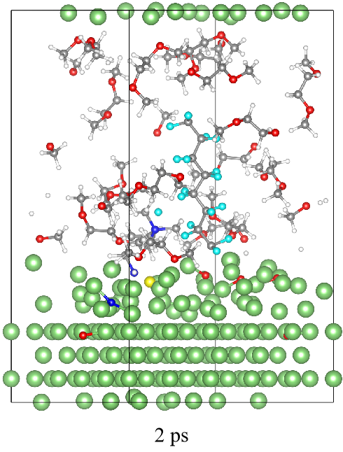
Fig. S1. Snapshots from AIMD simulation of decomposition reaction processes between PN with Li metal at 2 ps.
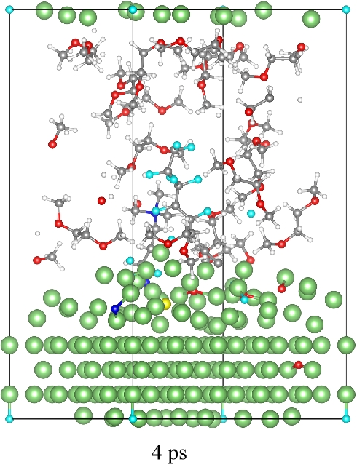
Fig. S2. Snapshots from AIMD simulation of decomposition reaction processes between PN with Li metal at 4 ps.

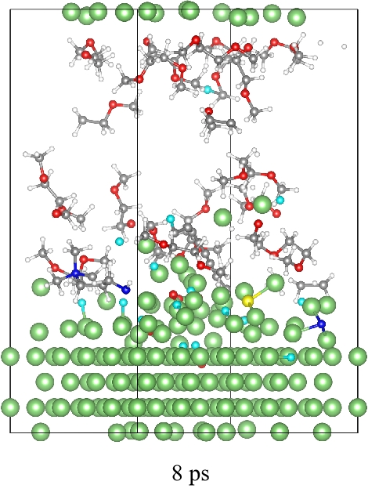
Fig. S3. Snapshots from AIMD simulation of decomposition reaction processes between PN with Li metal at 8 ps.

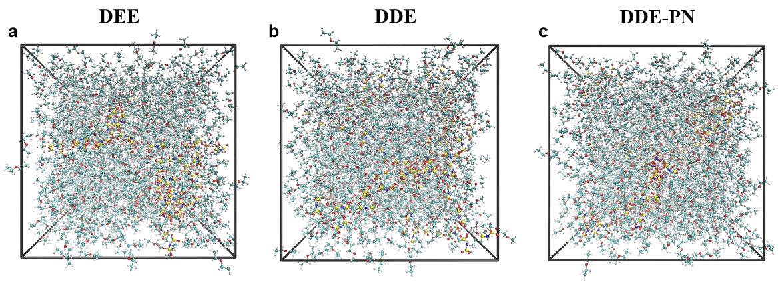
Fig. S4. The MD snap shot of (a) DEE, (b) DDE and (c) DDE-PN.

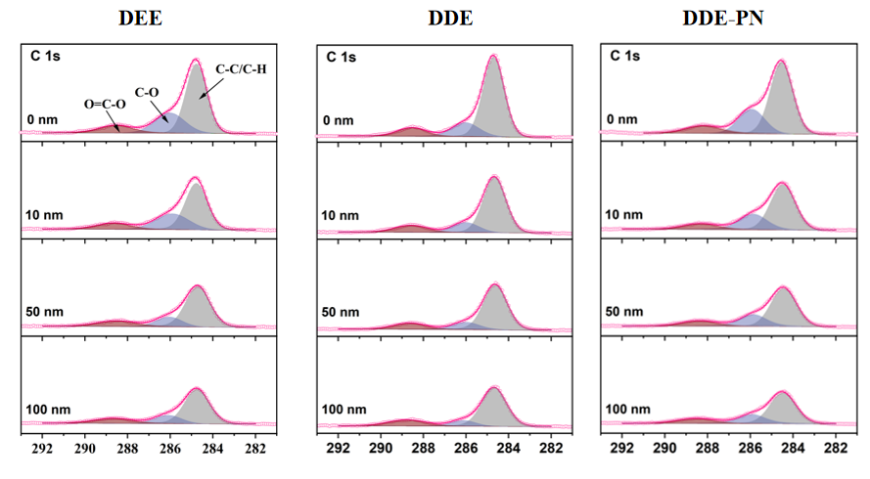
Fig. S5. XPS depth profiles of C 1s of SEI formed on Lithium metal surface after 20 cycles in Li||Cu coin cells with (a) DEE, (b) DDE and (c) DDE-PN electrolyte.

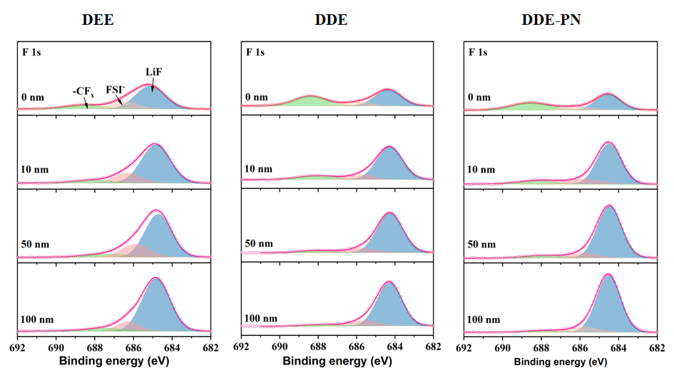
Fig. S6. XPS depth profiles of F 1s of SEI formed on Lithium metal surface after 20 cycles in Li||Cu coin cells with (a) DEE, (b) DDE and (c) DDE-PN electrolyte.

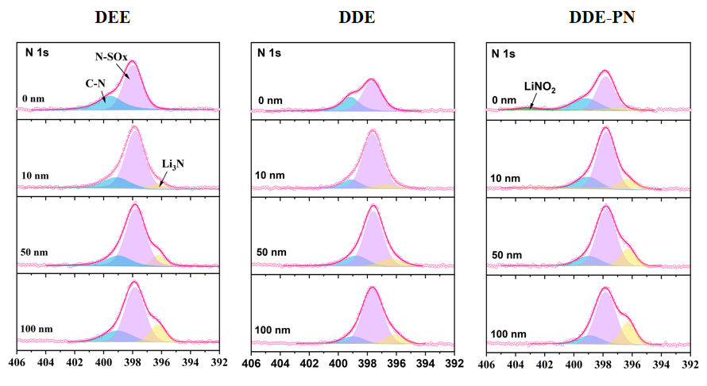
Fig. S7. XPS depth profiles of N 1s of SEI formed on Lithium metal surface after 20 cycles in Li||Cu coin cells with (a) DEE, (b) DDE and (c) DDE-PN electrolyte.

Fig. S8. Cycling performance of Li||Li cells under 25 ℃. The current density is 1 mA cm⁻² and the plating capacity is 1 mAh cm⁻².

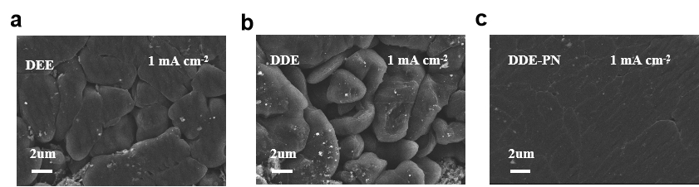
Fig. S9. Li plating morphology on copper working electrodes at 1 mAh cm⁻² in the (a) DEE, (b) DDE and (c) DDE-PN electrolyte under 25 ℃.

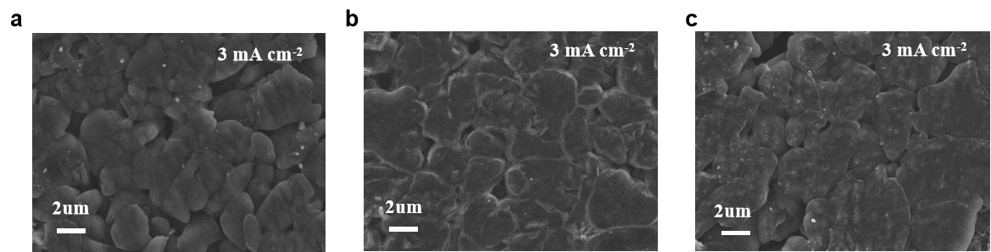
Fig. S10. Li plating morphology on copper working electrodes at 3 mAh cm⁻² in the (a) DEE, (b) DDE and (c) DDE-PN electrolyte under 25 ℃.

Fig. S11. Cycling CE of Li||Cu cells. The current density is 1 mA cm⁻² and the plating capacity is 1 mAh cm⁻² under 25 ℃.

Fig. S12. Aurbach CE test of Li||Cu cells under 25 ℃.

Fig. S13. Rate capability of Li||NMC811 cells under different charging/discharging rates.

Fig. S14. CE of Li||NMC811 cells at 1.0 C using different electrolytes.

Fig. S15.CE of Li||NMC811 cells at 5.0 C using different electrolytes.

Fig. S16. Impedance spectra of the NMC811 cathode after 5 cycles using different electrolytes.

Fig. S17. Impedance spectra of the NMC811 cathode after 100 cycles using different electrolytes.

Fig. S18. Cyclic voltammetry curves of the NMC811 cathode after 5 cycles using different electrolytes.

Fig. S19. Cyclic voltammetry curves of the NMC811 cathode after 100 cycles using different electrolytes.

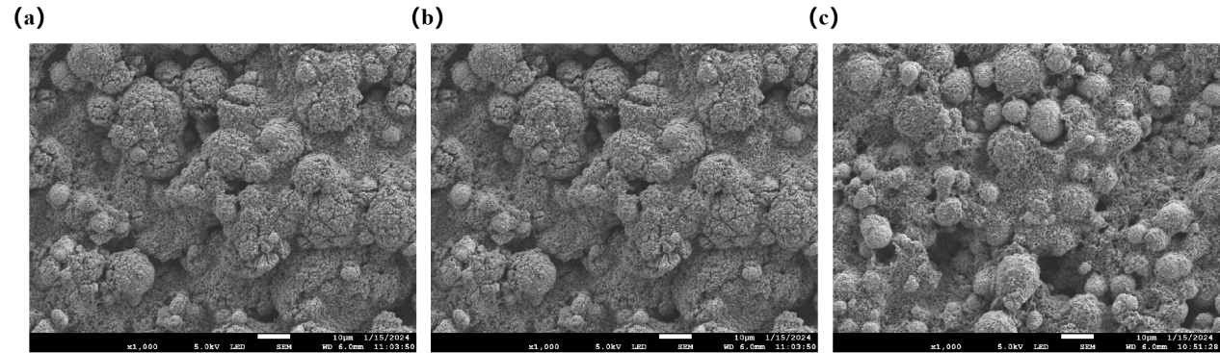
Fig. S20. SEM images of the NCM811 cathode morphology from the cell after 100 cycles in the (a) DEE, (b) DDE and (c) DDE-PN electrolyte.
.

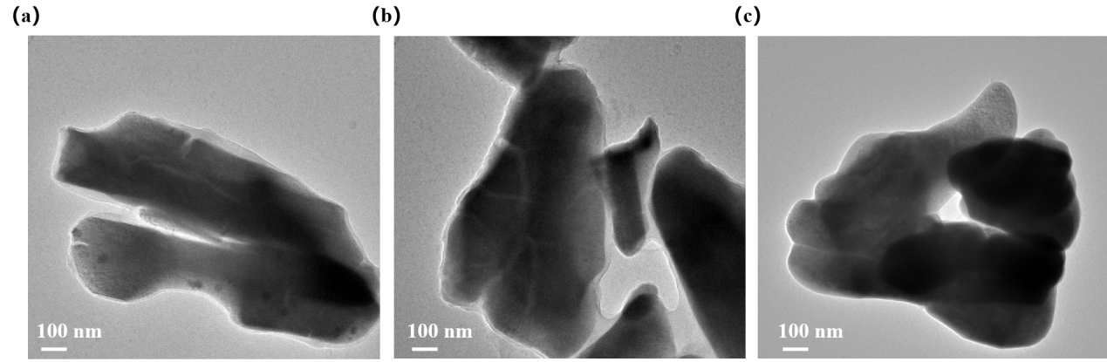
Fig. S21. TEM images of the NCM811 cathode morphology from the cell after 100 cycles in the (a) DEE, (b) DDE and (c) DDE-PN electrolyte.

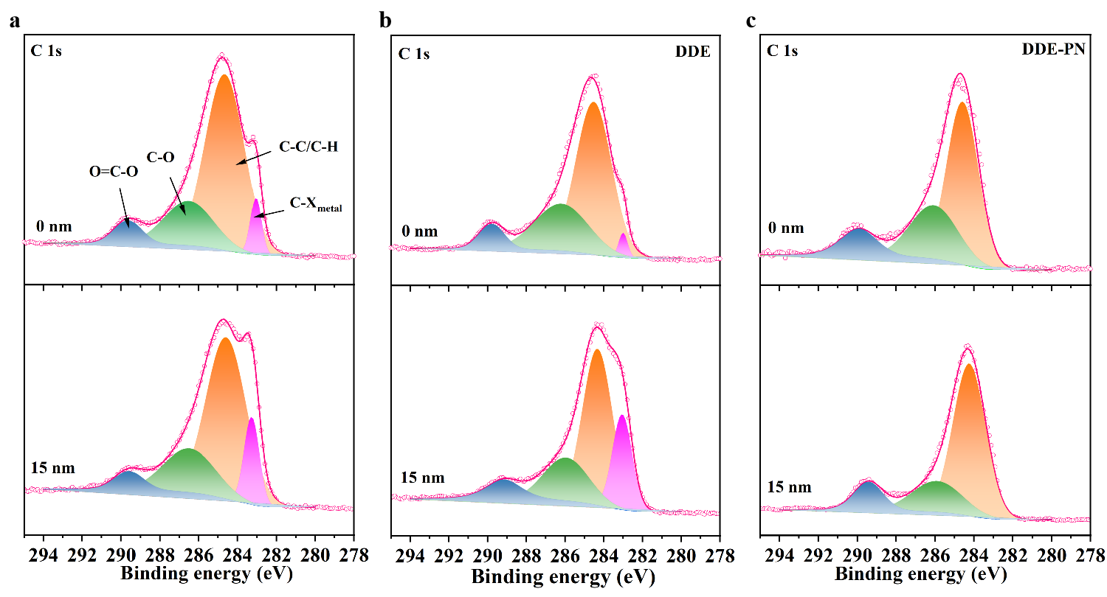
Fig. S22. XPS depth profiles of C 1s of SEI formed on Lithium metal surface after 50 cycles in Li||NMC811 coin cells with (a) DEE, (b) DDE and (c) DDE-PN electrolyte.

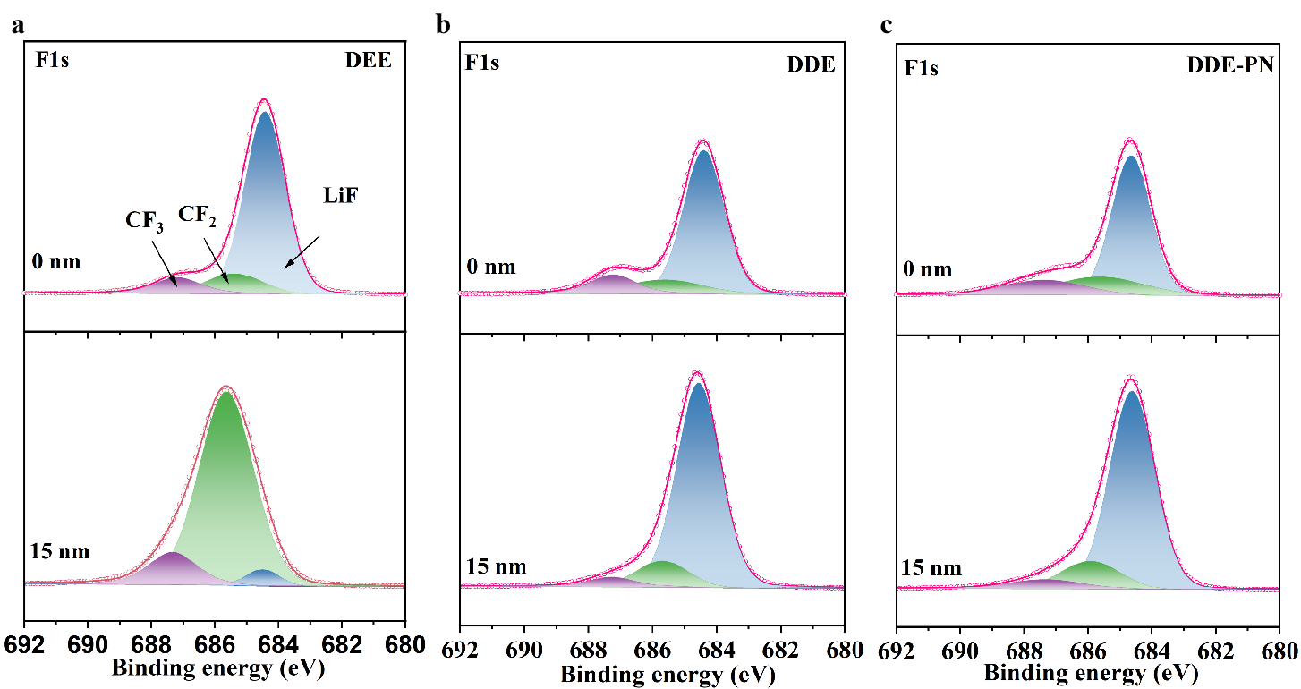
Fig. S23. XPS depth profiles of F 1s of SEI formed on Lithium metal surface after 50 cycles in Li||NMC811 coin cells with (a) DEE, (b) DDE and (c) DDE-PN electrolyte.

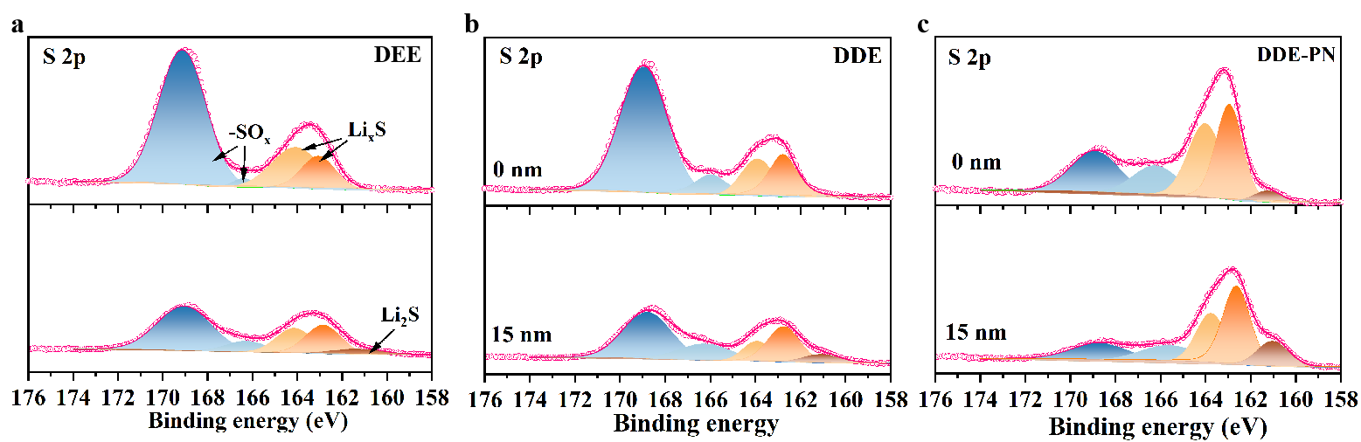
Fig. S24. XPS depth profiles of S 2p of SEI formed on Lithium metal surface after 50 cycles in Li||NMC811 coin cells with (a) DEE, (b) DDE and (c) DDE-PN electrolytes.

Fig. S25. Raman spectra of NO₃⁻ on the working electrode under different voltages in DDE-PN electrolytes.

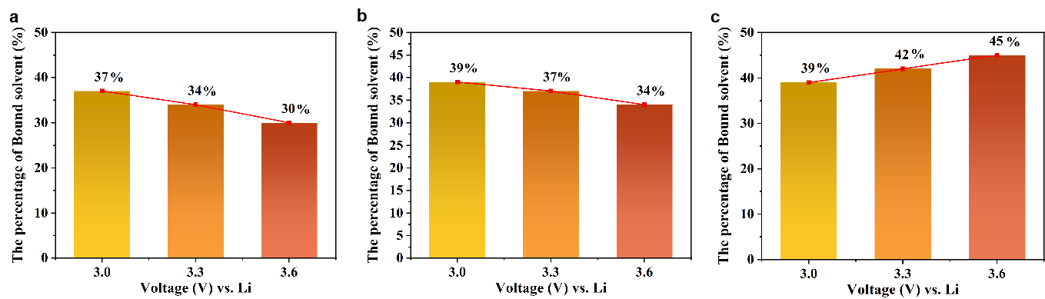
Fig. S26. The variation trend of Bound-solvent in the double layer with respect to voltage in (a) DEE, (b) DDE and (c) DDE-PN electrolytes .

Fig. S27. Typical voltage profiles of the Li||NMC811 pounch cells with various currents ranging from 0.1 C to 2.0 C under -50 ℃.

Table S1. Comparison of our work with recent works on low-temperature lithium-based pouch cells.
Electrolyte | Cell condition | Cutoff voltage  （vs Li/Li⁺） | Cell  capacity | (Maximum)  Energy density at low temperature | (Maximum)  Power Density at low temperature | Refs.
1M LiFSI in DEE | Li||SPAN  pouch cell | 3.5 V | 160 mAh | 143 Wh kg⁻¹ at -40 ℃ | 17.2 W kg⁻¹ at -40 ℃ (calculated) | Ref.11
1 M LiFSI in BTFE/DME (5 : 1 vol%) | Li||NMC811  pouch cell | 4.3 V | 5 Ah | 230 Wh kg⁻¹ at -40 ℃ | 23 W kg⁻¹ at -40 ℃ (calculated) | Ref.12
1.0 M LiFSI in DiFEC/ MTFC/HFME (1:2:2 vol%) | Graphite||NMC523 pouch cell | 4.6 V | 2 Ah | 270 Wh kg⁻¹ at -40 ℃ | 16.5 W kg⁻¹ at -40 ℃ (calculated) | Ref.13
0.6 M LiFSI + 0.4 M LiDFOB in  DMS | LCO||Graphite pouch cell | 4.3 V | 1 Ah | 160 Wh kg⁻¹ at -50 ℃ | 19.3 W kg⁻¹ at -50 ℃ (calculated) | Ref.14
LiPF₆ in PC/TFEP/EMC | NMC811||Graphite pouch cell | 4.3 V | 1 Ah | 221 Wh kg⁻¹ at -40 ℃ (calculated) | 22.1 W kg⁻¹ at -40 ℃ (calculated) | Ref.15
DDE-PN | NMC811||Li pouch cell | 4.3 V | 0.5 Ah | 308.9 Wh kg⁻¹ at -50 ℃ | 938.5 W kg⁻¹ at -50 ℃ | This work

Reference:
[1] M. J. Abraham, T. Murtola, R. Schulz, S. Páll, J. C. Smith, B. Hess, E. Lindahl, SoftwareX 2015, 1, 19-25.
[2] Y. Wang, F. U. Shah, S. Glavatskih, O. Antzutkin, A. Laaksonen, J. Phys. Chem. B 2014, 118, 8711.
[3] M. J. Frisch, G. W. Trucks, H. B. Schlegel, G. E. Scuseria, M. A. Robb, J. R. Cheeseman, G. Scalmani, V. Barone, G. A. Petersson, H. Nakatsuji, X. Li, M. Caricato, A. V. Marenich, J. Bloino, B. G. Janesko, R. Gomperts, B. Mennucci, D. J. Hratch, Gaussian 16, Revision C.01 Gaussian, Inc., Wallingford CT (2016).
[4] G. Kresse, J. Furthmüller, Phys. Rev. B 1996, 54, 11169.
[5] J. P. Perdew, K. Burke, M. Ernzerhof, Phys. Rev. Lett. 1996, 77, 3865.
[6] S. Grimme, S. Ehrlich, L. Goerigk, J. Comput. Chem. 2011, 32, 1456.
[7] P. E. Blochl, Matter 1994, 50, 17953.
[8] S. Nose, J. Chem. Phys. 1984, 81, 511.
[9] W. G. Hoover, Phys. Rev. A 1985, 31, 1695.
[10] K. Momma, F. Izumi. J. Appl. Crystallogr. 2008, 41, 653.
[11] J. Holoubek, H. Liu, Z. Wu, Y. Yin, X. Xing, G. Cai, S. Yu, H. Zhou, T. A. Pascal, Z. Chen, P. Liu, Nat. Energy 2021, 6, 303.
[12] J. Holoubek, K. Kim, Y. Yin, Z. Wu, H. Liu, M. Li, A. Chen, H. Gao, G. Cai, T. A. Pascal, P. Liu, Z. Chen, Energy Environ. Sci. 2022, 15, 1647.
[13] X. Zheng, Z. Cao, W. Luo, S. Weng, X. Zhang, D. Wang, Z. Zhu, H. Du, X. Wang, L. Qie, H. Zheng, Y. Huang, Adv. Mater. 2023, 35, 2210115.
[14] Y. Zhao, Z. Hu, Z. Zhao, X. Chen, S. Zhang, J. Gao, J. Luo, J. Am. Chem. Soc. 2023, 145, 22184.
[15] L. Chen, J. Wang, M. Chen, Z. Pan, Y. Ding, Z. Song, X. Ai, Y. Cao, Z. Chen, Energy Storage Mater. 2024, 65, 103098.

