Images of silver-stained whole gels of the crude somatic extract of adult paramphistomids obtained by sodium dodecyl sulfate-polyacrylamide gel electrophoresis (SDS-PAGE)

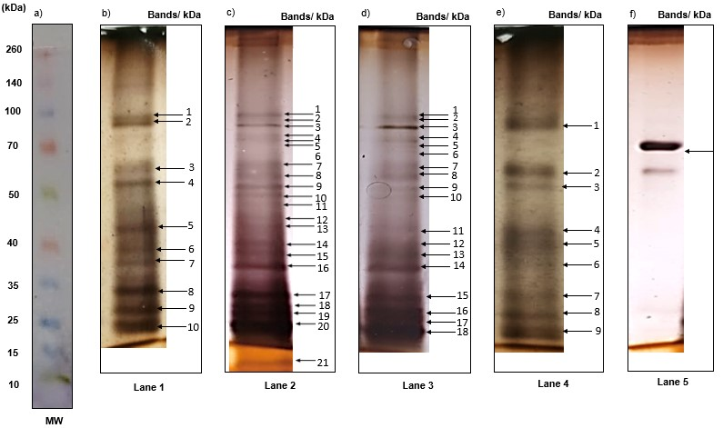
Fig. 2 Silver-stained somatic protein profile of different numbers of adult paramphistomids analysed by SDS-PAGE and their corresponding protein concentration. MW presents the molecular weight standards; lane 1 (500 µg/mL, n = 10); lane 2 (726.5 µg/mL, n = 20); lane 3 (1979.5 µg/mL, n = 30); lane 4 (2000 µg/mL, n = 50) and lane 5 (bovine albumin 250 μg/mL)

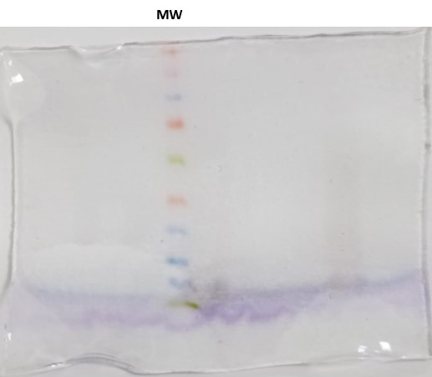

Fig. 2 (a) MW presents molecular weight standards in the range of 10–260 kDa. MW (MW in Fig. 2)

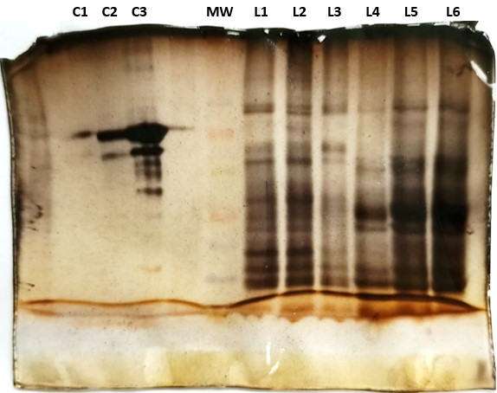
Fig. 2 (b, e) Silver-stained somatic protein profile of different numbers of adult paramphistomids analysed by SDS-PAGE. L1 (n = 10 paramphistomids); L2 (n = 20 paramphistomids); L3 (n = 50 paramphistomids); L4 (n = 10 paramphistomids, different sample); L5 and L6 (n = 20 paramphistomids, different sample); C1 (bovine albumin 125 μg/mL); C2 (bovine albumin 250 μg/mL); C3 (bovine albumin 500 μg/mL); MW presents the molecular weight standards. L1 (500 µg/mL, lane 1 in Fig. 2) and L3 (2000 µg/mL, lane 4 in Fig. 2)

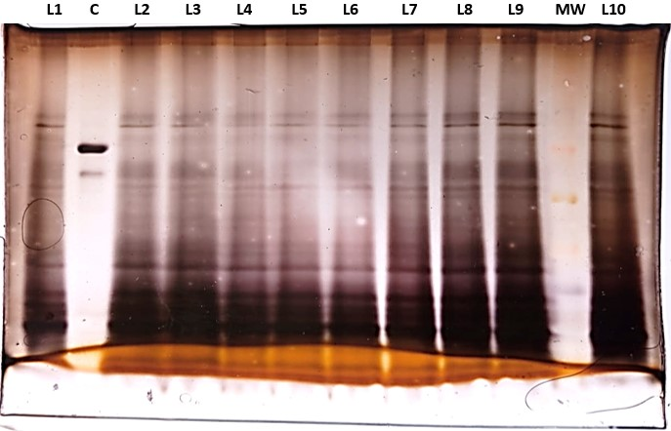
Fig. 2 (c, f) Silver-stained somatic protein profile of twenty adult paramphistomids analysed by SDS-PAGE. L1-L10 (n = 20 paramphistomids, different samples), C (bovine albumin), MW presents the molecular weight standards. L7 (726.5 µg/mL, lane 2 in Fig. 2) and C (250 μg/mL lane 5 in Fig. 2)

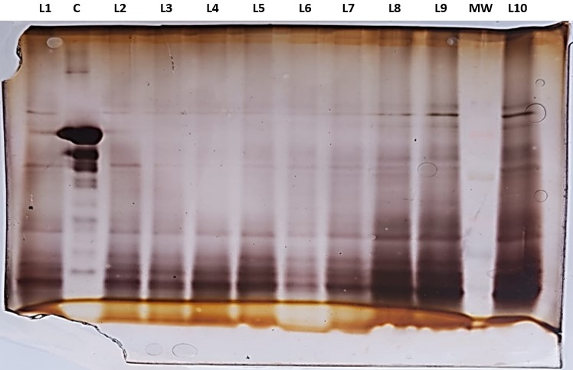
Fig. 2 (d) Silver-stained somatic protein profile of twenty and thirty adult paramphistomids analysed by SDS-PAGE. L1-L7 (n = 20 paramphistomids, different samples), L8-L10 (n = 30 paramphistomids, different samples), C (bovine albumin 500 μg/mL), MW presents the molecular weight standards. L9 (1979.5 µg/mL, lane 3 in Fig. 2)

