Supplementary Information for “Single-photon dual-comb ghost imaging spectroscopy”

Daowang Peng¹, Liang Mei^{1,}*, Zhenfeng Gong¹, Zhong Zuo², Zhiwei Liu³, Yuanfeng Di⁴, Xu Liu³, Chenglin Gu⁵,Wenxue Li⁵ & Guofeng Yan^{3,}*

¹School of Optoelectronic Engineering and Instrumentation Science, Dalian University of Technology, Dalian 116024, China
²State Key Laboratory of Magnetic Resonance and Atomic and Molecular Physics, Wuhan Institute of Physics and Mathematics, Innovation Academy for Precision Measurement Science and Technology, Chinese Academy of Sciences, Wuhan 430071, China.
³Research Center for Novel Computing Sensing and Intelligent Processing, Zhejiang Laboratory, Hangzhou 311121, China.
⁴Shanghai Nanyang Model High School, Shanghai 200032, China.
⁵State Key Laboratory of Precision Spectroscopy, East China Normal University, Shanghai 200062, China.

*e-mail: meiliang@dlut.edu.cn; yanguofeng@zhejianglab.com.

Supplementary Information note 1: Supplementary data of single-photon dual comb ghost imaging spectroscopy (DC-GIS) based on a single electro-optic (EO) dual-comb system.
- Theoretical derivation of the dual-comb matrix using the single EO dual-comb system
The single EO dual-comb system enables the controlling over the intensity of each spectral tooth by the driving waveform of an arbitrary waveform generator (AWG). The driving waveform $w(t)$ is defined by the sum of two optical frequency combs (OFCs) with slightly different repetition rates^{1,2},
$$\begin{aligned}w\left(t\right)=\sum_{i}{\sum_{n}{A_{n,i}\cos\left[2π\left(nf_{r,i}+f_{0,i}\right)t+ϕ_{n,i}\right]}}\#\left(1\right)\end{aligned}$$
where $i=1, 2$ and $n$ are the indices of the combs and the OFC’s lines; $A_{n,i}$ and $ϕ_{n,i}$ are the amplitude and phase of the corresponding wave, respectively; $f_{r,i}$ and $f_{0,i}$ are the repetition rate and the frequency of the first tooth of the $i$-th comb, respectively. The intensity signal $I(t)$ of the seed CW modulated by the electro-optic modulator (EOM) is expressed by
$$\begin{aligned}I\left(t\right)=w^{2}\left(t\right)∝A_{n,1}A_{n,2}\cos\left[2π\left(n∆f_{r}+∆f_{0}\right)t+∆ϕ_{n}\right]\#\left(2\right)\end{aligned}$$
where $∆f_{r}=f_{r,1}-f_{r,2}$, $∆f_{r}=f_{0,1}-f_{0,2}$ and $∆ϕ_{n}=ϕ_{n,1}-ϕ_{n,2}$. Therefore, this system can generate a mode-resolved spectrum in radio-frequency domain, similar to that of a dual-comb system composed of two OFCs with slightly different repetition rates. In this way, the intensity of each tooth $A_{n,i}$ can been defined by the driving waveform $w(t)$ to generate different spectral patterns for DC-GIS. It is worth mentioned that in this experiment, the phase relationship $ϕ_{n}$ between the comb teeth was nonlinear and set to $ϕ_{n}=\tan{n^{2}}$, where $ϕ_{n}=ϕ_{n,1}=ϕ_{n,2}$. Figure S1 compares time-domain signals under linear and nonlinear phase relationships, with simulated parameters detailed in Table S1. Under the linear phase relationship of $ϕ_{n}=0$, the coherent superposition of multiple frequency modes leads to strong centerbursts appearing on the interferogram, as shown as the Fig. S1a. The peak-to-average intensity ratio (PAPR) of the interferogram is 24.08 dB, which is defined as the ratio of the peak intensity to the average intensity. On the contrary, the temporal signal of the nonlinear phase relationship is similar to a disordered noise signal, as shown in Fig. S1b, where the PAPR is as low as 12.85 dB. In the single EO dual-comb scheme, a lower PAPR value enhances the accuracy of the driving waveform and the output intensity of the dual-comb source, due to the limited vertical resolution of the AWG^{1,3}.
Table S1. Simulated parameters in Figure S1.
Center wavelength | Number of teeth | Amplitude of teeth | Sampling rate
1550 nm | 64 | 1 | 32 GSa/s
$$f_{r,1}$$ | $$f_{r,2}$$ | $$f_{0,1}$$ | $$f_{0,2}$$
124.8 MHz | 125 MHz | 7 GHz | 7.03 GHz
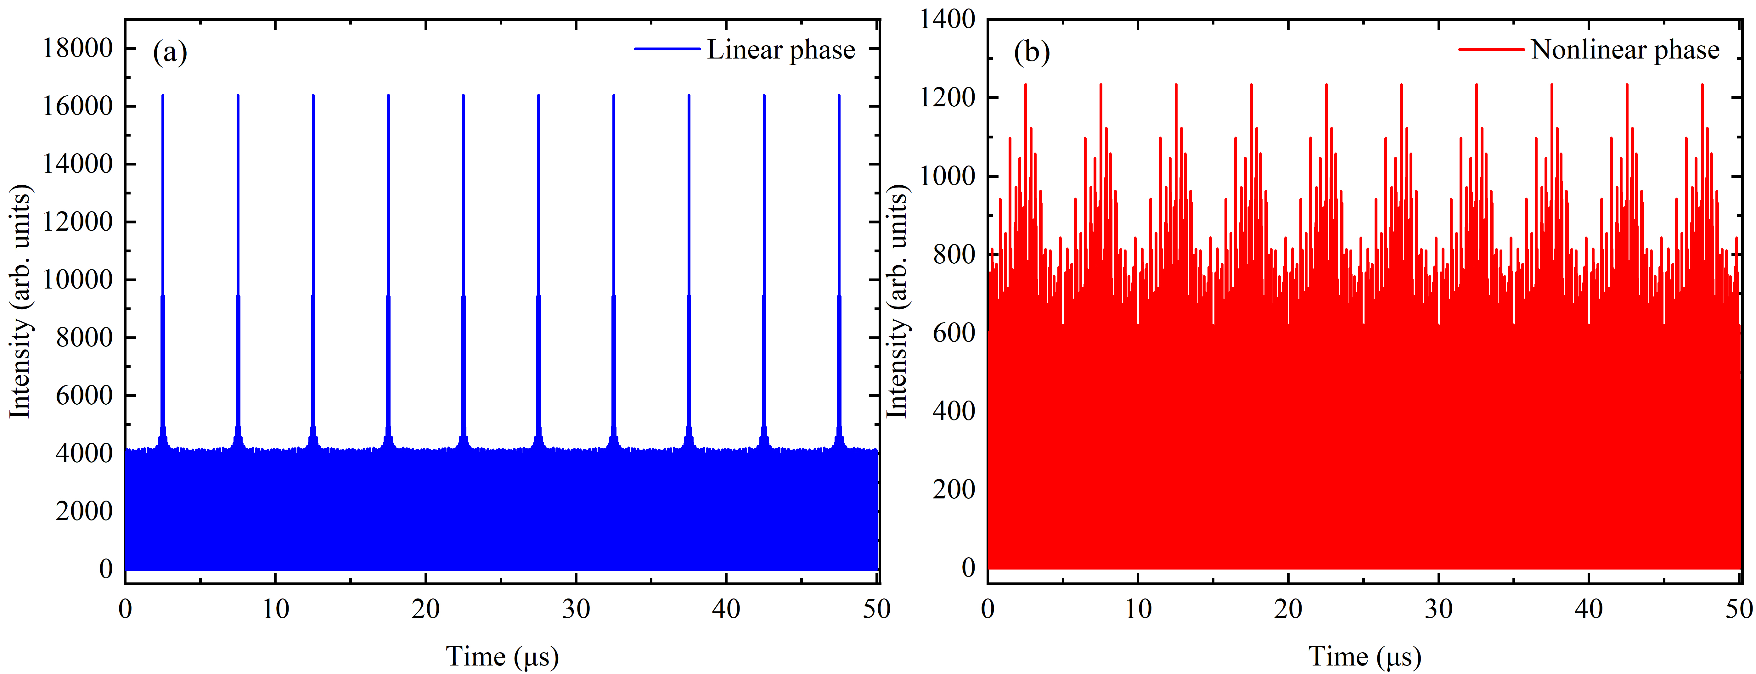
Fig. S1 Comparison of time-domain waveforms under linear and nonlinear phase relationships. a Time-domain signal of the dual-comb interferogram with the linear phase relationship between comb teeth. b Time-domain signal of the dual-comb interferogram with the nonlinear phase relationship between comb teeth.
Based on the single EO dual-comb scheme, we realized the dual-comb matrix for ghost imaging spectroscopy. The amplitudes $A_{n,1}=A_{n,2}$ ($n=1,2,3,⋯,N$) of the dual-comb source are sequentially coded as the elements of the row array of the $2N×N$ matrix shown in Fig. 2a, which is a binary matrix consisting of $[\frac{H_{N×N}+1}{2};1-\frac{H_{N×N}+1}{2}]$ ($H_{N×N}$ is the $N×N$ Hadamard matrix and $N$ is the number of frequency teeth). The temporal amplitude waveforms corresponding to different dual-comb spectral patterns are stitched together and output by the AWG to drive the EOM. The duration of the stitched waveform is 0.64 ms, as shown in Fig. S2a. The CW laser centered at 1550 nm is modulated by an EOM, where the driving signal is played in a loop by an AWG with a sampling rate of 32 GSa/s, a vertical resolution of 8 bits and a voltage amplitude of 1 V. The modulated signal is detected, bandpass filtered, and then sampled by a data acquisition card, as shown in Fig. S2b. The time-domain signal within the pink area in the figure consists of a dual-comb spectrum encoded with “1”, while the gray area represents the signal encoded with “0”. As a result, the measured dual-comb signals exhibit higher and lower offsets, respectively.
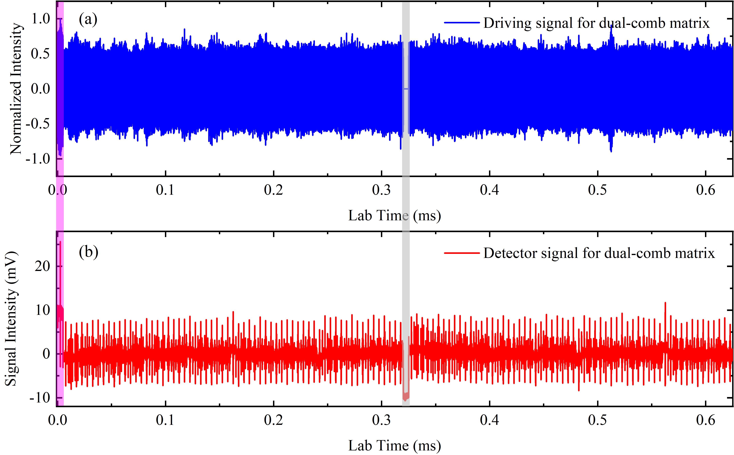
Fig. S2 Driving and detected signals for the dual-comb matrix. a Driving signal for the dual-comb matrix during a 0.64-ms period. The signal consists of the time-domain sum of 128 sets of dual-comb spectra. b Detected signal for the dual-comb matrix during a 0.64-ms period. The CW laser is modulated by an EOM with a driving signal as shown in Fig. S2a. The modulated signal is detected by an InGaAs photodetector and filtered by a 0-78 MHz lowpass filter.
- Generation of the dual-comb matrix using the single EO dual-comb system
DC-GIS requires encoding the dual-comb spectrum to generate a structured spectral matrix for ghost imaging calculations. In the early work by Nathalie Picqué¹ and Miguel Soriano-Amat^{3,4}, dual-comb systems based on a single EOM have been applied to fingerprint spectral detection and fiber sensing. According to theoretical derivations mentioned above in this work, the dual-comb matrix can be achieved by modulating a CW laser with different amplitude waveforms. In our experiment, an AWG repeatedly plays the driving waveforms as shown in Fig. S2a into an EOM to modulate the output of the CW laser. The output voltage of the AWG is set as 1 V, and the actual peak-to-peak voltage of the electrical waveform is about 0.7 V. The DC bias voltage of the EOM is locked at the point of the minimum transmitted intensity with about 4 μW. Figure S3a shows the spectrum of dual-comb system directly measured by a spectrometer (YOKOGAWA, AQ6370D) with a resolution of 0.02 nm. It is obvious that waveform modulation causes sidebands on both sides of the CW center wavelength. To avoid aliasing in dual-comb multiheterodyne beating, a tunable optical filter (SANTEC, OTF-980) is used to filter out the spectral sideband at long wavelengths. The filtered spectrum is shown in Fig. S3b, where the residual optical intensity from the seed CW is greatly attenuated to prevent the potential influence on the photon-counting signal. The optical intensity after filtered by the tunable optical filter is ~0.4 μW.
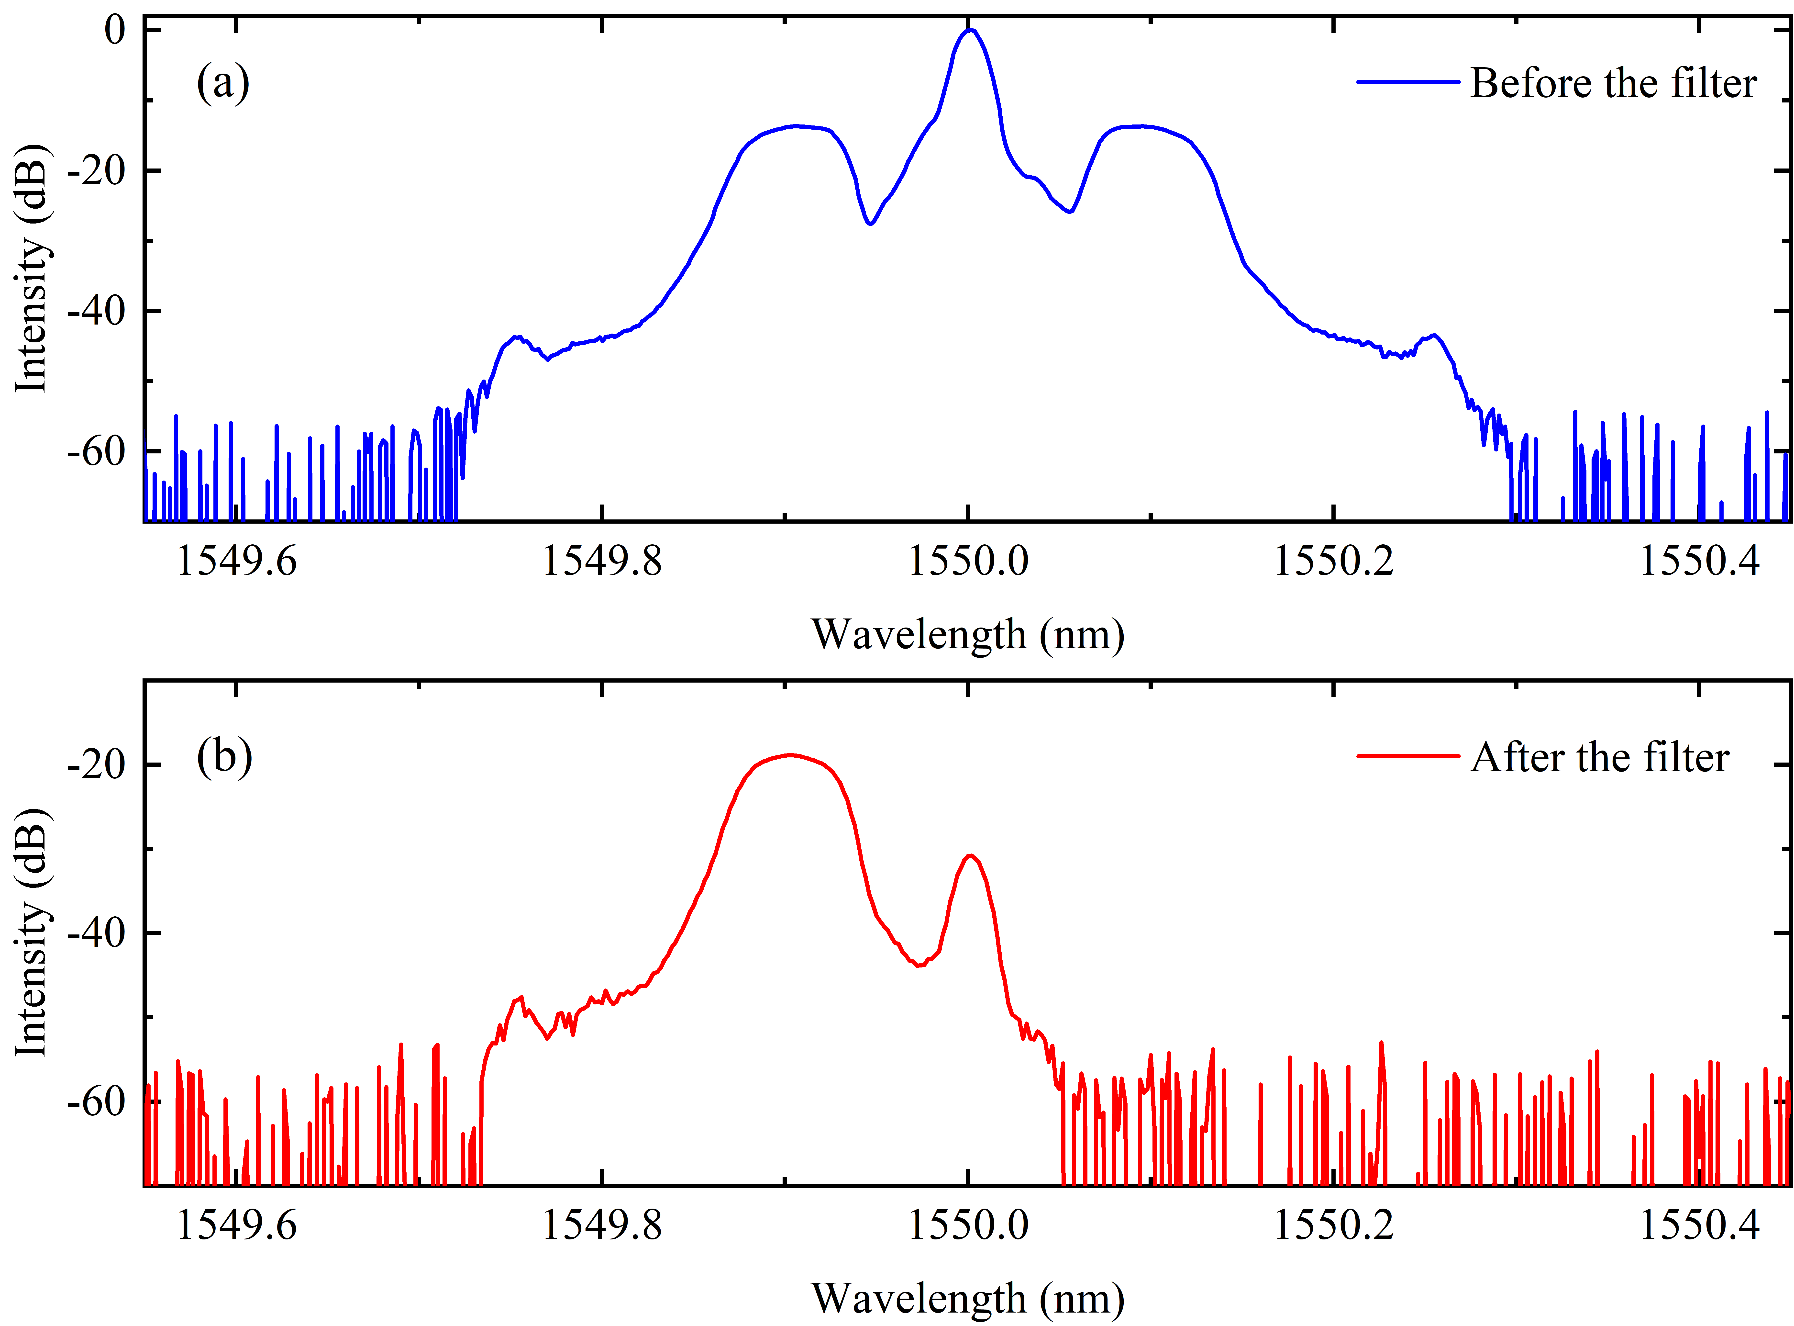
Fig. S3 Spectra of the dual-comb system. a Spectrum of the single EO dual-comb system directly measured by a spectrometer. b Measured spectrum after a tunable optical filter to avoid aliasing.
Supplementary Information note 2: Method of dual-comb ghost imaging spectroscopy.
The ghost imaging technique, which has been widely employed in single-pixel imaging, open-path detection and extreme wavelength detection¹¹⁻¹³, leverages the correlation between the intensity of a reference beam and a measured beam to reconstruct the image of a target object. Currently, this powerful technology has been expanded to perform time-domain and frequency-domain imaging of objects. In time domain, temporal ghost imaging has been developed to reconstruct the time-domain transfer function of an object, effectively enabling the capture of time-dependent changes⁸. In frequency domain, the ghost imaging technique can directly calculate the response spectrum of a target by collecting the intensity information after the sample at the measuring end with a single-pixel detector, allowing for spectral analysis in open path⁹⁻¹¹. However, the spectral resolution of the current ghost imaging technique is limited to sub-nanometer level within a few minutes of measurement time even under photon-rich scenarios.
Dual-comb spectroscopy (DCS), utilizing two optical frequency combs with slightly different repetition rates, can provide high-speed, high-resolution and high-precision broadband spectral measurements. In photon-deficient scenarios with picowatt-level light, DCS has also to accumulate photon distributions from discrete photon-counting signals in time domain to reconstruct the dual-comb interferogram. Although a high spectral resolution down to 100 MHz can be achieved, the statistical reconstruction process is time consuming.
In this work, we, for the first time, proposes dual-comb ghost imaging spectroscopy (DC-GIS) for high-speed high-resolution spectral measurements specifically in photon-scarce regime by combining the ghost imaging technique and DCS.
- Theory of dual-comb ghost imaging spectroscopy (DC-GIS).
The DC-GIS scheme is a crucial means for achieving high-speed and high-resolution spectral analysis at the single-photon level. The method of obtaining the dual-comb matrix has been explained in the previous Supplementary Information note 1. We now discuss how to reconstruct the response spectrum $T(ω)$ of a sample based on ghost imaging and DCS. For the i-th measurement of spectral pattern $S_{i}(ω)$ with a duration of a dual-comb interferogram, the measurement signal $I_{i}$ is the integral value of the spectral intensity after interacted by the response spectrum $T(ω)$,
$$\begin{aligned}I_{i}=\int{S_{i}\left(ω\right)T\left(ω\right)}dω\#\left(3\right)\end{aligned}$$
Due to the mode-resolved characteristics of the dual-comb system, the above equation can be rewritten as
$$\begin{aligned}I_{i}=\sum_{n=1}^{N}{S_{i}\left(n∆f_{r}+∆f_{0}\right)T\left(n∆f_{r}+∆f_{0}\right)}\#\left(4\right)\end{aligned}$$
where $n=1,2,3,⋯,N$ is the index of the frequency tooth, ${∆f}_{r}$ and ${∆f}_{0}$ denote the difference of repetition rates and the frequency difference between the first tooth of two optical combs, respectively. The signal $I_{i}$ contains information about the response spectrum $T$, but does not allow for resolving the spectrum. Matrix operations are used to represent the ghost-imaging sampling for the M-pattern dual-comb spectra, $I=ST$, where the measurement matrix $I=[I_{1};I_{2};I_{3};⋯;I_{N}]$ and the dual-comb matrix $S=\left[\begin{matrix}S_{1,1} & ⋯ & S_{N,1} \\ ⋮ & ⋱ & ⋮ \\ S_{1,M} & ⋯ & S_{N,M}\end{matrix}\right]$. The row vectors of $S$ are the dual-comb spectral patterns. The spectral vector $T$ can be reconstructed through matrix inversion $T=S^{-1}I=S^{-1}ST$, if the dual-comb matrix $S$ is invertible as $S^{-1}$. For example, for the classical orthogonal Hadamard matrix $H_{N×N}$, there exists the following relationship $H_{N×N}^{T}H_{N×N}=H_{N×N}H_{N×N}=NE_{N×N}$, where the superscript $T$ indicates transposition operation and $E_{N×N}$ denotes the N-order identity matrix. However, the Hadamard matrix consists of only -1 and +1 elements, which cannot be achieved in optical systems. In this study, we decompose the Hadamard matrix into two N×N matrices consisting of only 0 and 1 elements as shown in Fig. 2a,
$$\begin{aligned}\left\{\begin{matrix}H_{N×N}^{+}=\frac{H_{N×N}+1}{2} \\ H_{N×N}^{-}=1-H_{N×N}^{+}\end{matrix} \right.\#\left(5\right)\end{aligned}$$
In this way, the orthogonal matrix can be obtained by $H_{N×N}=H_{N×N}^{+}-H_{N×N}^{-}$. Thus, we use two complementary sets of measurement matrices consisting of 0 and 1 elements to encode the dual-comb spectrum as the dual-comb matrix. This scheme doubles the measurement time of ghost imaging. The additional noise $A_{N×N}^{n}$ in the measurement can be expressed as the noise in the measurement matrix¹¹,
$$\begin{aligned}\left\{\begin{matrix}H_{N×N}^{+^{'}}=H_{N×N}^{+}+A_{N×N}^{n} \\ H_{N×N}^{-^{'}}=H_{N×N}^{-}+A_{N×N}^{n}\end{matrix} \right.\#\left(6\right)\end{aligned}$$
The noise can be greatly suppressed during the reconstruction process of DC-GIS. We theoretically analyzed the impact of using two encoding matrices $S_{N×N}=H_{N×N}^{+}$ and $S_{2N×N}=[H_{N×N}^{+};H_{N×N}^{-}]$ on the reconstruction results of DC-GIS. Figure S4a compares the simulated DC-GIS spectra encoding by the $S_{N×N}$ (the red-dot line) and $S_{2N×N}$ (the blue line) matrices with the absorption signal under ideal noise-free conditions. Without noise interference, DC-GIS can perfectly reconstruct the absorbed signal through these two encoding matrices. Furthermore, we compare DC-GIS spectra based on different matrices with the absorption signal in Fig. S4b, where both encoding matrices have been added with random noise with an intensity of 5%. The spectrum (the blue line) can be reconstructed without noise by the dual-comb matrix of $S_{2N×N}$, while there is about 9% error between the spectrum (the red-dot line) based on the matrix $S_{N×N}$ and the absorption signal (the black line). Therefore, this result has fully demonstrated the necessity of the $S_{2N×N}=[H_{N×N}^{+};H_{N×N}^{-}]$ matrix for high-SNR DC-GIS.
Fig. S4 Simulation of dual-comb ghost imaging spectroscopy (DC-GIS). a Comparison of ghost imaging spectra and the absorption signal based on different dual-comb matrices under ideal noise-free condition. b Comparison of ghost imaging spectra and the absorption signal based on different dual-comb matrices under random noise condition. c Background spectrum (black line) and absorption spectrum (blue line) from ghost-imaging calculations. d Normalized absorption spectrum removing the background spectrum, and the red-dot line is the absorption signal for comparison.
Additionally, it is necessary to consider the impact of non-ideal dual-comb matrix on the DC-GIS experiment. Limited by the bandwidth of EOM and the vertical resolution of AWG^{1,2}, the dual-comb system based on a single EOM has a background spectral shape. This can be compensated by measuring the background spectrum without the sample. The DC-GIS spectra with and without the absorption sample are shown in the blue and black curve in Fig. S4c, respectively. The DC-GIS spectrum without the absorption sample can be regarded as the background spectrum for normalizing the absorption signal. The blue line in Fig. S4d is the normalized spectrum removing the background spectrum, which is highly consistent with the absorption signal (the red-dot line in Fig. S4d), indicating the feasibility of the scheme.
- Single-photon dual-comb ghost imaging spectroscopy.
Optical signals with extremely low power appear in discrete photon states, so traditional DCS requires a large number of repeated measurements to obtain continuous interferogram in time domain^{14,15}. Single-photon DC-GIS utilizes ghost-imaging technique to directly reconstruct the high-resolution dual-comb spectrum of extremely weak light at the femto-watt level through the “low-dimensional” photon-counting signal. In single-photon DC-GIS scheme, a single-photon detector is used to count the number of photons within each period of the dual-comb pattern, which includes the absorption information without spectral resolution. For the $i$-th tooth with an intensity $I_{i}$, the photon count ($n_{i}$) recorded by the SPAD is proportional to the light intensity ($n_{i}∝I_{i}$). To some extent, the photon-counting signal is equivalent to the intensity information. Therefore, the photon-counting signal can be used to reconstruct high-resolution ghost-imaging spectra.
In present experiments, the detector catches discrete photon counts. The matrix equation of single-photon DC-GIS can be expressed as $T=SP$, where $T$ is the matrix representing the response spectrum, $S$ is the dual-comb matrix and $P=\left[P_{1};P_{2};P_{3};…;P_{N}\right]$ is the matrix representing the photon-counting signal. It is worth noting that the ghost-imaging reconstruction is based on a few-photon signal. In a photon counting rate of 1×10⁵ photons/s and a dual-comb refresh rate of 200 kHz, an average of only 0.5 photons are collected in each dual-comb pattern, which means that the few-photon signal measured in a single cycle has a poor SNR in absorption information. The number of photons recorded by the detector follows a Poisson distribution, the SNR of the photon-counting statistics is given by ${SNR}_{PC}=\sqrt{n_{pr}t}$, where $n_{pr}$ is photon-counting rate and $t$ is the measurement time¹⁶. The dark count of the detector (~800 photons/s) is much less than the photon-counting rate and thus can be neglected in the SNR formula. The SNR of photon-counting signal scales with the square root ratio of the measurement time. It is feasible to increase the measurement time to accumulate sufficient SNR for the photon-scarce scenarios, which can be verified from the experimental data shown in Fig. 3d and 3e.
- Signal-to-noise ratio (SNR) of single-photon DC-GIS.
In this section, we theoretically explore the noise characteristics of the single-photon DC-GIS scheme, which is distinct from other single-photon techniques. In this paper, we primarily consider the additional inevitable noise introduced by both the measurement arm and the reference arm. Therefore, the reconstruction equation of DC-GIS can be rewritten as
$$\begin{aligned}T_{DC-GIS}=\left(S+n^{r}\right)\left(P+n^{m}\right)=SP+Sn^{m}+n^{r}P+n^{r}n^{m}\#\left(7\right)\end{aligned}$$
where $n^{r/m}$ is the additional noise of the reference/measurement arm. By expanding the above equation using matrix elements, we can obtain the following equation,
$$T_{DC-GIS}=\left[\begin{matrix}S_{11}P_{1}+S_{12}P_{2}⋯S_{1N}P_{N} \\ S_{21}P_{1}+S_{22}P_{2}⋯S_{2N}P_{N} \\ \begin{matrix}⋮ \\ S_{M1}P_{1}+S_{M2}P_{2}⋯S_{MN}P_{N}\end{matrix}\end{matrix}\right]+\left[\begin{matrix}S_{11}n_{1}^{m}+S_{12}n_{2}^{m}⋯S_{1N}n_{N}^{m} \\ S_{21}n_{1}^{m}+S_{22}n_{2}^{m}⋯S_{2N}n_{N}^{m} \\ \begin{matrix}⋮ \\ S_{M1}n_{1}^{m}+S_{M2}n_{2}^{m}⋯S_{MN}n_{N}^{m}\end{matrix}\end{matrix}\right]$$
$$\begin{aligned}+\left[\begin{matrix}n_{11}^{r}P_{1}+n_{12}^{r}P_{2}⋯n_{1N}^{r}P_{N} \\ n_{21}^{r}P_{1}+n_{22}^{r}P_{2}⋯n_{2N}^{r}P_{N} \\ \begin{matrix}⋮ \\ n_{M1}^{r}P_{1}+n_{M2}^{r}P_{2}⋯n_{MN}^{r}P_{N}\end{matrix}\end{matrix}\right]+\left[\begin{matrix}n_{11}^{r}n_{1}^{m}+n_{12}^{r}n_{2}^{m}⋯n_{1N}^{r}n_{N}^{m} \\ n_{21}^{r}n_{1}^{m}+n_{22}^{r}n_{2}^{m}⋯n_{2N}^{r}n_{N}^{m} \\ \begin{matrix}⋮ \\ n_{M1}^{r}n_{1}^{m}+n_{M2}^{r}n_{2}^{m}⋯n_{MN}^{r}n_{N}^{m}\end{matrix}\end{matrix}\right]\#\left(8\right)\end{aligned}$$
In the above equation, the first term represents the ideal noise-free DC-GIS signal, the second and third terms account for the noise introduced by the ghost imaging reconstruction algorithm in the measurement arm and the reference arm, respectively, and the final term describes the noise coupling effect between the measurement arm and the reference arm. The second term indicates that the noise signal of the measuring arm has been weighted by a dual-comb matrix, while the third term shows that the noise of the reference arm is weighted by the photon-counting signal of the measurement arm.
Referring to the processing method of additive noise¹⁷⁻²⁰, the SNR of single-photon DC-GIS can be derived
$$\begin{aligned}{SNR}_{DC-GIS}=\frac{1}{\sqrt{\frac{1}{{SNR}_{PC}^{2}}+\frac{1}{{SNR}_{DCS}^{2}}+\frac{β}{{SNR}_{PC}^{2}*{SNR}_{DCS}^{2}}}}\#\left(9\right)\end{aligned}$$
where ${SNR}_{PC}$ is the SNR of the photon-counting signal, ${SNR}_{DCS}$ is the SNR of the dual-comb signal in the reference arm, and the constant $β$ is the noise coupling factor between DCS and the photon-counting signal. The noise of the reference signal detected by DCS can be expressed by the following equation^{21,22},
$$\begin{aligned}{SNR}_{DCS}=\frac{0.8\sqrt{T}}{N\sqrt{α_{DCS}}}\#\left(10\right)\end{aligned}$$
where $T$ is the measurement time, $N$ is the number of the OFC teeth, the noise coefficient $α_{DCS}=α_{NEP}+α_{shot}+α_{RIN}+α_{range}$ is the sum of the noise equivalent power ($α_{NEP}$) including all additive noise terms up to the digitization of the signal, the shot noise ($α_{shot}$), the relative intensity noise ($α_{RIN}$) and the detector dynamic range ($α_{range}$). According to measurement data in our experiments, the noise coefficient is estimated to be about 1.56×10⁻⁸. When the photon-counting statistics follows the Poisson distribution, the quantum-noise-limited SNR of the photon-counting signal is given by^{14,16}
$$\begin{aligned}{SNR}_{PC}=\frac{n_{signal}}{\sqrt{n_{signal}}}=\sqrt{n_{pr}T}\#\left(11\right)\end{aligned}$$
where $n_{signal}$ is the photon-counting number corresponding to the signal intensity, $n_{pr}$ is the photon-counting rate (in photons/s), and $T$ is the measurement time. By substituting Eq. (10) and Eq. (11) into Eq. (9), the SNR of single-photon DC-GIS can be expressed as follows:
$$\begin{aligned}{SNR}_{DC-GIS}=\frac{T}{\sqrt{\left(\frac{α_{DCS}N^{2}}{0.64}+\frac{1}{n_{pr}}\right)T+\frac{βα_{DCS}N^{2}}{0.64n_{pr}}}} \#\left(12\right)\end{aligned}$$
Fig. S5 Signal-to-noise ratio (SNR) in single-photon DC-GIS. a SNR for single-photon DC-GIS versus the measurement time. The red-dash and blue-dash lines are asymptotes with the slopes of 1 and 1/2, respectively. b SNR for single-photon DC-GIS versus the photon-counting rate with a measurement time of 1000 s. The red-dash line is an asymptote with a slope of 1/2, and the blue-dash line remains constant.
Based on the above analysis, we have performed theoretical simulations of the SNR in single-photon DC-GIS, where the simulation parameters are consistent with the experimental parameters ($n_{pr}=5×{10}^{5}$, $N=64$, $α=1.56×{10}^{-8}$). The noise coupling factor $β=4×{10}^{4}$ is obtained by fitting the SNR curve of $n_{pr}=5×{10}^{5}$ in Figure 4. Figure S5a shows the simulated SNR curve (the black line) as a function of measurement time $T$. Within a short measurement time ($T≪\frac{βα_{DCS}N^{2}}{βα_{DCS}{n_{pr}N}^{2}+0.64}$), the SNR of single-photon DC-GIS varies linearly with the measurement time, as indicated by the red dashed asymptote,
$$\begin{aligned}{SNR}_{DC-GIS}=\frac{T}{N} \sqrt{\frac{0.64n_{pr}}{βα_{DCS}}}\#\left(13\right)\end{aligned}$$
When the measurement time is long enough to satisfy $T≫\frac{βα_{DCS}N^{2}}{βα_{DCS}n_{pr}N^{2}+0.64}$, the SNR would be proportion to the square root of the measurement time as shown by the blue-dash asymptote,
$$\begin{aligned}{SNR}_{DC-GIS}=\frac{\sqrt{T}}{\sqrt{\frac{α_{DCS}N^{2}}{0.64}+\frac{1}{n_{pr}}}} \#\left(14\right)\end{aligned}$$
If $n_{pr}≫\frac{0.64}{α_{DCS}N^{2}}$, Eq. (12) can be further simplified as
$$\begin{aligned}{SNR}_{DC-GIS}=\frac{0.8\sqrt{T}}{N\sqrt{α_{DCS}}} \#\left(15\right)\end{aligned}$$
Clearly, the SNR of DC-GIS approaches the SNR of a classic DCS, implying that the SNR of the photon-counting spectrum can be significantly improved through the correlation calculation with the dual-comb spectrum based on the ghost imaging method. According to the discussion above, increasing the measurement time is an effective way to improve the SNR in the photon-scarce scenarios.
We have further analyzed the relationship between the SNR of single-photon DC-GIS and light power (the photon-counting rate). Equation (12) can be rewritten as,
$$\begin{aligned}{SNR}_{DC-GIS}=\sqrt{\frac{n_{pr}}{\frac{α_{DCS}N^{2}}{0.64T}n_{pr}+\left(\frac{1}{T}+\frac{βα_{DCS}N^{2}}{0.64T^{2}}\right)}} \#\left(16\right)\end{aligned}$$
Figure S5b shows the SNR (the black line) of single-photon DC-GIS versus the photon-counting rate (photons/s) with a measurement time of 1000 s. In photon-scarce scenarios with low photon-counting rates, the SNR of single-photon DC-GIS scales with the square root of the photon-counting rate ($\sqrt{n_{pr}}$), as shown by the red-dash asymptote and Eq. (16). As the photon-counting rate continues to increase, the achievable SNR within the same measurement time tends to a constant as shown by the blue-dash asymptote in Fig. S5b, which explains the phenomenon shown in Figure 4 of the main text that the SNR of single-photon DC-GIS is independent of photon counting rate when the measurement time exceeds a certain value.
Supplementary Information note 3: Experimental setup of single-photon DC-GIS based on the broadband dual-comb system
In this paper, we proposed and demonstrated single-photon DC-GIS under extremely weak light conditions at the sub-picowatt level with several-picometer spectral resolution and millisecond-level measurement time, which can be applied in fingerprint spectral analysis and ultra-long-distance fiber sensing. As a demonstration, a single EO dual-comb system is used to output the dual-comb matrix and excite the molecular response at the photon level within a narrow spectral range. This scheme can be easily extended to photon-level broadband precision spectroscopy based on the fiber OFCs.
In this section, we propose a broadband dual-comb encoding method based on spatial-frequency domain transformation^{23,24} for single-photon DC-GIS, and the experimental setup is shown in Fig. S6. In this scheme, two OFCs with slightly different repetition rates are combined by a beam splitter (BS), and sequentially pass through polarization beam splitter (PBS) and a quarter wave plate (λ/4). Then, the light is focused by a cylindrical lens (L1) to a virtual imaging phase array (VIPA), which is dispersed into a one-dimensional spectral array. A vertically positioned grating further disperses the dual-comb signal into a two-dimensional array of spectral pixel points. A digital micro-mirror device (DMD) can control the reflectivity of each pixel, guiding light back to the PBS for reflection and output. The DMD is composed of hundreds of thousands of tiltable micro-mirrors, whose tilt angles can be controlled at high speeds by a computer. The DMD continuously controls the micro-mirrors to obtain the Hadamard patterns in frequency domain, and the duration of each pattern is an integer multiple of the period of the dual-comb interferogram. The dual-comb matrix consisting of Hadamard patterns is attenuated by a variable attenuator (VA) to single-photon level, and loaded by the absorption fingerprint of multiple gas molecules in the sample cell. The absorption signal in photon level is detected by a single-photon avalanche detector (SPAD). The broadband spectrum can be directly reconstructed by ghost-imaging calculation from the dual-comb matrix and the photon-counting signals.
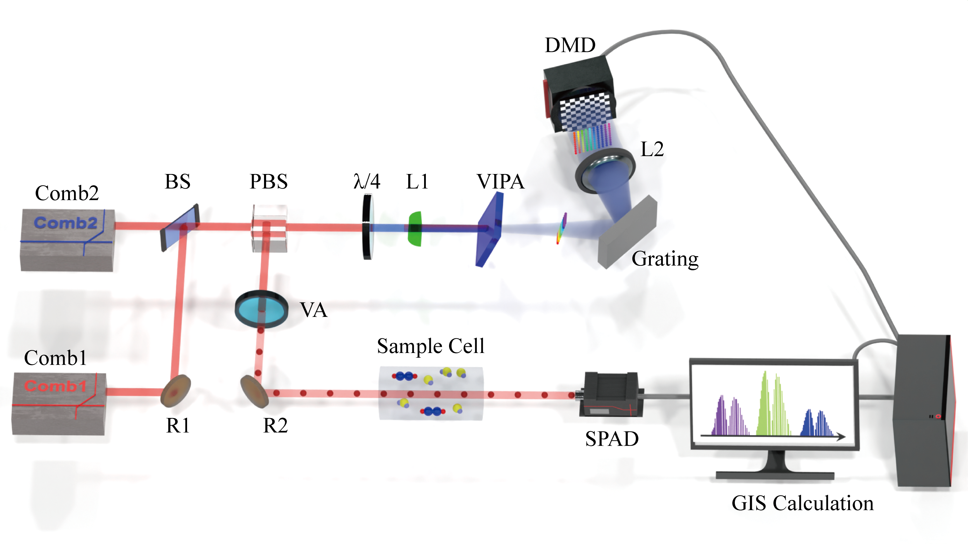
Fig. S6 Detailed schematic for the experimental setup of the broadband single-photon DC-GIS. Comb1 and Comb2: optical frequency comb; R1 and R2: mirror; BS: beam splitter; PBS: polarization beam splitter; λ/4: quarter wave plate; L1: cylindrical lens; VIPA: virtual imaging phase array; L2: lens; DMD: digital micro-mirror device; VA: variable attenuator; SPAD: single-photon avalanche detector; GIS: ghost imaging spectroscopy.
The implementation of broadband DC-GIS is currently under experimental exploration, which is expected to achieve spectral encoding covering several terahertz spectral region. This method paves the way for the measurement of single-photon broadband spectroscopy, which will meet the requirements of broadband precision spectral detection in photon-deficient scenarios, such as high-sensitivity massively parallel sensing of trace molecules and single-molecule spectral analysis.
Reference
- Huh, J. H., Chen, Z., Vicentini, E., Hänsch, T. W. & Picqué, N. Time-resolved dual-comb spectroscopy with a single electro-optic modulator. Opt. Lett. 46(16), 3957-3960 (2021).
- Soriano-Amat, M., Soto, M. A., Duran, V., Martins, H. F., Martin-Lopez, S., Gonzalez-Herraez, M. & Fernández-Ruiz, M. R. Common-path dual-comb spectroscopy using a single electro-optic modulator. J. Lightwave Technol. 38(18), 5107-5115 (2020).
- Soriano-Amat, M., Martins, H. F., Durán, V., Costa, L., Martin-Lopez, S., Gonzalez-Herraez, M. & Fernández-Ruiz, M. R. Time-expanded phase-sensitive optical time-domain reflectometry. Light Sci. Appl. 10(1), 51 (2021).
- Fernández-Ruiz, M. R., Soriano-Amat, M., Durán, V., Martins, H. F., Martin-Lopez, S. & Gonzalez-Herraez, M. Time expansion in distributed optical fiber sensing. J. Lightwave Technol. 41(11), 3305-3315 (2023).
- Gatti, A., Brambilla, E., Bache, M. & Lugiato, L. A. Ghost imaging with thermal light: comparing entanglement and classical correlation. Phys. Rev. Lett. 93(9), 093602 (2004).
- Erkmen, B. I. & Shapiro, J. H. Ghost imaging: from quantum to classical to computational. Adv. Opt. Photonics 2(4), 405-450 (2010).
- Ferri, F., Magatti, D., Lugiato, L. A. & Gatti, A. Differential ghost imaging. Phys. Rev. Lett. 104(25), 253603 (2010).
- Ryczkowski, P., Barbier, M., Friberg, A. T., Dudley, J. M. & Genty, G. Ghost imaging in the time domain. Nat. Photonics 10(3), 167-170 (2016).
- Janassek, P., Blumenstein, S. & Elsäßer, W. Ghost spectroscopy with classical thermal light emitted by a superluminescent diode. Phys. Rev. Appl. 9(2), 021001 (2018).
- Amiot, C., Ryczkowski, P., Friberg, A. T., Dudley, J. M. & Genty, G. Supercontinuum spectral-domain ghost imaging. Opt. Lett. 43(20), 5025-5028 (2018).
- Zhao, J., Liu, F., Tang, Z. & Pan, S. Open-path ghost spectroscopy based on Hadamard modulation. J. Lightwave Technol. 40(21), 7030-7038 (2022).
- Olbinado, M. P., Paganin, D. M., Cheng, Y. & Rack, A. X-ray phase-contrast ghost imaging using a single-pixel camera. Optica 8(12), 1538-1544 (2021).
- Wang, Y., Huang, K., Fang, J., Yan, M., Wu, E. & Zeng, H. Mid-infrared single-pixel imaging at the single-photon level. Nat. Commun. 14(1), 1073 (2023).
- Xu, B., Chen, Z., Hänsch, T. W. & Picqué, N. Near-ultraviolet photon-counting dual-comb spectroscopy. Nature 627(8003), 289-294 (2024).
- Koviri, P., Komori, H., Tian, H., Ishizeki, M., Kato, T., Asahara, A., Ryosuke, S., Thomas, R. S. & Minoshima, K. Single-photon level ultrafast time-resolved measurement using two-color dual-comb-based asynchronous linear optical sampling. Appl. Phys. Express 17(2), 022001 (2024).
- Goodman, J. W. Statistical optics. John Wiley & Sons (2015).
- Bhattacharyya, S. S., Deprettere, E. F., Leupers, R. & Takala, J. (Eds.). Handbook of signal processing systems. New York: Springer (2013).
- Ziemer, R. Error probabilities due to additive combinations of Gaussian and impulsive noise. IEEE Trans. Commun. Technol. 15(3), 471-474 (1967).
- Saritas, E. U., Lee, J. H. & Nishimura, D. G. SNR dependence of optimal parameters for apparent diffusion coefficient measurements. IEEE Trans. Med. Imaging 30(2), 424-437 (2010).
- Triantafyllou, C., Polimeni, J. R. & Wald, L. L. Physiological noise and signal-to-noise ratio in fMRI with multi-channel array coils. Neuroimage 55(2), 597-606 (2011).
- Newbury, N. R., Coddington, I. & Swann, W. Sensitivity of coherent dual-comb spectroscopy. Opt. Express 18(8), 7929-7945 (2010).
- Coddington, I., Swann, W. C. & Newbury, N. R. Coherent dual-comb spectroscopy at high signal-to-noise ratio. Phys. Rev. A 82(4), 043817 (2010).
- Hase, E., Minamikawa, T., Mizuno, T., Miyamoto, S., Ichikawa, R., Hsieh, Y. D., Shibuya, K., Sato, K., Nakajima, Y., Asahara, A., Minoshima, K., Mizutani, Y., Iwata, T., Yamamoto, H., Yasui, T. & Yasui, T. Scan-less confocal phase imaging based on dual-comb microscopy. Optica 5(5), 634-643 (2018).
- Wang, C., Deng, Z., Gu, C., Liu, Y., Luo, D., Zhu, Z., Li, W. & Zeng, H. Line-scan spectrum-encoded imaging by dual-comb interferometry. Opt. Lett. 43(7), 1606-1609 (2018).

