Supplementary material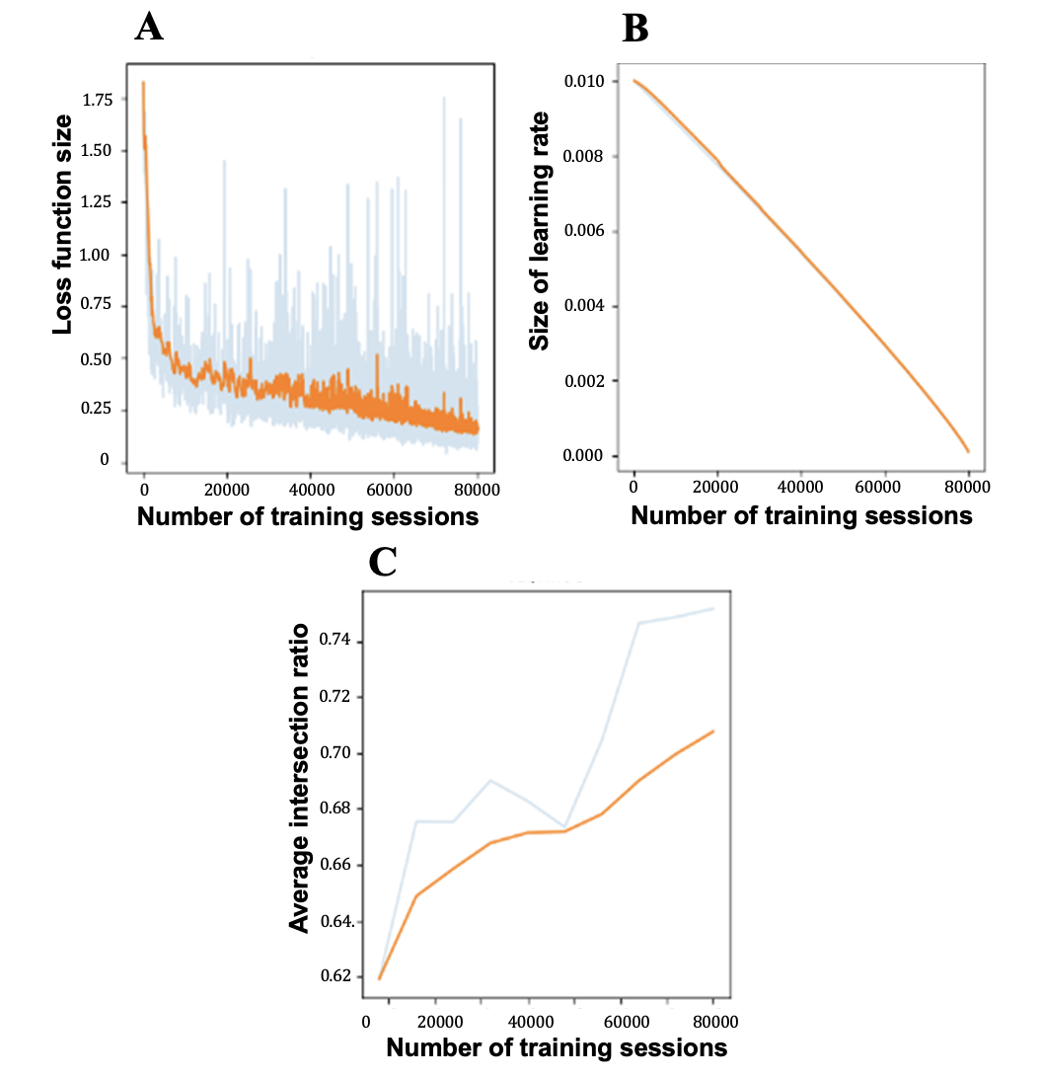
Supplementary Figure 1 depicts the training process. The blue line represents the actual values, while the orange line segments indicate the results after smoothing. The figure is divided into three parts: A) Reduction in loss function. B) Decrease in learning rate. C) Increase in the average intersection over union (IoU).
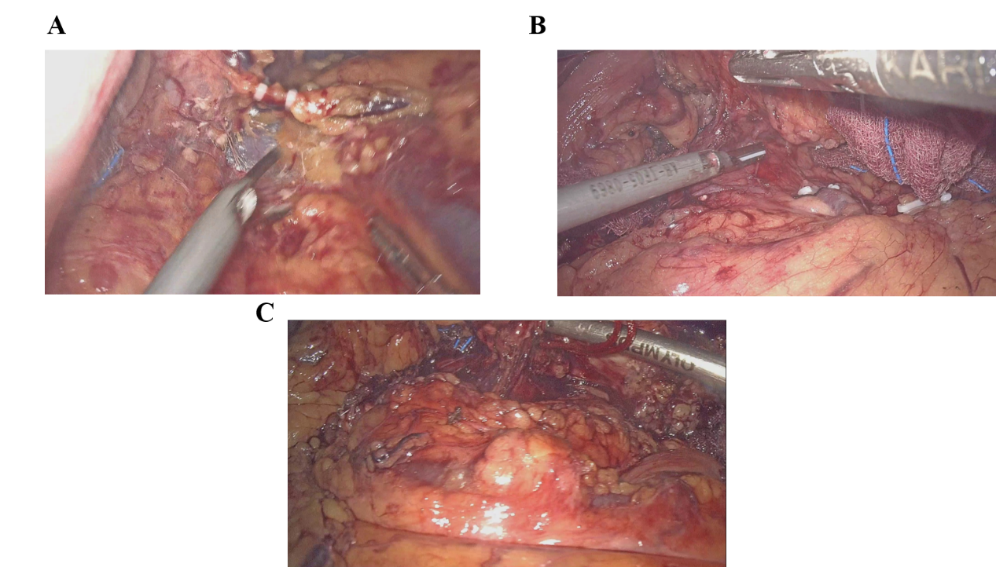
Supplementary Figure 2 Examples of low recognition group. A) Blurred image. B) Excessive occlusion. C) Exposure area ≤64*64 pixels and poor exposure.
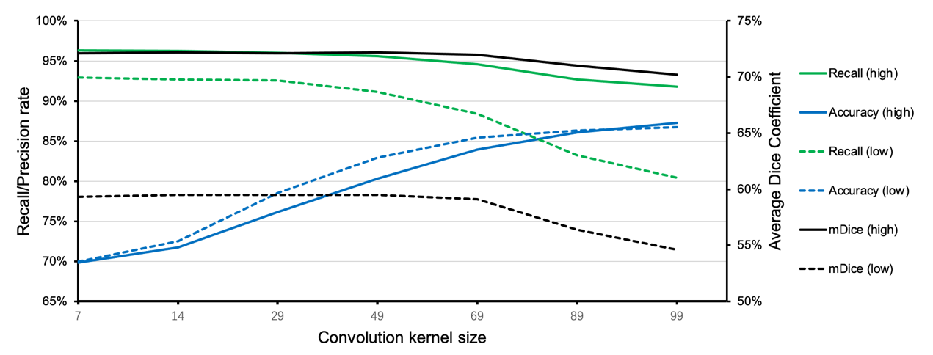Supplementary Figure 3 Impact of different post-processing convolution kernel sizes on recognition performance.
We adjusted the size of the convolution kernel used in morphological processing, gradually increasing it from 7×7 to 99×99. It can be observed that as the size of the morphological processing convolution kernel increases, the recall rate and precision exhibit opposing trends. Specifically, the recall rate decreases with an increase in kernel size, while precision significantly increases. The mDice coefficient remains relatively stable when the kernel size is less than or equal to 69×69, but rapidly declines when it exceeds 69×69. Considering that the misidentification of small fragments in clinical applications can significantly interfere with a physician's subjective perception, we chose a 69×69 convolution kernel to balance recall and precision, ultimately adopting this size for the model's final output.
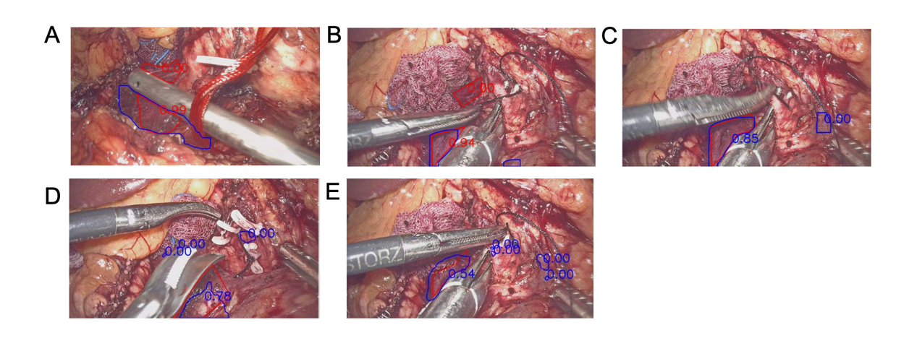
Supplementary Figure 4 Examples of false negative and false positive.
The red box represented the ground truth box, and the blue box represented the prediction box. The number corresponded to the IoU of the prediction box and the ground truth box. Examples of false negative were including: A) Vessels shielded by tools and B) Segmentation failure by indistinguishable vessel features. Examples of false positive were including: C) Features of vessels similar with surrounded tissues and D), E) Small unfiltered targets.

Supplementary Table 1 Data in training set and testing set*
Data set | Patient | Videos | Pictures | Low difficulty | High difficulty
LDP Training | 19 | 95 | 10,434 | 7,251 | 3,183
LDP Testing | 6 | 31 | 2,260 | 1,548 | 712
Whipple training | 22 | 109 | 28,915 | - | -
Whipple testing | 8 | 29 | 7,071 | 4,835 | 2,236
*The Whipple training set does not distinguish between high-difficulty and low-difficulty groups.

Supplementary Table 2 Result of multiclass segmentation of SMV-PV axis and splenic vein*
Class | Difficulty | Recall | Precision | False negative | False positive | Mean Dice
Splenic vein | Low | 0.771 | 0.822 | 0.229 | 0.178 | 0.545
Splenic vein | High | 0.740 | 0.809 | 0.260 | 0.191 | 0.452
SMV-PV axis | Low | 0.795 | 0.646 | 0.205 | 0.354 | 0.466
SMV-PV axis | high | 0.754 | 0.682 | 0.246 | 0.318 | 0.463
* IoU threshold is 0.1

Supplementary Table 3 presents the recognition results in the binary segmentation task. It can be observed that high IoU threshold which indicates high accuracy to recognize the vessels, did not affect the prediction, recall or mean dice coefficient significantly. The only notable effect was a slight increase in the false negative in the low recognition group from 0.150 to 0.256. This indicates the reliability of our model's predictions.
Supplementary Table 3 Result of binary classification of segmentation of veins and backgrounds
 | Recall |  | Precision |  | False negative |  | False positive |  | Mean Dice
IoU threshold | 0.1 | 0.3 | 0.1 | 0.3 | 0.1 | 0.3 | 0.1 | 0.3
Low difficulty | 0.946 | 0.923 | 0.839 | 0.827 | 0.054 | 0.076 | 0.161 | 0.173 | 0.720
High difficulty | 0.884 | 0.868 | 0.854 | 0.744 | 0.116 | 0.132 | 0.146 | 0.256 | 0.591
Total | 0.925 | 0.905 | 0.844 | 0.802 | 0.074 | 0.095 | 0.156 | 0.198 | 0.680

We then compared the performance differences of all models in the binary segmentation task of the SMV-PV axis system. This comparison encompassed FLOPs, recall, precision, false negative rate, false positive rate, and mean Dice coefficient as key metrics. HRNet_FCN achieved a mean Dice coefficient of 0.720 in the high recognition group, outperforming all other models in this category.

Supplementary Table 4 Comparison with different models in binary segmentation task*
Model | GFLOPs | Difficulty | Recall | Precision | False negative | False positive | Mean Dice
HRNet_FCN | 38.75 | Low | 0.946 | 0.839 | 0.054 | 0.161 | 0.720
HRNet_FCN | 38.75 | High | 0.884 | 0.854 | 0.116 | 0.146 | 0.591
Dlink-Net¹ | 47.76 | Low | 0.939 | 0.841 | 0.061 | 0.159 | 0.709
Dlink-Net¹ | 47.76 | High | 0.893 | 0.850 | 0.107 | 0.150 | 0.572
Deeplabv3+² | 37.05 | Low | 0.915 | 0.860 | 0.085 | 0.140 | 0.703
Deeplabv3+² | 37.05 | High | 0.867 | 0.888 | 0.133 | 0.112 | 0.620
U-Net++³ | 403.53 | Low | 0.879 | 0.688 | 0.121 | 0.312 | 0.619
U-Net++³ | 403.53 | High | 0.832 | 0.741 | 0.168 | 0.259 | 0.565
UperNet_swin_tiny⁴⁻⁶ | 465.97 | Low | 0.963 | 0.730 | 0.037 | 0.270 | 0.684
UperNet_swin_tiny⁴⁻⁶ | 465.97 | High | 0.912 | 0.783 | 0.088 | 0.217 | 0.524
* IoU threshold is 0.1

Supplementary Table 5 Binary segmentation recognition performance of the HRNet_FCN model on the SMV-PV axis + splenic vein in the test set*
Recognition | Recall Rate | Accuracy | Missed Positive | False Positive | mDice
High | 0.963 | 0.698 | 0.037 | 0.302 | 0.721
Low | 0.929 | 0.699 | 0.071 | 0.301 | 0.593
*The size of the morphological processing convolution kernel is 7×7, IOU threshold = 0.1

Supplementary Table 6 Impact of different post-processing convolution kernel sizes on recognition performance*.
Convolution kernel size (n×n) | Recognition (High) |  |  | Recognition (Low)
Convolution kernel size (n×n) | Recall Rate | Accuracy | mDice | Recall Rate | Accuracy | mDice
7 | 0.963 | 0.698 | 0.721 | 0.929 | 0.699 |  | 0.593
14 | 0.963 | 0.713 | 0.722 | 0.927 | 0.725 | 0.595
29 | 0.960 | 0.761 | 0.721 | 0.926 | 0.785 | 0.595
49 | 0.956 | 0.803 | 0.722 | 0.911 | 0.829 | 0.595
69 | 0.946 | 0.839 | 0.720 | 0.884 | 0.854 | 0.591
89 | 0.927 | 0.861 | 0.710 | 0.832 | 0.863 | 0.564
99 | 0.918 | 0.873 | 0.702 | 0.804 | 0.867 | 0.546
*IOU threshold is 0.1
Supplementary Table 7. Binary Classification Results for Combined Vein Segmentation with Uniform Difficulty（with sample size attached）
Training Set | Test Set | Recall | Precision | False Negative | False Positive | Dice
LDP | LDP | 83.60%  (2,220/2,655) | 91.60%  (2,324/2,536) | 16.40%  (435/2,655) | 8.40%  (212/2,536) | 0.686
Whipple | Whipple | 83.20%  (8,948/10,753) | 89.20%  (8,985/10,075) | 16.80%  (1,805/10,753) | 10.80%  (1,090/10,075) | 0.763
Combined | LDP | 89.70%  (2,381/2,655) | 93.50%  (2,438/2,607) | 10.30%  (274/2,655) | 6.50%  (169/2,607) | 0.713
Combined | Whipple | 83.80%  (9,010/10,753) | 90.40%  (8,906/9,849) | 16.20%  (1,743/10,753) | 9.60%  (943/9,849) | 0.767
Combined | Combined | 85.00%  (11,391/13,408) | 91.10%  (11,344/12,456) | 15.00%  (2,017/13,408) | 8.90%  (1,112/12,456) | 0.754

Reference
1 Zhou, L., Zhang, C. & Wu, M. in Proceedings of the IEEE conference on computer vision and pattern recognition workshops. 182-186.
2 Chen, L.-C., Papandreou, G., Schroff, F. & Adam, H. Rethinking atrous convolution for semantic image segmentation. arXiv preprint arXiv:1706.05587 (2017).
3 Zhou, Z., Rahman Siddiquee, M. M., Tajbakhsh, N. & Liang, J. in Deep Learning in Medical Image Analysis and Multimodal Learning for Clinical Decision Support: 4th International Workshop, DLMIA 2018, and 8th International Workshop, ML-CDS 2018, Held in Conjunction with MICCAI 2018, Granada, Spain, September 20, 2018, Proceedings 4. 3-11 (Springer).
4 Xiao, T., Liu, Y., Zhou, B., Jiang, Y. & Sun, J. in Proceedings of the European conference on computer vision (ECCV). 418-434.
5 Liu, Z. et al. in Proceedings of the IEEE/CVF international conference on computer vision. 10012-10022.
6 Nie, K., Zdrnja, S. & Gangaraju, S. Neuronal Cell Instance Segmentation.

