Comparison of single and repeated dosing of anti-inflammatory human umbilical cord mesenchymal stromal cells in a mouse model of polymicrobial sepsis
Barbara Fazekas, Senthilkumar Alagesan, Luke Watson, Olivia Ng, Callum M. Conroy, Cristina Català, Maria Velasco de Andres, Neema Negi, Jared Q. Gerlach, Francisco Lozano, Stephen J. Elliman and Matthew D. Griffin

Supplementary Material

Supplementary Methods
Flow cytometric analysis of kidney immune cell subpopulations: The kidneys were de-capsulated, manually chopped and digested in 1mL of Dulbecco’s modified Eagle’s medium (DMEM) containing 0.25unit/mL of recombinant collagenase class I and II originating from Clostridium histolyticum (KITECH, South Korea), 0.06mg/mL of Thermolysine (Sigma-Aldrich, Arklow, Ireland) and 0.4mg/mL DNase I (Sigma-Aldrich). Samples were incubated at 37°C for 40 minutes with rotation at 250 rpm. Upon completion of digestion, cell suspensions were washed with Hank’s balanced salt solution (HBSS, Sigma-Aldrich), strained through a 40μm cell strainer and treated with ACK lysis buffer (150mM NH₄Cl, 10mM KHCO₃ and 0.1mM Na₂EDTA dissolved in dH₂O, pH 7.2-7.4). The suspensions were washed once in HBSS, then twice with Dulbecco’s phosphate buffered saline (D-PBS, Thermo Fisher Scientific) and then suspended in FACS buffer at 2.5x10⁵ cells/mL. For CD45⁺ cell enrichment, magnetic column separation of kidney cell suspensions was carried out in MACS buffer (PBS, 0.5% BSA and 100mM EDTA) by manufacturer-recommended protocols using MS columns and an OctoMACS® separator (Miltenyi Biotec Inc., Bisley, Surray, UK). Aliquots of the kidney cell suspensions were stained with combinations of fluorochrome-labelled antibodies for 30 min at 4°C: anti-TCRβ-PE (H57-597), anti-CD19-FITC (1D3) and anti-CD45-FITC (EM-05) from Immunotools, Friesoythe, Germany; anti-CD4-PerCp-Cy5.5 (RM4-5), anti-CD11c-PE (HL3) and anti-CD45-V450 (30F11) from BD Biosciences, Berkshire, UK; anti-CD8 -PE-Cy7 (53-6.7), anti-NK1.1-APC (DX5), anti-CD45-APC-Cy7 (30-F11), anti-Ly6C-PerCp-Cy5.5 (HK1.4), anti-Ly6G (1A8), anti-CD206-V450 (C068C2) and anti-MHC-II-FITC (AF6-120.1) from Biolegend, London, UK; anti-F4/80 (BM8) from Invitrogen/eBioSciences (Bio-Sciences Ltd., Dublin, Ireland); and anti-CD64-APC-Cy7 (REA286) from Miltenyi Biotech. Cell viability was analysed by using the fixable Viability Dye eFluor™ 506 (Invitrogen/eBioSciences). After staining, the cells were washed in FACS buffer, fixed in 1% paraformaldehyde and re-suspended in FACS buffer before being analyzed on a FACS Canto II cytometer (BD Biosciences). A total of 150,000 events were collected for each sample and the acquired data were analyzed using FlowJo 6 software. Fluorescence minus one (FMO) controls were prepared for fluorophores identifying infrequent cell populations and were used to define positive staining. Compensation was performed with OneComp beads (eBioscience) stained with appropriate antibodies. Absolute cell numbers were calculated by using the CountBright Absolute Counting Beads (Thermo Fisher Scientific, Bio-Sciences Ltd.).
ELISA of plasma for NGAL: 96-well microtiter plates (Thermo-Fisher Scientific) were coated with the capture antibody, and non-specific binding sites were blocked with reagent diluent (1% BSA in PBS, pH 7.2–7.4). Adequately-diluted plasma samples (0.4x10³, 10⁴ to 10⁵-fold) were incubated in duplicates for 2 hours, and then the detection antibody was added. Next, Streptavidin-HRP was added for 20 minutes, followed by addition of 50μL of 3,3',5,5'-Tetramethylbenzidine (TMB) substrate (Sigma-Aldrich). Between each step, plates were washed three times with wash buffer. The enzymatic reaction was terminated by addition of 25μL of stop solution containing H₂SO₄. The optical density was measured with Victor3™ 1420 Multilabel Counter (PerkinElmer, Wallac Oy, Finland) at 450nm with wavelength correction set to 544nm. The NGAL concentrations were calculated with Excel software (Microsoft Office), using a four-parameter logistic curve-fit.
Histologic staining of kidney tissue sections: For hematoxylin and eosin (H&E) staining, sections were dewaxed in xylene, rehydrated, and stained in Gill no. 3 hematoxylin (Sigma-Aldrich) followed by eosin (Sigma-Aldrich) before being dehydrated through graded alcohols, cleared in xylene, and then covered with DPX mounting medium and coverslips. For periodic acid-Schiff (PAS) staining, sections were dewaxed in xylene, rehydrated, and then oxidized in 0.5% periodic acid solution. Sections were then washed and incubated in Schiff reagent (Sigma-Aldrich) for 20 minutes in dark. Following counterstaining in Gill no. 3 hematoxylin (Sigma-Aldrich), sections were dipped in acid alcohol and ammonia water, dehydrated, cleared in xylene, and mounted in DPX medium.
Semi-quantitative scoring of kidney injury: Individual fields from each stained tissue sections were scored in blinded fashion according to the following scoring system: 0 = no lesion; 1 = minimal or focal changes affecting less than 20% of the field; 2 = mild changes or the extension of the lesion to approximately 25% of the field; 3 = moderate changes or the extension of the lesion from 25% to 50% of the field; 4 = severe changes or the extension of the lesion to more than 50% of the field. The total injury score (A or B) consisted of the sum of the scores from three separate histology sections per kidney.

Supplementary Table S1: Flow cytometry-based surface marker staining combinations for defined immune cell sub-populations in CD45-enriched kidney cell suspensions
Immune Cell Type | Surface Staining Combination
M1 Macrophage | Ly6C-CD11b+CD68+
M2 Macrophage | Ly6C-CD11b+CD206+
CD4 T cells | CD45⁺TCRβ⁺CD4⁺CD8⁻
CD8 T cells | CD45⁺TCRβ⁺CD4⁻CD8⁺
Double negative (DN) T cells | CD45⁺TCRβ⁺CD4⁻CD8⁻
B cells | CD45⁺TCRβ⁻CD4⁻CD8⁻CD19⁺
NK cells | CD45⁺TCRβ⁻CD4⁻CD8⁻CD19⁻NK1.1⁺
Myeloid cells | CD45⁺CD11b⁺
Neutrophils | CD45⁺CD11b⁺Ly6G⁺
Mononuclear phagocytes | CD45⁺CD11b⁺Ly6G⁻CD11c⁻F4/80^{+/-}Ly6C^{+/-}
CD206⁺ Macrophage-like cells | CD45⁺CD11b⁺Ly6G⁻CD11c⁻F4/80^{+/-}Ly6C^{+/-}CD206+
Dendritic cells | CD45⁺Ly6G⁻CD11b⁻CD11c⁺
CD11c⁺ Myeloid cells | CD45⁺CD11c⁺MHC II⁺
Conventional (c)DC | CD45⁺(MHC II⁺CD11c⁺)(CD64⁻F4/80⁻)
CD103⁺ DCs | CD45⁺(MHC II⁺CD11c⁺)(CD64⁻F4/80⁻)CD103⁺
CD11b ⁺ DCs | CD45⁺(MHC II⁺CD11c⁺)(CD64⁻F4/80⁻)CD11b^{mid/high}
Monocytes & Macrophages | CD45⁺(MHC II⁺CD11c⁺)(CD64^{mid/high}F4/80^{mid/high})

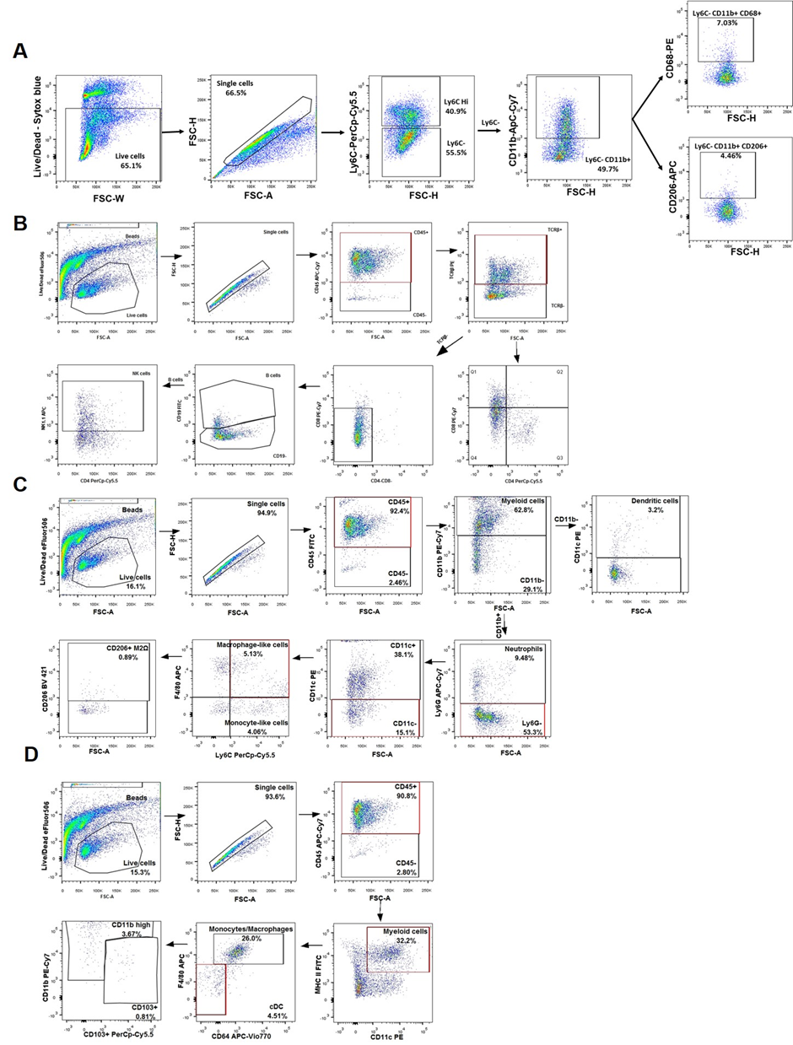Supplementary Figure S1. Representative examples of gating strategies for phenotypic analysis of immune cell subpopulations by flow cytometery: A) Gating strategy for peritoneal macrophages. B) Gating strategies for renal lymphoid cell populations C-D) Gating strategies for renal myeloid cell populations.

