Table 1. Sociodemographic and Clinical Characteristics of Registered Patients at Baseline, by Implementation Period.
Characteristic, N (%) | Total  N=21,922 | Pre-Implementation  N=5,506 (25.1%) | Implementation  N=16,416 (74.9%) | P Value
Area Council |  |  |  | <.0001
Abaji | 3,257 (14.9%) | 883 (16.0%) | 2,374 (14.5%)
AMAC | 7,006 (32.0%) | 1,655 (30.1%) | 5,351 (32.6%)
Bwari | 3,249 (14.8%) | 846 (15.4%) | 2,403 (14.6%)
Gwagwalada | 4,218 (19.2%) | 1,123 (20.4%) | 3,095 (18.9%)
Kuje | 1,999 (9.1%) | 369 (6.7%) | 1,630 (9.9%)
Kwali | 2,193 (10.0%) | 630 (11.4%) | 1,563 (9.5%)
Age, years, Median (IQR) | 49 (40, 58) | 48 (38, 57) | 50 (41, 58) | <.0001
Female | 14,942 (68.2%) | 3,664 (66.6%) | 11,278 (68.7%) | 0.003
BMI, kg/m², Median (IQR) | 26.6 (23.1, 30.9) | 26.6 (23.3, 30.8) | 26.6 (23.1, 30.9) | 0.74
Education |  |  |  | <.0001
Never attended | 5,899 (27.0%) | 1,478 (26.9%) | 4,421 (27.1%)
Primary | 4,105 (18.8%) | 1,059 (19.3%) | 3,046 (18.7%)
Secondary | 6,123 (28.1%) | 1,596 (29.1%) | 4,527 (27.7%)
College/Post-Secondary | 4,828 (22.1%) | 1,150 (21.0%) | 3,678 (22.5%)
Professional | 751 (3.4%) | 159 (2.9%) | 592 (3.6%)
Theological | 115 (0.5%) | 46 (0.8%) | 69 (0.4%)
History of Diabetes | 974 (4.4%) | 311 (5.7%) | 663 (4.1%) | <.0001
Current Smoker | 201 (0.9%) | 56 (1.0%) | 145 (0.9%) | 0.37
Current Alcohol User | 774 (3.5%) | 227 (4.1%) | 547 (3.3%) | 0.006
Hypertension Status at First Visit
Previous Diagnosisª | 10,683 (48.7%) | 2,896 (52.6%) | 7,787 (47.4%) | <.0001
Among Patients with Previous Diagnosis
Walk-in Treated | 6,966 (65.2%) | 2,112 (72.9%) | 4,854 (62.3%) | <.0001
Walk-in Controlled* | 2,059 (19.3%) | 575 (19.9%) | 1,484 (19.1%) | 0.35
Among All Patients
Walk-in Treated | 9,457 (43.1%) | 3,049 (55.4%) | 6,408 (39.0%) | <.0001
Walk-in Controlled* | 2,792 (12.7%) | 749 (13.6%) | 2,043 (12.5%) | 0.03
Systolic BP^{b}, mmHg, Median (IQR) | 154 (143, 168) | 152 (142, 164) | 154 (143, 169) | <.0001
Diastolic BP^{b}, mmHg, Median (IQR) | 96 (88, 105) | 95 (88, 104) | 96 (88, 105) | <.0001
Heart Rate, bpm, Median (IQR) | 82 (74, 92) | 83 (75, 92) | 82 (74, 91) | 0.01
Walk-Out Treated | 20,941 (95.5%) | 5,032 (91.4%) | 15,909 (96.9%) | <.0001
ª Vs. self-report or clinic knowledge of a prior diagnosis.
^{b} Average of two measurements following a prescribed measurement protocol.
* < 140/90 mmHg Following the Nigeria Hypertension Treatment Protocol
Abbreviations: AMAC, Abuja Municipal Area Council; BMI, body mass index; BP, blood pressure; HTN, hypertension; IQR, interquartile range

Table 2. Patient Engagement and Hypertension Status by Implementation Period at Enrollment.
 | Total  N=21,922 | Pre-Implementation  N=5,506 (25.1%) | Implementation  N=16,416 (74.9%) | P Value
All Patients
Months Enrolled, Median (IQR) | 12 (4, 24) | 22 (8, 36) | 10 (4, 20) | <.0001
Visits per Patient, median (IQR) | 3 (1, 9) | 4 (1, 14) | 3 (1, 8) | <.0001
Patients with ≥2 Visits
Patients with 2+ Visits, N (%) | 14,619 (66.7%) | 3,944 (71.6%) | 10,675 (65.0%) | <.0001
Months Enrolled, Median (IQR) | 12 (4, 24) | 22 (8, 36) | 10 (4, 20) | <.0001
N Visits per Patient, median (IQR) | 6 (3, 13) | 8 (3, 19) | 6 (3, 11) | <.0001
Blood Pressure, Treatment, and Control among All Patient Visits
Systolic BPª, Median (IQR), mmHg | 137.0 (124.5, 150.5) | 142.5 (130.0, 156.0) | 136.0 (124.0, 150.0) | <.0001
Diastolic BPª, Median (IQR), mmHg | 85.0 (77.5, 94.0) | 89.5 (81.0, 98.0) | 85.0 (77.0, 93.5) | <.0001
Heart rate, Median (IQR), bpm | 80 (72, 88) | 81 (74, 90) | 80 (72, 88) | <.0001
Walk-out Treated, N (%) | 135,534 (95.1%) | 13,286 (90.6%) | 122,248 (95.6%) | <.0001
Controlled*, N (%) | 69,154 (48.5%) | 5,141 (35.1%) | 64,013 (50.1%) | <.0001
ª Average of two measurements using standardized measurement protocol.
* Defined as < 140/90 mmHg based on the Nigeria national hypertension treatment protocol
Abbreviations: BP, blood pressure

Table 3. Six Month Rolling Treatment Rates, Overall and Stratified by Sex.
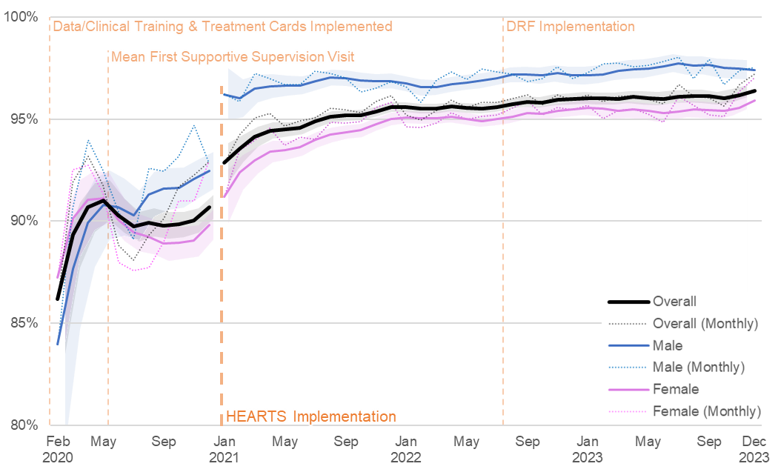
 | Pre-Implementation |  |  |  | Implementation
 | Baseline  (Feb 2020ª) | Slope Per Month^{b} |  | Level Change at Implementation^{c} |  | Baseline  (Jan 2021)^{c} | Slope Per  Month^{b} | End  (Dec 2023^{b}) | Pre- vs.  Post^{d}
Overall, β (95% CI)
 | 86.2%  (83.5%, 88.8%) | 0.8%  (0.6%, 1.0%) |  | 3.5%  (2.3%, 4.6%) |  | 92.9%  (91.9%, 93.8%) | 0.02%  (0.01%, 0.03%) | 96.4%  (96.1%, 96.7%) | -0.8%  (-1.0%, -0.5%)
 | - | p<.0001 |  | p=0.0002 |  | - | p=0.008 | - | p=0.002
Male, β (95% CI)
 | 84.0%  (79.0%, 88.9%) | 0.8%  (0.6%, 1.0%) |  | 3.5%  (2.3%, 4.6%) |  | 96.2%  (94.9%, 97.5%) | 0.02%  (0.01%, 0.03%) | 97.4%  (96.9%, 97.9%) | -0.8%  (-1.0%, -0.5%)
 | - | p<.0001 |  | p<.0001 |  | - | p=0.50 | - | p<.0001
Female, β (95% CI)
 | 87.2%  (84.1%, 90.4%) | 0.3%  (0.1%, 0.5%) |  | 1.5%  (0.4%, 2.6%) |  | 91.2%  (89.9%, 92.5%) | 0.10%  (0.04%, 0.16%) | 95.9%  (95.5%, 96.3%) | -0.2%  (-0.5%, 0.1%)
 | - | p=0.01 |  | p=0.01 |  | - | p=0.003 | - | p=0.14
ª First full month of enrollment; ^{b} 6-month rolling; ^{c} 6-month rolling recommenced; ^{d} Comparison of pre- and post-implementation slopes
Abbreviations: DRF, Drug Revolving Fund

Table 4. Six Month Rolling Control Rates, Overall and Stratified by Sex.
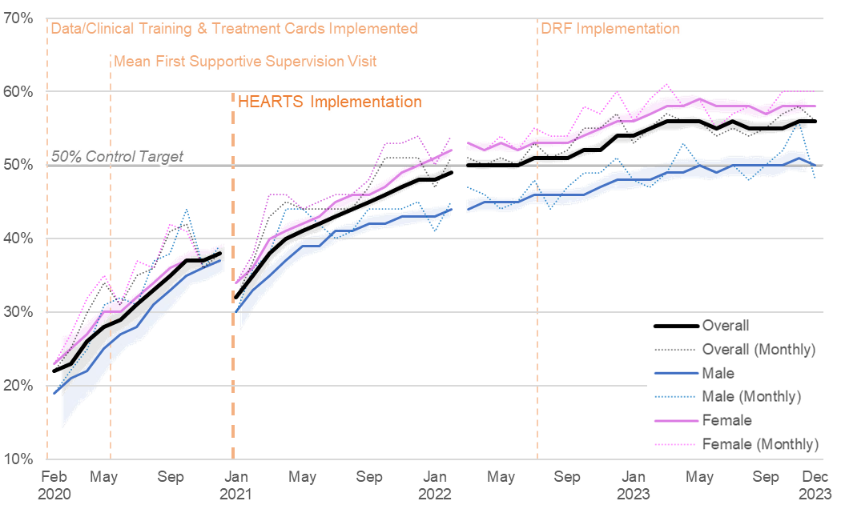
 | Pre-Implementation |  |  |  | Implementation
 | Baseline  (Feb 2020ª) | Slope Per Month^{b} |  | Level Change at Implementation^{c} |  | Baseline  (Jan 2021)^{c} | Slope Per  Month^{b} | End  (Dec 2023^{b}) | Pre- vs.  Post^{d}
Overall, β (95% CI)
 | 21.7%  (18.5%, 24.8%) | 1.7%  (1.2%, 2.1%) |  | -6.1%  (-7.7%, -4.6%) |  | 32.5%  (30.7%, 34.3%) | 0.7%  (0.5%, 0.9%) | 55.9%  (55.1%, 56.7%) | -1.0%  (-1.6%, -0.5%)
 | - | p<.0001 |  | p<.0001 |  | - | p<.0001 | - | p=0.0004
Male, β (95% CI)
 | 19.3%  (14.0%, 24.7%) | 1.9%  (1.4%, 2.3%) |  | -7.3%  (-8.8%, -5.8%) |  | 30.3%  (27.3%, 33.4%) | 0.6%  (0.4%, 0.8%) | 50.4%  (48.9%, 51.8%) | -1.3%  (-1.8%, -0.8%)
 | - | p<.0001 |  | p<.0001 |  | - | p<.0001 | - | p<.0001
Female, β (95% CI)
 | 22.8%  (18.8%, 26.7%) | 1.6%  (1.1%, 2.1%) |  | -5.5%  (-7.3%, -3.7%) |  | 33.5%  (31.3%, 35.7%) | 0.7%  (0.5%, 0.9%) | 58.4%  (57.4%, 59.4%) | -0.9%  (-1.5%, -0.3%)
 | - | p<.0001 |  | p<.0001 |  | - | p<.0001 | - | p=0.004
NOTE: The interrupted time series analyzes the post-implementation period as a whole (Jan 2021 – Dec 2023); the figure depicts the implementation period stratified at the 50% overall control rate target.
ª First full month of enrollment; ^{b} 6-month rolling; ^{c} 6-month rolling recommenced; ^{d} Comparison of pre- and post-implementation slopes
Abbreviations: DRF, Drug Revolving Fund

