Supplemental Table 1. Enumeration of Patients Enrolled and Visits, by Area Council, N (%).
Area Council (N PHCs) | Patients Enrolled | Patient Visits
Abaji (N=8) | 3,257 (14.9%) | 29,006 (20.4%)
AMAC (N=15) | 7,006 (32.0%) | 32,166 (22.6%)
Bwari (N=8) | 3,249 (14.8%) | 18,973 (13.3%)
Gwagwalada (N=11) | 4,218 (19.2%) | 33,134 (23.3%)
Kuje (N=8) | 1,999 (9.1%) | 16,076 (11.3%)
Kwali (N=10) | 2,193 (10.0%) | 13,138 (9.2%)
Overall (N=60) | 21,922 (100.0%) | 142,493 (100.0%)
Abbreviations: AMAC, Abuja Municipal Area Council; PHC, primary healthcare center

Supplemental Table 2. Sociodemographic and Clinical Characteristics of Registered Patients at Baseline, by Sex.
Characteristic, N (%) | Total  N=21,922 | Male  N=6,980 (31.8%) | Female  N=14,942 (68.2%) | P Value
Area Council |  |  |  | <.0001
Abaji | 3,257 (14.9%) | 1,062 (15.2%) | 2,195 (14.7%)
AMAC | 7,006 (32.0%) | 1,971 (28.2%) | 5,035 (33.7%)
Bwari | 3,249 (14.8%) | 1,058 (15.2%) | 2,191 (14.7%)
Gwagwalada | 4,218 (19.2%) | 1,346 (19.3%) | 2,872 (19.2%)
Kuje | 1,999 (9.1%) | 692 (9.9%) | 1,307 (8.8%)
Kwali | 2,193 (10.0%) | 851 (12.2%) | 1,342 (9.0%)
Age, years, Median (IQR) | 49 (40, 58) | 53 (45, 61) | 47 (39, 56) | <.0001
BMI, kg/m², Median (IQR) | 26.6 (23.1, 30.9) | 25.9 (22.9, 29.4) | 27.0 (23.3, 31.6) | <.0001
Education |  |  |  | <.0001
Never attended | 5,899 (27.0%) | 1,133 (16.3%) | 4,766 (32.0%)
Primary | 4,105 (18.8%) | 1,113 (16.0%) | 2,992 (20.1%)
Secondary | 6,116 (28.0%) | 2,015 (28.9%) | 4,101 (27.6%)
College/Post-Secondary | 4,828 (22.1%) | 2,214 (31.8%) | 2,614 (17.6%)
Professional | 751 (3.4%) | 422 (6.1%) | 329 (2.2%)
Theological | 115 (0.5%) | 45 (0.7%) | 70 (0.5%)
History of Diabetes | 974 (4.4%) | 326 (4.7%) | 648 (4.3%) | 0.27
Current Smoker | 201 (0.9%) | 148 (2.1%) | 53 (0.4%) | <.0001
Current Alcohol User | 774 (3.5%) | 533 (7.7%) | 241 (1.6%) | <.0001
Hypertension Status at First Visit
Previous Diagnosisª | 10,683 (48.7%) | 3,227 (47.1%) | 7,396 (49.5%) | 0.001
Among Patients with Previous Diagnosis
Walk-in Treated | 6,966 (65.2%) | 2,138 (65.0%) | 4,828 (65.3%) | 0.81
Walk-in Controlled* | 2,059 (19.3%) | 588 (17.9%) | 1,471 (19.9%) | 0.02
Among All Patients
Walk-in Treated | 9,457 (43.1%) | 2,966 (42.5%) | 6,491 (43.4%) | 0.19
Walk-in Controlled* | 2,792 (12.7%) | 802 (11.5%) | 1,990 (13.3%) | 0.0002
Systolic BP^{b}, mmHg, Median (IQR) | 154 (143, 168) | 156 (145, 170) | 153 (142, 167) | <.0001
Diastolic BP^{b}, mmHg, Median (IQR) | 96 (88, 105) | 96 (88, 105) | 96 (88, 105) | 0.96
Heart Rate, bpm, Median (IQR) | 82 (74, 92) | 81 (73, 90) | 83 (75, 92) | <.0001
Walk-out Treated | 20,941 (95.5%) | 6,680 (95.7%) | 14,261 (95.4%) | 0.39
ª Vs. self-report or clinic knowledge of a prior diagnosis.
^{b} Average of two measurements using standardized measurement protocol.
* Defined as < 140/90 mmHg based on the Nigeria national hypertension treatment protocol
Abbreviations: AMAC, Abuja Municipal Area Council; BMI, body mass index; BP, blood pressure; HTN, hypertension; IQR, interquartile range

Supplemental Table 3. Six Month Rolling Systolic Blood Pressure, mm Hg, Overall and Stratified by Sex.
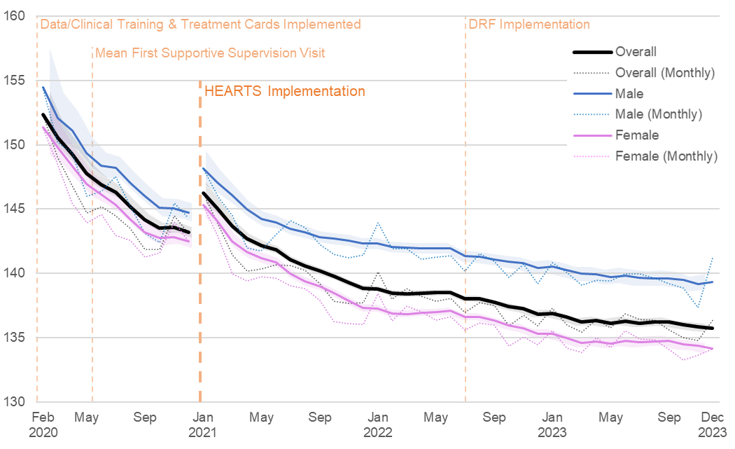
 | Pre-Implementation |  |  |  | Implementation
 | Baseline  (Feb 2020ª) | Slope Per Month^{b} |  | Level Change at Implementation^{c} |  | Baseline  (Jan 2021)^{c} | Slope Per  Month^{b} | End  (Dec 2023^{b}) | Pre- vs.  Post^{d}
Overall, β (95% CI)
 | 152.4  (150.6, 154.1) | -1.0  (-1.2, -0.7) |  | 3.3  (2.5, 4.1) |  | 146.3  (145.4, 147.1) | -0.3  (-0.4, -0.2) | 135.8  (135.4, 136.1) | 0.7  (0.4, 0.9)
 | - | p<.0001 |  | p<.0001 |  | - | p<.0001 | - | p<.0001
Male, β (95% CI)
 | 154.5  (151.5, 157.5) | -1.1  (-1.3, -0.8) |  | 3.6  (2.7, 4.4) |  | 148.2  (146.8, 149.5) | -0.2  (-0.3, -0.1) | 139.4  (138.8, 140.0) | 0.8  (0.6, 1.1)
 | - | p<.0001 |  | p<.0001 |  | - | p<.0001 | - | p<.0001
Female, β (95% CI)
 | 151.3  (149.2, 153.5) | -0.9  (-1.2, -0.7) |  | 3.1  (2.3, 4.0) |  | 145.3  (144.3, 146.3) | -0.3  (-0.4, -0.2) | 134.2  (133.8, 134.5) | 0.6  (0.3, 0.9)
 | - | p<.0001 |  | p<.0001 |  | - | p<.0001 | - | p=0.0001
NOTE: Among all patients, treated and untreated
ª First full month of enrollment; ^{b} 6-month rolling; ^{c} 6-month rolling recommenced; ^{d} Comparison of pre- and post-implementation slopes
Abbreviations: DRF, Drug Revolving Fund

Supplemental Table 4. Six Month Rolling Diastolic Blood Pressure, mm Hg, Overall and Stratified by Sex.
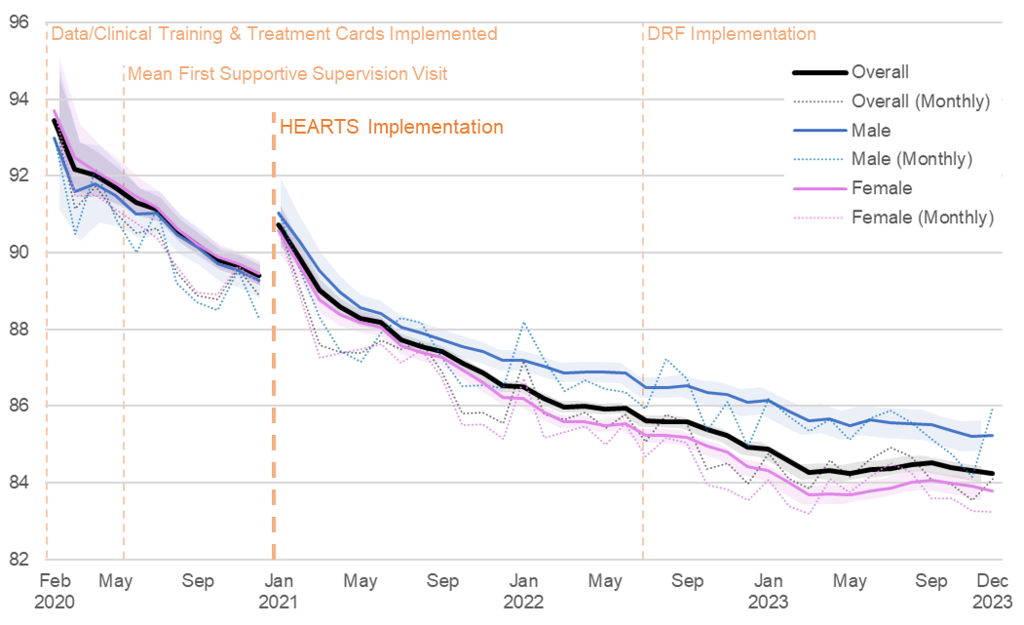
 | Pre-Implementation |  |  |  | Post-Implementation
 | Baseline  (Feb 2020ª) | Slope Per Month^{b} |  | Level Change at Implementation^{c} |  | Baseline  (Jan 2021)^{c} | Slope Per  Month^{b} | End  (Dec 2023^{b}) | Pre- vs.  Post^{d}
Overall, β (95% CI)
 | 93.5  (92.3, 94.6) | -0.4  (-0.6, -0.3) |  | 1.5  (1.0, 2.0) |  | 90.7  (90.2, 91.2) | -0.2  (-0.2, -0.1) | 84.2  (84.0, 84.4) | 0.3  (0.1, 0.4)
 | - | p<.0001 |  | p<.0001 |  | - | p<.0001 | - | p=0.004
Male, β (95% CI)
 | 93.0  (91.1, 94.8) | -0.4  (-0.6, -0.3) |  | 1.9  (1.3, 2.4) |  | 91.0  (90.1, 92.0) | -0.2  (-0.2, -0.1) | 85.2  (84.9, 85.6) | 0.3  (0.1, 0.4)
 | - | p<.0001 |  | p<.0001 |  | - | p<.0001 | - | p=0.004
Female, β (95% CI)
 | 93.7  (92.3, 95.1) | -0.5  (-0.6, -0.3) |  | 1.3  (0.7, 1.8) |  | 90.6  (89.9, 91.2) | -0.2  (-0.3, -0.1) | 83.8  (83.5, 84.0) | 0.3  (0.1, 0.4)
 | - | p<.0001 |  | p<.0001 |  | - | p<.0001 | - | p=0.004
NOTE: Among all patients, treated and untreated
ª First full month of enrollment; ^{b} 6-month rolling; ^{c} 6-month rolling recommenced; ^{d} Comparison of pre- and post-implementation slopes
Abbreviations: DRF, Drug Revolving Fund

Supplemental Table 5. Six Month Rolling Fixed Dose Combination Utilization, Overall and Stratified by Sex.
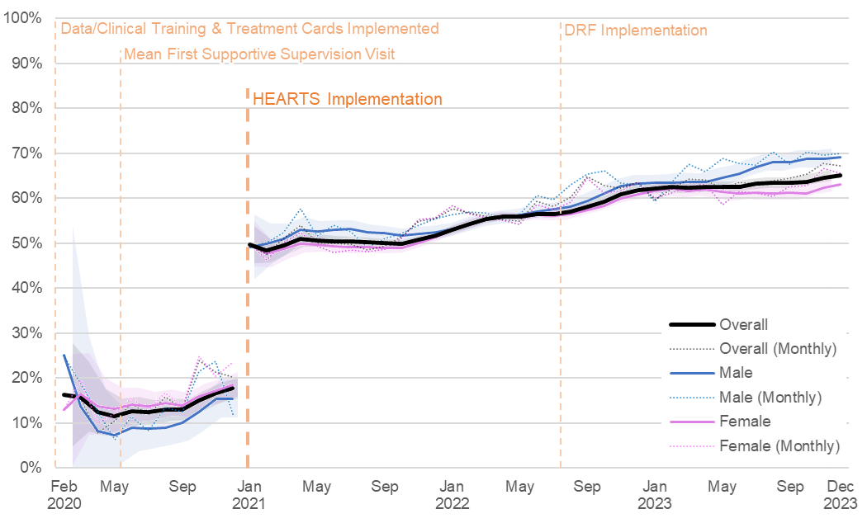
 | Pre-Implementation |  |  |  | Post-Implementation
 | Baseline  (Feb 2020ª) | Slope Per Month^{b} |  | Level Change at Implementation^{c} |  | Baseline  (Jan 2021)^{c} | Slope Per  Month^{b} | End  (Dec 2023^{b}) | Pre- vs.  Post^{d}
Overall, β (95% CI)
 | 16.3%  (4.8%, 27.8%) | 0.1%  (-0.2%, 0.4%) |  | 32.1%  (30.7%, 33.5%) |  | 49.6%  (45.5%, 53.8%) | 0.5%  (0.4%, 0.6%) | 65.2%  (64.0%, 66.3%) | 0.4%  (0.04%, 0.8%)
 | - | 0.49 |  | <.0001 |  | - | <.0001 | - | 0.03
Male, β (95% CI)
 | 25.0%  (0.0%, 53.7%) | -0.8%  (-1.7%, 0.1%) |  | 33.9%  (29.8%, 38.0%) |  | 49.2%  (42.1%, 56.4%) | 0.7%  (0.6%, 0.8%) | 69.2%  (67.3%, 71.1%) | 1.5%  (0.5%, 2.5%)
 | - | 0.08 |  | <.0001 |  | - | <.0001 | - | 0.01
Female, β (95% CI)
 | 12.9%  (0.4%, 25.4%) | 0.4%  (0.0%, 0.7%) |  | 29.9%  (28.0%, 31.8%) |  | 49.9%  (44.8%, 54.9%) | 0.5%  (0.4%, 0.6%) | 63.0%  (61.6%, 64.5%) | 0.1%  (-0.2%, 0.5%)
 | - | 0.04 |  | <.0001 |  | - | <.0001 | - | 0.48
ª First full month of enrollment; ^{b} 6-month rolling; ^{c} 6-month rolling recommenced; ^{d} Comparison of pre- and post-implementation slopes
Abbreviations: DRF, Drug Revolving Fund

Supplemental Table 6. Adverse Events, by Implementation Period.
N Patients  (N Occurrences) | Total  Nª=21,922 | Pre-Implementation  Nª=5,506 | Implementation  Nª=19,667
Deaths | 92 | 13 | 79
Adverse events | 45 | 19 | 26
Acute kidney injury | 0 | 0 | 0
Angioedema | 1 (1) | 0 | 1 (1)
Cough | 2 (2) | 1 (1) | 1 (1)
Dizziness | 16 (17) | 9 (10) | 7 (7)
Electrolyte abnormality | 0 | 0 | 0
Erectile dysfunction^{b} | 1 (1) | 1 (1) | 0
Feverᵃ | 1 (1) | 1 (1) | 0
Insomniaᵃ | 1 (1) | 0 | 1 (1)
Low blood pressure^{b,c} | 14 (15) | 0 | 14 (15)
Low heart rate^{b} | 1 (1) | 0 | 1 (1)
Low libido^{b} | 1 (1) | 0 | 1 (1)
Pain^{b,d} | 2 (2) | 2 (2) | 0
Partial paralysis^{b} | 1 (1) | 1 (1) | 0
Poor visionᵃ | 1 (2) | 1 (2) | 0
(Partial) Stroke^{b} | 4 (4) | 3 (3) | 1 (1)
Syncope | 0 | 0 | 0
Weaknessᵃ | 2 (2) | 2 (2) | 0
ª Patients seen
^{b} Not systematically tracked; adverse events were disclosed via free-text comment
^{c} Reported as such by healthcare worker
^{d} n=1 stomach pain after taking medications, n=1 left upper arm

Supplemental Figure 1. Participant Flowchart: Enrollment and Inclusion.
Excluded (n=323)
Did not meet inclusion criteria:
- No Patient Visit (n=31)
- No Hypertensionª (n=44)
- Sex Unspecified (n=5)
- Age Unspecified (n=246)
Enrolled (n=22,245)
Analyzed (n=21,922)
ª Patients without a pre-existing hypertension diagnosis who had blood pressure < 140/90 mmHg and were not prescribed blood pressure-lowering medication at the first patient visit.
^{b} Patients were considered active from enrollment through their last visit.
NB: Patients with multiple visits in a month were counted only once.

