Authors profile:
- Hassan Abdelnour.
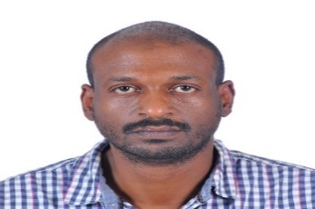
Assistant Professor, Physiotherapy Department, Faculty of Allied Medical Sciences, Jerash University, Jerash, Jordan.
Email contact: hasphysio@gmail.com
ORCID ID: https://orcid.org/0009-0001-9873-5966

- Norhan Hawari.
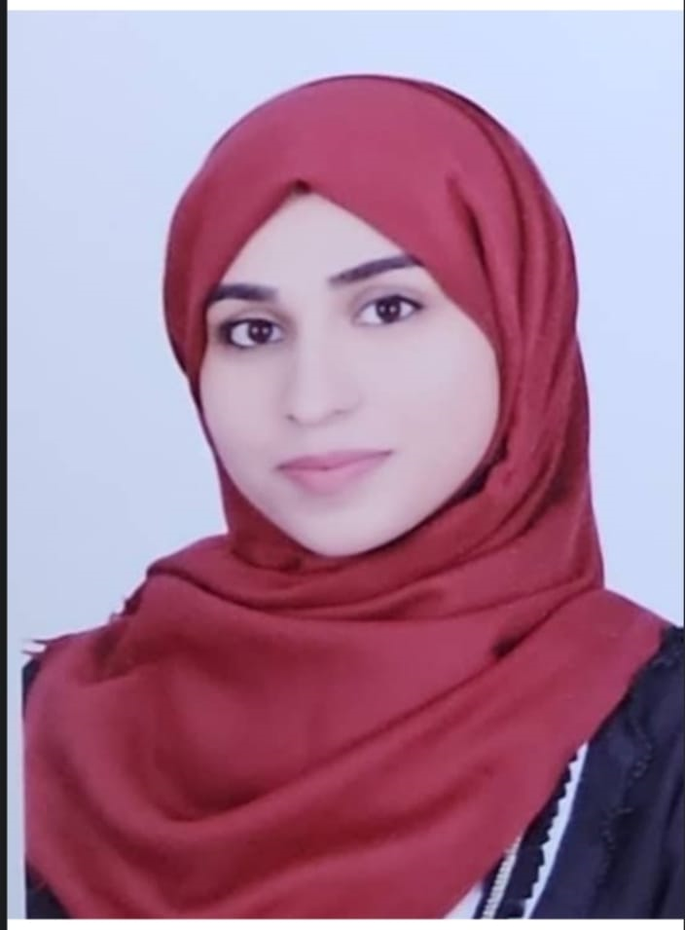
MSc student, Department of Clinical Rehabilitation Sciences, Faculty of Applied Medical Sciences, Jordan University of Sciences and Technology, Irbid, Jordan.
Email contact: hawarinorhan@gmail.com
ORCID ID: https://orcid.org/0009-0000-7643-0523

- Omnia Mortada.
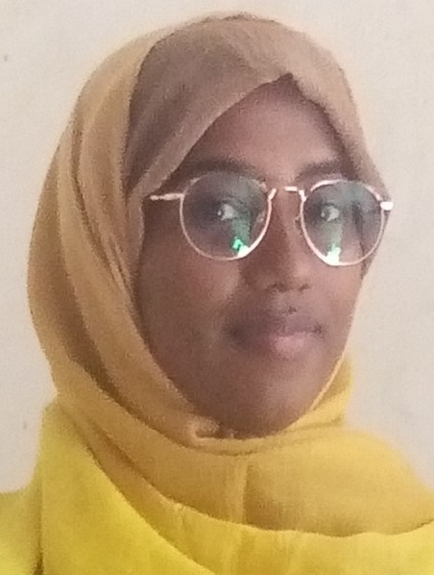
BSc Physiotherapy, Physiotherapy Department, School of Health Sciences, Ahfad University for Women, Omdurman, Sudan.
Email contact: mememortada999@gmail.com
ORCID ID: https://orcid.org/0009-0006-0295-8046

- Sulwan Yagoub.
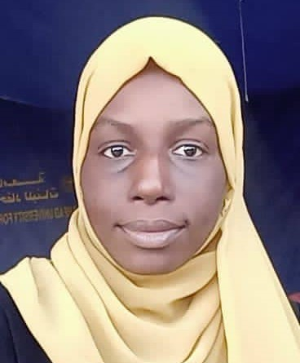
BSc Physiotherapy, Physiotherapy Department, School of Health Sciences, Ahfad University for Women, Omdurman, Sudan.
Email contact: sulwanyagoub@gmail.com
ORCID ID: https://orcid.org/0009-0004-5294-10

