Supplementary Information

EIS measurement
Figure S1(a) presents the EIS measurements of the iontronic diode at five different operating points: -1V, -0.5V, 0V, 0.5V, and 1V. The measurements span frequencies from 0.1 Hz to 1 MHz. In Figure S1(b), the circuit on the left represents the equivalent circuit used for fitting the data (the fitted results are shown as dashed lines in FigureS1(a)). After examining the behavior of each component with respect to the applied DC voltage, we concluded that a simpler equivalent circuit (middle circuit in Figure S1(b)) could also fit the data. The values of C₀₁ and R₁, C₀₁ can be neglected at lower frequencies, thus enabling the circuit on the right depicted in Figure S1b to describe the system's behavior.
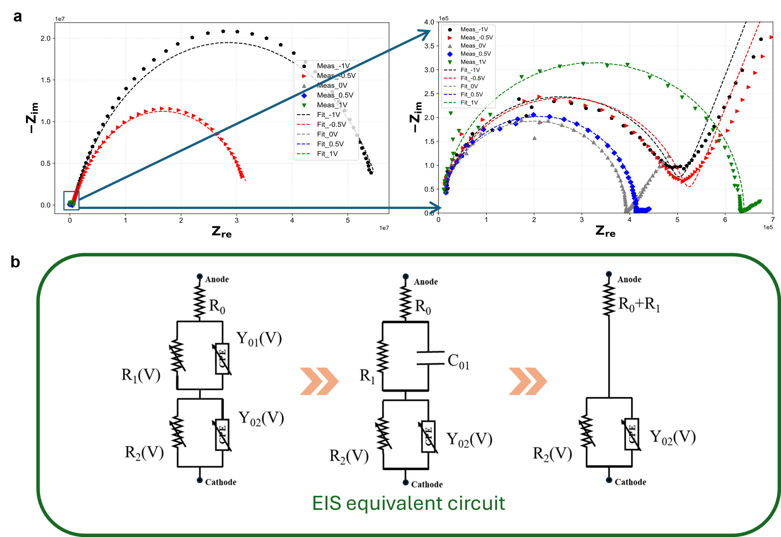
Figure S 1: (a) EIS measurements of the iontronic diode operating at voltage points of: -1V, -0.5V, 0V, 0.5V, and 1V (0.1 Hz to 1 MHz). The dashed lines represent the fitting of the left circuit model from (b) to the measured data. (b) Equivalent circuit models for data fitting: left (full model), middle (simplified model), and right (neglecting C01 at low frequencies).

I_{on} and I_{off} measurements on a chip with 15 integrated diodes

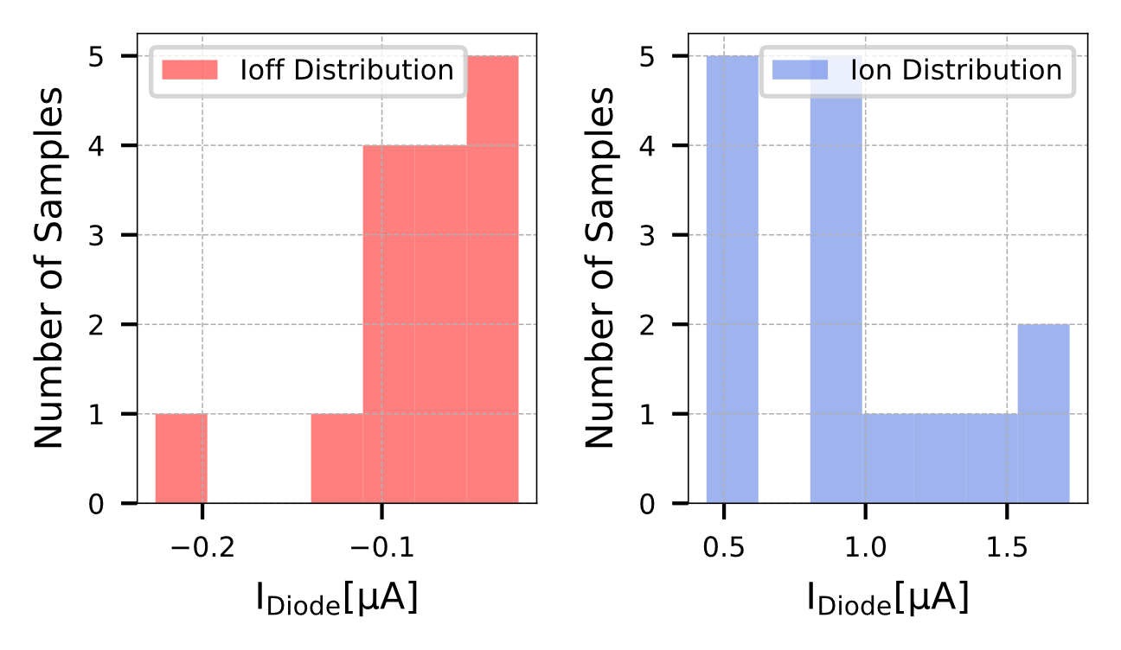
Figure S 2 Distribution of I_{on} and I_{off} in a chip with 15 integrated diodes: The variations observed in the electrical characteristics of an integrated chip with 15 diodes. The differences were caused by variations during chip fabrication. Ioff and Ion are the diode’s current when applying a $V_{Diode}$ equal to -1V and 1V, respectively.

