Supplementary Information

Title
Wearable intelligent throat enables natural speech in stroke patients with dysarthria

Authors
Chenyu Tang^{†1}, Shuo Gao^{†*2}, Cong Li^{†2}, Wentian Yi¹, Yuxuan Jin³, Xiaoxue Zhai⁴, Sixuan Lei⁵, Hongbei Meng², Zibo Zhang¹, Muzi Xu¹, Shengbo Wang², Xuhang Chen⁶, Chenxi Wang², Hongyun Yang², Ningli Wang⁷, Wenyu Wang⁸, Jin Cao⁹, Xiaodong Feng¹⁰, Peter Smielewski⁶, Yu Pan⁴, Wenhui Song¹¹, Martin Birchall¹², and Luigi G. Occhipinti^{*1}

Affiliations
¹Department of Engineering, University of Cambridge, Cambridge, UK
²School of Instrumentation and Optoelectronic Engineering, Beihang University, Beijing, China
³Cavendish Laboratory, University of Cambridge, Cambridge, UK
⁴Department of Rehabilitation Medicine, Beijing Tsinghua Changgung Hospital, Tsinghua University, Beijing, China
⁵Shenzhen International Graduate School, Tsinghua University, Shenzhen, China
⁶Department of Clinical Neurosciences, University of Cambridge, Cambridge, UK
⁷Beijing Tongren Hospital, Capital Medical University, Beijing, China
⁸Thrust of Smart Manufacturing, Hong Kong University of Science and Technology (Guangzhou)
⁹School of Life Sciences, Beijing University of Chinese Medicine, Beijing, China
¹⁰Department of Rehabilitation Center, The First Affiliated Hospital of Henan University of Chinese Medicine, Zhengzhou, China
¹¹Department of Surgical Biotechnology, University College London, London, United Kingdom
¹²Royal National Ear Nose and Throat and Eastman Dental Hospitals, University College London Hospital, London, UK

†These authors contributed equally: Chenyu Tang, Shuo Gao, Cong Li,
*Correspondence to: Shuo Gao (shuo_gao@buaa.edu.cn) and Luigi G. Occhipinti (lgo23@cam.ac.uk)

Supplementary Note 1-2
Supplementary Figure 1-13
Supplementary Table 1-4

Supplementary Video Captions 1-2

Supplementary Note 1: Background and motivation of this study

What is dysarthira and why it is a significant issue?
Dysarthria, a motor speech disorder, significantly impacts patients' quality of life, hindering their ability to communicate and leading to complex physical and psychological challenges. Originating from neuromuscular impairments, dysarthria affects the voluntary control of muscles involved in speech, including the laryngeal, pharyngeal, and facial muscles. This disorder spans across various neurological conditions such as stroke, ALS, Parkinson’s disease, multiple sclerosis, and traumatic brain injuries. Notably, dysarthria occurs in approximately 20–30% of stroke patients, 80–90% of ALS patients, and 60–70% of those with Parkinson's disease, making it a prevalent issue across these populations. These impairments disrupt the nervous system's coordination of speech-related muscle movements, resulting in challenges with articulation, phonation, and resonance, which severely limits effective communication [1, 2, 3, 4].

Beyond communication barriers, dysarthria poses broader consequences that affect both the physical and mental well-being of patients. Social isolation is a prevalent issue, as individuals with dysarthria often struggle to express their thoughts and emotions, leading to a sense of disconnection from those around them. This isolation can create a compounding effect, contributing to heightened levels of anxiety and depression [5, 6]. Furthermore, communication challenges hinder rehabilitation by making it difficult for patients to convey their needs and responses during therapy sessions, which is crucial for personalized adjustments in treatment. This lack of effective feedback can compromise therapeutic outcomes, potentially placing additional physiological strain on patients as they navigate rehabilitation with limited adaptive support [7, 8].

To alleviate these multifaceted challenges, there is an urgent need for augmentative and alternative communication (AAC) technology that enables fluid and contextually rich communication in diverse settings, helping patients restore a sense of connection and control. Effective communication solutions can improve quality of life, reduce mental health risks, and enhance the efficacy of rehabilitation, ultimately promoting holistic well-being for individuals affected by dysarthria.

BCIs achieved remarkable success in complete paralysis cases, yet not enough for broader dysarthria applications
Brain-computer interface (BCI)-based AAC systems are among the most advanced approaches developed for individuals with severe communication impairments. These systems are particularly effective for patients experiencing near-total paralysis, such as those with locked-in syndrome or advanced stages of ALS, where voluntary control over the facial, laryngeal, and other speech-related muscles is completely lost. By bypassing the motor system entirely, BCIs translate brain activity into direct communication output, often through technologies like EEG, ECoG, or even implanted electrodes. For patients with no means of physical communication, BCI-based systems have opened critical avenues for re-engaging with the world, restoring a level of independence and connection that would otherwise be inaccessible [9, 10].

However, despite their transformative potential, BCI-based AAC systems come with significant limitations, especially in terms of accessibility and user-friendliness. First, these systems are often complex and cumbersome, requiring substantial technical setup, ongoing calibration, and expert supervision, which limits their usability in day-to-day environments outside of clinical or highly controlled settings. Additionally, the need for electrodes and the relatively invasive nature of some setups contribute to a lack of portability and comfort, rendering BCI systems impractical for routine, non-hospital use. This limited practicality is compounded by the often substantial cost and the invasive procedures associated with implant-based BCI solutions, making them inaccessible to many who might benefit from an alternative, less intrusive approach.

For patients who retain some voluntary control over facial or laryngeal muscles—an ability present in most dysarthria cases—the limitations of BCI systems highlight a need for more intuitive, accessible solutions that can integrate seamlessly into daily life without sacrificing portability or comfort.

Wearable silent speech systems: progress and persistent gaps
Wearable silent speech systems represent a promising, non-invasive alternative to BCIs for patients with moderate dysarthria who retain partial neuromuscular control over speech-related muscles. These systems capture subtle, non-acoustic signals, such as muscle vibrations or electrophysiological signals generated through silent articulation, offering a portable and user-friendly solution for those unable to communicate verbally. Unlike BCIs, wearable silent speech systems allow for relatively seamless integration into daily life, bringing potential for greater accessibility and comfort [11-15].

However, despite these advances, wearable silent speech systems still face three significant gaps that limit their ability to deliver truly natural and expressive communication:

- Lack of zero-delay expression: Current wearable silent speech systems often rely on fixed time windows (e.g., 1–3 seconds) for word decoding. For example, Kim et al. utilized a 2s time window in decoding a 100 words dataset [13], and Tang el al. utilized a 3s time window to decode a 30 words dataset [14]. This timing requires users to complete each word within a set interval and pause before continuing, leading to fragmented and artificial expression. In real-world communication, fluency is crucial, as it allows for spontaneous, uninterrupted conversation that reflects natural speaking patterns. Without zero-delay expression, users must adjust their speech to the constraints of the device, resulting in an unnatural and often frustrating communication experience.

- Limited emotional and logical coherence: Another major limitation is the lack of emotional expressiveness and contextual coherence in the sentences generated by current systems. Natural speech is more than a series of words; it conveys emotions, intonations, and logical transitions that help the listener understand the speaker’s intent. Without the ability to capture these nuances, wearable silent speech systems fail to provide a complete and effective communication solution. However, all current silent speech systems can only decode fixed words or sentences, lacking in-depth analysis of emotions and logic [11-15].

- Restricted accessibility for patient populations: Finally, the accessibility of wearable silent speech systems for a broad range of patients remains limited. Most current systems are tested primarily on healthy individuals, with limited clinical validation among dysarthric patients. Yang et al. were the first to test their developed silent speech system on a patient with speech impairment (one post-laryngectomy patient). However, while the system achieved over 99% accuracy in healthy individuals, this accuracy dropped sharply to 90% when transferred to the patient [11]. Without extensive testing and refinement tailored to patients with varying neuromuscular abilities, these silent speech devices may not meet the unique needs of dysarthria patients, especially those with complex neurological conditions. This gap in accessibility underscores the need for more inclusive designs and expanded clinical trials to better serve the dysarthria population.

The intelligent throat: bridging key gaps in wearable silent speech systems
Therefore, we developed the Intelligent Throat (IT) system to address these critical issues, enabling zero-delay expression, enhancing emotional and logical coherence in generated sentences, and expanding accessibility for a broader range of dysarthric patients. By integrating flexible sensing, electronics, and artificial intelligence technologies, the IT system provides an intuitive, real-time communication platform specifically designed for stroke patients with dysarthria, thereby enhancing their social engagement, independence, and quality of life, and helping them reconnect with the world around them on their own terms. Below is a figure showing the comparison between the IT system and state-of-the-art wearable silent speech systems.
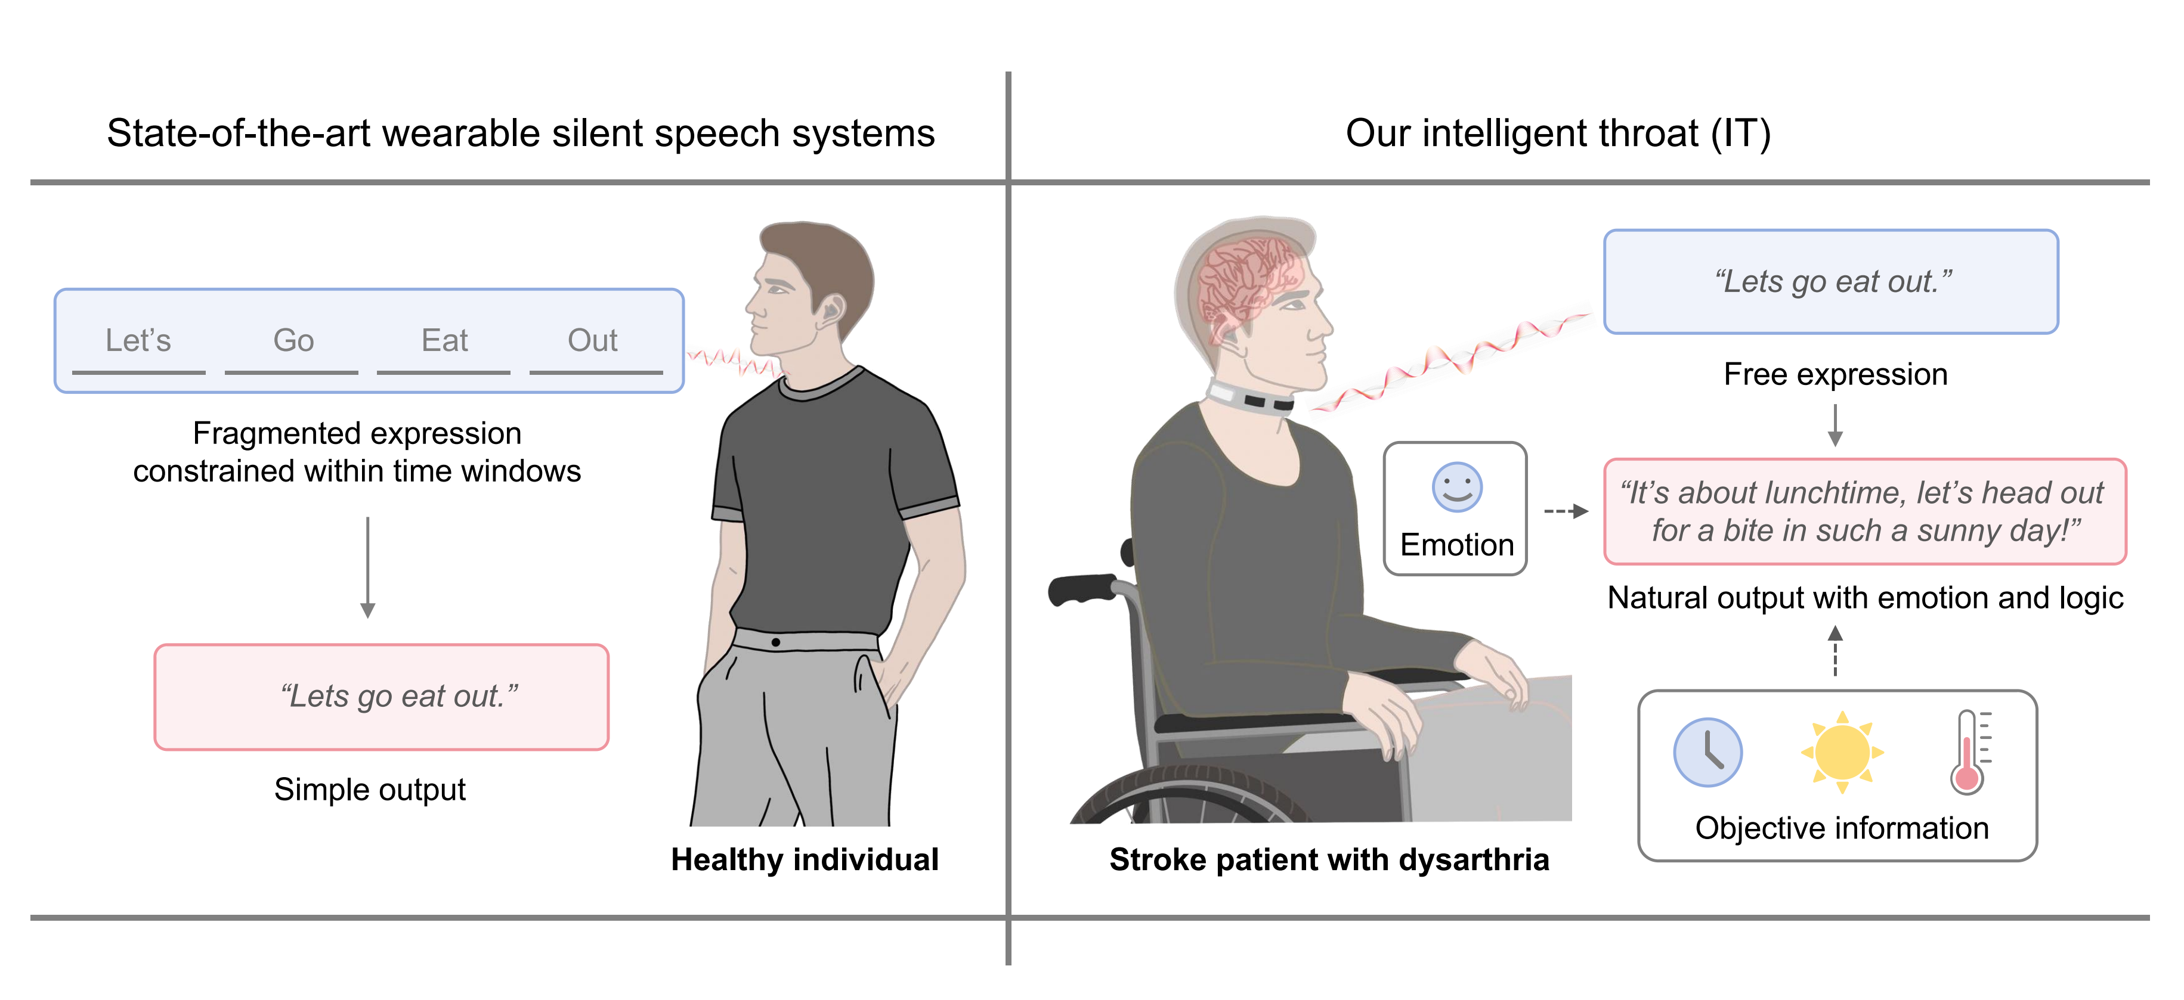Supplementary Note Figure: Comparison between the IT system and state-of-the-art wearable silent speech systems.

Supplementary Note 2: The latency analysis of the IT system
This note provides an in-depth latency analysis for each component within the IT system. Key elements include PCB transmission, ML computation, LLM generation, and text-to-speech (TTS) synthesis. While the IT system allows for “zero-delay expression,” providing uninterrupted and continuous speech without requiring pauses for word segmentation, it does not fully eliminate communication delay due to waiting for sentence completion. This inherent waiting delay, marked by detecting blank tokens at the end of a sentence, is common in silent speech systems and unavoidable for coherent sentence synthesis. Below, we quantify each source of latency based on theoretical and empirical estimations.

1. PCB transmission latency
The IT system’s PCB facilitates the acquisition and transmission of silent speech and carotid pulse signals. The transmission latency includes data acquisition and data transmission components:
Data acquisition delay: This delay is based on the analog-to-digital converter (ADC) clock and sampling period, yielding a data acquisition delay of 173.33 μs.
Data dransmission delay: Calculated based on the baud rate of the serial communication port and the data volume, the data transmission delay is approximately 26.04 μs.
Thus, the total PCB transmission latency is minimal, at 199.37 μs (or approximately 0.2 ms).

- Machine learning model computation latency
The machine learning latency in the IT system arises primarily from the token decoding model, which processes silent speech signals, and the emotion decoding model, which processes carotid pulse signals for emotional context. The token decoding model has a larger computational demand, with a requirement of 0.738 GFLOPs (student model, 1D ResNet-18), while the emotion decoding model’s computation load is considerably smaller. Given the multi-threading capabilities of modern CPUs, the emotion decoding model can execute concurrently with the token decoding model, effectively making its latency negligible in the overall system performance. Therefore, we focus on estimating the token decoding model’s latency.
Token decoding model
Assuming a typical CPU with a processing efficiency of 10 GFLOPs/ms (common in modern, low-power multi-threaded processors), the estimated computation time for the token decoding model is:
Token Decoding Model Latency: With 0.738 GFLOPs required, the processing time on a 10 GFLOP/ms-capable CPU is approximately 0.0738 ms.
This minimal processing time enables real-time, efficient token decoding, making it feasible for the IT system’s continuous, delay-free expression.

- LLM generation latency
For a lightweight GPT-4-based API, the sentence generation time typically ranges from 100-150 ms, depending on context length. For this analysis, we use an average LLM generation delay of 125 ms.
This latency, while relatively longer than PCB and ML computation delays, remains acceptable for real-time interaction, as it occurs only at the end of a sentence and does not impact the continuous speech decoding process.

- Text-to-speech (TTS) synthesis and playback latency
Once the LLM generates a sentence, the system uses a TTS model to produce a synthesized audio output matching the user’s natural voice. The TTS synthesis and playback latency involve:
TTS model inference delay: With a lightweight, open-source TTS model (such as Tacotron 2 or FastSpeech, here we utilized ByteDance Volcano Engine TTS) capable of real-time synthesis, generating a sentence (around 10 words) takes approximately 150-200 ms.
Audio playback delay: Standard audio playback latency is negligible, typically <10 ms on most devices.
Thus, the TTS synthesis and playback latency totals approximately 160-210 ms, with 180 ms as the average estimate.

Total latency summary
PCB transmission: ~0.2 ms
ML computation (token decoding model): ~0.0738 ms
LLM generation: ~125 ms
TTS synthesis and playback: ~200 ms
The combined theoretical latency of the IT system is approximately 325.27 ms. In practical tests, however, an average delay of ~1s was observed between the end of the user’s silent expression and the playback of the synthesized sentence. This observed latency accounts for a redundancy measure, where the system waits for the detection of five consecutive blank tokens to confirm sentence completion, enhancing real-world stability.
While the ML model’s computation latency is nearly negligible compared to LLM generation and TTS synthesis, optimizing computational power remains essential, especially as future deployments target edge computing devices. Knowledge distillation is therefore vital, compressing the ML model to reduce both computational load and energy consumption, making the system feasible for practical, long-term wearable applications.

Zero-delay expression vs. zero-delay communication
The IT system introduces “zero-delay expression,” allowing users to communicate naturally and continuously without pauses or fixed time windows for word segmentation. This high-resolution token segmentation enables a seamless flow of speech, setting a new benchmark for wearable silent speech systems.However, “zero-delay communication” is not fully attainable with SSI systems, as decoding only begins once the user has finished speaking. This inherent delay stems from the need for the silent speech action itself to complete before generating the strain signals required for processing. Unlike systems that might anticipate input, SSI-based approaches naturally rely on the completion of silent articulation, creating a trade-off between real-time, intuitive user interaction and this fundamental latency. Despite this structural limitation, our IT system optimally balances continuous expression with the brief delay required for sentence decoding, establishing a powerful and practical tool for dysarthria patients. By enabling expressive, natural interaction, the IT system reintroduces ease and fluidity into daily communication.
Supplementary Figure 1: Schematic of the printing process. The number of prints refers to the number of cycles the substrate is printed for. During each cycle, the silk frame is lowered to the substrate, the flood blade travels backward to spread the ink, the squeegee travels to print, and the silk frame is raised to leave the substrate.

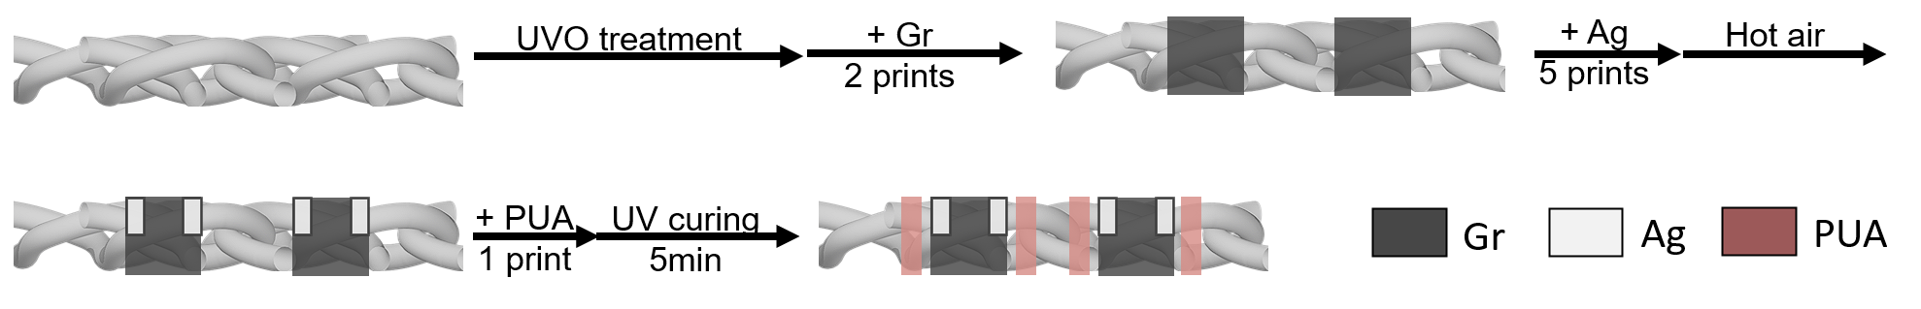
Supplementary Figure 2: Finite element analysis (FEA) simulation for strain distribution of the smart choker under 40% of uniaxial tensile.

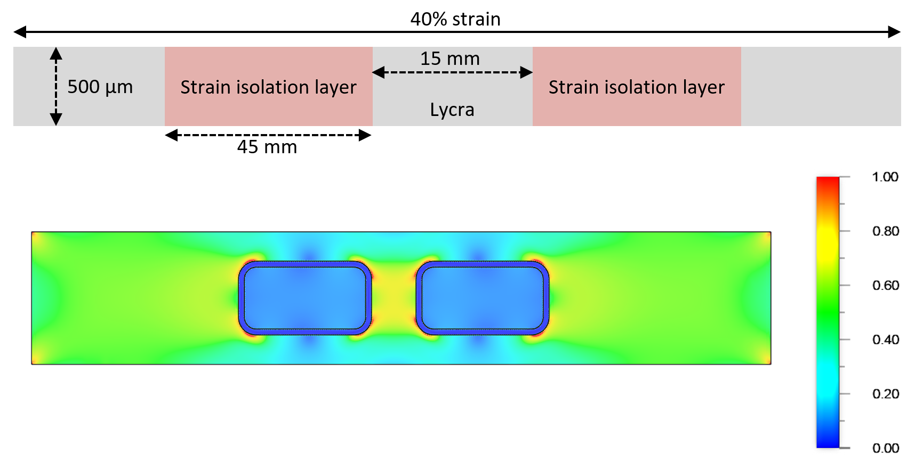

Supplementary Figure 3: Sweat environment test on the sensing area of the artificial throat. According to ISO 3160-2 standard, we prepared artificial sweat solution consisting of 20 g/L sodium chloride (NaCl), 17.5 g/L ammonium chloride (NH4Cl), 5 g/L urea, 2.5 g/L acetic acid (CH3COOH), 15 g/L lactic acid, 80 g/L sodium hydroxide (NaOH) for pH adjustment, and deionized water. The pH of the solution was adjusted to 4.7 using NaOH. Sweat volumes were calculated based on the surface area of the smart garment's sensing area, with minimum (0.32 mg/cm²/min) and maximum (2.7 mg/cm²/min) sweat rates applied over a 10-minute period [16]. The calculated artificial sweat was evenly distributed across the sensing area using a pipette. The artificial throat was in the environment of 16 °C, 63% RH for the duration of the test.

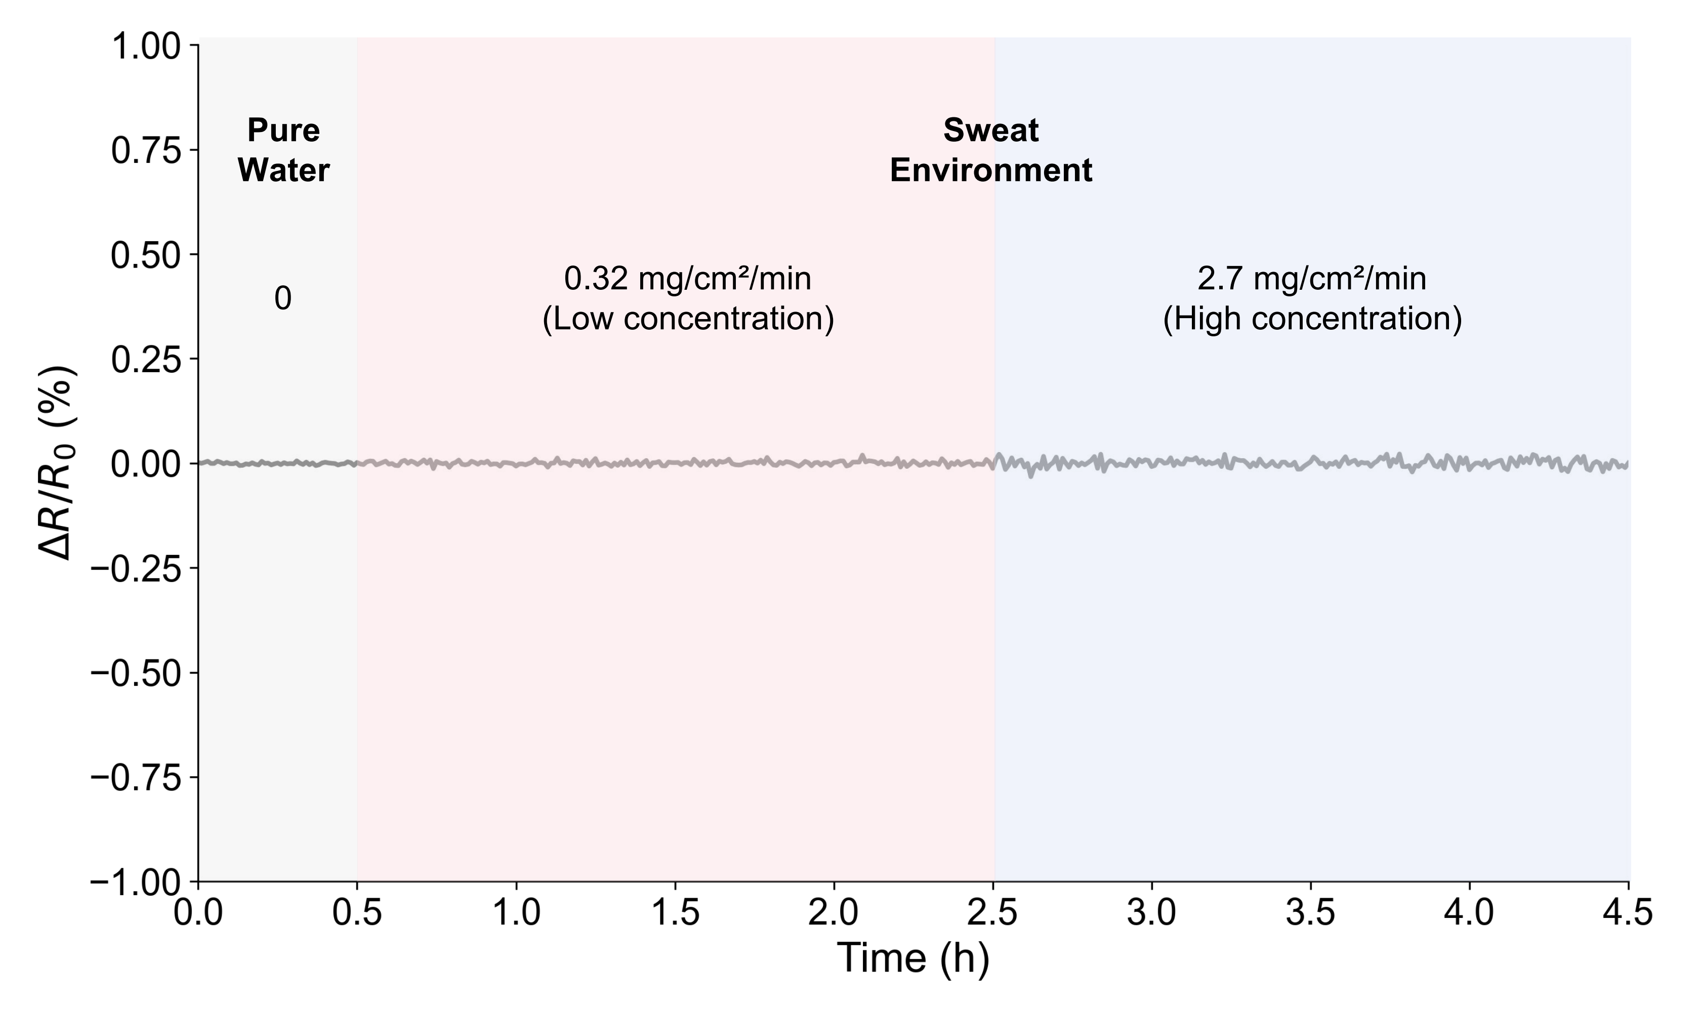
Supplementary Figure 4: Circuit schematic of IT’s electronic system.

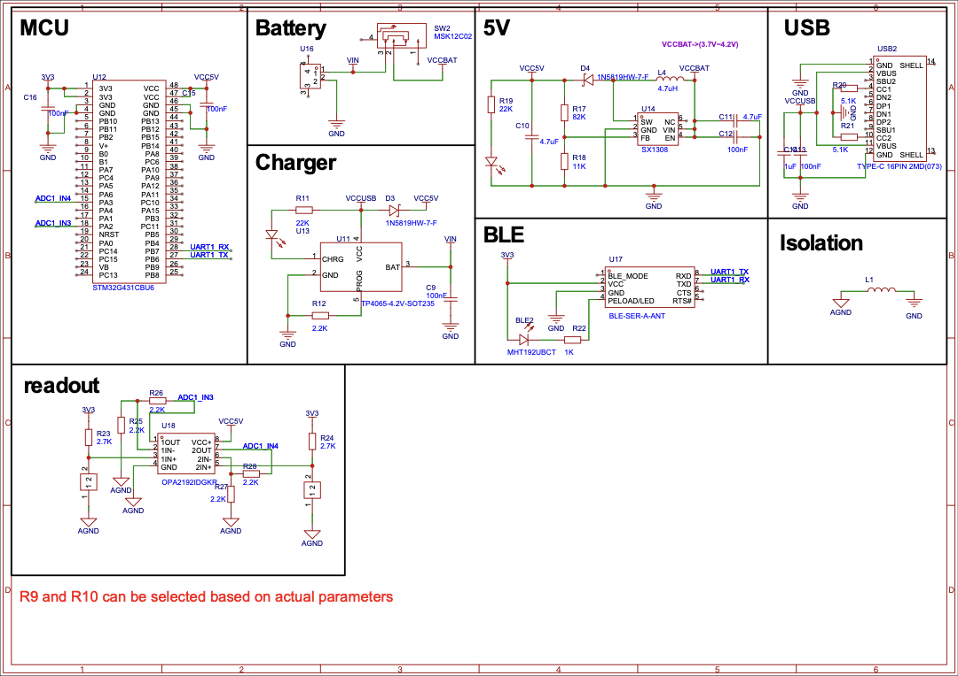

Supplementary Figure 5: The miniaturized PCB of IT system.
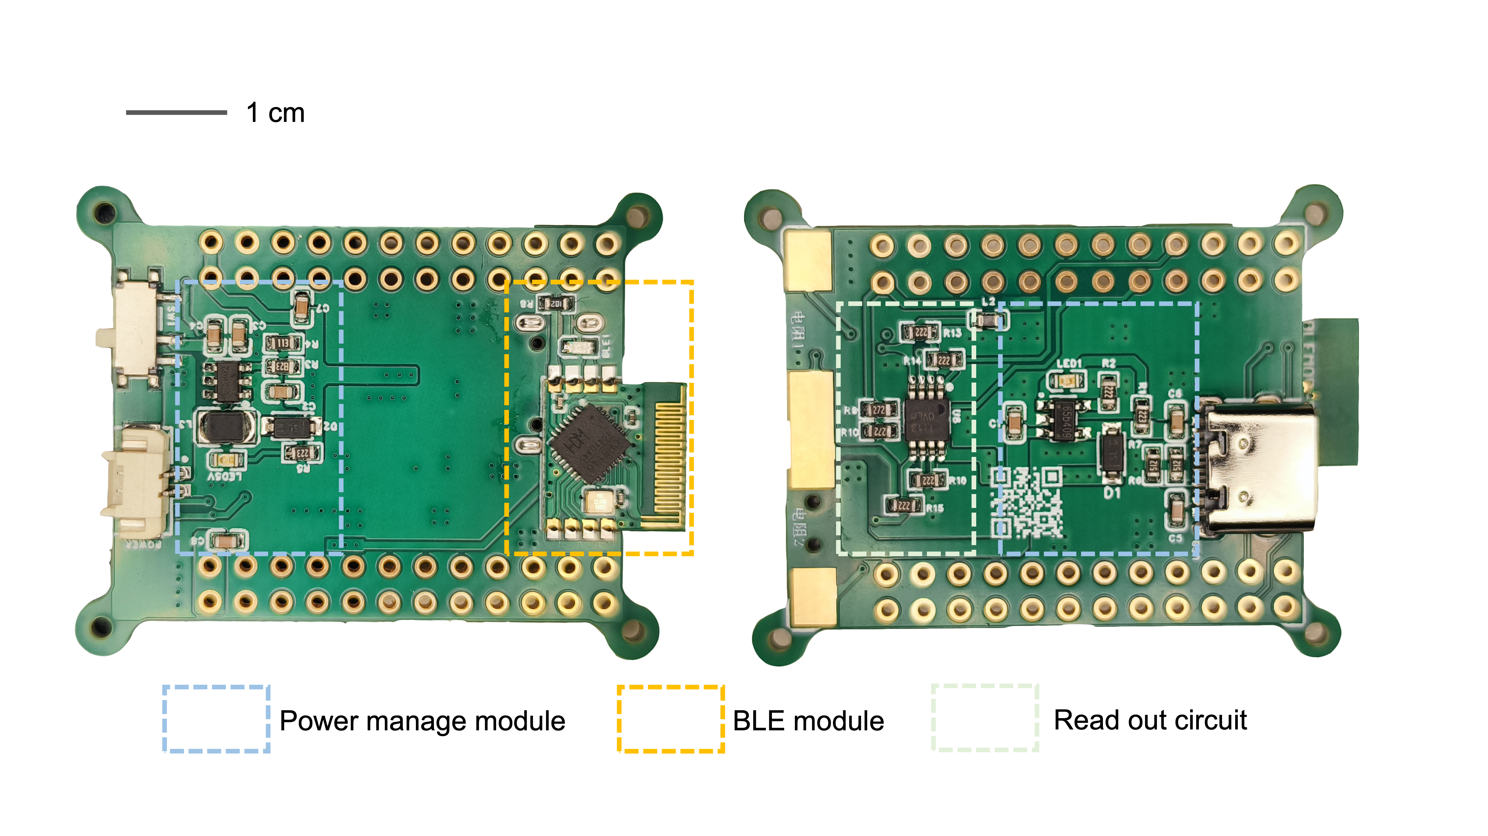

Supplementary Figure 6: Time-frequency spectrogram display of silent speech signals.

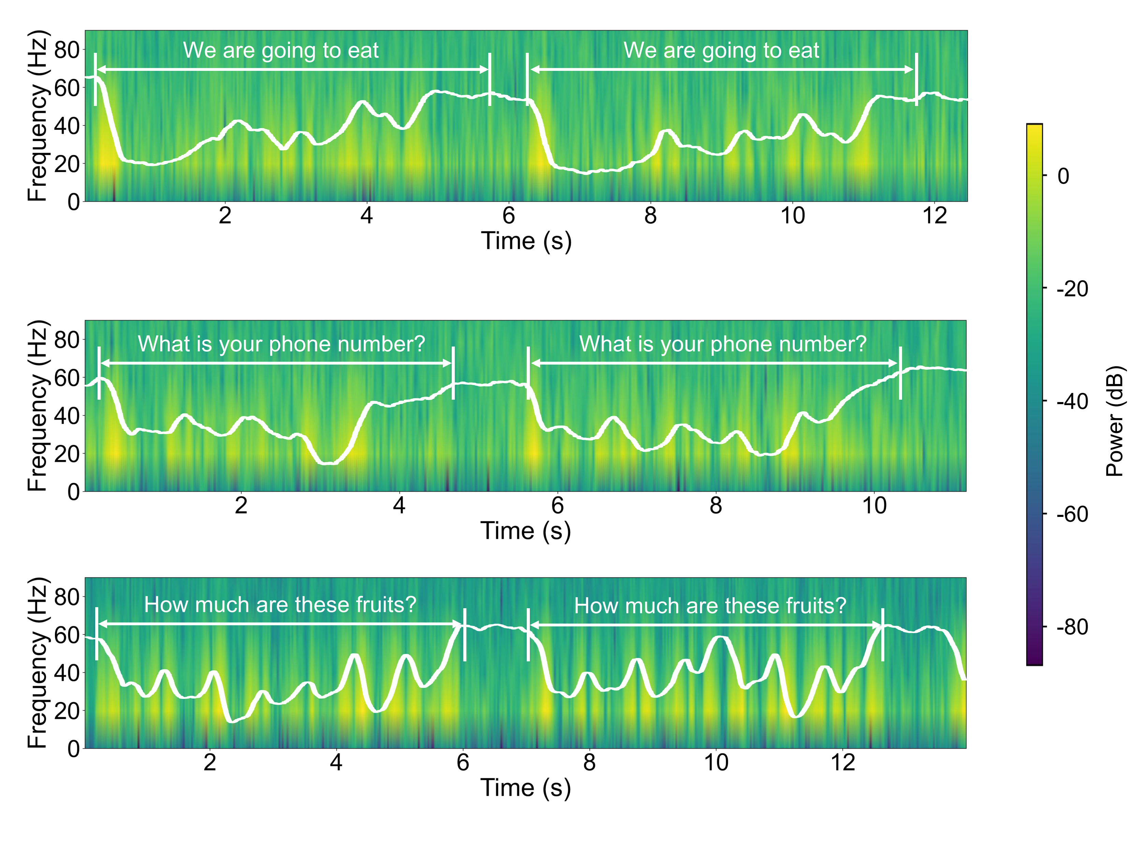

Supplementary Figure 7: Time-frequency spectrogram display of pulse signals.

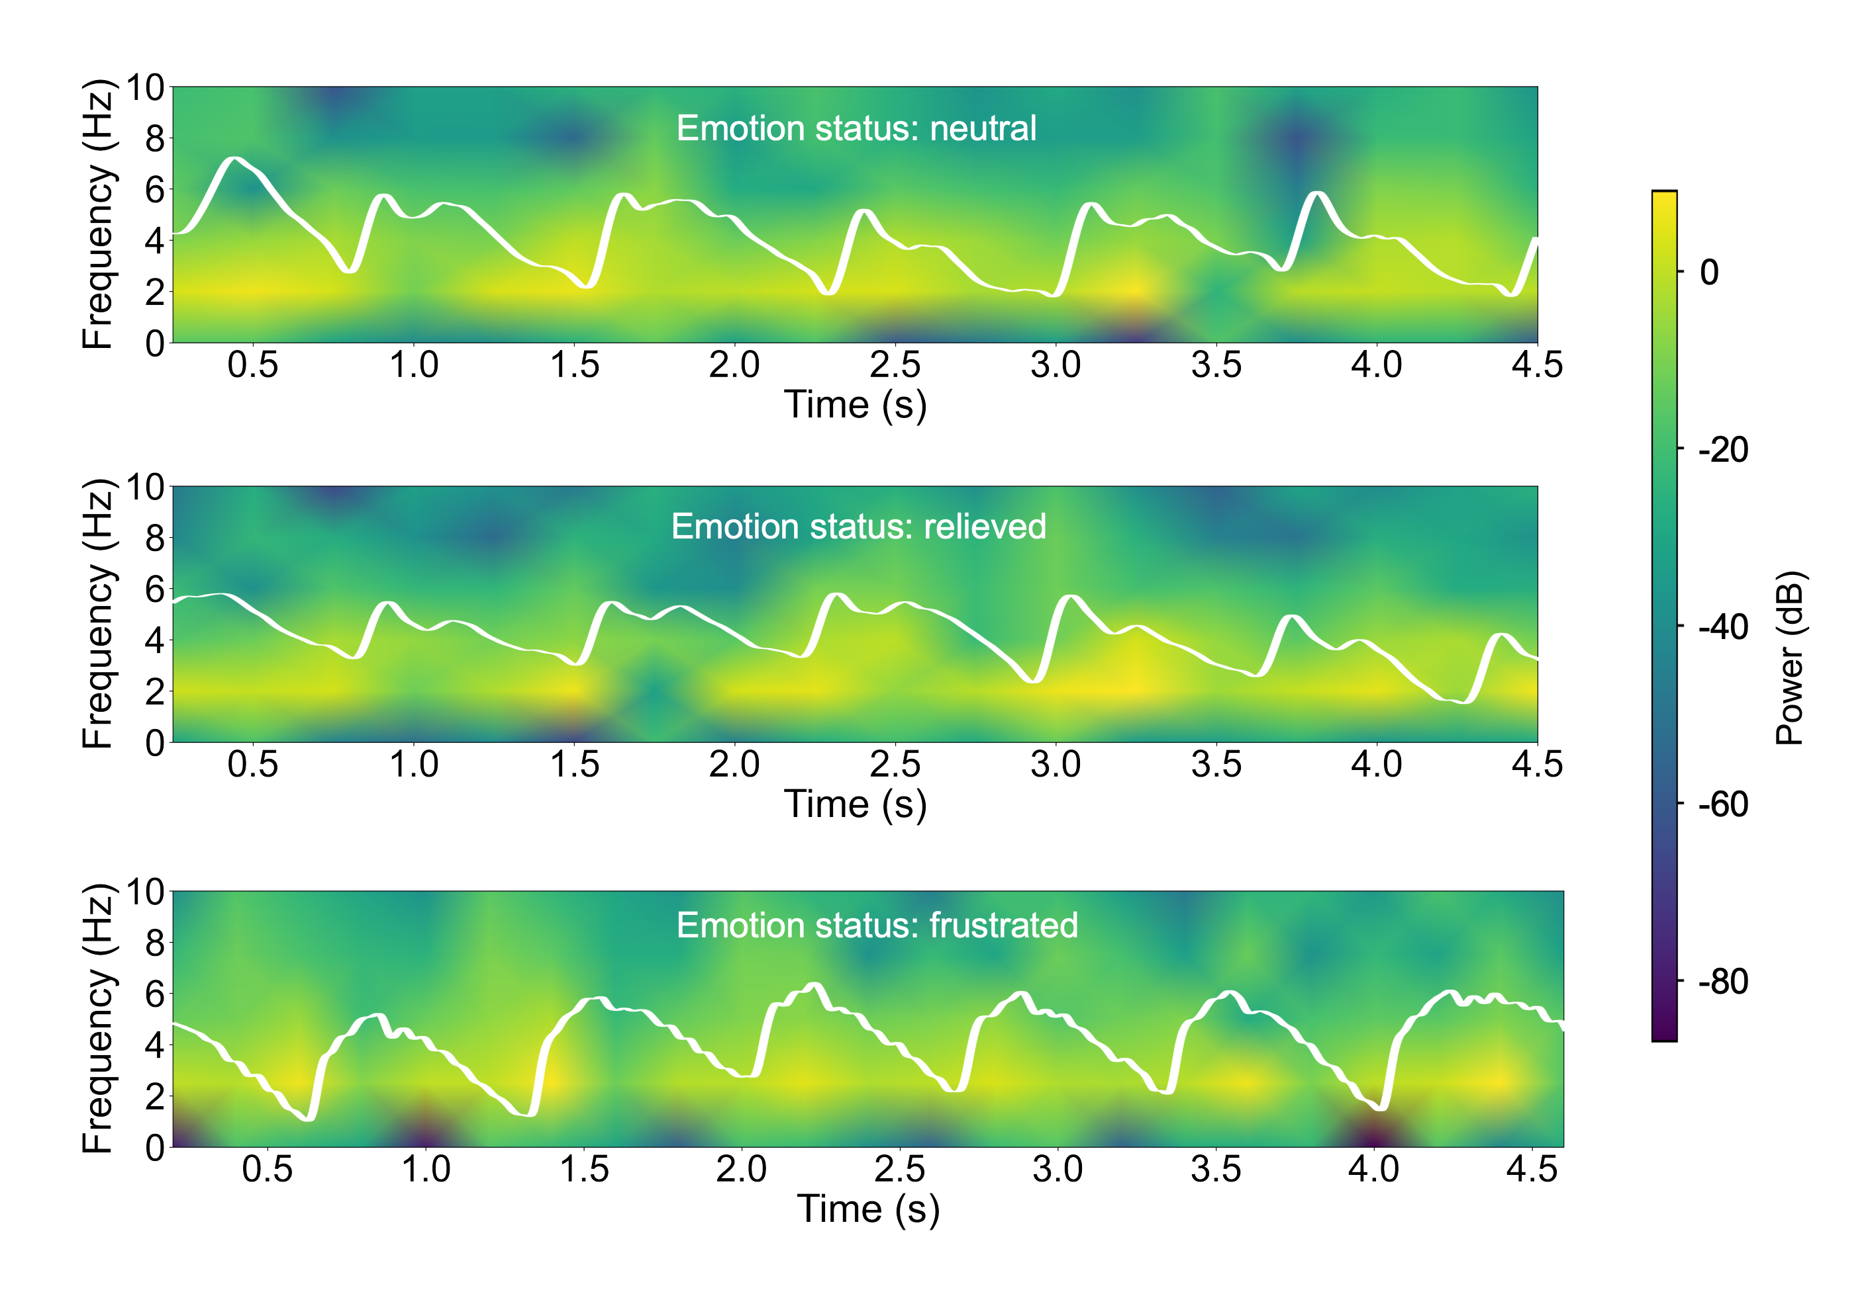

Supplementary Figure 8: The optimal parameters and training curves of the final token decoding model (with 1D ResNet-101 as the teacher model and 1D ResNet-18 as the student model). After pre-training on healthy individuals’ data, fine-tuning on patients’ data, and transferring to the more computationally efficient 1D ResNet-18 via knowledge distillation, the model achieved a token decoding accuracy of 91.3%. Notably, in the pre-training stage, we trained for only 10 epochs; although continued training could further reduce the loss, testing revealed that a lower pre-train loss did not improve the final performance. We believe this is because overtraining during the pre-training phase may lead the model to overfit to healthy individuals' silent speech features, thereby reducing its generalizability.

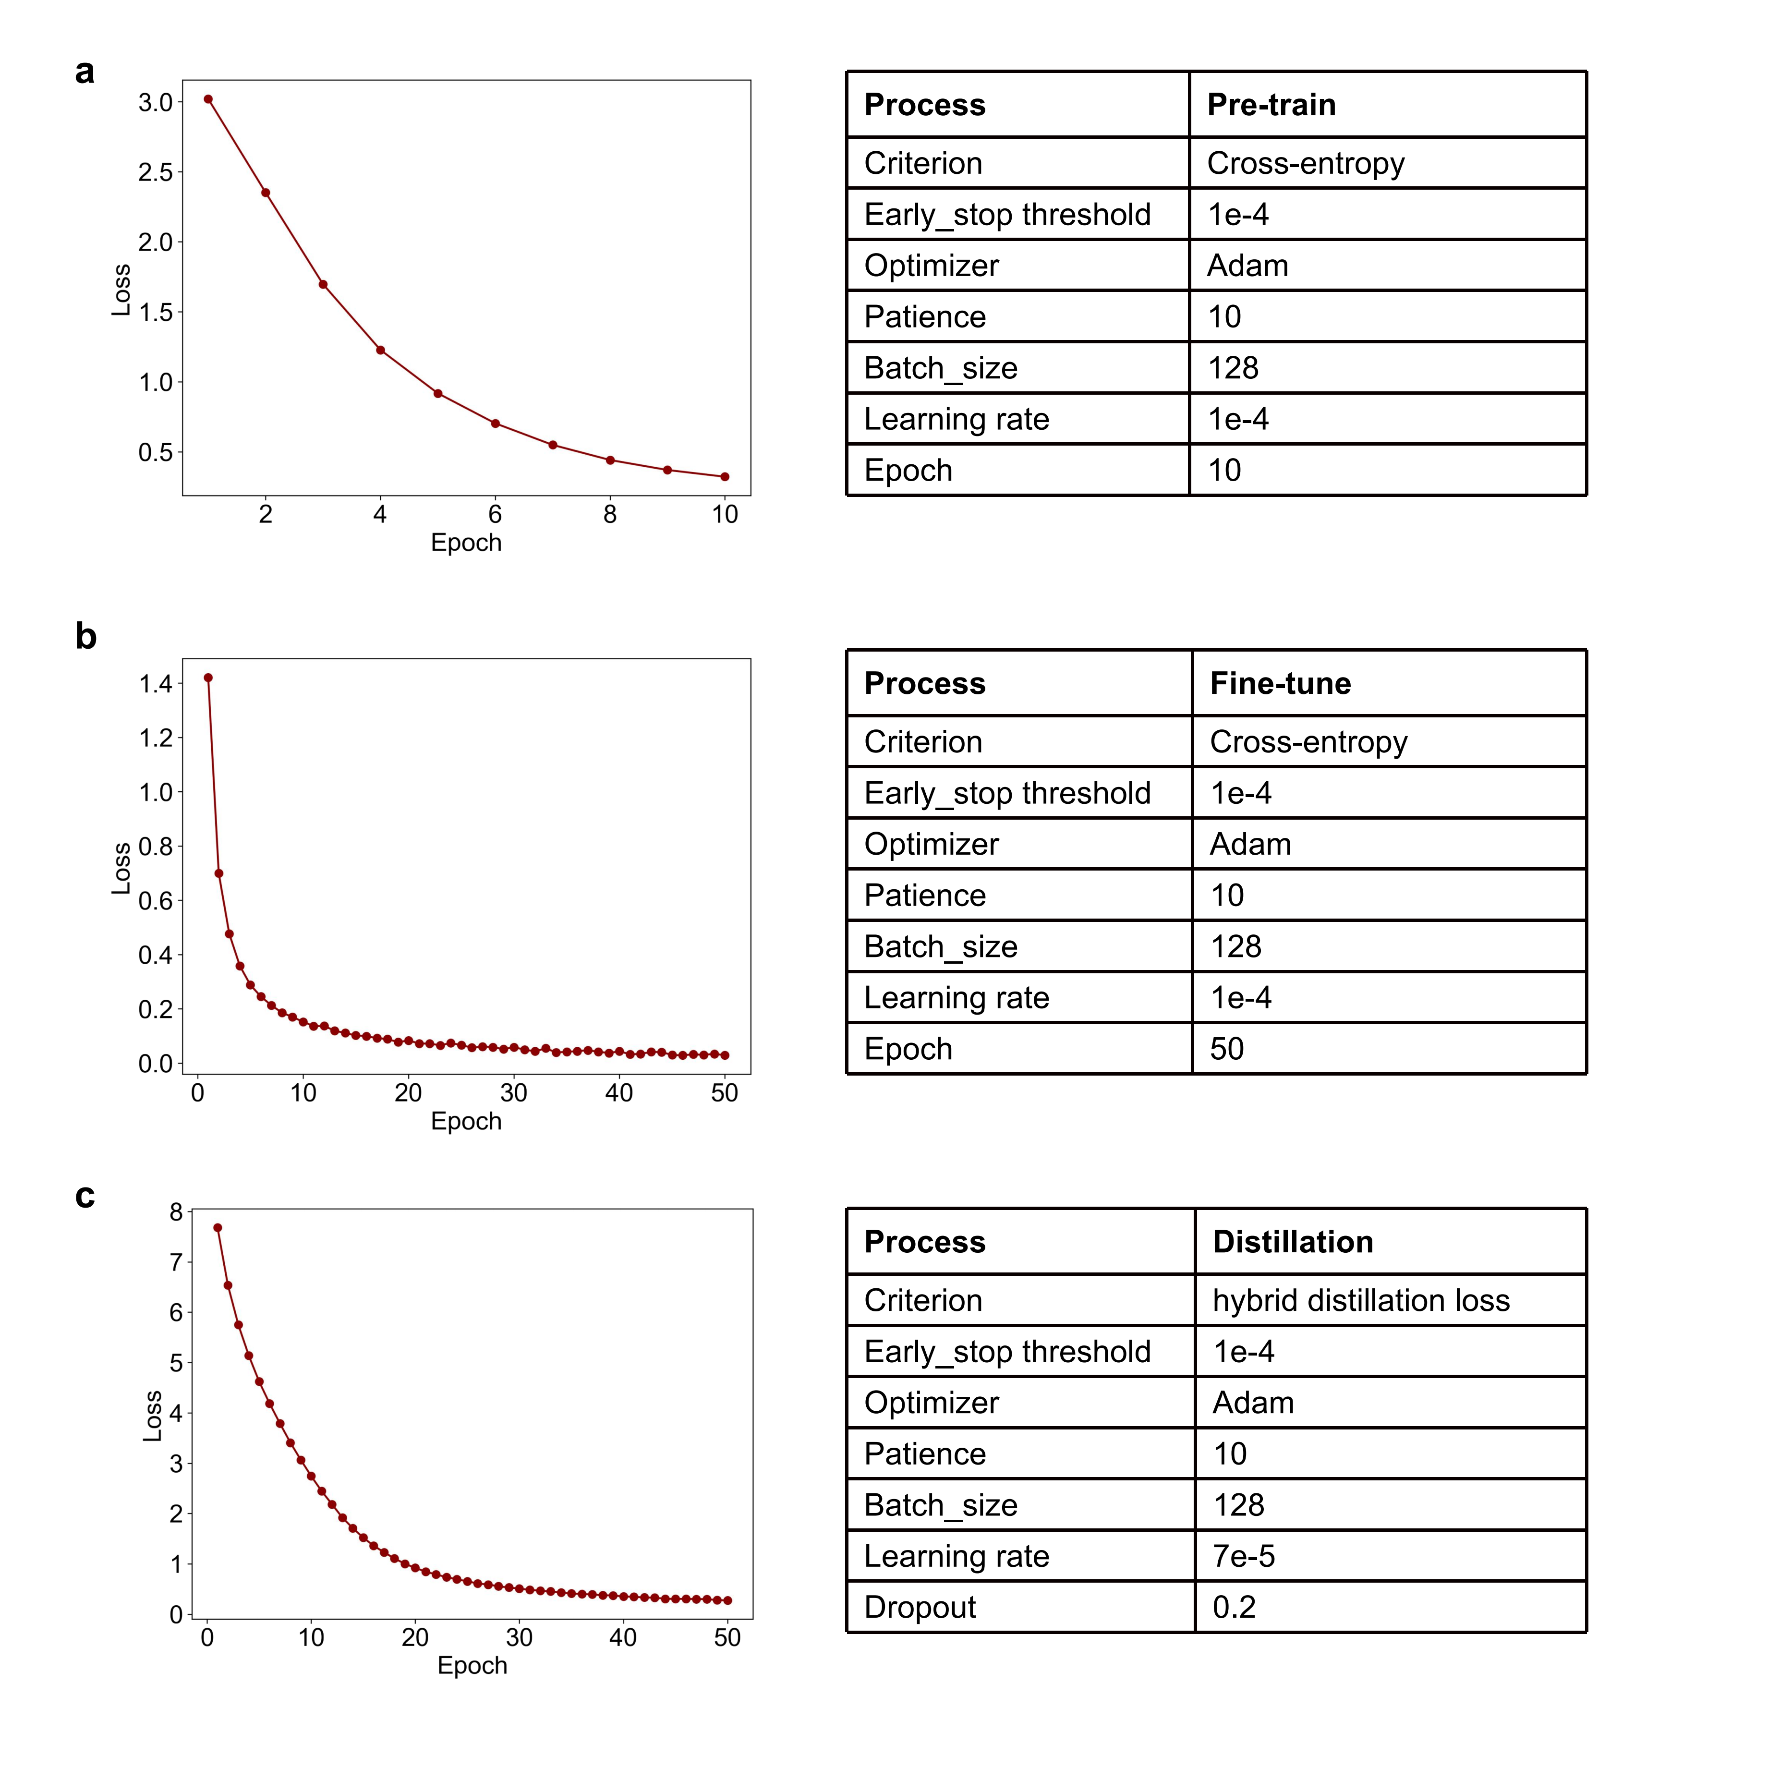

Supplementary Figure 9: The optimal parameters and training curves of other models in the comparative experiments.
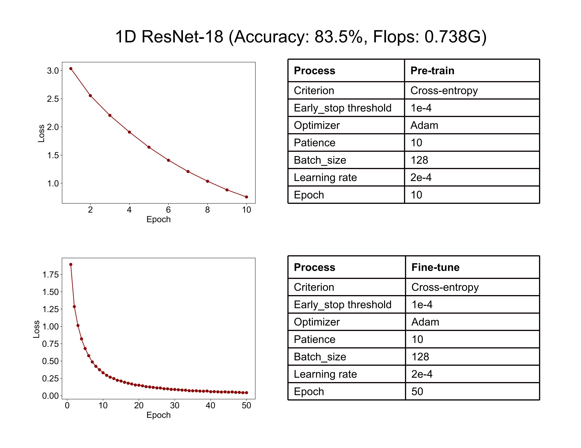
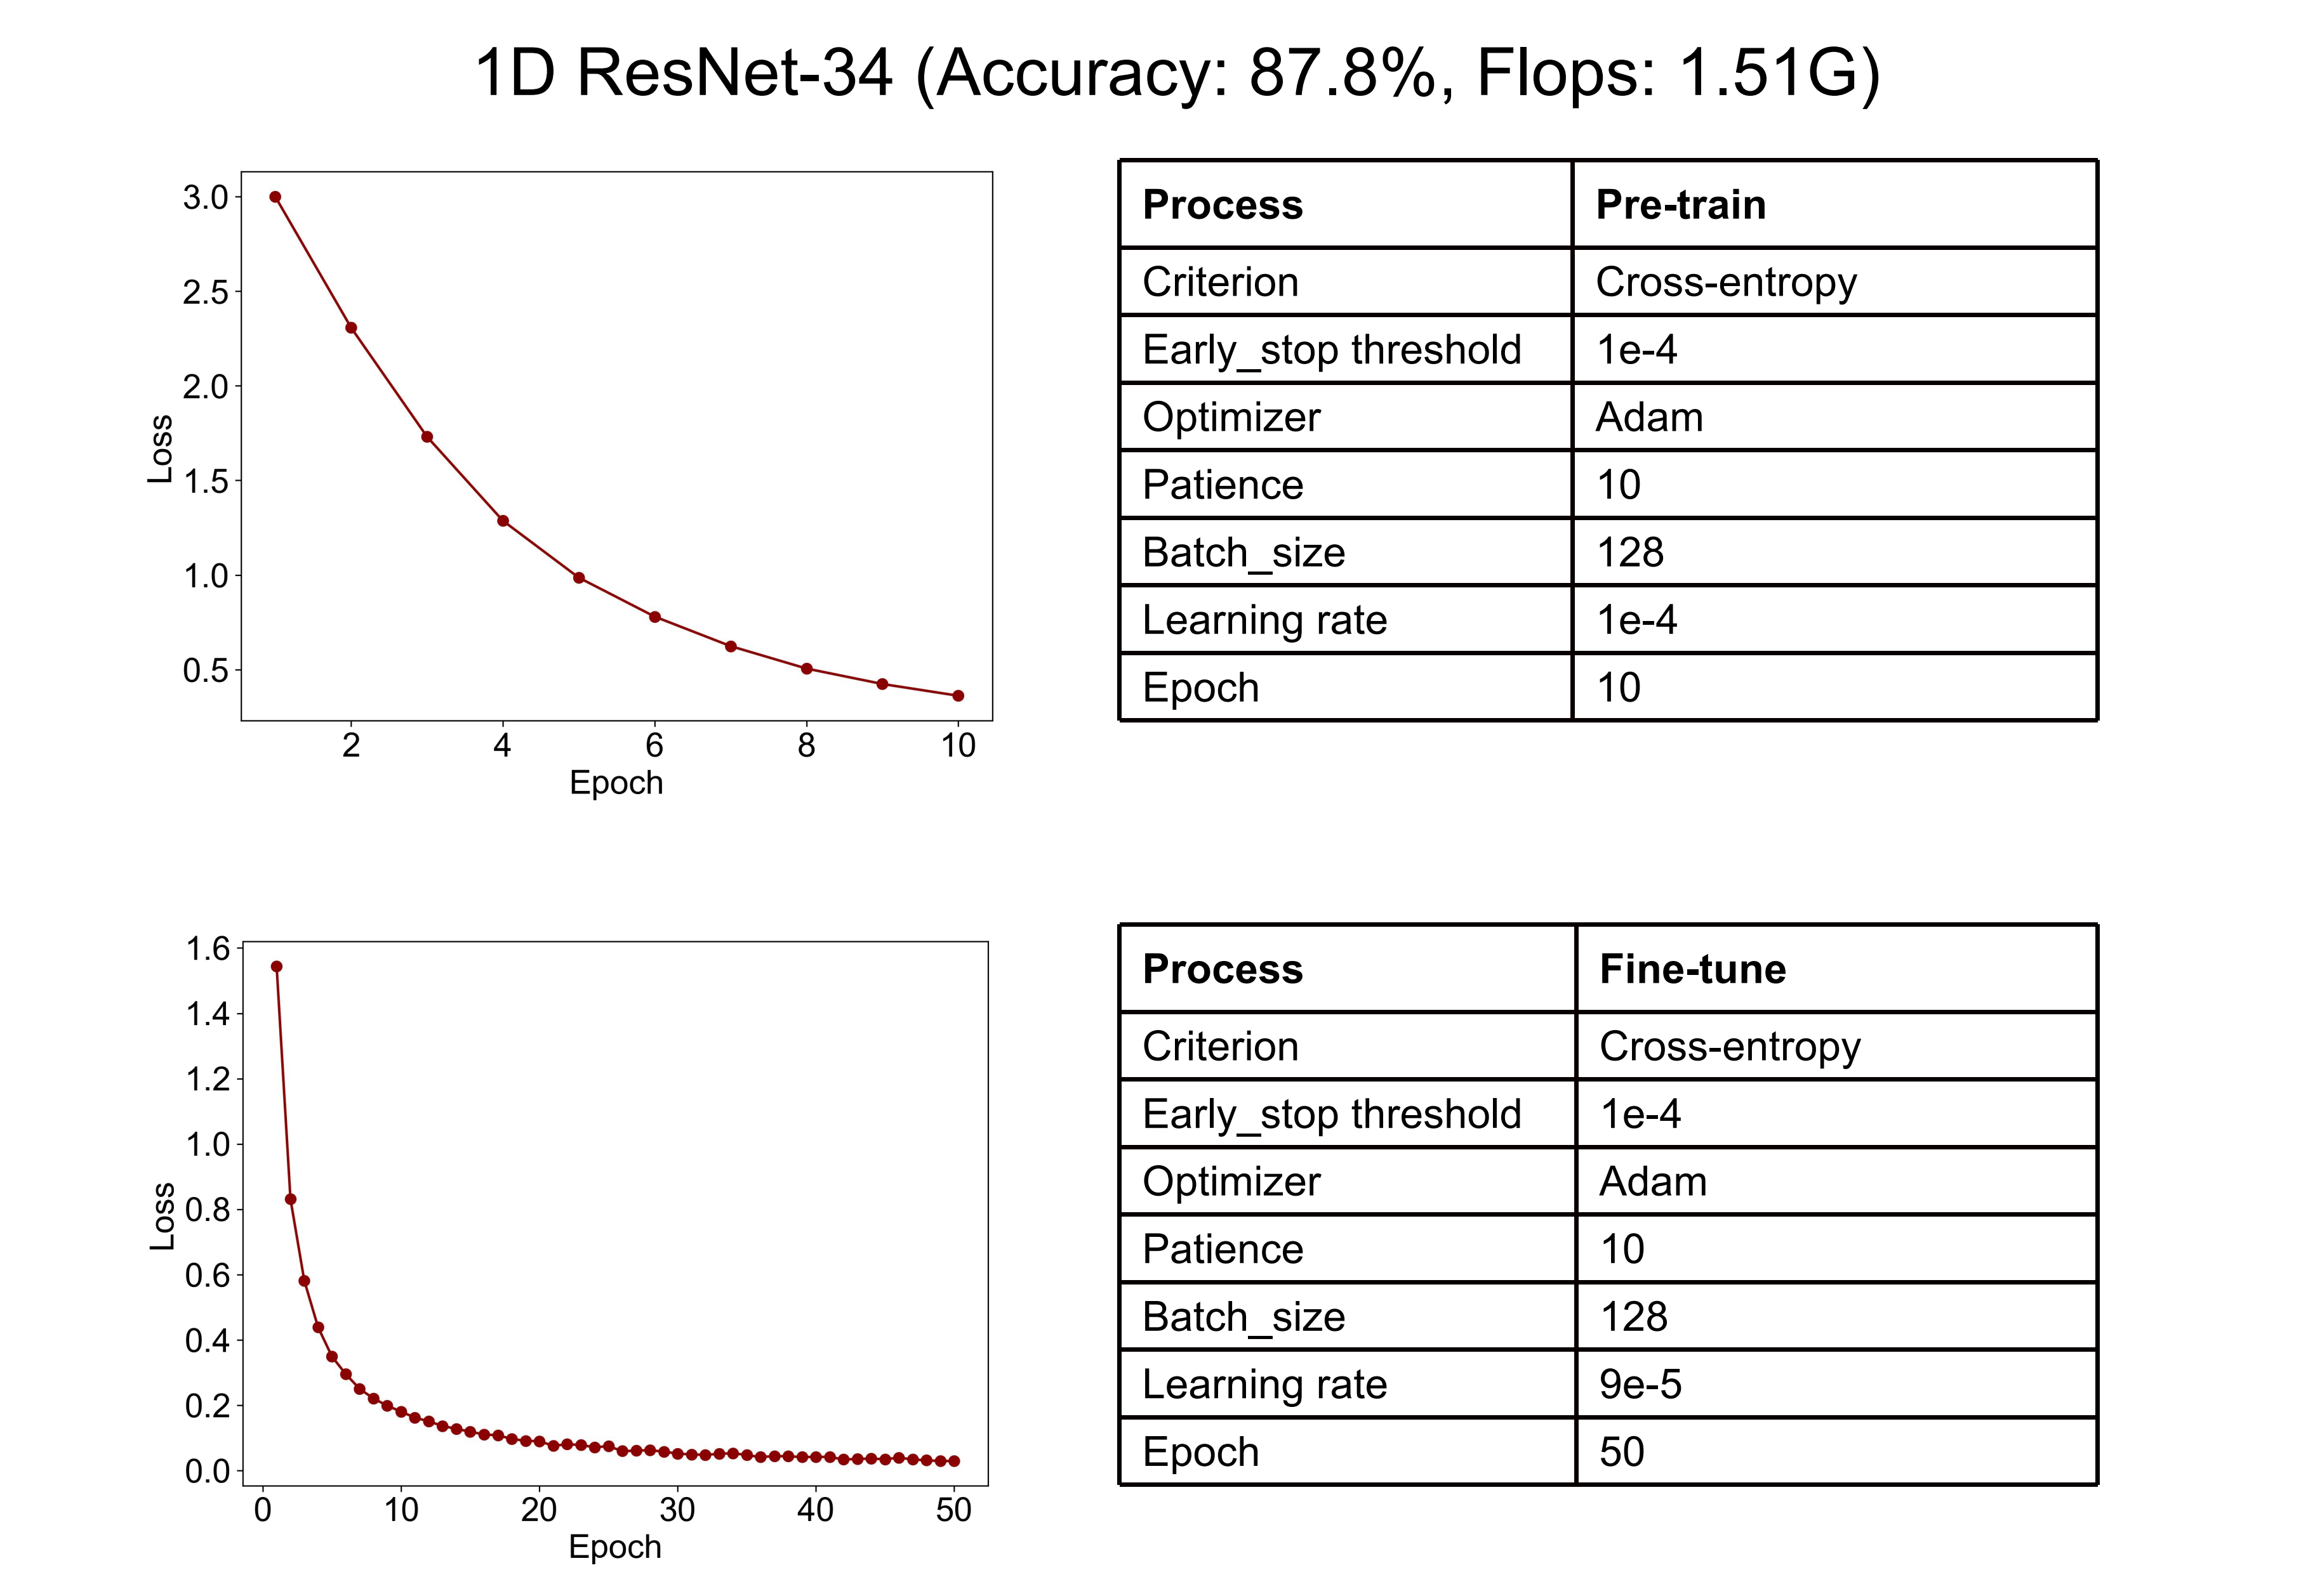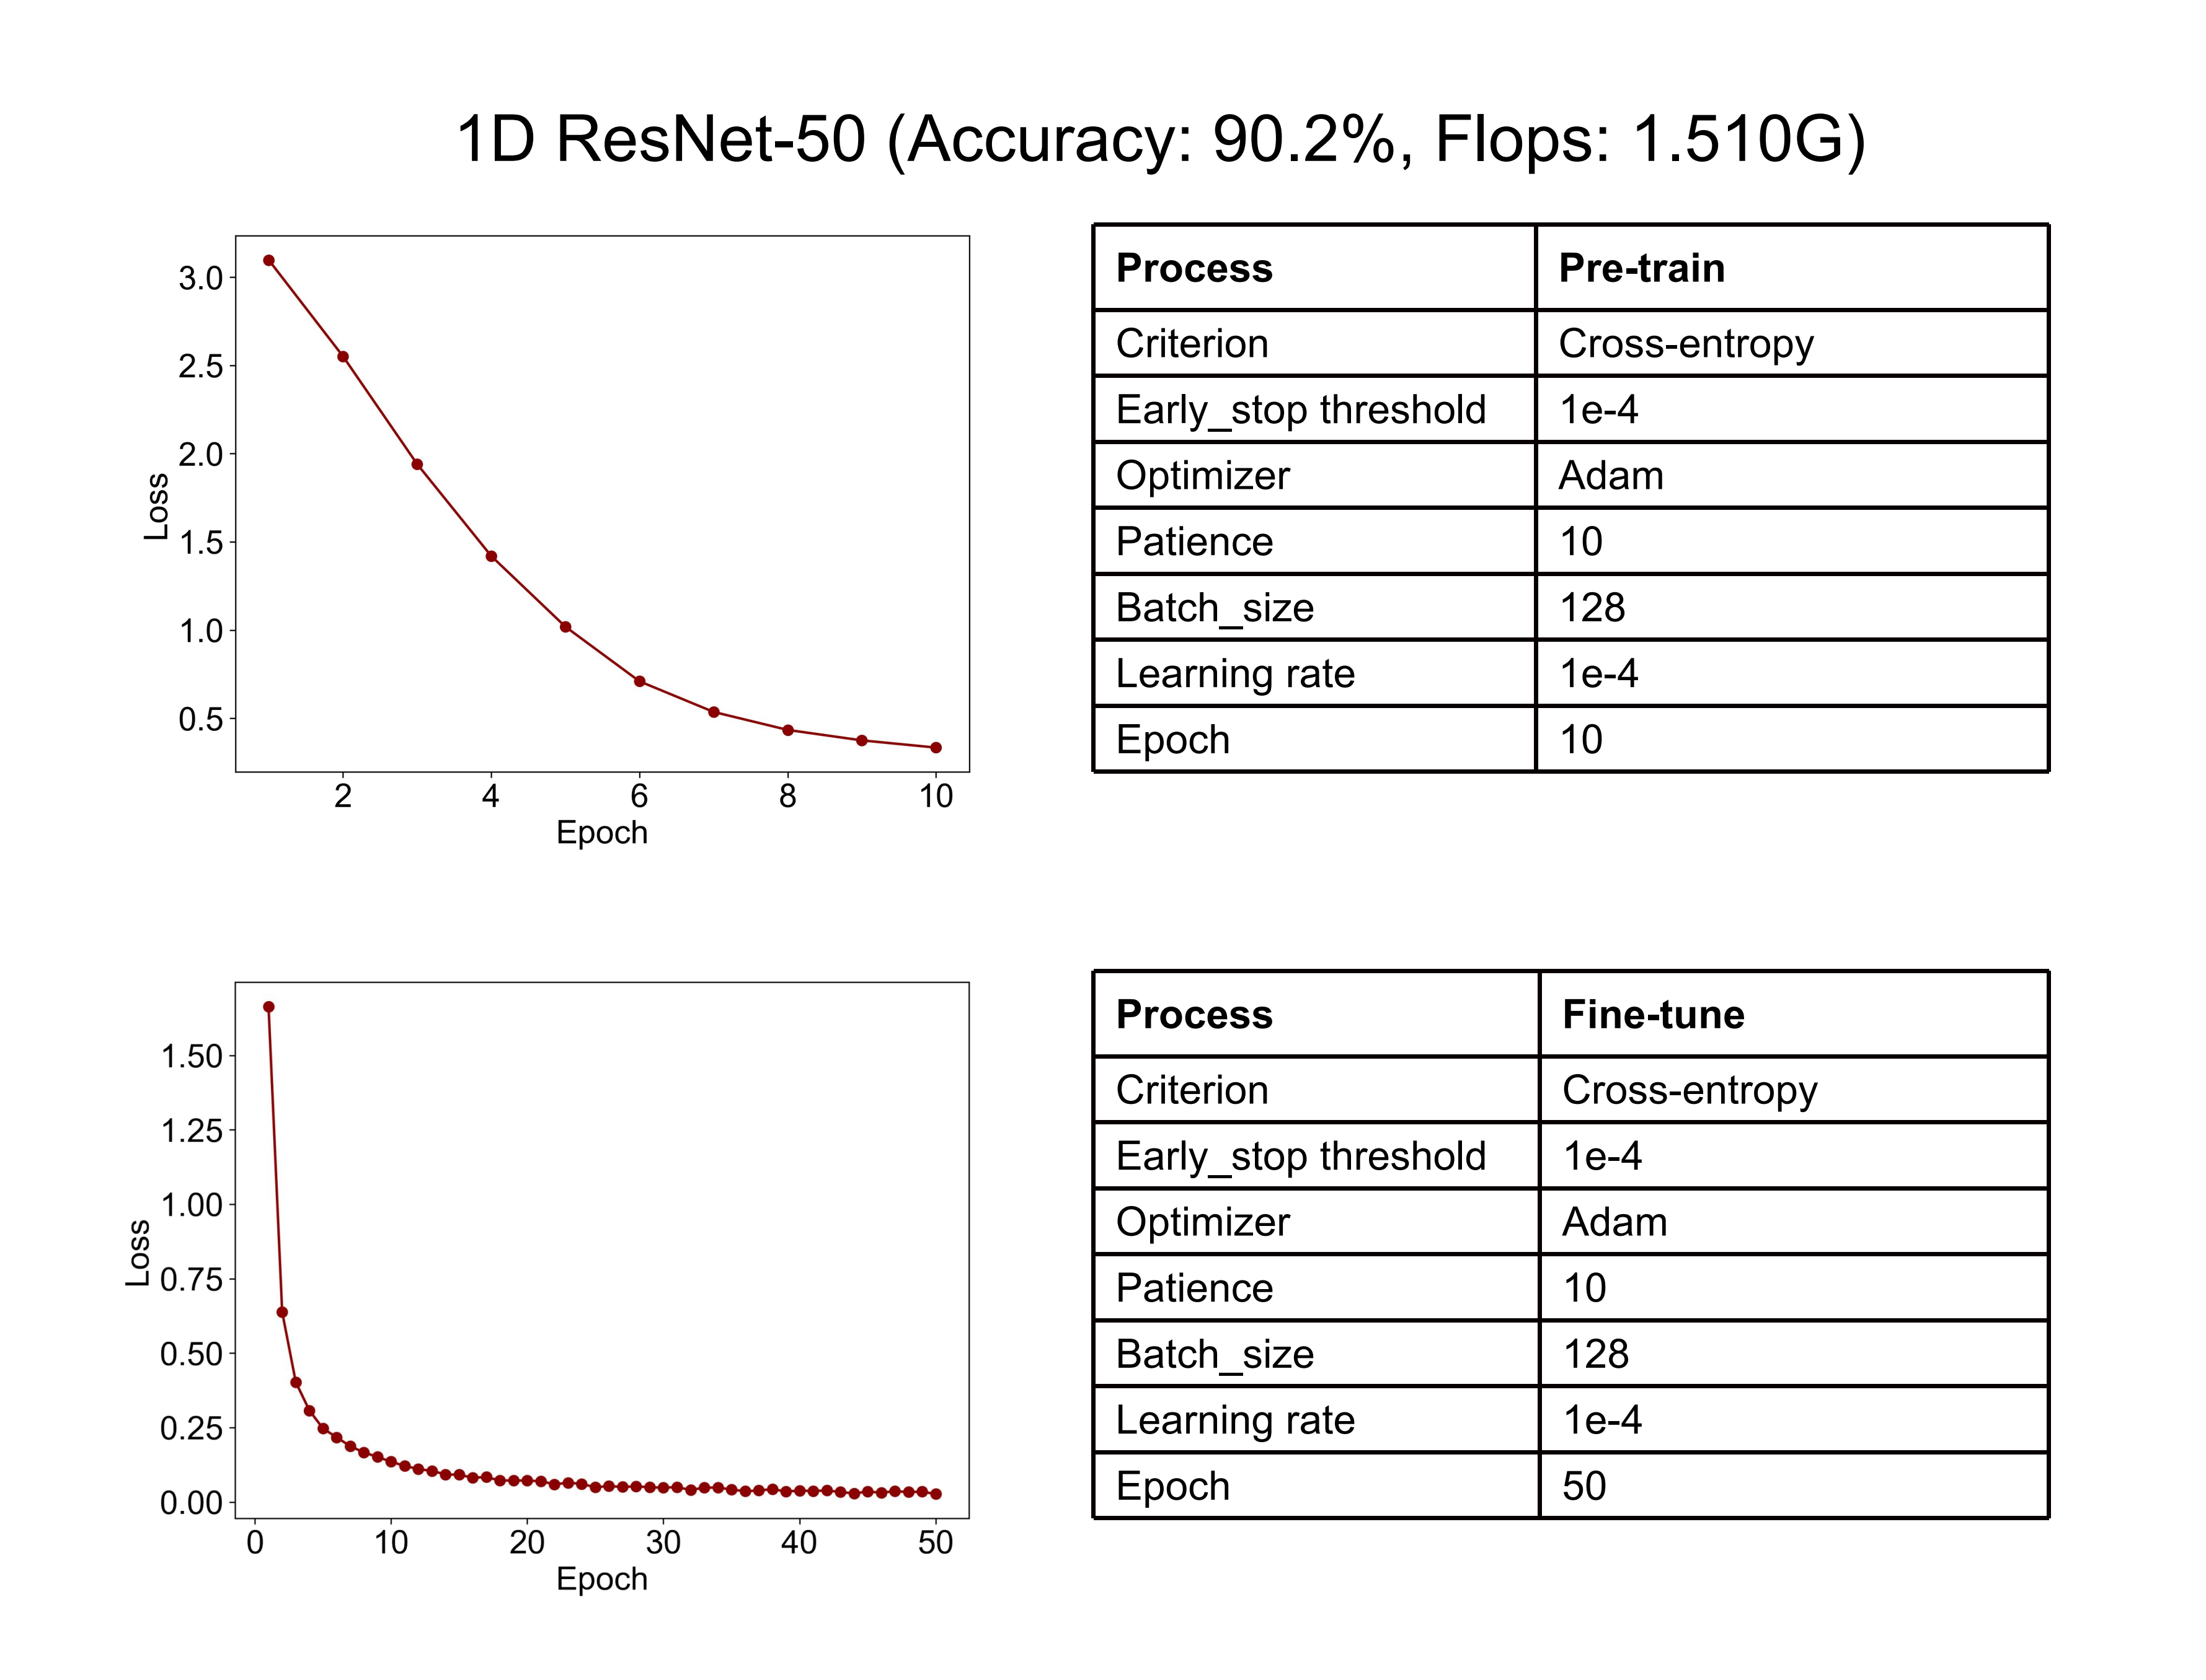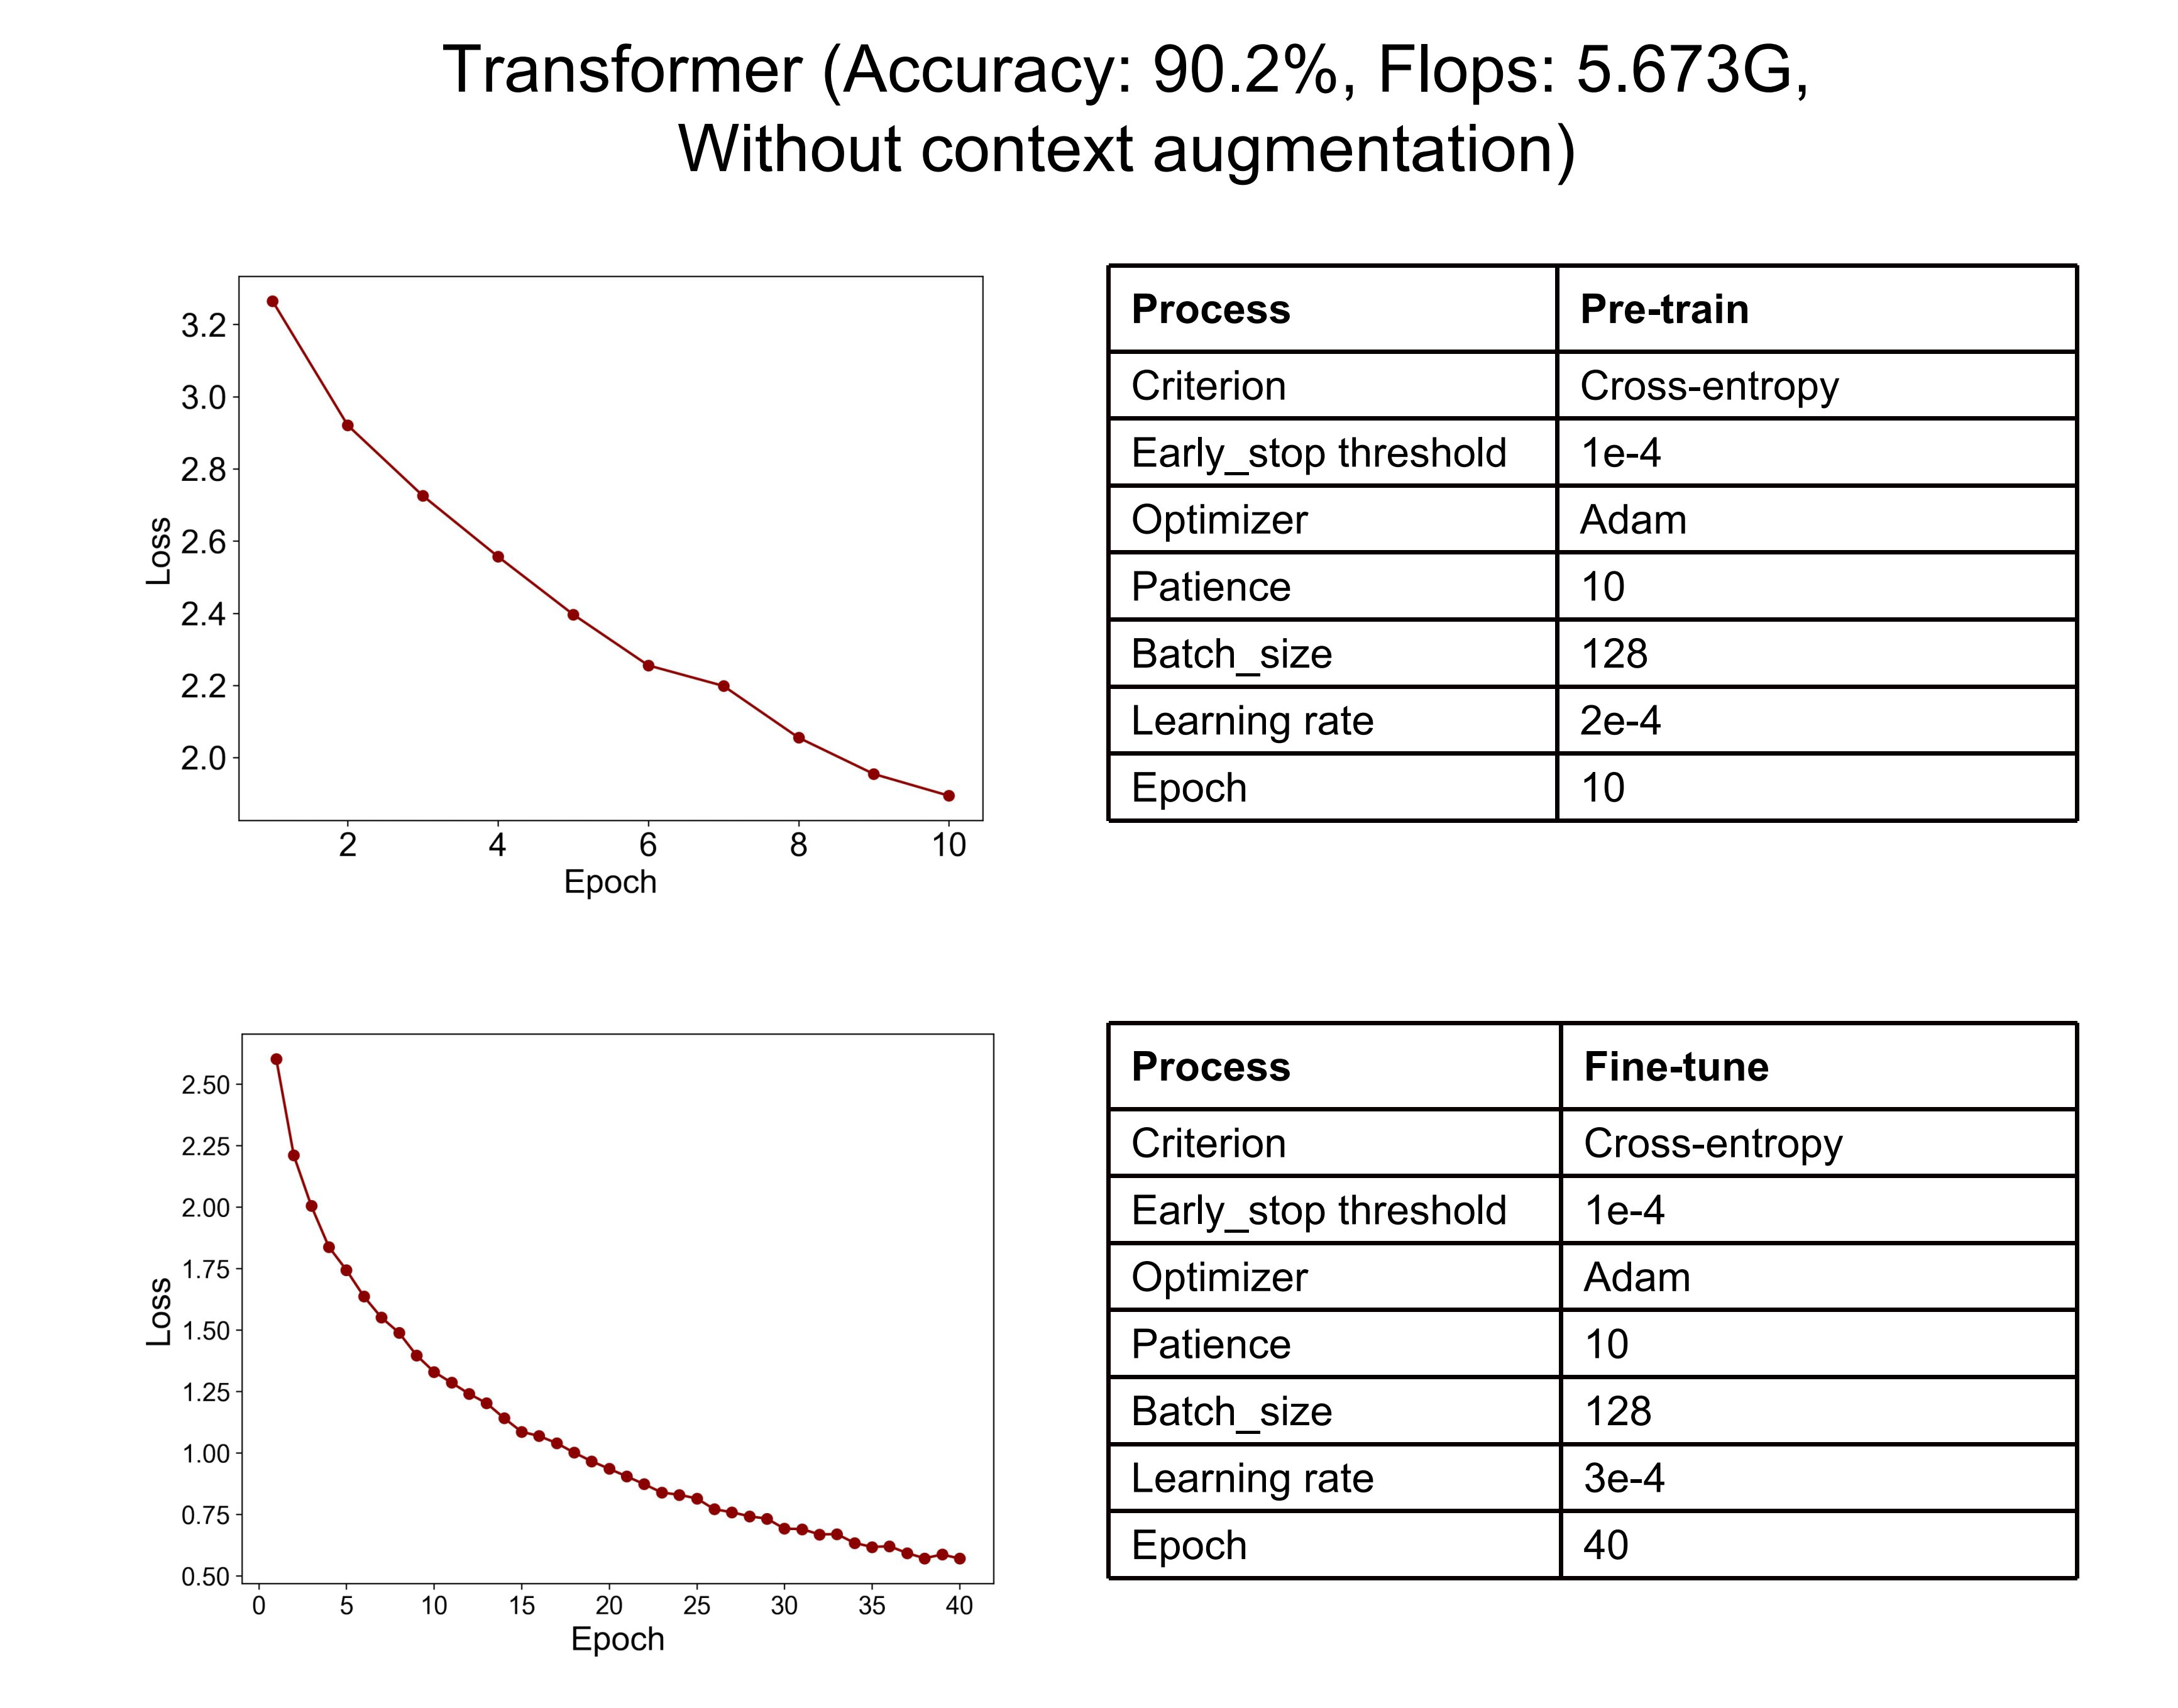
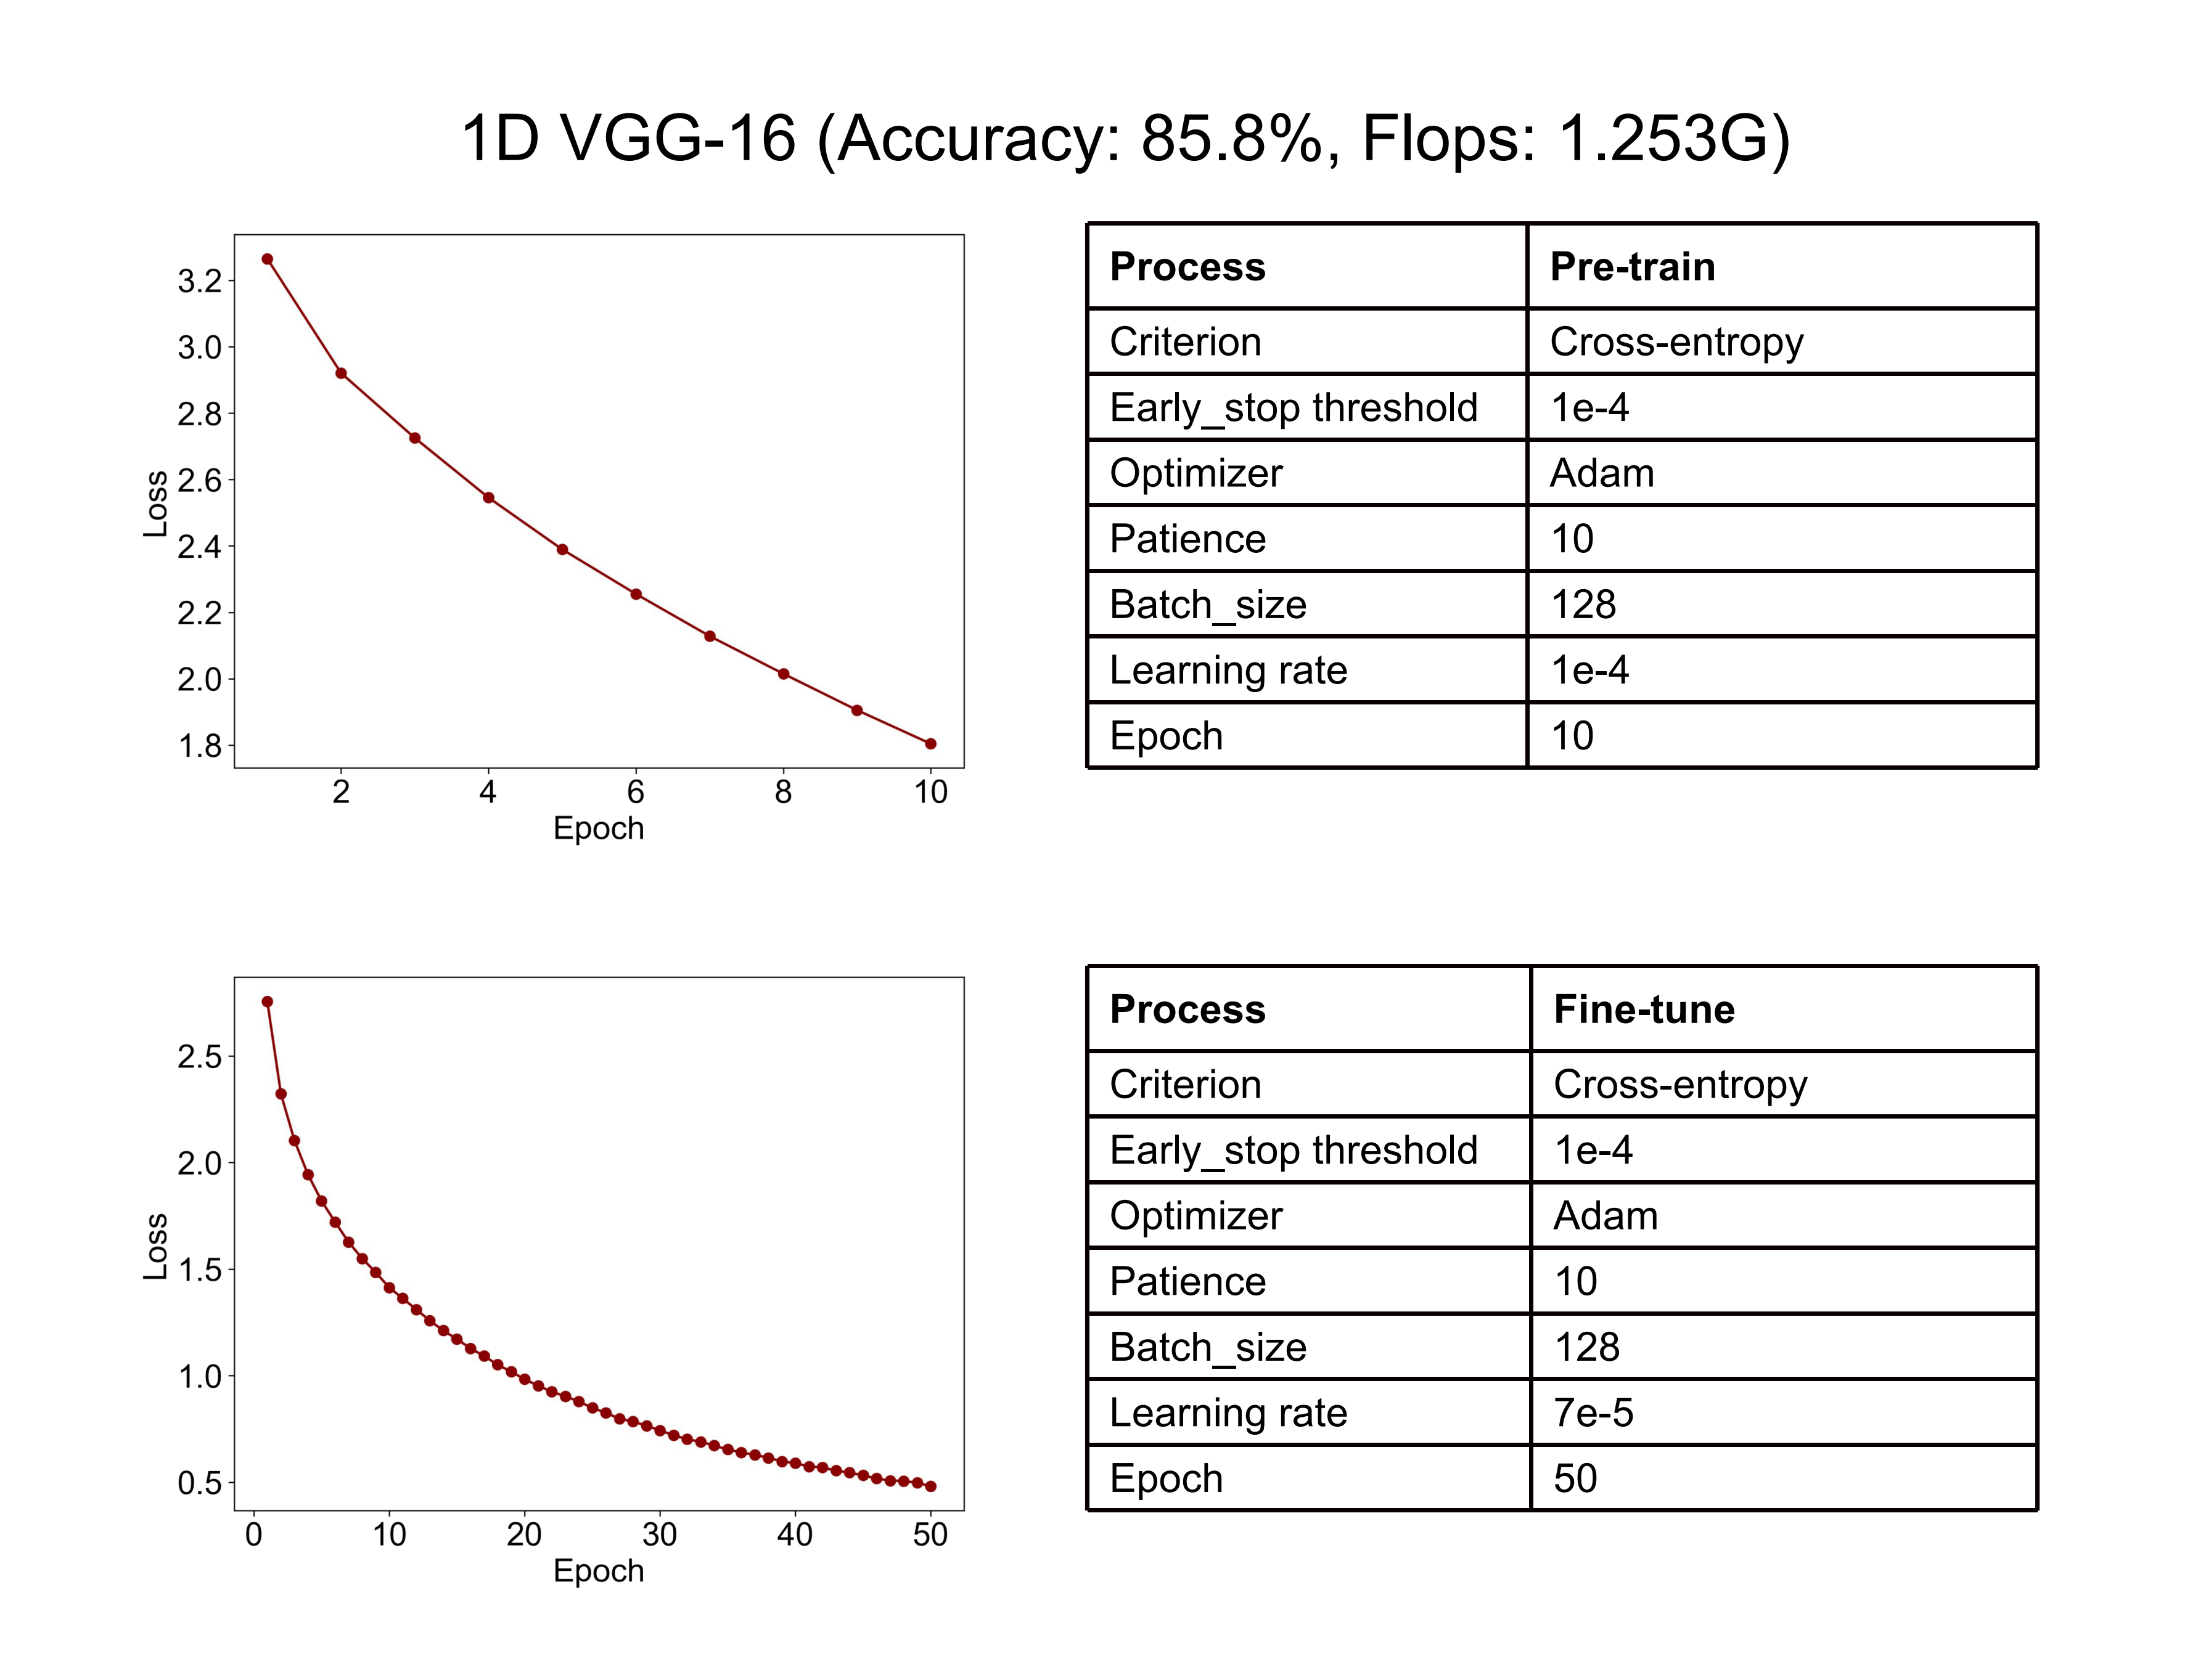

Supplementary Figure 10: Attention map (SmoothGrad) visualizes the contribution distribution of signals within token-combined samples for classification. It can be observed that the token decoding model pays more attention on the signal area at the end of the sample (current token) when making classification decisions, while also giving a relatively evenly distributed but lower level of attention to signals from other parts (context tokens). This indicates that when determining the class of the current token, the model primarily relies on the signal information of the current token, while also taking into account the preceding information from the context tokens [17].
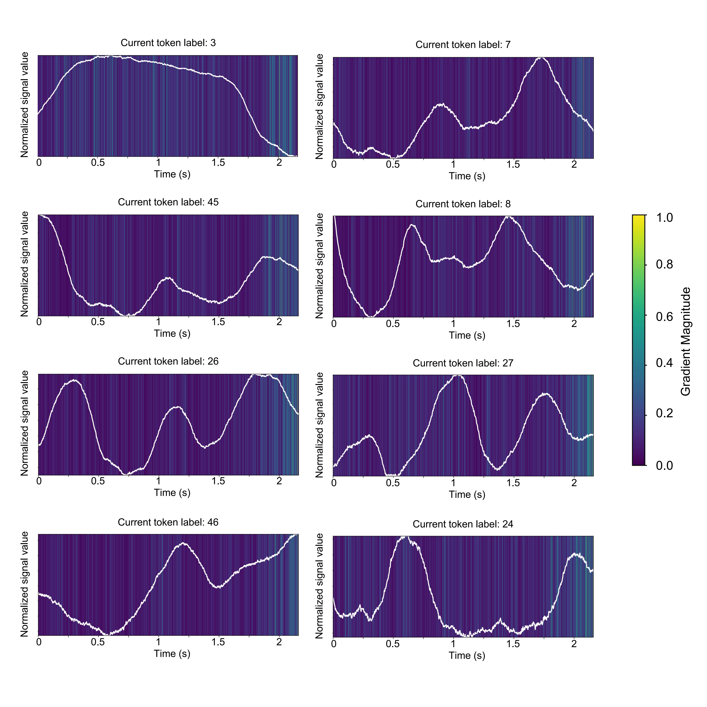

Supplementary Figure 11: SHAP plot illustrating the contributions of different pulse signal frequency bands to emotion classification. The plot reveals that lower frequency bands (0-1Hz, 1-2Hz) contribute most significantly to the classification, aligning with the expected effective frequency range of pulse signals. This result suggests that the model’s classification is grounded in relevant physiological signals, rather than biased by noise or unrelated features.

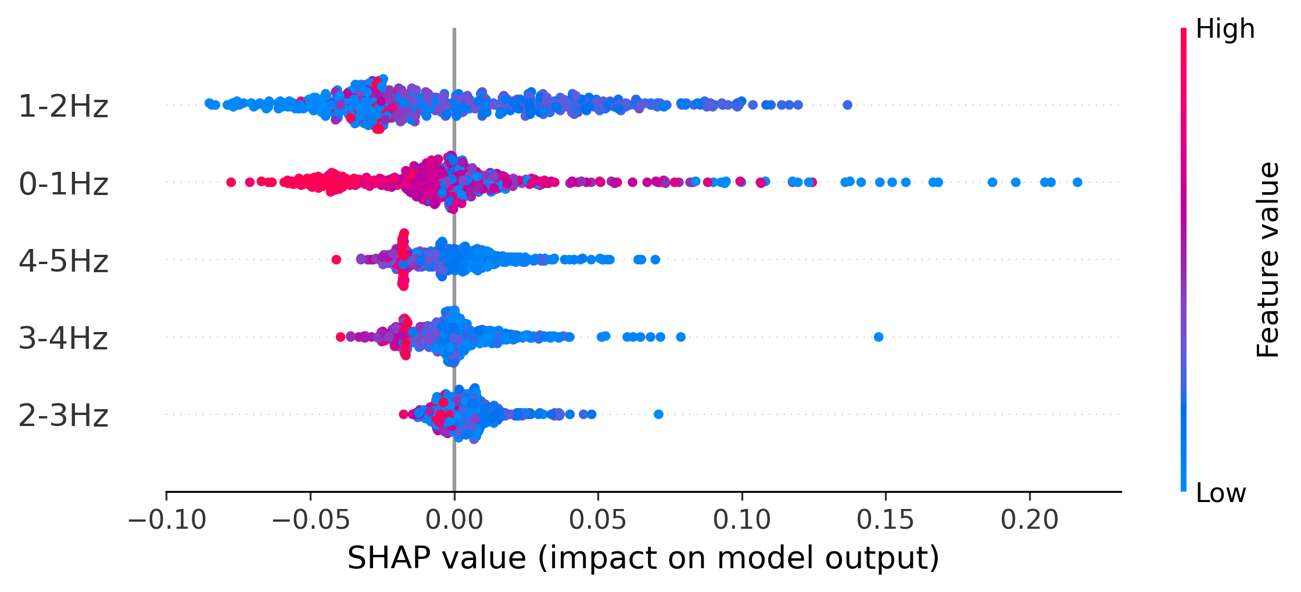

Supplementary Figure 12: Demonstration of some SEA expansion results, comparing basic expansion, CoT prompt expansion, and the combined result of CoT prompt and few-shot demo prompt. The original results were in Chinese and have been translated into English. It can be observed that the CoT prompt effectively enhances the sentence's coherence, and when combined with the few-shot demo, the sentences better align with the patients' usual language habits (such as being gentle, straightforward, polite, etc.).

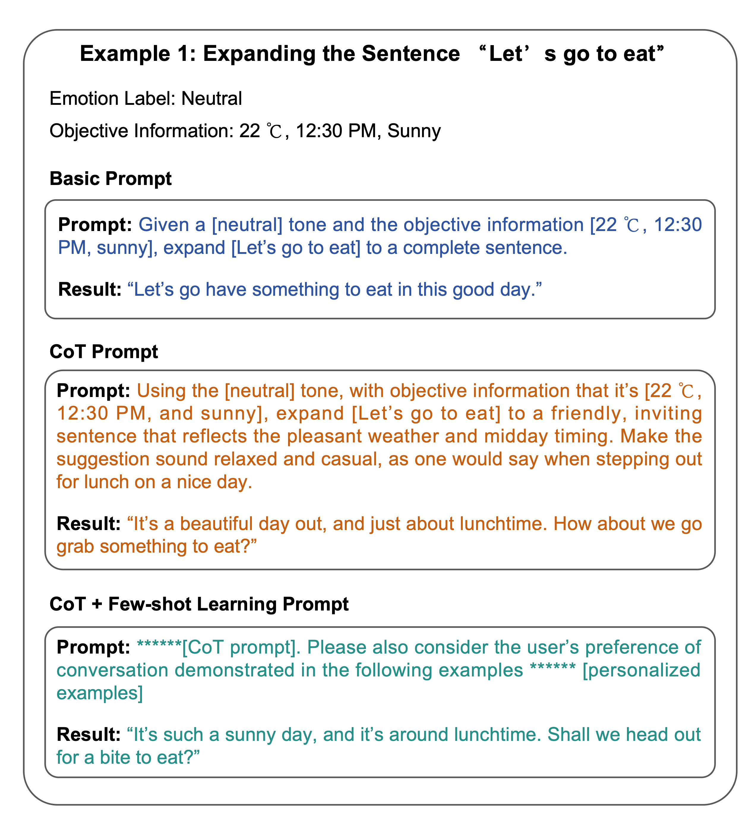

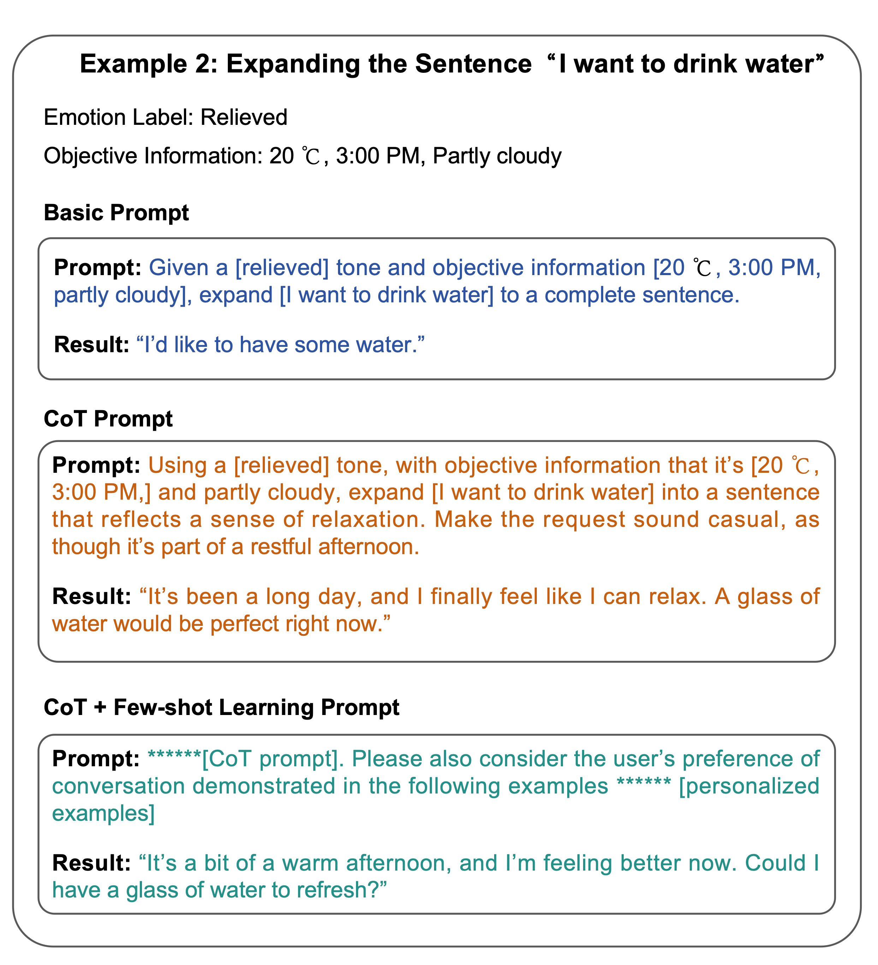
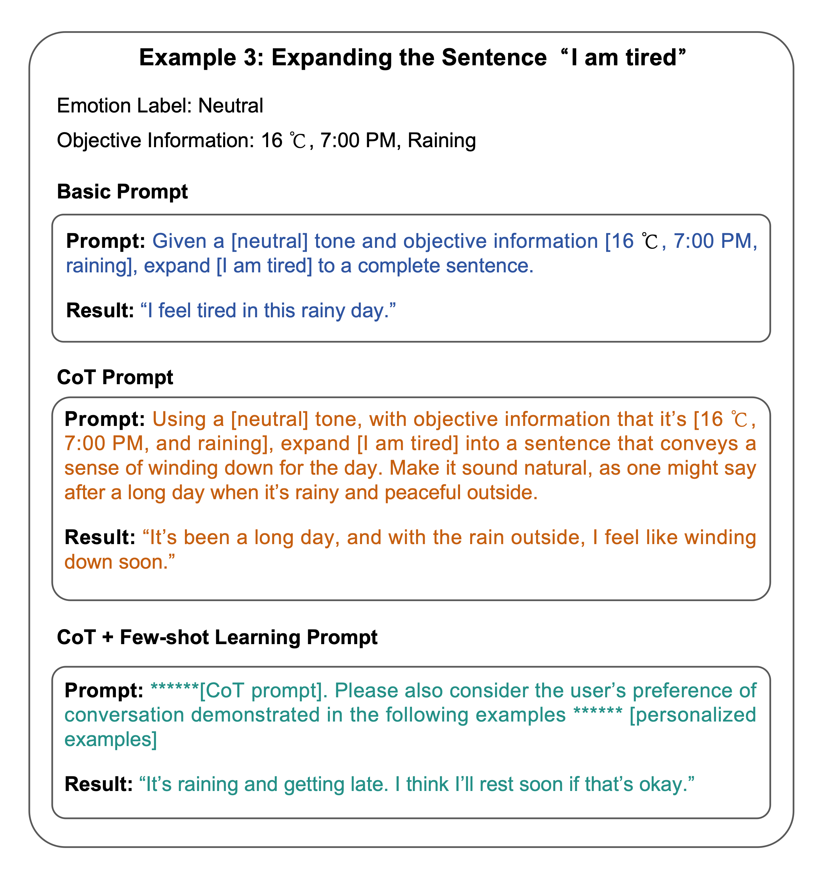
Supplementary Figure 13: Scores for SEA-generated sentences by different patient subjects.

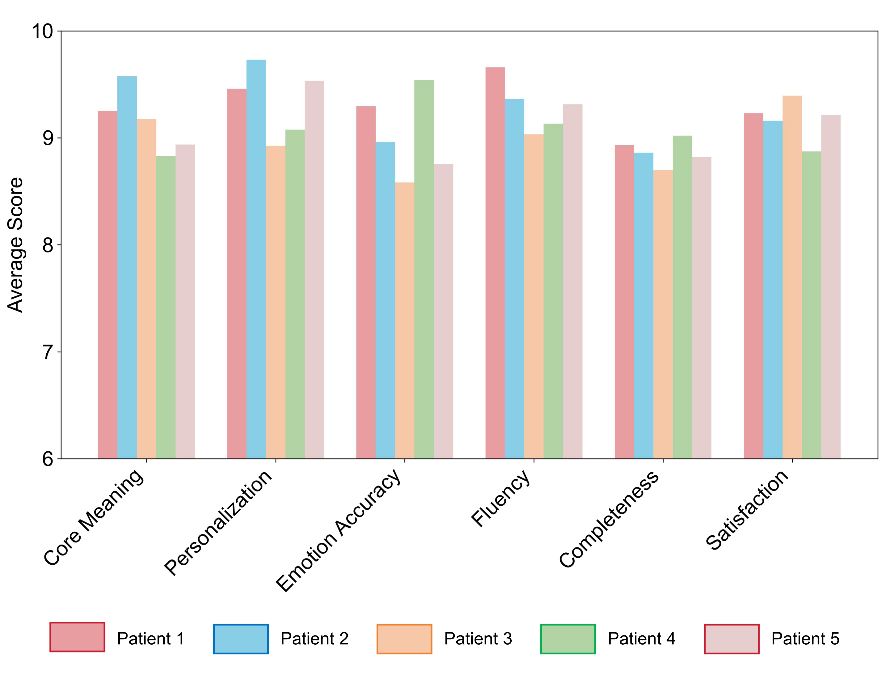
 | This Work | Yang  et al. [11] | Liu  et al. [12] | Kim  et al. [13] | Tang  et al. [14] | Lu  et al. [15]
Form factor | Textile choker | Throat  patch | Headband+  facial unit | Facial  patches | Textile choker | Mask
Sensors | Two strain sensors | One strain sensor | Three IMUs | Eight strain sensors | One strain sensor | One TENG sensor
Sensing materials | Graphene | Laser-scribed graphene | Platinum | Crystalline-  silicon | Graphene | PVC and nylon
Corpus | 47 words, 20 sentences | Four tones, five vowels, and six words | 93 words, 92 sentences | 100 words | 30 words | 20 words
Subjects | 10 healthy individuals, five stroke patients | Five healthy individuals, one post-  laryngectomy patient | Eight healthy individuals | Two healthy individuals | Six healthy individuals | Four healthy individuals
Performance summary | Word error rate of 4.2%, sentence error rate of 2.9%, and overall satisfaction rated as “fully satisfied” on five stroke patients | Average accuracy of 99.05% on healthy individuals, and 91% accuracy on one post- laryngectomy patient | Word accuracy of 97.4%, sentence accuracy  of 92.0% | Word accuracy  of 87.53% | Word accuracy of 95.25% | Word accuracy of 94.5%
Zero-delay expression | √ | × | × | × | × | ×
Emotive-logical capacity | √ | × | × | × | × | ×
Wireless | √ | × | √ | × | × | √
Robustness¹ | Good | Medium | Good | Medium | Medium | Medium
Comfortability² | Good | Medium | Medium | Bad | Medium | Medium
Patients accessibility | Good | Medium | Bad | Bad | Bad | Bad
Supplementary Table 1 | Comparison of the proposed intelligent throat’s features with state-of-the-art wearable silent speech systems.
¹Robustness is a comprehensive measure, including durability, resistance to artefacts, and environmental stability.
²Comfortability is a comprehensive measure, including stretchability, biocompatibility, and breathability.
Supplementary Table 2: Corpus words list.

ID | Chinese Vocabulary | English Translation | ID | Chinese Vocabulary | English Translation
1 | 我 | I | 25 | 洗澡 | Take a shower
2 | 我的 | My | 26 | 厕所 | Toilet
3 | 我们 | We | 27 | 一个 | One
4 | 你 | You | 28 | 这些 | These
5 | 想要 | Want | 29 | 多少 | How much
6 | 需要 | Need | 30 | 钱 | Money
7 | 吃饭 | Eat | 31 | 你好 | Hello
8 | 睡觉 | Sleep | 32 | 谢谢 | Thank you
9 | 医院 | Hospital | 33 | 请 | Please
10 | 去 | Go | 34 | 麻烦 | Excuse me
11 | 哪里 | Where | 35 | 今天 | Today
12 | 回来 | Come back | 36 | 明天 | Tomorrow
13 | 什么 | What | 37 | 胳膊 | Arm
14 | 时候 | When | 38 | 很好 | Very good
15 | 眼睛 | Eyes | 39 | 不用 | Don’t need
16 | 舒服 | Comfortable | 40 | 担心 | worry
17 | 不 | Not | 41 | 杯子 | Cup
18 | 累了 | Tired | 42 | 勺子 | Spoon
19 | 好的 | Okay | 43 | 筷子 | Chopsticks
20 | 知道 | Know | 44 | 水果 | Fruit
21 | 你们 | You (plural) | 45 | 电话 | Phone
22 | 我想 | I want | 46 | 微信 | WeChat (messaging app)
23 | 给我 | Give me | 47 | 联系 | Contact
24 | 喝水 | Drink Water

Supplementary Table 3: Corpus sentences list.

ID | Chinese Sentence | English Translation
1 | 我们去吃饭 | Let’s go to eat
2 | 我想要喝水 | I want to drink water
3 | 我需要洗澡 | I need to take a shower
4 | 我想去厕所 | I want to go to the toilet
5 | 我想睡觉 | I want to sleep
6 | 我需要去医院 | I need to go to the hospital
7 | 你们去哪里 | Where are you (plural) going?
8 | 你今天什么时候回来 | When are you coming back today?
9 | 我们明天去医院 | Let’s go to the hospital tomorrow
10 | 我的眼睛不舒服 | My eyes are uncomfortable
11 | 我胳膊不舒服 | My arm is uncomfortable
12 | 我很好，不用担心 | I am fine, no need to worry
13 | 我累了 | I am tired
14 | 好的，我知道 | Okay, I know
15 | 你好，请给我一个杯子 | Hello, please give me a cup
16 | 麻烦给我一个勺子 | Please give me a spoon
17 | 谢谢你 | Thank you
18 | 这些水果多少钱 | How much are these fruits?
19 | 我们微信联系 | Let’s contact via WeChat
20 | 你电话多少 | What is your phone number?

Supplementary Table 4: Scoring criteria used for evaluating the generated sentences.

Criterion | Description | Scoring Guidelines
Core Meaning Expression | Does the sentence accurately express the intended core meaning? | 1-3: Sentence fails to convey the core meaning.  4-6: Partially conveys the meaning.  7-8: Mostly accurate.  9-10: Fully accurate.
Personalization & Habit Matching | Does the sentence align with the patient's usual speaking habits and style? | 1-3: Does not match at all.  4-6: Partially matches the patient's style.  7-8: Mostly matches.  9-10: Fully aligned with patient's usual speech.
Emotion Expression Accuracy | Is the generated sentence reflecting the correct emotional tone as intended? | 1-3: Incorrect emotion.  4-6: Partially correct emotion.  7-8: Mostly correct emotion.  9-10: Emotion fully accurate.
Sentence Naturalness & Fluency | Is the sentence natural and fluent, similar to everyday conversation? | 1-3: Very unnatural and stiff.  4-6: Somewhat natural but still mechanical.  7-8: Mostly natural.  9-10: Completely fluent and natural.
Completeness of Generated Sentence | Is the sentence complete, with no important missing information? | 1-3: Major information missing.  4-6: Some details missing.  7-8: Mostly complete.  9-10: Fully complete, no missing details.
Overall User Satisfaction | How satisfied is the user with the generated sentence? | 1-3: Very dissatisfied.  4-6: Somewhat satisfied.  7-8: Mostly satisfied.  9-10: Fully satisfied.

Supplementary References
- Pinto, S., et al. Treatments for dysarthria in Parkinson's disease. The Lancet Neurology 3, 547-556 (2004).
- Noffs, G., et al. What speech can tell us: A systematic review of dysarthria characteristics in Multiple Sclerosis. Autoimmunity reviews 17, 1202-1209 (2018).
- GBD 2019 Stroke Collaborators. Global, regional, and national burden of stroke and its risk factors, 1990–2019: a systematic analysis for the Global Burden of Disease Study 2019. The Lancet. Neurology 20, 795-820 (2021).
- Enderby, P. Disorders of communication: dysarthria. Handbook of clinical neurology 110, 273-281 (2013).
- Zinn, S., et al. The effect of poststroke cognitive impairment on rehabilitation process and functional outcome. Archives of physical medicine and rehabilitation 85, 1084-1090 (2004).
- Teshaboeva, F. Literacy education of speech impaired children as a pedagogical psychological problem." Confrencea 5, 299-302 (2023).
- Beaulieu, C. L., et al. Occupational, physical, and speech therapy treatment activities during inpatient rehabilitation for traumatic brain injury. Archives of physical medicine and rehabilitation 96, 222-234 (2015).
- Karges, J., and Smallfield, S. A description of the outcomes, frequency, duration, and intensity of occupational, physical, and speech therapy in inpatient stroke rehabilitation. Journal of allied health 38, 1-10 (2009).
- Patrick-Krueger, K.M., Burkhart, I. & Contreras-Vidal, J.L. The state of clinical trials of implantable brain–computer interfaces. Nature Reviews Bioengineering (2024).
- Silva, A. B., Littlejohn, K. T., Liu, J. R., Moses, D. A. & Chang, E. F. The speech neuroprosthesis. Nature Reviews Neuroscience 25, 473–492 (2024).
- Yang, Q. et al. Mixed-modality speech recognition and interaction using a wearable artificial throat. Nature Machine Intelligence 5, 169–180 (2023).
- Liu, S., et al. A data-efficient and easy-to-use lip language interface based on wearable motion capture and speech movement reconstruction. Science Advances 10, eado9576 (2024).
- Kim, T., et al. Ultrathin crystalline-silicon-based strain gauges with deep learning algorithms for silent speech interfaces. Nature Communications 13, 5815 (2022).
- Tang, C. et al. Ultrasensitive textile strain sensors redefine wearable silent speech interfaces with high machine learning efficiency. npj Flexible Electronics 8, 27 (2024).
- Lu, Y., et al. Decoding lip language using triboelectric sensors with deep learning. Nature Communications 13, 1401 (2022).
- Ma, C. et al. High sensitivity, broad working range, comfortable, and biofriendly wearable strain sensor for electronic skin. Advanced Materials Technologies 7, 2200106 (2022).
- Smilkov, D., et al. SmoothGrad: removing noise by adding noise. arXiv:1706.03825. (2017).

Supplementary Video Captions

Supplementary Video 1: Stroke patient with dysarthria attempts to speak.
This video shows the scenes of a stroke patient with dysarthria engaging in word/sentence echoic training and simple daily conversation exercises with a rehabilitation therapist, without IT assistance.

Supplementary Video 2: Intelligent Throat: system overview and live demonstration
This video illustrates the functional workflow of each component within the IT system during operation. Additionally, it showcases a real-world use case of the wearable IT system in practical scenario.

