Dear Editor Yasuo Ogawa,

We would like to resubmit our manuscript “An ultra-low magnetic field thermal demagnetizer for high-precision paleomagnetism” for consideration in Earth, Planets and Space.

Thank for two reviewer's comments on our manuscript named “An ultra-low magnetic field thermal demagnetizer for high-precision paleomagnetism” (EPSP-D-20-00137). We have thoroughly considered their suggestions and the revised parts are highlighted in blue format.

Summary of our major revisions：
The structure of the manuscript has been greatly adjusted. We deleted the comparison of thermal demagnetization experiments with other furnaces. We just focus on the description of the technology adopted in the new furnace, and then some representaitve demagnetization curves are given to prove the performance of the new furnace.

Reviewer #1: In my opinion, the success of AF demagnetization is the similarity of the wave of positive half phase and negative half phase which has proper ramped rate in strength other than the reconstruction of demagnetizing coils. A single sine wave will result smallest AF demagnetization treatment error: quicker ramping rate will result larger error. The reason of ultra as lower as 1nT in residual remaining field after demagnetization of magnetic shielding cases is newly applying of pure electric source.
This study focused more on the newly designed heating wire. For sure, the alternating demagnetization technology was not proposed by us, we just used the methods proposed by previous study. We have simplified this part according to another reviewer's opinion to highlight our new contributions.

Reviewer #2: This manuscript presents a design of thermal demagnetizer with reduced magnetic field and their experimental results to assess its performance. Reduction of magnetic noise in the thermal demagnetizer still remains an important issue because an electric furnace necessarily needs a large current for heating that potentially gives rise to undesired magnetic field. The new demagnetizer is characterized by a coiled (or spring-type) wire with "a straight core wire" (Figure 2c) to reduce the circular magnetic field around the coil axis. The straight core wire is an innovative and effective module that has never attempted in the previous thermal demagnetizer. The authors showed its effectiveness by calculation and testing measurements as written in the supplementary information.
However, this manuscript completely lacks magnetic field data generated by electric heaters of neither the new demagnetizer TD-PGL-100 nor the other demagnetizers ASC TD48 and MMTD-SC for comparison. Indeed the authors presented magnetic field data for a single coiled wire with "a straight core wire" (Figure S3c) or residual field within the shielding cylinder after degaussing (Figure 1c). Yet the heater element consists of a series of parallel or antiparallel coiled wires and its configuration seriously affects the magnetic field that samples themselves experience upon heating inside the furnace. Any illustration nor photograph of the heating element is not presented and no magnetic measurement data is available for the heater. Instead they just note single values such as 130 nT (l153) or 95 nT (l159) for heater current of 1A in the text. In addition, the authors did not mention the AC supply to the heating element. Because the heating wire works like AF degaussing coils
and the mode of AC supply (e.g., abrupt on-off, or gradual ramping etc.) is critical to the degree of how samples acquire spurious magnetization.
A lot of graphs are presented to claim advantages of the new thermal demagnetizer TD-PGL-100 over ASC TD48 using demagnetization data on synthetic samples containing hematite powder and natural sandstone samples. But it is quite doubtful to compare the results obtained by the two demagnetizers directly. Because ASC TD48 has separate heating and cooling chambers, and when samples move from heating to cooling chamber the samples should experience high stray field at the end of the heater. Again the magnetic field data covering a full range of the thermal demagnetizers of both TD-PGL-100 and ASC TD48 is indispensable to evaluate the performance.
Most surprising point on this manuscript is serious mismatches of the cited papers in the text and the reference list. The 14/40 (=35%) references in the list are not cited in the text, whereas nine cited papers are not appeared in the list. This kind of mismatches should be easily corrected if the nine coauthors truly checked the manuscript as declared in the authors' contributions. More importantly such mismatches hinders reviewers from accessing the references and checking the credibility of statements in the manuscript. Therefore I strongly recommend the authors to once withdraw and thoroughly rewrite the manuscript.
Thank you very much for the reviewer’s comments, and we carefully revised the manuscript according to the comments. The structure of the manuscript has been greatly adjusted. The comparison of thermal demagnetization experiments of different furnace was deleted. We added the detailed magnetic field data measured on the TD-PGL-100. We quite agree that “the heater element consists of a series of parallel or antiparallel coiled wires and its configuration seriously affects the magnetic field that samples themselves experience upon heating inside the furnace”. Therefore, we add some calculated simulation for the configuration of heating wires wire. It can show the advantages of our design of the furnace. It has a larger low magnetic field area in the furnace and is less constrained by the mode of connecting wires. And the references were carefully checked.

specific points
Abstract: Not representing the important points of the manuscript. I had quite different impressions when I took a look of the abstract before accepting the review's role and read the whole of the manuscript.
It has been modified. Simplify and highlight the characteristics of heating wire.

- Introduction: Must be concise. Just describe background, existing problems and scope of the manuscript.
Revised in the paper.

2.1 Degaussing the shield cylinder: First and third paragraphs are not needed. In the second paragraph the authors mention the longitudinal coil, yet this kind of coil is not based on your own new idea. Therefore just show Figure 1b and 1c in accordance with a short explanation.
It's simplified and moved to 2.3.

2.2 The design of heating wires using in the new furnace: This subsection includes most important point of the manuscript. The supplementary information should be brought back to this subsection. And present the detailed magnetic field data measured on the TD-PGL-100, ASC TD48 and MMTD-SC. Also the AC supply for the heater should be explained in details.
It has been modified. We have focused on the technical description of the new furnace. And present the detailed magnetic field data measured on the TD-PGL-100. We also measured the magnetic field of ASC TD48 and MMTD-SC. The results are consistent with the data reported in the previous paper. So we just refer to the previous data. We don't have a special way to deal with the power supply or cut off the heating current.
2.3 Temperature control and TD-PGL-100: Eliminate first paragraph and move second paragraph at the top of 2.1.
It has been modified.

3.1 Specimen description and thermal demagnetizers: Not so important, should be shortened significantly.
The sample description has been simplified and moved to supplementary information.

3.2 Thermal demagnetization of TRM: Too long and not so important. Move to supplementary information.
We have improved this part.

3.3 Comparisons of repeated progressive thermal demagnetization behavior for different furnace: ASC TD48 is not suitable for comparison. Instead use MMTD-SC as a demagnetizer and show the magnetic field data. Too many figures are presented.
We deleted the comparison with ASC TD48. Although we have done comparative experiments with MMTD-SC. The results are shown below in Fig1 and Fig2. Considering the current control during actual heating, the current is reduced when approaching the target point, and another reason is that a low AC magnetic field is always applied to the shield cylinder. We think that MMTD-SC is also not suitable for comparison. Therefore, the revised manuscript does not involve these contents.

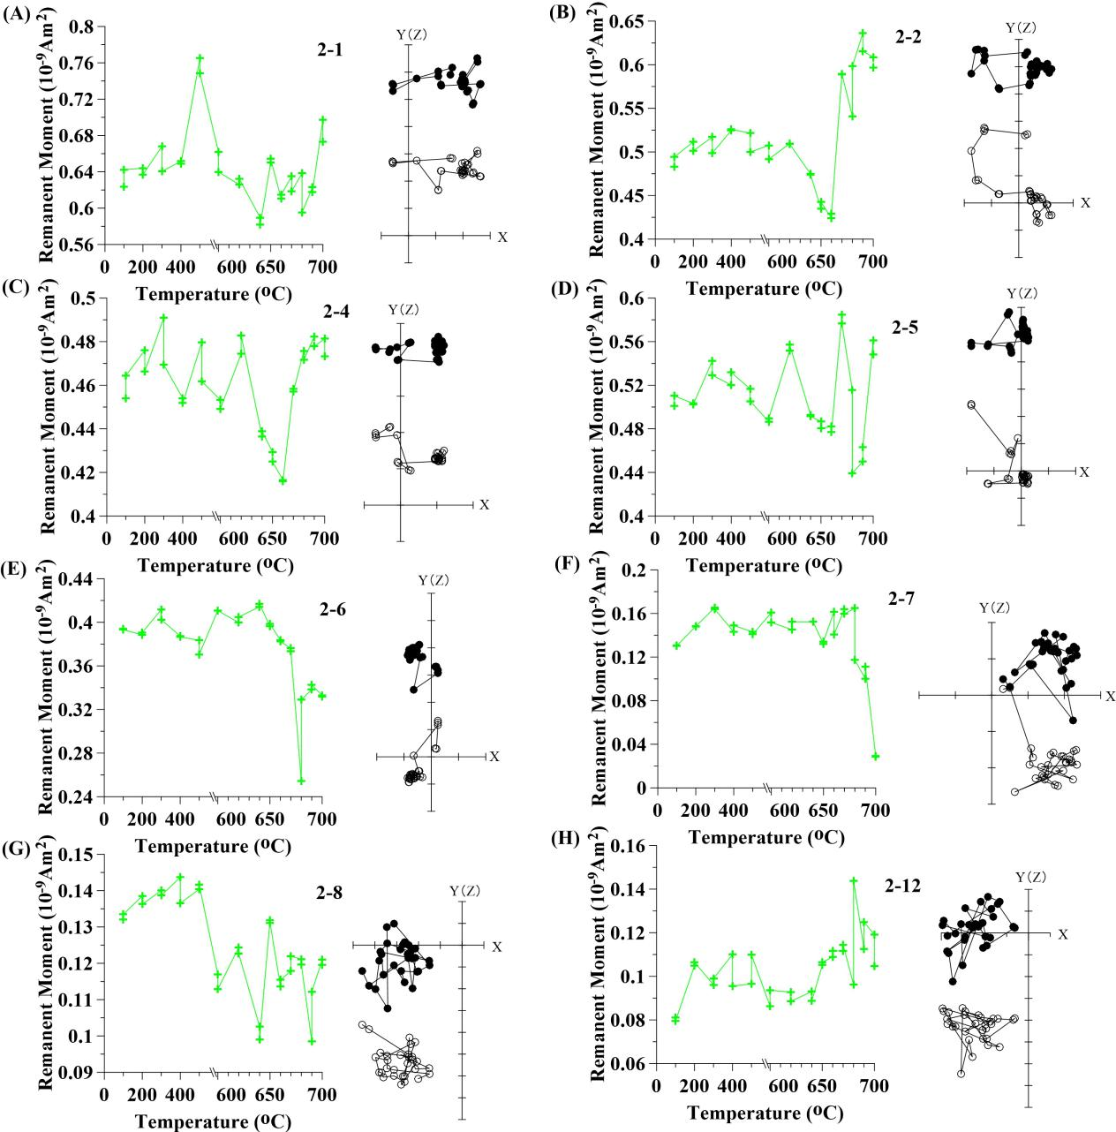
Figure 1. The thermal demagnetization curve (red symbol and line, left) and corresponding orthogonal plot (right) of repeated progressive thermal demagnetization of the synthetic hematite specimens using the MMTD-SC. Solid (open) circles indicate projection on the horizontal (vertical) plane.
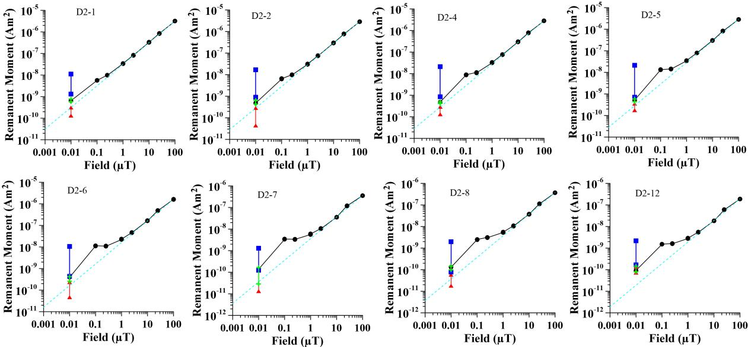
Figure 2. The magnetization of TRM dependence on applied magnetic field. dash lines indicate trend fitting line. The blue squares, red triangles and green crosses indicate the variation range of thermal demagnetization in the ASC TD48, TD-PGL-100 and MMTD-SC.

3.4 TRM acquisition in different fields: Conduct TRM experiments with both TD-PGL-100 and MMTD-SC for comparison.
The purpose of TRM is to assess the impact of the noise field. We don't know why the relationship between TRM intensity and field is not completely linear. And our newly designed furnace has no function of applying field at present. Because of the size of the heating chamber and shield cylinder. The shield cylinder may be magnetized by field coil. And this is a little far from our topic, so we deleted this part.

4. Discussion and 5. Conclusions: Rewrite according to the rewritten preceding sections. Note that restrict to points directly related to your results. Not discuss further away beyond your data.
We have improved this part.

We hope that our revisions satisfy both reviewers and editors.

Best regards,

Huafeng Qin

