7. Appendices

ROCHE Cobas E411
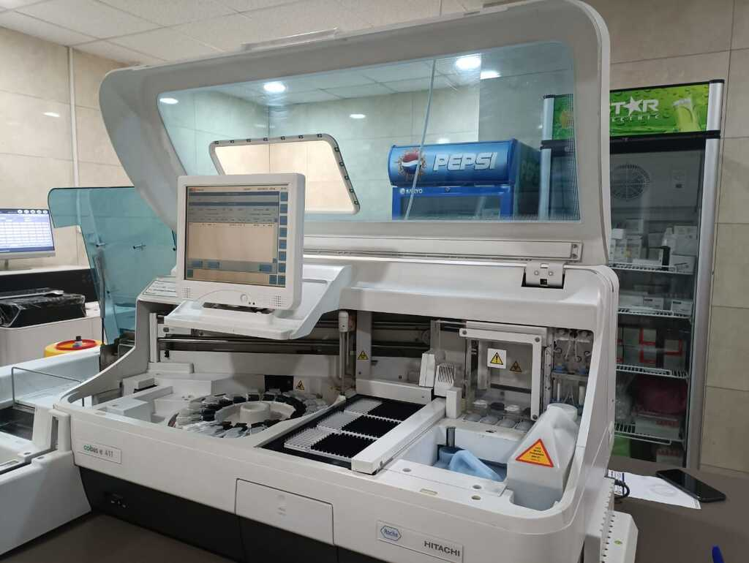

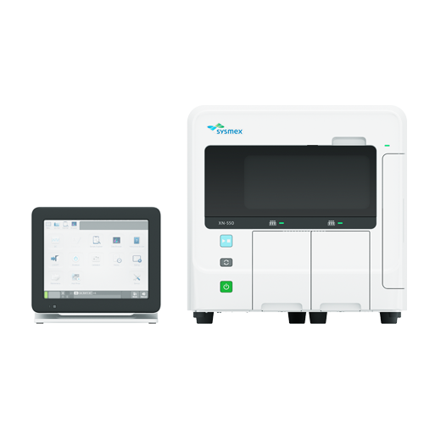
Sysmex KX-550TM).

