Extended Data Fig. 1 | Schematic of the calculations of LAI_{live} and LAI_{dead} (see Methods Derivation of annual LAI_{live} and LAI_{dead}). a, Calculations of LAI_{live} and LAI_{dead} slightly differ for the Northern and Southern Hemispheres due to their different seasonal LAI curves. For the Northern Hemisphere, LAI_{live,y} is the maximum three-consecutive-month averaged LAI (LAI_{max,y}) in year y, while LAI_{dead,y} is the difference between previous year LAI_{max,y-1} and the subsequent minimum three-consecutive-month averaged LAI (LAI_{min,y-1}). For the Southern Hemisphere, LAI_{live,y} is the LAI_{max,y}, while LAI_{dead,y} is the difference between LAI_{max,y} and the subsequent LAI_{min,y}. The green and orange curves indicate the three-consecutive months with maximum and minimum averaged LAI, respectively. b, Global maps showing LAI_{dead} calculated as the difference of LAI_{max} and LAI_{min}.

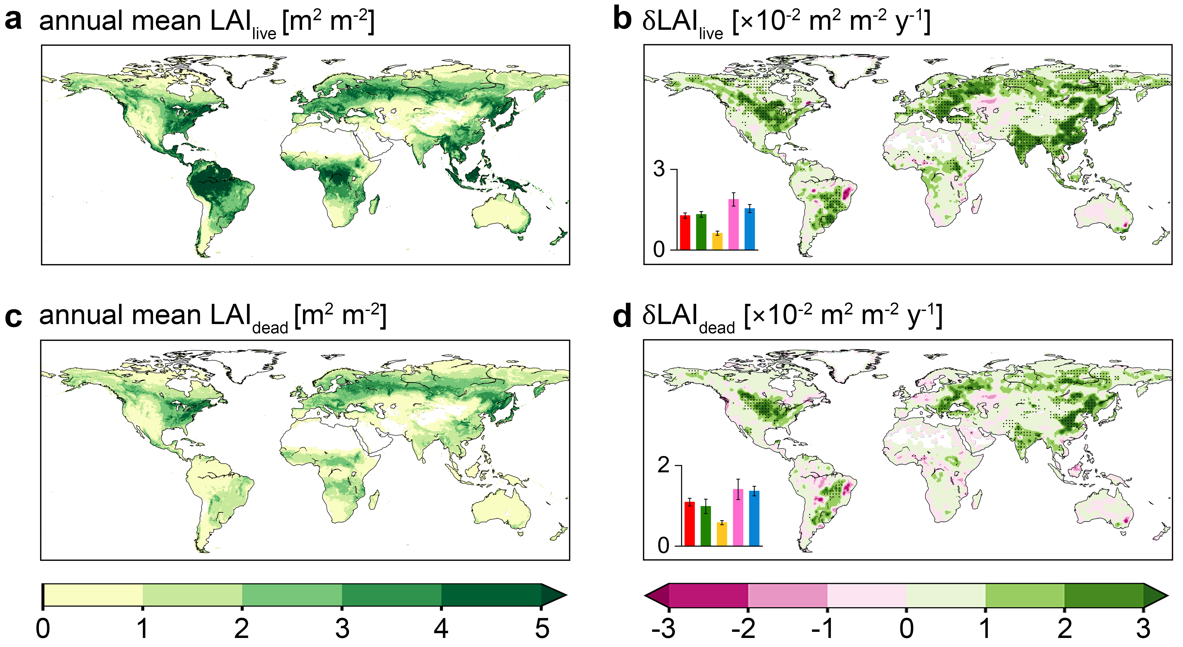
Extended Data Fig. 2 | Annual means and trends of LAI_{live} (a–b) and LAI_{dead} (c–d) over the period 2002–2020. The ensemble means (four LAI products) of trends in LAI_{live} and LAI_{dead} were presented. The black dots in b and d indicate regions with significant trend (p-value < 0.1). The bars and error bars at bottom left indicate the ensemble mean of median trend and standard error across products, respectively, for global (red), tropical (green), arid (orange), temperate (pink), and cold (blue) regions.

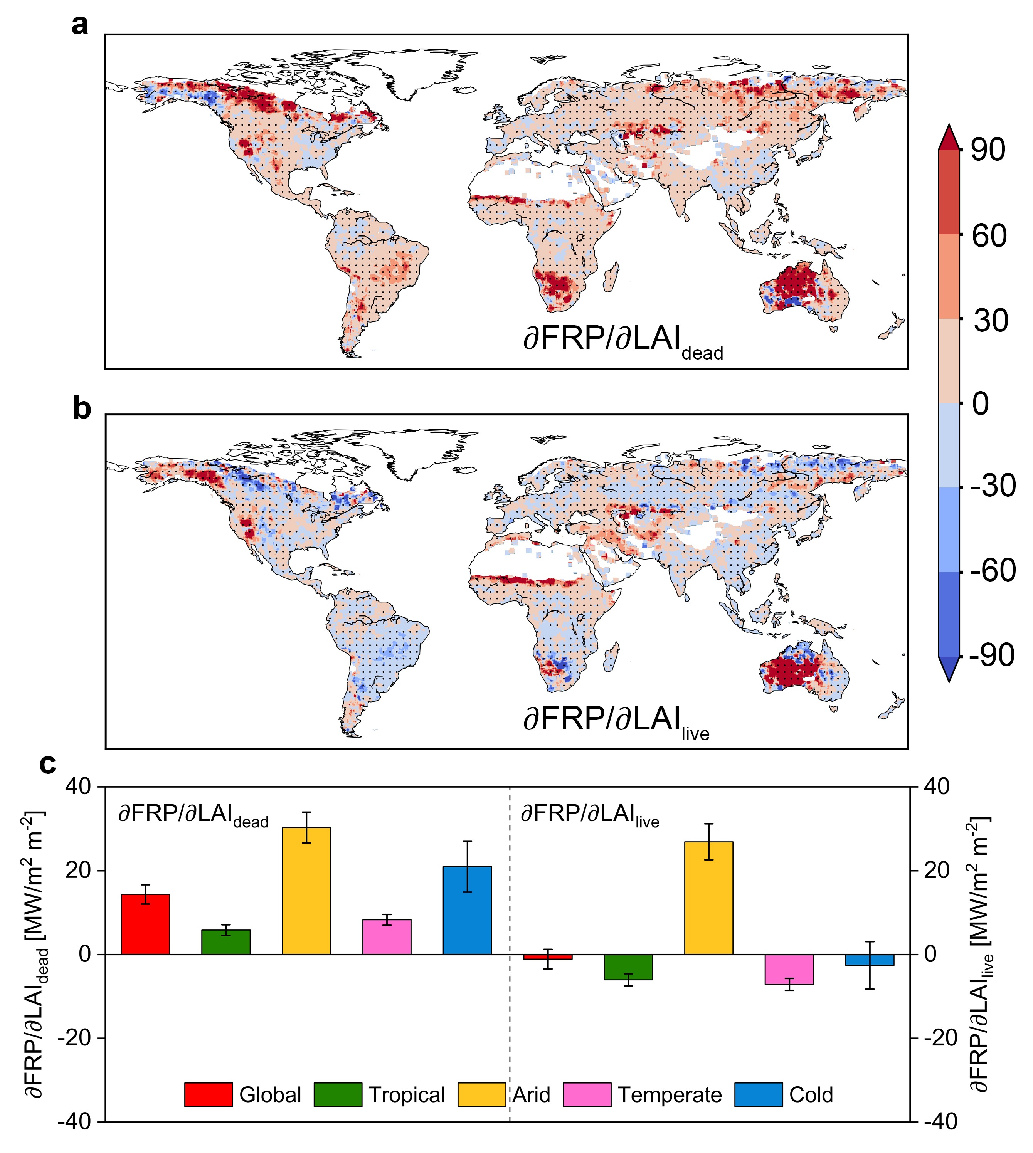
Extended Data Fig. 3 | Fire sensitivity to vegetation greening (LAI_{dead}, a; LAI_{live}, b) for fire radiative power (FRP) as a proxy of fire activity. FRP is derived from MCD14ML V6 product. The black dots indicate regions with significant sensitivity (p-value < 0.1). c, Ensemble mean of median sensitivity for global (red), tropical (green), arid (orange), temperate (pink), and cold (blue) regions. The error bars indicate the standard error across products.

Extended Data Fig. 4 | ∂BF/∂LAI_{live} and ∂BF/∂LAI_{dead} for different plant vegetation types (FTPs, a), biomes (b), and forest/non-forest (c-d). a, Quadratic relationship between ∂BF/∂LAI_{live} and ∂BF/∂LAI_{dead} at FTPs level. The red labels in the four quadrants indicate the percentages of global areas. b, Same as a but at biome level. c-d, Significant differences of ∂BF/∂LAI_{dead} (c) and ∂BF/∂LAI_{live} (d) between forest (green) and non-forest (orange). *** indicates a significantly different sensitivity between forest and non-forest by a two-sided Mann–Whitney U test at p-value < 0.01. Plant functional types are shown in Fig. S18 and biomes are shown in Fig. S19.

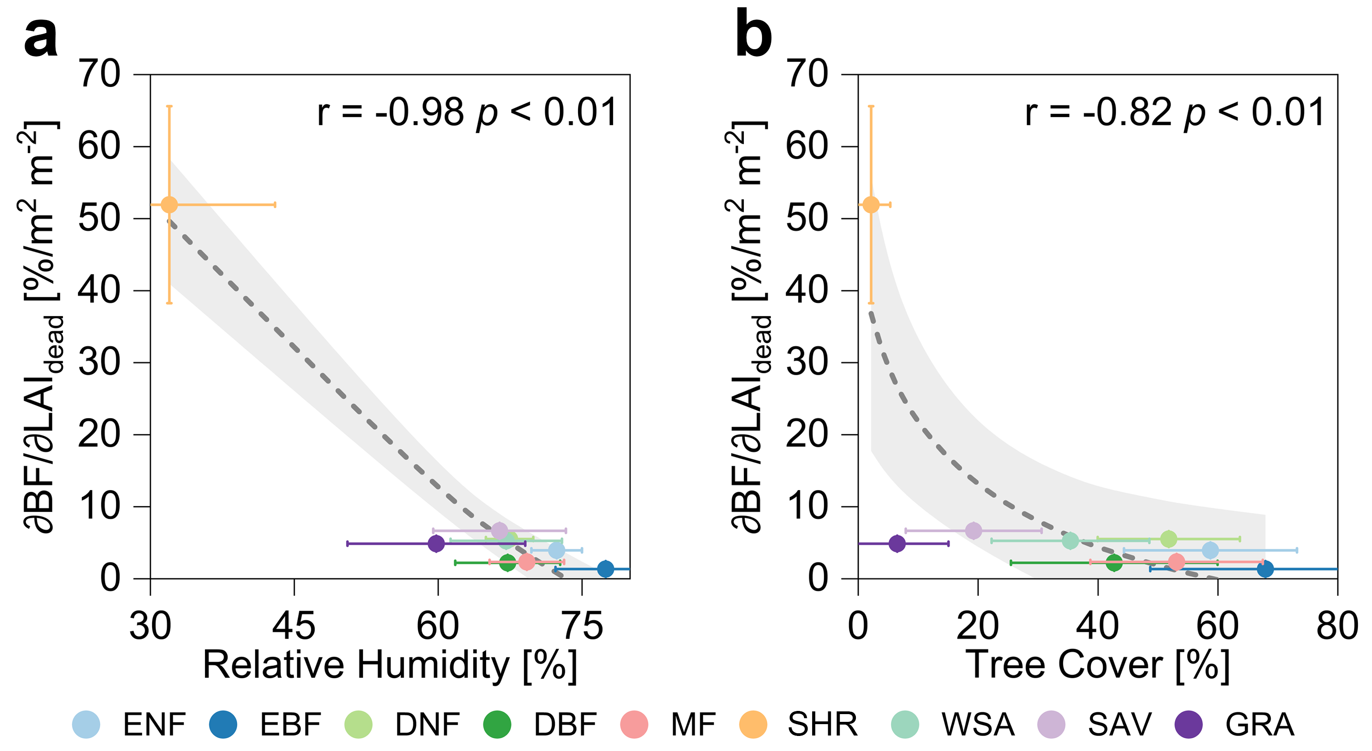
Extended Data Fig. 5 | Water availability and vegetation growth regulate ∂BF/∂LAI_{dead}. Same as Fig. 3a-b, but for the PFT-scale relationships between ∂BF/∂LAI_{dead} and relative humidity (a) and tree cover (b). The relationship is fitted by natural logarithmic function. The points relate ensemble means of median sensitivities with median values of factors for each PFT. The error bars indicate spatial standard deviation of factors (horizontal) and standard error of sensitivities across products (vertical). The shaded area indicates the 95% confidence interval of fitted line.

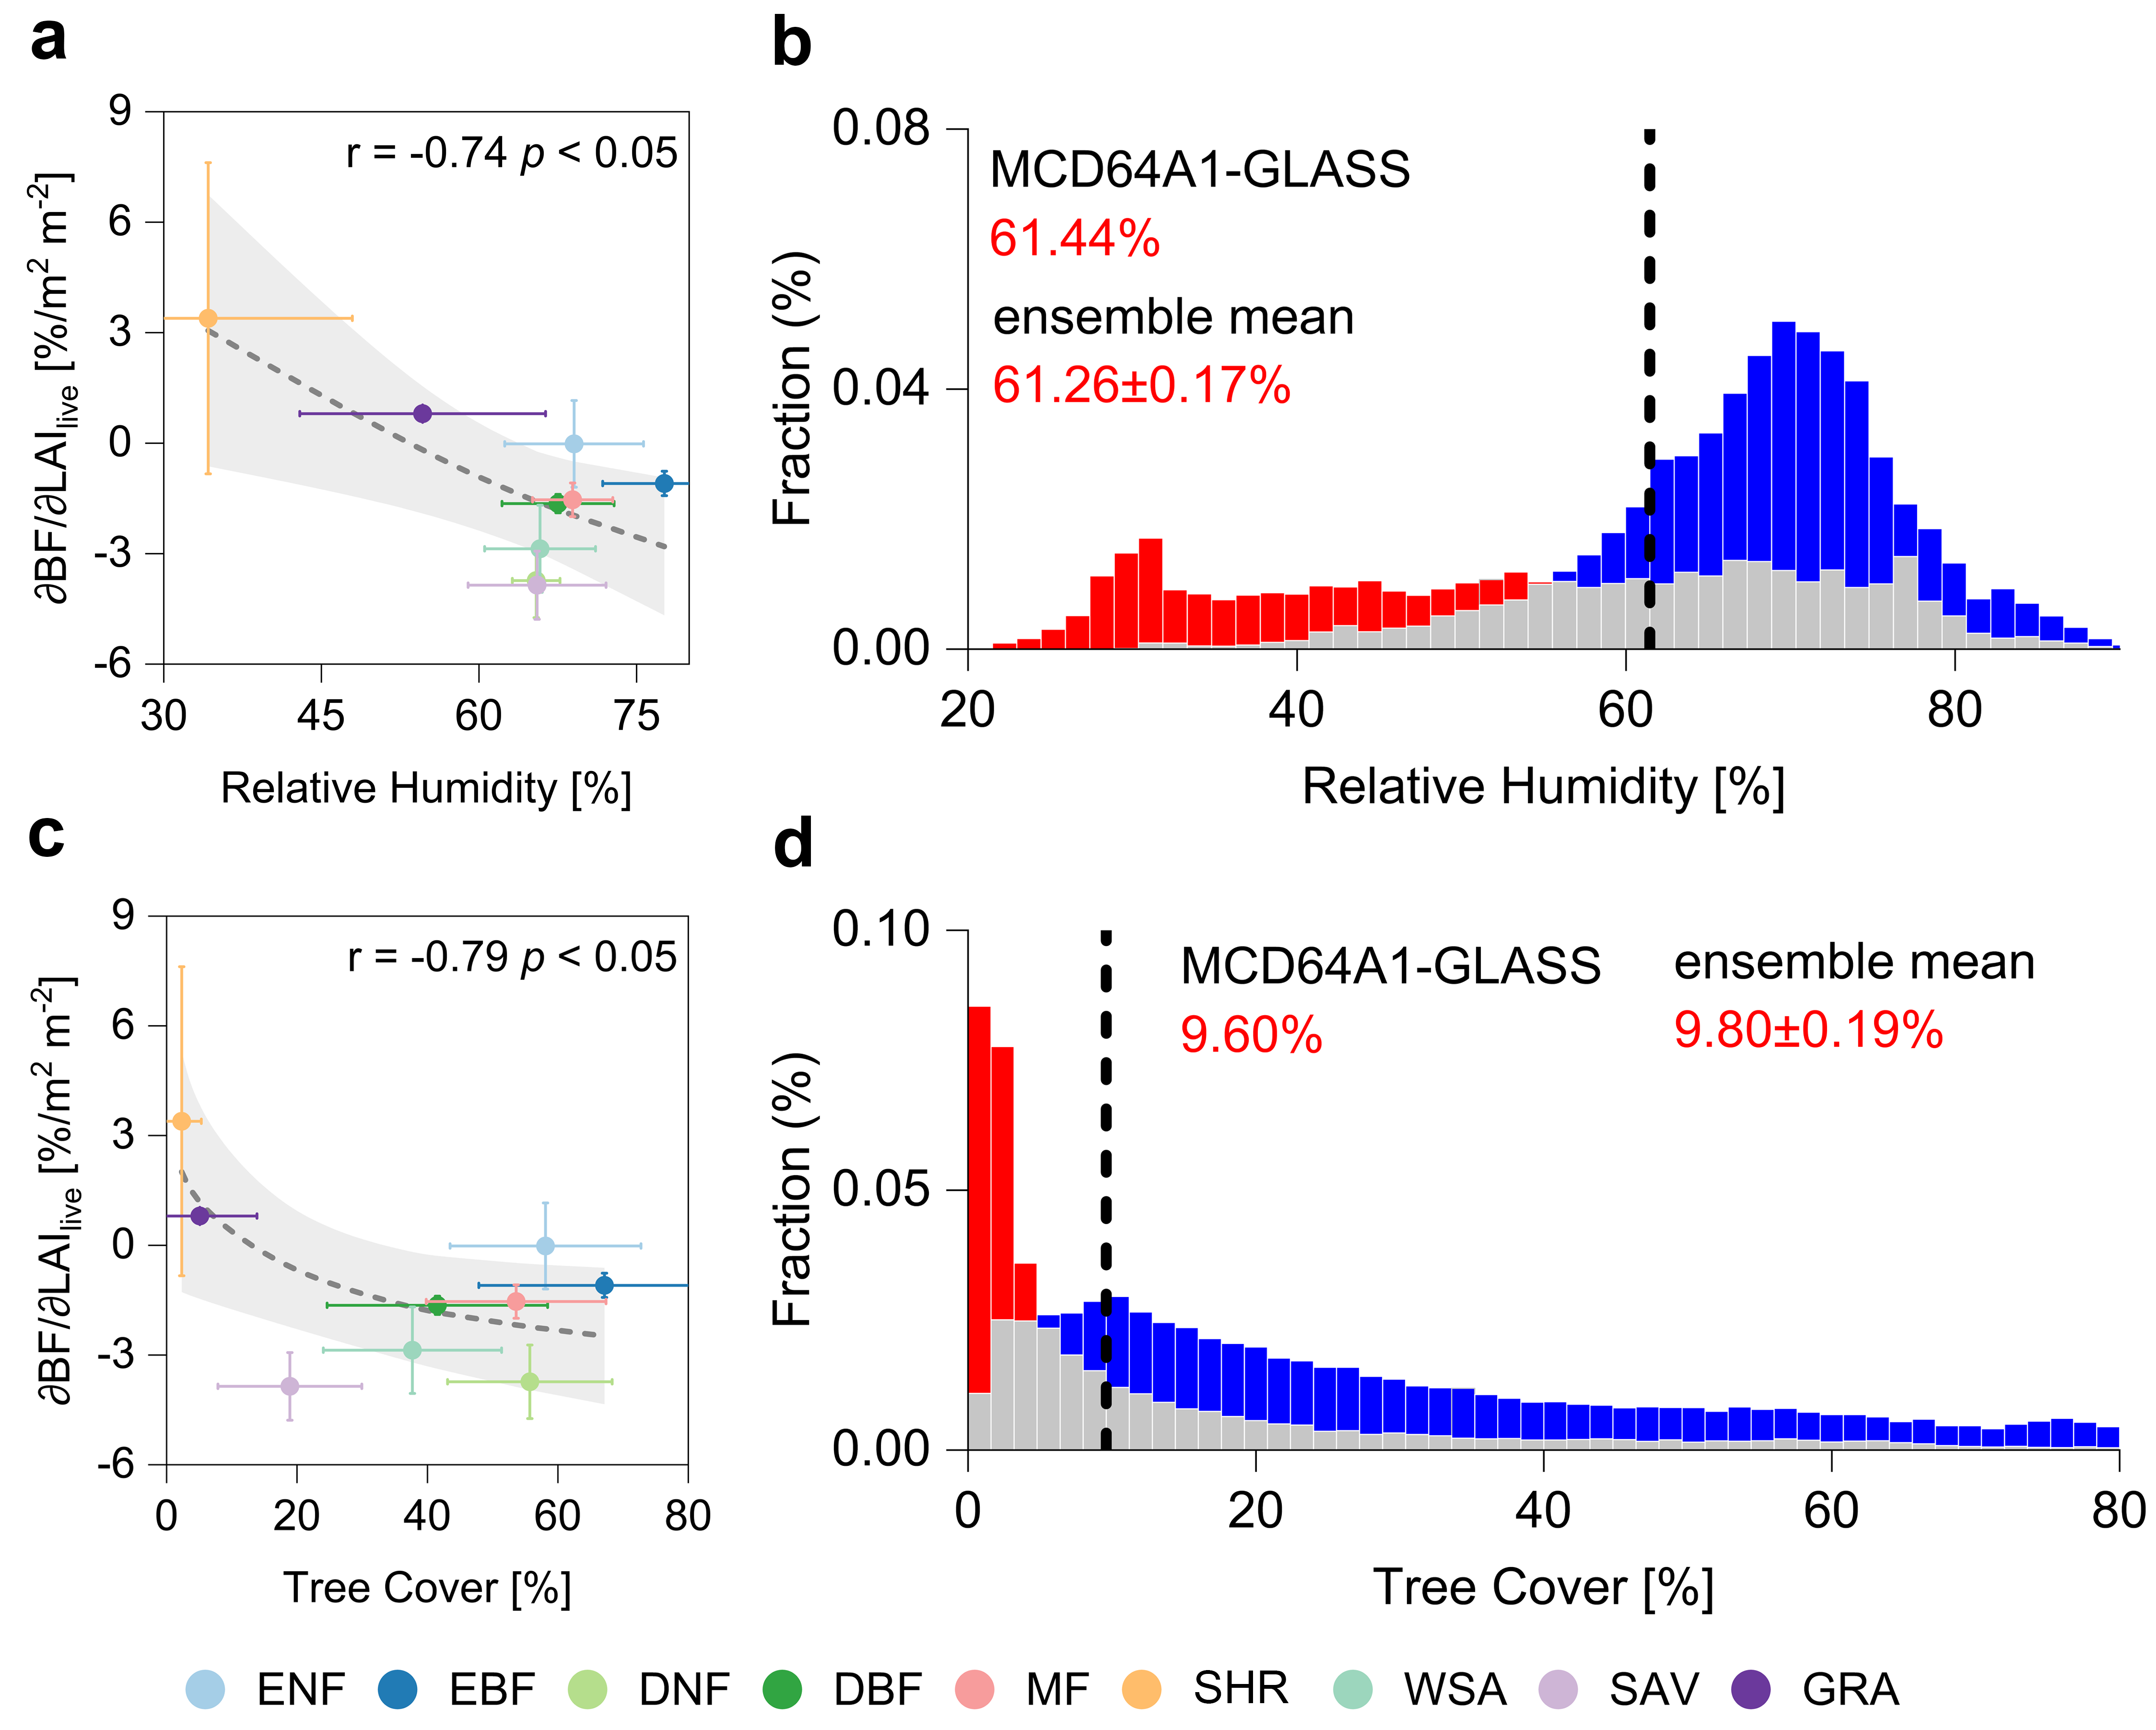
Extended Data Fig. 6 | Same as Fig. 3c-f but for the thresholds of relative humidity (RH) and tree cover regulate the spatial variability of ∂BF/∂LAI_{live}. a, PFT-scale relationship between RH and ∂BF/∂LAI_{live}. The relationship is fitted by natural logarithmic function. b, The threshold of RH partitions positive and negative ∂BF/∂LAI_{live}. The fractions of positive (red) and negative (blue) sensitivity in each RH bin (50 bins) are shown. The thresholds of tree cover (c and d) also regulate the spatial variability of ∂BF/∂LAI_{live}.

